**FlyinTravel User Manual**

**Steps to Use this Reservation System: (Here snapshots are from LinuxOS)**

(steps remain the same for any OS)

The main menu displays below Options for the user

1.Search Flights

2.Signup

3.Login

4.View Booking

5.Cancel Booking

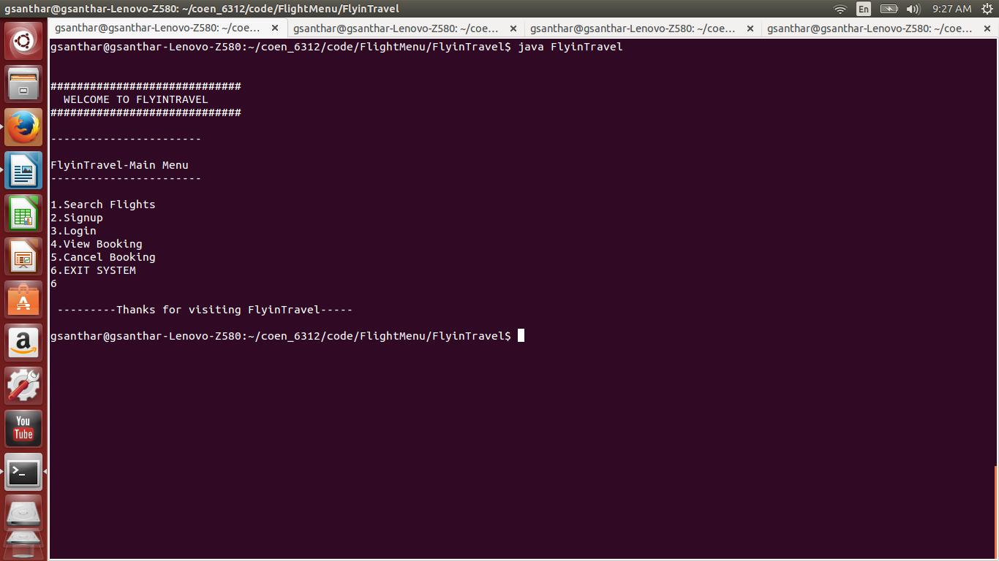

There is sub menu under some of the above sections, they are

1. Search Flights

1.Book Flights

2.Login

If Username is admin, ie for Admin Login

1.Update Flights

2.Delete Flights

3.Delete Account

4.Logout

If a Normal user logs in, then

1.View Account

2.Modify Account

3.Logout

Now let’s see the steps involved in each sections of the reservation system.

**1.Search Flights**

This Section requires to enter below Details need to search Flights----Select prefix numbers to enter the value

1.Source

2.Destination

3.Date

4.No of Passengers

5.IsDomestic: Enter 'true' for domestic OR 'false' for International

6.IsOneway: Enter 'true' for one-way OR 'false' for Return

7.quit

Enter the option number now example 1 for Source:

Snapshots of usage are below

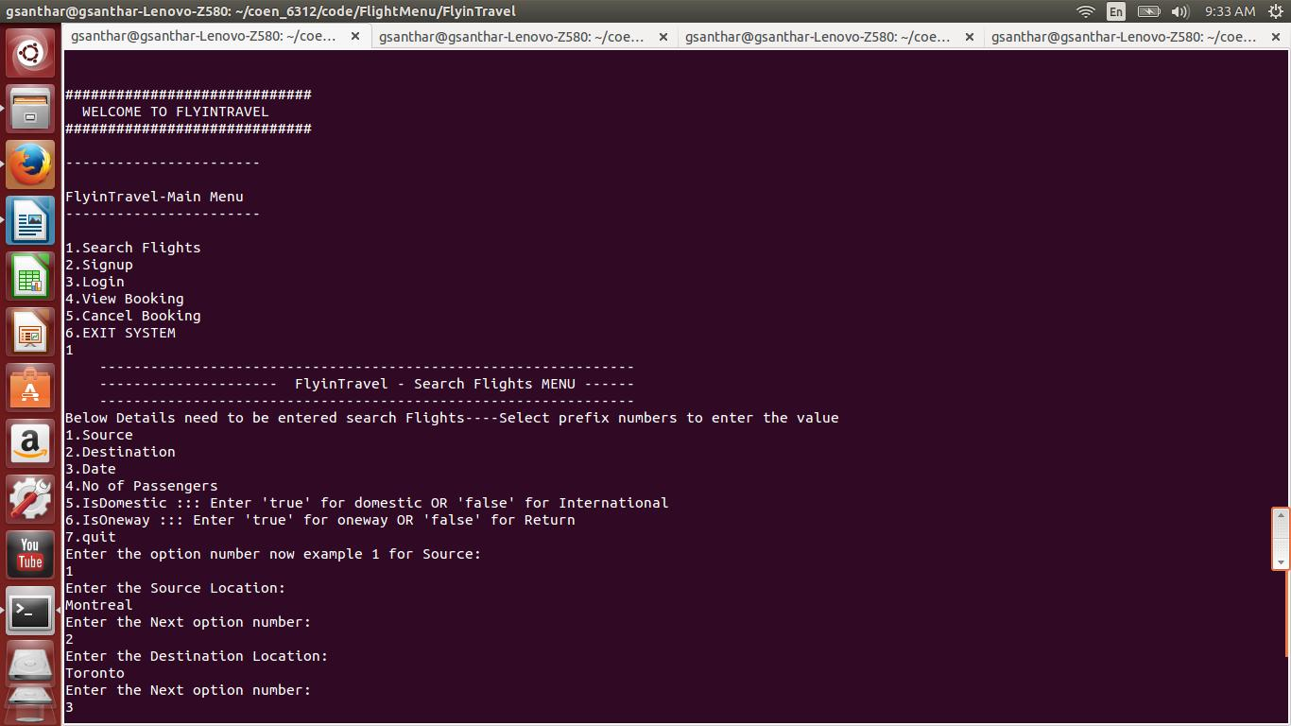

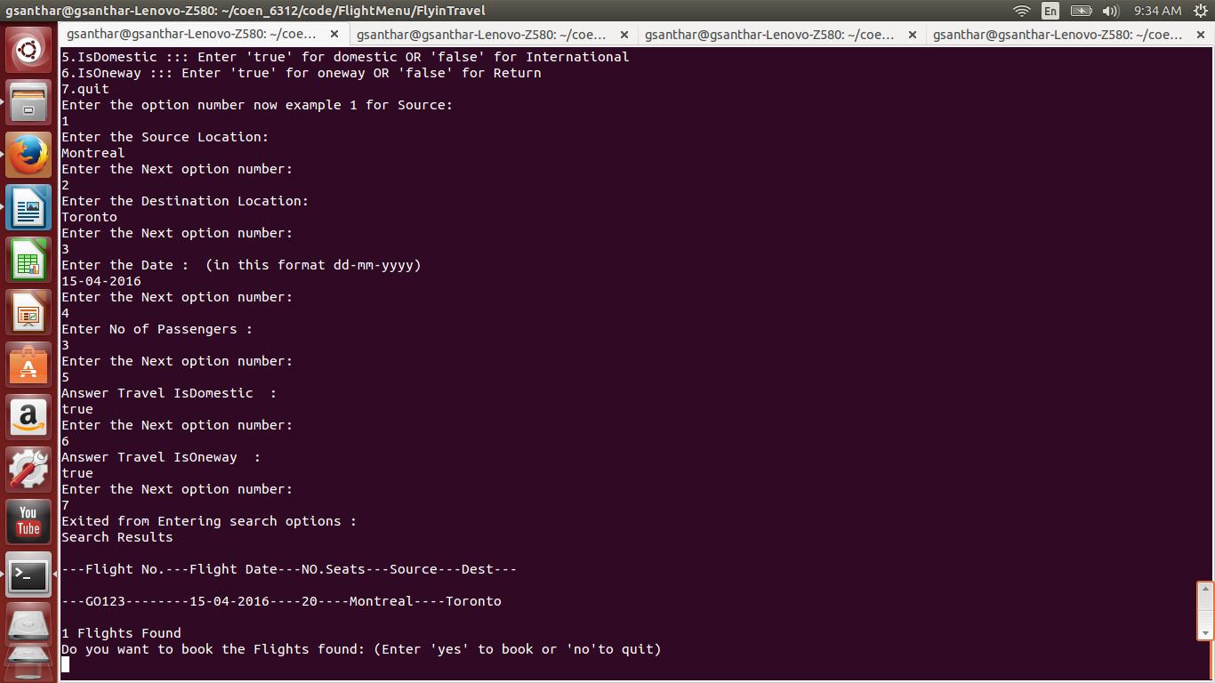

1.1 Book Flights

one can book the retrieved flights from the search. Booking will be completed with entering payment credentials.

Snapshot of a usage is below

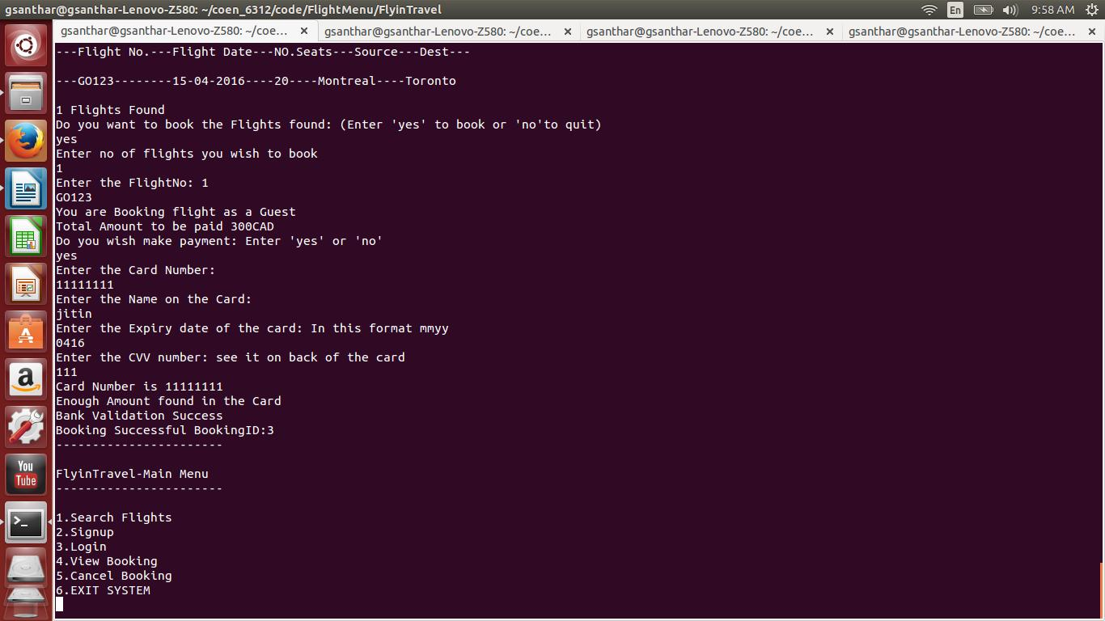

**2.Signup**

Let’s one to enter personal credentials to signup to Flight Reservation system

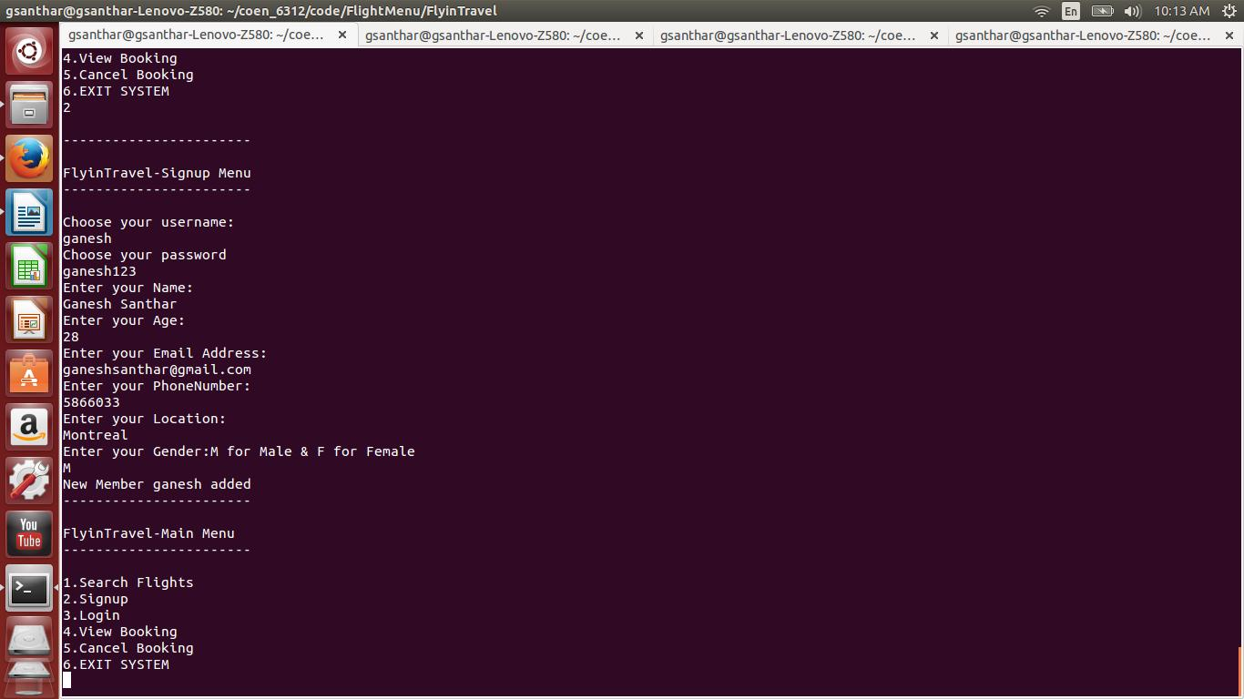

**3.Login**

Provides single login prompt for admin and as well as for Member

If its detects the username to admin credentials, then admin menu is displayed

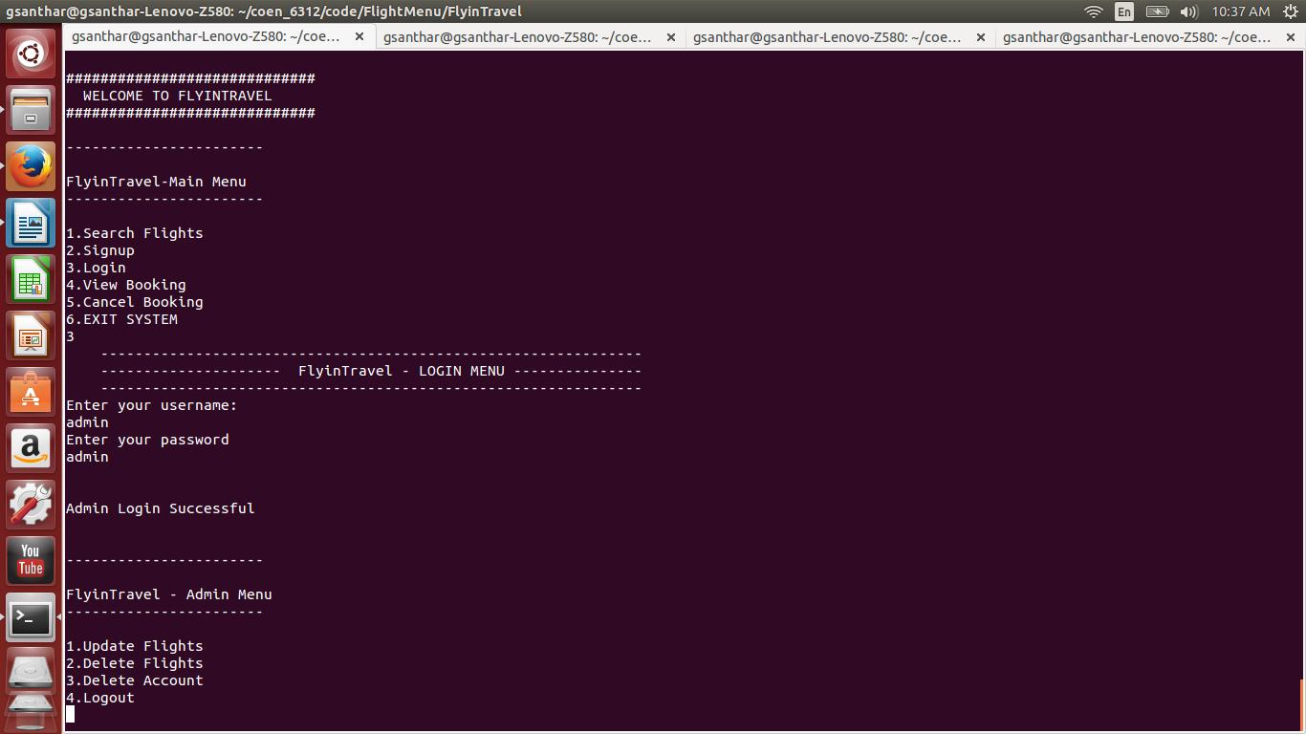

1.Update Flights

Admin can update the existing flights in the flight database and as well as add new flights to database.

Usage below:

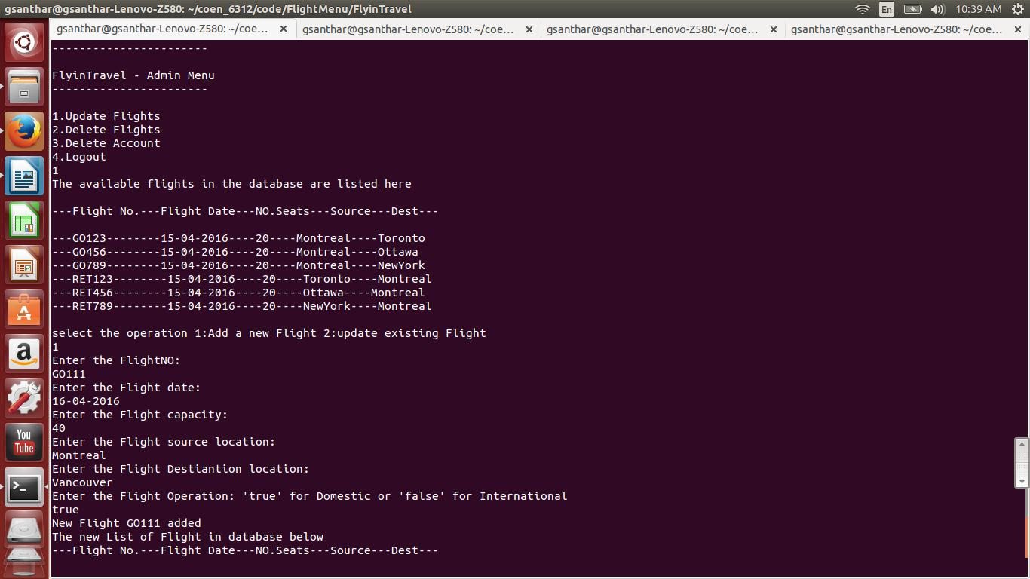

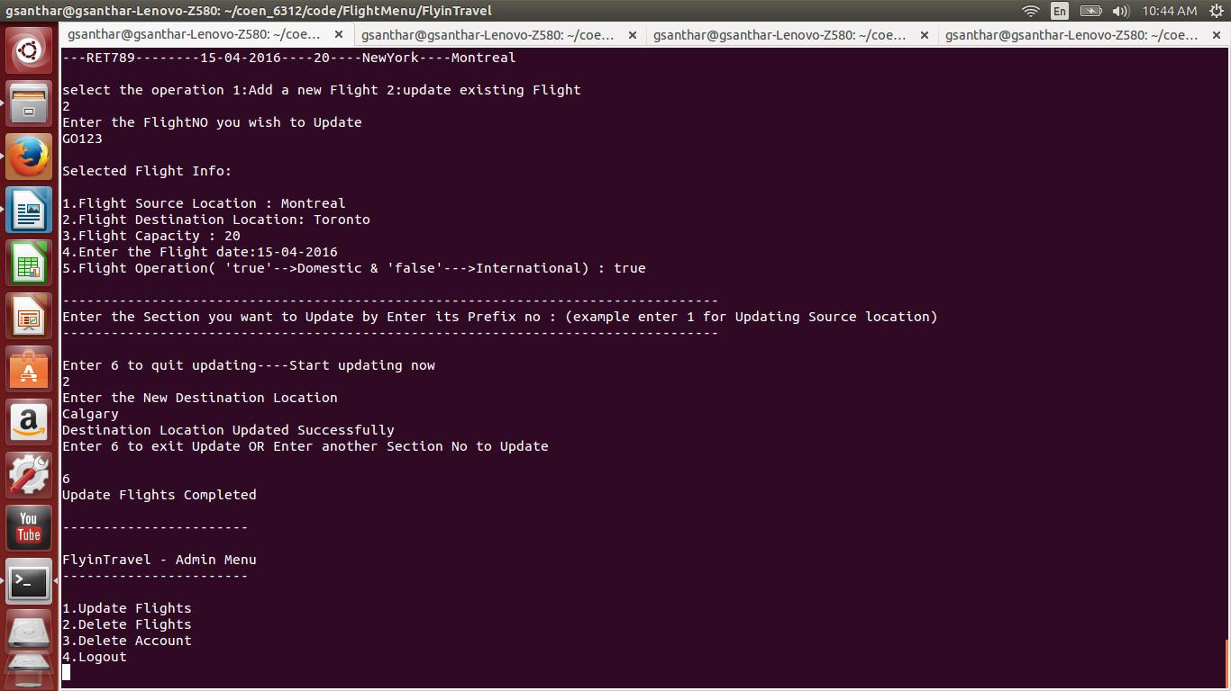

2.Delete Flights

Admin deletes the flights in the flight database

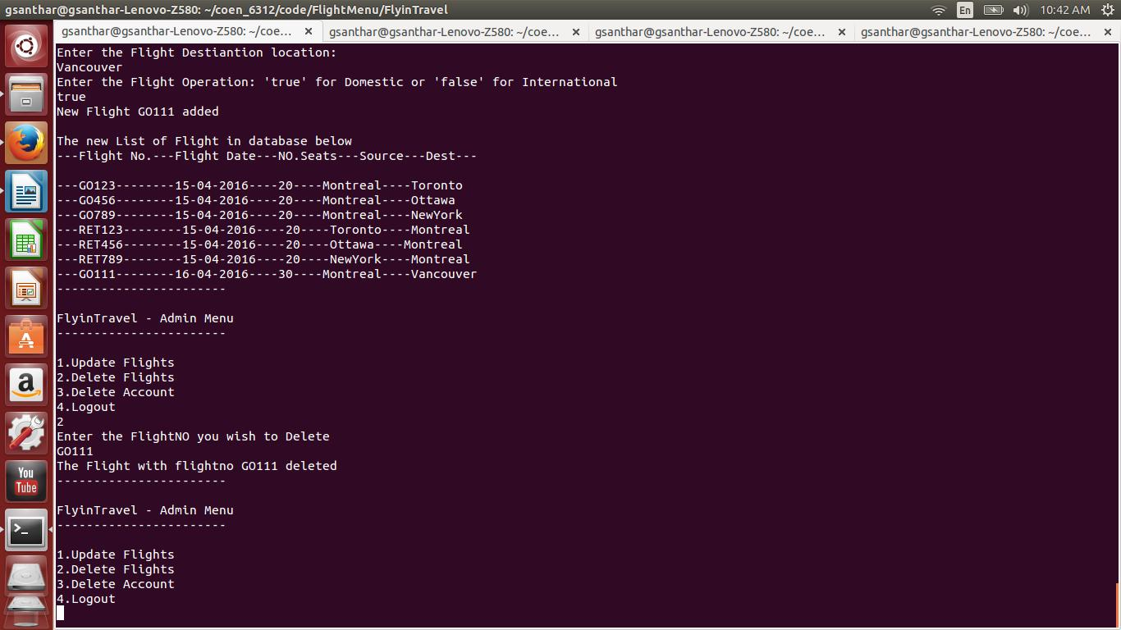

3.Delete Account

Admin delete member accounts from the Member database

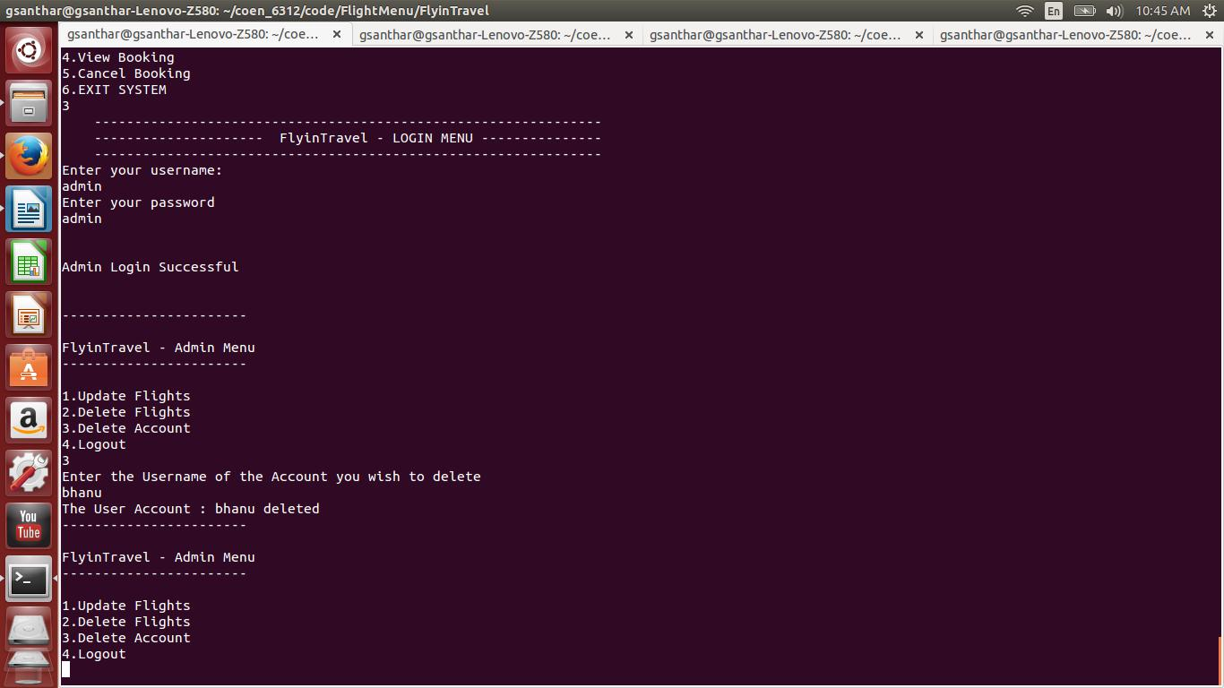

4.Logout

Admin logs out.

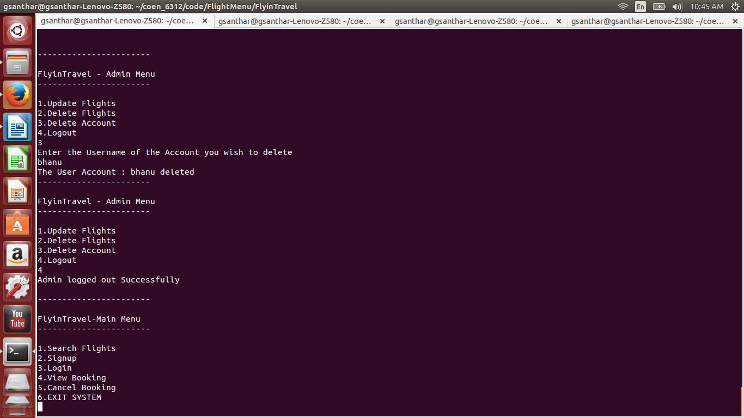

If its detects the username to be a member credentials, the member menu is displayed

1.View Account

A Member can view one's Personal details

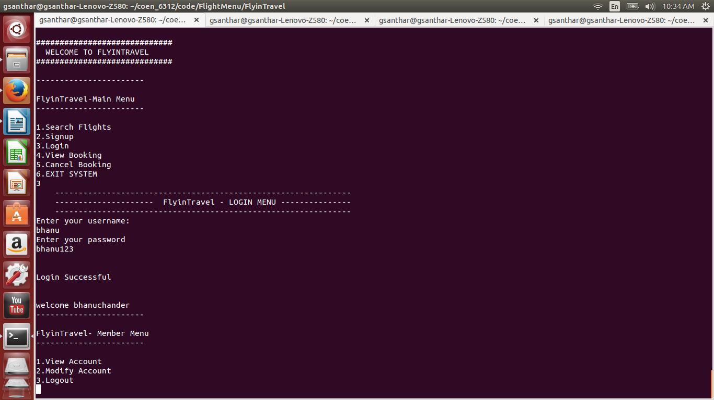

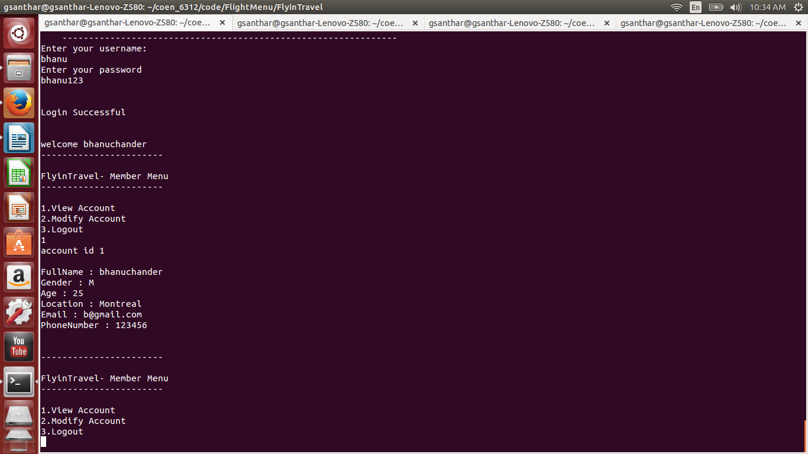

2.Modify Account

A Member can modify one's personal details

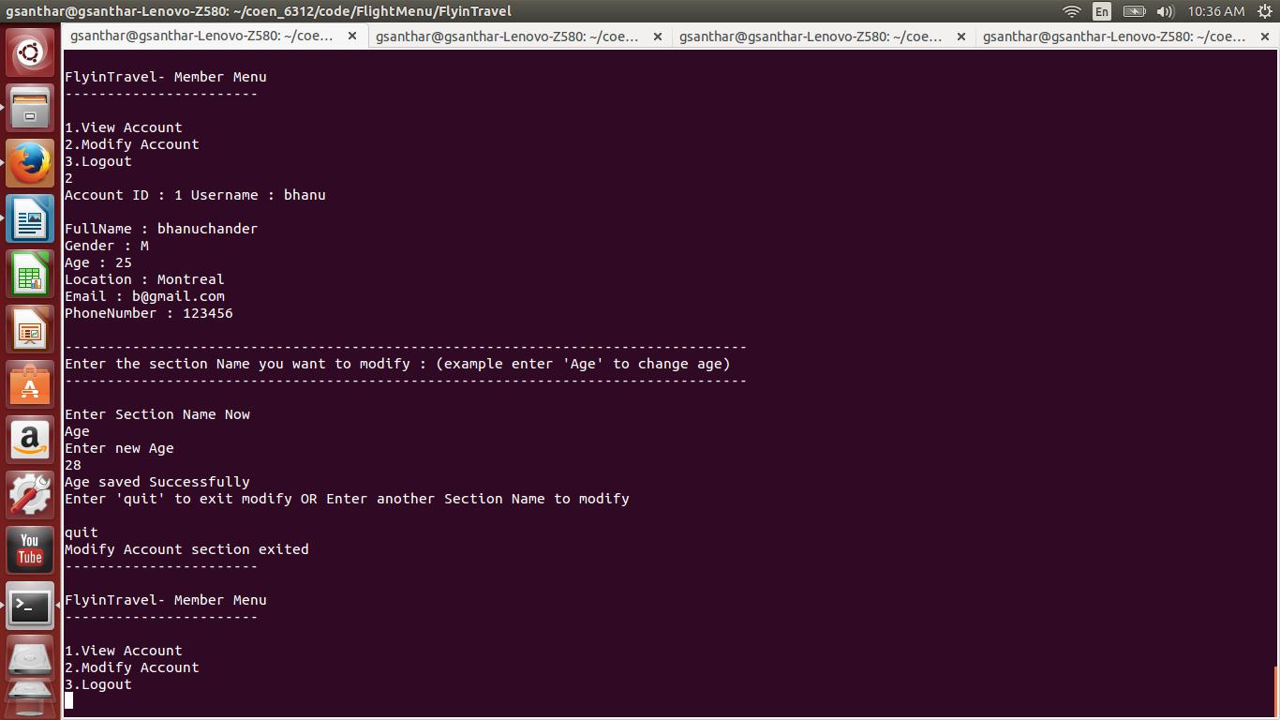

3.Logout

A Member logs out

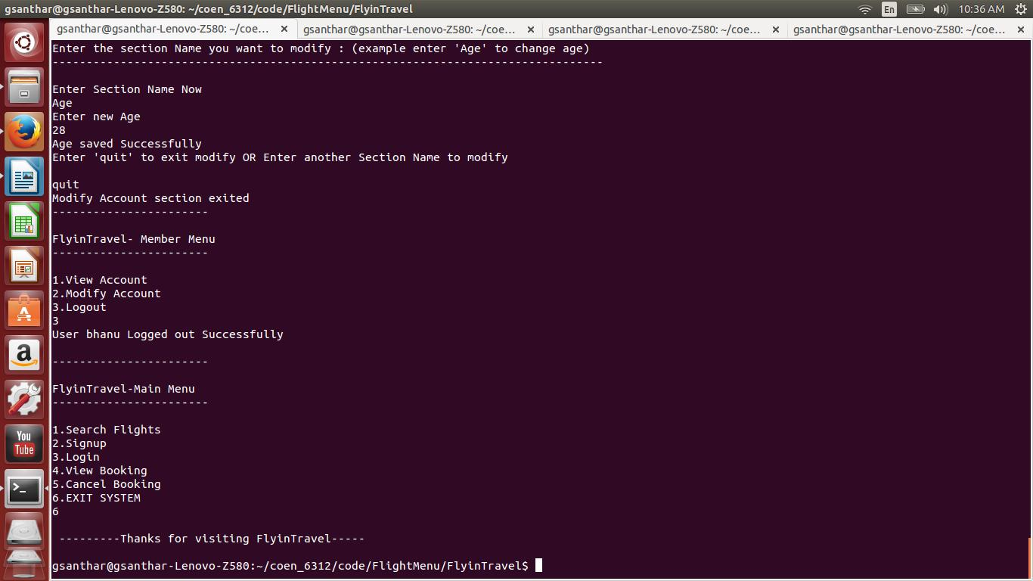

**4.View Booking**

One can view the booking details by entering the booking ID

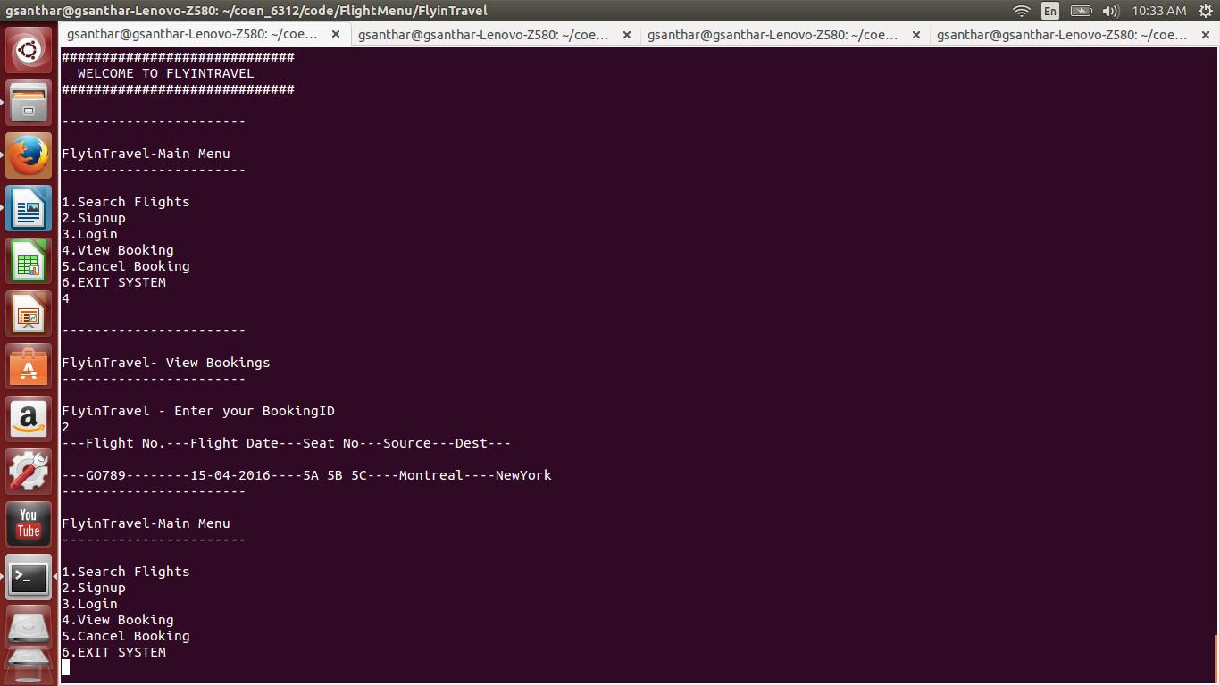

**5.Cancel Booking**

One can cancel the booking by entering the bookingID

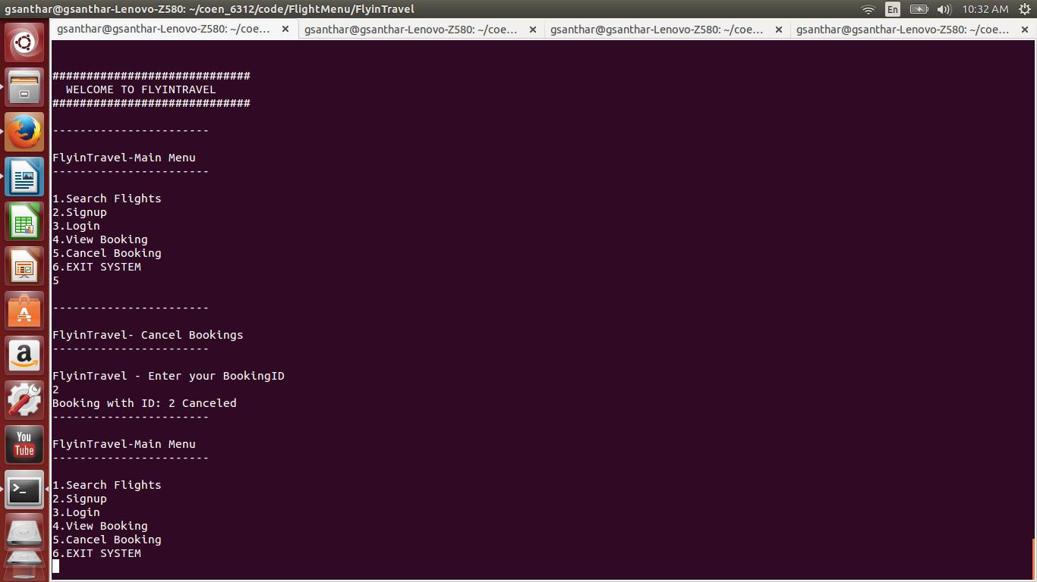

**6.Exit System**

Exit the Flight Reservation system

