PROVIGIL AETHER - XDR PLATFORM
Comprehensive System Architecture & Multi-Agent Topology Specification
Classification: Proprietary & Confidential | Platform Version: v2.4 (Unified NDR + SIEM) | Date: October 2026
1. Executive Summary & Architectural Overview
The Provigil AETHER platform is a unified Extended Detection and Response (XDR) enterprise cybersecurity solution that harmonizes Network Detection & Response (NDR) with Security Information and Event Management (SIEM). Engineered in high-performance Rust and modern Angular 19, the architecture provides zero-compromise multi-tenancy, processing tens of thousands of high-velocity telemetry events per second with sub-second threat detection and analytical query capabilities.
The ecosystem is divided into four distinct operational tiers: Ingress Edge Gateway (Caddy), Microservices Application Tier (Rust Auth and SIEM API), Ingestion & Agent Fleet (Wazuh Windows/Linux Endpoint Agents and Network Sensors), and the Columnar Big Data & Caching Tier (ClickHouse & Valkey).
2. End-to-End System Architecture Diagram
The high-resolution diagram below illustrates the comprehensive topology including edge TLS ingress, reverse proxy URI dispatching, Rust backend microservices, ClickHouse big data columnar storage, Wazuh remoted wire protocols, and distributed endpoint agents:
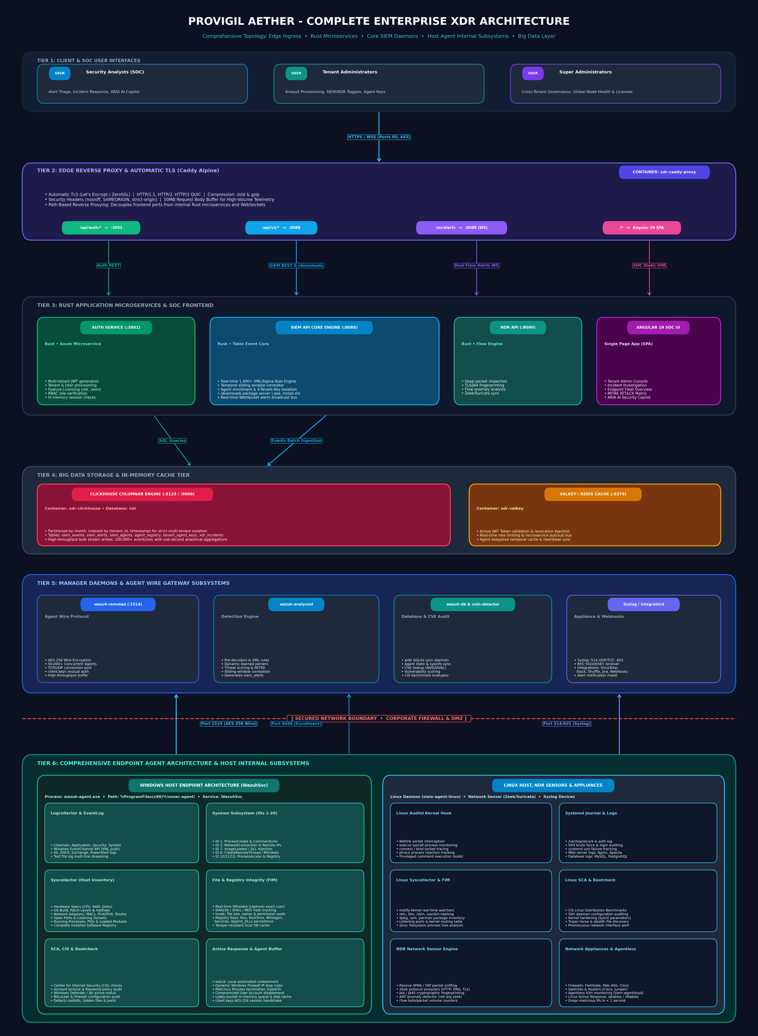
Figure 1: Provigil AETHER End-to-End Enterprise Architecture, Ingress Routing & Multi-Agent Topology
3. Detailed Core Components & Daemon Subsystems Breakdown
3.1 Edge Reverse Proxy (Caddy Alpine)
- Role: The single unified edge ingress gateway running in Docker container xdr-caddy-proxy on ports 80 (HTTP) and 443 (HTTPS/QUIC).
- Security & Performance: Terminates TLS with automated certificate renewal, enforces strict security headers (nosniff, SAMEORIGIN, strict-origin-when-cross-origin), and enables zstd/gzip compression.
- Smart Upstream Routing: Inspects request URI paths and distributes traffic dynamically without requiring client port awareness:
- • /api/auth/* & /api/v1/auth/*: Forwards to auth-service:3001.
- • /api/*, /api/v1/*, & /downloads/*: Forwards to siem-api:8088.
- • /ws/alerts & /ws/siem/*: Forwards full-duplex WebSocket connections to siem-api:8088.
- • Root /*: Serves the compiled production Angular 19 SPA with HTML5 push-state fallback.
3.2 Authentication & Licensing Service (auth-service)
- Technology: Compiled native binary built in Rust using Tokio, Axum, and SQLx/ClickHouse.
- Authentication: Issues and verifies HMAC-SHA256 JWT tokens containing user identity, active tenant_id, role scope, and licensed features.
- Feature Entitlement: Validates whether a tenant has access to 'ndr', 'siem', or unified 'xdr' modules, dynamically enforcing UI rendering and route authorization.
- Session Caching: Utilizes Valkey on port 6379 for millisecond token revocation checks, rate limiting, and session verification.
3.3 Core SIEM API & Processing Engine (siem-api)
- Architecture: Rust-based multi-threaded event processing engine listening on HTTP/REST (8088), Syslog UDP (514), and Syslog TCP (601).
- Detection Engine: Executes over 1,400+ Wazuh and Sigma XML/YAML rules across Windows EventLog, Linux Auditd, and network streams.
- Sliding Window Correlation: Maintains an in-memory temporal sliding window to detect brute force, lateral movement, port scans, and distributed attacks.
- WebSocket Push Bus: Broadcasts matching alerts in real time to connected Analyst SOC browsers via /ws/alerts.
- Agent Enrollment Handler: Handles POST /api/v1/agents/enroll requests, authenticating tenants via X-Tenant-Key and generating client.keys entries.
3.4 Core Manager Daemons & Wire Subsystems
- wazuh-remoted (Agent Wire Gateway): Listens on Port 1514 (TCP/UDP) with low-overhead AES-256 wire encryption. Capable of sustaining 50,000+ simultaneous persistent agent connections per cluster node with mutual client.keys cryptographic authentication.
- wazuh-analysisd (Detection Engine): High-speed pre-decoding and XML/Sigma rule evaluation daemon. Correlates multi-event security incident chains and outputs normalized siem_alerts.
- wazuh-db (Agent State Synchronization): SQLite database daemon managing agent synchronization, hardware inventories, and persistent host state.
- wazuh-vuln-detector (CVE Audit Engine): Continuously evaluates inventory discovered on host agents against the National Vulnerability Database (NVD) and OVAL CVE feeds to flag vulnerable software.
- siem-integratord & siem-maild: Orchestrates alert dispatches and automated incident ticketing to Slack, VirusTotal, Shuffle, Jira, and Email notifications.
4. Comprehensive Endpoint Agent Architecture & Host Internal Subsystems
The Provigil endpoint agent fleet runs lightweight native collectors embedded directly into host operating systems. The internal architecture of each agent is divided into dedicated, modular subsystems designed for sub-1% CPU consumption and zero business disruption:
4.1 Windows Host Internal Subsystems (WazuhSvc / wazuh-agent.exe)
- Host Installation: Operates as a registered Windows Service under %ProgramFiles(x86)%\ossec-agent\wazuh-agent.exe.
- Logcollector Engine: Streams raw Windows EventChannel events in real time across Application, Security, System, PowerShell, DHCP, and IIS channels.
- Sysmon Telemetry Integration: Deep kernel-level telemetry covering Event IDs 1-20: Process Creation & Command-Line arguments (ID 1), Network Connections & Remote IPs (ID 3), Driver Loads (ID 6), DLL Injection / Image Loads (ID 7), CreateRemoteThread / Mimikatz injection (ID 8), ProcessAccess (ID 10), and Registry Modifications (IDs 12-14).
- Syscollector (Host Inventory): Periodically audits the complete host profile: CPU/RAM hardware specs, OS build & hotfixes, network adapters, MAC addresses, IPv4/IPv6 routing tables, open/listening network ports, running processes & PIDs, and installed software registry packages.
- File & Registry Integrity Monitoring (FIM): Continuous cryptographic hashing (SHA256/SHA1/MD5) of critical system directories and Windows Registry persistence keys (Run, RunOnce, Winlogon, Services, AppInit_DLLs). Features real-time Whodata tracking that identifies the exact Windows user account responsible for file alterations.
- SCA & Rootcheck: Automated system hardening audits evaluated against Center for Internet Security (CIS) benchmarks, BitLocker status, Windows Defender real-time protection, and password policy compliance.
- Active Response (execd): Executes local automated containment commands dispatched by the SIEM: dynamic Windows Firewall IP drops, malicious process termination (taskkill), and compromised user account locking.
- Agent Resilience Queue: Features an in-memory leaky-bucket buffer backed by an encrypted disk queue, guaranteeing zero telemetry loss during network disruptions.
4.2 Linux Host Internal Subsystems (siem-agent-linux)
- Host Architecture: Native lightweight daemon managed under systemd as a high-priority system service.
- Linux Auditd Kernel Hook: Intercepts kernel-level system calls via Netlink socket, tracking execve process launches, socket connect/bind operations, ptrace debugging/injection, and privileged sudo executions.
- Journald & Logcollector: Continuously streams systemd journald logs, /var/log/secure, auth.log, SSH brute force events, and application logs (Nginx, Apache, MySQL, PostgreSQL).
- Linux Syscollector & FIM: Kernel inotify filesystem watchers monitoring /etc, /bin, /sbin, /usr/bin, package managers (dpkg, rpm, pacman), and /proc process tree states.
- SCA & Rootcheck: Hardening checks against CIS Linux Distribution benchmarks, SSH daemon security options, sysctl kernel parameters, and stealth rootkit detection.
- Active Response: Instantly drops attacker IP addresses via iptables / nftables and terminates compromised shell processes in under 1 second.
4.3 Network Sensor & Appliance Subsystems (NDR Module)
- Inspection Model: Connects to physical or virtual network TAP/SPAN ports to passively inspect Ethernet traffic without impacting throughput.
- Zeek & Suricata Analyzers: Extracts protocol metadata, JA4/JA4S TLS cryptographic fingerprints, unencrypted HTTP payloads, and DNS tunneling anomalies.
- ARP Anomaly Engine (ndr-arp.zeek): Monitors ARP broadcast tables to detect ARP poisoning, rogue DHCP servers, and gateway spoofing in real time.
- Syslog Appliance Ingestion: Receives standard RFC 5424/6587 syslog streams from FortiGate, Palo Alto, Cisco FTD, Juniper, and enterprise routers.
- Agentless Monitoring (siem-agentlessd): Uses SSH and SNMP protocols via siem-agentlessd to monitor routers, switches, and firewalls where software agents cannot be installed.
5. Network Communication & Port Matrix
The following matrix summarizes all network ports, transport protocols, and communication flows across the platform:
Port | Protocol | Direction | Source | Destination | Purpose & Security
80 / 443 | TCP/QUIC | Inbound | Web Browsers | Caddy Proxy | HTTPS Web UI, REST API, & WebSockets (TLS)
3001 | TCP | Internal | Caddy Proxy | auth-service | JWT Auth, Tenant/User provisioning, RBAC
8088 | TCP | Inbound/Int | Caddy / Agents | siem-api | REST Endpoints, /downloads, Agent Enrollment
1514 | TCP/UDP | Inbound | Endpoint Agents | remoted / SIEM | Encrypted Agent Telemetry & Keepalives (AES)
1515 | TCP | Internal | Agent CLI / Ops | wazuh-authd | Legacy agent registration daemon
514 / 601 | TCP/UDP | Inbound | Network Devices | siem-api | Syslog RFC 5424 / RFC 6587 Ingestion
8123 | TCP | Internal | Microservices | ClickHouse | HTTP Query & Batch Ingestion Port
9000 | TCP | Internal | CLI / Native | ClickHouse | High-speed Native TCP Client Protocol
6379 | TCP | Internal | Microservices | Valkey / Redis | In-memory token caching, session pub/sub

6. Multi-Tenancy & Cryptographic Isolation Model
Provigil AETHER implements a multi-layered tenant isolation architecture ensuring complete segregation of data, credentials, and management controls across customer organizations:
- Agent Provisioning Isolation: Every agent installation command embeds a unique 64-character tenant key (e.g., tk_187e9a96...). The enrollment API binds the newly spawned agent permanently to that specific tenant in ClickHouse (ndr.tenant_agent_keys and ndr.agent_registry).
- Storage Partitioning: All core telemetry tables in ClickHouse (siem_events, siem_alerts, siem_agents, xdr_incidents) are partitioned and sorted by tenant_id. Queries executed by analysts automatically inject WHERE tenant_id = :scope, preventing data leakage across tenant boundaries.
- Role-Based Access Control (RBAC): Super Admins can govern global system health and tenant licenses; Tenant Admins can provision analysts, toggle SIEM/NDR suites, and manage local agent enrollments; Analysts are constrained to alert triage and incident investigation for their assigned tenant only.
7. Agent Deployment & Enrollment Lifecycle
Understanding the precise handshake flow eliminates connectivity issues and explains the transition from PENDING to ACTIVE:
- 1. Script Generation: Administrator copies the one-line deployment script from the Tenant Admin or Fleet UI. The script specifies the SIEM Manager URL (http://<SIEM_IP>:8088) and the X-Tenant-Key.
- 2. Package Retrieval: PowerShell downloads wazuh-agent.exe, configuration files, and dynamically queries /downloads/windows/ossec.conf?manager=<IP> to write an IPv4-targeted ossec.conf.
- 3. Registration: The script makes a POST request to /api/v1/agents/enroll. The SIEM API validates the tenant key, issues a sequential agent ID (e.g. 019), and generates a 256-bit AES cryptographic key saved into client.keys.
- 4. Service Initialization: The script installs and starts the 'WazuhSvc' service. The agent initiates an AES handshake on TCP port 1514 to the manager.
- 5. State Activation: Upon receiving the first keepalive message and syscollector evaluation over port 1514, the SIEM engine updates the database, transitioning the agent status from PENDING to ACTIVE.

