PROVIGIL AETHER - XDR PLATFORM
Comprehensive System Architecture & Multi-Agent Topology Specification
Classification: Proprietary & Confidential | Platform Version: v2.4 (Unified NDR + SIEM) | Date: October 2026
1. Executive Summary & Architectural Overview
The Provigil AETHER platform is a unified Extended Detection and Response (XDR) enterprise cybersecurity solution that harmonizes Network Detection & Response (NDR) with Security Information and Event Management (SIEM). Engineered in high-performance Rust and modern Angular 19, the architecture provides zero-compromise multi-tenancy, processing tens of thousands of high-velocity telemetry events per second with sub-second threat detection and analytical query capabilities.
The ecosystem is divided into four distinct operational tiers: Ingress Edge Gateway (Caddy), Microservices Application Tier (Rust Auth and SIEM API), Ingestion & Agent Fleet (Wazuh Windows/Linux Endpoint Agents and Network Sensors), and the Columnar Big Data & Caching Tier (ClickHouse & Valkey).
2. End-to-End System Architecture Diagram
The high-resolution diagram below illustrates the comprehensive topology including edge TLS ingress, reverse proxy URI dispatching, Rust backend microservices, ClickHouse big data columnar storage, Wazuh remoted wire protocols, and distributed endpoint agents:
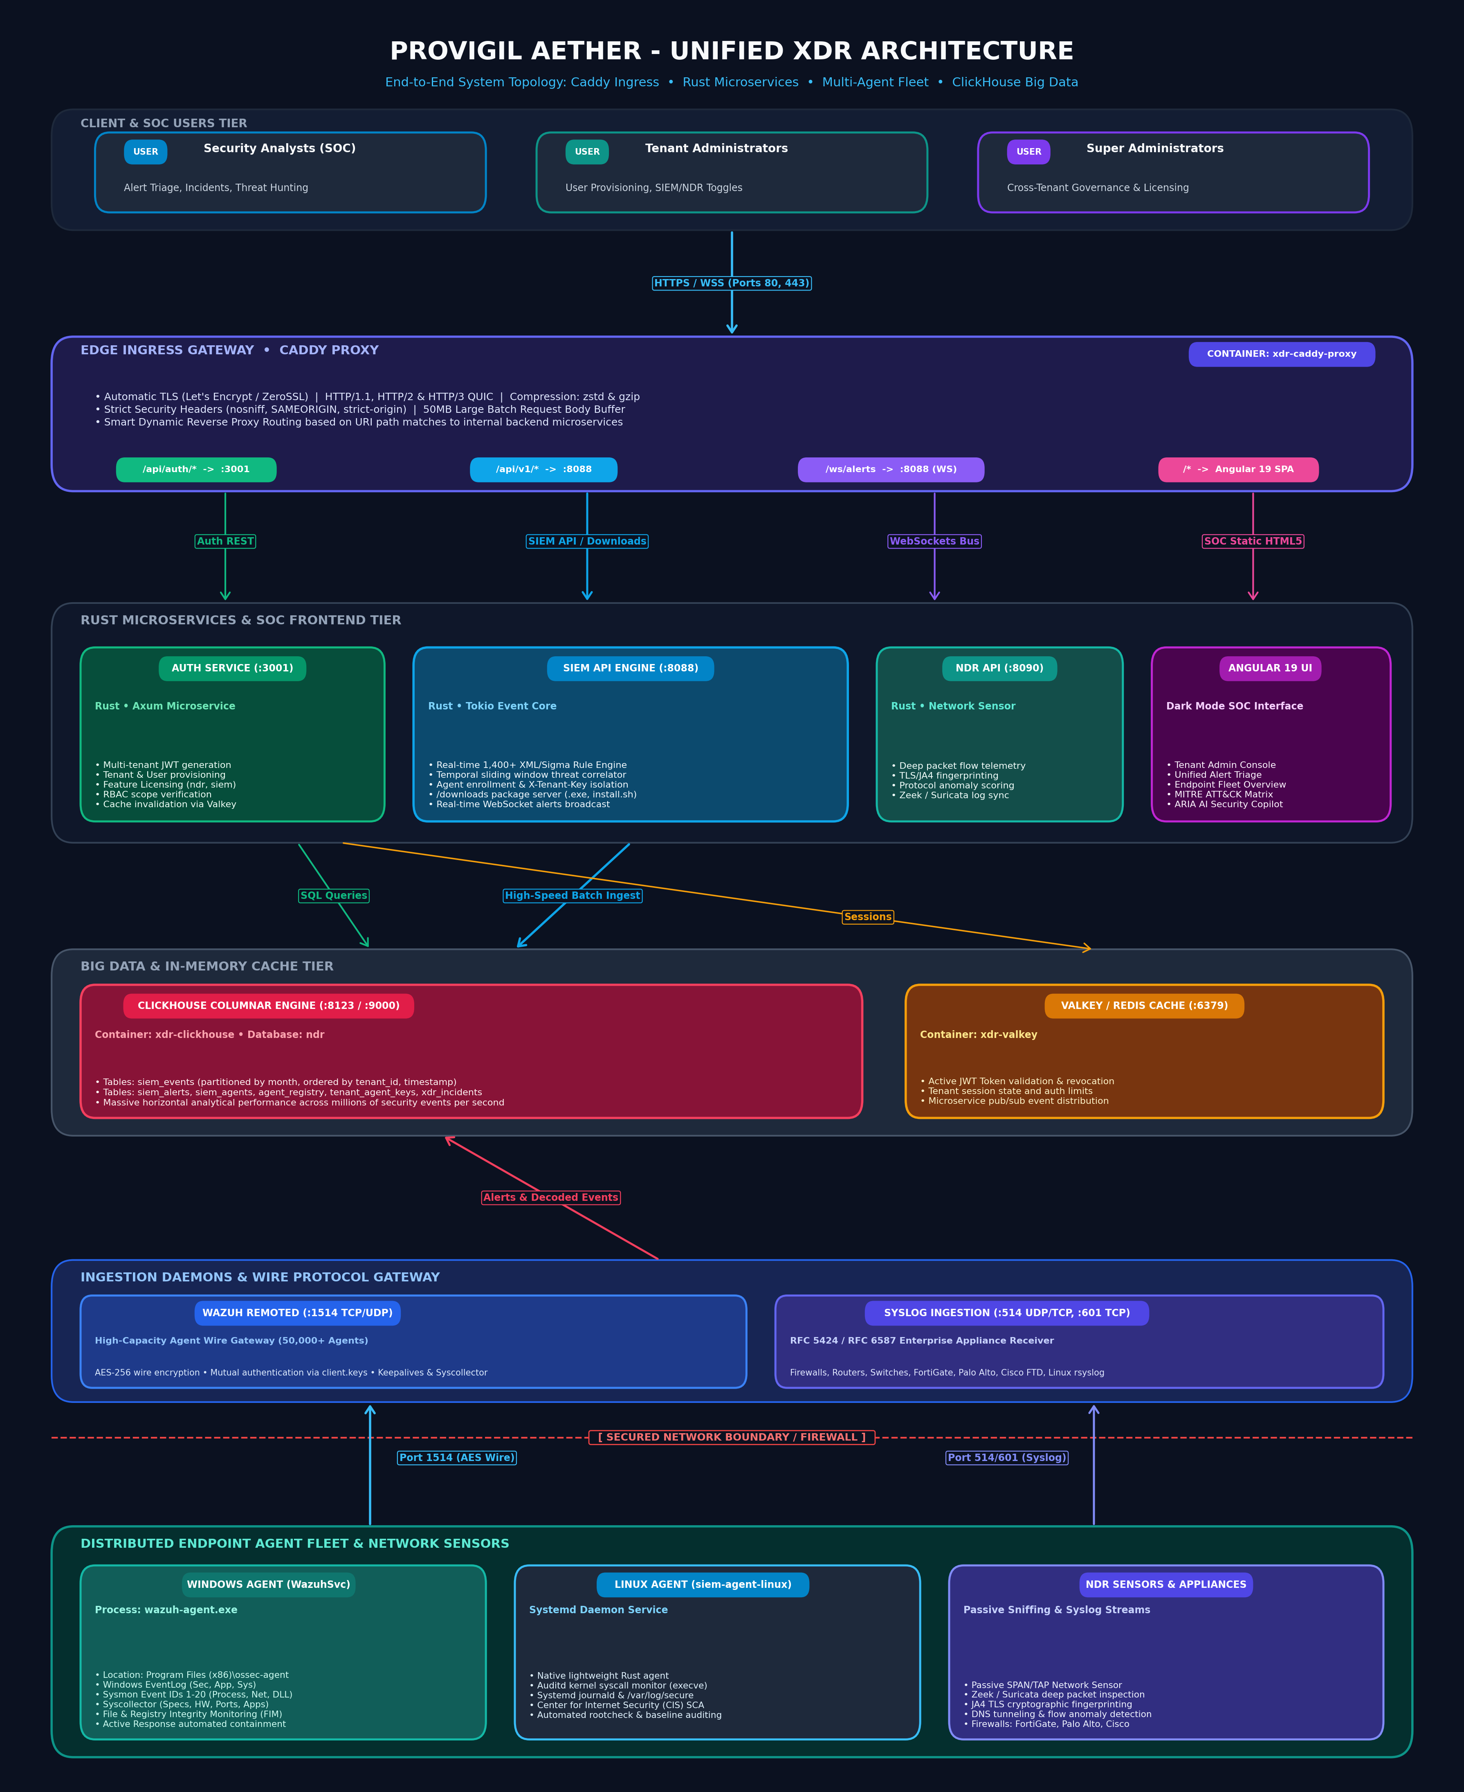
Figure 1: Provigil AETHER End-to-End Enterprise Architecture, Ingress Routing & Multi-Agent Topology
3. Detailed Core Components Breakdown
3.1 Edge Reverse Proxy (Caddy Alpine)
- Role: The single unified edge ingress gateway running in Docker container xdr-caddy-proxy on ports 80 (HTTP) and 443 (HTTPS/QUIC).
- Security & Performance: Terminates TLS with automated certificate renewal, enforces strict security headers (nosniff, SAMEORIGIN, strict-origin-when-cross-origin), and enables zstd/gzip compression.
- Smart Upstream Routing: Inspects request URI paths and distributes traffic dynamically without requiring client port awareness:
- • /api/auth/* & /api/v1/auth/*: Forwards to auth-service:3001.
- • /api/*, /api/v1/*, & /downloads/*: Forwards to siem-api:8088.
- • /ws/alerts & /ws/siem/*: Forwards full-duplex WebSocket connections to siem-api:8088.
- • Root /*: Serves the compiled production Angular 19 SPA with HTML5 push-state fallback.
3.2 Authentication & Licensing Service (auth-service)
- Technology: Compiled native binary built in Rust using Tokio, Axum, and SQLx/ClickHouse.
- Authentication: Issues and verifies HMAC-SHA256 JWT tokens containing user identity, active tenant_id, role scope, and licensed features.
- Feature Entitlement: Validates whether a tenant has access to 'ndr', 'siem', or unified 'xdr' modules, dynamically enforcing UI rendering and route authorization.
- Session Caching: Utilizes Valkey on port 6379 for millisecond token revocation checks, rate limiting, and session verification.
3.3 Core SIEM API & Processing Engine (siem-api)
- Architecture: Rust-based multi-threaded event processing engine listening on HTTP/REST (8088), Syslog UDP (514), and Syslog TCP (601).
- Detection Engine: Executes over 1,400+ Wazuh and Sigma XML/YAML rules across Windows EventLog, Linux Auditd, and network streams.
- Sliding Window Correlation: Maintains an in-memory temporal sliding window to detect brute force, lateral movement, port scans, and distributed attacks.
- WebSocket Push Bus: Broadcasts matching alerts in real time to connected Analyst SOC browsers via /ws/alerts.
- Agent Enrollment Handler: Handles POST /api/v1/agents/enroll requests, authenticating tenants via X-Tenant-Key and generating client.keys entries.
3.4 Agent Gateway & Wire Protocol (wazuh-remoted)
- Agent Wire Protocol: Listens on Port 1514 (TCP/UDP) with low-overhead AES wire encryption.
- Scale: Capable of sustaining 50,000+ simultaneous persistent agent connections per cluster node.
- Mutual Authentication: Validates incoming encrypted payloads against client.keys, ensuring no rogue agent can inject telemetry.
4. Agent Fleet & Telemetry Collection Topology
The Provigil platform supports diverse telemetry collectors deployed across cloud, server, and end-user infrastructure:
4.1 Windows Endpoint Agent
- Deployment: Installed as a native Windows Service named 'WazuhSvc' running from %ProgramFiles(x86)%\ossec-agent\wazuh-agent.exe.
- Telemetry Channels: Continuously monitors Windows EventLog channels: Application, Security, System, and Sysmon (Event IDs 1-20 including process creation, network connections, and code injection).
- Syscollector: Periodic hardware, OS version, installed software, open ports, and network interface audits pushed to the centralized inventory.
- File & Registry Integrity (FIM): Cryptographic hash tracking (MD5/SHA1/SHA256) of monitored directories and Windows Registry keys.
- Active Response: Executes automated host containment (firewall drop, process termination) commanded by the SIEM.
4.2 Linux & Server Agent
- Architecture: Native lightweight binary running under systemd as a daemon.
- Data Sources: Monitors Linux auditd system calls (execve, connect, ptrace), journald logs, and /var/log/secure.
- SCA & Hardening: Automated scanning against Center for Internet Security (CIS) distribution benchmarks.
4.3 Network Sensors (NDR Module)
- Methodology: Passive TAP or SPAN port integration inspecting raw Ethernet frames without endpoint intrusion.
- Inspection Scope: Deep packet inspection, JA4 TLS fingerprinting, HTTP request tracking, and suspicious payload discovery.
5. Network Communication & Port Matrix
The following matrix summarizes all network ports, transport protocols, and communication flows across the platform:
Port | Protocol | Direction | Source | Destination | Purpose & Security
80 / 443 | TCP/QUIC | Inbound | Web Browsers | Caddy Proxy | HTTPS Web UI, REST API, & WebSockets (TLS)
3001 | TCP | Internal | Caddy Proxy | auth-service | JWT Auth, Tenant/User provisioning, RBAC
8088 | TCP | Inbound/Int | Caddy / Agents | siem-api | REST Endpoints, /downloads, Agent Enrollment
1514 | TCP/UDP | Inbound | Endpoint Agents | remoted / SIEM | Encrypted Agent Telemetry & Keepalives (AES)
1515 | TCP | Internal | Agent CLI / Ops | wazuh-authd | Legacy agent registration daemon
514 / 601 | TCP/UDP | Inbound | Network Devices | siem-api | Syslog RFC 5424 / RFC 6587 Ingestion
8123 | TCP | Internal | Microservices | ClickHouse | HTTP Query & Batch Ingestion Port
9000 | TCP | Internal | CLI / Native | ClickHouse | High-speed Native TCP Client Protocol
6379 | TCP | Internal | Microservices | Valkey / Redis | In-memory token caching, session pub/sub

6. Multi-Tenancy & Cryptographic Isolation Model
Provigil AETHER implements a multi-layered tenant isolation architecture ensuring complete segregation of data, credentials, and management controls across customer organizations:
- Agent Provisioning Isolation: Every agent installation command embeds a unique 64-character tenant key (e.g., tk_187e9a96...). The enrollment API binds the newly spawned agent permanently to that specific tenant in ClickHouse (ndr.tenant_agent_keys and ndr.agent_registry).
- Storage Partitioning: All core telemetry tables in ClickHouse (siem_events, siem_alerts, siem_agents, xdr_incidents) are partitioned and sorted by tenant_id. Queries executed by analysts automatically inject WHERE tenant_id = :scope, preventing data leakage across tenant boundaries.
- Role-Based Access Control (RBAC): Super Admins can govern global system health and tenant licenses; Tenant Admins can provision analysts, toggle SIEM/NDR suites, and manage local agent enrollments; Analysts are constrained to alert triage and incident investigation for their assigned tenant only.
7. Agent Deployment & Enrollment Lifecycle
Understanding the precise handshake flow eliminates connectivity issues and explains the transition from PENDING to ACTIVE:
- 1. Script Generation: Administrator copies the one-line deployment script from the Tenant Admin or Fleet UI. The script specifies the SIEM Manager URL (http://<SIEM_IP>:8088) and the X-Tenant-Key.
- 2. Package Retrieval: PowerShell downloads wazuh-agent.exe, configuration files, and dynamically queries /downloads/windows/ossec.conf?manager=<IP> to write an IPv4-targeted ossec.conf.
- 3. Registration: The script makes a POST request to /api/v1/agents/enroll. The SIEM API validates the tenant key, issues a sequential agent ID (e.g. 019), and generates a 256-bit AES cryptographic key saved into client.keys.
- 4. Service Initialization: The script installs and starts the 'WazuhSvc' service. The agent initiates an AES handshake on TCP port 1514 to the manager.
- 5. State Activation: Upon receiving the first keepalive message and syscollector evaluation over port 1514, the SIEM engine updates the database, transitioning the agent status from PENDING to ACTIVE.

