ENTERPRISE SECURITY SPECIFICATION
Wazuh SIEM & XDR v4.14.7
Complete Features & Technical Architecture Guide
Exhaustive Technical Analysis of Multi-OS Agents, Real-Time Detection Daemons, Cloud Wodles, Threat Hunting, Compliance Engines & Distributed OpenSearch Storage Tier
Metadata Field | Specification Details
Platform Version | Wazuh SIEM Core v4.14.7 (Stage: rc1)
Ecosystem Components | Wazuh Core Manager/Agent, Wazuh Dashboard, Wazuh Plugins, Wazuh Indexer
Operating System Coverage | Windows, Linux, macOS, FreeBSD, OpenBSD, Solaris, IBM AIX, HP-UX
Source Code Base Path | e:\wazhu-Siem-code

1. Executive Architecture Overview
Wazuh v4.14.7 is a scalable, open-source Security Information and Event Management (SIEM) and Extended Detection and Response (XDR) platform designed to protect on-premises, virtualized, containerized, and cloud-native environments. The architecture functions across four distributed pillars:
- Pillar 1 — Endpoint Agents & Telemetry Ingestion: Multi-platform lightweight daemons deployed across servers, workstations, cloud instances, and network devices.
- Pillar 2 — Wazuh Central Management Server: C/C++ core daemons providing signature decoding, correlation rule evaluation, state synchronization, and active response execution.
- Pillar 3 — Wazuh Indexer (Storage Tier): OpenSearch-based distributed JSON document database providing petabyte-scale search, analytics, and Index State Management (ISM).
- Pillar 4 — Wazuh Dashboard (User Interface): React, TypeScript, and Node.js visual security operations center providing threat hunting, MITRE heatmaps, and compliance reporting.

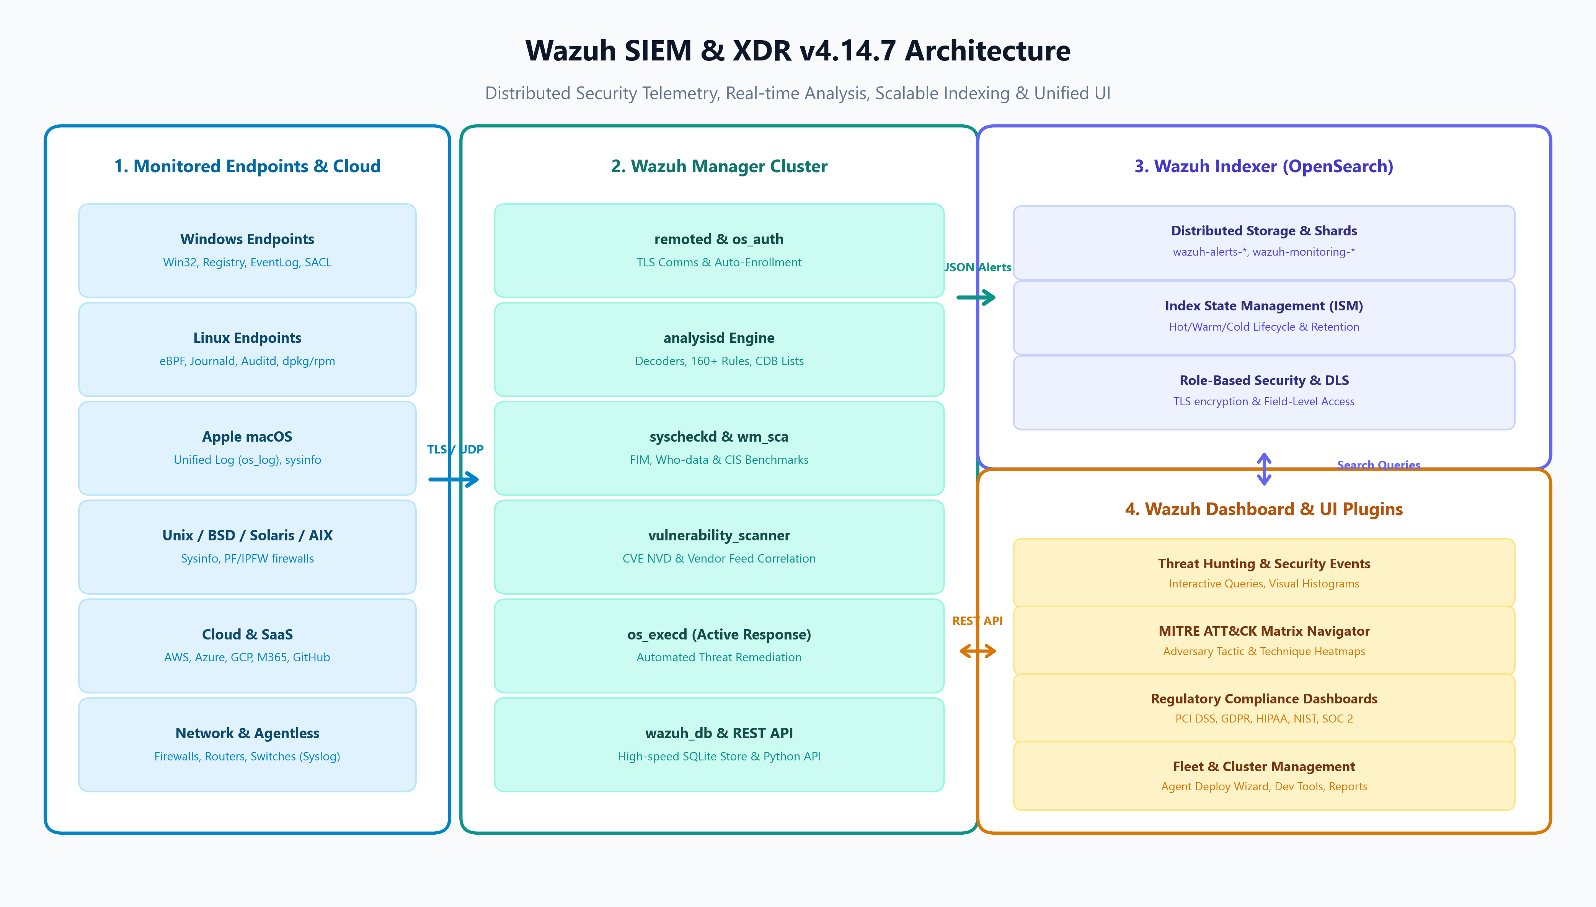
Figure 1.1: Complete End-to-End Wazuh SIEM v4.14.7 Architecture & Data Flow
[ARCHITECTURE INTEGRITY] All components in this release are synchronized at version 4.14.7 rc1, utilizing mutual TLS encryption for agent-to-manager and manager-to-indexer communication channels.

2. Multi-OS Endpoint Security Agents
The Wazuh Agent is engineered in highly optimized C/C++ (C99 and C++14) to maintain an ultra-low footprint (<1% CPU, ~35MB RAM). The agent code is organized into a modular core daemon (agentd) coupled with native OS-specific kernel drivers and userspace collectors.
2.1 Operating System Coverage & Subsystem Implementation
OS Family | Supported Distributions | Native Subsystems & Source Files | Package Formats
Microsoft Windows | Windows 11, 10, 8.1, 7  Server 2022, 2019, 2016, 2012, 2008 | src/win32/ (win_service.c, win_agent.c)  read_win_event_channel.c, sysInfoWin.cpp | MSI (.msi)  EXE (.exe)
Linux (DEB) | Ubuntu 16.04-24.04, Debian 9-12  Kali Linux, Linux Mint, Raspbian | src/syscheckd/src/ebpf/ (eBPF Kernel)  read_journald.c, read_audit.c, dpkg | DEB (.deb)  64-bit / ARM64
Linux (RPM) | RHEL 6-9, CentOS 7-9, Rocky, Alma  Fedora, Amazon Linux 2/2023, SUSE | sysInfoLinux.cpp, firewalld-drop.c  syscheckd inotify, rpm provider | RPM (.rpm)  x86_64 / aarch64
Apple macOS | macOS 10.15 Catalina through  macOS 14+ Sonoma & Sequoia | macos_log.c (Apple Unified Logging)  sysInfoMac.cpp, brew/app inspector | PKG (.pkg)  Apple Silicon / Intel
BSD Family | FreeBSD 11-14, OpenBSD 6.x-7.x  NetBSD | sysInfoFreeBSD.cpp, sysInfoOpenBSD.cpp  src/active-response/firewalls/pf.c | Source / Ports  Binary Package
Oracle Solaris | Solaris 10, Solaris 11 | sysInfoSolaris.cpp, solaris kstat  packages/solaris/pkg | PKG (.pkg)  p5p (SPARC / x86)
IBM AIX & HP-UX | IBM AIX 6.1, 7.1, 7.2, 7.3  HP-UX 11iv3 | sysInfoUnix.cpp, UtilsWrapperUnix.cpp  packages/aix/, packages/hp-ux/ | BFF (.bff)  Depot (.depot)

2.2 Core Endpoint Protection Engines
- FIM Engine — File Integrity Monitoring (syscheckd): Real-time filesystem observation utilizing inotify on Linux, ReadDirectoryChangesW on Windows, and FSEvents on macOS. Integrates Linux eBPF kernel probes for zero-overhead tracking and Who-data auditing (captures PID, PPID, UID, and program name responsible for file modifications).
- SCA Hardening — Security Configuration Assessment (wm_sca): Automated hardening audits evaluating host configurations against Center for Internet Security (CIS) benchmarks. Provides granular scoring, pass/fail status, rationale, and exact remediation instructions.
- Log Collection — Log Collector (logcollector): Ingests operating system logs, web server logs, application databases, raw flat files, multiline regex patterns, and command outputs.
- Rootcheck — Rootkit & Anomaly Detection (rootcheck): Performs deep scans against known trojans, rootkits, hidden processes, clandestine listening ports, and promiscuous network cards.
- IT Hygiene — System Inventory (syscollector): Periodically inventories system hardware (CPU, RAM), OS build, active network interfaces (IP, MAC), listening ports, running processes, and installed software.
- Active Response — Active Response (os_execd): Automated, event-driven remediation executing local firewall rules (netsh, firewalld, iptables, pf), user account disabling, or custom scripts upon alert trigger.
3. Real-Time Detection Engine & Rulesets
The Wazuh Manager analysis daemon (analysisd) evaluates incoming event streams in real-time using a two-tier normalization and correlation architecture.
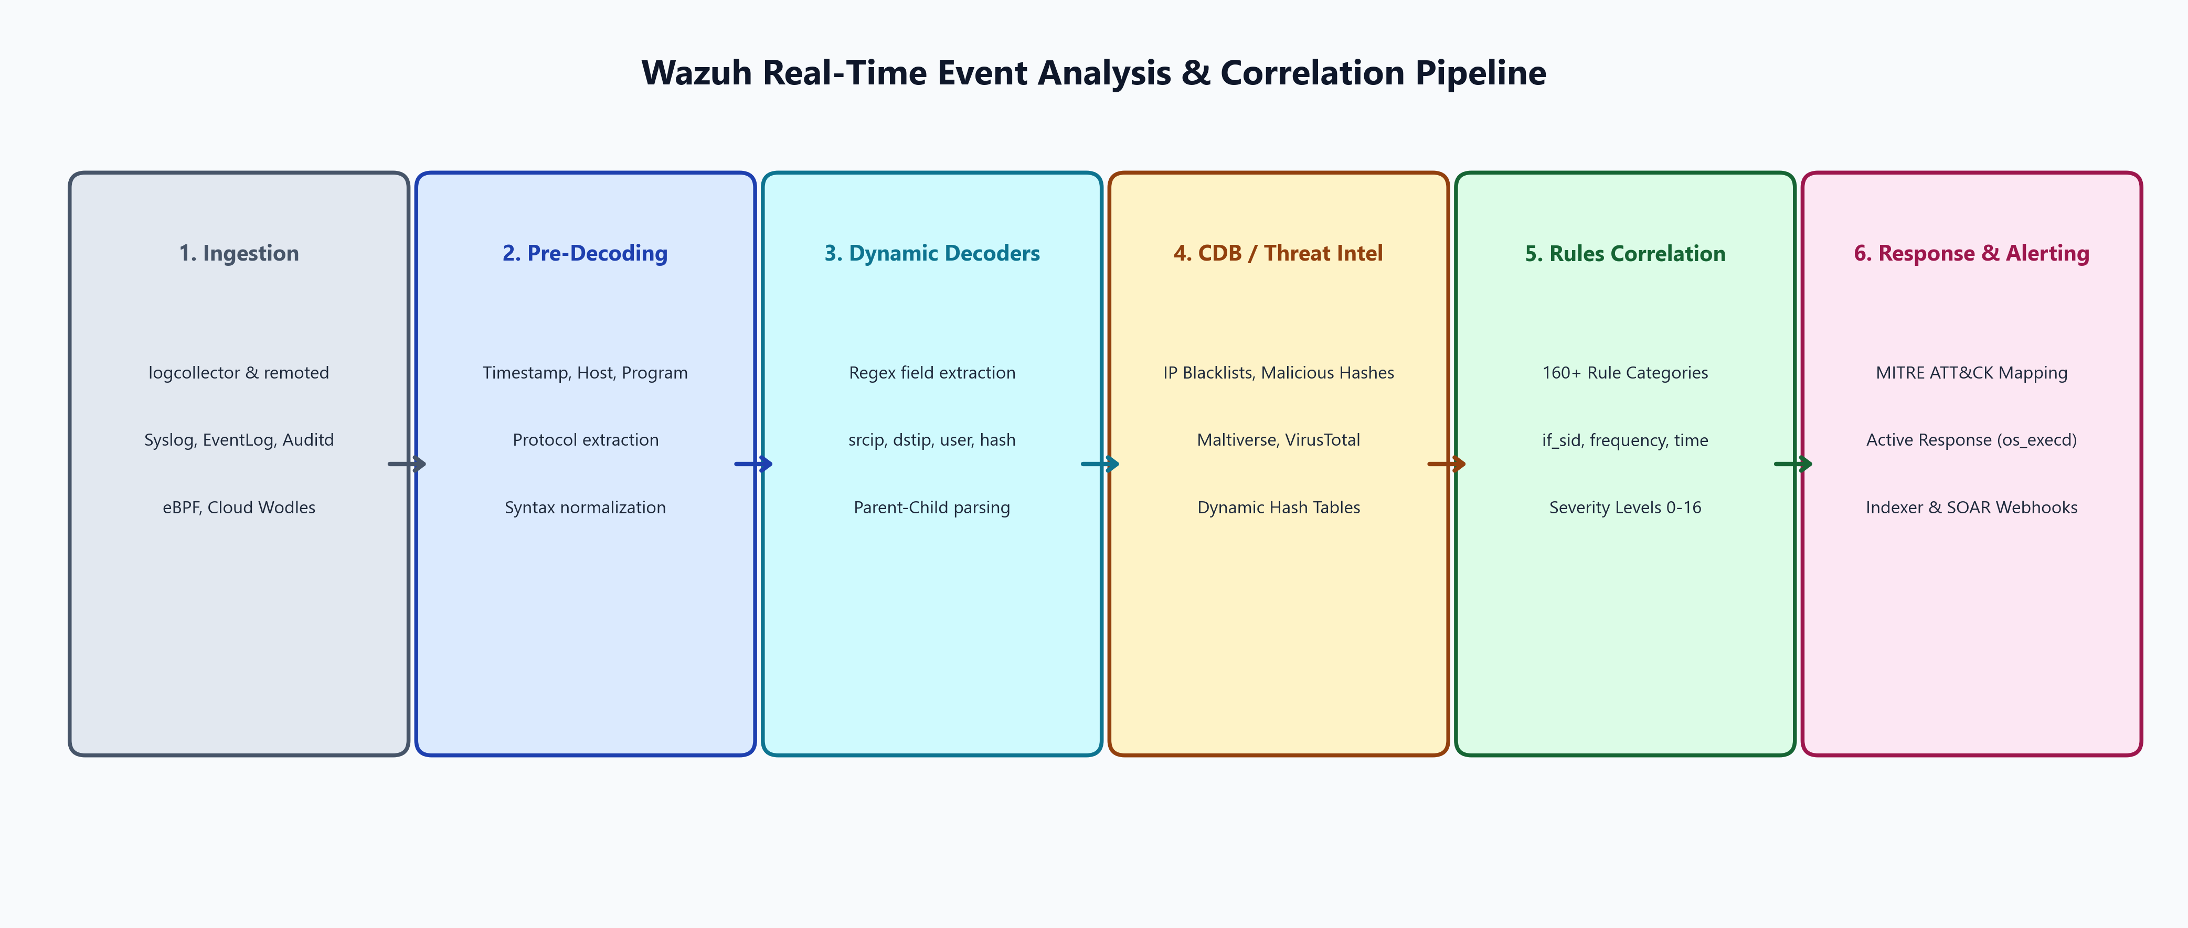
Figure 3.1: Wazuh Real-Time Event Analysis & Correlation Pipeline
3.1 Pre-Packaged Detection Rulesets (160+ Categories)
Located in ruleset/rules/, the detection repository contains over 160 specialized XML rule catalogs covering diverse threat domains:
Domain Category | Key XML Ruleset Files | Threats & Event Types Detected
Windows & Active Directory | win-security_rules.xml, win-powershell_rules.xml  sysmon_id_1.xml through sysmon_id_20.xml | Mimikatz, Kerberoasting, Golden Ticket, PowerShell obfuscation, Process hollowing
Linux & Unix Systems | sshd_rules.xml, pam_rules.xml, auditd_rules.xml  systemd_rules.xml, dropbear_rules.xml | SSH brute force, sudo privilege escalation, unauthorized setuid execution, audit tampering
Cloud & SaaS Platforms | amazon-security-lake_rules.xml, azure_rules.xml  office365_rules.xml, github_rules.xml | Root account login, S3 public exposure, M365 mass file download, GitHub token creation
Network & Perimeter | cisco-ios_rules.xml, paloalto_rules.xml  fortigate_rules.xml, checkpoint-smart1_rules.xml | VPN unauthorized access, firewall deny floods, IPS alerts, DDoS attempts, port scans
Web & Databases | apache_rules.xml, nginx_rules.xml, web_appsec_rules.xml  mysql_rules.xml, postgresql_rules.xml | SQL injection, Cross-Site Scripting (XSS), directory traversal, unauthorized database dumps
Malware & Threat Feeds | virustotal_rules.xml, maltiverse_rules.xml  malicious-ioc-rules.xml, ms_wdefender_rules.xml | Known hash execution, command-and-control IP matches, ransomware extensions, AV detections

3.2 MITRE ATT&CK Matrix Mapping
Every rule in ruleset/rules/ is tagged with MITRE ATT&CK metadata (mitre.id, mitre.tactic, mitre.technique). This enables real-time aggregation across all 14 enterprise tactics: Initial Access, Execution, Persistence, Privilege Escalation, Defense Evasion, Credential Access, Discovery, Lateral Movement, Collection, Command and Control, Exfiltration, and Impact.
3.3 Vulnerability Scanner Engine (vulnerability_scanner)
The vulnerability scanner engine (src/wazuh_modules/vulnerability_scanner/) continuously cross-references the endpoint software inventory gathered by syscollector against the National Vulnerability Database (NVD) and vendor security feeds (Canonical, Red Hat, Debian, Microsoft, Alpine, Alma, Rocky, SUSE). It identifies missing security patches, calculates CVSS v2/v3 severity scores, and flags zero-day exposures.
4. Cloud, Container & SaaS Security (Wodles)
Wazuh features native C-based background modules (wodles) that connect directly to cloud and SaaS provider APIs without requiring dedicated forwarding agents.
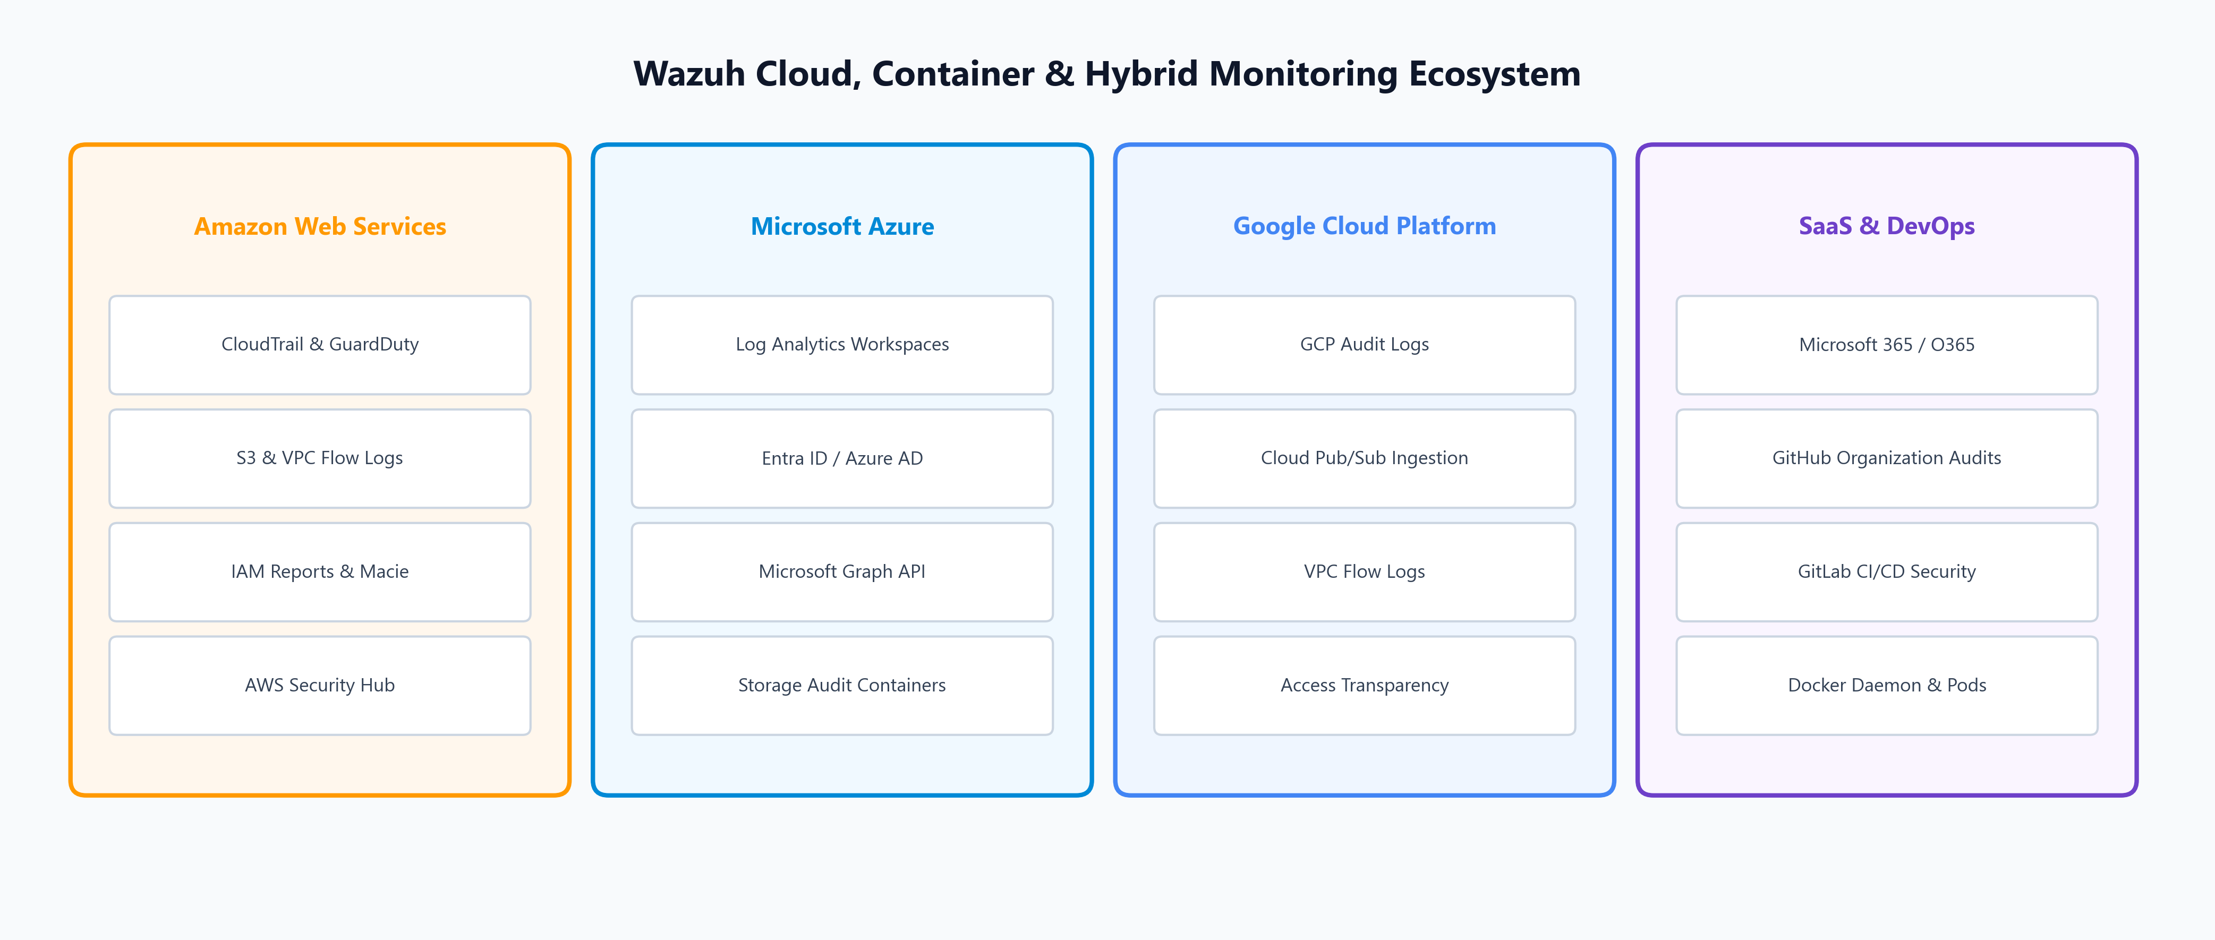
Figure 4.1: Wazuh Cloud, Container & Hybrid Ingestion Ecosystem
Cloud / Service | Module Source Code | Ingestion Channels & Security Capabilities
Amazon Web Services | src/wazuh_modules/wm_aws.c  wodles/aws/ | AWS CloudTrail, GuardDuty, S3 Access Logs, IAM Credential Reports, VPC Flow Logs, Macie, Inspector, AWS Security Hub
Microsoft Azure | src/wazuh_modules/wm_azure.c  wm_ms_graph.c, wodles/azure/ | Azure Log Analytics workspaces, Azure Blob Storage audit logs, Microsoft Graph Security API, Entra ID (Azure AD) sign-in logs
Google Cloud Platform | src/wazuh_modules/wm_gcp.c  wodles/gcloud/ | Google Cloud Pub/Sub topics, Cloud Audit Logs, VPC Flow Logs, Access Transparency logs, IAM changes
Microsoft 365 / O365 | src/wazuh_modules/wm_office365.c | Exchange Online, SharePoint, Microsoft Teams, OneDrive audit logs, administrator activity tracking
GitHub & DevOps | src/wazuh_modules/wm_github.c | Organization audit logs, repository visibility modifications, personal access token lifecycle, secret leaks
Docker & Containers | src/wazuh_modules/wm_docker.c  wodles/docker-listener/ | Docker socket (/var/run/docker.sock) monitoring, container creation/destruction, image pulls, privilege changes

5. External Alerting, SOAR & Threat Intelligence
Wazuh integrates seamlessly with external security orchestration platforms, threat intelligence feeds, and incident response channels via os_integrator (src/os_integrator/) and integrations/:
- VirusTotal — VirusTotal API (virustotal.py): Queries VirusTotal database with MD5/SHA256 hashes generated by FIM. Automatically triggers Level 12+ alerts when malware signatures are confirmed.
- Maltiverse — Maltiverse Threat Intelligence (maltiverse.py): Real-time threat intelligence queries correlating IP addresses, domains, and URLs against global threat feeds.
- Shuffle SOAR — Shuffle SOAR Integration (shuffle.py): Dispatches real-time webhooks to Shuffle SOAR workflows to execute multi-step automated containment and triage playbooks.
- ChatOps & Paging — Slack & PagerDuty Alerts (slack.py, pagerduty.py): Formats security incidents and dispatches immediate notifications to SecOps war rooms and on-call engineering schedules.
- Syslog Forwarding — Syslog Forwarding Daemon (os_csyslogd): Forwards normalized alerts to external SIEMs, Splunk, or enterprise data lakes using CEF, JSON, or standard Syslog format.
- SMTP Dispatcher — Email Notifications (os_maild): Dispatches customizable SMTP email alerts filtered by alert severity thresholds (e.g., Level >= 10) or specific rule IDs.
6. Regulatory Compliance Frameworks
Wazuh features pre-mapped regulatory compliance frameworks in its ruleset and dashboard plugins. Alerts are automatically classified against compliance requirements:
Compliance Standard | Target Scope | Wazuh Technical Controls & Dashboards
PCI DSS (v3.2.1 / v4.0) | Payment Card Industry & Financial Systems | Req 10 (Logging & Tracking), Req 11.5 (File Integrity Monitoring), Req 8 (Access Control & MFA enforcement)
GDPR | EU General Data Protection Regulation | Article 25 (Data Protection by Design), Article 32 (Security of Processing), Article 33 (72h Breach Notification)
HIPAA | Healthcare & Protected Health Info (PHI) | 164.312(b) (Audit Controls), 164.312(c)(1) (Data Integrity), 164.308(a)(1)(ii)(D) (Information System Activity Review)
NIST SP 800-53 | Federal & High-Security Enterprise Systems | AU (Audit & Accountability), AC (Access Control), SI (System & Information Integrity), CM (Configuration Management)
TSC (SOC 2) | Trust Services Criteria | CC6.1-CC6.8 (Logical & Physical Access Controls), CC7.1-CC7.4 (System Operations & Incident Monitoring)

7. Wazuh Dashboard & SIEM Analytics Interface
The Wazuh Dashboard (wazuh-dashboard/) and custom plugins (wazuh-dashboard-plugins/) provide an intuitive, high-performance web interface built with React, TypeScript, and OpenSearch Dashboards:
- Security Operations — Security Events Visualizer: Real-time search, histogram timelines, severity distribution, top triggered rules, and agent status summaries.
- Threat Hunting — Threat Hunting Console: Deep-dive investigative query interface with flexible Lucene and DQL syntax for complex multi-field threat analysis.
- MITRE Heatmap — MITRE ATT&CK Matrix Navigator: Interactive visual matrix highlighting detected adversary techniques with drill-downs into raw alerts and mitigation guides.
- FIM Analytics — Integrity Monitoring (FIM): Visualizes file modifications, deletions, permission changes, top targeted directories, and user attribution (who-data).
- Vulnerability & SCA — Vulnerability & SCA Dashboard: Displays system vulnerability profiles, CVSS scores, remediation recommendations, and CIS compliance percentages per agent.
- Fleet Management — Fleet Management & Deployment Wizard: One-click command generator for deploying agents on Windows, Linux, and macOS, with group configuration management (agent.conf).
- Dev Tools & Reports — API Dev Tools & Reporting: Interactive API console to execute REST calls against the manager, alongside scheduled PDF/CSV executive report generators.
8. Storage Tier: Wazuh Indexer
The Wazuh Indexer (wazuh-indexer/) is a distributed, JSON-based search and analytics engine derived from OpenSearch, written in Java with a Gradle build system.
- Index Sharding — Distributed Index Architecture: Stores security alerts and telemetry across optimized indices: wazuh-alerts-* (correlated security events), wazuh-archives-* (raw log streams), wazuh-monitoring-* (agent heartbeats and health metrics), and wazuh-statistics-* (engine throughput).
- ISM Lifecycle — Index State Management (ISM): Automated lifecycle policies managing rollover, compression, transitioning data between Hot, Warm, and Cold storage tiers, snapshotting to S3/GCS/NFS, and automated retention purging.
- Data Security — Role-Based Access Control & DLS: Fine-grained security with TLS node-to-node encryption, LDAP/Active Directory authentication, Document-Level Security (DLS), and Field-Level Security (FLS).
9. Enterprise High Availability & Fleet Management
- Manager High Availability — Wazuh Cluster Daemon (wazuh-clusterd): Master-Worker multi-node active-active cluster architecture. Automatically synchronizes agent registration keys, local databases, and group configuration files across all manager instances.
- WPK Remote Upgrades — Remote Signed Agent Upgrades (agent_upgrade, packages/wpk/): Over-the-air (OTA) remote agent upgrades using cryptographically signed WPK (Wazuh Package) files. Enables bulk upgrades across thousands of endpoints directly from the Dashboard or API without SSH/RDP.
- RBAC Multi-Tenancy — Role-Based Access Control (RBAC): Multi-tenant RBAC engine controlling granular read/write permissions for SOC analysts, IT administrators, and compliance auditors.
10. Technology Stack & Directory Map
Subsystem Layer | Programming Languages | Key Libraries, Tools & Build Systems
Wazuh Manager Core | C (C99), C++14, Python 3 | SQLite, OpenSSL, CMake, Autotools, libcurl, cJSON, eBPF, aiohttp
Wazuh Multi-OS Agent | C (C99), C++14 | Win32 API, Linux systemd, libaudit, macOS os_log, eBPF, inotify
Wazuh RESTful API | Python 3 (AsyncIO) | aiohttp, Connexion, PyYAML, Cryptography, Cerberus
Wazuh Dashboard Base | TypeScript, JavaScript | React, Redux, Node.js, OpenSearch Dashboards, EUI
Wazuh Dashboard Plugins | TypeScript, React, CSS | Elastic UI (EUI), Angular (legacy components), SCSS
Wazuh Indexer Engine | Java 11 / Java 17 | OpenSearch, Apache Lucene, Netty, Jackson, Gradle

