**Contemporary Issue Management Assignment PART A**

**PART A: MGMT-8760 – Contemporary Issue Identification & Team Contract (10% of Course Grade**

**BE SURE TO WATCH THE RECORDED INSTRUCTIONS AND REVIEW THE RUBRIC TO ENSURE YOU ARE INCLUDING ALL OF THE REQUIRED ELEMENTS IN YOUR WORK.**

**Complete all sections of the Issue Identification & Team Contract below: (10 Marks)**

|  |
| --- |
| **Team Member’s Name** |
| Priyanka Bhosle |
| Deepika Koti |
| Senthil Nathan Kathiresan |
| Sameer Khanal |
| Dilverjeet Kaur |
| Kaitlin Cheslie Batkam Bouopda |
| Vishwa Joshi |
| **Team Name: Group E** |

**Contemporary Issue Identification:**

For the first section your team must identify and agree upon a contemporary (modern) organizational behaviors issue/concern you will study and resolve for your organization.

Begin by doing some research to discover what modern issues exist in organizations today There are very few limitations—your team could select almost anything that is related to workplace behaviors. There is a possibility that your Professor will redirect

your selection if it is felt that there would not be enough information available on the topic a team initially selects.

**Topics Include (But are not limited to):**

* Employee Recognition/Reward Programs
* Social Media Policy in the Workplace
* Work-Life Balance
* Effective Use of Technology
* Promoting Positive Organizational Citizenship Behaviors
* Bullying in the Workplace
* Workplace Harassment
* Whistleblowing
* Diversity in the Workplace
* **Our Topic Is**: **Workplace Harassment** **(1 Mark)**

**Describe why your team chose this topic (be specific & detailed): (5 Marks)**

The topic of workplace harassment was chosen by our team for several reasons:

As we all are working in some industry and we all faced some kind of Harassment, we belief everyone should be aware of workplace harassment for safety and maintain the productivity and happiness at work.

We have specified some of the points which are necessary for Workplace Harassment:

1. **The importance of the problem**: Workplace harassment is a severe problem that affects individuals and groups across a range of sectors and professions. It significantly affects employees' output, workplace satisfaction, and all-around wellbeing. It is important to raise awareness of this issue and appreciate its implications in order to promote safer and more inclusive work environments.
2. **Supporting victims and potential targets**: We hope to provide support and tools to those who have experienced or are experiencing workplace harassment by talking about it. Establishing a safe space where victims can obtain counselling, learn about their legal options, report their abuse, and seek redress is crucial.
3. **Legal and moral ramifications**: Employers who don't address and end workplace harassment risk legal consequences. Not only is workplace harassment bad for employees' health. By discussing this issue, we can better understand the legal justification for workplace harassment, as well as anti-discrimination laws, policies, and procedures.
4. **Promoting a culture of respect in the workplace**: We intend to foster a culture of decency, equality, and fairness by tackling the problem of workplace harassment. It is essential to educate individuals on what constitutes harassment and provide them with how they can take action to put a stop to it.

**Provide 4-5 resources your team used to research your topic (site name & URL): (4 Marks)**

1. [Requirements for employers to prevent harassment and violence in federally regulated workplaces - Canada.ca](https://www.canada.ca/en/employment-social-development/programs/workplace-health-safety/harassment-violence-prevention.html)

2. Equal Employment Opportunity Commission (EEOC) - [www.eeoc.gov](http://www.eeoc.gov/)

3. Navex Global - [www.navexglobal.com](http://www.navexglobal.com/)

4. Employment Law Handbook - [www.employmentlawhandbook.com](http://www.employmentlawhandbook.com)

5. Canadian Human Right Commission - [www.chrc-ccdp.gc.ca](http://www.chrc-ccdp.gc.ca/)

**TEAM CONTRACT:**

Now that you have selected a topic you need to think about how you plan to complete the assignment as a team. As you will learn in upcoming modules there is a difference ***between Groupwork vs Teamwork***. To get you to **collaborate** and benefit from teamwork you will now fill out a contract that starts with establishing team goals, rules & an initial plan for your contemporary issue report & presentation (Parts B & C).

**Expectations of Team Members**

1. Be accountable for tasks/assignments.
2. Complete work on time and correctly
3. Listen to each other, the team leader, and the professor.
4. Give and get respect.
5. Make a fair contribution to the final product.
6. Let the team leader know about absence before team meetings.
7. Make your best effort.
8. Ask for assistance if unsure.

**Goals for the Issue Report are: (3 marks)**

|  |
| --- |
| 1. Examine Organizational Policies and Practices: Analyze organizational policies and practices to find ways to promote a respectful, diverse, and harassment-free culture  . |
| 2. Promote Bystander Intervention, foster a Culture of Speaking Up, and Empower Employees: Recommend strategies to empower employees through thorough and ongoing training programs. |
| 3. Foster Diversity and Inclusion: Analyze the company's attempts to create an inclusive and diverse workplace. Give advice on how to improve the diversity of hiring practices, develop inclusive policies and practices, and encourage cultural sensitivity and competency among employees. |

**Team Rules: (3 marks)**

|  |
| --- |
| 1. All team members should be treated with professionalism, decency, and respect. |
| 2. Take responsibility for assigned tasks and deliverables. Complete the tasks before deadlines and let the other know if you run into any problems/difficulties. |
| 3. Attend meetings, deadlines, and deliverables on time. If unable to make a deadline or attend a meeting, let the team know in advance. |

**Initial Workload Plan:** (Complete the missing information, you may add extra lines to create a more detailed plan) **(3 marks)**

**A: - Contract formation, Group Coordination, Recommendations**

**B: Gather information via research on established policies and practices and reported incidence of work life harassment in an organization.**

**C: Conduct bi-weekly meeting (virtual or in person) to share findings and recommendations to mitigate workplace harassment. The meeting will also be used for collaborative brainstorming and compilation of the findings to create a draft for the report.**

**D: Based on the draft, create a report identifying the preventions and recommendations to minimize workplace harassments. The whole team will review entire reports and submit their feedback and suggestions.**

**E: Submit finished report & presentation into the Submissions folder by the required deadline**

Be sure to consider final editing and reviewing your submissions when discussing deadlines.

**Group Meetings** (You may assign various members to coordinate and record your meetings)

Group Meetings will be planned according to schedules, but it will be expected that group members will attend, be on time, and contribute to them. Senthil Nathan Kathiresan will be responsible for recording the Meeting Minutes such as attendance, how workload is divided, internal deadlines and other relevant details.

**Consequences for Non-Performance** (You may amend or adopt new consequences as approved by your team)

1. First Offence -Team will issue a warning. Professor must be made aware that a warning was issued. Members receive a mark of zero for that part.
2. Second Offence -Team members will be removed permanently from the group. The team will notify the Professor prior to permanent removal.
3. If removed, we will recommend the Professor award a mark of zero for the whole project.

**THESE TERMS ARE AGREEABLE TO: (Type your names or add ‘e-signatures’)**

Priyanka Bhosle

Deepika Koti

Senthil Nathan Kathiresan

Sameer Khanal

Dilverjeet Kaur

Kaitlin Cheslie Batkam Bouopda

Vishwa Joshi

**(1 Mark)**

**Total = 20 Marks**

**Part A is worth 10% of your total course grade. You must submit on time so be sure to pay attention to the course deadlines.**

**Rubric: Team Contract & Contemporary Issue Assignment**

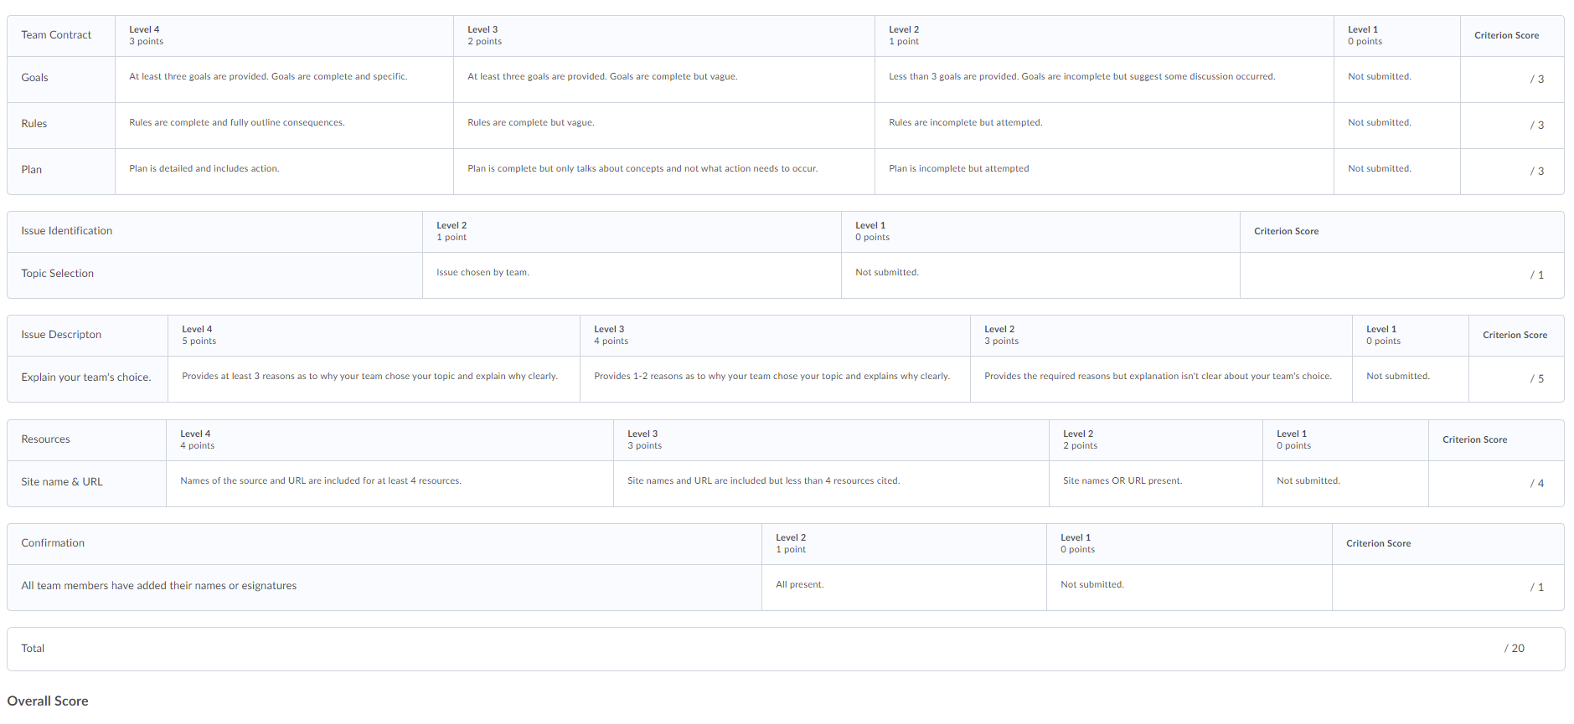

**Links to the rubrics can be found using the following path in eConestoga:**

**Content-Evaluations-Rubrics: select the individual rubric**