VOLUME MASTER
Master Index
Fourth Edition curriculum — Senior Engineering Expansion

Fourth Edition - Rebuilt as a teaching text, not an annotated checklist
Independent study guide based on public documentation and public practitioner material. Not an NVIDIA publication.

What changed in this rebuild
The series was rewritten around teaching. Concepts are explained before “why it matters.” Code is copyable. Visuals are original diagrams. Scenarios show the reasoning path step by step. Practitioner material and Udemy/Coursera/NVIDIA references appear as reinforcement after the teaching, not as substitutes for it.

Volume | Focus | Study style
1 | Linux, memory, storage, networking, containers | mechanism -> commands -> evidence -> scenario
2 | Python for production infrastructure | code-first worked examples -> failure -> tests -> capstone
3 | Kubernetes and platform engineering | control loops -> scheduling/network/storage -> troubleshooting
4 | GPU foundations | hardware/software stack -> Operator -> sharing -> health
5 | AI workloads | training/inference mechanics -> serving -> scaling -> state
6 | HPC/network/storage | distributed data path -> RDMA -> fabric -> storage -> scheduler
7 | Observability/reliability | question -> evidence -> hypothesis -> experiment
8 | Solutions architecture | discovery -> constraints -> options -> trade-offs -> recommendation
9 | Interview preparation | reasoning structure -> coding -> architecture -> customer scenarios

Guided tutor flow
TEACH mode should present one coherent block from the current chapter and stop. The learner reads, runs examples and asks doubts. When the learner says ready, the tutor tests that block one question at a time, corrects gaps, and then presents the next block. REFRESH and INTERVIEW modes can sample already-studied material randomly.
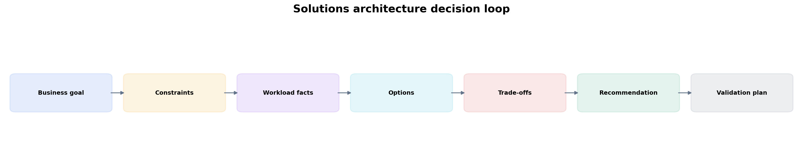
The later volumes reuse the same disciplined decision loop: requirements and evidence before recommendation.

FOURTH EDITION — CONTENT-RICH SENIOR ENGINEERING EXPANSION

This edition retains the readable Fourth Edition and adds substantial senior-level depth to every volume. It deliberately avoids priority labels or a prescriptive interview study order. The material is organized as a reference curriculum; study it in whichever sequence fits your preparation.
Volume | Fourth Edition additions
1 — Foundations | syscalls/scheduling, cgroup CPU, NUMA, memory pressure, VFS/block I/O, packet/conntrack/TCP path, GPU-host readiness
2 — Python | domain models, config validation, resilient API clients, bounded concurrency, subprocess safety, structured logs, testing, profiling, GPU-fleet CLI
3 — Kubernetes | API machinery, etcd, DRA, preemption/eviction, kubelet/CRI, dataplane/DNS/Gateway API, admission/policy, GPU node lifecycle
4 — GPU | execution/memory model, topology, driver/container stack, GPU Operator internals, MIG/sharing, DCGM/Xid/ECC, fleet lifecycle
5 — AI workloads | training parallelism, LLM prefill/decode/KV, NIM/engines, Dynamo/disaggregated serving, inference autoscaling, RAG/agents, benchmarking
6 — HPC/network/storage | collectives/NCCL, RDMA/RoCE/IB, GPUDirect, fabric design, storage hierarchy, Slurm, Enroot/Pyxis/BCM, hybrid scheduling
7 — Observability | SLO/USE/RED, Prometheus cardinality/query cost, OTel, DCGM, inference metrics, evidence-tree incidents, alert design and game days
8 — SA practice | workload discovery, AI factory architecture, capacity/TCO, PoC design, security/governance, product/scheduler decisions, executive communication
9 — Interview | senior answer method, Linux/Python/K8s/GPU/AI/network question banks, architecture/customer drills and current NVIDIA role-family signals

Source architecture
Technical authority: current official NVIDIA, Kubernetes and Python documentation. Practitioner scope signals: public posts and job-family material from NVIDIA Solutions Architects, especially Vishakha Sadhwani, plus public NVIDIA SA/hiring material on GPU Kubernetes, inference and AI factory architecture. Teaching reinforcement: targeted Udemy lecture sections rather than entire courses. Internal breadth source: your Staff Engineer study guide repository, especially Kubernetes, platform patterns, observability, databases/storage and distributed-log material.

