VOLUME 1
Foundations Beneath Kubernetes
Linux, networking, storage and container mechanisms from first principles
Fourth Edition - Teaching text with mechanisms, examples, visuals, scenarios and exercises
Independent study guide based on public documentation and public practitioner material. Not an NVIDIA publication.

Reading method
For every mechanism: first understand the model, then run the commands, then interpret evidence, then work the incident. Kubernetes mapping comes after the Linux mechanism is clear.
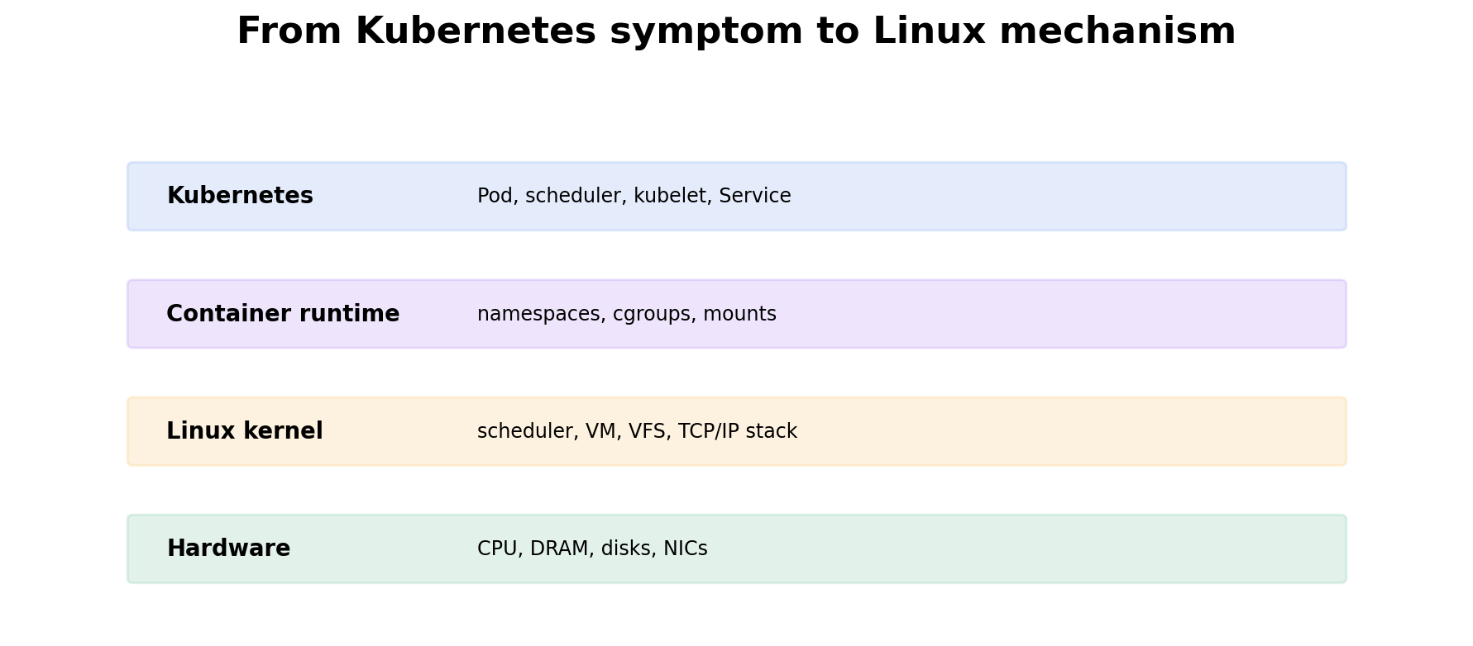
Figure 1. Move downward through abstractions until the symptom maps to a mechanism.

Chapter 1 - Processes, threads, CPU scheduling and load
Learning outcome
Explain process/thread state, scheduler queues, CPU time, context switches, load average, throttling and the evidence that distinguishes them.

1.1 Process and thread model
A program on disk is passive. A process is a running instance with virtual memory, credentials, file descriptors, signal state and one or more threads. Threads inside the same process share address space and open resources but have independent execution contexts. The Linux scheduler schedules tasks—roughly threads/process execution contexts—not Kubernetes Pods as a special kernel object.
Inspect process identity, threads, state and file descriptors
ps -eo pid,ppid,tid,stat,ni,psr,pcpu,pmem,comm --sort=-pcpu | head -30
ps -L -p <PID> -o pid,tid,psr,stat,pcpu,comm
cat /proc/<PID>/status
ls -l /proc/<PID>/fd | head

1.2 Process states
State | Meaning | Operational clue
R | running or runnable | CPU/run-queue pressure if many remain runnable
S | interruptible sleep | normally waiting for timer/event/I/O
D | uninterruptible sleep | often waiting on kernel I/O; cannot handle normal signals until wait completes
Z | zombie | child exited; parent has not reaped exit status
T | stopped/traced | job control or debugger/signal stopped the task
D state is a classic reason load can be high while CPU utilization is not. Load average includes runnable tasks and tasks in uninterruptible sleep, so it is a queue-pressure signal, not a CPU percentage.

1.3 CPU scheduling, run queue and context switches
Linux time-slices runnable tasks across CPUs according to scheduling policy and priority. A context switch changes the executing task. Context switches are normal, but extremely high rates can indicate excessive thread count, lock contention or I/O wakeups. The run queue tells you whether runnable work is waiting for CPU.
uptime
vmstat 1
mpstat -P ALL 1
pidstat -u -w 1
# vmstat: r=run queue, cs=context switches/s, us/sy/id/wa=CPU state percentages

1.4 CPU quotas and throttling
A container can be CPU-starved even when the host has idle CPU if cgroup quota restricts it. Kubernetes CPU limits can translate into CFS bandwidth control. Throttling evidence therefore belongs beside host CPU metrics when an application reports latency under low node utilization.
# cgroup v2 examples; exact path depends on runtime
cat /sys/fs/cgroup/cpu.max
cat /sys/fs/cgroup/cpu.stat
# look for nr_throttled / throttled_usec

Worked scenario
Situation
A 16-core node has load average 35, CPU utilization 45%, and application latency is rising.
1. Confirm the load pattern and run queue with uptime/vmstat. If r is small, high load may come from blocked D-state tasks rather than runnable CPU work.
2. Inspect process states with ps/pidstat. Count D-state processes and identify common commands/PIDs.
3. Inspect iostat and dependency latency if D-state tasks point to storage or network filesystems.
4. If the symptom is container-specific, inspect cgroup CPU throttling before buying more CPU.
5. Correlate the time window with deploys, storage events and kernel logs.
Conclusion
The correct first branch is “runnable versus blocked versus throttled,” not “CPU is high or low.”

Practice
1. Explain load average to an interviewer without saying it is CPU utilization.
2. Create CPU pressure with a stress tool in a lab and observe vmstat r, mpstat and load average.
3. Find the cgroup of a container process and inspect CPU quota/statistics.

Chapter 2 - Virtual memory, page cache, swap and OOM
Learning outcome
Trace allocation from virtual address space through pages, reclaim and cgroup limits; distinguish node OOM from container OOM.

2.1 Virtual memory
Each process sees a virtual address space. The kernel maps virtual pages to physical memory and may map files into memory. This abstraction enables isolation, shared libraries, memory-mapped files and efficient paging. RSS approximates resident physical pages for a process, but system memory accounting also includes page cache, kernel memory and shared pages.
cat /proc/<PID>/status | egrep 'VmRSS|VmSize|RssAnon|RssFile'
cat /proc/<PID>/smaps_rollup
pmap -x <PID> | tail -20

2.2 Page cache and “free memory”
Linux uses unused RAM as filesystem cache because cached data can avoid slower storage I/O. Cached pages are often reclaimable. This is why MemAvailable is usually more useful than the raw free column when asking whether the system has room for new allocations.
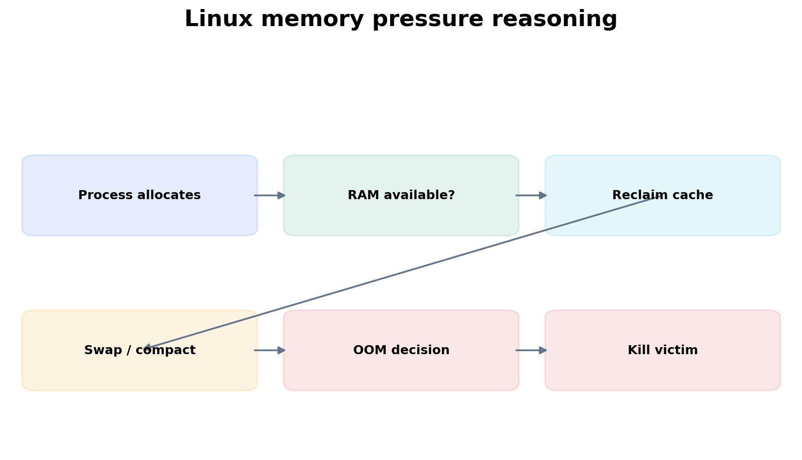
Figure 2. Reclaim and swap can occur before the OOM path is forced to select a victim.
free -h
grep -E 'MemAvailable|Cached|Buffers|Swap|Dirty|Writeback' /proc/meminfo
vmstat 1 # si/so reveal swap-in/out activity

2.3 OOM at different boundaries
Node-wide OOM means the kernel cannot satisfy allocations after reclaim strategies. A memory-cgroup OOM means a workload crossed its cgroup boundary even if the node still has memory. Kubernetes can also evict Pods under node memory pressure. These are related but distinct failure paths with different remediation.
dmesg -T | grep -i -E 'oom|killed process'
journalctl -k --since '-30 min' | grep -i oom
cat /sys/fs/cgroup/memory.current
cat /sys/fs/cgroup/memory.max
cat /sys/fs/cgroup/memory.events

Worked scenario
Situation
A Pod shows OOMKilled, but the node dashboard reports 40% memory available.
1. Read Pod/container limits and events; do not assume node exhaustion.
2. Check the container cgroup memory.max/current/events or runtime/Kubernetes evidence for a cgroup OOM.
3. Inspect process working set and growth. Determine whether the application legitimately needs a larger limit or has a leak/burst.
4. Check whether sidecars share the Pod/node memory picture and whether page cache or tmpfs behavior contributes.
5. Change limits only after understanding expected peak working set and node packing implications.
Conclusion
The exhausted boundary is the container cgroup, not necessarily the node.

Practice
1. Compare VmSize and VmRSS for a process and explain why they differ.
2. Trigger a bounded memory allocation in a container lab and inspect cgroup memory.events.
3. Explain why dropping page cache is not a normal production “memory fix.”

Chapter 3 - Files, file descriptors, filesystems and block I/O
Learning outcome
Understand how applications reach storage and distinguish capacity, metadata, throughput, IOPS and latency failures.

3.1 File descriptors and VFS
A process accesses files, sockets, pipes and many kernel objects through integer file descriptors. The VFS gives applications a common filesystem interface while specific filesystems implement semantics underneath. “Too many open files” is therefore a resource-limit/fd-leak problem, not a disk-capacity problem.
ls -l /proc/<PID>/fd | head
lsof -p <PID> | head
cat /proc/<PID>/limits | grep -i 'open files'
ss -s

3.2 Capacity versus latency
Question | Evidence
Is filesystem capacity full? | df -hT
Are inodes exhausted? | df -ih
Which directory owns space? | du -xhd1
Is device latency/queue high? | iostat -xz 1
Which process is issuing I/O? | pidstat -d 1 / iotop
Are mounts/network filesystems involved? | findmnt / mount / storage metrics
Throughput is data per unit time; IOPS is operations per second; latency is time per operation. A workload can have low throughput but still suffer high latency if it performs small synchronous I/O. Benchmark and diagnose against the application access pattern.

Worked scenario
Situation
A database Pod is slow after moving to a new storage class. CPU and memory look normal.
1. Measure application operation latency and correlate with storage timing.
2. Check filesystem capacity/inodes first to eliminate obvious failures.
3. Check device or CSI/backend latency, queue depth and errors rather than only throughput.
4. Compare mount options, volume topology, storage class parameters and zone/path changes.
5. Run a controlled storage benchmark with a pattern similar to the application before concluding the class is inherently slow.
Conclusion
Storage diagnosis is workload-pattern + path + latency evidence, not a single MB/s number.

Practice
1. Explain why df and du can disagree.
2. Find open deleted files in a lab using lsof +L1.
3. Compare sequential throughput and small random I/O using a safe benchmark tool in a test VM.

Chapter 4 - Networking: IP, routes, sockets, TCP, DNS, NAT and TLS
Learning outcome
Trace a connection from name lookup through application response and identify what each diagnostic proves.

4.1 Addressing and routing
IP addressing identifies interfaces/endpoints; a subnet prefix describes which addresses are on-link; the routing table decides the next hop. Linux performs a longest-prefix match. Before debugging an application protocol, prove that the host selected the expected source interface and route.
ip addr
ip route
ip route get 10.20.30.40
ip neigh

4.2 Sockets and TCP state
A socket binds application I/O to a transport endpoint. For TCP, connection state reveals which phase failed. SYN-SENT often means the client sent a SYN but did not complete the handshake. ESTABLISHED means transport is up; an application can still be broken above it. TIME-WAIT is normal connection lifecycle behavior, though extreme churn can matter operationally.
ss -lntp
ss -tn state syn-sent
ss -tn state established
tcpdump -ni any host 10.20.30.40 and port 443

4.3 DNS is a dependency, not magic
Name resolution may involve /etc/hosts, NSS configuration, a local stub/cache and upstream resolvers. Distinguish “name does not resolve” from “name resolves to an unexpected address” and from “connection to the resolved address fails.”
getent hosts api.example.com
resolvectl query api.example.com # systemd-resolved environments
dig +short api.example.com
cat /etc/resolv.conf

4.4 NAT, firewall, TLS and HTTP
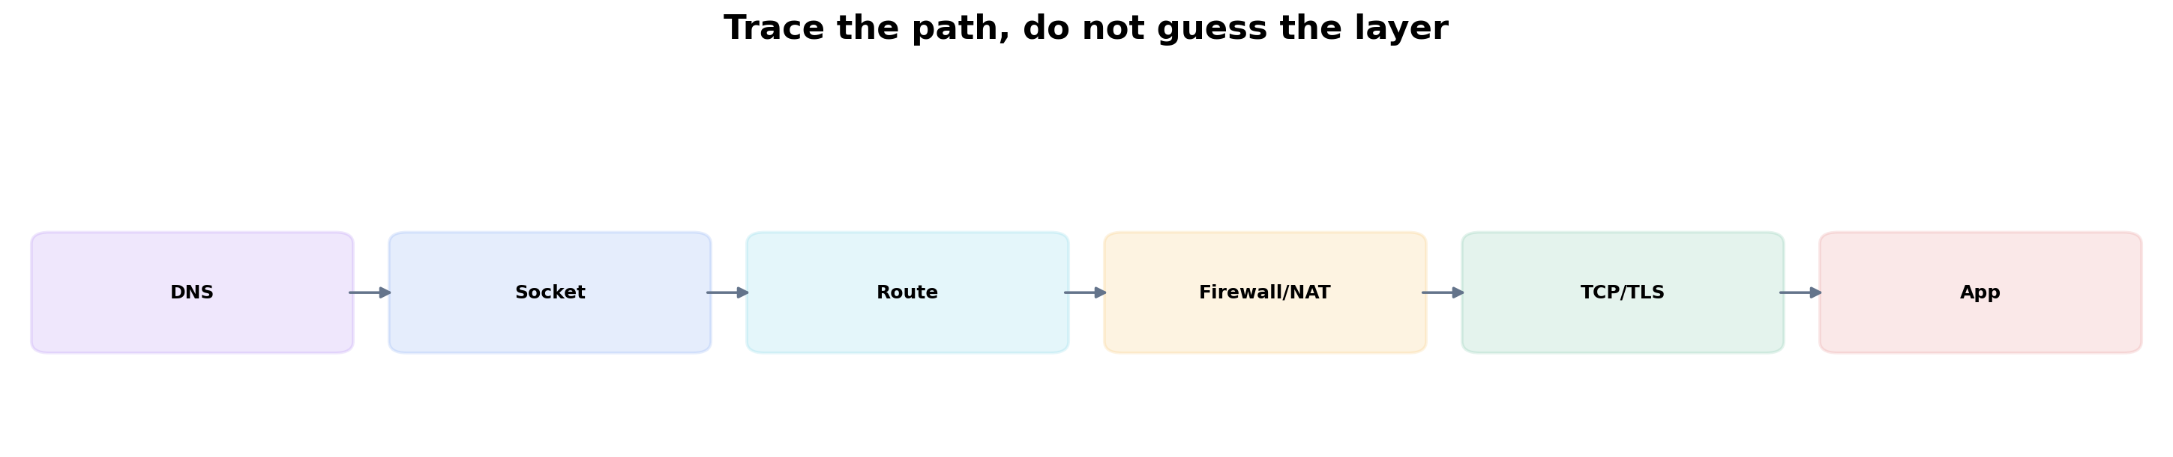
Figure 3. Prove each layer. A passing lower layer does not prove the higher layer.
A TCP connect timeout, connection refused, TLS certificate failure and HTTP 503 are four different diagnoses. curl -v is valuable because it exposes DNS, connect, TLS and HTTP phases in one trace. tcpdump proves whether packets actually leave/return. Firewall/NAT rules explain packet transformation or filtering, while the application log explains a valid HTTP response such as 500/503.
curl -vk --connect-timeout 2 https://api.example.com/health
nft list ruleset
# older systems may use iptables-save
tcpdump -ni any 'host 203.0.113.10 and port 443'

Worked scenario
Situation
A Pod can resolve api.example.com, but HTTPS calls time out.
1. Record the resolved IP and ensure it is the expected endpoint.
2. From the same network namespace, inspect route to the IP and source interface.
3. Attempt TCP/443 and capture packets. SYN with no SYN-ACK points below TLS/HTTP.
4. Inspect Kubernetes NetworkPolicy/CNI policy, node firewall/NAT and cloud firewall/load-balancer path as applicable.
5. If TCP connects, move upward to TLS certificate/SNI and HTTP response evidence.
Conclusion
“DNS works” only removes one branch of the hypothesis tree.

Practitioner lens
Vishakha Sadhwani: Kubernetes networking is Linux networking plus abstractions
A recent public post traces north-south and east-west traffic through load balancers, Gateway/Ingress, Services, kernel rules/eBPF, CNI and pod IPs. This chapter deliberately teaches the underlying socket/route/filter path first so those Kubernetes components become inspectable control points.
Public source

Practice
1. Trace an HTTPS connection in a lab with getent, ip route get, curl -v and tcpdump. Write what each command proves.
2. Explain timeout versus connection-refused versus TLS failure.
3. Draw the return path as well as the forward path; identify where asymmetric routing could appear.

Chapter 5 - Namespaces, cgroups and container mechanics
Learning outcome
Explain what a container actually is at the Linux level and how Kubernetes requests/limits map to resource control.

5.1 Namespaces
Namespace | Isolation view
pid | process IDs and process tree
net | interfaces, routes, sockets, firewall namespace
mnt | mount table/filesystem view
uts | hostname/domain
ipc | IPC resources
user | user/group ID mappings
lsns
readlink /proc/<PID>/ns/net
nsenter -t <PID> -n ip addr
nsenter -t <PID> -n ip route

5.2 cgroups
cgroups organize processes for resource accounting/control. In cgroup v2, controllers expose files for CPU, memory, I/O and other resources. Container runtimes place container processes into cgroups; Kubernetes requests influence scheduling while limits may become enforcement configuration.
cat /proc/<PID>/cgroup
cat /sys/fs/cgroup/cpu.stat
cat /sys/fs/cgroup/memory.current
cat /sys/fs/cgroup/memory.events

5.3 What an image is—and is not
A container image is a filesystem/content package plus metadata. Isolation comes from how the runtime launches the process: namespaces, cgroups, mounts, capabilities, seccomp, LSM policy and device access. This distinction is essential when debugging “container” problems that are actually host-kernel or cgroup problems.

Worked scenario
Situation
A Pod shows CPU latency but the node dashboard has idle CPU.
1. Inspect the Pod CPU limit and container cgroup cpu.stat for throttling.
2. Compare requested/limited CPU with application thread behavior.
3. Check node run queue and per-CPU utilization to distinguish local quota from host saturation.
4. Only then decide whether to change limits, requests or application concurrency.
Conclusion
A container can be locally constrained inside an apparently idle node.

Chapter 6 - systemd, boot, services, signals and logs
Learning outcome
Diagnose why a Linux service failed to start, restarted, stopped accepting traffic or was killed.

6.1 Unit state and dependency model
systemd manages units such as services, sockets, mounts and timers with dependency and ordering relationships. status is a summary; show exposes properties; journalctl gives event history. Always move from unit state to the actual process and external dependencies.
systemctl status myservice --no-pager
systemctl show myservice -p ActiveState -p SubState -p ExecMainStatus -p NRestarts
journalctl -u myservice --since '-30 min'
systemctl list-dependencies myservice

6.2 Signals and shutdown
SIGTERM requests graceful termination; SIGKILL cannot be handled. Kubernetes termination ultimately becomes process signals inside the container. Applications that ignore SIGTERM or take longer than their grace period may be killed before cleanup completes.
kill -TERM <PID>
kill -KILL <PID> # last resort; no cleanup handler can run

Worked scenario
Situation
A service repeatedly restarts every 30 seconds.
1. Read systemctl show/status and journal history to determine whether systemd is restarting after non-zero exit, watchdog failure or dependency issue.
2. Inspect the process exit code and application logs around each restart.
3. Check listeners, credentials, files, DNS and upstream dependencies the process needs during startup.
4. Confirm resource/OOM/kernel events are not killing it externally.
5. Fix the cause before increasing restart limits.
Conclusion
Restart policy is recovery behavior; it is not root cause.

Targeted references
Udemy - Complete Linux Troubleshooting Course - Target: Running Out of Memory, System is Running Slow, filesystem, access, logs/processes and networking sections.
Linux kernel documentation - Authoritative kernel behavior.
Coursera - The Bits and Bytes of Computer Networking - Target TCP/IP, routing, DNS and troubleshooting modules.

FOURTH EDITION — SENIOR ENGINEERING EXPANSION · VOLUME 1

Linux, networking and host mechanics for GPU and Kubernetes infrastructure
This expansion keeps the Fourth Edition teaching flow and adds the depth expected from a senior infrastructure engineer and customer-facing Solutions Architect. The emphasis is mechanism first: understand what the system is doing, observe it with concrete tools, then reason about failure, scale, reliability, performance and trade-offs.
The practitioner material used to shape the scope is a signal, not an authority. Technical behavior is anchored in official documentation and first-principles systems reasoning. Your Staff Engineer study guide contributes useful patterns around Kubernetes, observability, distributed systems, platform design and failure isolation; the NVIDIA material adds GPU systems, AI workloads, accelerated networking and customer architecture.
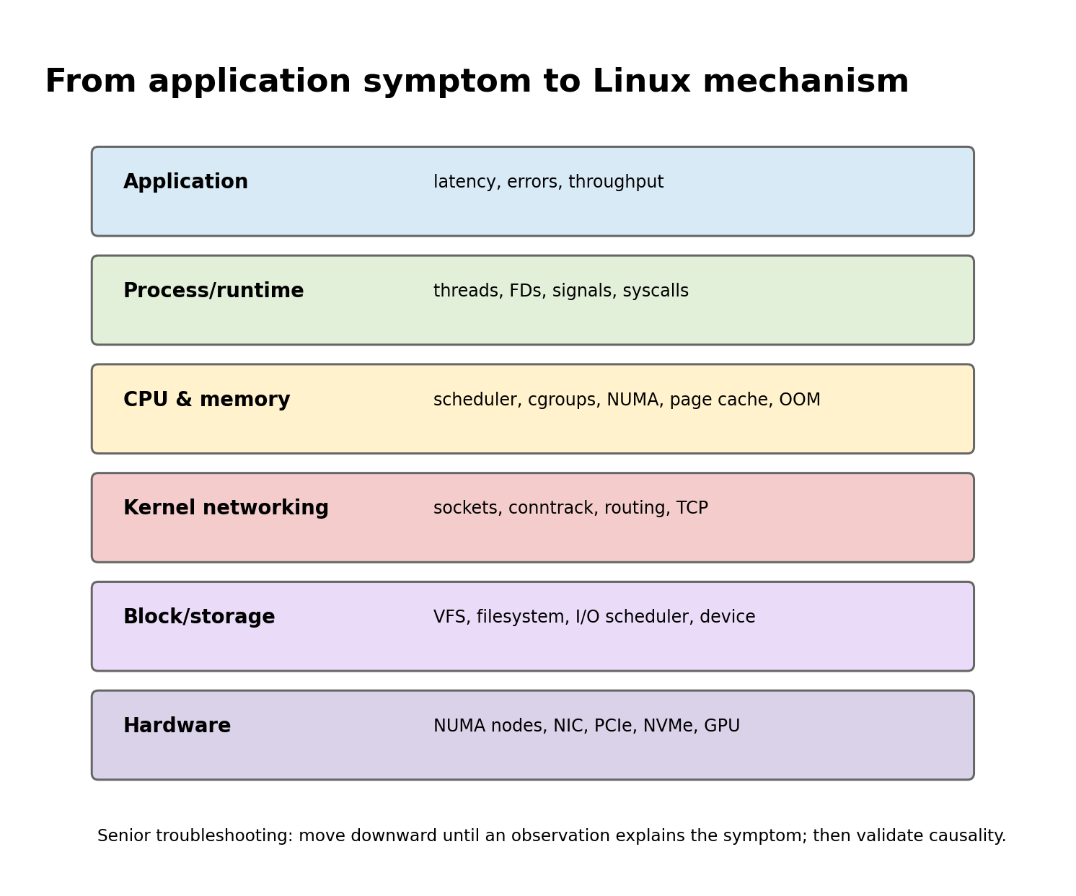
Figure A. Senior troubleshooting moves from symptom to mechanism instead of jumping between tools.

Senior Deep Dive 1 — Linux execution: syscalls, scheduling, run queues and CPU pressure
A production process alternates between user mode and kernel mode. Application code executes in user mode; operations such as reading a file, opening a socket, allocating certain memory mappings or changing process state cross into the kernel through system calls. This boundary is extremely useful in troubleshooting: if an application claims to be “stuck”, strace can tell you whether it is repeatedly polling, waiting on futexes, blocked on network reads, sleeping, or failing a syscall.
Linux schedules runnable tasks, not Kubernetes Pods. A Pod may contain several containers, each container may contain several processes, and each process may have many threads. CPU requests and limits ultimately shape cgroup CPU accounting and throttling, while the scheduler decides when runnable tasks receive CPU time. This explains a common production paradox: node CPU can look moderate while a latency-sensitive container is throttled because its own quota is exhausted.
Host commands: CPU and syscall evidence
# Which threads are runnable or blocked?
ps -eLo pid,tid,psr,pcpu,stat,wchan:32,comm --sort=-pcpu | head -30

# Scheduling and context-switch pressure
vmstat 1
pidstat -w -p <PID> 1
cat /proc/<PID>/sched

# What is the process actually waiting on?
strace -tt -T -p <PID>

# cgroup v2 CPU control for a container/task
cat /sys/fs/cgroup/<path>/cpu.stat
cat /sys/fs/cgroup/<path>/cpu.max

Observation | Likely mechanism | Validate next
High load, low CPU | Uninterruptible I/O or blocked runnable work | ps STAT/WCHAN, iostat, pressure stall information
High context switches | Lock contention, excessive threads, packet rate | pidstat -w, perf sched, thread count
Latency spikes, CPU < 100% | cgroup quota throttling or single-thread saturation | cpu.stat throttled_usec, per-thread CPU
High system CPU | syscalls, networking, storage or kernel work | perf top, softirq counters, syscall profile

Senior Deep Dive 2 — Memory: virtual address space, page faults, NUMA and OOM decisions
Virtual memory is an address-space abstraction. A process can reserve address ranges without immediately consuming physical RAM. Memory becomes operationally expensive when pages are faulted in, dirtied, pinned, swapped, reclaimed or moved across NUMA domains. Senior troubleshooting therefore distinguishes virtual size, resident set, anonymous memory, file-backed page cache, shared memory and pinned memory instead of treating “memory usage” as one number.
NUMA matters on large CPU/GPU servers because memory access latency and bandwidth depend on locality. A GPU connected beneath one PCIe root complex can be closer to one CPU socket and its memory controllers. If feeder threads, NIC interrupts and memory allocations land on the wrong NUMA node, an apparently healthy GPU may starve. This is one bridge between ordinary Linux knowledge and AI infrastructure: topology affects performance long before Kubernetes notices anything is wrong.
Host commands: memory and NUMA evidence
# Memory pressure and reclaim
free -h
vmstat 1
cat /proc/pressure/memory
cat /proc/meminfo | egrep 'MemAvailable|Anon|Mapped|Dirty|Writeback|Huge|Unevictable'

# Per-process mappings and faults
pmap -x <PID> | tail
pidstat -r -p <PID> 1

# NUMA layout and locality
numactl --hardware
numastat -p <PID>
lscpu -e=CPU,NODE,SOCKET,CORE

OOM reasoning must identify the boundary. A container can be OOM-killed inside its cgroup while the node still has free memory. Conversely, global node pressure can trigger the kernel OOM killer or kubelet eviction logic. The right question is not “did we run out of memory?” but “which allocator or control boundary could not satisfy the request, and what evidence records that decision?”

Senior Deep Dive 3 — Storage I/O: VFS to NVMe, latency queues and checkpoint behavior
An application write can pass through a language runtime, libc, the VFS, filesystem code, page cache, block layer, I/O scheduler, device driver and physical device. Each layer can buffer work, so throughput and durability are separate questions. fsync changes the contract; buffered writes may look fast until writeback or checkpoint pressure catches up.
AI infrastructure intensifies these issues. Training jobs can read enormous datasets while periodically writing multi-gigabyte checkpoints. Model-serving fleets may stampede object storage during rollout. Local NVMe can absorb bursty reads, but cache warm-up and eviction behavior must be considered. A storage design that advertises high sequential bandwidth may still collapse under metadata-heavy small-file access.
Host commands: storage evidence
# Device and filesystem pressure
iostat -xz 1
cat /proc/pressure/io
lsblk -o NAME,TYPE,SIZE,FSTYPE,MOUNTPOINTS,ROTA
findmnt -T /path/to/data

# Which processes are issuing I/O?
pidstat -d 1
lsof +D /path/to/checkpoint 2>/dev/null | head

# Quick latency test - never run destructive tests on production devices
fio --name=readcheck --filename=/safe/testfile --rw=randread --bs=4k --iodepth=32 --size=1G --runtime=30 --time_based

Senior Deep Dive 4 — Packet-level networking: routing, conntrack, TCP and DNS failure modes
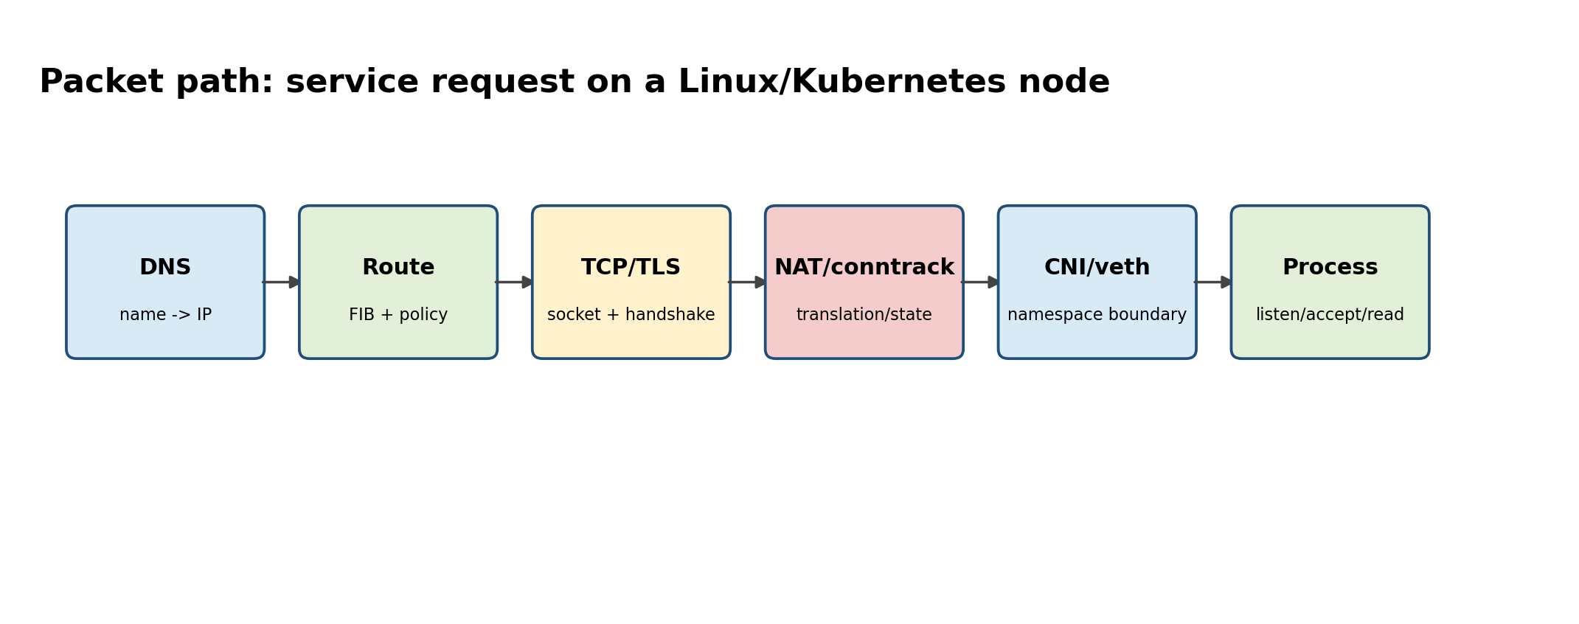
Figure B. A Kubernetes request still traverses ordinary Linux networking mechanisms.
Debugging should follow the packet. Name resolution produces an address; routing selects an egress interface and next hop; ARP or neighbor discovery resolves a local next hop; TCP establishes state; TLS authenticates and negotiates encryption; an HTTP request then reaches the application. NAT, conntrack, overlay encapsulation, service meshes and policy can add more state, but they do not replace those fundamentals.
Host commands: trace the network path
# Name resolution and route decision
dig +trace example.internal
getent ahostsv4 example.internal
ip route get 10.20.30.40
ip neigh show

# Socket and TCP state
ss -lntp
ss -s
ss -tan state syn-sent

# Packet evidence
sudo tcpdump -ni any host 10.20.30.40 and port 443

# Conntrack / firewall state (tooling varies by distro)
sudo conntrack -S
sudo nft list ruleset

For RDMA or GPU fabrics, these fundamentals remain useful because management traffic, discovery, DNS, control planes and many data services still use normal IP/TCP. RoCE adds lossless/congestion requirements and bypasses the TCP transport path for RDMA verbs, but you still need to understand interfaces, routing, MTU, VLANs and NIC topology.

Senior Deep Dive 5 — Containers: namespaces, cgroups v2, overlay filesystems and runtime boundaries
A container is a set of Linux processes constrained and isolated by kernel mechanisms. Namespaces provide views of resources; cgroups account and control resource consumption; capabilities and LSMs limit privilege; overlay filesystems build writable container roots from immutable image layers. containerd and an OCI runtime coordinate creation, but the kernel enforces the isolation.
Host commands: inspect the kernel boundaries behind a container
# See namespace identities for a process
lsns -p <PID>
readlink /proc/<PID>/ns/net
readlink /proc/<PID>/ns/mnt

# Enter a container's network namespace from the host
sudo nsenter -t <PID> -n ip addr
sudo nsenter -t <PID> -n ss -lntp

# Inspect cgroup placement and limits
cat /proc/<PID>/cgroup
cat /sys/fs/cgroup/<path>/memory.max
cat /sys/fs/cgroup/<path>/memory.events

Senior Deep Dive 6 — Host readiness for NVIDIA GPU nodes
GPU nodes add a second dependency graph to the host: kernel version and modules, NVIDIA driver, device nodes, IOMMU/PCIe topology, container runtime integration, CUDA user-space compatibility, NIC/RDMA stack, firmware, time synchronization, storage mounts and Kubernetes operands. A node can be Ready in Kubernetes while being unusable for accelerated workloads.
Layer | Evidence | Common failure
PCIe / device discovery | lspci -nn, nvidia-smi topo -m | device missing, link width/speed, bad topology
Driver | nvidia-smi, dmesg, lsmod | module mismatch, Xid, failed persistence/reset
Container runtime | nvidia-ctk, CDI specs, containerd config | GPU visible on host but not in container
RDMA | ibv_devinfo, rdma link, ethtool | wrong NIC/NUMA, MTU/QoS, driver mismatch
Kubernetes | node labels, device resources, operator pods | plugin/operator unhealthy, stale labels

Senior troubleshooting exercise — Slow GPU job with “healthy” Kubernetes
Scenario: a distributed training job runs 35% slower after a node pool refresh. Pods are Running, GPU utilization averages 70%, and no Kubernetes events show errors. A senior investigation does not restart the job first. Establish whether the slowdown is reproducible on specific nodes; compare GPU/NIC topology, CPU NUMA placement, driver versions, NVLink state, RDMA counters, storage throughput and CPU throttling. The goal is to isolate the changed layer before changing configuration.
• Scope: is every rank slow, only ranks on one node, or only communication-heavy phases?
• Baseline: compare known-good node firmware, driver, kernel, NIC and topology outputs.
• Host evidence: CPU throttling, memory PSI, NUMA misses, block latency, softirq saturation.
• GPU evidence: clocks, power, thermals, ECC/Xid, NVLink health, per-process utilization.
• Network evidence: link speed, RDMA errors/retries, congestion counters and NCCL topology.
• Validation: change one variable or move one rank; prove that performance follows the suspected layer.

Targeted references and reinforcement
Vishakha Sadhwani — Kubernetes networking traffic flow: https://www.linkedin.com/in/vsadhwani — Practitioner framing: Kubernetes networking is Linux networking plus abstractions; trace the traffic path.
Udemy — Complete Linux Troubleshooting Course: https://www.udemy.com/course/linux-troubleshooting-course — Target lectures: Server is Not Reachable (~14m), Running Out of Memory (~32m), IP Assigned but not Reachable (~21m), System is Running Slow (~34m).
NVIDIA GPU Operator docs: https://docs.nvidia.com/datacenter/cloud-native/gpu-operator/latest/index.html — Host prerequisites and the GPU software lifecycle managed on Kubernetes nodes.

