VOLUME 2
Python for Production Infrastructure
From scripting syntax to reliable infrastructure tooling

Fourth Edition - Rebuilt as a teaching text, not an annotated checklist
Independent study guide based on public documentation and public practitioner material. Not an NVIDIA publication.

How to use this volume
Read a chapter as a study block. Run the code. Change it. Break it. When you can explain why the broken version fails, move to the scenario and exercises. The tutor should quiz you only after you have studied the block.

Book map
Part | What you learn | What you build
I. Python mental model | references, mutability, execution, functions | small inventory and log tools
II. Infrastructure I/O | files, regex, JSON/YAML, environment, subprocess | config reader and diagnostics runner
III. Reliability | exceptions, logging, APIs, retries | resilient API client
IV. Design | OOP, generators, decorators, typing, concurrency | maintainable automation library
V. Quality & delivery | pytest, mocking, packaging, CLI, CI/CD | production-style diagnostic CLI

Chapter 1 - How Python actually executes your infrastructure script
After this chapter you should be able to: Explain references, mutability, module execution, the main guard, and why state bugs appear in automation.
Python feels simple because the syntax hides machinery. For production automation, you need a correct mental model of that machinery: a variable name refers to an object; objects have types and identity; functions create local namespaces; importing a file executes its top-level statements; and mutable objects can be shared by several names. These facts explain many bugs that look mysterious when you only think in terms of “boxes holding values.”
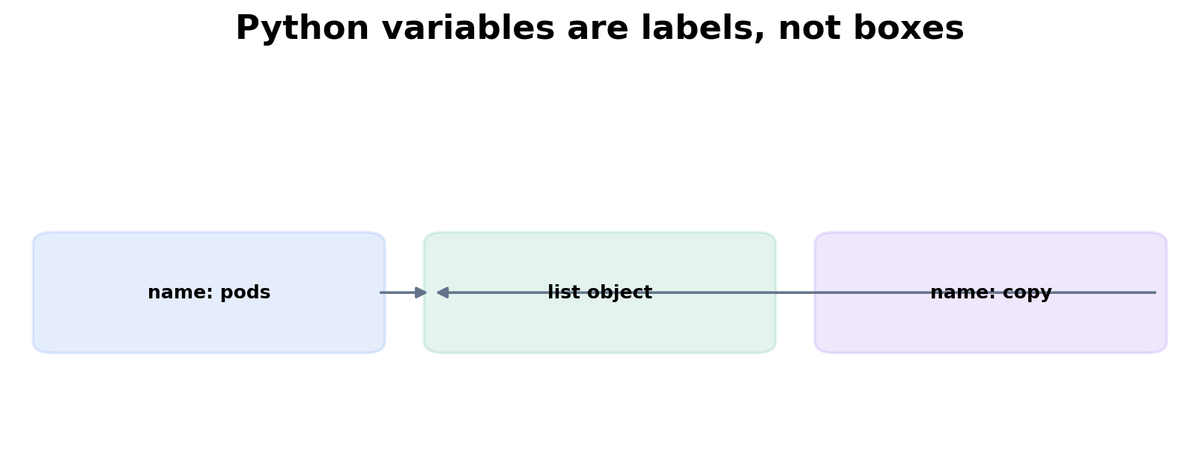
Figure 1. Two names can point at the same mutable object. Mutation through either name changes the same object.
Try it: aliasing a mutable list
pods = ["api-0", "api-1"]
copy = pods
copy.append("api-2")
print(pods) # ['api-0', 'api-1', 'api-2']
print(copy) # same object
print(id(pods) == id(copy)) # True

The important operation above is not assignment of list contents. The assignment copy = pods binds a second name to the existing list object. If you need an independent shallow copy, use pods.copy() or list(pods). If nested mutable objects exist, a shallow copy still shares those nested objects; that is when copy.deepcopy() becomes relevant.

Module execution and __name__
# healthcheck.py
def check_disk() -> bool:
print("checking disk")
return True
def main() -> int:
ok = check_disk()
return 0 if ok else 2
if __name__ == "__main__":
raise SystemExit(main())

When you run python healthcheck.py, Python sets __name__ to "__main__" and executes main(). When another module imports healthcheck, Python sets __name__ to the module name, so the CLI entry point does not run. This lets one file contain reusable functions and an executable command without causing side effects during import.
Memory hook
Think of import as “load the toolbox,” and the main guard as “only start the machine when this file is the program, not when someone opens the toolbox.”

Work the scenario step by step
Scenario
A unit test imports your disk checker and unexpectedly starts calling real system commands before the test begins.

1. Ask what executes at import time. Look for function calls, network requests, argparse parsing, environment validation, or subprocess calls at module scope.
2. Move executable behavior into functions. Keep module scope for constants, type definitions, and function/class definitions.
3. Use a main() function and guard it with if __name__ == "__main__".
4. Test the pure functions separately from the CLI adapter.
Reasoned conclusion
The bug is architectural: import should define reusable behavior, not launch production behavior.

Practice before moving on
1. Predict the result when two variables reference the same dictionary and one changes a nested list.
2. Write a module with main() that exits 0 on success and 2 on a failed health check. Import it from another file and prove the health check does not run.
3. Explain the difference between == and is using an infrastructure example.

Targeted references
Python documentation: Data model - Use this when you need exact behavior for identity, types, attributes, and special methods.
Udemy - Python for DevOps: Mastering Real-World Automation - Relevant lessons: Writing and running Python files; Variables; Lists; Dictionaries; Introduction to functions.

Chapter 2 - Choosing data structures by the problem, not by habit
After this chapter you should be able to: Select lists, tuples, sets, dictionaries, queues, and dataclasses based on access patterns and invariants.
Infrastructure scripts spend much of their time transforming collections: pod lists, node inventories, labels, API objects, log lines, metrics, and desired-state configuration. The useful question is not “which collection do I remember?” but “what operation dominates this problem?”
Need | Structure | Reason
Preserve ordered items, allow duplicates | list | Indexing, append, iteration; O(n) membership search
Fixed record-like sequence | tuple | Signals “do not mutate”; hashable when contents are hashable
Membership / de-duplication | set | Average O(1) membership and set algebra
Keyed lookup / structured object | dict | Average O(1) lookup by key; natural fit for JSON
Set algebra turns inventory comparison into a direct expression of intent
expected = {"api", "worker", "scheduler"}
running = {"api", "worker", "debug-shell"}
missing = expected - running
unexpected = running - expected
print("missing:", missing) # {'scheduler'}
print("unexpected:", unexpected) # {'debug-shell'}

nodes = [
{"name": "gpu-1", "zone": "a", "gpus": 8},
{"name": "gpu-2", "zone": "b", "gpus": 8},
{"name": "cpu-1", "zone": "a", "gpus": 0},
]
gpu_by_name = {n["name"]: n for n in nodes if n["gpus"] > 0}
print(gpu_by_name["gpu-2"]["zone"])

The comprehension builds an index once. If you need repeated lookups by node name, this is better than scanning the list each time. In interviews, explain the algorithmic reason: build O(n), then average O(1) lookup, instead of O(n) for every query.

Work the scenario step by step
Scenario
You receive 50,000 pod names from two clusters and need to report names present in cluster A but absent in B.

1. Recognize that the dominant operation is membership comparison, not ordered presentation.
2. Convert names to sets.
3. Use set difference A - B.
4. Sort only when producing human-readable output, because sorting is an output concern rather than a membership concern.
Reasoned conclusion
A set makes the algorithm both clearer and faster than nested loops.

Practice before moving on
1. Write a function that groups pods by namespace using dict[str, list[str]].
2. Find duplicate IP addresses in an inventory with a set.
3. Given a list of 100k log event IDs, explain when a list is acceptable and when a set is the right index.

Targeted references
Udemy - Python for DevOps - Relevant lessons: Introduction to lists; Tuples; Set operations; Dictionaries; Server Inventory Reporter coding exercise.

Chapter 3 - Functions: turn scripts into testable decisions
After this chapter you should be able to: Separate computation from side effects and design functions with explicit inputs, outputs, and failure semantics.
A production script becomes maintainable when the decision logic can be executed without the production environment. The easiest route is to separate pure computation from side effects such as reading files, calling APIs, printing, mutating remote systems, and executing subprocesses.
Pure decision function: easy to reason about and easy to test
from dataclasses import dataclass
@dataclass(frozen=True)
class NodeUsage:
name: str
cpu_pct: float
memory_pct: float
def classify_node(usage: NodeUsage) -> str:
if usage.memory_pct >= 95:
return "critical"
if usage.cpu_pct >= 85 or usage.memory_pct >= 85:
return "warning"
return "healthy"

def report(nodes: list[NodeUsage]) -> dict[str, list[str]]:
result = {"healthy": [], "warning": [], "critical": []}
for node in nodes:
result[classify_node(node)].append(node.name)
return result

Notice that report() does not call kubectl or the cloud API. Another adapter can obtain raw data, convert it to NodeUsage values, call report(), then format output. The core logic is deterministic. This design directly improves unit testing and incident confidence.
Common production bug
Avoid mutable default arguments such as def add_tag(tag, tags=[]). That list is created once when the function is defined and reused across calls. Use None and create a fresh object inside the function.

def add_tag(tag: str, tags: list[str] | None = None) -> list[str]:
if tags is None:
tags = []
tags.append(tag)
return tags

Practice before moving on
1. Refactor a function that reads a file, parses it, decides health, and prints output into three functions: read, decide, render.
2. Explain why a function returning a structured dict is often easier to test than a function that only prints.
3. Write a guard clause that rejects an empty cluster name before an API call.

Targeted references
Udemy - Python for DevOps - Relevant lessons: Defining functions and returning values; Parameters and arguments; Guard clauses; Docstrings; Enumerate and ZIP.

Chapter 4 - Files, pathlib, regex, JSON and YAML
After this chapter you should be able to: Read infrastructure data safely, parse only what is unstructured, and preserve clear boundaries between text and structured data.
Prefer structured data over regex whenever the source already has structure. Parse JSON with json, YAML with a safe YAML loader, CSV with csv, and use regular expressions for text that is genuinely unstructured or semi-structured. A common failure is using one giant regex to parse data that the producer could emit as JSON.
from pathlib import Path
import json
def load_inventory(path: Path) -> list[dict]:
try:
raw = path.read_text(encoding="utf-8")
data = json.loads(raw)
except FileNotFoundError as exc:
raise RuntimeError(f"inventory not found: {path}") from exc
except json.JSONDecodeError as exc:
raise RuntimeError(f"invalid JSON at line {exc.lineno}") from exc
if not isinstance(data, list):
raise ValueError("inventory root must be a list")
return data

Use named groups when regex is producing a structured record
import re
LOG = re.compile(
r"^(?P<ts>\S+)\s+(?P<level>ERROR|CRITICAL|FATAL)\s+"
r"service=(?P<service>[\w-]+)\s+message=(?P<message>.+)$"
)
def parse_error(line: str) -> dict[str, str] | None:
match = LOG.search(line)
return match.groupdict() if match else None

Named groups convert a cryptic regex into an extraction schema. Still, never make regex your first choice for Kubernetes API output: request JSON from the API or kubectl -o json and parse the JSON. This is more robust across spacing and formatting changes.
from pathlib import Path
log = Path("/var/log/myservice/events.log")
with log.open(encoding="utf-8") as handle:
for line in handle: # streaming, not read-all-at-once
if event := parse_error(line):
print(event)

Memory hook
Use pathlib for “where is the file?”, format-specific parsers for “what data is inside?”, and regex only for “what pattern is hidden in raw text?”

Work the scenario step by step
Scenario
A 20 GB application log must be searched for ERROR/CRITICAL events without exhausting memory.

1. Do not call read_text() or readlines() on the whole file.
2. Open the file and iterate line by line; the file object is already an iterator.
3. Compile the regex once outside the loop.
4. Yield matching events so downstream processing can remain lazy.
5. Keep output bounded or stream it to a sink rather than accumulating millions of results.
Reasoned conclusion
The core design is streaming I/O plus lazy transformation, not a bigger machine.

Practice before moving on
1. Parse a Kubernetes JSON pod list and return pods whose containerStatuses contain non-zero restart counts.
2. Write a regex with named groups for timestamp, severity, request ID, and message.
3. Create a config loader that accepts a Path and validates required top-level keys.

Targeted references
Python pathlib documentation - Path-oriented filesystem operations.
Udemy - Python for DevOps - Relevant lessons: The Path object; Regex: Introduction and essentials; Log Line Error Detector; JSON deserialization; Introduction to YAML operations; Log File Archiver.

Chapter 5 - Exceptions and context managers
After this chapter you should be able to: Fail deliberately, preserve diagnostic context, and guarantee cleanup of external resources.
Exceptions are not an alternative syntax for if/else. Use normal conditions for expected branches and exceptions for operations that could not fulfill their contract. A caller should be able to distinguish “resource absent,” “authentication failed,” “temporary timeout,” and “input invalid” because the recovery policy differs for each.
class InventoryError(Exception):
"""Base exception for inventory operations."""
class AuthenticationError(InventoryError):
pass
class TemporaryAPIError(InventoryError):
pass

Exception chaining preserves the original cause
try:
inventory = client.fetch_inventory()
except TimeoutError as exc:
raise TemporaryAPIError("inventory API timed out") from exc

The “from exc” matters during troubleshooting because the traceback shows both the infrastructure-level meaning you added and the low-level cause. Do not catch Exception merely to print and continue; that often turns a real failure into silent data corruption.
from contextlib import contextmanager
from tempfile import TemporaryDirectory
from pathlib import Path
@contextmanager
def workspace():
with TemporaryDirectory(prefix="infra-") as tmp:
path = Path(tmp)
yield path
# TemporaryDirectory cleans up even when the caller raises.

Practice before moving on
1. Design exception classes for auth failure, retryable 503, invalid config, and remote command failure. Decide which ones should be retried.
2. Use a context manager to open a temporary workspace and prove it is removed after an exception.
3. Explain why except Exception: pass is dangerous in an automation that changes infrastructure.

Targeted references
Udemy - Python for DevOps - Relevant lessons: Thinking in exceptions; Defining custom exceptions; Adding context to custom exceptions; Context managers and the with statement; Advanced Retry Decorator with Exponential Backoff and Jitter exercise.

Chapter 6 - Logging for operations, not print-debugging
After this chapter you should be able to: Create logs that answer what happened, to which resource, in which attempt, and with what outcome.
Operational logging is structured evidence. A useful record includes event type, resource identity, correlation or request ID, attempt count, duration, outcome, and exception information. Human prose alone is hard to aggregate; JSON fields can be indexed and queried.
import json
import logging
from datetime import datetime, timezone
logger = logging.getLogger("infra_doctor")
def log_event(event: str, **fields: object) -> None:
payload = {
"ts": datetime.now(timezone.utc).isoformat(),
"event": event,
**fields,
}
logger.info(json.dumps(payload, default=str))

log_event(
"api_request_completed",
service="inventory",
status=200,
duration_ms=184,
attempt=1,
)

In a larger system, use logging configuration and a JSON formatter instead of manually json.dumps() every message. The conceptual goal is the same: logs should be machine-queryable while remaining understandable during an incident.
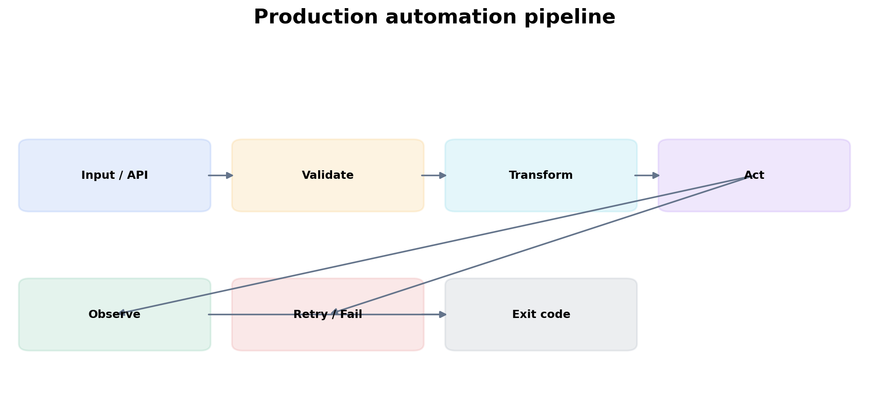
Figure 2. Reliable automation makes input validation, action, observation, and failure behavior explicit.

Work the scenario step by step
Scenario
A script failed in CI three hours ago, but the only output is “request failed.”

1. Identify what context is missing: endpoint, resource, status code, attempt number, timeout, correlation ID, exception class.
2. Add structured fields rather than concatenating one giant string.
3. Log once at the layer that owns the operational meaning; avoid logging the same exception at every layer.
4. Ensure secrets and tokens are filtered before logs leave the process.
Reasoned conclusion
Logging quality is part of program design because incidents happen after the original stack frame is gone.

Practice before moving on
1. Add duration_ms to a context-manager-based operation timer.
2. Create a logging.Filter that masks a token-like field.
3. Define DEBUG/INFO/WARNING/ERROR usage for a retrying API client.

Targeted references
Python logging HOWTO - Core logging concepts and configuration.
Udemy - Python for DevOps - Relevant lessons: Why logging?; Log levels; Structured logging with JSON; Extra fields and exceptions in structured logging; Dynamic log configuration.

Chapter 7 - System interaction and subprocess
After this chapter you should be able to: Run operating-system commands safely, capture evidence, enforce timeouts, and preserve exit semantics.
Infrastructure engineers often need to call existing tools. subprocess.run() is the normal high-level API. Pass arguments as a list rather than a shell string, use check=True when non-zero should become an exception, capture_output=True when you need output, text=True for decoded strings, and timeout= when a hung child process must not hang your automation forever.
import subprocess
def kubectl_json(namespace: str) -> str:
cmd = ["kubectl", "get", "pods", "-n", namespace, "-o", "json"]
try:
result = subprocess.run(
cmd,
check=True,
capture_output=True,
text=True,
timeout=10,
)
except subprocess.TimeoutExpired as exc:
raise RuntimeError(f"kubectl timed out after {exc.timeout}s") from exc
except subprocess.CalledProcessError as exc:
stderr = (exc.stderr or "").strip()
raise RuntimeError(f"kubectl failed rc={exc.returncode}: {stderr}") from exc
return result.stdout

Security rule
Avoid shell=True with untrusted input. A shell parses metacharacters such as ;, |, $, and redirects. Passing an argument list bypasses shell interpretation and is safer by default.

Work the scenario step by step
Scenario
A diagnostic command occasionally hangs because a kubeconfig credential plugin is blocked.

1. Add a timeout to the subprocess boundary.
2. Capture stderr because authentication/tool errors are often emitted there.
3. Return or raise a typed failure rather than returning empty output that looks valid.
4. Log command identity without logging secrets or sensitive arguments.
5. Consider using the Kubernetes API client directly when you need stronger typing and control than a CLI subprocess provides.
Reasoned conclusion
A subprocess is an external dependency. Treat its timeout, exit code, stdout, stderr, and environment as part of the API contract.

Practice before moving on
1. Write a safe ping wrapper returning a dataclass with target, success, duration, and stderr.
2. Explain when you would use subprocess versus an SDK/API client.
3. Demonstrate why string interpolation plus shell=True can create command injection.

Targeted references
Python subprocess documentation - Exact semantics for run, timeouts, CompletedProcess, and exceptions.
Udemy - Python for DevOps - Relevant lessons: Introduction to subprocesses; Handling subprocess errors; Handling expired timeouts; System Health Checker with ping coding exercise.

Chapter 8 - HTTP APIs, timeouts, retries and backoff
After this chapter you should be able to: Build clients that distinguish client errors, transient server errors, rate limiting, and network failure.
A reliable API client has policy. It does not retry everything. Authentication errors usually require corrected credentials, not ten more attempts. Validation errors are deterministic. A 429 may be retryable according to Retry-After. Many 5xx responses and network timeouts can be transient. The retry layer must understand idempotency: retrying GET is usually safe; retrying a POST that creates a resource may duplicate work unless the API provides an idempotency key or the operation is otherwise safe.
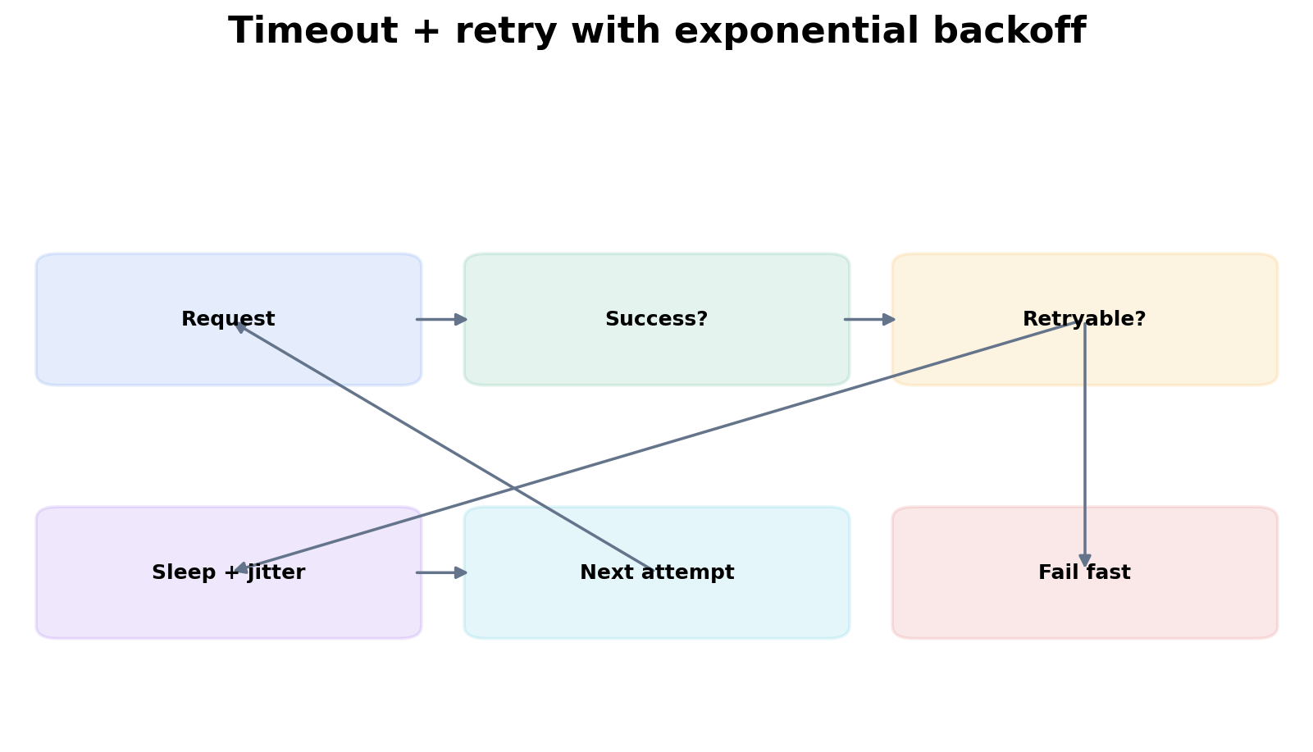
Figure 3. Retry is a policy branch after classification, not a loop around every exception.
import random
import time
import requests
RETRYABLE = {429, 500, 502, 503, 504}
def get_json(url: str, token: str, attempts: int = 4) -> dict:
headers = {"Authorization": f"Bearer {token}"}
for attempt in range(1, attempts + 1):
try:
response = requests.get(url, headers=headers, timeout=(2, 8))
if response.status_code not in RETRYABLE:
response.raise_for_status()
return response.json()
except (requests.Timeout, requests.ConnectionError):
if attempt == attempts:
raise
else:
if attempt == attempts:
response.raise_for_status()
delay = min(8.0, 0.5 * (2 ** (attempt - 1)))
time.sleep(delay + random.uniform(0, delay * 0.2))
raise AssertionError("unreachable")

The timeout tuple above separates connect timeout from read timeout. Jitter prevents many clients from retrying in lockstep after a shared outage. In mature systems, prefer a tested retry library or HTTP adapter configuration, but first understand the policy you expect the library to implement.

Work the scenario step by step
Scenario
A cloud API returns 503 to 500 CI jobs at the same time.

1. Do not have every job retry at the same fixed one-second interval; that creates synchronized load spikes.
2. Use exponential backoff so request rate drops while the dependency recovers.
3. Add jitter so clients spread their retries across time.
4. Respect server guidance such as Retry-After when present.
5. Cap attempts and total time; an automation that retries forever is not reliable.
Reasoned conclusion
Retry behavior must reduce pressure on a failing dependency, not amplify it.

Practice before moving on
1. Classify 400, 401, 403, 404, 409, 429, 500, 503 into retry/no-retry decisions and justify each.
2. Add a Retry-After branch to the sample client.
3. Implement pagination for an API returning next-page tokens.

Targeted references
Requests documentation - HTTP client API and exceptions.
Udemy - Python for DevOps - Relevant lessons: GET requests; HTTP status codes; Token-based authentication; Handling timeouts; Retries: Simple strategy; Retries: Exponential backoff with jitter.

Chapter 9 - OOP that helps infrastructure code
After this chapter you should be able to: Use objects to hold cohesive state and behavior; prefer composition over inheritance when components have different responsibilities.
Object-oriented design is useful when an automation has stateful collaborators: an API client, credential provider, retry policy, renderer, and command runner. Do not create classes merely to satisfy “use OOP.” A class should represent a concept that owns state and operations. Composition lets you assemble behavior by giving one object another object to collaborate with.
from dataclasses import dataclass
from typing import Protocol
class CommandRunner(Protocol):
def run(self, args: list[str]) -> str: ...
@dataclass
class PodInspector:
runner: CommandRunner
namespace: str
def raw_pods(self) -> str:
return self.runner.run([
"kubectl", "get", "pods",
"-n", self.namespace, "-o", "json"
])

PodInspector does not inherit from a generic KubernetesTool. It receives a runner. In tests, you can inject a fake runner. In production, inject a subprocess-backed runner. The Protocol describes the behavior needed without forcing a rigid class hierarchy.
class FakeRunner:
def __init__(self, output: str):
self.output = output
self.calls: list[list[str]] = []
def run(self, args: list[str]) -> str:
self.calls.append(args)
return self.output

Memory hook
Inheritance says “is a specialized form of.” Composition says “uses.” Infrastructure tools are usually assemblies of clients, policies, parsers, and adapters, so “uses” is often the more natural relationship.

Practice before moving on
1. Design an ApiClient that composes a RetryPolicy and AuthProvider.
2. Explain when inheritance would actually make sense.
3. Replace a class that only contains one stateless staticmethod with a normal function and explain why it is clearer.

Targeted references
Udemy - Python for DevOps - Relevant lessons: Introduction to classes; Class methods; Inheritance; Object-Oriented Deployment Manager coding exercise.

Chapter 10 - Generators and decorators without magic
After this chapter you should be able to: Use generators for lazy streams and decorators for reusable cross-cutting behavior while preserving function semantics.
A generator is a function that can suspend its execution at yield and resume later. It is valuable when the data stream may be large or indefinite. Instead of returning one huge list of parsed log events, yield one event at a time and let the caller decide how far to consume the stream.
from pathlib import Path
from collections.abc import Iterator
def error_lines(path: Path) -> Iterator[str]:
with path.open(encoding="utf-8") as handle:
for line in handle:
if "ERROR" in line or "CRITICAL" in line:
yield line.rstrip("\n")

A decorator wraps a function but should preserve its metadata and return value
from functools import wraps
from time import perf_counter
def timed(func):
@wraps(func)
def wrapper(*args, **kwargs):
start = perf_counter()
try:
return func(*args, **kwargs)
finally:
elapsed = perf_counter() - start
print(f"{func.__name__} took {elapsed:.3f}s")
return wrapper

functools.wraps copies important metadata such as __name__ and __doc__. Without it, tooling and debugging may report the wrapper rather than the wrapped function. A production decorator should also preserve exceptions unless it has a deliberate policy for translating or retrying them.

Practice before moving on
1. Modify error_lines() to parse and yield structured events instead of raw strings.
2. Write a decorator that rejects calls when a required environment variable is absent.
3. Explain why a generator is usually preferable to returning a 10-million-element list.

Targeted references
Udemy - Python for DevOps - Relevant lessons: Generator syntax; The yield statement; State in generators; Coding lazy pipelines; Introduction to decorators; functools.wraps; RBAC Decorator Factory exercise.

Chapter 11 - Concurrency for infrastructure engineers
After this chapter you should be able to: Choose threads, asyncio, processes, or sequential execution by the bottleneck and operational complexity.
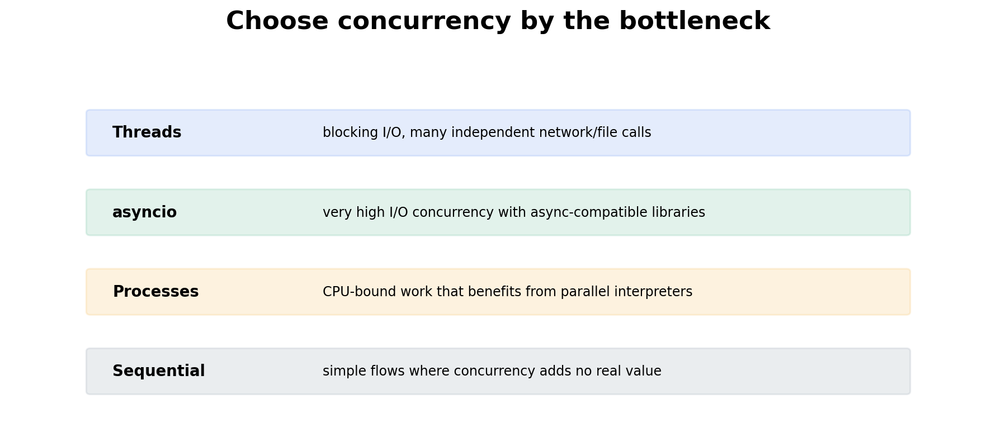
Figure 4. Concurrency is a bottleneck decision, not an “advanced Python” badge.
Most infrastructure concurrency is I/O-bound: hundreds of HTTP calls, SSH sessions, DNS lookups, or file reads. Threads can overlap blocking I/O with familiar synchronous libraries. asyncio can scale to very high I/O concurrency when the entire call path uses async-compatible libraries. Multiprocessing is useful for CPU-heavy work because separate processes have separate Python interpreters and can execute Python bytecode in parallel.
from concurrent.futures import ThreadPoolExecutor, as_completed
import requests
def health(url: str) -> tuple[str, int]:
response = requests.get(url, timeout=3)
return url, response.status_code
urls = [f"https://service-{i}.example/health" for i in range(20)]
with ThreadPoolExecutor(max_workers=8) as pool:
futures = [pool.submit(health, url) for url in urls]
for future in as_completed(futures):
try:
print(future.result())
except requests.RequestException as exc:
print("failed:", exc)

The max_workers limit is operational backpressure. Unbounded concurrency can overload your own machine, the dependency, DNS, ephemeral ports, or rate limits. Senior reasoning includes deciding concurrency limits and failure aggregation, not merely knowing ThreadPoolExecutor syntax.

Work the scenario step by step
Scenario
You need to check 2,000 HTTP endpoints every five minutes.

1. Estimate latency and service rate limits before picking a concurrency model.
2. If using requests, a bounded thread pool is straightforward. If scaling to much higher concurrency and async clients are acceptable, asyncio may reduce thread overhead.
3. Bound concurrency. Add per-request timeouts.
4. Collect partial failures without canceling successful results.
5. Emit metrics for total, success, failure, timeout, and duration distribution.
Reasoned conclusion
The architecture is “bounded concurrent I/O with observable partial failure,” not simply “use async.”

Practice before moving on
1. Rewrite the endpoint checker with asyncio and an async HTTP client if available in your environment.
2. Explain why multiprocessing is a poor default for 2,000 HTTP requests.
3. Design a concurrency limit when the upstream API permits 50 requests/second.

Chapter 12 - Type hints and pytest: make changes safer
After this chapter you should be able to: Use static contracts and automated tests to protect decision logic and dependency boundaries.
Type hints improve the feedback loop before runtime; tests validate behavior at runtime. For infrastructure tools, the most valuable tests target parsing, validation, policy decisions, retries, and translation of dependency failures. The most valuable mocks sit at dependency boundaries, not inside every function.
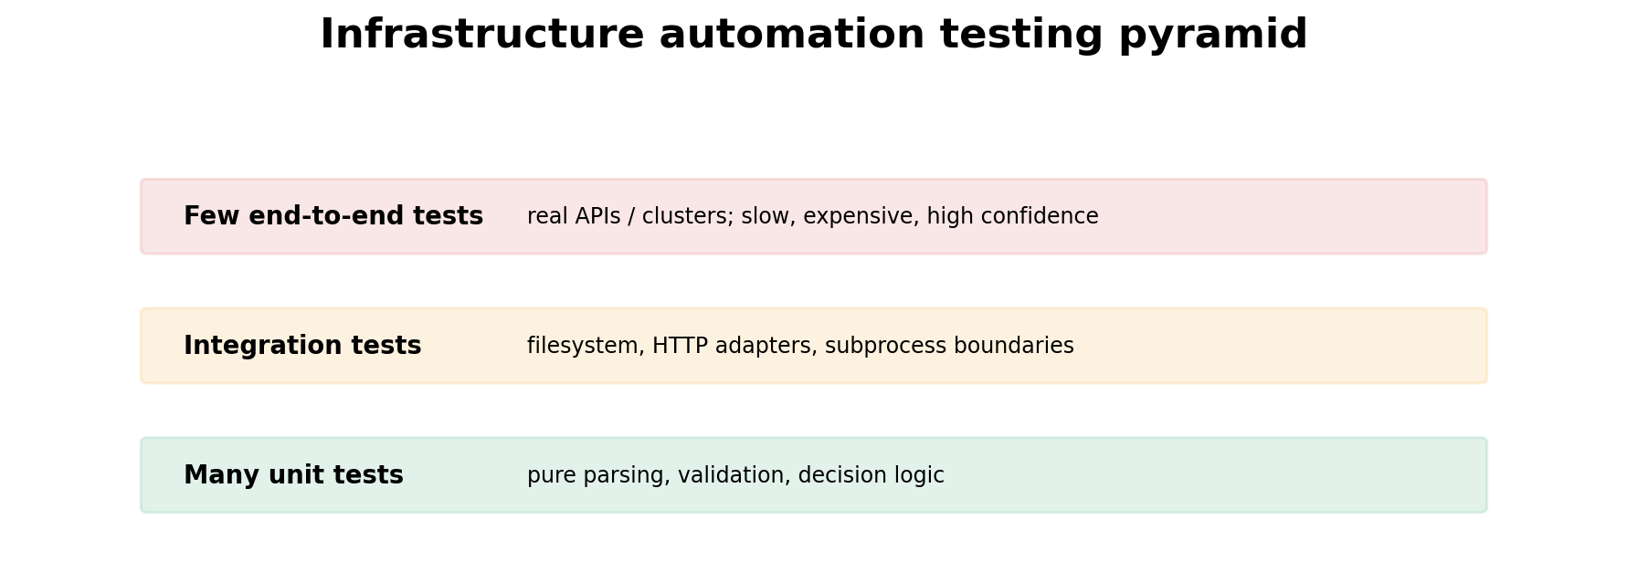
Figure 5. Keep most tests close to deterministic decision logic; use fewer real-environment tests for integration confidence.
from dataclasses import dataclass
@dataclass(frozen=True)
class PodHealth:
name: str
restarts: int
ready: bool
def unhealthy(pod: PodHealth) -> bool:
return not pod.ready or pod.restarts >= 5

import pytest
@pytest.mark.parametrize(
("pod", "expected"),
[
(PodHealth("api", 0, True), False),
(PodHealth("worker", 7, True), True),
(PodHealth("db", 0, False), True),
],
)
def test_unhealthy(pod: PodHealth, expected: bool) -> None:
assert unhealthy(pod) is expected

Mock the external HTTP boundary to test retry policy deterministically
def test_client_retries_503(mocker):
fake_get = mocker.patch("mytool.client.requests.get")
fake_get.side_effect = [
FakeResponse(503),
FakeResponse(200, {"ok": True}),
]
assert get_json("https://api", "token")["ok"] is True
assert fake_get.call_count == 2

Patch where the dependency is looked up by the code under test, not necessarily where the dependency was originally defined. This detail explains many “my mock did nothing” failures.

Practice before moving on
1. Write tests for 401 no-retry and 503 retry behavior.
2. Use a fixture to create a temporary config file.
3. Add mypy/pyright-friendly type hints to a JSON parsing function and decide where TypedDict or dataclass is appropriate.

Targeted references
pytest documentation - Assertions, fixtures, parametrization, monkeypatching and plugins.
Udemy - Python for DevOps - Relevant lessons: Introduction to type hints; Hands-on: Test-driven implementation; Testing exceptions; Introduction to fixtures; Parametrization; Mocking fundamentals; Patch decorator and mocker fixture.

Chapter 13 - Project structure, CLI and CI/CD
After this chapter you should be able to: Package automation so another engineer can install, test, invoke, and release it predictably.
A small production-style src layout
infra-doctor/
├── pyproject.toml
├── src/
│ └── infra_doctor/
│ ├── __init__.py
│ ├── cli.py
│ ├── model.py
│ ├── parser.py
│ └── kubernetes.py
└── tests/
├── test_parser.py
└── test_policy.py

# pyproject.toml
[project]
name = "infra-doctor"
version = "0.1.0"
requires-python = ">=3.12"
dependencies = ["requests>=2.32"]
[project.scripts]
infra-doctor = "infra_doctor.cli:main"

An entry point makes the tool executable after installation without asking users to know its package layout. CI should run formatting/lint checks, static analysis, tests, and build verification before publishing or packaging.
# .github/workflows/ci.yml (core idea)
jobs:
test:
runs-on: ubuntu-latest
steps:
- uses: actions/checkout@v4
- uses: actions/setup-python@v5
with:
python-version: "3.12"
- run: pip install -e . pytest
- run: pytest -q

Practice before moving on
1. Create a pyproject.toml with a console entry point.
2. Explain why imports are more predictable with a package than with a directory full of ad-hoc scripts.
3. Design a CI gate for formatting, lint, types, security scan, unit tests and build.

Targeted references
Python Packaging User Guide - Modern packaging concepts and pyproject.toml.
Udemy - Python for DevOps - Relevant lessons: Python modules; Python packages; pyproject.toml file; Adding tests to multi-file projects; CI/CD pipeline overview; Add static type and security checks; Pytest integration; Building the Python library.

Chapter 14 - Capstone: design a cluster diagnostics CLI
After this chapter you should be able to: Combine parsing, subprocess/API boundaries, data models, logging, retries, tests, and exit semantics.
The capstone is intentionally not a single giant script. Model it as adapters around a deterministic core. Kubernetes access can come from an SDK or kubectl adapter. The parser converts raw responses into typed domain values. Policy functions classify health. A renderer produces text or JSON. The CLI maps results to exit codes.

Figure 6. Use the same pipeline for the capstone: inputs become validated domain data, decisions drive actions, and every external edge is observable.
from dataclasses import dataclass
@dataclass(frozen=True)
class Finding:
severity: str
resource: str
reason: str
def assess_pod(name: str, ready: bool, restarts: int) -> list[Finding]:
findings: list[Finding] = []
if not ready:
findings.append(Finding("critical", name, "pod not ready"))
if restarts >= 5:
findings.append(Finding("warning", name, f"restarts={restarts}"))
return findings

Work the scenario step by step
Scenario
The tool must diagnose 500 pods across multiple namespaces and be safe to run in CI.

1. Define the output contract first: human table, JSON option, and exit codes for healthy/warning/critical/tool-failure.
2. Separate Kubernetes collection from health policy so policy can be tested with fixtures.
3. Use bounded concurrency only if collection latency justifies it.
4. Add timeouts and retry only retryable API failures.
5. Emit structured logs to stderr and report output to stdout so pipelines can consume JSON cleanly.
6. Test malformed data, auth failure, timeout, partial pod failures, and classification edge cases.
Reasoned conclusion
A production-quality infrastructure tool is a small system: clear contracts, controlled side effects, observable failure, and testable decisions.

Field note: practitioner perspective
Vishakha Sadhwani: script vs system thinking
Recent public material emphasizes that infrastructure work stops being “just a script” when retries, timeouts, observability, approvals, versioning, and failure handling become part of the design. Use that as the quality bar for this capstone: successful happy-path execution is only one requirement.

Public source

Targeted Udemy study map
Use the Udemy course as reinforcement after reading the matching chapter. The integration does not expose stable deep links for individual enrolled lectures, so the exact lecture titles and durations are listed below; open the course and jump directly to those titles rather than watching the whole course linearly.
Book topic | Exact Udemy lecture / exercise | Approx. duration
Execution / basics | Writing and running Python files; Hands-on: Disk usage calculation | 1:47; 3:33
Data structures | Set operations; Dictionaries; Server Inventory Reporter | 6:01; 12:12; exercise
Generators | Generator syntax; The yield statement; Coding lazy pipelines | 6:15; 5:23; 18:38
Exceptions | Thinking in exceptions; Adding context to custom exceptions | 4:22; 8:59
Logging | Structured logging with JSON; Extra fields and exceptions in structured logging | 11:29; 4:56
Files / regex | The Path object; Regex: Introduction and essentials; Log Line Error Detector | 6:03; 13:03; exercise
Subprocess | Introduction to subprocesses; Handling expired timeouts | 10:31; 3:27
HTTP | GET requests; Handling timeouts; Retries: Exponential backoff with jitter | 7:43; 3:45; 10:48
Typing | Introduction to type hints; Typed dictionaries | 10:53; 5:15
Pytest | Hands-on: Test-driven implementation; Introduction to fixtures; Mocking fundamentals | 20:17; 10:44; 8:17
Packaging / CI | Pyproject.toml file; CI/CD pipeline overview; Add static type and security checks | 7:31; 3:22; 10:58
Open the Udemy course and search by the exact lecture titles above.

Final Python checklist
You can... | Evidence you should produce
Design an algorithm before coding | pseudocode + chosen data structure + complexity explanation
Build resilient I/O | timeouts + error translation + retry policy
Keep code testable | pure decisions separated from adapters
Operate the tool | structured logs + exit codes + metrics where appropriate
Ship it | pytest + typing + package + CLI + CI

FOURTH EDITION — SENIOR ENGINEERING EXPANSION · VOLUME 2

Production Python for infrastructure automation, diagnostics and control planes
This expansion keeps the Fourth Edition teaching flow and adds the depth expected from a senior infrastructure engineer and customer-facing Solutions Architect. The emphasis is mechanism first: understand what the system is doing, observe it with concrete tools, then reason about failure, scale, reliability, performance and trade-offs.
The practitioner material used to shape the scope is a signal, not an authority. Technical behavior is anchored in official documentation and first-principles systems reasoning. Your Staff Engineer study guide contributes useful patterns around Kubernetes, observability, distributed systems, platform design and failure isolation; the NVIDIA material adds GPU systems, AI workloads, accelerated networking and customer architecture.
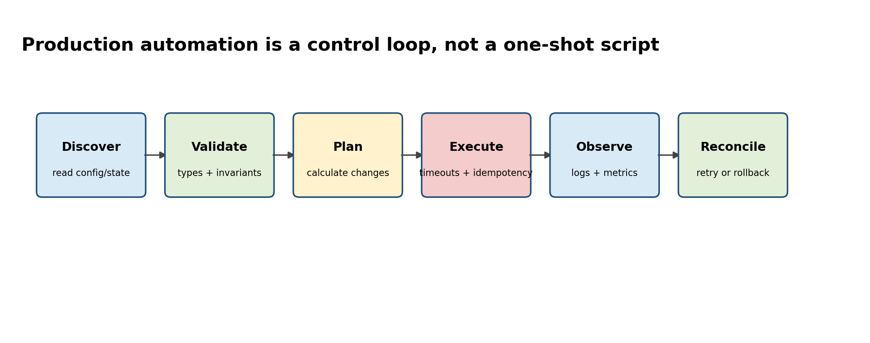
Figure A. A production tool is a bounded reconciliation loop with validation and observability.

Senior Deep Dive 1 — The Python object model, mutability and interfaces
Senior Python does not mean clever syntax. It means predictable behavior under change. Names refer to objects; mutation changes an object in place; assignment changes a binding; default arguments are evaluated once; iterators are stateful; exceptions are part of the API contract. These details matter because infrastructure tools often manipulate shared configuration, cached API responses and mutable state across many functions.
Use immutable value objects where accidental mutation would be dangerous
from dataclasses import dataclass, field
from typing import Mapping

@dataclass(frozen=True, slots=True)
class Node:
name: str
labels: Mapping[str, str]
allocatable_gpus: int

@dataclass(slots=True)
class FleetReport:
nodes: list[Node] = field(default_factory=list)

@property
def total_gpus(self) -> int:
return sum(n.allocatable_gpus for n in self.nodes)

Dataclasses are useful when a tool has domain objects such as Node, GPU, Incident or Deployment. Composition usually produces clearer infrastructure code than deep inheritance: an ApiClient owns a RetryPolicy and AuthProvider; a ClusterInspector owns clients for Kubernetes, Prometheus and DCGM. Each piece can be replaced in a test.

Senior Deep Dive 2 — Configuration is an API: validation, secrets and precedence
Production tools need deterministic configuration precedence. A common pattern is defaults < config file < environment < explicit CLI flags. Fail early on malformed configuration, distinguish secret values from ordinary config, and never silently infer destructive targets. Treat configuration loading as a pure function so it is testable.
Configuration loader with explicit validation
from dataclasses import dataclass
from pathlib import Path
import os, yaml

@dataclass(frozen=True)
class Settings:
namespace: str
timeout_s: float
prometheus_url: str

@classmethod
def load(cls, path: Path) -> "Settings":
raw = yaml.safe_load(path.read_text()) or {}
namespace = os.getenv("NAMESPACE", raw.get("namespace", "default"))
timeout_s = float(os.getenv("TIMEOUT_S", raw.get("timeout_s", 5)))
url = os.getenv("PROMETHEUS_URL", raw.get("prometheus_url", ""))
if not url.startswith(("http://", "https://")):
raise ValueError("prometheus_url must be http(s)")
return cls(namespace, timeout_s, url)

Senior Deep Dive 3 — Build API clients that fail safely
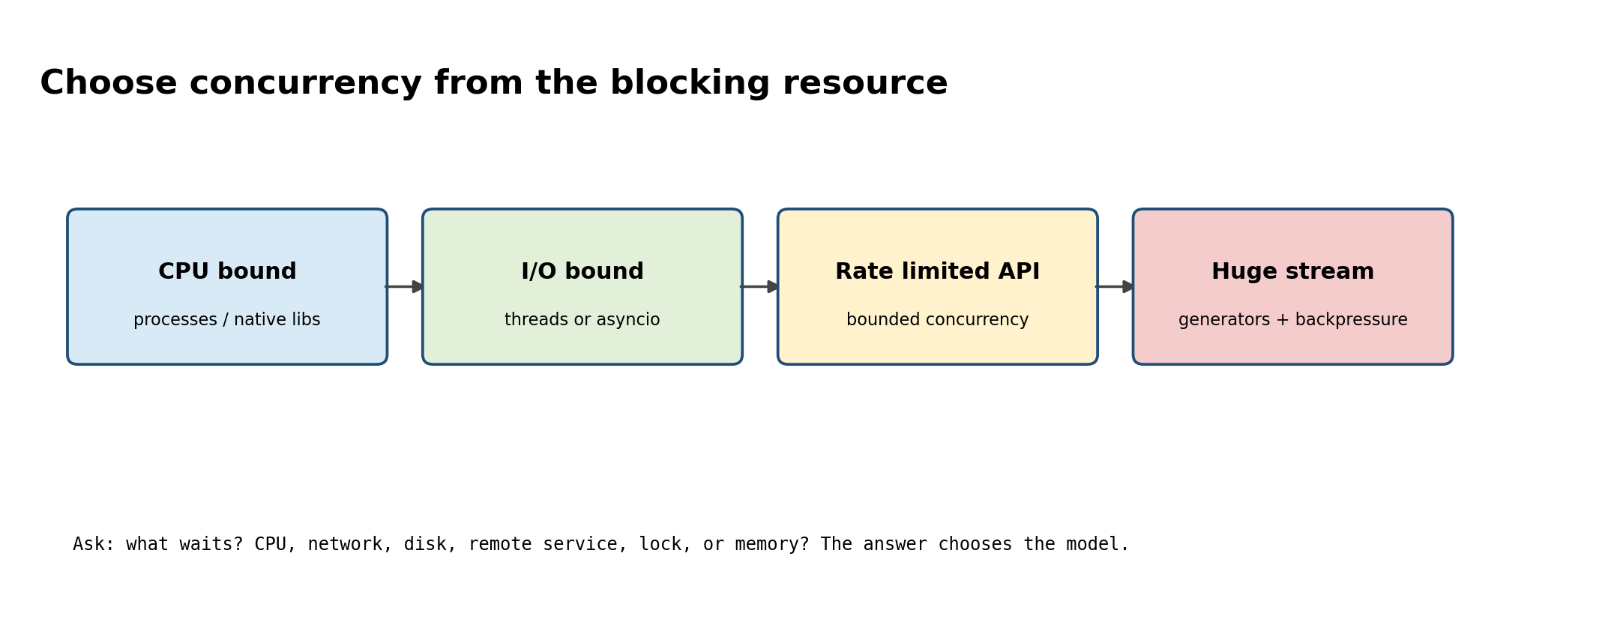
Figure B. Concurrency is chosen by the bottleneck, not because async is fashionable.
Remote APIs fail in several distinct ways: DNS/connect timeout, TLS failure, read timeout, 4xx client error, 429 rate limit, 5xx server error, truncated response, incompatible schema and success responses containing semantically invalid data. A retry policy must classify these failures. Retrying a validation error only amplifies load; retrying a non-idempotent POST can duplicate side effects.
Resilient GET client: bounded retries, timeout tuple and full jitter
from __future__ import annotations
import random, time
from dataclasses import dataclass
import requests

@dataclass(frozen=True)
class RetryPolicy:
attempts: int = 4
base_delay_s: float = 0.25
max_delay_s: float = 4.0

class JsonApi:
def __init__(self, base_url: str, token: str, policy: RetryPolicy):
self.base_url = base_url.rstrip("/")
self.policy = policy
self.session = requests.Session()
self.session.headers.update({"Authorization": f"Bearer {token}"})

def get(self, path: str) -> dict:
last_error: Exception | None = None
for attempt in range(self.policy.attempts):
try:
r = self.session.get(
self.base_url + path,
timeout=(2.0, 8.0),
)
if r.status_code == 429 or 500 <= r.status_code < 600:
raise requests.HTTPError(f"retryable {r.status_code}", response=r)
r.raise_for_status()
payload = r.json()
if not isinstance(payload, dict):
raise ValueError("expected JSON object")
return payload
except (requests.Timeout, requests.ConnectionError,
requests.HTTPError) as exc:
last_error = exc
if attempt == self.policy.attempts - 1:
break
cap = min(self.policy.max_delay_s,
self.policy.base_delay_s * 2**attempt)
time.sleep(random.uniform(0, cap))
raise RuntimeError("API request exhausted retries") from last_error

A senior engineer also thinks about budgets. If a CLI checks 500 nodes and each call can wait 8 seconds with four retries, the worst-case runtime is unacceptable. Bound concurrency, set a global deadline, cache immutable responses when appropriate, and expose retry counts and latency in logs/metrics.

Senior Deep Dive 4 — Async, threads and processes with backpressure
For infrastructure work, most concurrency is I/O concurrency: querying many APIs, reading many files or running remote checks. Threads are often the simplest option for blocking libraries; asyncio is powerful when the whole dependency chain is async; processes are appropriate for CPU-heavy pure Python work. The critical production feature is bounded concurrency. Launching 10,000 tasks simultaneously can exhaust file descriptors, memory or the remote service.
Bounded fan-out for infrastructure checks
from concurrent.futures import ThreadPoolExecutor, as_completed

def inspect_node(name: str) -> tuple[str, dict]:
# bounded network/subprocess checks live here
return name, {"ok": True}

nodes = [f"gpu-node-{i:03d}" for i in range(200)]
results: dict[str, dict] = {}
with ThreadPoolExecutor(max_workers=16) as pool:
futures = {pool.submit(inspect_node, n): n for n in nodes}
for future in as_completed(futures):
node = futures[future]
try:
name, report = future.result(timeout=20)
results[name] = report
except Exception as exc:
results[node] = {"ok": False, "error": str(exc)}

Senior Deep Dive 5 — Subprocess is a process API, not a shell shortcut
Use argument arrays, not shell strings, whenever possible. Decide whether stderr is evidence you need to preserve, enforce timeouts, capture exit status, and make command execution injectable so tests do not require real kubectl or nvidia-smi. shell=True is an explicit trust boundary because shell metacharacters become executable syntax.
Safe external command wrapper
from dataclasses import dataclass
import subprocess

@dataclass(frozen=True)
class CmdResult:
argv: tuple[str, ...]
rc: int
stdout: str
stderr: str

def run(argv: list[str], timeout_s: float = 10) -> CmdResult:
try:
cp = subprocess.run(
argv,
text=True,
capture_output=True,
timeout=timeout_s,
check=False,
)
except subprocess.TimeoutExpired as exc:
raise RuntimeError(f"timeout: {argv}") from exc
return CmdResult(tuple(argv), cp.returncode, cp.stdout, cp.stderr)

result = run(["nvidia-smi", "--query-gpu=index,uuid,temperature.gpu",
"--format=csv,noheader,nounits"])
if result.rc != 0:
raise RuntimeError(result.stderr.strip())

Senior Deep Dive 6 — Structured logs, metrics and correlation IDs
A production tool should explain what it did without a debugger. Log events, not prose. Include stable fields such as operation, cluster, namespace, node, attempt, elapsed_ms and correlation_id. Do not put secrets or high-cardinality unbounded payloads into metrics labels. Logs answer “what happened”; metrics answer “how often/how much”; traces answer “where time went”.
Minimal structured logger
import json, logging, time, uuid

class JsonFormatter(logging.Formatter):
def format(self, record: logging.LogRecord) -> str:
payload = {
"ts": time.time(),
"level": record.levelname,
"message": record.getMessage(),
"logger": record.name,
"correlation_id": getattr(record, "correlation_id", None),
"node": getattr(record, "node", None),
}
if record.exc_info:
payload["exception"] = self.formatException(record.exc_info)
return json.dumps(payload, separators=(",", ":"))

handler = logging.StreamHandler()
handler.setFormatter(JsonFormatter())
log = logging.getLogger("fleetcheck")
log.addHandler(handler); log.setLevel(logging.INFO)

cid = str(uuid.uuid4())
log.info("gpu check started", extra={"correlation_id": cid,
"node": "gpu-node-07"})

Senior Deep Dive 7 — Testing infrastructure code: isolate decisions from effects
The most valuable unit tests target decisions: classification, parsing, retry behavior, diff calculation, policy evaluation and output formatting. Effects—HTTP, Kubernetes API, subprocess, filesystem—should sit behind narrow interfaces. Then a test can replace the effect and assert the decision without needing a live cluster.
Test the policy, not requests itself
# retry.py
def should_retry(status: int | None, exc: Exception | None) -> bool:
if exc is not None:
return isinstance(exc, (TimeoutError, ConnectionError))
return status == 429 or (status is not None and 500 <= status < 600)

# test_retry.py
import pytest
from retry import should_retry

@pytest.mark.parametrize("status,expected", [
(200, False), (400, False), (404, False),
(429, True), (500, True), (503, True),
])
def test_status_classification(status, expected):
assert should_retry(status, None) is expected

For a Kubernetes or NVIDIA API wrapper, test parsing with recorded small fixtures; use integration tests against a disposable kind/minikube cluster for the wire contract; reserve end-to-end tests for a few critical workflows. A large suite of tests that all mock the implementation details is fragile and provides false confidence.

Senior Deep Dive 8 — Complete project: GPU fleet health CLI
Build one tool that combines the concepts: discover GPU nodes, query Kubernetes allocatable resources, run or consume GPU health telemetry, optionally query Prometheus, classify findings and produce both human and JSON output. The architecture below separates policy from transport so the same classifier can be used in a CLI, scheduled job or API service.
Recommended production package shape
# package layout
fleetcheck/
pyproject.toml
src/fleetcheck/
__init__.py
cli.py # argparse/click/typer boundary
model.py # dataclasses / enums
kubernetes.py # K8s API adapter
gpu.py # DCGM/nvidia-smi adapter
prometheus.py # metrics adapter
classify.py # pure health decisions
report.py # table/json output
tests/
test_classify.py
test_gpu_parser.py
test_retry.py

Keep health policy pure and explicit; UNKNOWN is not HEALTHY
from dataclasses import dataclass
from enum import StrEnum

class Health(StrEnum):
HEALTHY = "healthy"
DEGRADED = "degraded"
FAILED = "failed"
UNKNOWN = "unknown"

@dataclass(frozen=True)
class GpuSample:
uuid: str
temperature_c: int | None
power_w: float | None
xid_errors: int | None

def classify_gpu(s: GpuSample) -> Health:
if s.xid_errors is None or s.temperature_c is None:
return Health.UNKNOWN
if s.xid_errors > 0:
return Health.FAILED
if s.temperature_c >= 85:
return Health.DEGRADED
return Health.HEALTHY

Performance and profiling for operational Python
Do not optimize syntax before measuring. First identify whether time is spent in Python CPU, remote I/O, serialization, subprocess startup, regex, filesystem traversal or retries. cProfile gives function-level CPU time; tracemalloc helps find Python allocation growth; py-spy can sample a running process with low intrusion; line_profiler is useful for CPU-heavy functions. For large log/data processing, generators and streaming parsers reduce memory footprint more reliably than micro-optimizing loops.
Measure before optimizing
python -m cProfile -s cumulative -m fleetcheck.cli report
python -X tracemalloc=25 -m fleetcheck.cli report
# external sampler if available:
py-spy top --pid <PID>

Targeted references and reinforcement
Udemy — Python for DevOps: Mastering Real-World Automation: https://www.udemy.com/course/python-devops — Target lectures: Coding lazy pipelines (~18m38s); Structured logging with JSON (~11m29s); Introduction to subprocesses (~10m31s); Exponential backoff with jitter (~10m48s); TDD implementation (~20m17s); Mocking fundamentals (~8m17s).
Vishakha Sadhwani — scripts versus systems: https://www.linkedin.com/in/vsadhwani — Practitioner signal: production automation needs retries, timeouts, visibility, versioning and failure handling, not only task execution.
Python documentation: https://docs.python.org/3/ — Language/runtime authority for subprocess, logging, concurrency, typing, packaging and standard-library behavior.

