VOLUME 3
Kubernetes and Platform Engineering
Control loops, scheduling, networking, storage, security, scaling and platform operations
Fourth Edition - Teaching text with mechanisms, examples, visuals, scenarios and exercises
Independent study guide based on public documentation and public practitioner material. Not an NVIDIA publication.

Starting assumption
You already know kubectl, Deployments, Services and Helm. This volume focuses on internals, evidence and architectural trade-offs rather than beginner YAML.

Chapter 1 - API server, etcd and the object model
Learning outcome
Trace reads/writes, resourceVersion, watches and declarative desired state through the API control plane.
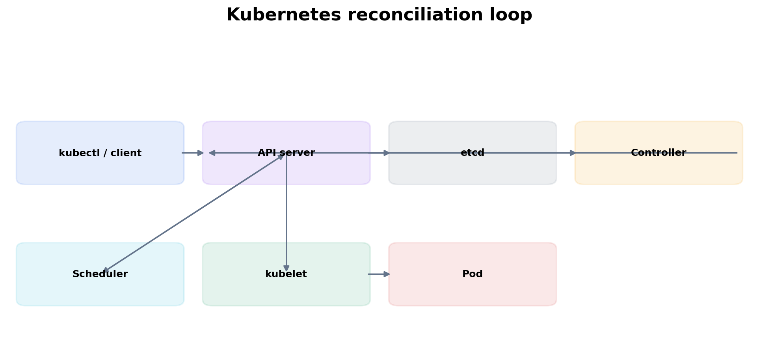
Figure 1. Kubernetes components coordinate through API objects and watch/reconcile behavior.

1.1 API objects are records of desired/observed state
A Kubernetes object contains spec-like desired configuration plus metadata; controllers and node agents update status/conditions to describe observed state. The API server authenticates, authorizes, admits and validates requests before persistence. Most components interact through the API rather than directly modifying etcd.
kubectl get deploy api -o yaml
kubectl get deploy api -o jsonpath='{.metadata.resourceVersion}{"\n"}'
kubectl get events --sort-by=.lastTimestamp

1.2 Watches and reconciliation
Controllers commonly watch API changes, enqueue work, compare desired and actual state, and issue idempotent API updates. Reconciliation is level-based: the controller should make progress toward the desired state even if it misses an individual event, because the current object state remains authoritative.

Worked scenario
Situation
A Deployment object exists with replicas=3 but no Pods appear.
1. Check Deployment conditions and whether a ReplicaSet exists. This asks whether the Deployment controller reconciled.
2. If no ReplicaSet exists, inspect controller-manager health/events/admission and selector/template validity.
3. If a ReplicaSet exists but no Pods exist, inspect ReplicaSet status/events and admission failures.
4. If Pods exist but are Pending, move to the scheduler branch rather than continuing controller logs.
Conclusion
Find which controller/agent should have produced the next object/action.

Chapter 2 - Scheduler mechanics, resources and topology
Learning outcome
Explain filter/score thinking, requests/allocatable, affinity, taints, topology and extended GPU resources.

2.1 Requests drive placement
The scheduler checks whether candidate nodes satisfy Pod requirements. Resource requests are reservation/accounting inputs for CPU and memory; limits primarily affect runtime enforcement. A node can be 20% utilized yet unable to fit a Pod because its unallocated requested capacity is insufficient.
kubectl describe pod <pending-pod>
kubectl get node <node> -o jsonpath='{.status.allocatable}'
kubectl describe node <node> | sed -n '/Allocated resources:/,$p'

2.2 Constraints: taints, affinity and topology
Taints repel Pods unless a matching toleration exists. Node affinity constrains or prefers labels. Pod affinity/anti-affinity considers co-location relative to other Pods and topology keys. Topology spread constraints express distribution. These rules can reduce the eligible node set to zero even when aggregate capacity exists.
kubectl get nodes --show-labels
kubectl describe node <node> | grep -A3 Taints
kubectl get pod <pod> -o yaml | sed -n '/affinity:/,/containers:/p'

2.3 Extended resources and GPUs
GPUs are typically advertised as extended resources by a device plugin. The scheduler allocates named resources; it does not infer GPU availability from nvidia-smi utilization. MIG can expose slice-specific resource names. Therefore low hardware utilization does not imply that the requested resource exists or is unallocated.

Worked scenario
Situation
A GPU Pod is Pending with Insufficient nvidia.com/gpu while several GPU nodes show low utilization.
1. Inspect Pod requests and Node allocatable/allocated nvidia.com/gpu resources.
2. Check labels, taints/tolerations, affinity and topology restrictions.
3. Verify the NVIDIA device plugin is healthy and advertising the expected resource.
4. If MIG is configured, confirm the workload requests the correct advertised MIG resource name.
5. Check cluster autoscaler/NAP limits, quotas and compatible node pool availability.
Conclusion
Scheduling evidence is allocation + constraints. Utilization belongs to a later runtime/performance question.

Chapter 3 - Kubelet, CRI and Pod lifecycle
Learning outcome
Understand how an assigned Pod becomes namespaces, cgroups, volumes, network setup and running containers on a node.
The kubelet watches Pods assigned to its node, manages volumes/secrets/config, asks the container runtime through CRI to create sandboxes/containers, and reports status back to the API. CNI plugins handle network setup through the runtime integration path; CSI handles storage interactions. A Pod can therefore be scheduled correctly but fail during node-local preparation.
kubectl describe pod <pod>
kubectl get pod <pod> -o jsonpath='{.status.containerStatuses[*].state}'
journalctl -u kubelet --since '-20 min'
crictl ps -a
crictl inspectp <sandbox-id>
Symptom | Likely stage
Pending, no nodeName | scheduler / admission / PVC binding
nodeName set, ContainerCreating | kubelet: image, CNI, CSI, mounts, sandbox
ImagePullBackOff | registry/auth/image pull
CrashLoopBackOff | container starts then exits repeatedly
Running but NotReady | readiness/dependency/application health

Chapter 4 - Kubernetes networking from Service to CNI
Learning outcome
Trace DNS, Service selection, data plane implementation, CNI routing and NetworkPolicy.
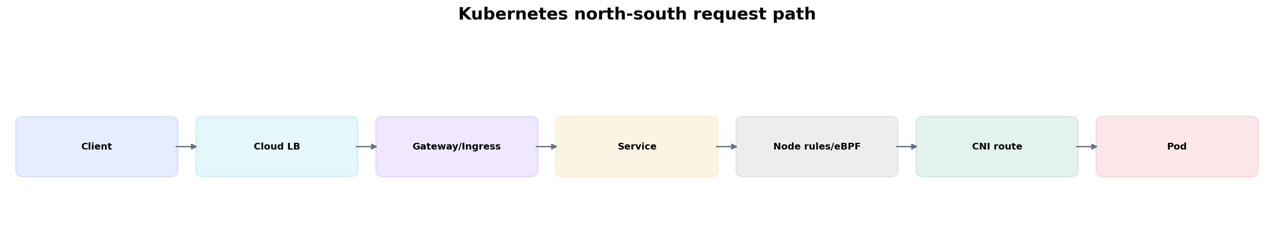
Figure 2. North-south traffic crosses distinct components; prove each stage rather than restarting random Pods.

4.1 Service and EndpointSlice
A Service selects backend endpoints, typically represented through EndpointSlices. If a Service has no endpoints, kube-proxy/eBPF rules cannot send traffic to healthy Pods. Check selectors and readiness before debugging lower networking layers.
kubectl get svc api -o yaml
kubectl get endpointslice -l kubernetes.io/service-name=api -o wide
kubectl get pods -l app=api -o wide --show-labels

4.2 Data plane implementation
Depending on the cluster, Service forwarding may be implemented with iptables, IPVS or eBPF. The conceptual contract is stable: virtual Service address maps to eligible endpoints. Your troubleshooting commands should match the implementation rather than memorizing iptables for every environment.

4.3 DNS, CNI and policy
CoreDNS resolves cluster/service names; the CNI provides Pod interfaces/IP allocation/routing; NetworkPolicy is enforced by capable CNIs. For east-west timeouts, verify name resolution, EndpointSlice, routing and policy independently.
kubectl exec -it <pod> -- getent hosts api.default.svc.cluster.local
kubectl exec -it <pod> -- curl -sv http://api:8080/health
kubectl get networkpolicy -A
kubectl -n kube-system get pods -l k8s-app=kube-dns

Practitioner lens
Vishakha Sadhwani: understand the traffic path
Her public networking breakdown follows client -> LB -> Gateway/Ingress -> Service -> node rules/eBPF -> CNI -> Pod and an east-west path with CoreDNS and NetworkPolicy. This chapter uses the same path, then teaches what each component contributes and how to prove it.
Public source

Worked scenario
Situation
Service DNS resolves, but requests from one namespace time out while another namespace works.
1. Compare EndpointSlices: the backend set is common, so namespace-specific failure points toward source policy/path.
2. Inspect NetworkPolicies affecting source and destination namespaces and confirm CNI enforcement semantics.
3. From both namespaces, compare route/connect behavior to Service and direct Pod IP if policy permits testing.
4. Inspect service mesh/sidecar policy if present because mTLS/authz can introduce namespace-specific behavior.
5. Use packet/eBPF observability on nodes only after object-level policy and endpoint evidence is collected.
Conclusion
The differential clue—one namespace works—narrows the search toward source identity/policy rather than backend availability.

Chapter 5 - Storage and StatefulSets
Learning outcome
Understand CSI provisioning/attach/mount, PVC binding modes, topology and StatefulSet identity.
CSI separates storage control-plane operations from Kubernetes core. A StorageClass can dynamically provision a PV for a PVC. WaitForFirstConsumer binding can delay provisioning/binding until Pod scheduling reveals topology. Attach/mount occurs later on the selected node. Distinguish these phases.
kubectl get pvc,pv -o wide
kubectl describe pvc <claim>
kubectl describe pod <pod> | sed -n '/Events:/,$p'
kubectl get storageclass -o yaml

Worked scenario
Situation
A StatefulSet Pod stays Pending after a zone outage.
1. Inspect PVC/PV topology and node affinity on the volume.
2. Check whether the volume can attach in another zone or is intrinsically zonal.
3. Review StorageClass replication/failure-domain behavior and StatefulSet disruption expectations.
4. Do not delete claims blindly; stateful recovery must preserve data semantics.
Conclusion
Stateful scheduling is constrained by both compute and data locality/failure-domain design.

Chapter 6 - Security: authentication, RBAC, workload identity and Pod hardening
Learning outcome
Reason about who can call the API, what they can do, how workloads obtain cloud identity and how container privileges change risk.

6.1 RBAC is authorization over API verbs/resources
kubectl auth can-i get secrets --as=system:serviceaccount:team-a:app -n team-a
kubectl auth can-i --list --as=system:serviceaccount:team-a:app -n team-a
A ServiceAccount identifies a Kubernetes workload to the API. Cloud workload identity mechanisms can map workload identity to cloud IAM without static keys. Keep these trust domains conceptually separate: Kubernetes RBAC authorizes Kubernetes API actions; cloud IAM authorizes cloud APIs.

6.2 Pod security context
securityContext:
runAsNonRoot: true
allowPrivilegeEscalation: false
readOnlyRootFilesystem: true
capabilities:
drop: ["ALL"]
Security settings should derive from workload need. Privileged mode, hostPath, hostNetwork and broad capabilities collapse isolation boundaries. In GPU/HPC environments, device and network access requirements make explicit privilege design especially important.

Chapter 7 - Autoscaling and capacity
Learning outcome
Understand HPA/VPA/KEDA signals, cluster autoscaler constraints and why application scaling and node scaling are different loops.
HPA adjusts workload replicas based on metrics; KEDA can translate event/external metrics; VPA recommends or adjusts resource requests depending on mode; cluster autoscaler changes node count when Pods are unschedulable due to capacity and an eligible node group can help. These loops interact through requests and scheduling.
kubectl get hpa -A
kubectl describe hpa <name>
kubectl get events --field-selector reason=FailedScheduling

Worked scenario
Situation
HPA increases replicas from 5 to 20, but 12 Pods remain Pending and cluster autoscaler does not add nodes.
1. Read FailedScheduling reasons. Autoscaler only helps if a node group expansion could make the Pod schedulable.
2. Check node-group max size and cluster resource limits/quotas.
3. Check affinity/taints/topology/PVC/GPU constraints that a new generic node would not solve.
4. Check autoscaler logs/events for “max limit reached” or “no expansion options.”
5. Review whether the HPA metric and resource requests produce a feasible scaling model.
Conclusion
Application autoscaling can create desired Pods that capacity/autoscaler constraints cannot satisfy.

Chapter 8 - Operators, GitOps and platform engineering
Learning outcome
Use reconciliation to package domain operations and expose safe self-service without hiding operational truth.
A CRD defines new API types; a controller reconciles them. The operator pattern is valuable when lifecycle logic belongs with a domain resource. GitOps uses a similar desired-state idea for cluster configuration: Git records desired configuration and a controller pulls/reconciles it. The value is auditability, drift detection and controlled automation—not simply “store YAML in Git.”
# Useful Flux-style evidence
flux get kustomizations -A
flux get helmreleases -A
kubectl describe helmrelease <name> -n <ns>
Platform engineering adds product thinking: create paved roads that encode security, observability, ownership and lifecycle defaults while allowing escape hatches for workloads that need specialized GPU, network or storage behavior.

Practitioner lens
Vishakha Sadhwani: learn the platform structurally
Her “11 practical steps” Kubernetes post moves from foundations through workloads, storage/config, networking/security, autoscaling/resources, operators, AI/ML, observability, GitOps and production concepts. This volume turns those layers into mechanisms and troubleshooting paths.
Public source

Chapter 9 - Upgrades, reliability and cluster operations
Learning outcome
Plan control-plane/node changes around skew, disruption budgets, workload topology and rollback evidence.
Kubernetes upgrades are distributed-system changes. Managed services hide some control-plane work but not workload disruption, node image/driver compatibility, admission changes, deprecated APIs or GPU/operator compatibility. Inventory versions and APIs before change, define surge/drain strategy, and measure workload health during rollout.
kubectl get pdb -A
kubectl get nodes -o wide
kubectl api-resources
kubectl get --raw /readyz?verbose

Practice
1. For a Pending Pod, write a decision tree that starts from Events and ends at the exact violated constraint.
2. Trace a Service request and name one artifact/evidence at each step.
3. Explain HPA vs cluster autoscaler to a customer using two separate control loops.
4. Design a GitOps rollback that preserves audit trail and explain when an emergency imperative change may still be justified.

Targeted references
Kubernetes documentation - Primary API, scheduling, networking, storage, security and operations reference.
NVIDIA Kubernetes technical blog - Current GPU Kubernetes operations, Slurm integration, observability and inference patterns.
Vishakha Sadhwani public profile/posts - Practitioner signals for platform/networking/GitOps/AI-infra learning paths.

FOURTH EDITION — SENIOR ENGINEERING EXPANSION · VOLUME 3

Kubernetes internals, production operations and GPU-aware platform engineering
This expansion keeps the Fourth Edition teaching flow and adds the depth expected from a senior infrastructure engineer and customer-facing Solutions Architect. The emphasis is mechanism first: understand what the system is doing, observe it with concrete tools, then reason about failure, scale, reliability, performance and trade-offs.
The practitioner material used to shape the scope is a signal, not an authority. Technical behavior is anchored in official documentation and first-principles systems reasoning. Your Staff Engineer study guide contributes useful patterns around Kubernetes, observability, distributed systems, platform design and failure isolation; the NVIDIA material adds GPU systems, AI workloads, accelerated networking and customer architecture.
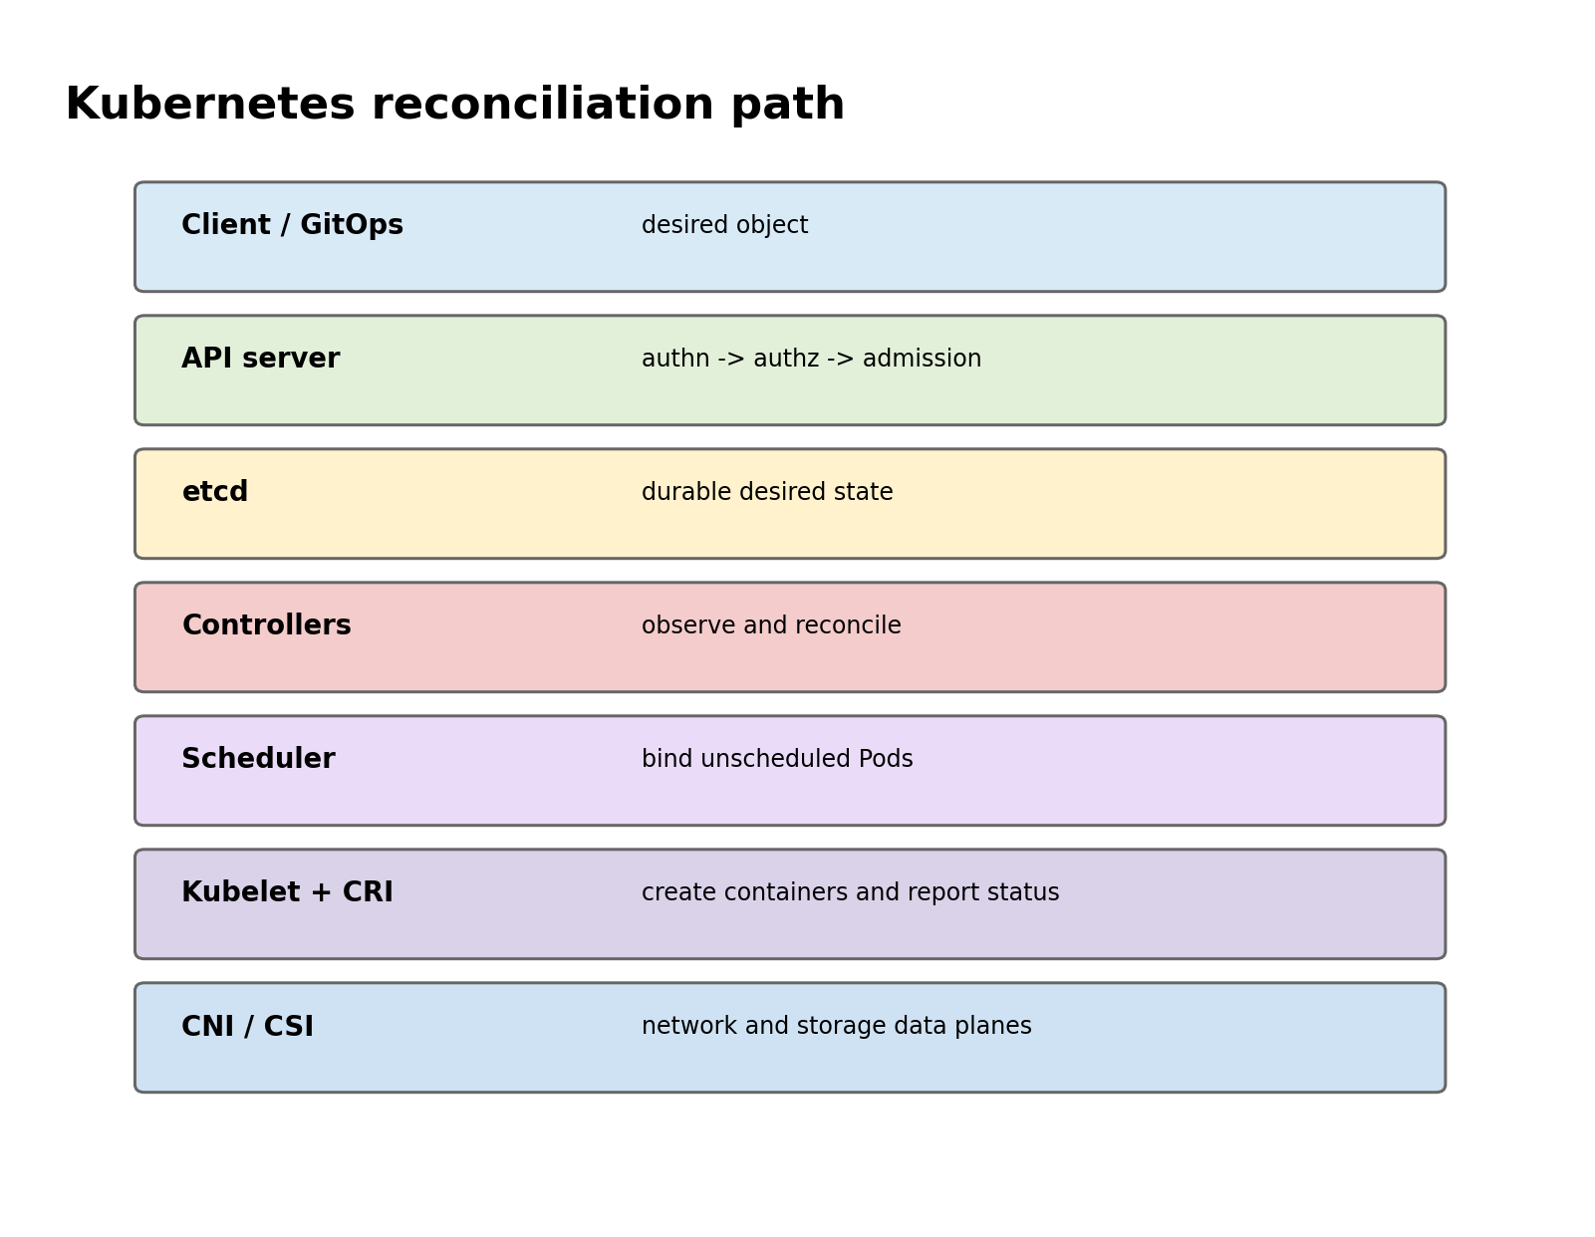
Figure A. Most Kubernetes behavior is an API-state transition followed by one or more reconcilers.

Senior Deep Dive 1 — API machinery: resourceVersion, watches, finalizers and ownership
The API server is not only a REST endpoint. It provides optimistic concurrency, versioned storage, watch streams and admission. Controllers list objects, establish a resourceVersion, watch changes and reconcile. Clients must expect watch closure, relist, retries and conflicts. This is why a reliable controller is idempotent and why “event received” is not equivalent to “state changed successfully”.
Finalizers turn deletion into a two-phase operation. A delete request sets deletionTimestamp; controllers that own finalizers perform cleanup and remove their keys; only then can the object disappear. OwnerReferences drive garbage collection. When a namespace or custom resource is stuck Terminating, inspect finalizers and the controller responsible rather than force-deleting first.
Inspect API state before guessing
kubectl get pod mypod -o json | jq '.metadata.resourceVersion,.metadata.finalizers,.metadata.ownerReferences'
kubectl get --raw '/apis/apps/v1/namespaces/default/deployments?limit=5'
kubectl get events --sort-by=.lastTimestamp

Senior Deep Dive 2 — etcd quorum, control-plane failure and recovery boundaries
etcd provides strongly consistent storage using quorum. A three-member cluster tolerates one member failure; a five-member cluster tolerates two, at greater write coordination cost. Losing quorum is different from losing one API server. Running workloads can continue when the control plane is unavailable, but new scheduling, reconciliation and API-driven changes stop progressing.
Symptom | Control-plane hypothesis | Evidence
kubectl times out, Pods keep serving | API/LB/control plane unavailable | API health, apiserver logs, LB endpoints
Reads work, writes stall | etcd latency/quorum or admission dependency | etcd metrics, apiserver request latency
Objects revert or controllers flap | multiple reconcilers or bad desired state | managedFields, events, GitOps/controller logs
Namespace stuck deleting | finalizer/controller unavailable | namespace conditions, finalizers, APIService health

Senior Deep Dive 3 — Scheduling framework, preemption, gang/topology and DRA
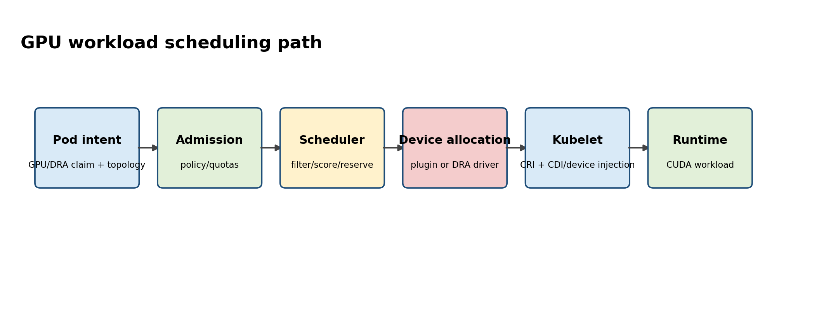
Figure B. Specialized hardware placement is a multi-stage scheduling and allocation problem.
The scheduler first establishes feasible nodes, then scores them. Requests, node selectors/affinity, taints, topology spread, inter-pod affinity, storage constraints and plugin-specific resources all participate. Priority affects queue order and can trigger preemption, but preemption is not a general capacity-management strategy; PodDisruptionBudgets and topology constraints can prevent the expected victim set from making the Pod schedulable.
Dynamic Resource Allocation (DRA) is now a key concept for accelerators. Core DRA APIs graduated to GA in Kubernetes 1.34. Instead of expressing only an integer extended resource, workloads can request devices through structured resource claims and device classes, enabling richer matching and allocation semantics for GPUs and other hardware. A senior GPU-platform engineer should understand both the traditional device-plugin path and DRA because clusters will contain both during transition periods.
Scheduling: prove which constraint eliminates nodes
# Scheduling evidence for a Pending Pod
kubectl describe pod <pod>
kubectl get pod <pod> -o json | jq '.status.conditions,.spec.priorityClassName'
kubectl get nodes -o custom-columns=NAME:.metadata.name,GPU:.status.allocatable.nvidia\.com/gpu
kubectl get events --field-selector involvedObject.name=<pod> --sort-by=.lastTimestamp

# DRA resources on clusters that support them
kubectl api-resources | grep -Ei 'resourceclaim|deviceclass'

Senior Deep Dive 4 — Kubelet, CRI, pod sandbox and node pressure
The kubelet is the node control agent. It watches desired Pods for its node, asks the container runtime through CRI to create sandboxes and containers, mounts volumes, executes probes and reports status. A Running Pod therefore depends on kubelet health, runtime health, storage/network plugins and host resources. When the node is unhealthy, Kubernetes status is only one layer of evidence; systemd, journalctl, crictl and kernel logs become first-class tools.
Node-level evidence
systemctl status kubelet containerd
journalctl -u kubelet -S -30m
crictl pods
crictl ps -a
crictl inspectp <pod-sandbox-id>
cat /proc/pressure/{cpu,memory,io}

Node-pressure eviction is not the same as scheduler preemption. The kubelet can evict Pods when memory, disk or inode thresholds are breached. QoS class, usage relative to requests and Pod priority influence victim selection. For GPU nodes, a tiny root filesystem or image filesystem can evict expensive workloads even when GPU memory and compute are healthy.

Senior Deep Dive 5 — Networking: Service abstraction, CNI dataplane, DNS and Gateway API
Trace north-south and east-west traffic explicitly. A Service is an API abstraction over endpoints; implementation may use iptables, IPVS or eBPF depending on the dataplane. CNI configures Pod interfaces and routing; CoreDNS implements service discovery; NetworkPolicy is enforced by the chosen network plugin. A service-mesh proxy adds another hop and another failure domain.
Network triage follows the actual packet path
# Service -> EndpointSlice -> Pod
kubectl get svc mysvc -o yaml
kubectl get endpointslice -l kubernetes.io/service-name=mysvc -o yaml
kubectl get pod -l app=myapp -o wide

# DNS from inside the workload namespace
kubectl exec deploy/client -- cat /etc/resolv.conf
kubectl exec deploy/client -- getent hosts mysvc.default.svc.cluster.local

# Node dataplane - varies by CNI/proxy implementation
ip route
ip neigh
nft list ruleset | head -100

Gateway API is replacing many ad-hoc Ingress patterns with a more expressive role-oriented model. AI inference adds model-aware routing concerns such as cache locality, request criticality and token-aware metrics; the Gateway API Inference Extension exists because ordinary HTTP round-robin is often insufficient for long-running, stateful-ish LLM serving requests.

Senior Deep Dive 6 — Admission, policy and multi-tenant guardrails
Authentication answers who; authorization answers whether that identity may perform an API verb; admission can mutate or validate the object after authorization and before persistence. Pod Security Admission enforces Pod Security Standards at namespace boundaries. ValidatingAdmissionPolicy provides in-process CEL policy and is a strong choice for deterministic validation without webhook availability risk. Webhooks remain useful for integrations and mutations but they extend the control-plane failure path.
Policy evidence
# Can this identity perform the action?
kubectl auth can-i create pods --as=system:serviceaccount:team-a:builder -n team-a

# Namespace Pod Security Admission example
kubectl label ns team-a pod-security.kubernetes.io/enforce=restricted

# Inspect admission webhooks and policies
kubectl get validatingwebhookconfigurations,mutatingwebhookconfigurations
kubectl get validatingadmissionpolicies,validatingadmissionpolicybindings

Senior Deep Dive 7 — Platform patterns from the Staff Engineer guide
Several microservice patterns in your Staff Engineer guide become platform requirements when operated at scale. Circuit breakers protect dependencies but can hide sustained failure if telemetry is weak. Bulkheads isolate queues, worker pools or tenants. Sidecars move cross-cutting behavior next to the workload at the cost of resource and lifecycle complexity. Externalized configuration enables safe promotion. Event-driven systems decouple producers but introduce ordering, lag and replay semantics.
Pattern | Platform implementation question | Failure to design for
Gateway | Where are auth, rate limit, retries and routing owned? | duplicate policy, retry storms
Circuit breaker | Who emits breaker state and dependency health? | silent partial outage
Bulkhead | What is the isolation unit: tenant, queue, node pool, GPU pool? | one workload exhausts shared capacity
Sidecar | Does helper lifecycle match the app and resource budget? | proxy/log agent breaks readiness or capacity
Event-driven | What are ordering, idempotency and replay contracts? | duplicate effects, unbounded consumer lag

Senior Deep Dive 8 — GPU platform operations: node pools, operators and resource isolation
GPU Kubernetes clusters require a node lifecycle that coordinates host drivers, container runtime integration, device discovery, metrics, MIG configuration and workload disruption. The NVIDIA GPU Operator automates much of that dependency graph, but an operator is not magic: inspect its ClusterPolicy, operands, DaemonSets, node labels and reconciliation status when devices disappear.
Treat GPU pools as scarce stateful capacity even when applications are stateless. Rollouts, node upgrades, MIG reconfiguration and driver changes can drain many expensive jobs. Plan disruption budgets at workload and capacity level, stage upgrades on representative hardware, and validate a known-good CUDA workload plus telemetry before returning a node to service.

Targeted references and reinforcement
NVIDIA Solutions Architect, DevOps job listing — Germany: https://de.linkedin.com/jobs/view/solutions-architect-devops-at-nvidia-4424636420 — Role signal: Kubernetes AI/ML workloads, Linux/storage, Python/Bash, IaC, observability and customer architecture.
Kubernetes DRA: https://kubernetes.io/blog/2025/09/01/kubernetes-v1-34-dra-updates/ — Core Dynamic Resource Allocation APIs graduated to GA in Kubernetes 1.34.
Udemy — Kubernetes Troubleshooting: Real-World Production Fixes: https://www.udemy.com/course/kubernetes-troubleshooting — Target lectures: CrashLoopBackOff (~12m31s), Pending Pods (~8m05s), DNS failures (~7m19s), NetworkPolicy (~6m47s), eviction (~7m41s), HPA troubleshooting (~18m18s), RBAC (~11m32s).
Vishakha Sadhwani — Kubernetes networking: https://www.linkedin.com/in/vsadhwani — Practitioner signal: understand traffic flow, CNI, Services, CoreDNS and Linux dataplane instead of treating networking as abstraction magic.

