VOLUME 4
GPU and Accelerated Computing Foundations
Hardware, memory paths, drivers, CUDA, operators, sharing and operational health
Fourth Edition - Teaching text with mechanisms, examples, visuals, scenarios and exercises
Independent study guide based on public documentation and public practitioner material. Not an NVIDIA publication.

Chapter 1 - GPU execution and memory mental model
Learning outcome
Explain why GPUs favor throughput parallelism and how compute, HBM bandwidth and data movement become separate bottlenecks.
CPUs optimize low-latency general-purpose execution with sophisticated control flow and relatively few powerful cores. GPUs dedicate much more silicon to parallel execution and memory throughput. For infrastructure work, you do not need to write CUDA kernels to reason about the system, but you must distinguish compute occupancy from memory bandwidth, device memory capacity and host/device transfer costs.
Resource | Question
Compute/SMs | Are execution units busy doing useful kernels?
HBM capacity | Does the model/batch/KV cache fit?
HBM bandwidth | Is performance limited by moving data inside device memory?
PCIe/NVLink | Is inter-device/host-device transfer the bottleneck?
NIC/fabric | Are distributed collectives/network transfers limiting scale?

1.1 Utilization is not a complete performance model
A GPU can report high utilization while throughput is poor because the active kernel is inefficient, memory-bound, serialized by communication, or serving tiny batches with poor economics. Conversely, an interactive low-latency service may intentionally keep headroom. Always pair device metrics with workload outcomes such as samples/s, tokens/s, TTFT, step time or queue delay.
First host-level orientation
nvidia-smi
nvidia-smi dmon -s pucvmet
nvidia-smi topo -m

Chapter 2 - PCIe, NVLink and topology
Learning outcome
Understand why “same number of GPUs” can produce different performance depending on physical connectivity and NUMA placement.
GPUs connect to CPUs and sometimes to peer GPUs through PCIe and higher-bandwidth links such as NVLink/NVSwitch on supported systems. NICs also attach through PCIe topology. Distributed and multi-GPU performance can depend on whether GPU-GPU or GPU-NIC traffic traverses favorable paths or crosses CPU/NUMA boundaries.
nvidia-smi topo -m
lspci -tv
numactl --hardware

Worked scenario
Situation
Two 8-GPU servers have identical GPU models, but one is consistently slower for multi-GPU training.
1. Compare nvidia-smi topo -m and NIC/GPU placement rather than assuming equivalent topology.
2. Check CPU NUMA binding and whether workers/communication threads align with local GPUs/NICs.
3. Check link width/speed/errors and firmware/driver consistency.
4. Benchmark peer-to-peer and collective performance before blaming the framework.
Conclusion
GPU count is a capacity number; topology is a performance property.

Chapter 3 - Driver, CUDA runtime and container stack
Learning outcome
Know which layer must be compatible and which parts are host versus container responsibility.
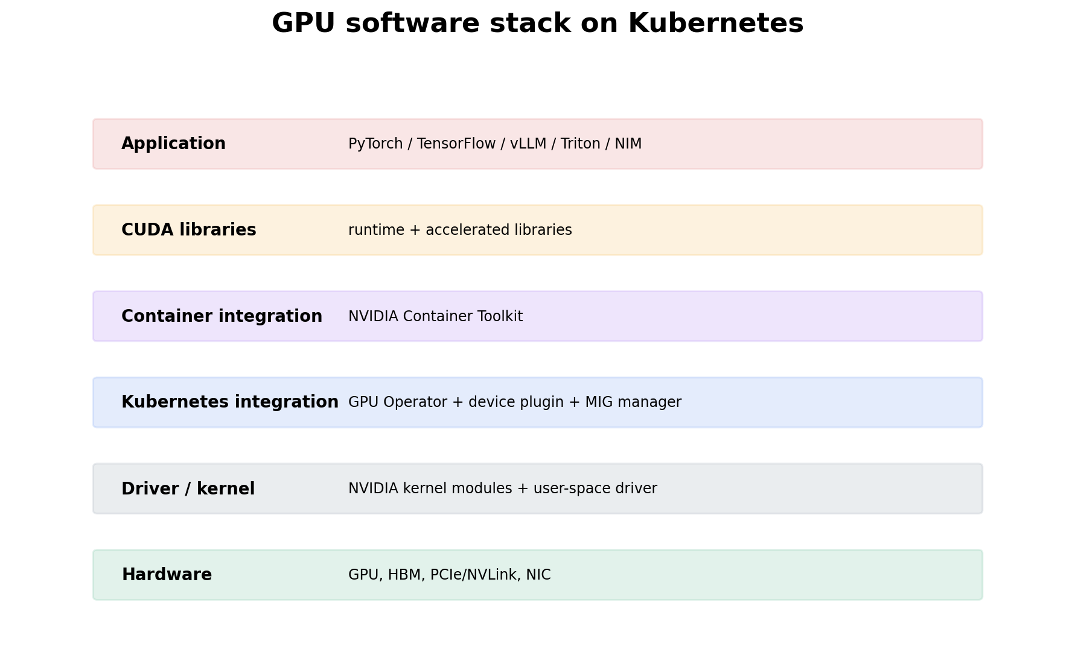
Figure 1. Debug bottom-up: hardware/driver before container runtime, operator, model server and application.
The kernel/user-space NVIDIA driver enables device access. CUDA provides a programming/runtime ecosystem and accelerated libraries. Application containers typically carry compatible user-space libraries while relying on the host driver. NVIDIA Container Toolkit configures container runtime integration so containers receive GPU devices and driver libraries.
nvidia-smi
cat /proc/driver/nvidia/version
docker run --rm --gpus all nvidia/cuda:12.8.0-base-ubuntu24.04 nvidia-smi
Do not diagnose “CUDA mismatch” from one version string alone. Compatibility has direction and constraints: application/runtime libraries, container image, host driver, framework build and GPU architecture all participate. Use the compatibility matrix/documentation for the versions in question.

Chapter 4 - Kubernetes device plugins and GPU Operator
Learning outcome
Trace how hardware becomes an allocatable Kubernetes extended resource and how operator lifecycle automation fits around it.
Kubernetes device plugins advertise specialized devices to kubelet; the Node status then exposes allocatable extended resources. GPU Operator automates GPU-node software such as drivers, container toolkit integration, device plugin, telemetry and MIG-related components depending on configuration. It is lifecycle automation around the node stack; scheduling still follows Kubernetes resource requests.
kubectl get nodes -o jsonpath='{range .items[*]}{.metadata.name}{" "}{.status.allocatable.nvidia\.com/gpu}{"\n"}{end}'
kubectl -n gpu-operator get pods -o wide
kubectl describe node <gpu-node> | grep -A10 -i nvidia

Worked scenario
Situation
nvidia-smi works on a node, but Kubernetes does not show nvidia.com/gpu.
1. Host hardware/driver is partially proven by nvidia-smi; move upward.
2. Check container-toolkit/runtime configuration and GPU Operator validation/components.
3. Check the device-plugin Pod logs/health on that node.
4. Inspect Node allocatable/resources and feature labels.
5. If MIG mode is active, verify what resource names/strategies are intentionally advertised.
Conclusion
Host driver success does not prove the Kubernetes device-advertisement layer.

Chapter 5 - GPU sharing: MIG, time slicing, MPS and vGPU
Learning outcome
Choose sharing based on isolation, latency determinism, memory behavior, hardware support and operational model.
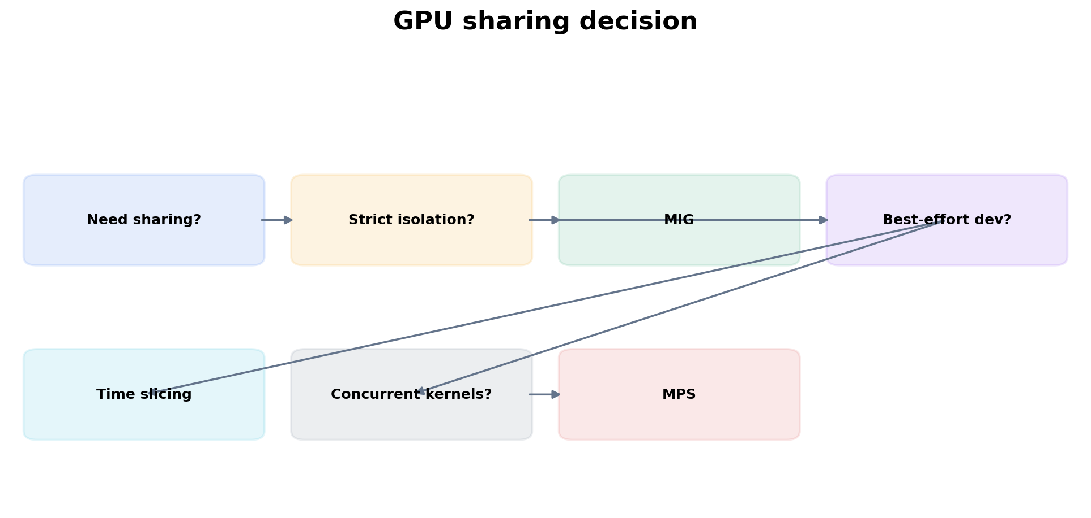
Figure 2. Decide from workload requirements; sharing mode is the consequence.
Mode | Strength | Trade-off
MIG | hardware-partitioned isolation on supported GPUs | fixed slice geometries; workload must fit slice; supported hardware only
Time slicing | simple over-subscription / improved dev utilization | shared memory/resources; variable latency; no hard slice isolation
MPS | concurrent CUDA process execution / throughput | different isolation semantics; CUDA workload compatibility/operations
vGPU | virtualization/VM-oriented resource sharing | licensing and hypervisor/virtualization operational model

Practitioner lens
Sagar Desai: hollow GPUs are a workload-packing problem
A public example compares sharing strategies for an LLM plus smaller ASR/TTS services and argues for hardware partitioning when predictable isolation and consolidation are both required. The important method is to measure workload footprint/latency sensitivity before choosing the sharing primitive.
Public source

Chapter 6 - GPU telemetry, DCGM and health
Learning outcome
Interpret hardware telemetry in the context of workload performance and distinguish demand, health and throttling.
DCGM provides health/telemetry/diagnostic capabilities for NVIDIA GPUs in data-center environments, and dcgm-exporter exposes metrics to Prometheus. Typical operational dimensions include utilization, framebuffer memory use, temperature, power, clocks and error/health counters. Device metrics need ownership labels so you can map them to node, Pod, namespace and workload.
# Prometheus-style examples vary by exporter version/config
DCGM_FI_DEV_GPU_UTIL
DCGM_FI_DEV_FB_USED
DCGM_FI_DEV_FB_FREE
DCGM_FI_DEV_POWER_USAGE
Autoscaling is a separate concern: device utilization helps explain hardware state, but inference demand may be better represented by request concurrency, queue delay, TTFT, throughput or tokens/s depending on the server.

Chapter 7 - Capacity and failure-domain design
Learning outcome
Plan GPU pools around workload shape, topology, maintenance, spare capacity and heterogeneous generations.
GPU capacity planning should account for usable memory per workload, sharing mode, target throughput/latency, topology, driver/image compatibility, node boot/provisioning time, maintenance and failure reserve. A “64 GPU cluster” tells you little about whether those GPUs are eight 8-GPU nodes with fast fabric or 64 isolated single-GPU nodes.

Worked scenario
Situation
A customer wants 95% average GPU utilization across production inference.
1. Ask whether the SLO is latency, throughput, cost per token, or utilization itself. Utilization is usually an efficiency signal, not the business outcome.
2. Measure queueing and latency as concurrency rises; identify the safe saturation point.
3. Reserve failure/traffic headroom if the service has an availability SLO.
4. Evaluate batching/sharing/model optimization before simply reducing replicas.
5. Define utilization targets by workload class rather than one fleet-wide percentage.
Conclusion
Optimize customer outcomes and unit economics, not a vanity utilization percentage.

Practice
1. Draw the software path from a PyTorch container to the physical GPU.
2. Explain why GPU Operator and device plugin are related but not the same component.
3. Choose MIG versus time slicing for dev notebooks, latency-sensitive voice inference, and a full-GPU training job.
4. Create a metric set that distinguishes GPU health from inference saturation.

Targeted references
NVIDIA GPU Operator docs - Current component, install, MIG and troubleshooting details.
NVIDIA DCGM - GPU management/monitoring foundation.
Monitoring GPUs in Kubernetes with DCGM - Kubernetes + exporter + Prometheus/Grafana flow.

FOURTH EDITION — SENIOR ENGINEERING EXPANSION · VOLUME 4

GPU systems, lifecycle management and accelerated compute operations
This expansion keeps the Fourth Edition teaching flow and adds the depth expected from a senior infrastructure engineer and customer-facing Solutions Architect. The emphasis is mechanism first: understand what the system is doing, observe it with concrete tools, then reason about failure, scale, reliability, performance and trade-offs.
The practitioner material used to shape the scope is a signal, not an authority. Technical behavior is anchored in official documentation and first-principles systems reasoning. Your Staff Engineer study guide contributes useful patterns around Kubernetes, observability, distributed systems, platform design and failure isolation; the NVIDIA material adds GPU systems, AI workloads, accelerated networking and customer architecture.
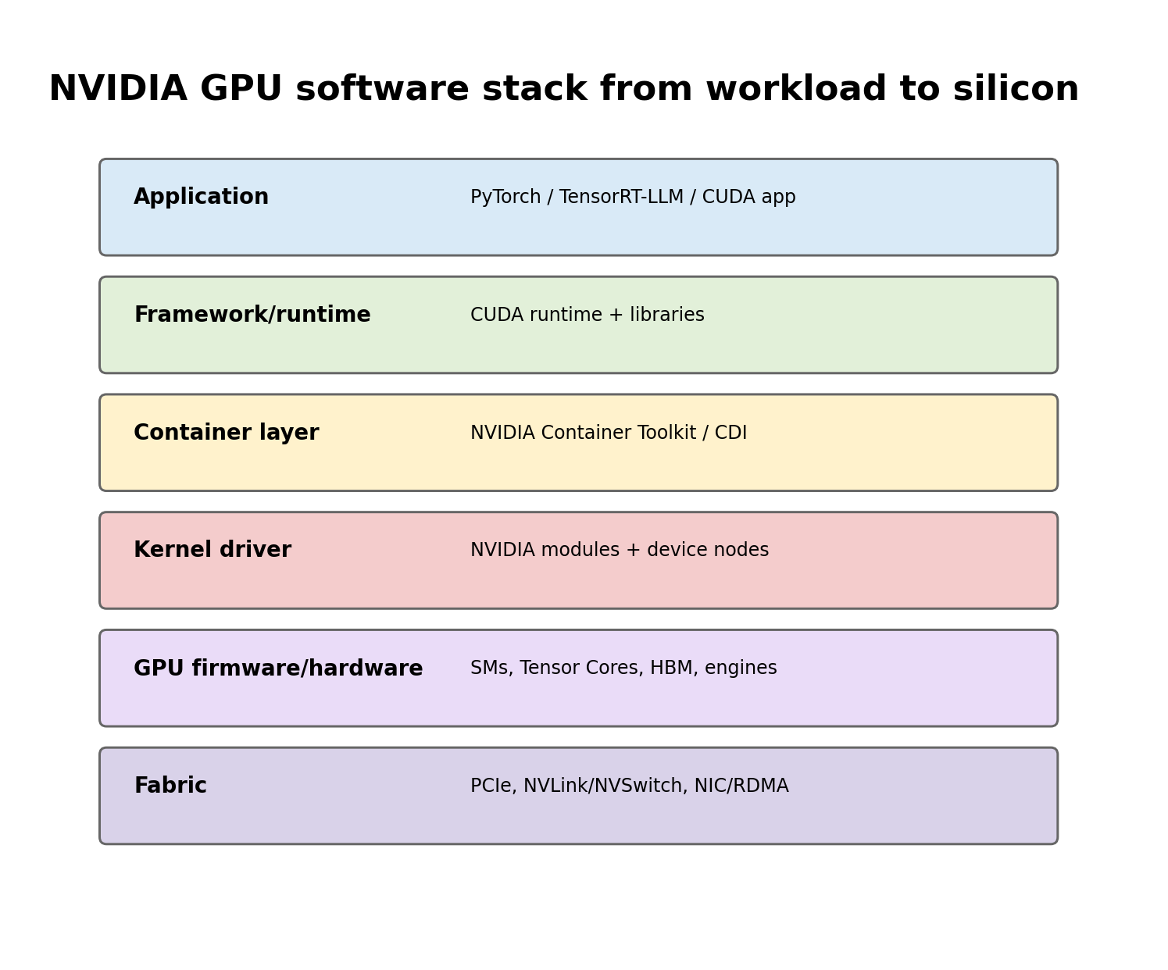
Figure A. GPU problems can originate in application, runtime, container integration, driver, silicon or fabric.

Senior Deep Dive 1 — GPU execution model without CUDA-programming overload
A GPU is built to execute large amounts of parallel work. Streaming multiprocessors schedule warps of threads; Tensor Cores accelerate matrix operations used heavily by deep learning; HBM provides very high bandwidth but finite capacity. Workloads can be compute-bound, memory-bandwidth-bound, latency-bound, launch-bound or communication-bound. “GPU utilization 100%” does not identify which resource is limiting useful work.
Arithmetic intensity is a useful mental model: how much computation is performed per byte moved. Large matrix multiplies can reuse data effectively and become compute-bound. Decode phases in LLM inference often move weights and KV data repeatedly and can become memory-bandwidth-sensitive. This is why the same GPU can behave very differently for prefill and decode.

Senior Deep Dive 2 — Topology: PCIe, NVLink, NVSwitch and NUMA
Topology is performance architecture. PCIe connects GPUs, NICs and CPUs through a tree of root complexes and switches. NVLink provides high-bandwidth GPU-to-GPU connectivity; NVSwitch creates a switched fabric across GPUs in supported systems. For multi-GPU communication, the fastest path depends on which devices are peers and how the topology is wired. A scheduler that knows only “8 GPUs free” can still make a poor placement if the workload requires tightly connected devices.
Topology evidence on a GPU node
nvidia-smi topo -m
nvidia-smi topo -p2p r
nvidia-smi nvlink --status
lspci -tv
numactl --hardware

NIC locality matters for distributed jobs. GPUDirect RDMA is most effective when GPU and high-speed NIC placement avoids unnecessary CPU/socket crossings. CPU feeder threads, pinned memory, interrupts and storage traffic also interact with NUMA locality. Think of the node as a topology graph, not a bag of identical GPUs.

Senior Deep Dive 3 — Driver, CUDA compatibility and container integration
The NVIDIA kernel driver owns the device. User-space CUDA libraries and frameworks communicate through driver APIs. Containers normally bring user-space libraries but depend on a compatible host driver. The NVIDIA Container Toolkit configures the runtime so GPU devices and required driver libraries are made visible inside the container. This is why “CUDA works on the host” does not prove “the container can use the GPU”.
Prove each boundary separately
# Host
nvidia-smi
modinfo nvidia | head
ls -l /dev/nvidia*

# Runtime integration (commands depend on installation)
nvidia-ctk --version
find /var/run/cdi /etc/cdi -maxdepth 1 -type f 2>/dev/null

# Container smoke test
ctr -n k8s.io containers list | head
# or run a vendor-supported CUDA container through your normal runtime

Senior Deep Dive 4 — GPU Operator as a dependency reconciler
The GPU Operator automates the NVIDIA driver, Container Toolkit, Kubernetes device plugin, GPU Feature Discovery / node labels, DCGM-based monitoring and related operands. Operationally, this means one ClusterPolicy expresses desired GPU software state and multiple controllers/DaemonSets converge nodes toward it. When a node exposes zero GPUs, inspect operator state and each operand rather than reinstalling the driver blindly.
Failure | Likely boundary | Evidence
nvidia-smi fails on host | driver/device/firmware | driver pod or host driver logs, dmesg, lspci
host works, Pod has no GPU | device plugin/runtime injection | device-plugin logs, allocatable resource, CDI/runtime config
GPU exists, wrong labels | feature discovery | GFD/NFD pods, node labels
metrics absent | DCGM/DCGM exporter/ServiceMonitor | exporter logs, /metrics endpoint, Prometheus target
operator stuck upgrading | ClusterPolicy/operand rollout | CSV/Helm status, DaemonSet readiness, node conditions

Senior Deep Dive 5 — Sharing: MIG, time-slicing, MPS and vGPU
These mechanisms solve different problems. MIG partitions supported GPUs into hardware-isolated instances with dedicated portions of compute and memory-system resources, giving much stronger performance isolation than simple time-sharing. Time-slicing lets multiple workloads take turns on a GPU but does not create the same memory or fault isolation. MPS improves concurrent CUDA process execution for compatible workloads. vGPU virtualizes GPU access into VMs and involves a separate licensing and hypervisor stack.
Choose from requirements: isolation, predictable latency, memory capacity, workload elasticity, operational complexity and licensing. A small inference model requiring predictable tenant isolation may fit MIG; a bursty development cluster may prefer time-sharing; large training normally needs whole GPUs with topology-aware placement.

Senior Deep Dive 6 — DCGM, Xid, ECC and health semantics
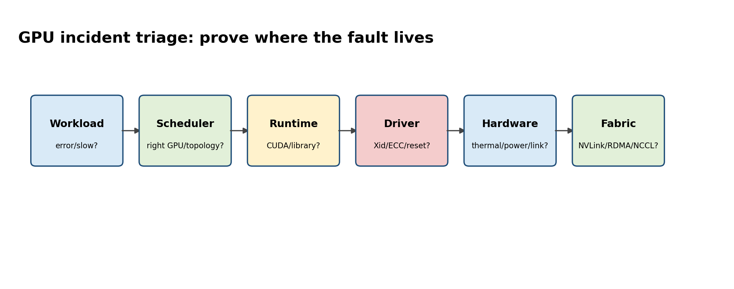
Figure B. GPU health requires correlating workload errors with software, hardware and fabric evidence.
NVIDIA Data Center GPU Manager (DCGM) provides telemetry, diagnostics, health monitoring and APIs for data-center GPUs. The operational goal is not merely collecting utilization. Track temperature, power, clocks, memory use, ECC and error conditions, PCIe/NVLink health and job-level behavior. Xid messages from the driver indicate GPU-related errors but require context; the Xid number, frequency, affected device, workload and recovery behavior determine the next action.
Health evidence: preserve timestamps and device UUIDs
nvidia-smi -q
nvidia-smi --query-gpu=uuid,pci.bus_id,temperature.gpu,power.draw,clocks.sm,memory.used,memory.total,ecc.errors.uncorrected.volatile.total --format=csv

dmesg -T | grep -iE 'NVRM|Xid|nvidia'
# DCGM tooling if deployed
dcgmi discovery -l
dcgmi health -g 0 -c
dcgmi diag -r 2

Senior Deep Dive 7 — Fleet lifecycle: upgrades, draining and known-good validation
GPU nodes should have an explicit lifecycle: provision -> validate -> admit workloads -> observe -> drain -> upgrade -> revalidate -> return to service. Driver and operator upgrades are workload-impacting changes. Use a canary node group, representative CUDA/inference/training smoke tests and rollback criteria. Firmware, NIC drivers, OFED/DOCA, kernel and GPU driver compatibility form a matrix; change control should capture the entire node image, not only the Kubernetes manifest.
Base Command Manager remains relevant for on-prem AI/HPC estates where bare-metal lifecycle, Slurm, Kubernetes, provisioning and firmware/software image management must be coordinated. 2026 BCM releases include current Slurm and CUDA stacks, illustrating why an SA must be comfortable with both Kubernetes-native and HPC-oriented operations.

Targeted references and reinforcement
NVIDIA GPU Operator: https://docs.nvidia.com/datacenter/cloud-native/gpu-operator/latest/index.html — Operator-managed GPU software dependency stack.
NVIDIA MIG User Guide: https://docs.nvidia.com/datacenter/tesla/mig-user-guide/latest/ — MIG isolation, supported GPUs and operational considerations.
NVIDIA DCGM: https://docs.nvidia.com/datacenter/dcgm/latest/contents.html — Telemetry, diagnostics, health and topology APIs; current documentation updated in 2026.
NVIDIA Base Command Manager: https://docs.nvidia.com/base-command-manager/ — Bare-metal/HPC/Kubernetes lifecycle context for AI clusters.

