VOLUME 5
AI Workloads and AI Platform Architecture
Training, inference, serving, scaling, state, security and performance trade-offs
Fourth Edition - Teaching text with mechanisms, examples, visuals, scenarios and exercises
Independent study guide based on public documentation and public practitioner material. Not an NVIDIA publication.

Chapter 1 - Classify the AI workload before designing infrastructure
Learning outcome
Distinguish training, fine-tuning, evaluation, batch inference and online inference by compute, communication, storage and SLO behavior.
Workload | Dominant concerns
Pretraining / large training | GPU-hours, distributed collectives, dataset feed, checkpoints, job reliability
Fine-tuning | model memory, training framework, smaller distributed jobs, artifacts/checkpoints
Batch inference | throughput, scheduling, queue completion time, cost
Online inference | P95/P99 latency, TTFT/TPOT, concurrency, autoscaling, availability
Evaluation | repeatability, dataset/model versioning, controlled benchmark environment
Start architecture discovery by naming the workload and measurable outcome. An online service with a 500 ms P95 constraint needs a different capacity strategy from an overnight batch job that only needs to finish by 06:00.

Chapter 2 - Training architecture: compute, data, checkpoints and collectives
Learning outcome
Understand why distributed training depends on GPU topology, fabric, storage and scheduler behavior.
Training repeatedly loads batches, performs forward/backward computation, exchanges data across devices when distributed, and periodically writes checkpoints. The critical path can shift across phases. GPU utilization drops if data preprocessing starves the device; scaling efficiency drops if collective communication grows faster than useful compute.

2.1 Parallelism vocabulary for infrastructure
Pattern | Infrastructure implication
Data parallel | replicas process different data; gradient synchronization creates collective traffic
Tensor/model parallel | single model split across GPUs; latency/bandwidth sensitivity to interconnect
Pipeline parallel | layers/stages distributed; pipeline bubbles and stage balance matter
Checkpointing | large writes + durability/restart time; storage path affects recovery

Worked scenario
Situation
A training job scales from 8 to 32 GPUs but throughput only doubles.
1. Calculate scaling efficiency rather than celebrating total throughput alone.
2. Compare GPU step time and collective/communication time at 8 versus 32 GPUs.
3. Check topology/fabric and placement: are workers crossing slower links or nodes unexpectedly?
4. Check data-loader/storage throughput; more GPUs may amplify input demand.
5. Check batch/global-batch changes and framework configuration before blaming hardware.
Conclusion
Distributed scaling is an efficiency curve; adding GPUs increases both compute capacity and coordination cost.

Chapter 3 - LLM inference: prefill, decode, batching and KV cache
Learning outcome
Connect model-serving mechanics to memory, latency, throughput and scaling decisions.
Autoregressive inference has a prompt-processing phase (prefill) and iterative token generation (decode). Prefill can be compute-heavy; decode repeatedly accesses model/KV state and is sensitive to memory behavior. Continuous batching lets a server combine work from multiple requests. KV cache stores attention state for active sequences and can become a major memory consumer as concurrency/context grows.
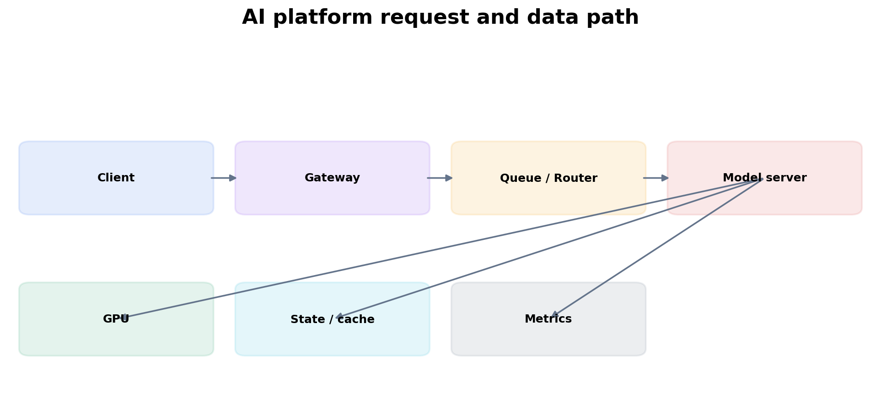
Figure 1. The model server is one stage in a production request system with routing, state/caches, GPU and observability.
Metric | Interpretation
TTFT | how quickly the first token arrives; includes queue + prefill + overhead
TPOT / inter-token latency | decode responsiveness
tokens/s | throughput / capacity outcome
queue duration/depth | demand versus service capacity
concurrency | active requests and memory pressure
GPU memory | model + KV cache + runtime workspace headroom

Practitioner lens
Anshul Jindal: production inference spans mechanics and operations
Public material for an NVIDIA GTC session links prefill/decode and KV-cache behavior to NIM/vLLM deployment, aggregated/disaggregated inference, API gateways, cost/token tracking and Prometheus/Grafana/Loki/Tempo. The useful lesson is that platform design starts with serving mechanics, then adds operational layers.
Public source

Chapter 4 - Serving frameworks and the platform boundary
Learning outcome
Place Triton, NIM, vLLM and application gateways in an architecture without treating product names as the design.
A model server owns model execution, batching/scheduling and model-specific runtime behavior. NVIDIA Triton provides a general inference serving platform; NIM packages optimized model inference into standardized service containers/APIs; vLLM is a popular LLM-serving engine. The gateway layer can handle authentication, routing, quotas, request logging, canary/version routing and tenant controls independently of the model server.
Benchmark engines on the target model, precision, GPU and request distribution. Do not choose an engine solely from a public benchmark with a different workload.
# Example Kubernetes resource boundary (illustrative)
resources:
requests:
nvidia.com/gpu: 1
cpu: "4"
memory: 16Gi
limits:
nvidia.com/gpu: 1
memory: 24Gi

Chapter 5 - Autoscaling inference
Learning outcome
Choose signals that represent demand and saturation, then account for model-load time, GPU granularity and cold capacity.
CPU utilization is often weakly correlated with GPU inference demand. Candidate scaling inputs include request concurrency, queue depth/duration, TTFT/latency, requests/s and tokens/s. GPU utilization/memory help determine whether a replica can safely take more load and whether memory is the limiting resource. The correct signal depends on the server and SLO.

Practitioner lens
Sagar Desai: hardware metrics and service metrics answer different questions
A public post contrasts DCGM metrics (hardware behavior/health) with model-server traffic/queue metrics for scaling decisions. Use that split as a diagnostic framework: demand is not the same thing as device busy percentage.
Public source

Worked scenario
Situation
GPU utilization sits at 95%, but P95 latency is within SLO and queue depth is near zero.
1. Do not scale solely because device utilization looks high.
2. Check concurrency, queue duration, TTFT/TPOT and error rate to determine service saturation.
3. Check headroom for traffic bursts/failures and memory capacity.
4. If unit economics matter, high utilization with healthy SLO may be desirable.
5. Scale when the chosen saturation/demand signal predicts SLO risk, not on a universal utilization threshold.
Conclusion
A busy GPU can be an efficient GPU; saturation is defined relative to service outcomes.

Chapter 6 - Distributed and disaggregated inference
Learning outcome
Understand when multi-GPU/multi-node inference is necessary and what new failure/performance dependencies appear.
Large models may require tensor/model parallelism across GPUs. Very high-throughput systems may distribute work across replicas and specialized stages. Disaggregated architectures can separate prefill and decode pools, which creates explicit network/state-routing requirements. The benefit must outweigh added scheduling, routing, network and failure complexity.
For multi-node inference, capacity planning becomes topology-aware. A replica is not simply N interchangeable GPUs; it may require a specific connected set and communication characteristics.

Chapter 7 - State, caches and RAG dependencies
Learning outcome
Classify durable state, request state, model artifacts, vector data and caches so replicas can scale safely.
Keep application compute stateless when practical, but do not confuse “stateless service” with “no state in the system.” Conversation history, vector indexes, model artifacts, prompt/result caches and KV-cache have different durability/locality requirements. Make each explicit.

Practitioner lens
Sagar Desai: decouple conversational state from Pod lifetime
A public architecture example argues against relying on local in-process history/sticky sessions for horizontally scaled Kubernetes LLM services. The general lesson is to externalize durable session state while treating local caches as disposable acceleration.
Public source
State | Typical property
Model artifact | versioned, large, read-mostly; startup distribution matters
Conversation/session | durable across replica changes; low-latency access
Vector index | persistent/search optimized; update/query behavior
KV cache | request/runtime-local performance state; large GPU memory footprint
Prompt/result cache | optional performance/cost optimization with invalidation/privacy concerns

Chapter 8 - Security and tenancy for AI platforms
Learning outcome
Apply familiar platform security controls to models, prompts, data, artifacts and shared GPUs.
AI infrastructure inherits cloud-native security requirements—identity, RBAC, network segmentation, secrets, image provenance, runtime hardening—and adds model/data supply chain concerns. Ask who can deploy models, pull artifacts, access prompts/data, call inference endpoints, use expensive GPU quota and read logs containing sensitive content.
GPU sharing also becomes a tenancy decision: cost-efficient packing is not enough if isolation requirements demand dedicated resources or hardware partitioning. Logging/telemetry must avoid leaking prompts, tokens or secrets by default.

Chapter 9 - Performance and cost engineering
Learning outcome
Translate benchmarks into capacity, cost per unit work and headroom under real request distributions.
For inference, useful economic units include cost per 1K/1M tokens, cost per request at an SLO, or throughput per GPU. For training, GPU-hours and time-to-train matter, but failed/restarted jobs and checkpoint overhead can dominate cost. Benchmark warm and cold behavior, typical and peak request distributions, and failure headroom.

Worked scenario
Situation
A cheaper GPU produces 60% of the throughput of a premium GPU at 45% of the hourly price.
1. Normalize by the actual outcome: tokens/s at required latency, not peak FLOPS.
2. Include replica count required for peak demand and availability headroom.
3. Include model fit, precision support, power/operational constraints and startup time.
4. Compute cost per unit work under expected utilization, then sensitivity-test traffic changes.
5. Recommend the cheaper device only if operational and SLO constraints remain acceptable.
Conclusion
Architecture cost decisions require normalized workload outcomes, not list price comparisons.

Practice
1. Draw a training data/checkpoint/collective path and list observability at each boundary.
2. For an LLM service, define TTFT, queue duration, tokens/s and GPU memory, then explain how they interact.
3. Design autoscaling signals for batch inference versus interactive inference.
4. Classify five types of AI platform state by durability and locality.

Targeted references
NVIDIA Developer: Deploying Generative AI in Production with NIM - Short visual overview of NIM, Kubernetes scaling, metrics and production deployment.
NVIDIA Kubernetes technical blog - Current posts on disaggregated inference, Dynamo, autoscaling and AI platform operations.

FOURTH EDITION — SENIOR ENGINEERING EXPANSION · VOLUME 5

AI workload architecture, LLM serving and production inference systems
This expansion keeps the Fourth Edition teaching flow and adds the depth expected from a senior infrastructure engineer and customer-facing Solutions Architect. The emphasis is mechanism first: understand what the system is doing, observe it with concrete tools, then reason about failure, scale, reliability, performance and trade-offs.
The practitioner material used to shape the scope is a signal, not an authority. Technical behavior is anchored in official documentation and first-principles systems reasoning. Your Staff Engineer study guide contributes useful patterns around Kubernetes, observability, distributed systems, platform design and failure isolation; the NVIDIA material adds GPU systems, AI workloads, accelerated networking and customer architecture.
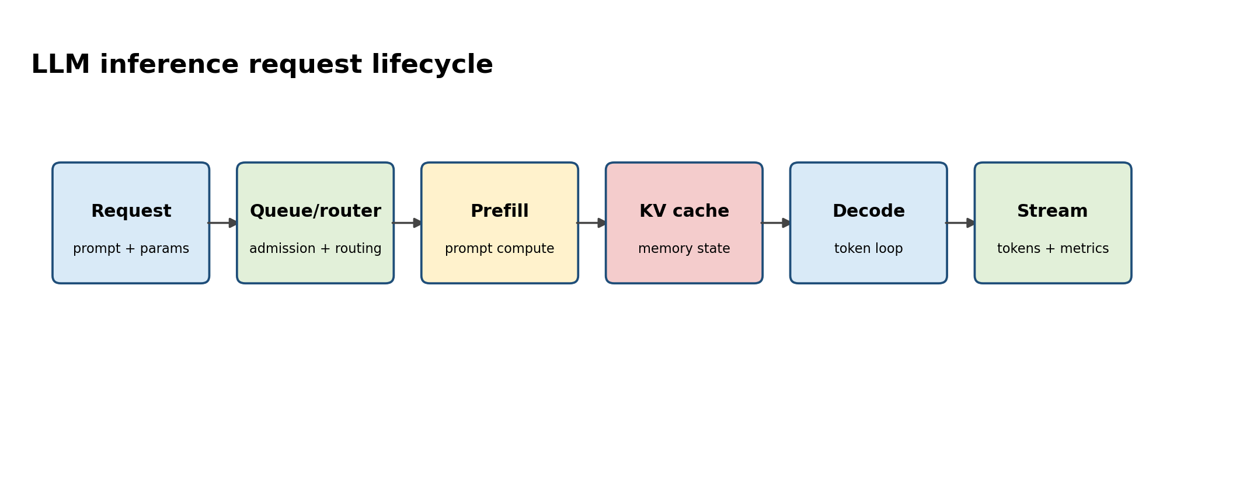
Figure A. Decompose latency before selecting a scaling strategy.

Senior Deep Dive 1 — Training systems: parallelism, collectives and checkpoint economics
Distributed training is a pipeline of compute, communication and data movement. Data parallelism replicates the model and exchanges gradients; tensor parallelism splits tensor operations across devices; pipeline parallelism splits layers/stages; expert parallelism distributes mixture-of-experts experts. These choices change the required GPU topology, collective patterns, memory pressure and sensitivity to stragglers.
Checkpointing is reliability architecture. Decide checkpoint size, frequency, synchronous versus asynchronous write behavior, target storage and restore time objective. A checkpoint every five minutes is not useful if it stalls training for two minutes. Measure application throughput and storage behavior together.

Senior Deep Dive 2 — LLM inference: prefill, decode, KV cache and continuous batching
Prefill processes the input prompt and creates KV cache state; decode generates output tokens iteratively using that state. Prefill tends to reward compute throughput and grows with input length. Decode repeatedly reads weights and KV state and is often sensitive to memory bandwidth, KV capacity and concurrency. Continuous batching improves GPU utilization by admitting and interleaving requests dynamically instead of waiting for fixed batches.
KV cache is operational state. Longer context, higher concurrency and more layers increase memory consumption. Prefix caching can avoid recomputing shared prompt prefixes, but it changes routing: a worker that already owns relevant cache may be a better destination than the least-loaded worker. This is one reason LLM-aware routing is different from round-robin HTTP load balancing.
Metric | What it captures | Primary pressure
TTFT | request arrival -> first output token | queue + prefill + network
ITL / TPOT | spacing/time per output token | decode scheduling + memory bandwidth
End-to-end latency | complete request duration | queue + prefill + decode length
Tokens/s | throughput | batching, parallelism, utilization
Concurrent users | capacity at SLO | memory/KV + latency budget

Senior Deep Dive 3 — NIM, vLLM, TensorRT-LLM and serving boundaries
An inference engine optimizes model execution; a serving product adds packaging, health, security, lifecycle and operational contracts. NVIDIA NIM for LLMs currently packages vLLM behind a production-oriented proxy with liveness/readiness, OpenAI-compatible inference endpoints and Prometheus-compatible metrics. TensorRT-LLM provides NVIDIA-optimized inference capabilities, while vLLM and SGLang are widely used engines with different feature/performance trade-offs. An SA should compare workloads and operational requirements rather than treating engines as interchangeable labels.

Senior Deep Dive 4 — NVIDIA Dynamo: system-level inference optimization
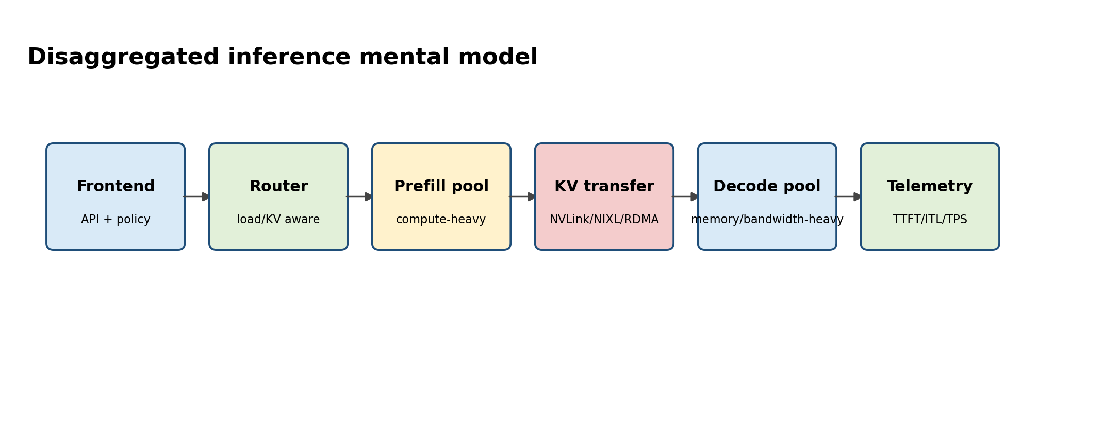
Figure B. Disaggregated serving separates resource shapes and turns KV transfer into a first-class data path.
NVIDIA Dynamo became GA in 2026 as a distributed inference platform. It adds system-level capabilities around inference engines: request routing, KV cache management, disaggregated serving, data transfer, scaling and Kubernetes-native deployment. The key mental model is that the engine optimizes execution on GPUs while Dynamo coordinates the distributed system around those engines.
Disaggregated serving separates prefill and decode worker pools. This helps when their resource shapes diverge—long prompts make prefill expensive, while high concurrency and long outputs stress decode and KV memory. It is not automatically faster: KV transfer becomes a critical path. On-node NVLink can make transfer cheap; cross-node designs require high-performance data movement, often RDMA, and careful placement.
Dynamo also introduces KV-aware routing: route requests where useful cache already exists while balancing load. The senior design question is when cache locality improves TTFT enough to justify additional routing/state complexity, and how failures or worker turnover invalidate that state.

Senior Deep Dive 5 — Autoscaling inference from work, not only CPU
CPU utilization is usually a weak signal for GPU inference. Better scaling signals include queue depth, pending tokens, request concurrency, TTFT/ITL SLOs, KV pressure and engine-specific utilization. Scaling too slowly violates latency; scaling too aggressively incurs model-load cost and wastes scarce GPUs. Model load time can be minutes, so predictive capacity, warm pools and staged rollout may outperform reactive HPA alone.
Run:ai and similar workload managers add scheduling and allocation capabilities above Kubernetes. Current NVIDIA enterprise reference architecture material demonstrates scaling NIM workloads and fractional GPU scheduling as a utilization/TCO lever. Treat results as workload-specific; validate your model, sequence-length distribution, concurrency and SLO.

Senior Deep Dive 6 — RAG, vector search and stateful dependencies
A RAG request is a distributed transaction-like pipeline: authenticate -> embed/transform query -> retrieve candidates -> optional rerank -> construct prompt -> infer -> return/stream. Reliability depends on multiple services whose latency distributions add or amplify. Vector databases are not “AI magic”; understand indexing, replication, consistency, query filters, cache behavior and backup/restore just as with other data systems.
Your Staff Engineer guide’s database and distributed-log material is useful here as a mental bridge: partitioning increases parallelism but changes balancing and failure behavior; replication increases availability at coordination/storage cost; consumer lag is backpressure evidence. Apply the same thinking to embedding pipelines, ingestion queues and asynchronous inference jobs.

Senior Deep Dive 7 — Agentic and multimodal infrastructure
Agentic workloads can turn one user request into many model calls, tool calls and retrieval steps. Capacity planning must reason about amplification: requests per user action, token distribution, tool latency, retry behavior and maximum loop depth. A service that is safe at 100 user requests/s can overwhelm model endpoints if each request fans out into ten model calls. Add budgets, concurrency controls and trace-level observability.

Senior Deep Dive 8 — Production benchmark design
A useful benchmark reproduces workload shape, not only peak throughput. Record input/output sequence-length distributions, concurrency, streaming behavior, model precision, engine/version, GPU type/topology, cache state and network/storage conditions. Report p50/p95/p99 TTFT and ITL together with tokens/s and GPU efficiency. A single average hides tail latency and overload behavior.

Targeted references and reinforcement
NVIDIA NIM LLM architecture: https://docs.nvidia.com/nim/large-language-models/latest/reference/architecture.html — Current NIM LLM architecture, health and metrics surfaces.
NVIDIA NIM benchmarking metrics: https://docs.nvidia.com/nim/benchmarking/llm/latest/metrics.html — Definitions for TTFT and common inference latency/throughput metrics.
NVIDIA Dynamo: https://docs.nvidia.com/dynamo/getting-started/introduction — 2026 distributed inference platform: disaggregation, routing, KV management and Kubernetes-native operation.
Anshul Jindal public NVIDIA workshop signal: https://de.linkedin.com/in/ansjin — Practitioner scope: prefill/decode, KV cache, NIM/vLLM, Dynamo, API gateway and Prometheus/Grafana/Loki/Tempo observability.
Vishakha Sadhwani — AI systems for DevOps: https://www.linkedin.com/in/vsadhwani — Practitioner scope: APIs, GPU-backed services, autoscaling, RAG awareness, event-driven systems, reliability and cost.

