VOLUME 6
HPC, Networking and Storage for AI
Distributed communication, RDMA fabrics, storage paths, Slurm and performance troubleshooting
Fourth Edition - Teaching text with mechanisms, examples, visuals, scenarios and exercises
Independent study guide based on public documentation and public practitioner material. Not an NVIDIA publication.

Chapter 1 - Distributed systems performance for GPU jobs
Learning outcome
Build a scaling-efficiency model that separates compute, communication, synchronization and I/O.
A single GPU can run independently. Multiple GPUs introduce coordination. Within a node, peer links/topology matter; across nodes, the network fabric and collective library matter. Scaling efficiency falls when communication/synchronization consumes an increasing fraction of step time.
speedup = throughput_N / throughput_1
efficiency = speedup / N
# Example: 8 GPUs give 6.4x throughput -> 80% scaling efficiency
Do not treat efficiency loss as automatically “network.” Input pipelines, CPU preprocessing, imbalance and framework configuration can all create idle time. Profile the phase that grew with scale.

Chapter 2 - Ethernet fundamentals for AI fabrics
Learning outcome
Understand link speed, MTU, queues, loss, ECMP and congestion before learning RoCE.
High-speed Ethernet still follows familiar networking principles. Link speed is a ceiling; application throughput depends on protocol overhead, path, congestion and flow distribution. MTU mismatch can cause fragmentation or connectivity failures. ECMP can distribute flows across equal-cost paths. Queue drops and congestion can damage latency and RDMA behavior.
ip -s link show dev <iface>
ethtool <iface>
ethtool -S <iface> | egrep -i 'drop|err|pause|ecn|pfc'
ping -M do -s 8972 <peer> # example jumbo-frame validation; adjust for headers/environment

Chapter 3 - RDMA, RoCE and InfiniBand
Learning outcome
Explain remote memory operations, queue pairs and why loss/congestion configuration matters.
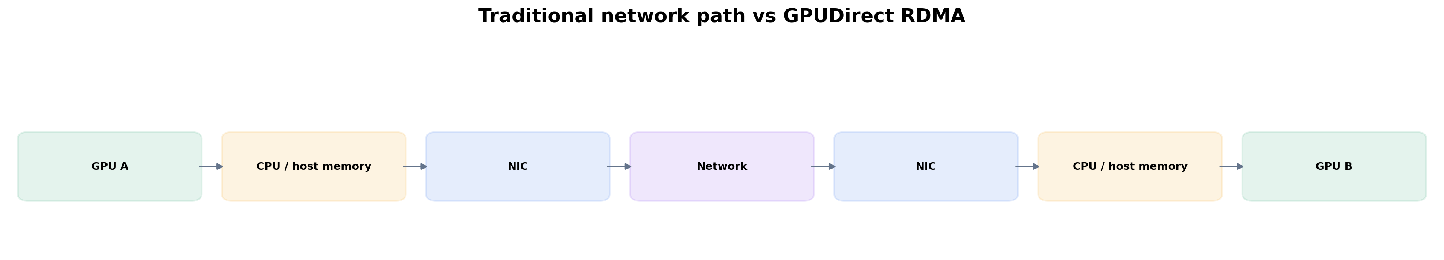
Figure 1. GPUDirect RDMA can shorten the GPU-to-network data path on supported systems.
RDMA enables direct access to registered memory with reduced CPU-copy overhead. InfiniBand is a purpose-built fabric supporting RDMA. RoCE carries RDMA semantics over Ethernet. RoCE deployments require careful fabric design because packet loss/congestion characteristics affect transport behavior; modern designs may use ECN/congestion control and, in some environments, PFC depending on architecture.
Do not memorize “RoCE needs lossless Ethernet” as a sufficient design answer. Ask which RoCE generation/transport, congestion control, switch/NIC design, oversubscription and vendor reference architecture are in use.
rdma link
ibv_devinfo
ibstat
# Perftest tools such as ib_write_bw / ib_read_bw may be used in controlled labs.

Chapter 4 - GPUDirect RDMA, NIC/GPU topology and NCCL
Learning outcome
Connect GPU collectives to host topology and fabric evidence.
GPUDirect RDMA allows supported NICs to transfer data directly to/from GPU memory, reducing staging through host memory/CPU. The effective path depends on GPU/NIC PCIe topology and system configuration. NCCL implements GPU collective communication patterns and selects transports/topology based on environment.
nvidia-smi topo -m
env | grep -E '^NCCL_'
# NCCL debug is powerful but verbose; enable deliberately in a test/incident window.
export NCCL_DEBUG=INFO

Worked scenario
Situation
A 32-GPU distributed training job slows after one node replacement.
1. Compare the replacement node hardware, NIC/GPU topology, driver/firmware and link speed with peers.
2. Check RDMA link/counters and switch-side errors/drops/congestion for paths involving that node.
3. Compare NCCL logs/collective benchmark performance node-by-node.
4. Check CPU/NUMA affinity and PCIe link width/speed.
5. Remove/replace the node in a controlled test to verify causal impact.
Conclusion
A single topology/fabric outlier can slow synchronized distributed work.

Chapter 5 - NVIDIA Network Operator and Kubernetes accelerated networking
Learning outcome
Understand the software automation layer that prepares nodes for high-performance network devices and secondary networks.
Network Operator automates deployment/configuration of networking components such as drivers, device plugins and CNI-related pieces for supported accelerated networking patterns. GPU Operator and Network Operator address different device stacks but may work together for GPU workloads requiring GPUDirect RDMA.
Kubernetes primary Pod networking may remain conventional while workloads receive additional high-performance interfaces via Multus/SR-IOV patterns. The design must define which traffic uses which network and how identity/policy/observability work across both.

Targeted references
NVIDIA Network Operator technical blog - Operator component model, accelerated network modes and GPUDirect context.

Chapter 6 - Storage for AI: datasets, checkpoints and model distribution
Learning outcome
Design storage by access pattern, concurrency, locality and recovery behavior.
Pattern | Infrastructure concern
Millions of small files | metadata operations, directory traversal, client concurrency
Large sequential dataset shards | aggregate throughput and client parallelism
Frequent checkpoints | write bursts, durability, checkpoint time, restart path
Model startup | artifact size, cache locality, parallel pulls, cold-start SLO
Vector/RAG stores | query latency, index durability, update pattern
Parallel filesystems and high-performance object/file layers are common in AI/HPC, but no product name removes the need to measure the workload. Cache/local NVMe can absorb hot artifacts or preprocessing, while durable shared storage provides persistence. Model startup can become a fleet-wide network/storage event during scale-out.

Worked scenario
Situation
GPU utilization oscillates: 100% for a few seconds, then near zero while training continues.
1. Compare GPU duty cycle with data-loader and storage metrics.
2. Measure step timeline: does the idle interval align with batch fetch/preprocessing?
3. Check CPU worker saturation, page cache behavior and storage latency/throughput.
4. Test larger prefetching/local cache or dataset sharding in a controlled run.
5. Only after data supply is ruled out should you focus on GPU kernel inefficiency.
Conclusion
Starved GPUs can be a storage/CPU input-pipeline problem.

Chapter 7 - Slurm scheduling model
Learning outcome
Understand jobs, allocations, partitions, nodes and why HPC schedulers optimize a different operating model from general service orchestration.
Slurm allocates resources to batch/interactive jobs across partitions and nodes, with scheduling priorities, reservations, topology and accounting features suited to HPC. Users submit jobs; the scheduler grants allocations; launch tools start tasks. The natural unit is often a job requiring a coordinated set of resources rather than a long-lived microservice.
sinfo
squeue
scontrol show node <node>
scontrol show job <jobid>
sacct -j <jobid> --format=JobID,State,Elapsed,AllocTRES,ExitCode

Chapter 8 - Kubernetes, Slurm or both
Learning outcome
Choose orchestration by workload and operating model, not by platform loyalty.
Dimension | Kubernetes strength | Slurm strength
Long-lived services | native Deployments/Services/operators | not primary design center
Batch HPC jobs | possible via jobs/operators | core scheduling model
Application ecosystem | cloud-native service/platform ecosystem | HPC job ecosystem/tooling
GPU gang/coordinated jobs | requires scheduler/operator patterns | native HPC allocation concepts
Platform self-service/API extensibility | CRDs/operators/GitOps | HPC workflow/accounting integration
Hybrid environments can integrate the two, but integration adds lifecycle and ownership questions. A Solutions Architect should discover which workloads, teams and operational processes must be preserved before recommending consolidation.

Practice
1. Explain RDMA to a Kubernetes engineer using the data path rather than protocol jargon.
2. List five checks for a suspected RoCE performance issue.
3. Design a storage benchmark that resembles model startup rather than training reads.
4. Compare Kubernetes and Slurm for an organization with 80% batch training and 20% online inference.

Targeted references
NVIDIA Kubernetes technical blog - Includes recent 2026 Slurm/Kubernetes and GPU cluster validation material.
NVIDIA Network Operator - Use current docs for supported configurations; verify release/version in your environment.

FOURTH EDITION — SENIOR ENGINEERING EXPANSION · VOLUME 6

HPC scheduling, accelerated networking and storage for multi-node AI
This expansion keeps the Fourth Edition teaching flow and adds the depth expected from a senior infrastructure engineer and customer-facing Solutions Architect. The emphasis is mechanism first: understand what the system is doing, observe it with concrete tools, then reason about failure, scale, reliability, performance and trade-offs.
The practitioner material used to shape the scope is a signal, not an authority. Technical behavior is anchored in official documentation and first-principles systems reasoning. Your Staff Engineer study guide contributes useful patterns around Kubernetes, observability, distributed systems, platform design and failure isolation; the NVIDIA material adds GPU systems, AI workloads, accelerated networking and customer architecture.
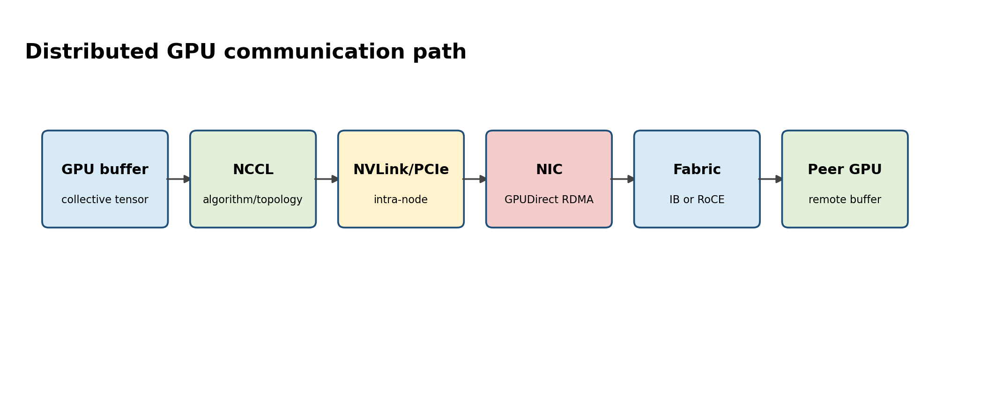
Figure A. A collective operation is a data path across GPU, PCIe/NVLink, NIC and fabric.

Senior Deep Dive 1 — Collective communication and straggler amplification
Distributed training performance is bounded by the slowest rank at synchronization points. AllReduce, AllGather, ReduceScatter and All-to-All move different amounts of data and stress the fabric differently. A single node with slower PCIe, NIC congestion, thermal throttling or storage delay can reduce throughput for the whole job. Therefore monitor distributions per rank/node, not only cluster averages.
NCCL chooses algorithms and transport based on topology and environment. Troubleshooting starts by confirming topology, then validating link state and RDMA path, then comparing NCCL logs and per-node timings. Avoid cargo-cult environment variables: each tuning flag changes transport or algorithm decisions and can hide the real infrastructure defect.
Multi-node communication evidence
# Topology and fabric evidence
nvidia-smi topo -m
ibv_devinfo
rdma link
ethtool -S <iface> | egrep -i 'drop|discard|pause|ecn|error'

# NCCL diagnostics - enable only for diagnosis because logs can be large
export NCCL_DEBUG=INFO
export NCCL_DEBUG_SUBSYS=INIT,NET,GRAPH

Senior Deep Dive 2 — RDMA: InfiniBand versus RoCE
RDMA allows direct memory operations with low CPU overhead. InfiniBand provides an integrated RDMA fabric with its own link/network architecture. RoCE carries RDMA over Ethernet. RoCE therefore inherits Ethernet operational concerns and usually needs intentional congestion management, QoS and loss behavior. “The link is up” is not enough; validate MTU, queue configuration, ECN/PFC behavior where used, path symmetry and error/retry counters.
GPUDirect RDMA reduces unnecessary copies through host memory by enabling direct data movement between GPU memory and compatible NICs. It increases the importance of PCIe/NUMA topology and software compatibility. Think end-to-end: GPU -> PCIe/NVLink -> NIC -> fabric -> remote NIC -> remote GPU.

Senior Deep Dive 3 — Network design for AI: oversubscription, rails and failure domains
AI fabrics are capacity systems. Oversubscription that is acceptable for web traffic can devastate synchronized collectives. Model the expected communication pattern and bisection bandwidth. Multi-rail designs can improve throughput and resilience but require correct routing, NIC/GPU affinity and workload configuration. Failure domains should align with scheduler placement so a single leaf/spine or rack event does not destroy all replicas or checkpoints.
Design variable | Why it matters | Evidence / validation
Link rate and lane health | raw capacity | ethtool/IB port counters
MTU | fragmentation/compatibility | ip link, ping with DF where appropriate
Congestion | tail latency and retries | ECN/PFC/pause/drop counters
Topology/rails | collective parallelism | NCCL graph/topology, switch layout
NUMA locality | host/NIC/GPU path | nvidia-smi topo -m, lspci, numactl

Senior Deep Dive 4 — Storage hierarchy and data pipeline architecture
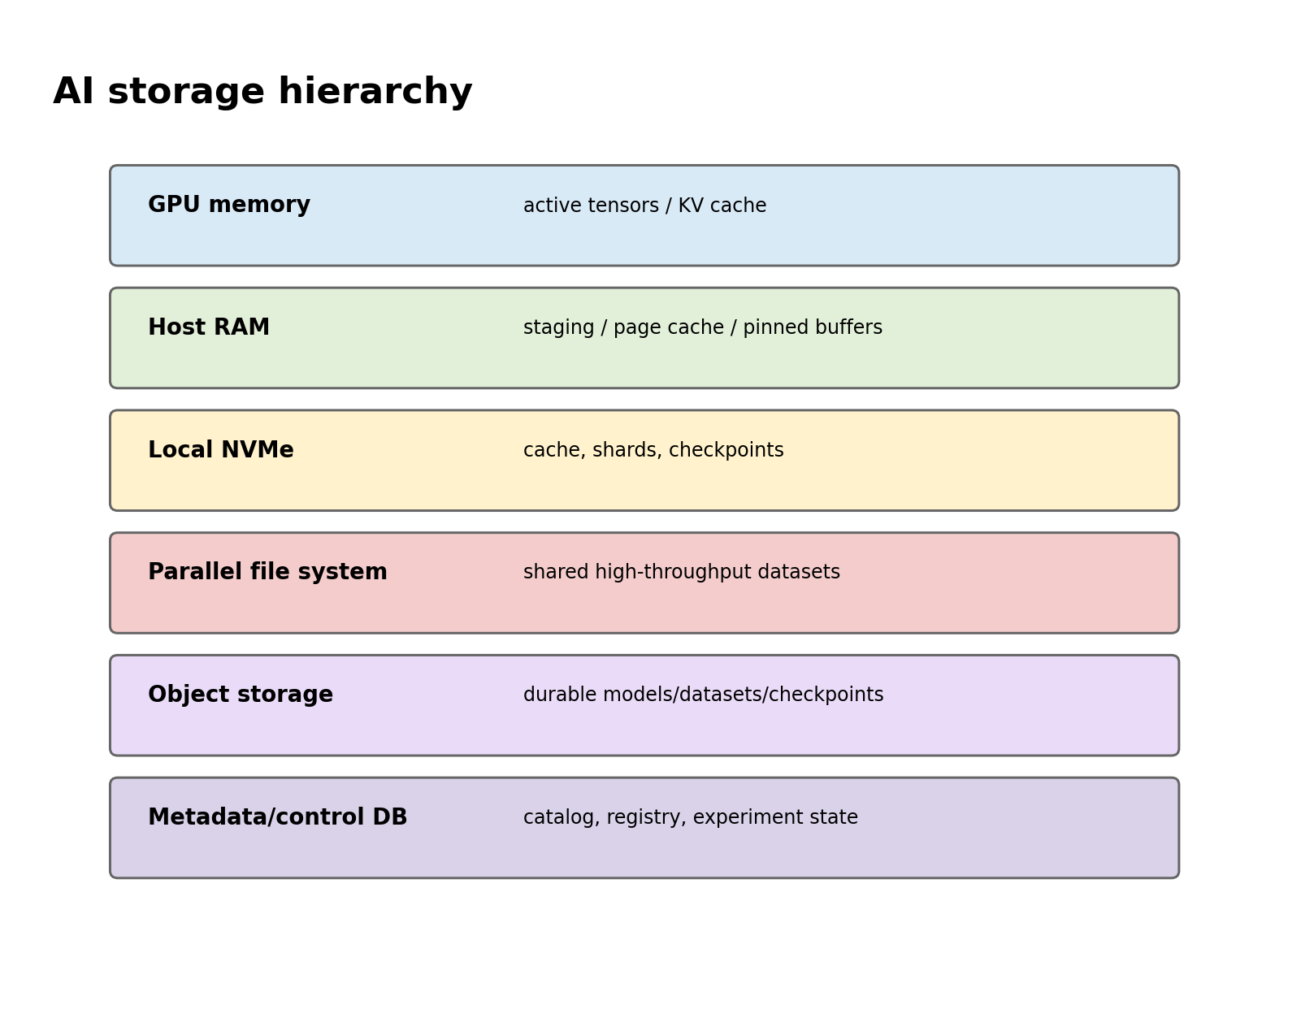
Figure B. AI platforms need several storage tiers because active tensors, datasets and durable checkpoints have different requirements.
Separate capacity, throughput, IOPS, metadata performance and durability. Large sequential training shards favor bandwidth; millions of tiny files can bottleneck metadata; checkpoints demand sustained write bandwidth and durability; model rollout may need high fan-out reads. Object stores scale durability and distribution but have different semantics from POSIX parallel filesystems. Local NVMe is excellent cache/scratch but is a node-local failure domain.
Measure the application data loader. GPU starvation may be caused by CPU decode/augmentation, small-file lookups, network storage, page cache misses or insufficient prefetch—not the storage array headline throughput. Capture GPU duty cycle together with read throughput, queue depth and data-loader wait.

Senior Deep Dive 5 — Slurm concepts beyond sbatch
Slurm separates control and execution: slurmctld schedules jobs; slurmd runs on compute nodes; partitions group resources/policy; jobs request resources and can contain job steps. GRES/TRES express accelerators and track consumption. Fair-share, QoS, reservations and priorities shape queue behavior. Prolog/epilog hooks prepare and clean nodes; failures there can make nodes drain or jobs fail before user code runs.
Slurm operational evidence
sinfo -Nel
squeue -o '%.18i %.9P %.16j %.8u %.2t %.10M %.6D %R'
scontrol show job <JOBID>
scontrol show node <NODE>
sacct -j <JOBID> --format=JobID,State,Elapsed,AllocTRES,MaxRSS,ExitCode

NVIDIA Base Command Manager 2026 releases include current Slurm, CUDA, container toolkit and Enroot/Pyxis stacks. Enroot provides an HPC-friendly container runtime model; Pyxis integrates containers with Slurm. This is an important bridge for SAs because many AI factories use Slurm for tightly coupled batch workloads while teams may also run Kubernetes for services and platform workflows.

Senior Deep Dive 6 — Kubernetes, Slurm and hybrid scheduling
Kubernetes excels at declarative services, APIs, controllers and cloud-native platform integration. Slurm excels at queued HPC jobs, reservations, gang-like resource allocation and mature batch scheduling. The decision depends on workload shape, organizational model and integrations—not ideology. Hybrid estates often share physical infrastructure but need clear ownership of nodes, drivers, networking and storage to avoid conflicting control planes.

Senior Deep Dive 7 — Distributed-system patterns from the Staff Engineer guide
Kafka concepts from your study guide provide reusable reasoning patterns. A partition creates an ordered unit and parallelism boundary; replication trades capacity for fault tolerance; leader/follower state creates failover behavior; consumer lag measures backpressure. Map those ideas to AI systems: dataset shards, inference queues, checkpoint replicas, distributed schedulers and control-plane logs all have partitioning, replication and lag-like failure modes.

Targeted references and reinforcement
NVIDIA Base Command Manager 11 release notes: https://docs.nvidia.com/base-command-manager/bcm-11-release-notes/ — Current 2026 support context for Slurm, Enroot/Pyxis, CUDA and Network Operator.
NVIDIA Dynamo disaggregated serving: https://docs.nvidia.com/dynamo/latest/user-guides/disaggregated-serving — Cross-node KV transfer makes accelerated networking a serving concern, not only training.
Staff Engineer study guide repository: https://github.com/jithinpnjm/studyguide-staff-engineer — Distributed-log/partition/replication material used as a reasoning bridge, rewritten for AI infrastructure.
NVIDIA Solutions Architect AI Infrastructure job signal: https://www.linkedin.com/jobs/view/senior-solutions-architect-ai-infrastructure-at-nvidia-4413184237 — Current SA family signal: compute/networking integration, POCs and accelerated networking for AI/HPC.

