VOLUME 7
Observability, Reliability and Troubleshooting
From telemetry primitives to SLOs and full-stack incident diagnosis
Fourth Edition - Teaching text with mechanisms, examples, visuals, scenarios and exercises
Independent study guide based on public documentation and public practitioner material. Not an NVIDIA publication.

Chapter 1 - Metrics, logs and traces as different evidence
Learning outcome
Know what each telemetry type preserves and choose it by question.
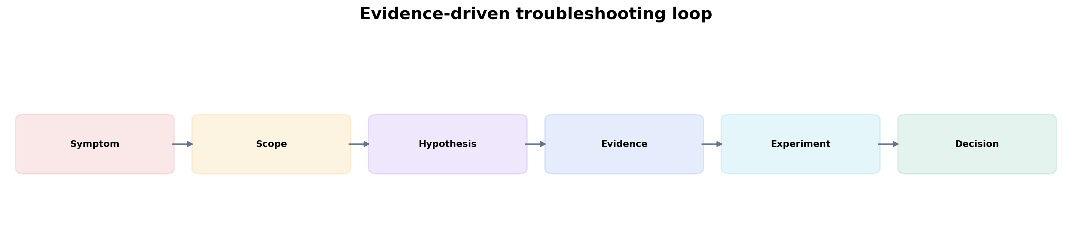
Figure 1. Each evidence request should discriminate hypotheses and lead to a decision.
Signal | Strength | Weakness
Metrics | cheap aggregation, trends, alerting, rates/percentiles | limited event context; labels/cardinality must be designed
Logs | rich event details, errors and state transitions | volume/cost; unstructured logs are hard to query
Traces | request path, spans and dependency latency | sampling/instrumentation complexity; not a replacement for metrics
Telemetry is useful when it answers operational questions. Start from a user/workload symptom, define scope and SLO impact, then choose metrics/logs/traces. Dashboard browsing without a hypothesis can waste incident time.

Chapter 2 - SLIs, SLOs and error budgets
Learning outcome
Connect reliability work to measurable user outcomes instead of infrastructure percentages.
An SLI measures an outcome such as successful requests or latency under threshold. An SLO defines the target over a window. Error budget is the tolerated failure proportion. Infrastructure metrics explain causes, but an SLO should usually represent what the service/customer experiences.
availability = successful_requests / valid_requests
error_budget = 1 - target_slo
# 99.9% availability -> 0.1% error budget over the window
For training platforms, useful SLO-style measures might include job-start latency, successful completion rate, cluster availability or checkpoint/recovery expectations. For inference, request success and latency/tokens are closer to user experience.

Chapter 3 - Prometheus mental model and PromQL reasoning
Learning outcome
Understand counters, gauges, histograms, rates and label dimensions before copying queries.
Metric type | Use
Counter | monotonic event total; apply rate()/increase() over time
Gauge | current value that can go up/down
Histogram | bucketed observations enabling distributions/quantiles with aggregation
Summary | client-side quantiles/count/sum; aggregation trade-offs
# Request rate
sum(rate(http_requests_total{job="api"}[5m]))
# 5xx ratio
sum(rate(http_requests_total{job="api",status=~"5.."}[5m]))
/
sum(rate(http_requests_total{job="api"}[5m]))
Always inspect label cardinality. User IDs, request IDs or unbounded model/session identifiers can explode time-series count. Use logs/traces for high-cardinality event identity when metrics do not need it.

Chapter 4 - Kubernetes observability: object state plus runtime evidence
Learning outcome
Combine kube-state-style desired/observed state, kubelet/container metrics and application telemetry.
Kubernetes incidents require both control-plane/object evidence and runtime telemetry. A Pending Pod is best explained by status/events/scheduler constraints; CPU graphs cannot tell you why it never scheduled. A Running-but-slow Pod requires application and node/cgroup metrics. Choose the data source that owns the fact.
kubectl get events --sort-by=.lastTimestamp
kubectl get pod <pod> -o yaml
kubectl describe node <node>

Chapter 5 - GPU observability with DCGM
Learning outcome
Separate device health/utilization from workload demand and performance.
DCGM Exporter can expose GPU utilization, framebuffer memory, temperature, power and error/health-related metrics to Prometheus. Add Kubernetes ownership labels/joins so engineers can answer “which workload owns this GPU?” rather than staring at GPU index numbers.
For inference autoscaling, queue/demand metrics from the serving layer may be stronger triggers. For training, step time and collective/network behavior should be correlated with device utilization. The operational model is multi-layer.

Practitioner lens
Sagar Desai: GPU utilization is not service saturation
A public post illustrates the distinction between DCGM hardware metrics and inference-server queue/request metrics. Use GPU telemetry to understand the device; use service telemetry to understand user demand and SLO saturation.
Public source

Chapter 6 - Logs that survive incidents
Learning outcome
Design event fields, severity and correlation; prevent secrets and noisy duplication.
A useful operational event contains timestamp, service/component, resource identity, operation, outcome, duration, attempt and correlation context where applicable. Log the error once at the layer with operational meaning; repeated stack traces at every layer increase noise. Sensitive prompts/tokens/credentials need explicit redaction policy.
{
"event": "model_load_failed",
"model": "llama-x",
"node": "gpu-12",
"duration_ms": 18342,
"attempt": 2,
"error_class": "ArtifactTimeout"
}

Chapter 7 - Traces and distributed latency
Learning outcome
Use spans to decompose request latency across gateway, queue, model server and dependencies.
A trace connects causal work across services. For inference, spans can separate gateway/auth, queueing, retrieval, model prefill/decode, external tool calls and state-store latency. Tracing is most valuable when services propagate context consistently and span attributes are bounded/meaningful.

Chapter 8 - Alert design and runbooks
Learning outcome
Alert on actionable risk to an SLO or critical dependency, then make the first diagnostic steps deterministic.
A good alert tells the responder what is broken, scope, severity and where to begin. Avoid alerting on every transient metric threshold. Multi-window burn-rate approaches can detect fast and slow SLO consumption. Infrastructure alerts remain appropriate for imminent hard failures such as disk exhaustion or GPU hardware errors when action is required before user impact.
Bad alert | Better question
CPU > 80% | Is service latency/error budget burning because CPU saturation is limiting work?
GPU util > 90% | Is queue/latency rising or is the GPU efficiently serving demand?
Pod restarted | Is restart rate abnormal and causing availability impact?
Disk 70% | At current growth, when will capacity breach safe threshold?

Chapter 9 - Incident playbook: Pending Pods, CrashLoops and OOM
Learning outcome
Use object/event evidence before host-level investigation, then descend the stack.

Worked scenario
Situation
A production Pod is Pending for 15 minutes.
1. kubectl describe Pod and read scheduling events: resource, taint, affinity, PVC, topology or admission reason.
2. Check eligible nodes and allocatable/requested resources.
3. Check PVC binding/topology and quota if referenced.
4. Check autoscaler ability/limits only if adding a node could satisfy the Pod.
5. Make one change that directly addresses the proven constraint.
Conclusion
Pending is a desired placement problem; start with scheduler evidence, not container logs.

Worked scenario
Situation
A Pod alternates Running and CrashLoopBackOff.
1. Read current/previous container termination reason and exit code.
2. Read previous logs (kubectl logs -p) because the last process instance may already be gone.
3. Separate application exit, OOM, probe-triggered restart and external eviction/node failure.
4. Reproduce with the same config/secret/env if safe; do not simply increase restart backoff.
Conclusion
CrashLoopBackOff is a retry state, not the root cause.

Chapter 10 - Incident playbook: GPU workload slow or failing
Learning outcome
Walk from workload SLO through GPU, container/runtime, host, network and storage evidence.

Worked scenario
Situation
Distributed training throughput drops 35% after maintenance with no application code change.
1. Scope: one job/node group/all jobs; compare a known-good baseline.
2. Inventory changes: driver, firmware, operator, kernel, NIC, switch, storage, topology.
3. GPU: utilization, clocks, memory, health/error/throttle indicators.
4. Host: CPU/memory/I/O pressure and cgroup throttling.
5. Fabric: link state, RDMA/NIC counters, drops/congestion, collective benchmark.
6. Storage: dataset/checkpoint latency if step timeline aligns with I/O.
7. Perform a controlled node/path benchmark or rollback that isolates the changed layer.
Conclusion
“No code change” narrows change history, but evidence must still identify the bottleneck.

Chapter 11 - Incident communication and postmortem
Learning outcome
Separate mitigation, root cause, contributing factors and prevention; communicate by audience.
During an incident, communicate impact, scope, current hypothesis/evidence, mitigation and next decision time. Afterward, root cause should describe the mechanism that produced failure; contributing factors explain why impact was larger or detection/recovery slower. Action items should change systems/processes, not say “be more careful.”

Practice
1. Write a PromQL expression for 5xx ratio and state assumptions about labels.
2. Design three GPU alerts: one hardware-health, one capacity, one inference SLO alert.
3. For a CrashLoop, list the exact Kubernetes evidence that distinguishes OOM from app exit.
4. Write a one-paragraph executive incident update without losing factual accuracy.

Targeted references
NVIDIA: Monitoring GPUs in Kubernetes with DCGM - GPU telemetry -> exporter -> Prometheus/Grafana.
NVIDIA: GPU Usage Monitor - Recent integrated GPU/Kubernetes visibility pattern.
Prometheus documentation - Metric model, PromQL and alerting reference.

FOURTH EDITION — SENIOR ENGINEERING EXPANSION · VOLUME 7

Observability, reliability engineering and evidence-led troubleshooting
This expansion keeps the Fourth Edition teaching flow and adds the depth expected from a senior infrastructure engineer and customer-facing Solutions Architect. The emphasis is mechanism first: understand what the system is doing, observe it with concrete tools, then reason about failure, scale, reliability, performance and trade-offs.
The practitioner material used to shape the scope is a signal, not an authority. Technical behavior is anchored in official documentation and first-principles systems reasoning. Your Staff Engineer study guide contributes useful patterns around Kubernetes, observability, distributed systems, platform design and failure isolation; the NVIDIA material adds GPU systems, AI workloads, accelerated networking and customer architecture.
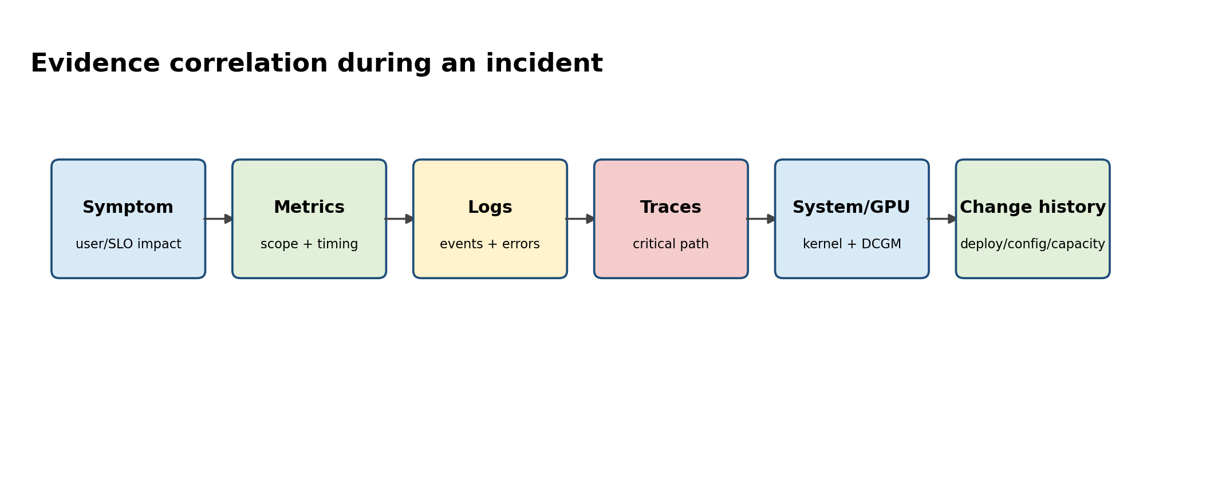
Figure A. High-confidence diagnosis comes from correlated evidence, not from a single dashboard.

Senior Deep Dive 1 — Start with SLO impact and scope
Troubleshooting starts by defining what is wrong in measurable terms: which users/workloads, which region/cluster/node/model, since when, and which SLO or business behavior is affected. Establish a baseline and recent changes. This prevents an engineer from drowning in dashboards and makes every subsequent query an attempt to falsify a hypothesis.
USE (utilization, saturation, errors) is useful for resources; RED (rate, errors, duration) is useful for request-driven services. Neither replaces system understanding. For a GPU inference endpoint, useful dimensions include request rate, errors, queue depth, TTFT/ITL, tokens/s, GPU memory/utilization, KV pressure, model worker health and fabric/storage signals.

Senior Deep Dive 2 — Prometheus internals, cardinality and query cost
Prometheus stores labeled time series. Every unique label set is a series, so unbounded labels such as user_id, request_id or pod UID in long-lived metrics can create cardinality explosions. Query cost depends on how many series and samples must be scanned and aggregated. Recording rules precompute common expensive expressions; federation/remote systems such as Thanos can aggregate retention/query across Prometheus instances, but they do not excuse poor metric design.
PromQL: derive service behavior, do not graph raw everything
# Request error ratio
sum(rate(http_requests_total{status=~"5.."}[5m]))
/
sum(rate(http_requests_total[5m]))

# p95 from histogram buckets
histogram_quantile(0.95,
sum by (le) (rate(http_request_duration_seconds_bucket[5m])))

# GPU utilization grouped by node (metric names depend on exporter/version)
avg by (instance) (DCGM_FI_DEV_GPU_UTIL)

Your Staff Engineer guide already emphasizes Prometheus data model, PromQL, federation, Thanos, label cardinality and monitoring Prometheus itself. The senior expansion adds the operational question: what failure will this metric distinguish? A metric that cannot change a diagnosis or a capacity decision is usually telemetry cost without operational value.

Senior Deep Dive 3 — OpenTelemetry and trace context across AI services
Traces become valuable when a user request spans gateway, retrieval, reranking, inference and tool calls. Carry a correlation/trace context through those boundaries and attach low-cardinality attributes such as model, deployment, region and operation. Avoid embedding prompts or secrets in telemetry by default. For agentic systems, trace fan-out and retries because a single user action can become dozens of downstream operations.

Senior Deep Dive 4 — GPU observability with DCGM and driver evidence
A GPU dashboard should combine device health and workload performance. Device health: temperature, power, clocks, memory, ECC/error events, NVLink/PCIe status. Workload: utilization, memory occupancy, engine behavior, throughput and job identity. Driver logs provide Xid context. Correlate GPU UUID across DCGM, nvidia-smi, Kubernetes labels/allocations and job logs so that an incident survives node renumbering or Pod rescheduling.

Senior Deep Dive 5 — Inference observability: TTFT, ITL/TPOT and saturation
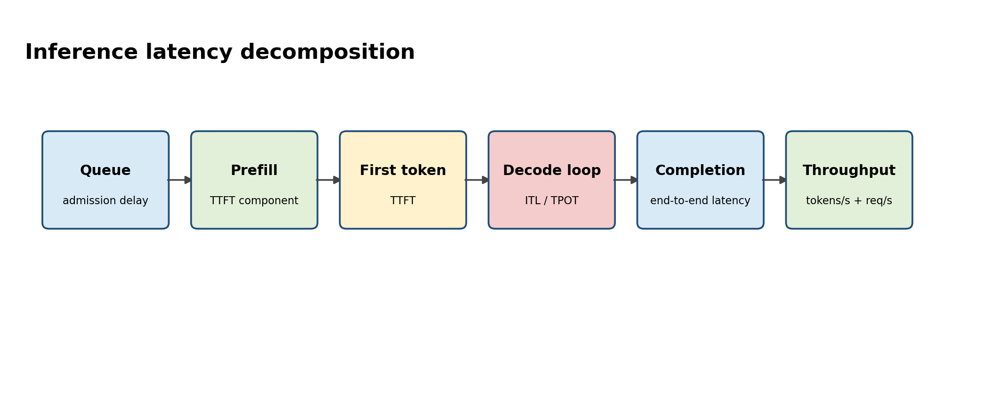
Figure B. End-to-end latency hides several different scaling pressures.
NVIDIA NIM benchmarking documentation defines TTFT as request submission to first received token. TTFT includes queueing, prefill and network components. ITL/TPOT focuses on the decode token cadence. A system can have excellent average tokens/s but unacceptable TTFT because queueing is saturated. Report distributions and workload shape, not only averages.
Symptom | Likely bottleneck families | Evidence
TTFT rises, ITL stable | queue/prefill/model load/router | queue depth, input length, prefill workers, cache hit
ITL worsens with concurrency | decode/KV/memory bandwidth | active sequences, KV usage, GPU memory BW proxies
Both worsen on selected nodes | GPU/fabric/CPU/storage node issue | DCGM, topology, CPU PSI, RDMA counters
Latency fine, cost/token high | low batching/utilization/oversizing | tokens/s/GPU, batch occupancy, request mix

Senior Deep Dive 6 — Incident workflow: evidence tree and safe mitigation
Separate mitigation from root cause. Draining a node, rolling back a release or reducing concurrency may restore service, but the incident is not understood until evidence explains why the action worked. Preserve logs, metrics, manifests, versions and topology before destructive remediation when possible.
• Define symptom and blast radius; identify the first known-bad interval.
• List top hypotheses across application, orchestration, host, GPU, network and storage.
• Choose the cheapest/highest-information test for each hypothesis.
• Mitigate only when the customer/SLO requires it; record what changed.
• Validate recovery with the original symptom metric, not “pods are green”.
• Perform root-cause and contributing-factor analysis; create prevention or faster-detection actions.

Senior Deep Dive 7 — Alert design for expensive GPU systems
Alert on conditions that require human action. Capacity alerts should give enough lead time to acquire or shift scarce GPU capacity. Health alerts should avoid paging on transient telemetry gaps unless redundancy is affected. Multi-signal alerts can reduce false positives—for example sustained inference SLO violation plus queue saturation, rather than GPU utilization alone.

Senior Deep Dive 8 — Reliability testing and game days
Run controlled failures: kill model workers, block DNS, remove an EndpointSlice target, fill node image filesystem, introduce API latency, drain a GPU node, interrupt a storage path or isolate a network rail. The goal is to validate detection, failover, runbooks and customer impact assumptions. Chaos is valuable only when the hypothesis and success criteria are explicit.

Targeted references and reinforcement
NVIDIA DCGM: https://docs.nvidia.com/datacenter/dcgm/latest/contents.html — GPU telemetry, diagnostics and health APIs.
NVIDIA NIM benchmarking metrics: https://docs.nvidia.com/nim/benchmarking/llm/latest/metrics.html — TTFT and inference performance metric definitions.
Staff Engineer guide — Observability: https://github.com/jithinpnjm/studyguide-staff-engineer — Prometheus/Grafana, cardinality, scaling, alerting and production maintenance themes.
Vishakha Sadhwani — AI infra skill signal: https://www.linkedin.com/in/vsadhwani — Practitioner emphasis on observability, distributed inference, GPU scheduling and cost optimization.

