VOLUME 8
Senior Solutions Architecture Practice
Discovery, architecture, PoCs, economics, migrations and customer communication
Fourth Edition - Teaching text with mechanisms, examples, visuals, scenarios and exercises
Independent study guide based on public documentation and public practitioner material. Not an NVIDIA publication.

Chapter 1 - Discovery that changes the architecture
Learning outcome
Turn “we need an AI platform” into workload, SLO, scale, security, operations and cost facts.
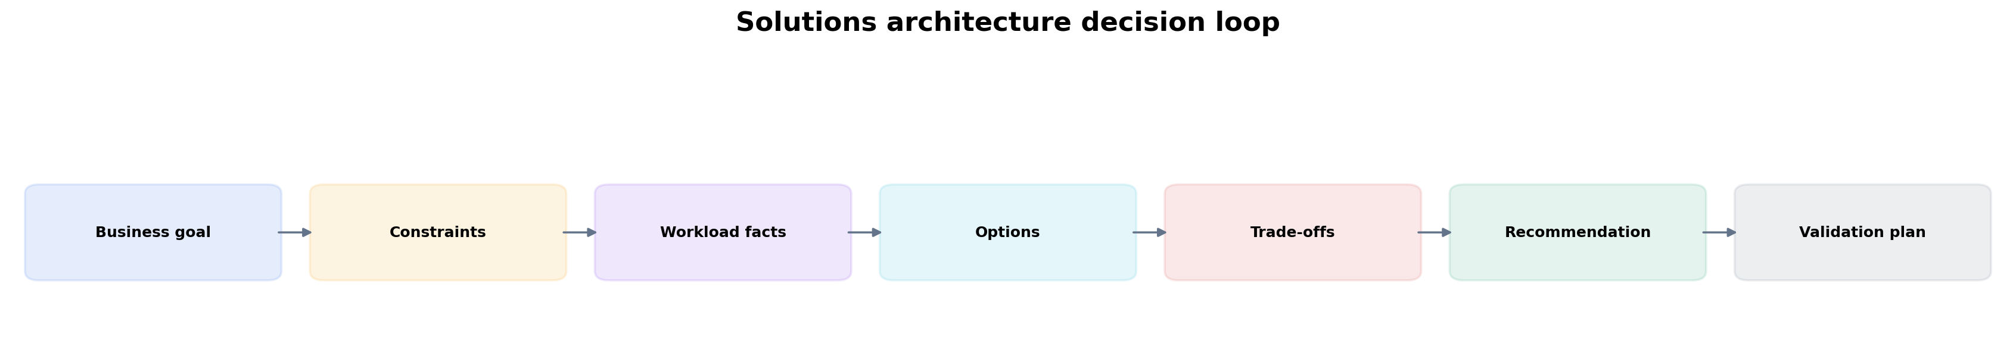
Figure 1. Recommendation comes after goals, constraints and workload facts.
Discovery is not a checklist recital. Ask questions whose answers eliminate or favor architecture options. “How many users?” is less useful than “What peak concurrent requests and P95 TTFT target must the inference service support?”
Discovery area | Questions with architectural consequence
Workloads | training vs inference; model sizes; batch/online; distributed requirements
SLOs | latency, throughput, availability, recovery time, job queue/start time
Scale | GPU count now/12 months; concurrency; dataset/model growth
Data | where it lives; throughput; sensitivity; sovereignty; movement cost
Security | tenancy, identity, network segmentation, artifact/prompt access
Operations | Kubernetes/Slurm skills, on-call model, GitOps/IaC, upgrade windows
Economics | budget, cloud/on-prem constraints, utilization goals, procurement lead time

Practitioner lens
Vishakha Sadhwani: SA combines technical recommendation with customer requirements
Her public role comparison describes SAs as advising customers, defining business/technical requirements, evaluating trade-offs, building PoCs, guiding implementation and presenting to stakeholders. Treat each of these as a technical competency, not generic “communication skills.”
Public source

Chapter 2 - Architecture from data and control paths
Learning outcome
Draw what moves, what controls it, where state lives and where failure can occur before choosing products.
For an AI platform, draw at least: user/API request path, model/artifact path, training dataset/checkpoint path, GPU scheduling/control path, observability path and identity/security boundaries. This exposes dependencies that a product-box diagram hides.
A control plane tells systems what should happen; a data plane carries workload traffic/data. Kubernetes API/controller behavior is control plane; inference requests and model data are data plane. Keeping this distinction clear helps with security, scaling and failure-domain reasoning.

Chapter 3 - Trade-off matrices with weighted requirements
Learning outcome
Compare options transparently without pretending all dimensions matter equally.
Dimension | Example measure
Performance | P95 TTFT, tokens/s/GPU, training scaling efficiency
Reliability | failure domains, recovery, upgrade disruption
Operability | skills, automation, debugging, lifecycle burden
Security | isolation, IAM, network/data controls
Economics | cost/unit work, utilization, licensing, staff time
Time-to-value | procurement + integration + migration timeline
Weights come from customer priorities. A 10% performance advantage may be irrelevant if the option violates data residency. A cheaper platform may be more expensive if operational complexity consumes scarce engineering capacity. Make assumptions explicit so the customer can challenge them.

Chapter 4 - Kubernetes versus Slurm decision workshop
Learning outcome
Practice a common AI infrastructure architecture decision without forcing a universal answer.

Worked scenario
Situation
A research organization runs 80% large batch training, 10% interactive notebooks and 10% online model services. It already operates Slurm but also has a mature Kubernetes platform team.
1. Separate workload classes instead of asking for one scheduler to “win.”
2. For batch training, evaluate existing Slurm scheduling/accounting/topology capabilities and whether Kubernetes adds enough platform value to justify migration.
3. For online services, evaluate Kubernetes service/GitOps/observability/autoscaling ecosystem.
4. For notebooks, evaluate tenancy, quotas and developer experience across both.
5. Consider integration/shared identity/storage/observability and define ownership boundaries if using both.
Conclusion
A multi-platform answer can be correct when workload operating models differ; simplicity must include migration/operational reality.

Chapter 5 - GPU sharing and capacity recommendation
Learning outcome
Translate workload footprint and SLOs into full GPU, MIG, time-slicing or other resource models.
Collect model memory footprint, peak memory with batching/KV cache, latency sensitivity, failure isolation and concurrency. Then test sharing modes. A production recommendation should include how slices/resources are scheduled, observed and reconfigured—not only the hardware feature.
Workload | Likely starting point | Validate
large training job | full GPUs / coordinated multi-GPU allocation | scaling efficiency, topology, checkpoint/recovery
small dev notebooks | time slicing or shared dev pool | fairness, memory interference, user experience
latency-sensitive small inference | MIG where supported if slice fits | P95 latency, isolation, packing efficiency
mixed model services | benchmark full/MIG/sharing pools | fragmentation, SLO, operational complexity

Chapter 6 - PoC design: test uncertainty, not product demos
Learning outcome
Define hypotheses, metrics, controls and pass/fail criteria before building.
A good PoC answers the risky questions that block a production decision. Example hypothesis: “On H100 with candidate serving engine X, model Y can sustain 200 concurrent requests with P95 TTFT < 1 s and cost < €Z/1M tokens.” The PoC needs request distribution, warm/cold state, instrumentation, comparison baseline and repeatability.
PoC hypothesis
-> test environment + versions
-> workload generator + data
-> metrics/SLO
-> baseline
-> experiment matrix
-> pass/fail criteria
-> decision and residual risks

Worked scenario
Situation
Customer asks for a 2-week PoC of “GPU Kubernetes.”
1. Ask what production decision the PoC should enable: lifecycle automation, serving performance, distributed training, tenancy, networking?
2. Choose 2–3 hypotheses rather than attempting every platform feature.
3. Define measurable pass/fail and a baseline.
4. Use production-representative security/network/storage constraints where they affect the hypothesis.
5. Produce a decision report: validated, failed, unknown, recommendation, next risk.
Conclusion
A PoC is an experiment with a decision outcome, not a showroom.

Chapter 7 - TCO and capacity conversations
Learning outcome
Normalize cost by useful work and include operations, headroom, failure and licensing.
Hardware/hour price is only one input. Calculate usable throughput at the target SLO, utilization under real demand, failure/maintenance reserve, storage/network, software licensing and staff operational cost. Cloud elasticity can reduce idle capacity but may have availability/quota/data-egress constraints. On-prem may improve steady-state economics but introduces procurement and lifecycle burden.
cost_per_million_tokens = total_hourly_cost / (tokens_per_hour / 1_000_000)
effective_capacity = nominal_capacity * expected_utilization * availability_factor

Chapter 8 - Security architecture and governance
Learning outcome
Map identities, trust boundaries, data/model flows and administrative planes.
Start with identities: human admin, developer, CI/CD, workload, model-serving client. Map what each can access: Kubernetes API, cloud APIs, registries, model artifacts, prompts/data, GPUs and observability. Separate control-plane and data-plane network paths. Define secrets, image/model provenance and audit requirements.
For shared GPUs, tenancy and data isolation requirements may change resource-sharing strategy. For AI services, logs/traces may contain prompts or retrieved data, so observability design is part of privacy/security architecture.

Chapter 9 - Migration and adoption strategy
Learning outcome
Design phased transitions with compatibility, rollback, training and operational readiness.
A migration plan should state source/target operating models, workload segmentation, dependencies, data movement, identity/networking, observability, success criteria and rollback. Avoid “big bang” migration when workload classes can be validated incrementally. The team must be able to operate the target before critical workloads move.

Worked scenario
Situation
Customer wants to move all Slurm training to Kubernetes in one quarter because Kubernetes is the company standard.
1. Inventory job patterns, scheduling features, accounting/quotas, topology and storage assumptions currently supplied by Slurm.
2. Identify workloads that map cleanly to Kubernetes and those relying on HPC-specific behavior.
3. Prototype representative large jobs and measure scheduling/launch/scaling/recovery.
4. Define coexistence period and common identity/storage/observability.
5. Migrate by workload class with rollback and operator readiness gates.
Conclusion
Standardization is valuable only when the target platform reproduces required workload semantics and can be operated safely.

Chapter 10 - Customer communication and executive explanation
Learning outcome
Change abstraction level while preserving technical truth and decision rationale.
Audience | Focus
Operator | failed component, evidence, command/runbook, immediate mitigation
Platform lead | blast radius, root-cause hypothesis, reliability/operational trade-off
Engineering director | delivery risk, staffing/complexity, cost and roadmap
Executive | business/customer impact, decision options, risk, cost, timeline
A strong SA answer can explain the same design three ways without contradicting itself. Practice beginning with the outcome, then one level of mechanism, then the recommendation/trade-off. Avoid drowning executives in component names or giving engineers vague “business” language.

Practitioner lens
Rob Magno: virtualization/networking/Kubernetes foundations applied to AI/ML architecture
NVIDIA’s public author bio describes an SA background in virtualization, networking, Docker and Kubernetes used to architect complex AI/ML environments. This reinforces the role model for this book: AI Solutions Architecture builds on infrastructure mechanisms rather than replacing them.
Public source

Practice
1. Run a 15-minute discovery role-play for an inference platform and list only questions whose answers change architecture.
2. Create a weighted decision matrix for Kubernetes vs Slurm for a hypothetical customer.
3. Write PoC success criteria for GPU Operator lifecycle automation and for LLM P95 latency—two very different hypotheses.
4. Explain MIG to an executive, platform engineer and SRE in three different levels of detail.

FOURTH EDITION — SENIOR ENGINEERING EXPANSION · VOLUME 8

Customer discovery, AI factory architecture, PoCs and senior trade-off decisions
This expansion keeps the Fourth Edition teaching flow and adds the depth expected from a senior infrastructure engineer and customer-facing Solutions Architect. The emphasis is mechanism first: understand what the system is doing, observe it with concrete tools, then reason about failure, scale, reliability, performance and trade-offs.
The practitioner material used to shape the scope is a signal, not an authority. Technical behavior is anchored in official documentation and first-principles systems reasoning. Your Staff Engineer study guide contributes useful patterns around Kubernetes, observability, distributed systems, platform design and failure isolation; the NVIDIA material adds GPU systems, AI workloads, accelerated networking and customer architecture.
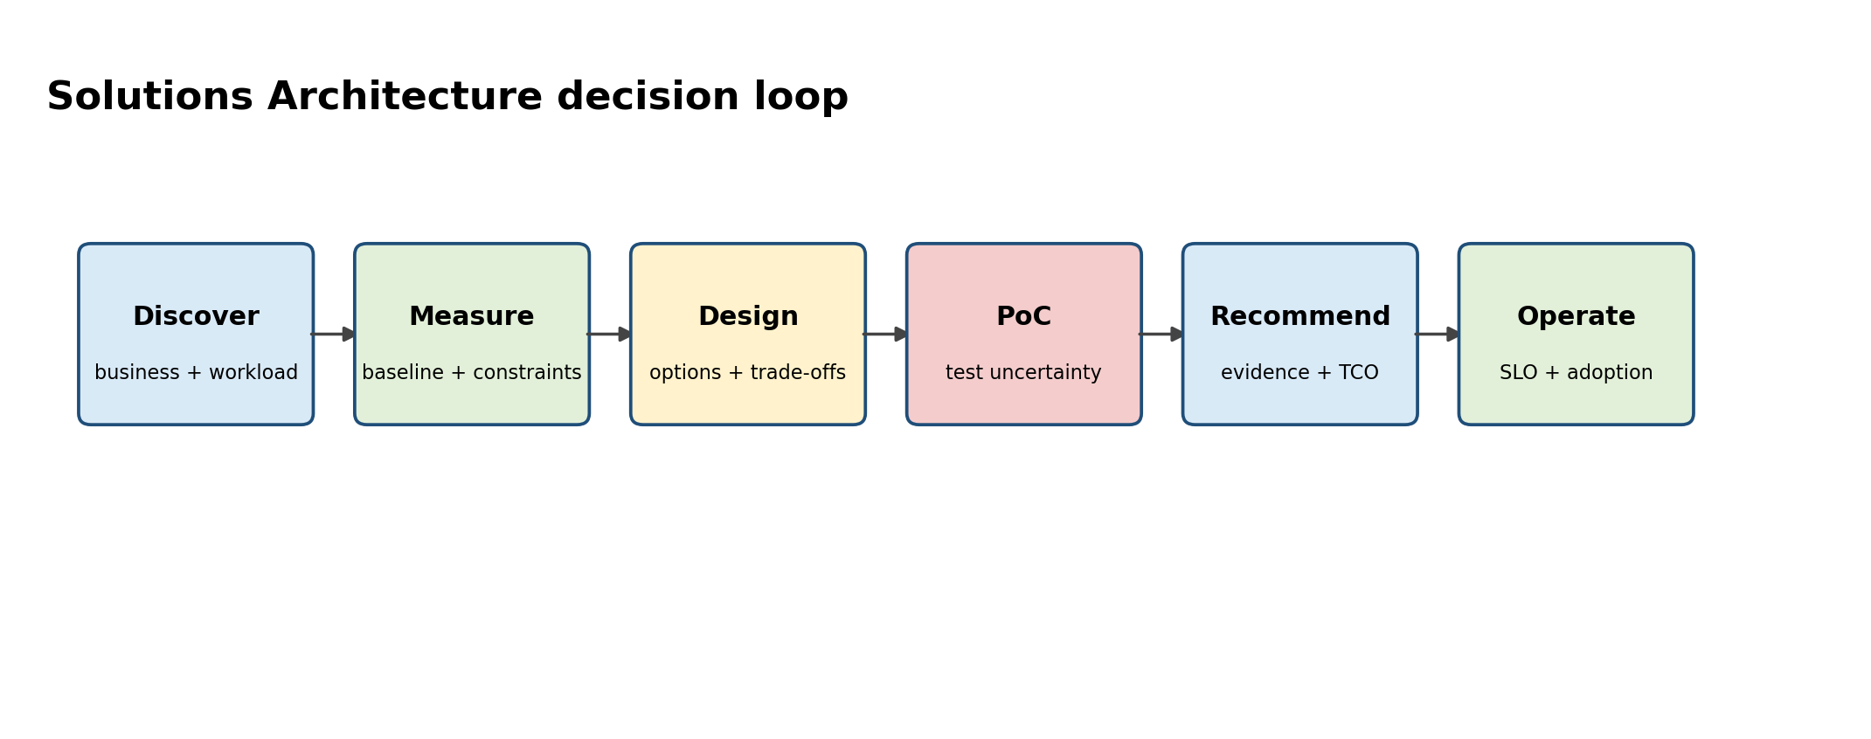
Figure A. A senior SA turns ambiguity into evidence, then into a decision.

Senior Deep Dive 1 — Workload characterization before architecture
Do not start a customer conversation with products. Characterize workload: training versus inference, model sizes, precision, sequence lengths, concurrency, batch behavior, data volume, checkpoint frequency, latency/throughput SLOs, tenancy, regions, compliance, lifecycle and operator skills. The same “LLM platform” requirement can imply one GPU in Kubernetes or hundreds of nodes with a dedicated fabric.
Discovery area | Questions that change design
Performance | TTFT/ITL targets? tokens/s? training step time? tail latency?
Scale | peak concurrency, model count, GPU count, growth, burstiness?
Data | dataset size, small-file count, checkpoint size/frequency, locality?
Availability | RTO/RPO, multi-zone/rack, maintenance windows, failover behavior?
Tenancy | hard isolation or fair-share? chargeback? reservations? priorities?
Operations | Kubernetes or Slurm skills? GitOps? on-call ownership? air-gap?

Senior Deep Dive 2 — AI factory layered architecture
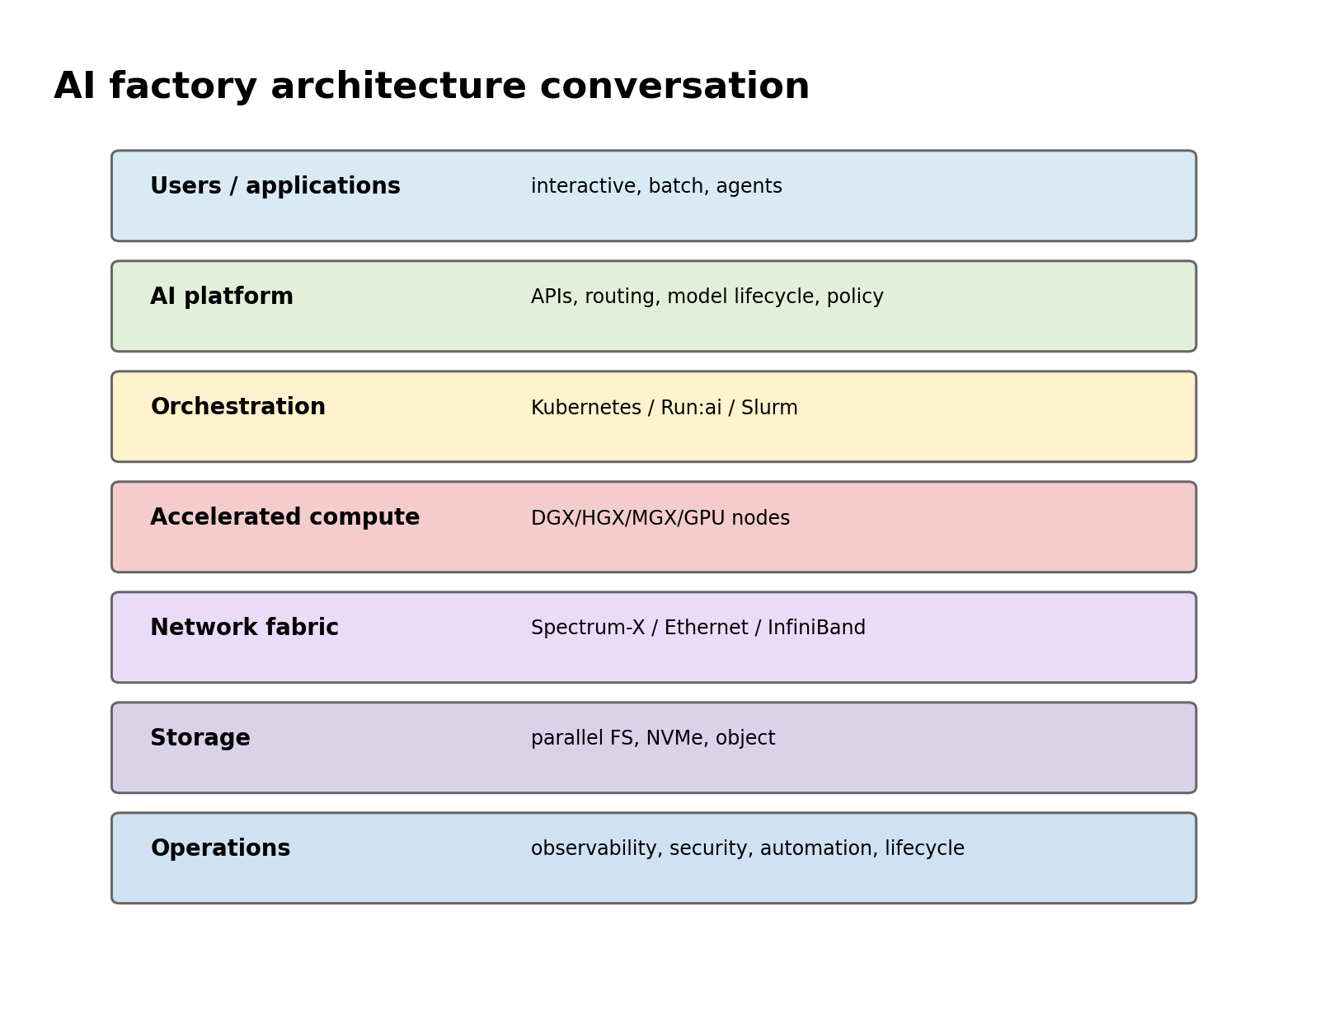
Figure B. Architecture reviews must connect user workloads to orchestration, accelerated compute, network, storage and operations.
An AI factory is an integrated system, not “GPUs plus Kubernetes”. Compute nodes, high-speed fabric, storage, provisioning/lifecycle, scheduler/orchestrator, model/runtime stack, observability, identity/security and developer workflows must form one operational product. The data path and control path should be explicit in the diagram.

Senior Deep Dive 3 — Capacity and TCO: convert SLO into resources
Sizing begins with a measured throughput/latency point for a specific model, engine, precision, hardware and traffic distribution. Then account for peak load, headroom, failure capacity, maintenance, model replicas, load time and utilization. TCO includes GPU hours, CPU/RAM, storage, network, licenses, operator effort, idle capacity and cost of SLO misses. Avoid quoting theoretical GPU peak performance as application capacity.
For shared platforms, utilization is a portfolio problem. MIG, fractional scheduling, queueing, reservations, priorities and autoscaling change both efficiency and predictability. The customer conversation should make the trade explicit: highest utilization can conflict with deterministic latency or isolation.

Senior Deep Dive 4 — PoC design: test the uncertainty
A PoC is not a product demo. Start with the architecture uncertainty that could invalidate the recommendation: Can the storage system feed 64 GPUs? Does disaggregated inference improve SLO/TCO for this prompt mix? Does RoCE remain stable under concurrent training? Can the customer’s security controls work with privileged GPU operands? Define success thresholds, workload generator, telemetry and failure tests before implementation.
PoC question | Metric | Pass/fail example
Inference capacity | p95 TTFT, p95 ITL, tokens/s/GPU | meets SLO at peak concurrency + headroom
Training fabric | step time, collective bandwidth, straggler spread | within agreed % of baseline across nodes
Storage | GB/s, metadata ops, GPU idle due to input | GPU feed target sustained during checkpoint cycle
Resilience | recovery time, failed requests/jobs | node loss stays within RTO/SLO
Operations | upgrade duration, rollback, observability | canary upgrade + verified rollback procedure

Senior Deep Dive 5 — Security and governance for GPU/AI platforms
Separate cluster administration, platform administration and tenant privileges. Protect model/data secrets, registry credentials and cloud identities. GPU Operator components may require elevated privileges to configure host devices, so isolate and audit their deployment. For inference APIs, enforce authentication, authorization, rate limits, tenant quotas, request size/token limits and sensitive-data handling. For air-gapped environments, image/model/package mirroring becomes a lifecycle problem.

Senior Deep Dive 6 — Decision workshops: Kubernetes, Slurm, Run:ai, NIM and Dynamo
The correct answer is often a composition. Kubernetes may host long-running inference, platform APIs and operators. Slurm may run tightly coupled batch training. Run:ai may provide AI-aware scheduling and GPU allocation on Kubernetes. NIM provides packaged model serving; Dynamo coordinates distributed inference when advanced routing, cache management or disaggregated serving is justified. Every layer adds capability and operational responsibility; only add it to solve an explicit requirement.

Senior Deep Dive 7 — Communicate at three levels
With engineers, show data paths, failure modes and commands. With platform leaders, show operational ownership, SLOs, lifecycle and adoption. With executives, show business outcome, risk, cost and decision. The architecture is the same; the representation changes. A strong SA can move between these levels without contradicting the technical model.

Senior Deep Dive 8 — Practitioner role model: Solutions Architect versus implementation engineer
Public practitioner material from NVIDIA SAs emphasizes requirements discovery, evaluating trade-offs, PoCs, guiding implementation and stakeholder communication. This is the differentiator from an engineer who only knows product configuration. During an interview, make your reasoning visible: clarify constraints, propose options, state trade-offs, recommend one, and define how you would validate it.

Targeted references and reinforcement
NVIDIA Solutions Architect, DevOps — Germany: https://de.linkedin.com/jobs/view/solutions-architect-devops-at-nvidia-4424636420 — Current role-family requirements: K8s AI/ML workloads, Linux/storage, automation/observability and consultative architecture.
NVIDIA SA hiring signal — MLOps/LLMOps/GenAI platform: https://www.linkedin.com/posts/amitnvidia_hiring-bengaluru-mlops-activity-7475583242381721600-DIXX — Current practitioner signal: serving, GPU Kubernetes, batching/routing/KV cache, TTFT/TPOT/tokens/s, RAG/agents, enterprise readiness.
Vishakha Sadhwani profile/posts: https://www.linkedin.com/in/vsadhwani — SA versus FDE framing and infrastructure-to-AI skill transition.
NVIDIA DGX Cloud Run:ai: https://docs.nvidia.com/dgx-cloud/run-ai/latest/overview.html — Kubernetes-based AI workload management and GPU allocation context.

