VOLUME 9
JR2018680 Interview Preparation
Coding, full-stack troubleshooting, AI infrastructure architecture and customer scenarios
Fourth Edition - Teaching text with mechanisms, examples, visuals, scenarios and exercises
Independent study guide based on public documentation and public practitioner material. Not an NVIDIA publication.

Chapter 1 - The answer framework: expose your reasoning
Learning outcome
Use clarification, hypotheses, evidence and trade-offs so the interviewer can follow your technical judgment.
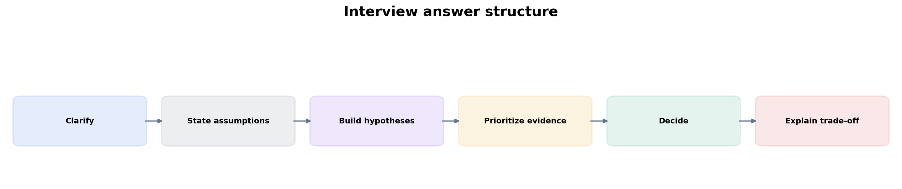
Figure 1. Strong answers are ordered reasoning, not command dumps.
For troubleshooting, say what you need to know, then state the first branch of your hypothesis tree and what evidence will distinguish it. For architecture, discover requirements before naming technologies. For Python, state the algorithm/data structure before typing. This makes seniority visible even when you do not remember one command or API exactly.
Bad opening
“I would check logs, restart the Pod, and see if it works.”
Better opening
“First I want to scope whether this is one Pod/node or the service. If the Pod is Pending, container logs do not exist yet; I’ll read scheduling events to determine whether capacity, taint/affinity, PVC or GPU resource accounting is blocking placement.”

Chapter 2 - Python coding interview workflow
Learning outcome
Turn an infrastructure problem into algorithm, data structures, functions, tests and edge cases before production hardening.
Problem
-> define input/output
-> identify dominant operation
-> choose data structure
-> pseudocode
-> implement smallest correct core
-> test edge cases
-> discuss complexity
-> add production reliability
Example prompt: “Parse a large log and report ERROR/CRITICAL counts by service.” Say: stream file line-by-line; regex or structured parser extracts severity/service; Counter[str] aggregates; skip/track malformed lines; O(n) time and O(k) memory where k is number of services, not number of lines.
from collections import Counter
from collections.abc import Iterable
import re
EVENT = re.compile(r"level=(ERROR|CRITICAL).*service=([\w-]+)")
def count_errors(lines: Iterable[str]) -> Counter[str]:
counts: Counter[str] = Counter()
for line in lines:
match = EVENT.search(line)
if match:
counts[match.group(2)] += 1
return counts
Then discuss malformed input, memory, testing, structured logs, and whether JSON output would be more reliable than regex when available. Do not start by inventing classes or concurrency before the core algorithm is correct.

Chapter 3 - Linux troubleshooting questions
Learning outcome
Practice translating symptoms into CPU, memory, I/O, process or network evidence.
Question | Strong first branch
Load 30, CPU 40% | runnable vs D-state blocked tasks vs cgroup throttling
OOMKilled but node has free memory | container cgroup limit vs node OOM
disk is slow | capacity vs inode vs latency/queue vs workload pattern
service restarts | exit code/app crash vs OOM/signal vs systemd policy/dependency

Worked scenario
Situation
Interviewer: “The system is slow. What do you do?”
1. Clarify what “system” and “slow” mean: request latency, shell responsiveness, job throughput, one node or fleet.
2. Check recent changes and scope.
3. Use a resource saturation snapshot: CPU/run queue, memory/swap, I/O latency, network/dependency latency.
4. Drill into the subsystem that correlates with the symptom.
5. Propose a safe mitigation only after evidence.
Conclusion
The senior answer converts an ambiguous symptom into measurable dimensions before commands.

Chapter 4 - Kubernetes troubleshooting questions
Learning outcome
Use object status/events to find the control-loop stage, then descend to node/Linux evidence.
Symptom | First evidence
Pending | Pod events + scheduler constraints
ContainerCreating | kubelet/CNI/CSI/image/sandbox events
CrashLoopBackOff | previous termination reason/exit code + previous logs
NotReady | readiness probe/dependency/application evidence
Service unreachable | EndpointSlice -> DNS -> service dataplane -> CNI/policy

Worked scenario
Situation
Interviewer: “Pods are Pending despite cluster autoscaler enabled.”
1. Read FailedScheduling reason.
2. Ask whether any node type the autoscaler can create would satisfy the Pod.
3. Check max size/resource limits/quota.
4. Check affinity/taints/PVC topology/GPU resource type that may prevent expansion from helping.
5. Only then investigate autoscaler implementation/logs.
Conclusion
Autoscaler is not a universal cure for unschedulable constraints.

Chapter 5 - GPU and AI infrastructure troubleshooting
Learning outcome
Walk application -> serving/training -> GPU -> runtime/operator -> host -> network/storage.

Worked scenario
Situation
Interviewer: “A distributed GPU training job is 40% slower than yesterday.”
1. Clarify whether slowdown is startup, step time, collective phase, data load or checkpointing.
2. Scope across jobs/nodes and identify recent infrastructure changes.
3. GPU: utilization, memory, clocks, errors/throttling.
4. Host: CPU/memory/I/O/cgroup pressure.
5. Network: link/RDMA counters, errors, topology, NCCL/collective benchmark.
6. Storage: dataset/checkpoint latency/throughput.
7. Isolate with controlled benchmark, node removal or rollback.
Conclusion
The answer is a layered hypothesis tree with phase timing—not “check GPU utilization.”

Chapter 6 - AI inference architecture questions
Learning outcome
Use workload metrics, serving mechanics and SLOs to justify GPU count, sharing and scaling.
Prompt | What interviewer wants to hear
Scale an LLM service | queue/concurrency/TTFT/TPOT/tokens + cold start + GPU granularity, not CPU-only HPA
MIG vs time slicing | workload fit, isolation, latency variance, hardware support, operational complexity
Triton/NIM/vLLM | benchmark target model/hardware; distinguish model server from gateway/platform
Low GPU utilization | could be low demand, input starvation, batching issue, CPU/network/storage bottleneck
When asked for a number of GPUs, state that capacity is benchmark-derived. You can explain the formula: required throughput divided by measured per-replica throughput at SLO, rounded for replica/GPU granularity, then add availability/peak headroom.

Chapter 7 - HPC networking questions
Learning outcome
Explain RDMA/RoCE/InfiniBand and troubleshoot performance from link to collective behavior.
A good explanation of RDMA starts from data movement and CPU-copy overhead, then describes registered memory/remote operations and fabric implications. A good RoCE answer includes Ethernet fabric/congestion/loss design rather than only “RDMA over Ethernet.” A good training-network answer connects NIC/GPU topology and NCCL collectives to observed step time.

Worked scenario
Situation
Interviewer: “How do you prove the network is slowing training?”
1. Show that the slow phase is communication/collective time, not data loading or compute.
2. Compare collective benchmark/bandwidth across nodes or before/after change.
3. Inspect NIC/RDMA link state, speed and error/congestion counters.
4. Check topology and outlier nodes/paths.
5. Correlate network evidence with job step time.
Conclusion
Network suspicion becomes network diagnosis only when communication timing and fabric evidence correlate.

Chapter 8 - Solutions architecture whiteboard method
Learning outcome
Discover, model paths/state/failure domains, compare options, recommend and define validation.
Before drawing boxes, ask workload type, SLO, scale, data location, tenancy/security, current platform skills, budget and growth. Then draw request/data/control paths and failure domains. Compare two or three options on weighted dimensions. End with a recommendation plus what the PoC/benchmark must validate.

Worked scenario
Situation
Design a shared 128-GPU platform for training and inference.
1. Clarify training/inference split, models, concurrency, distributed job sizes and SLOs.
2. Define GPU pool strategy: homogeneous/heterogeneous, full GPU vs MIG/shared pools, topology requirements.
3. Choose scheduler/orchestration model per workload; consider Kubernetes, Slurm or integration.
4. Design fabric/storage around distributed training and model/data paths.
5. Define identity/tenancy/quota, observability, lifecycle automation and failure domains.
6. Capacity-test peak inference + training contention and define admission/fair-share policy.
Conclusion
A platform architecture is workload + resource-control + data-path + operations, not a Kubernetes diagram.

Chapter 9 - Customer discovery interview
Learning outcome
Practice consultative questions that reveal constraints instead of demonstrating jargon.
Use a funnel: business outcome -> workload/SLO -> current state -> constraints -> risks -> decision. Ask follow-ups based on answers. If the customer says “on-prem because security,” clarify which data/residency/control requirement prevents cloud; do not accept or challenge the premise without understanding it.
Customer statement | Useful follow-up
We need GPUs | For training, inference or both? Which model sizes and peak concurrency/job sizes?
We need high availability | Which workload SLO and failure domains? What RTO/RPO for state/checkpoints?
We want Kubernetes | Which existing operational strengths or platform integration drive that choice?
We need low cost | Cost per what outcome—job completion, tokens, request SLO? What utilization/headroom is acceptable?

Chapter 10 - Behavioral and stakeholder stories
Learning outcome
Structure examples around ownership, conflict, customer ambiguity, incident leadership and measurable outcome.
Use STAR, but make the technical decision visible. Situation should be brief. Task states your responsibility. Action is the bulk: how you reasoned, influenced, handled trade-offs and changed the system. Result includes measurable impact and what you learned. Senior stories should show decisions under ambiguity, not only task execution.
Theme | Story ingredients
Incident | scope, evidence, mitigation, coordination, prevention, MTTR/reliability result
Cost optimization | baseline, constraints, safe changes, performance guardrail, quantified savings
Architecture disagreement | requirements, alternatives, trade-off evidence, stakeholder alignment
Customer ambiguity | discovery, reframing problem, PoC/decision, adoption outcome
Failure/lesson | wrong assumption, signal missed, correction, system/process change

Chapter 11 - Question bank: foundations to SA depth
Learning outcome
Use after studying the corresponding volumes; answer aloud and force one evidence/trade-off follow-up.
Domain | Question
Python | Why is a set a better choice than a list for repeated membership checks?
Python | Design a retry policy for a POST API. What changes if the operation is not idempotent?
Linux | Why can load average be high while CPU is low?
Linux | Container OOMKilled with node memory available—explain.
Networking | DNS resolves but TCP connect times out. What does each next test prove?
Kubernetes | Deployment exists but no Pods—where can reconciliation have stopped?
Kubernetes | Why can an idle node be unschedulable?
Kubernetes | Explain HPA and cluster autoscaler as two loops.
GPU | Driver works but Kubernetes has no GPU resource—trace layers.
GPU | MIG versus time slicing for production inference.
AI | What makes TTFT different from tokens/s as a capacity signal?
AI | Why can GPU utilization be a poor HPA trigger?
HPC | RoCE versus InfiniBand from an architecture perspective.
HPC | How do you isolate NCCL/network versus storage slowdown?
Observability | Which metric/log/trace evidence do you want for rising P99 latency?
SA | Kubernetes or Slurm? Ask five questions before answering.
SA | How would you design a PoC for a new GPU platform?
Customer | Explain GPU sharing to a CTO versus an SRE.

Chapter 12 - 45-minute mock interview structure
Learning outcome
Practice realistic pacing rather than endless question banks.
Minutes | Segment
0–5 | intro + current role / architecture summary
5–15 | Python or automation coding/reasoning
15–27 | full-stack troubleshooting
27–38 | AI/GPU infrastructure architecture / whiteboard
38–43 | customer/stakeholder scenario
43–45 | candidate questions / wrap
After each mock, score only meaningful competencies: clarity of assumptions, mechanism depth, evidence ordering, trade-off quality, coding correctness and customer communication. Choose one or two gaps for the next refresh session rather than re-studying everything.

Practice
1. Answer five questions from the bank aloud with a 2-minute limit, then add a 1-minute follow-up.
2. Do one Python problem using algorithm-first workflow without looking at code.
3. Whiteboard a 64-GPU training platform and explicitly draw control path, data path and failure domains.
4. Prepare four STAR stories: incident, cost/reliability improvement, architecture trade-off, stakeholder disagreement.

FOURTH EDITION — SENIOR ENGINEERING EXPANSION · VOLUME 9

Senior NVIDIA Solutions Architect interview drills and answer patterns
This expansion keeps the Fourth Edition teaching flow and adds the depth expected from a senior infrastructure engineer and customer-facing Solutions Architect. The emphasis is mechanism first: understand what the system is doing, observe it with concrete tools, then reason about failure, scale, reliability, performance and trade-offs.
The practitioner material used to shape the scope is a signal, not an authority. Technical behavior is anchored in official documentation and first-principles systems reasoning. Your Staff Engineer study guide contributes useful patterns around Kubernetes, observability, distributed systems, platform design and failure isolation; the NVIDIA material adds GPU systems, AI workloads, accelerated networking and customer architecture.
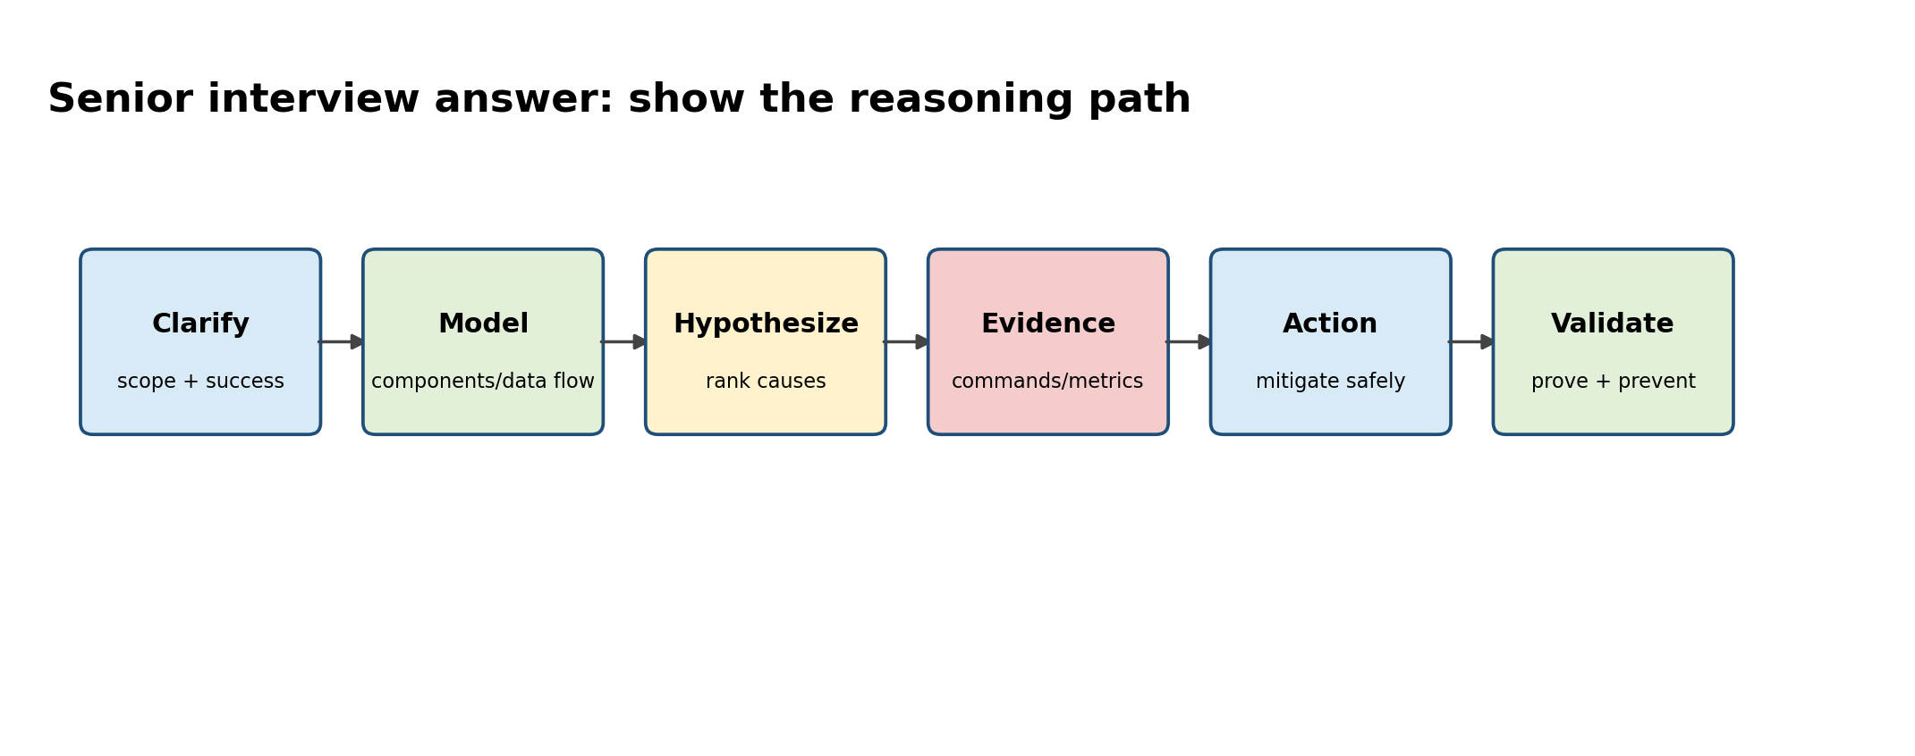
Figure A. The interviewer should hear your reasoning, not only the final technology choice.

Senior Interview Method — Clarify, model, hypothesize, test, recommend
For troubleshooting questions, do not enumerate random commands. Clarify scope and recent changes; draw the relevant data path; rank hypotheses; name the evidence that separates them; choose a safe mitigation; validate the original symptom; then discuss prevention. For architecture questions, replace hypotheses with requirements and options, but keep the evidence-led structure.
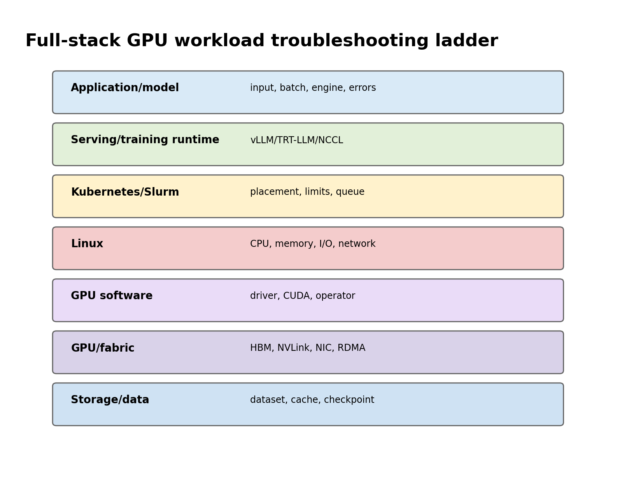
Figure B. When a GPU workload is slow, descend the stack systematically until evidence explains the symptom.

Question set A — Linux and host mechanics
Question | What a senior answer should expose
Load average 40 but CPU 25% — explain | runnable vs D-state tasks, I/O, per-cgroup throttling, vmstat/ps/wchan/PSI
Container OOM but node has free RAM | cgroup memory boundary, memory.events, working set, requests/limits
Only some GPU nodes are slow | NUMA, PCIe/NIC topology, driver/kernel image, CPU feeder/storage/fabric evidence
TCP connection times out | DNS/route/SYN path/firewall/conntrack/listener; packet capture and ss
Disk 70% full yet writes fail | inodes, quotas, read-only FS, mount/device errors, filesystem reservations

Question set B — Python coding and production automation
Practice coding in small increments. State the data structure before code, make parsing and policy pure, then add effects. Typical tasks: parse multi-format logs, aggregate errors by service/node, implement bounded retry, query many endpoints concurrently, compare desired/actual state, build a CLI and test it.
Practice explaining complexity, malformed input and memory strategy
# Interview task skeleton: summarize failures by node and error type
from collections import Counter, defaultdict
import re

PATTERN = re.compile(
r"^(?P<ts>\S+)\s+(?P<node>\S+)\s+"
r"(?P<level>ERROR|CRITICAL|FATAL)\s+(?P<msg>.+)$"
)

def summarize(lines: list[str]) -> dict[str, Counter[str]]:
result: dict[str, Counter[str]] = defaultdict(Counter)
for line in lines:
m = PATTERN.match(line.strip())
if not m:
continue
# In a real problem, classify msg into stable error categories.
result[m['node']][m['level']] += 1
return dict(result)

Question set C — Kubernetes platform depth
Prompt | Expected reasoning
Pod Pending on GPU cluster | scheduler event -> requests/DRA -> affinity/taint -> topology -> capacity/autoscaler
Service reachable from some Pods only | EndpointSlice, DNS, policy, CNI route, node-specific dataplane
Node Ready but GPU unavailable | host driver -> operator operands -> device plugin/DRA -> allocatable -> runtime injection
Deployment rollout stuck | new ReplicaSet, readiness/startup, capacity, PDB/maxSurge, image/config, events
Control plane writes slow | apiserver latency, admission webhooks/policies, etcd latency/quorum

Question set D — GPU and accelerated networking
Prompt | Expected reasoning
GPU util 100%, throughput low | compute vs memory/communication, clocks, batch, kernel/engine metrics
8 GPUs visible, scaling poor | NVLink/NVSwitch/PCIe topology, NCCL algorithm, CPU/NIC locality
MIG or time-slicing? | hard isolation/predictability vs flexible sharing, workload memory/latency, ops
Multi-node training regressed | rank scope, RDMA/NCCL/fabric counters, topology, straggler amplification
Xid appears | correlate device/time/workload, DCGM/driver logs, recurrence/recovery, vendor guidance

Question set E — AI inference architecture
Prompt | Expected reasoning
TTFT high, ITL normal | queue/prefill/input length/model load/cache routing
ITL high under concurrency | decode/KV/memory pressure/batching
When disaggregate prefill/decode? | different resource shapes + fast KV transfer + measured benefit
Round-robin vs KV-aware routing | cache reuse/load balance/worker state/failure complexity
Scale on what metric? | queue/tokens/SLO/engine state, warmup/model load, GPU scarcity

Question set F — Customer architecture and PoC
• A customer wants 32 H100-class GPUs for “an LLM platform”. What workload facts do you request before sizing?
• The customer mandates Kubernetes but training team wants Slurm. Design an operating model that avoids two schedulers fighting for the same nodes.
• Storage vendor claims 200 GB/s. Design a PoC that proves whether training GPUs will stay fed during checkpointing.
• Security disallows privileged workloads. Explain why GPU node enablement may require elevated host access and propose governance/isolation options.
• The customer wants maximum GPU utilization and strict p99 latency. Explain the inherent tension and the experiments needed to choose a sharing model.

Question set G — Whiteboard: production GenAI platform
Whiteboard from requirements outward: client/gateway -> auth/rate limits -> model routing -> serving runtime -> GPU scheduling -> compute topology -> network/storage -> observability -> lifecycle/CI/CD -> failure domains. Ask about model count, prompt/output distribution, concurrency, data residency, availability and cost. Then choose components. A diagram that begins with “NIM” or “Kubernetes” before requirements is backwards.

Question set H — Behavioral stories for a senior SA
Prepare evidence-rich stories around: a production incident where you reduced uncertainty; a design where you rejected a fashionable technology; a disagreement with an application/customer team; a cost optimization that preserved reliability; an automation that replaced manual toil; a migration with risk control; and a situation where you explained a complex system to a non-specialist stakeholder. Use situation/context briefly, spend most time on decisions, trade-offs and measurable outcome.

Current role-family signals to be able to discuss
A current NVIDIA Solutions Architect, DevOps listing in Germany explicitly emphasizes Kubernetes for AI/ML workloads, HPC/AI hardware and high-speed interconnects, Linux/storage, Python/Bash, IaC, Prometheus/Grafana/Loki and customer architecture. Other current NVIDIA SA postings emphasize NIM/Triton/TensorRT-LLM/vLLM, GPU Kubernetes, MIG/scheduling, TTFT/TPOT/tokens-per-second, RAG/agents, RDMA and on-prem AI factory design. Treat these as role-family signals, not a claim that every question will cover every technology.

Targeted references and reinforcement
NVIDIA Solutions Architect, DevOps — Germany: https://de.linkedin.com/jobs/view/solutions-architect-devops-at-nvidia-4424636420 — Direct role-family signal for the interview focus.
NVIDIA Senior SA GenAI practitioner hiring signal: https://www.linkedin.com/posts/amitnvidia_hiring-bengaluru-mlops-activity-7475583242381721600-DIXX — Inference operations, GPU Kubernetes, metrics, RAG/agents and enterprise architecture.
NVIDIA SA inference deployments: https://www.linkedin.com/jobs/view/solutions-architect-inference-deployments-at-nvidia-4395478253 — Current role-family signal for Dynamo, Kubernetes and multiple inference backends.
Vishakha Sadhwani public posts: https://www.linkedin.com/in/vsadhwani — Foundations-first, networking traffic flow, AI infrastructure transition, system thinking and customer-facing SA role framing.

