LeAD SCORE CASE STUDY SUBJECTIVE QUESTIONS



ABHISHEK BHATTACHARYA

JITHIN PRAKASH K

# Which are the top three variables in your model which contribute most towards the probability of a lead getting converted?

The variables with coefficients obtained are.

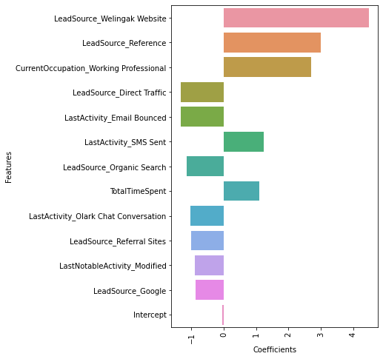

Top 3 variables that contribute most towards lead conversion are:

* **Lead Source**
* **Current occupation**
* **Last Activity**

# What are the top 3 categorical/dummy variables in the model which should be focused the most on in order to increase the probability of lead conversion?

Final formula obtained from the model is

$$logit\left(p\right)= log\left(\frac{p}{1-p}\right)= (4.49 x LeadSource_Welingak Website) + (2.99 x LeadSource_Reference) + (2.71 x CurrentOccupation_Working Professional) - (1.33 x LeadSource_Direct Traffic) - (1.32 x LastActivity_Email Bounced) + (1.24 x LastActivity_SMS Sent) - (1.16 x LeadSource_Organic Search) + (1.09 x TotalTimeSpent) - (1.03 x LastActivity_Olark Chat Conversation) - (1.01 x LeadSource_Referral Sites) - (0.88 x LastNotableActivity_Modified) - (0.88 x LeadSource_Google) - (0.06 x Intercept)$$

Top 3 variables that contribute most towards lead conversion are:

* **Lead Source: Welingak Website** – Positively related. If lead source category is from welingak website, then likelihood of conversion is more.
* **Lead Source: Reference** - Positively related. If lead source category is from Reference, then likelihood of conversion is more.
* **Current occupation: Working professional** - Positively related. If Occupation category is from Working professional, then likelihood of conversion is more.

# X Education has a period of 2 months every year during which they hire some interns. The sales team, in particular, has around 10 interns allotted to them. So, during this phase, they wish to make the lead conversion more aggressive. So, they want almost all of the potential leads (i.e. The customers who have been predicted as 1 by the model) to be converted and hence, want to make phone calls to as much of such people as possible. Suggest a good strategy they should employ at this stage.

**X Education** is planning to call as many people predicted by the model as 1, i.e. high probability of conversion, to increase the number of people with converted category as 1, we could reduce the optimum cut off value further down, from 0.33 to say 0.20 or lower, which would give much more results with predicted conversion and the interns can follow up with the additional leads that are shown as converted along with the originally existed leads. When the cut-off point is reduced, the prediction of number of converted lead increases, and the interns will have more people to contact.

Since the X Education team already has the list of potential lead, they have hired the Interns so they need to concentrate on leads those have a higher probability to convert. Make prompt calls to such leads to attract them towards X Education. The main leads to concentrate are

* **Lead Source – Welingak website (less leads), References**
* **Lead Origin – Lead Add Form**
* **Occupation – Working professional**
* **Last Activity – SMS Sent**
* **Total Time spent on website**

These leads show the highest probability to convert as per the model built,

Also, from the individual leads in the following categories show that,

* **Specialization – Healthcare Management**: Shows that the convert ratio is higher compared to non-convert ratio (Approx. 50%) however there are only few leads from this category, so the interns should concentrate to call more leads from such category so that X Education can convert much more leads in healthcare management specialization.
* **How did you hear? – Email:** Shows that the convert ratio is higher compared to non-convert ratio (around 50%), However there are only few leads from this category, so the interns should concentrate to call more leads from such category.
* **Lead Profile – Potential lead**: Potential leads have a highest conversion number and ratio. So, interns have to concentrate calling potential leads as they results in higher lead conversion.
* **Lead Profile – Lateral Student, Dual Specialization:** In both the categories, the lead conversion ratio is much higher but the total number leads are far too low. Inters has to identify such leads and make as many calls so that it will result in obtaining much more conversion number.
* **Last Notable Activity – SMS Sent:** This category has a highest correlation with the Last Activity SMS sent, as mentioned above. So, Interns have to concentrate on leads which are not intersecting with those leads, i.e. unique in the category to improve the lead conversion and business.

# Similarly, at times, the company reaches its target for a quarter before the deadline. During this time, the company wants the sales team to focus on some new work as well. So, during this time, the company’s aim is to not make phone calls unless it’s extremely necessary, i.e. They want to minimize the rate of useless phone calls. Suggest a strategy they should employ at this stage.

When X Education’s target for the quarter is met for the quarter, intention would be to reduce the number of phone calls, which can be done by reducing the cut-off point, say from 0.33 to 0.70 or higher, so that we would have less number of predicted conversions and hence less number of leads to concentrate, which helps in making decision as to which lead is critical and required to make a call. This would effectively reduce the number of calls that need to be made for lead conversion to meet the target as needed. Also concentrate more on Emails, SMS and Chat to Working professionals and lead source: References to convert the leads.