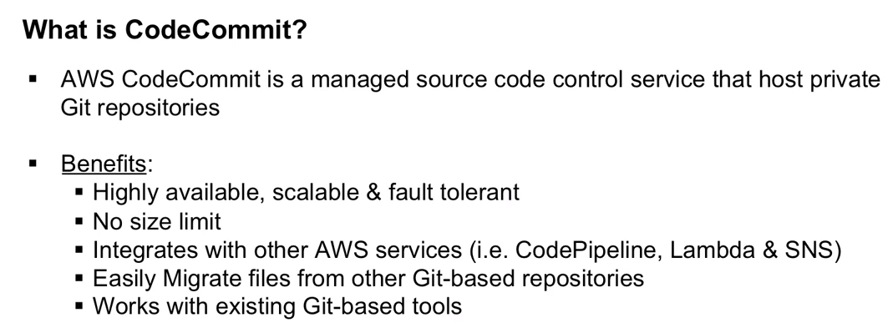

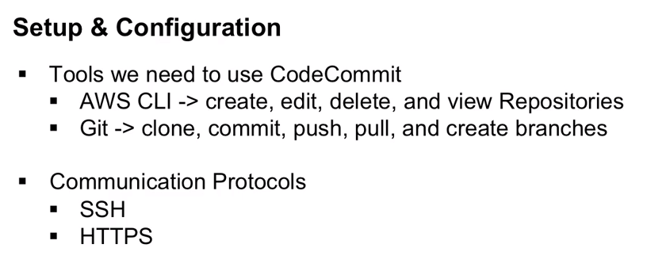

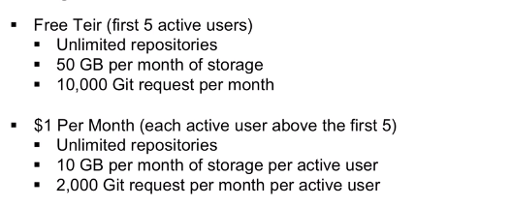

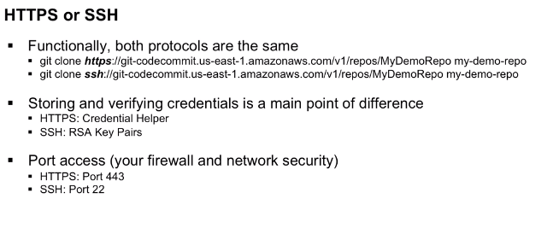

With ssh connection, we use RSA key pair (Public and private key files on local machine).We associate public key with the IAM user and private key on the local machine.

git config --global –edit //For checking and modifying the git credentials using code commit.

1. These credentials will only stay for 50 minutes, after that it won’t work.

There are two solutions for the same, they are

a) Find a version of git that doesn’t use key change by default.

b)