**Ansible**

* Ansible is an IT automation tool. It can configure systems, deploy software, and orchestrate more advanced IT tasks such as continuous deployments or zero downtime rolling updates.
* Ansible’s main goals are simplicity and ease-of-use.
* Ansible manages machines in an agent-less manner.
* Ansible is decentralized–it relies on your existing OS credentials to control access to remote machines.
* Ansible by default manages machines over the SSH protocol.

Features of Ansible

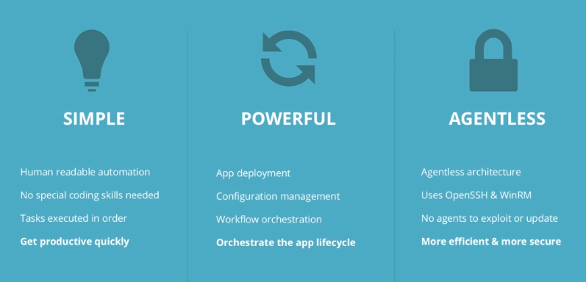

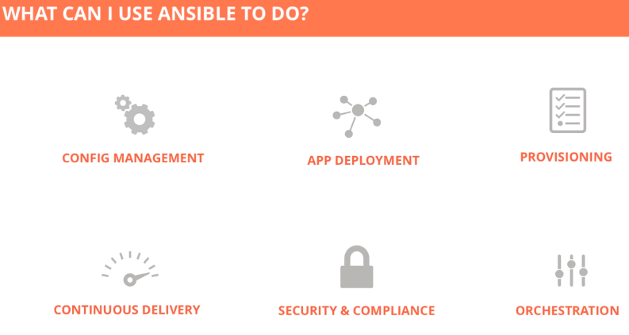

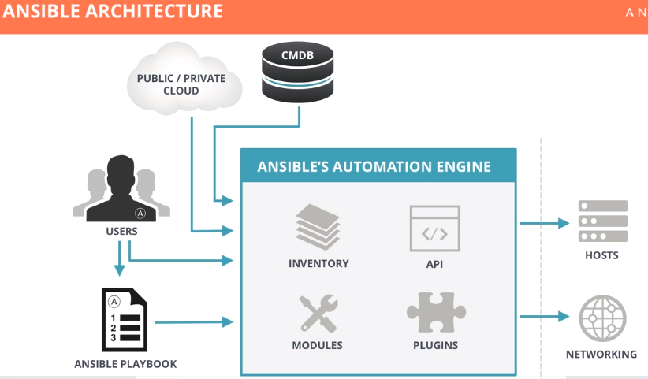

* We need to install ansible on Control machine (Server).

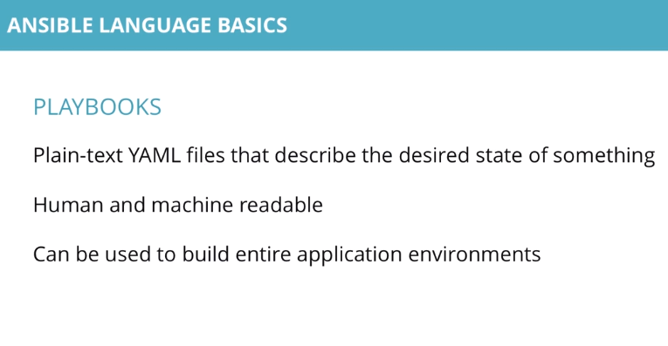

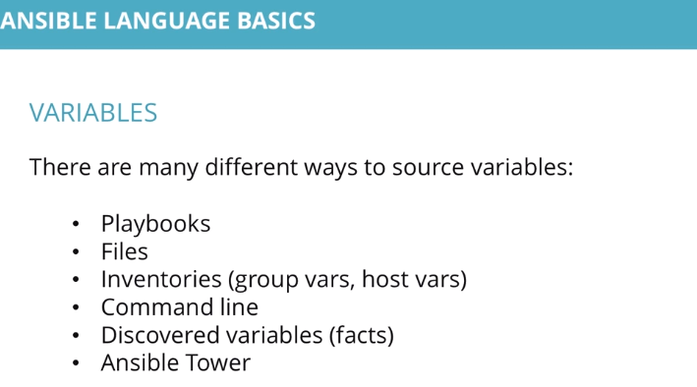

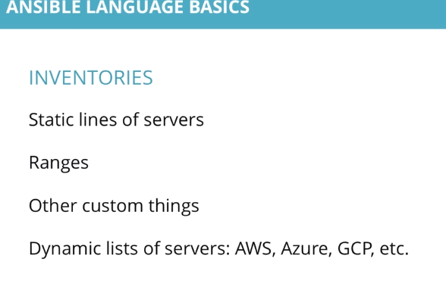

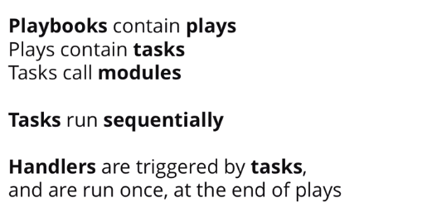

Ansible roles are special kind of playbook that are fully self-contained with tasks, variables,configurations templates and other supporting files.

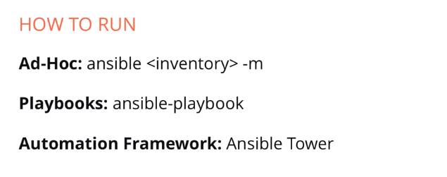

Ansible is currently owned by Redhat, they offer ansible and ansible tower.