**Terraform vs Cloud Formation**

Before we start, both tools are following a very similar approach.

1. You define a template (CloudFormation) or configuration (Terraform) describing the target state of your infrastructure.
2. The tool (CloudFormation or Terraform) calculates the necessary steps to reach the defined target.
3. The tool (CloudFormation or Terraform) executes the changes.

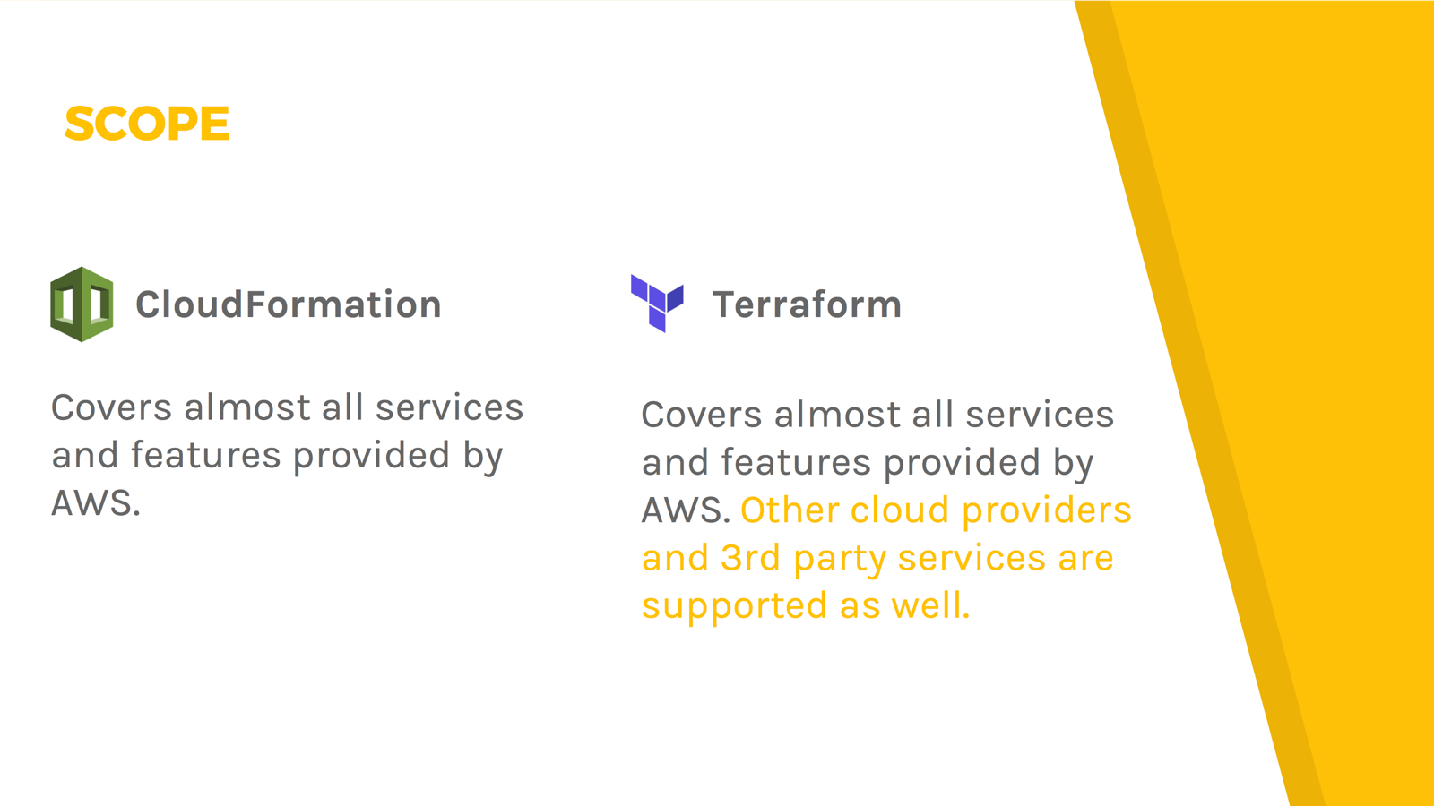

Depending on your infrastructure a big or at least small plus for Terraform

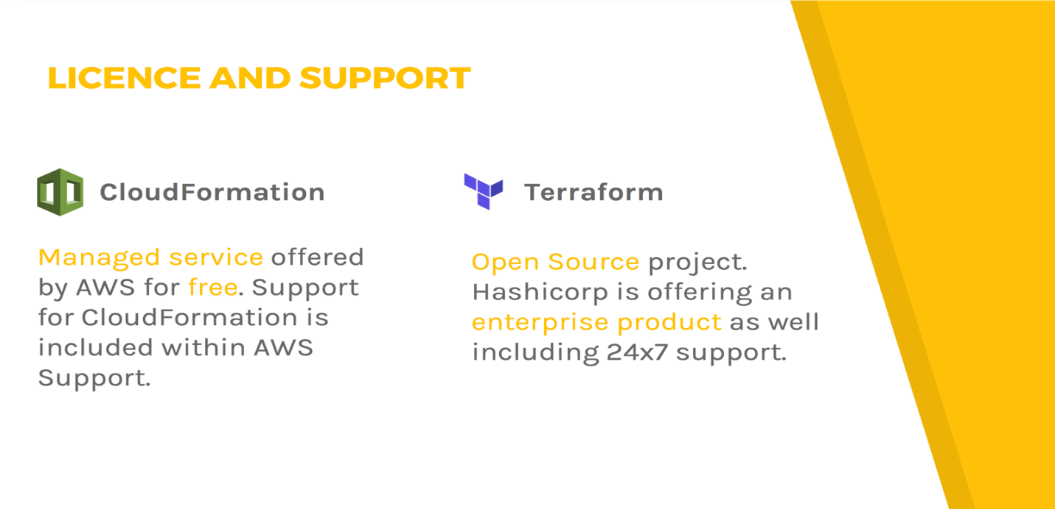

When already subscribed to an AWS support plan that might be a plus for CloudFormation. If you prefer Open Source that is a plus for Terraform.

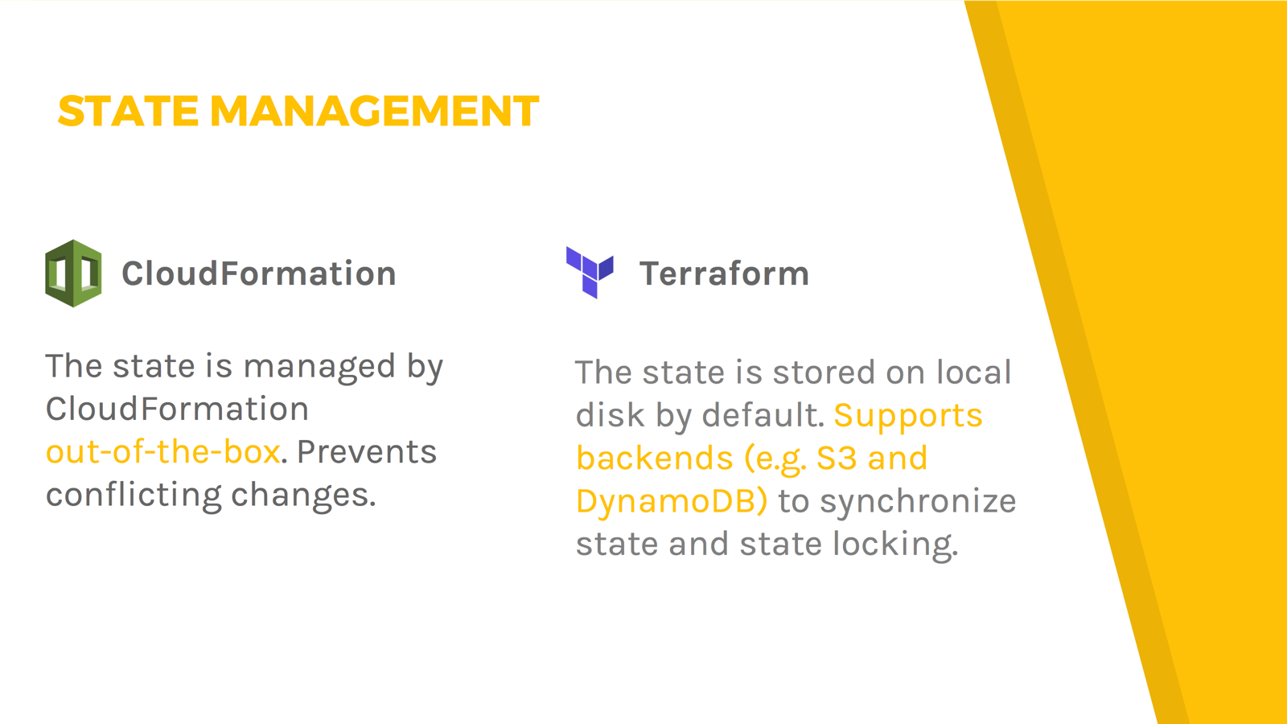

CloudFormation manages state within the managed service out-of-the-box which is a small plus compared to Terraform where you need to configure remote state yourself.

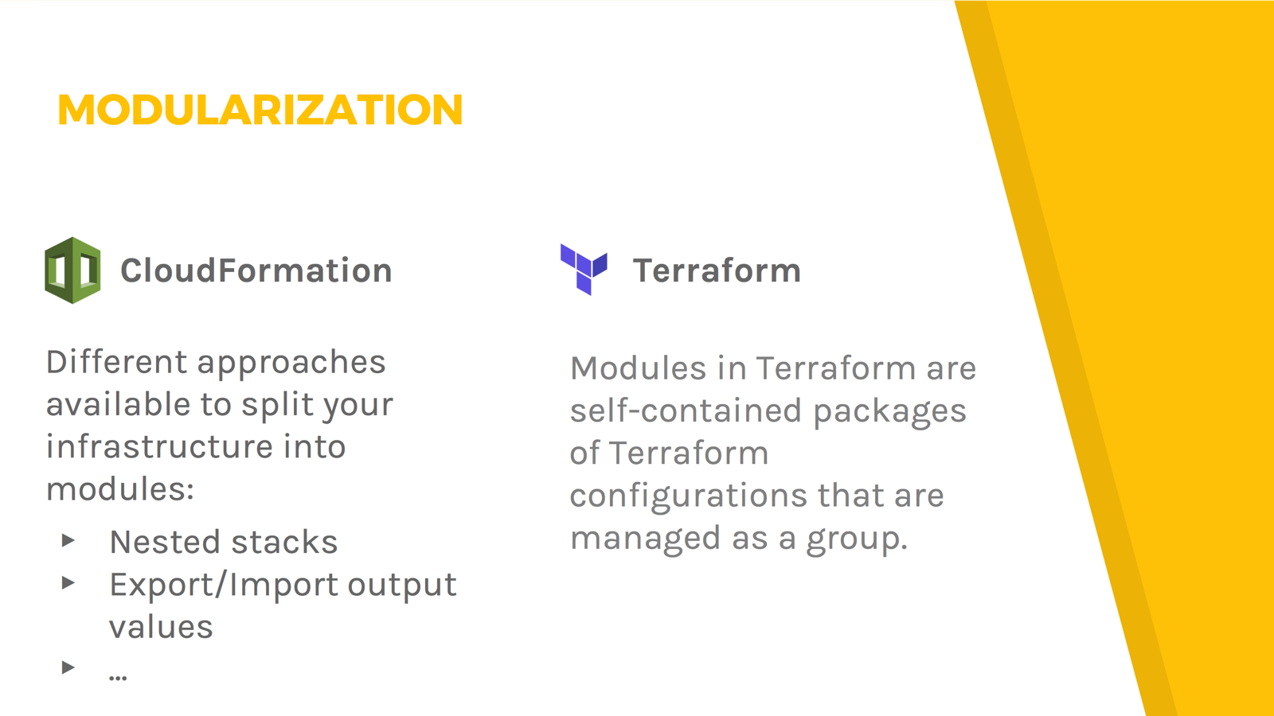

Handling modules with Terraform is simple. CloudFormation is offering multiple ways to create modules with different pros and cons. I’d award Terraform with a plus for usability.

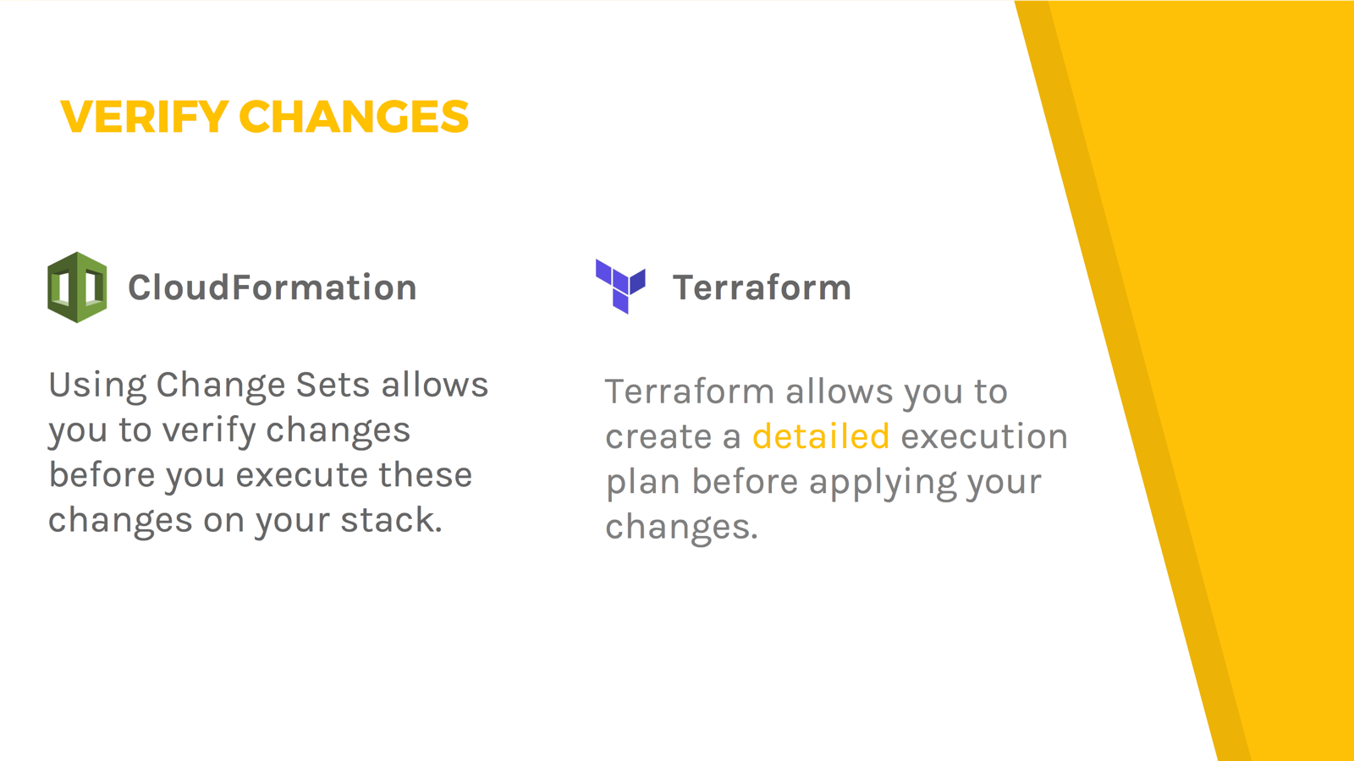

Terraform presents a detailed and readable summary of the changes that will be applied. That’s a big plus compared to the basic overview CloudFormation is providing with a change set.

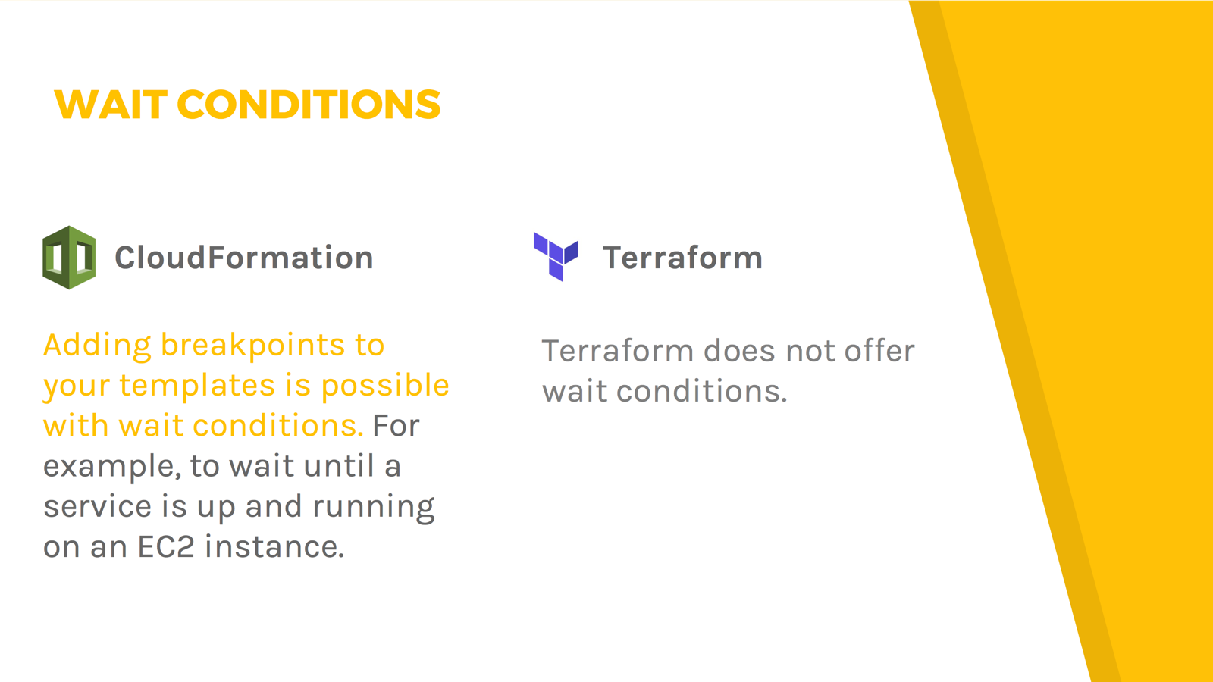

Being able to use wait conditions is a plus for CloudFormation. Terraform does not support wait conditions.

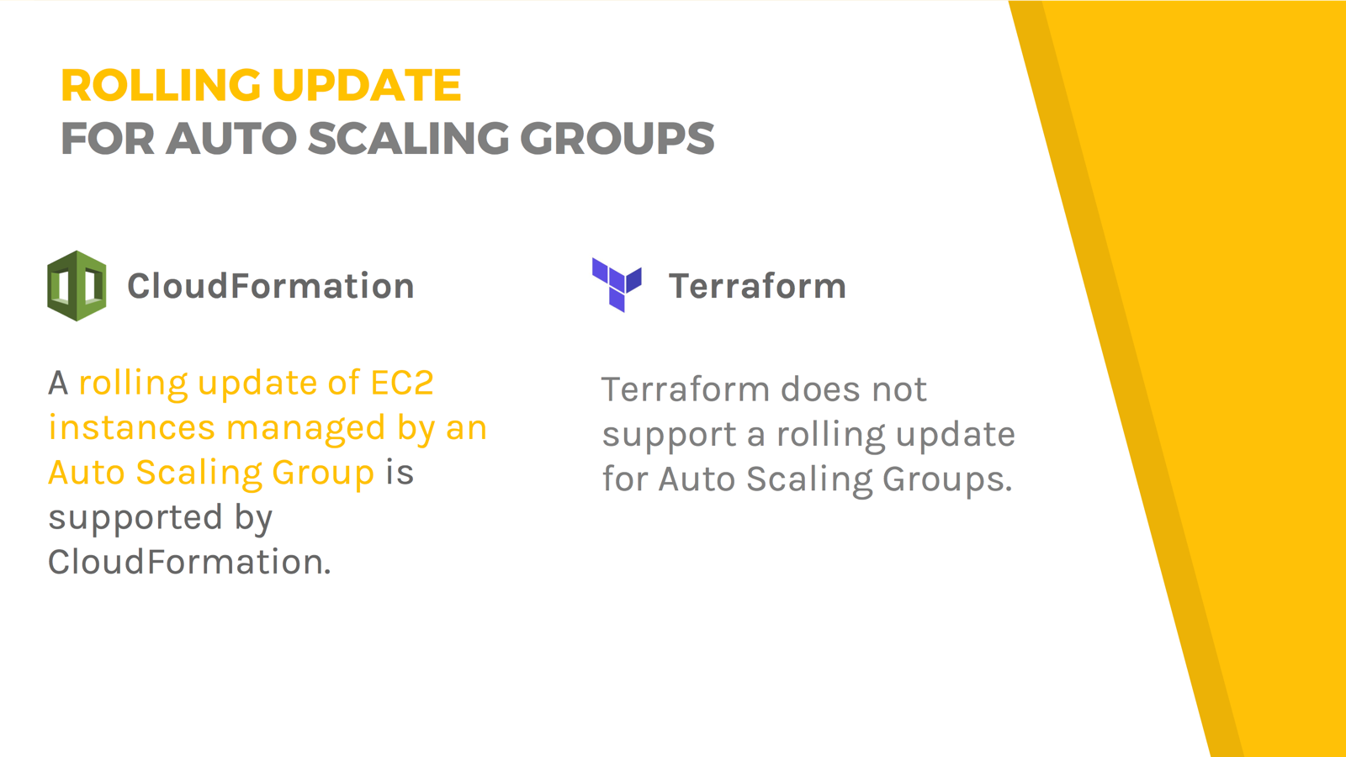

Supporting rolling updates for Auto Scaling Groups is a plus for CloudFormation.

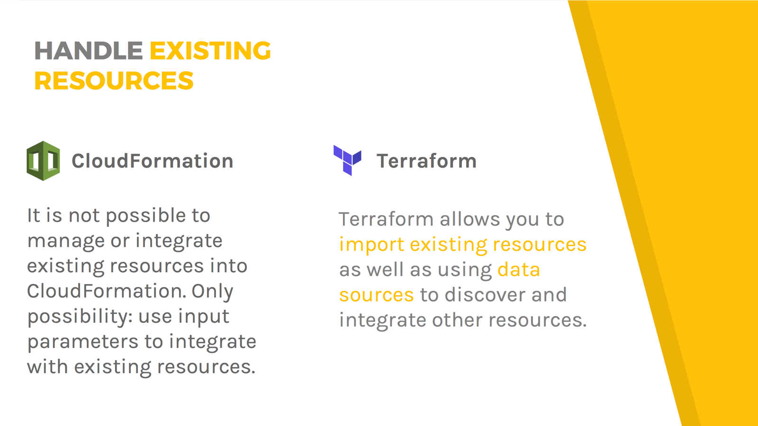

Handling existing resources is a plus for Terraform.