**CloudWatch**

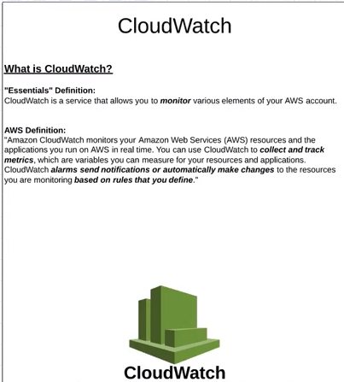

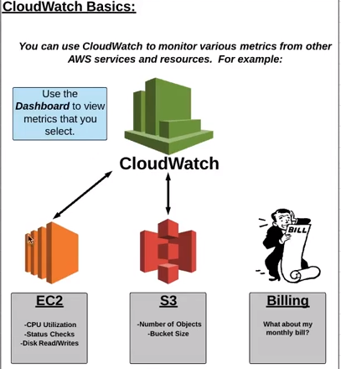

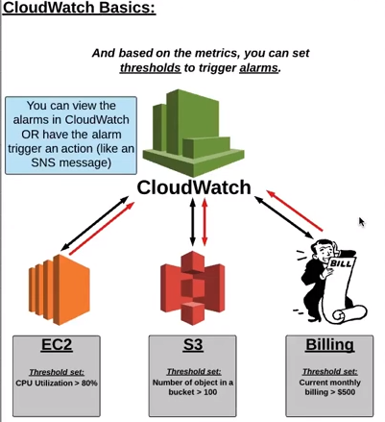

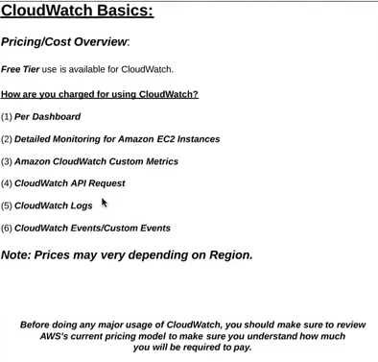

Using alarms we can trigger SNS topics.

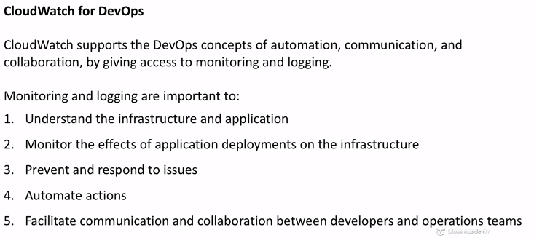

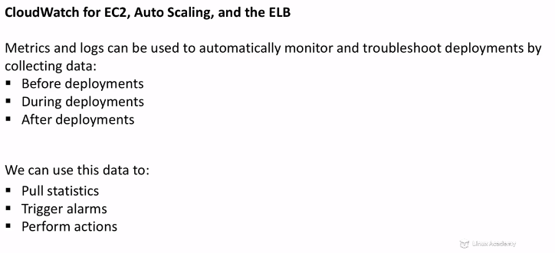  
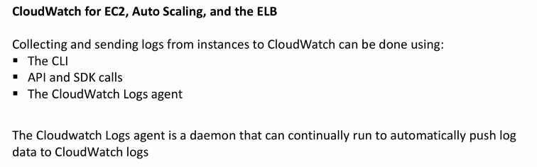

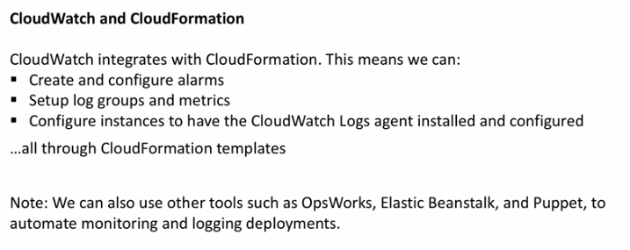

CloudTrail is used to monitor API calls made against our resources and AWS account.

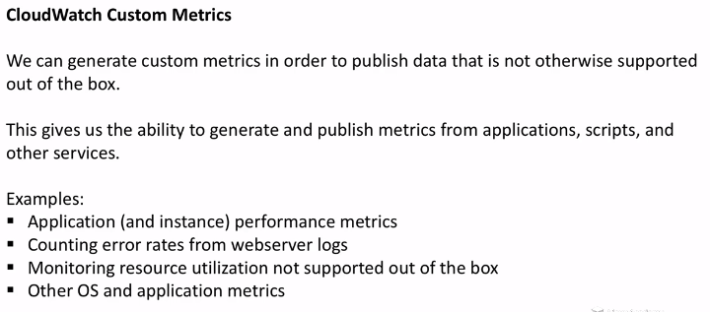

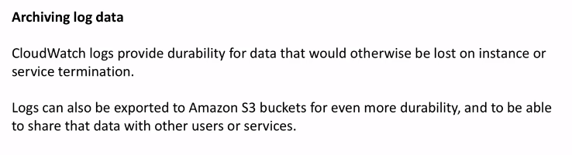

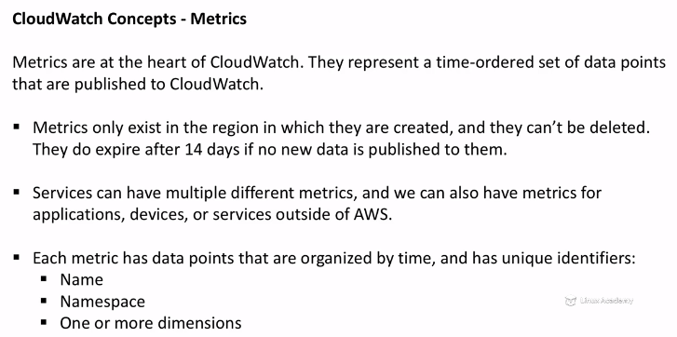

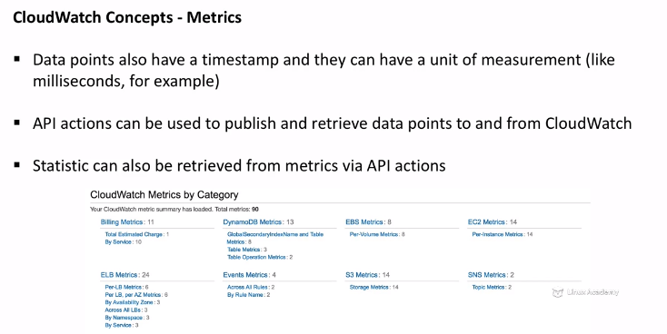

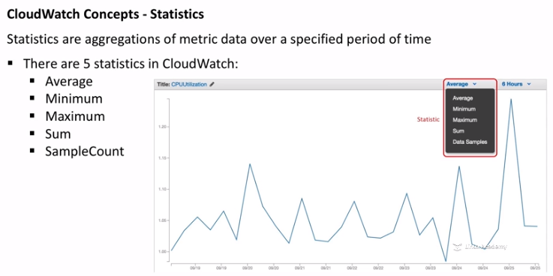

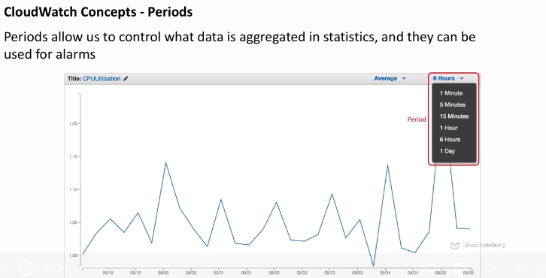

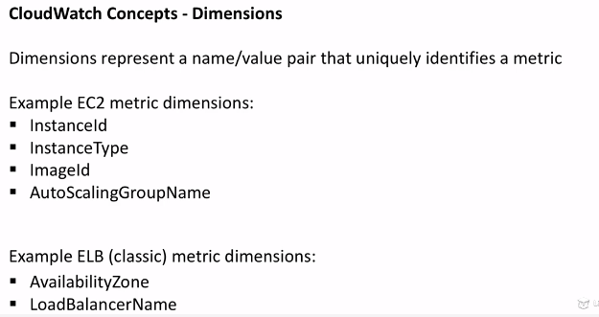

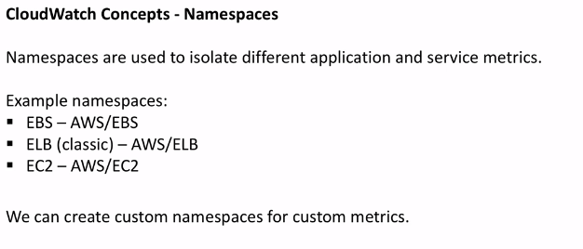

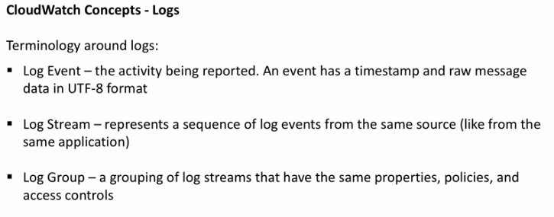

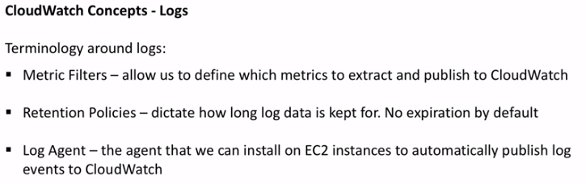

Metrics and logs reports different kinds of data that can be used for different purposes.

a) Elastic load balancer metrics: - Metrics are reported only when requests flow through the load balancer,and they are measured and sent in 60-second intervals.

Different types of metrics include BackendConnectionErrors, HealthyHostCount, UnhealthyHostCount, HTTPCode_Backend_XXX, HTTPCode_ELB_4XX, HTTPCode_ELB_5XX, latency etc.

b)AutoScalingMetrics: The various AutoScalingMetrics includes GroupMinSize, GroupMaxSize, GroupDesiredCapacity,GroupInserviceInstance, GroupPendingInstance, GroupStandbyInstance, GroupTerminateInstance and GroupTotalnstance.

c) EC2 Metrics :- EC2 metrics include CPU Utilization, DiskReadOps, DiskWriteOps, DiskReadBytes, DiskWriteBytes, NetworkIn, NetworkOut etc.

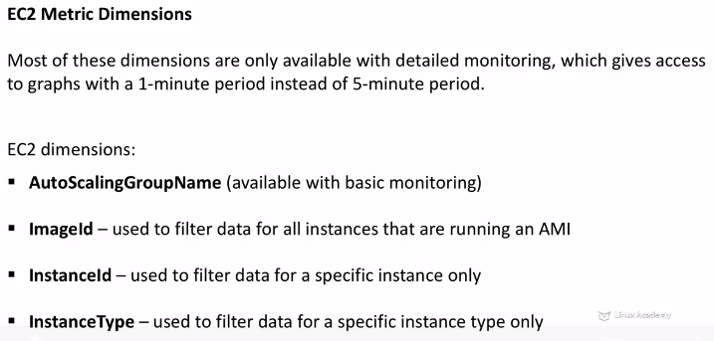

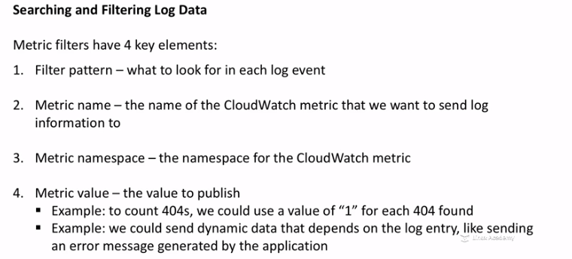

Amazon CloudWatch does not aggregate data across regions. Metrics are completely separate between regions.

If there are requests flowing through the load balancer, Elastic Load Balancing measures and sends its metrics in 60-second intervals. If there are no requests flowing through the load balancer or no data for a metric, the metric is not reported.

Logs Agent is the agent that we can install on EC2 instances to automatically publish log events to CloudWatch.