**Jenkins**

* It is open source
* It is web based java tool
* Highly extensible

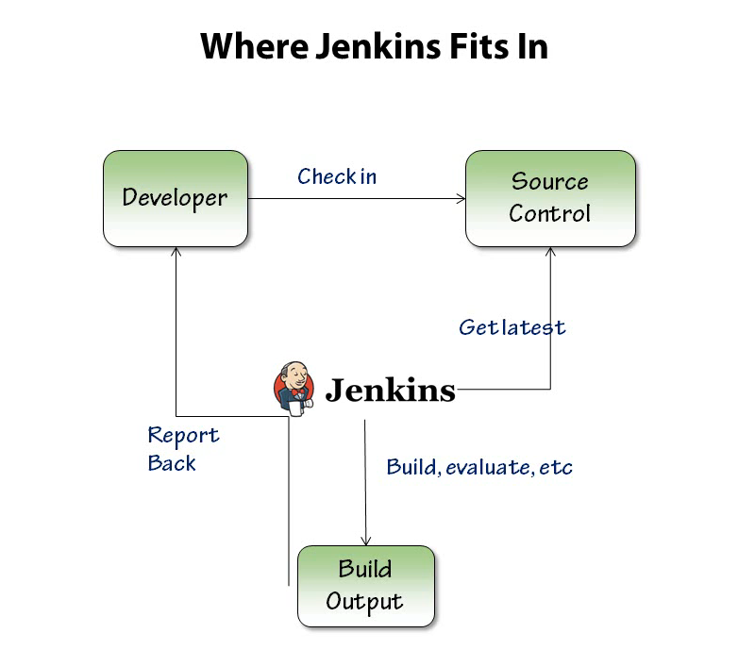

1. How to install Jenkins on Windows

* Download the Jenkins.war file on windows
* Check that java is installed on windows and set it on environment variable.
* Java –jar Jenkins.war
* Java –jar Jenkins.war --httpPort=8081
* Java –jar Jenkins.war --httpPort= -1 --httpsPort=8080

1. How to install Jenkins as a service

* Download the Jenkins.zip file from the official site and install it , then it will be installed it as a service.

Main uses of Nodes are to distribute the workload,to run it on different operating system.