**AWS Certified Solutions Architect - Associate**

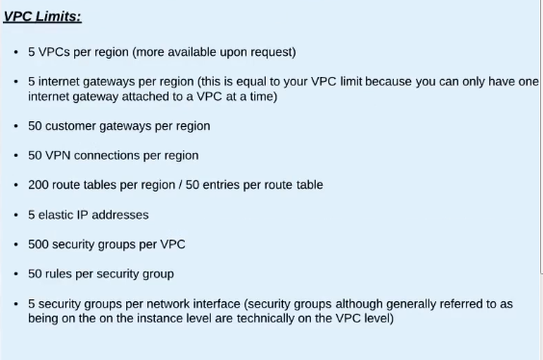

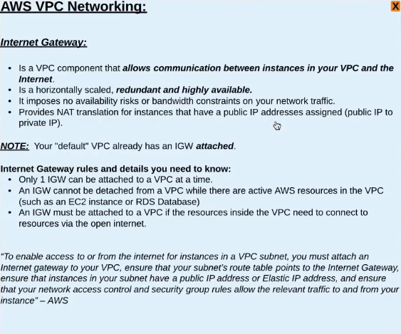

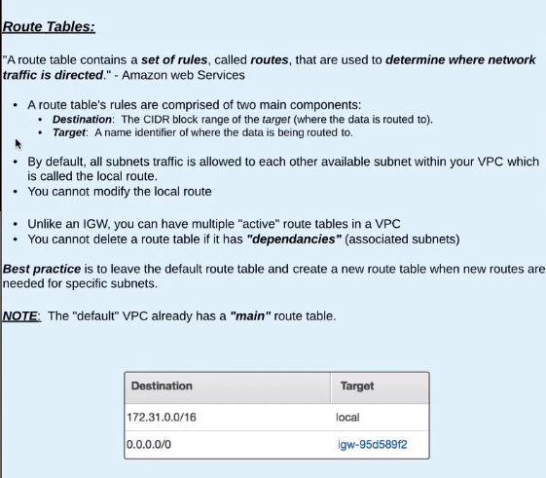

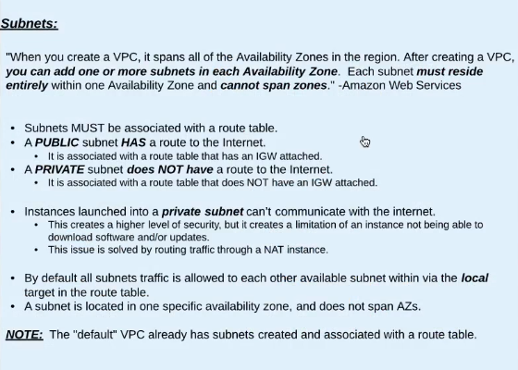

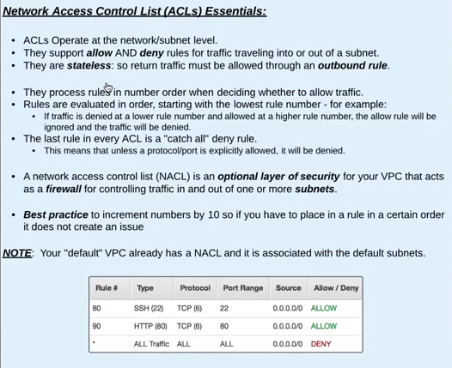

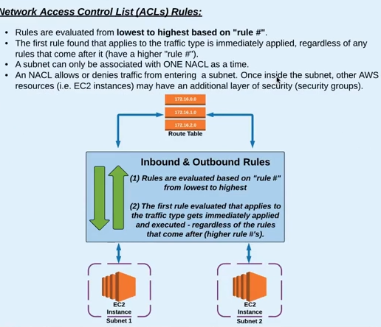

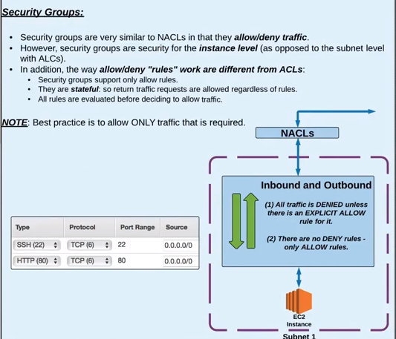

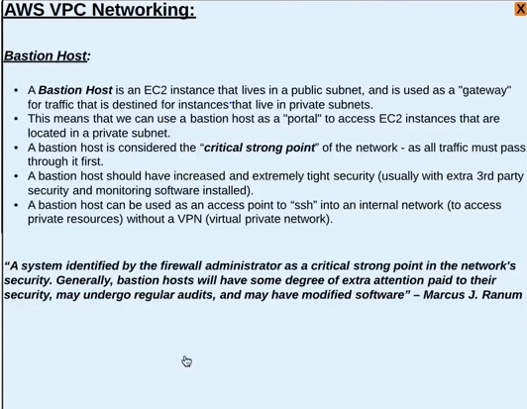

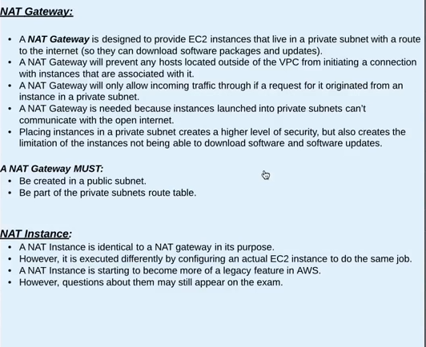

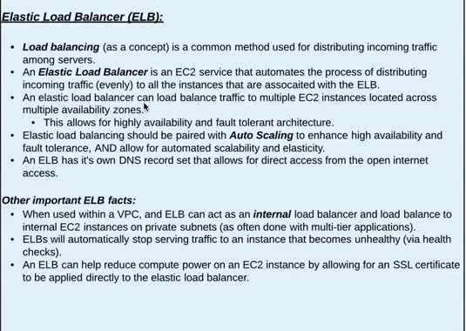

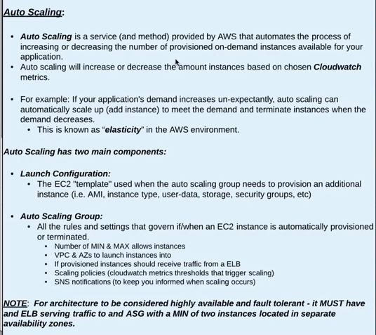

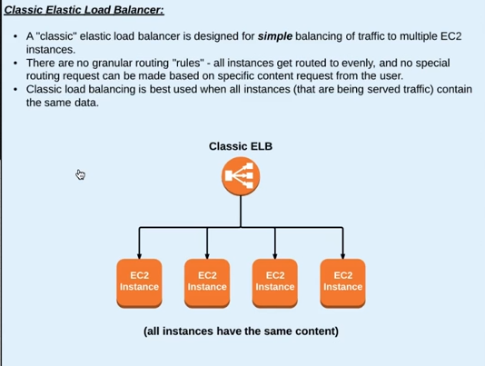

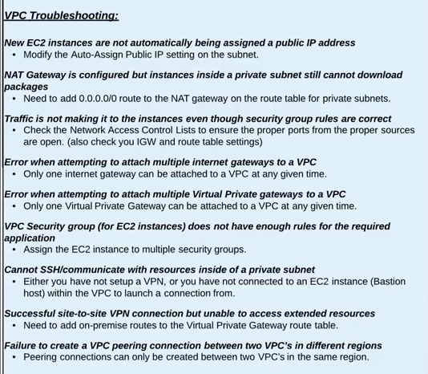

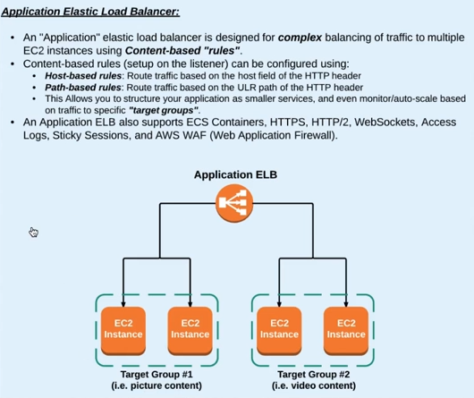

By using Bastion Host, NAT gateway and ELB, we can protect EC2 instances by placing them in private subnets, while still being able to access and traffic to them.

A NAT Gateway will not allow any unsolicited traffic through. All traffic that passes through it MUST have been asked for by a resource inside the VPC.

A NAT gateway must be provisioned into a public subnet, and it must part of the private subnet's route table.

A bastion host is used is used as a "gateway" for traffic that is destined for instances located in a private subnet, whereas a NAT gateway provides instances in a private subnet with a route to the internet.

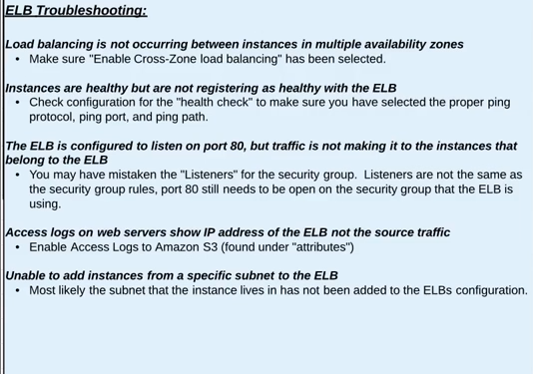

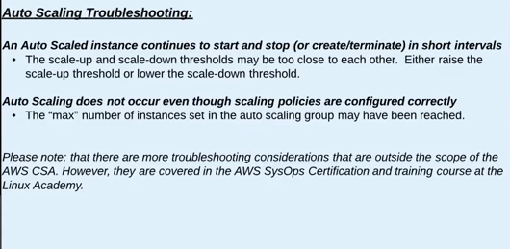

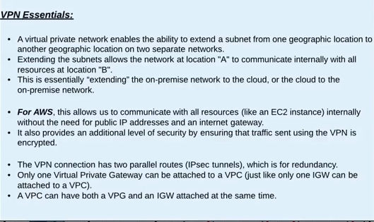

VPN connection will happen using the private ip addresses, not through the public ip addresses or through internet gateway.

Customer Gateway – On premise endpoint

Virtual Private Gateway – VPC side endpoint

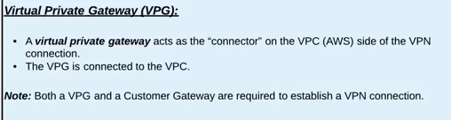

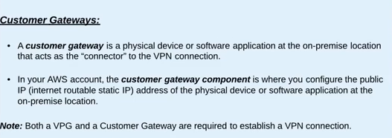

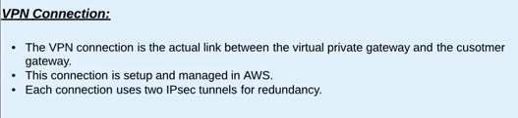

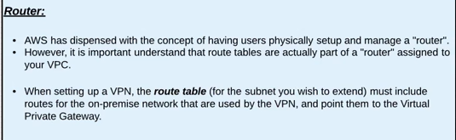

A virtual private network is a great backup solution for AWS direct connect. A virtual private network provides the same access, just with fewer benefits.

AWS Direct Connect is a service that provides a dedicated network connection between your data center and one of AWS's Direct Connect locations. One of the main benefits of Direct Connect is a low-latency connection.

The cross-network connection is the connection between your on-premise data center and the Direct Connect Authorized Provider.

