
DATASTRUCTURES AND ALGORITHMS
23CSE203 LAB MANUAL
Submitted by
Name | TADIPARTHI JITHIN
Roll No | AV.SC.U4CSE25148
Year/Sem/Section | 2nd year/Sem-3/CSE-B
Credits | 05

Submitted to
Name | Dr. RAJ KUMAR BATCHU
Department | School of Computing
Designation | Asst.Professor(SL Grade)

INDEX

Sno | Title/Topics | Page No. | Date
1. | WEEK 1:  Recursion  - Recursive program for countdown from n to 1, followed by 'launch'.  - Recursive program to calculate P^n (compound interest growth factor P, years n).  - Recursive program to print first n terms of Fibonacci series.  - Recursive program to search for an employee ID in a list.  - Recursive program to calculate factorial (n!) for parcel arrangement. | 4-14 | 14-07-26
2. | WEEK 2:  Searching  - Python program to perform Linear Search on given input.  - Python program to perform Binary Search on given input (verify with sorted and  unsorted lists). | 15-23 | 21-07-26
3. | WEEK 3:  Elementary Sorting  - Python program to implement Bubble Sort (user input).  - Python program to implement Selection Sort (user input).  - Python program to implement Insertion Sort (user input). | 24-32 | 01-08-26
4. | WEEK 4:  Advanced Sorting  - Python program to implement Merge Sort (user input).  - Python program to implement Quick Sort (user input). | 33-38 | 11-08-26
5. | WEEK 5:  Linked Lists  Implement operations for:  - Singly Linked List (SLL)  - Doubly Linked List (DLL)  - Circular Linked List (CLL)  Operations: 1. Create LL 2. Insert at Beginning 3. Insert at End 4. Insert at Index 5.  Delete by Value 6. Delete Prior Node 7. Delete Last Node 8. Count Nodes 9.  Display/Traverse 10. Exit | 39-70 | 18-08-26
6. | WEEK 6:  Stacks  - Implement Stack operations (Push, Pop, Peek, Display) using Array.  - Implement Stack operations (Push, Pop, Peek, Display) using Linked List. | 71-80 | 25-08-26

7. | WEEK 7:  Queues  - Implement Queue using Arrays.  - Implement Queue using Linked List.  - Implement Circular Queue using Arrays.  - Implement Circular Queue using Linked List. | 81-101 | 22-09-26
8. | WEEK 8:  Binary Trees  - Implement Binary Tree with operations using Array.  - Implement Binary Tree with operations using Linked List. | 102-115 | 29-09-26
9. | WEEK 9:  Binary Search Trees  Python program to implement Binary Search Tree (BST) operations. | 116-131 | 06-10-26
10. | WEEK 10:  AVL Tree  Write a Python program to implement an AVL Tree with all its operations. | 132-153 | 13-10-26
11. | WEEK 11:  Hashing  Python program to implement Hashing (Separate chaining, Linear probing, and  Quadratic probing). | 154-158 | 27-10-26

WEEK -1

A.Aim :
A rocket launch system displays a countdown before launch. Instead
of using a loop implement the countdown using recursion. Write a recursion
python program to display a countdown from n to 1 followed by “launch”.

Program:

def launch(n): if n>=1:
print(n) launch(n-1)
launch(10)
print('launch completed')

Negative Output:
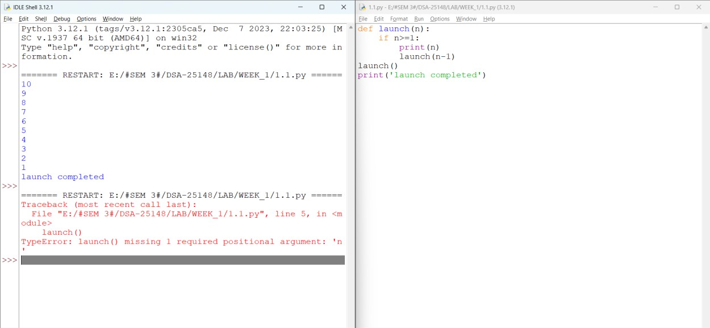

Output:

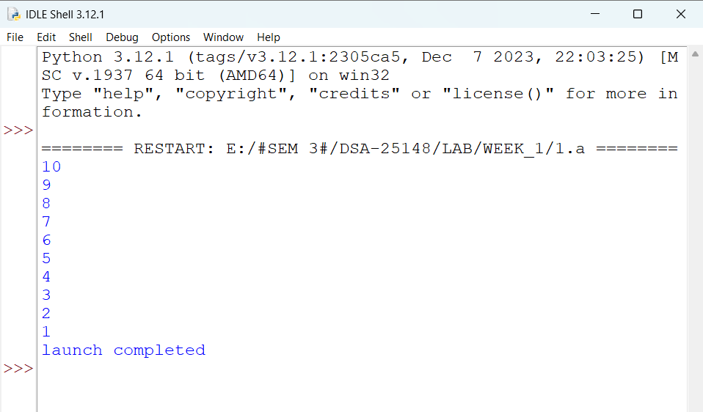

Explanation:
- Launch(10) starts the function with n = 10.
- if n >= 1 checks whether n is at least 1.
- print(n) prints the current value.
- launch(n-1) calls the function again with the value decreased by 1.
- This continues until n becomes 0; then the condition is false and recursion stops.
- Finally, "launch completed" is printed.
Output:
10 9 8 ... 1, followed by launch completed.

Error Table:

S.No | Error
1 | TypeError: launch() missing 1 required positional argument: 'n'

B.Aim:
The banks calculate the growth of an investment using compound
interest; the formula requires calculating powers. Which can be implemented
recursively. Write a recursive program to calculate p^n(power), where
p=principal growth factor, n= number of years.

Program:
def power(p,n):
if n==0:
return 1
else:
return p*power(p,n-1) p=float(input('get me the amount:\t')) n=int(input('agreed years:\t')) print(power(p,n))

Negative Output:

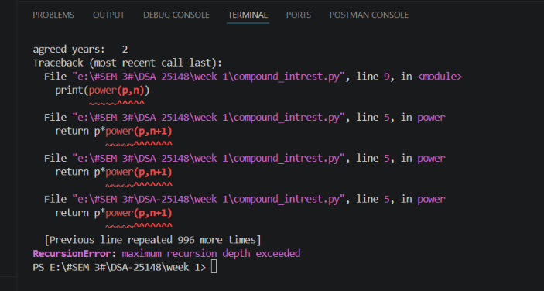

Output:

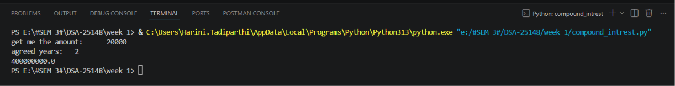

Explanation:
- Power(p, n) calculates p raised to the power n using recursion.
- If n == 0, it returns 1 because any number raised to 0 is 1.
- Otherwise, p * power(p, n-1) repeatedly multiplies p.
- The recursion continues until n becomes 0.
- p is taken as a float and n as an integer from the user.
- Finally, print(power(p,n)) displays the calculated power.

Error Table:

S.no | Error
1. | Recurrsion Error

Aim:
An HIR department stores employee IDs in a list. Develop a recursive
program to search for a given employee ID. Write a recursive function to search
for an employee ID in a list.

Program:
def search():
i=int(input('get me the id of employee:\t')) for n in range(len(emp)):
if emp[n]==i: print('employee found')
else:
print('no such id exist') emp=[101,102,103,104,105,106,107,108,109]
search()

Negative Output:

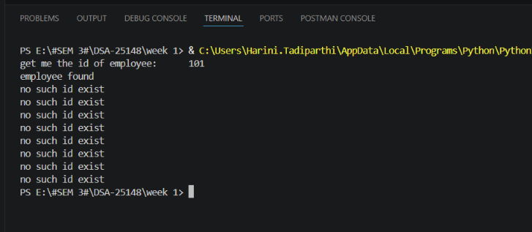

Output:

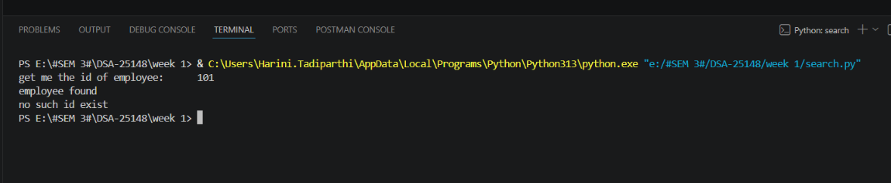

Explanation:
- emp stores the employee IDs.
- search() gets an employee ID from the user.
- for loop checks each ID in the list.
- if emp[n] == i checks whether the entered ID exists.
- If matched, it prints employee found.
- The else belongs to the for loop and executes after the loop completes.

Error Table:

S.no | Error
1. | compileError: it gives output but not desired

Explanation :
As the else is given wrt to if other than for it repeats for every input.

Aim:
In a logistics company the number of possible ways to arrange n
different parcels are calculated using the factorial formula(n!). develop a
recursive program to calculate the factorial of a given number.

Program:
def fib(n): if n == 0:
return 0 elif n == 1:
return 1 else:
return fib(n - 1) + fib(n - 2) def pfib(n,i):
if n==i:
return else:
print(fib(i)) pfib(n,i+1)

n = int(input("Enter the number of terms: "))

if n <= 0:
print("Wrong input") else:
i=0 pfib(n,i)

Negative Output:

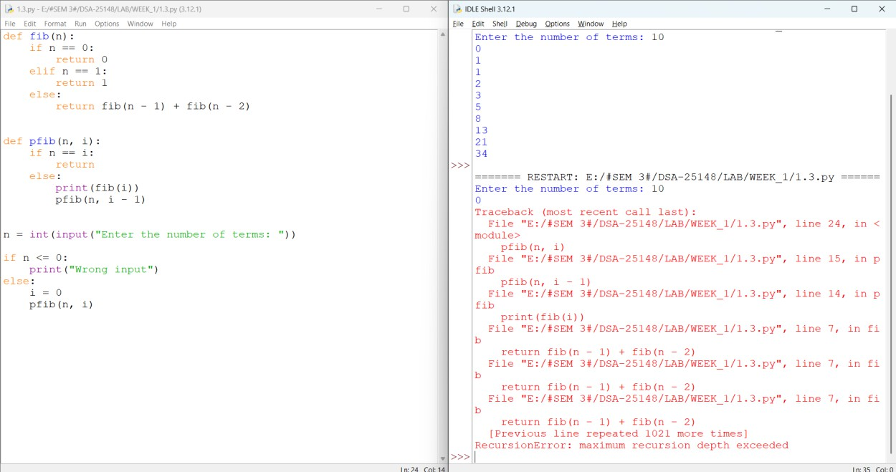

Output:

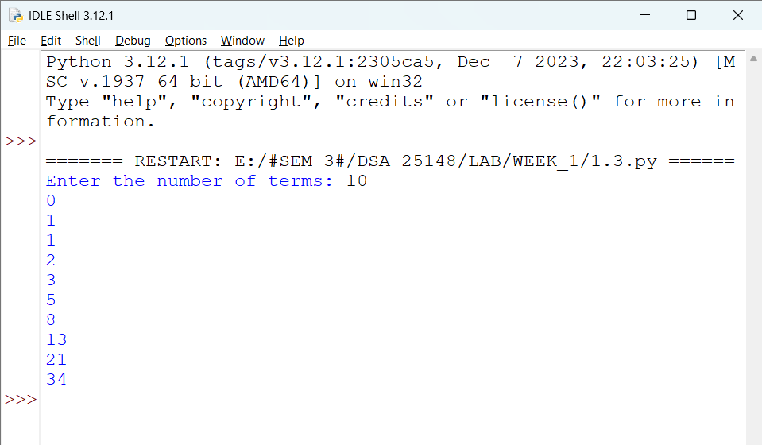

Explanation:
- fib(n) calculates the nth Fibonacci number using recursion.
- If n == 0, it returns 0.
- If n == 1, it returns 1.
- Otherwise, it calculates fib(n-1) + fib(n-2).
- pfib(n, i) prints Fibonacci numbers from position 0 up to n-1.
- When n == i, recursion stops.
- If the user enters 0 or a negative number, it prints Wrong input.

Error Table:

S.no | Error
1. | RecursionError: maximum  recursion depth exceeded

Aim:
Write a recursive python program to print the first n terms of the Fibonacci series.

Program:
def fact(n): if n==0:
return 1 elif n==1: return 1
else:
return n*fact(n-1)
n = int(input('Get me the number for Factorial calculate:\t')) print(f'Factorial of {n} is {fact(n)}')

Negative Output:

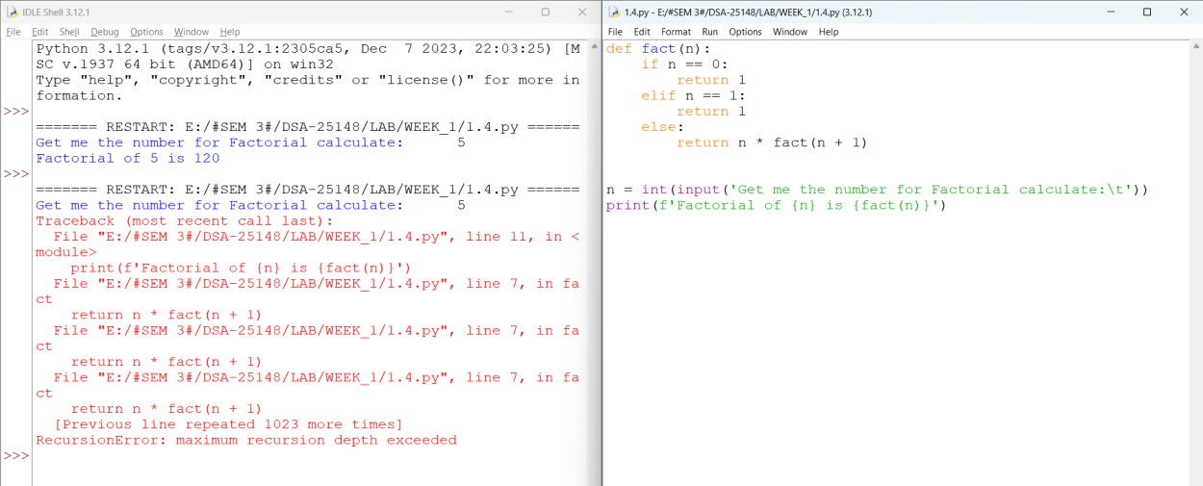

Output:

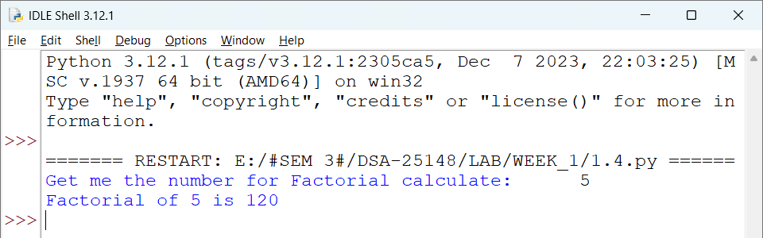

Explanation:
- fact(n) calculates the factorial of n using recursion.
- If n == 0 or n == 1, it returns 1 because 0! = 1 and 1! = 1.
- Otherwise, it calculates n * fact(n-1).
- The function keeps calling itself with n-1 until it reaches 0 or 1.
- The user enters the number, and the final factorial is printed.

Error Table:

S.no | Error
1. | RecursionError: maximum recursion depth exceeded

Week-2

A.Aim: Code for Linear Search

Program:
def linear(arr, key):
for i in range(len(arr)): if arr[i] == key:
return i return -1

def main():
n = int(input("get me the size of list:\t"))
if n <= 0:
print("Try again ")
return

arr = []

for i in range(n):
s = int(input(f"get me the element {i+1}:\t")) arr.append(s)
key = int(input("get me the value to search:\t"))

if linear(arr, key) != -1:
print(f"The {key} is found in array") else:
print("Not found")

main()

Negative Output:
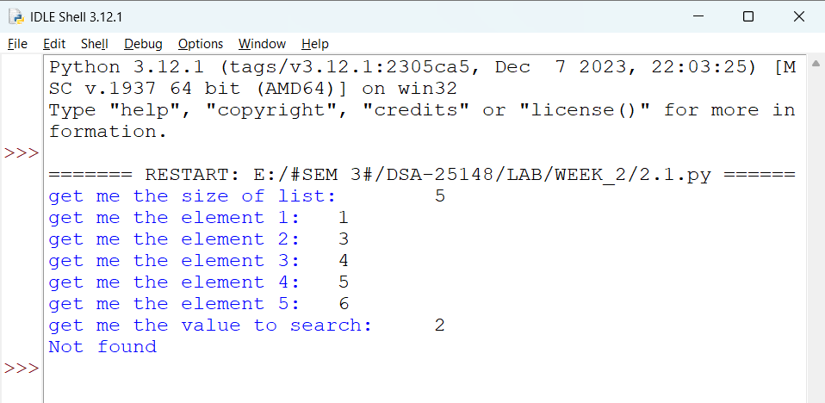

Output:

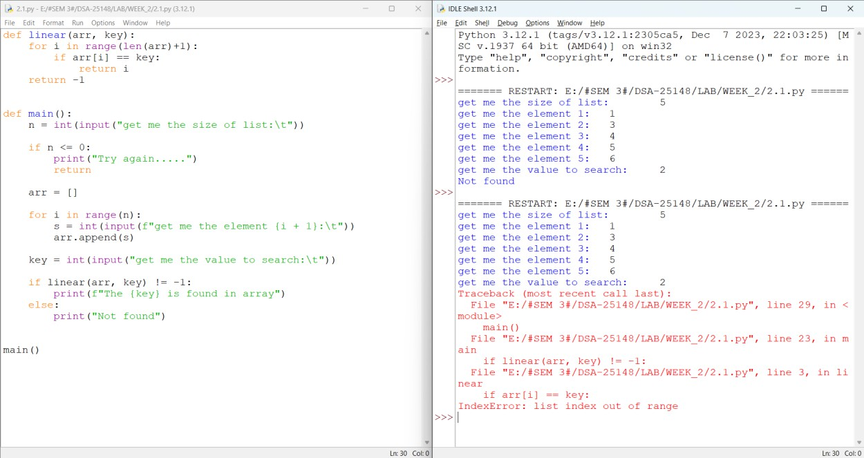

Explanation:
- linear(arr, key) performs a linear search on the array.
- The for loop checks every element one by one.
- If arr[i] == key, it returns the index i.
- If the key is not found, it returns -1.
- main() gets the size of the list and its elements from the user.
- It then gets the value to search and calls linear().
- If the returned value is not -1, it prints found; otherwise, it prints Not found.

Error Table:

S.no | Error
1. | IndexError: list index out of  range

B1.Aim: Write a program to perform linear search on a given input.

Program:
def binary(arr, key):

llimit, rlimit = 0, len(arr) - 1

while llimit <= rlimit:
mid = (llimit + rlimit) // 2

if arr[mid] == key: return mid
elif arr[mid] < key: llimit = mid + 1
else:
rlimit = mid - 1

return -1

def main():

n = int(input("Enter the size of the list: "))
if n <= 0:
print("Invalid size") return
arr = []

for i in range(n):
arr.append(int(input(f"Enter element {i+1}: ")))

key = int(input("Enter the element to search: "))

if arr!= sorted(arr): print('sorting array') arr.sort()
print(f'sorted array {arr}')

index = binary(arr, key)

if index != -1:
print(f"{key} found at index {index}") else:
print("Element not found") main()

Negative Output:
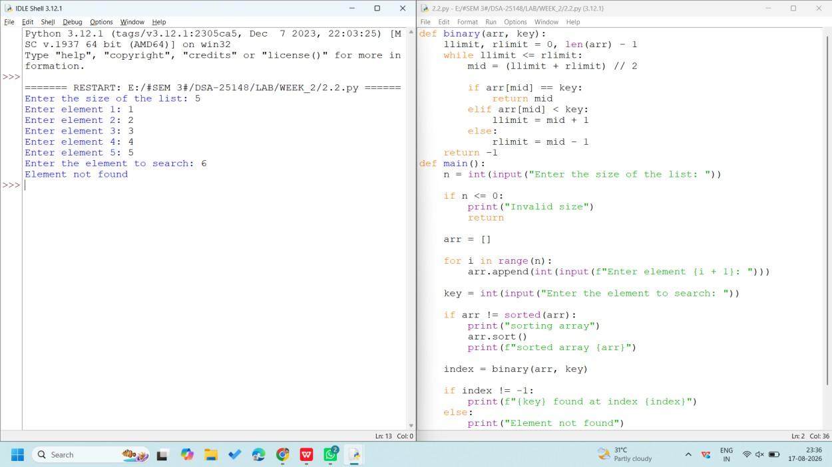

Output:

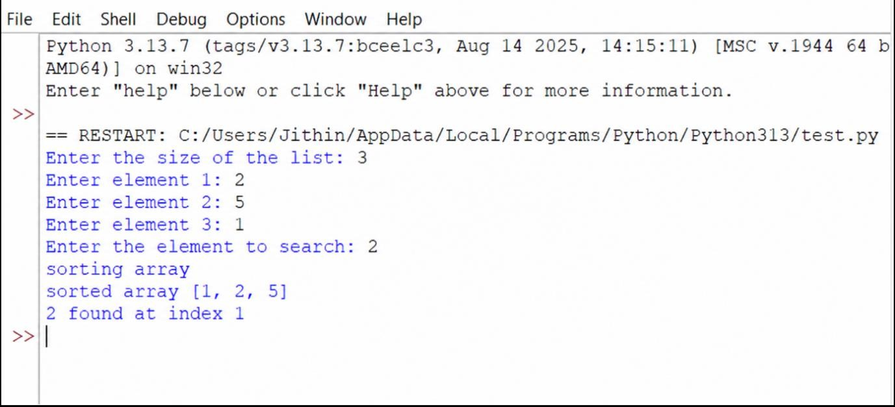

Explanation:
- binary(arr, key) performs a binary search on the array.
- llimit and rlimit represent the left and right boundaries.
- mid finds the middle element.
- If arr[mid] == key, its index is returned.
- If arr[mid] < key, the search continues in the right half.
- Otherwise, it searches the left half.
- If the element isn't found, it returns -1.
- In main(), the array is automatically sorted before binary search if it isn't already sorted.
- Finally, it prints whether the key was found.

Error Table:

S.no | Error
1. | Element Not Found

B2.Aim: Write a python program to implement binary search with sorted array as an input.

Program:
def binary(arr, key):

llimit, rlimit = 0, len(arr) - 1

while llimit <= rlimit:
mid = (llimit + rlimit) // 2

if arr[mid] == key: return mid
elif arr[mid] < key: llimit = mid + 1
else:
rlimit = mid - 1
return -1

def main():

n = int(input("Enter the size of the list: "))
if n <= 0:
print("Invalid size") return

arr = []

for i in range(n):
arr.append(int(input(f"Enter element {i+1}: ")))

key = int(input("Enter the element to search: "))

index = binary(arr, key)

if index != -1:
print(f"{key} found at index {index}")

else:
print("Element not found") main()

Negative Output:

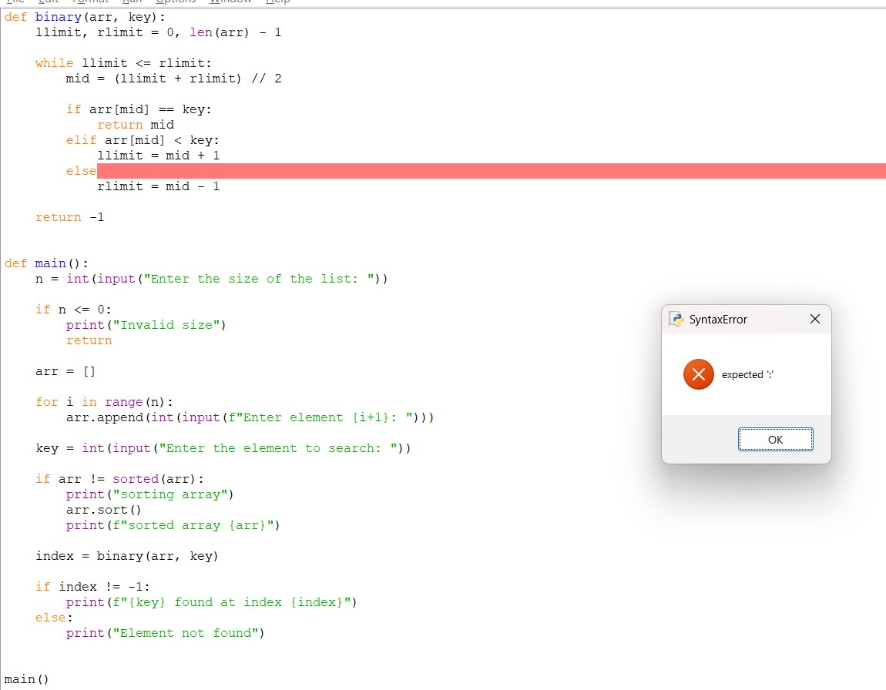

Output:
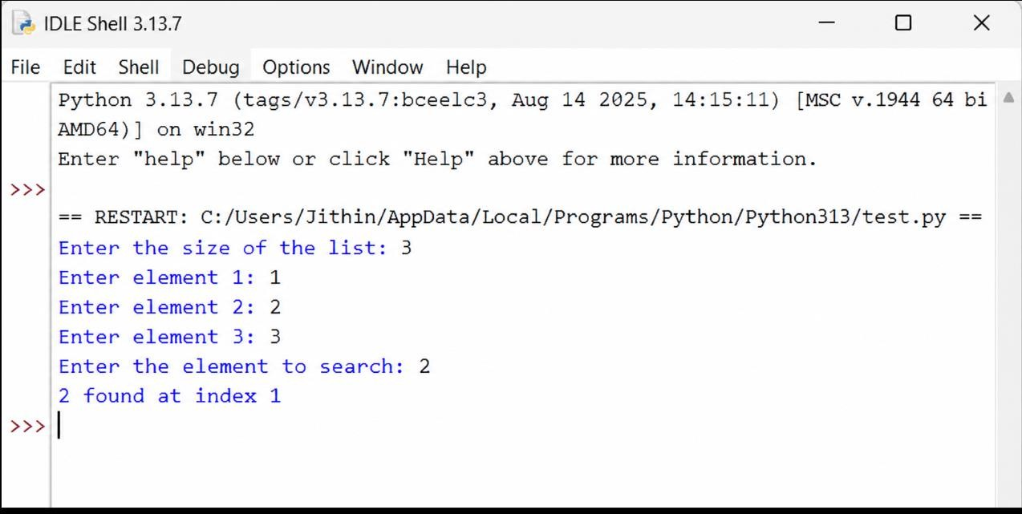

Explanation:
- binary(arr, key) searches for an element using Binary Search.
- llimit and rlimit represent the left and right limits of the array.
- mid calculates the middle index.
- If arr[mid] == key, the index is returned.
- If arr[mid] < key, the search moves to the right half.
- Otherwise, it moves to the left half.
- If the element is not found, -1 is returned.
- In main(), the user enters the array and search value.
- If the array is unsorted, arr.sort() sorts it before binary search.
- Finally, the program prints whether the element was found.

Error Table:

S.no | Error
1. | Syntax Error

WEEK-3

5A. Python program to implement Bubble Sort (user input).

Input code: -
#Bubble Sort

def bubbleSort(arr):
n = len(arr)
for i in range(n):
for j in range(0, n - i - 1):

if arr[j] > arr[j + 1]:
arr[j], arr[j + 1] = arr[j + 1], arr[j]
return arr
#INPUT FROM USER
arr = [ ]
n = int(input("Enter size of the list: ")) print("Enter the elements:")
for i in range(n):
arr.append(int(input()))
print("Sorted array:")
print(bubbleSort(arr))

Output : -
Enter size of the list: 5 Enter the elements:
1
15
23
12
5
Sorted array:
[1, 5, 12, 15, 23]

Negative Output: -
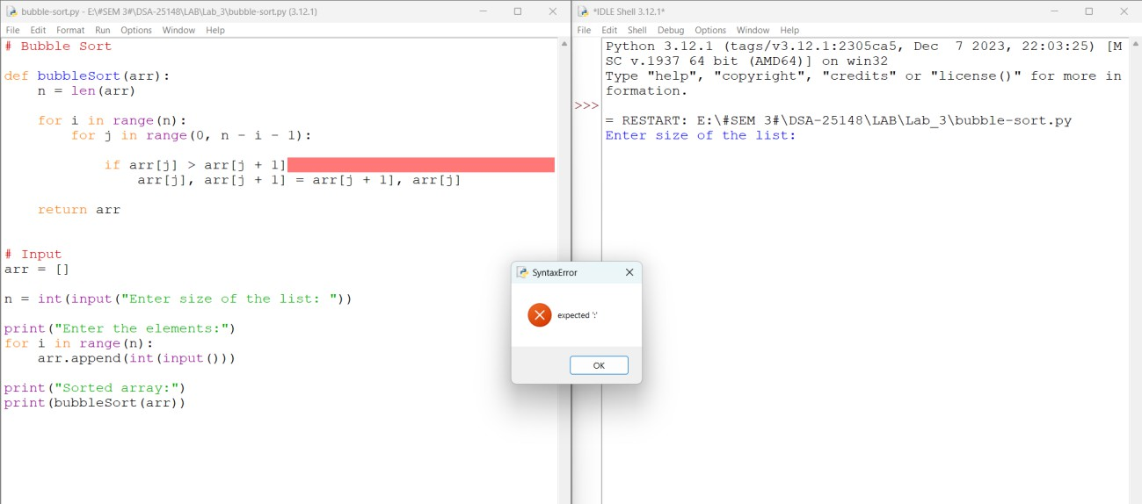
Errors: -
[SYNTAX ERROR. That is I forgot to be keeping the colon (:) in the if loop So, that it raises an Invalid Syntax.

Explanation: -

- Read the size and elements of the list from the user and store them in arr.
- The outer for loop runs through the list multiple times to sort all the elements.
- The inner for loop compares two adjacent elements, arr[j] and
arr[j+1].
- The comparison is made between the current element and the next element to check whether they are in the correct order.
- If the first element is greater than the second, they are swapped using:
arr[j], arr[j+1] = arr[j+1], arr[j]
- After each pass, the largest unsorted element moves towards the end of the list.
- The inner loop compares fewer elements in each subsequent pass because the elements at the end are already in their correct positions.
- After all the passes, the elements are arranged in ascending order, and
return arr returns the sorted list.

5B.Write a Python Program to implement Insertion-Sort, where the Input Elements are taken by the User.

Input code:
#Insertion –Sort

def insertionSort(arr):
n = len(arr)
for i in range(1, n): key = arr[i]
j = i - 1

while j >= 0 and arr[j] > key: arr[j + 1] = arr[j]
j = j - 1

arr[j + 1] = key return arr
#INPUT FROM USER
arr = [ ]
n = int(input("Enter size of the list: ")) print("Enter the elements:")
for i in range(n): arr.append(int(input())) print("Sorted array:")
print(insertionSort(arr))

Output : -
Enter size of the list: 5 Enter the elements:
1
5
2
9
3
Sorted array:
[1, 2, 3, 5, 9]

Negative Output: -

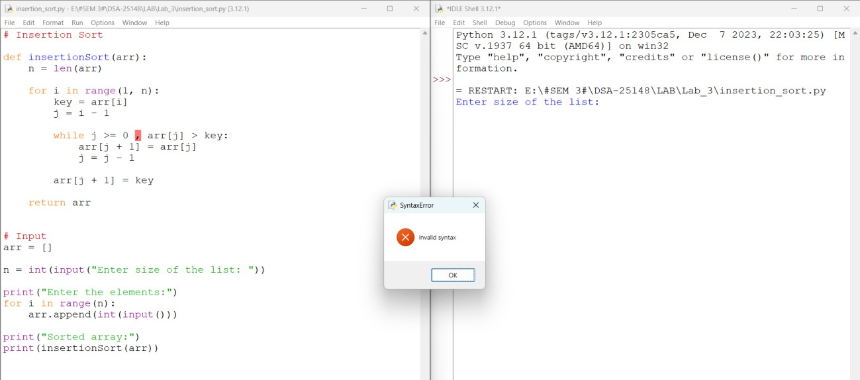

Error: -
In the while loop in the place of 'and' I used comma[,] [SYNTAX ERROR]
after seeing the pop-up I have changed it to and so that I got the desired output...

Explanation: -
- Read the size and elements of the list from the user and store them in arr.
- The for loop starts from the second element, considering the first element as already sorted.
- The current element is stored in a variable called key, which is the element that needs to be placed in its correct position.
- A variable called j is used to point to the element just before the key.
- The while loop compares the key with the previous elements of the sorted part of the list.
- If a previous element is greater than the key, it is shifted one position to the right, and j is moved one position to the left.
- This shifting continues until a smaller element is found or the beginning of the list is reached. Then, the key is inserted into its correct position.
- The process is repeated for all elements, and after all iterations, return arr returns the sorted list in ascending order.

5C. Write a Python Program to implement Selection-Sort, where the Input Elements are taken by the User.

Input code: -

#SELECTION-SORT

def selectionSort(arr) :

n = len(arr)

for i in range(n): min_index = i
for j in range(i + 1, n):
if arr[j] < arr[min_index]: min_index = j
arr[i], arr[min_index] = arr[min_index], arr[i] return arr

#INPUT FROM USER
arr = [ ]
n = int(input("Enter size of the list: ")) print("Enter the elements:")
for i in range(n): arr.append(int(input()))
print("Sorted array:") print(selectionSort(arr))

Output : -
Enter size of the list: 3 Enter the elements:
1

10

8

Sorted array:

[1, 8, 10]

Negative Output: -
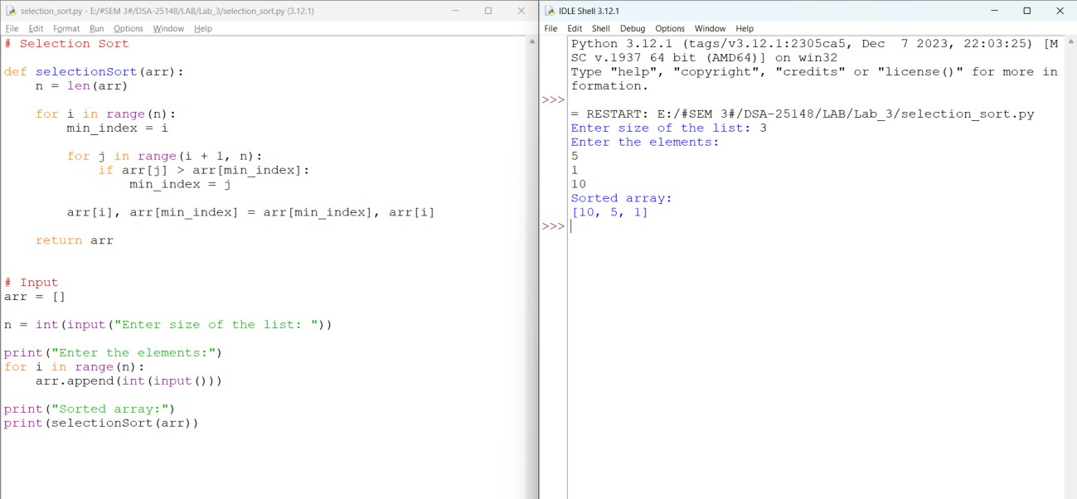

Error: - [RUN-TIME ERROR]

I used ‘>’ symbol in the place ‘<’ so that i get reverse sorted order.. That means it gives the output but the output is not correct.

Explanation: -
- Read the size and elements of the list from the user and store them in arr.
- The outer for loop selects each position of the array one by one, starting from the first position.
- A variable called min_index is used to store the index of the smallest element found.
- The inner for loop compares the current minimum element with the remaining elements of the list.
- If a smaller element is found, its index is stored in min_index.
- After finding the smallest element, it is swapped with the element at the current position using:
- arr[i], arr[min_index] = arr[min_index], arr[i]
- This process is repeated until the entire list is sorted and return arr
- returns the sorted list in ascending order.

WEEK-4

A.AIM: Write a python program to implement merge sort, where the input elements are taken from the user.
PROGRAM:
def merge_sort(arr):
if len(arr) <= 1:
return arr
mid = len(arr) // 2
left = arr[:mid]
right = arr[mid:]
left = merge_sort(left)
right = merge_sort(right)
i = j = k = 0

while i < len(left) and j < len(right):
if left[i] <= right[j]:
arr[k] = left[i]
i += 1
else:
arr[k] = right[j]
j += 1
k += 1

while i < len(left):
arr[k] = left[i]
i += 1
k += 1

while j < len(right):
arr[k] = right[j]
j += 1
k += 1
return arr

n = int(input("Enter number of elements: "))
arr = []
print("Enter elements:")
for i in range(n):
arr.append(int(input()))

merge_sort(arr)
print("Sorted array:")
for element in arr:
print(element, end=" ")

OUTPUT:
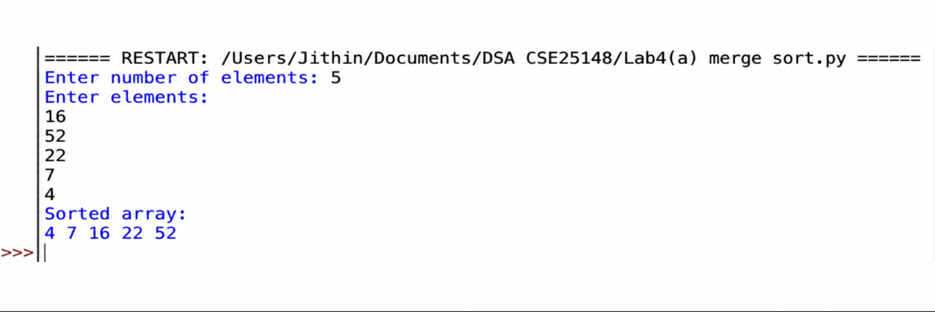
EXPLANATION:
- The merge_sort() function is defined to arrange the elements of the list in ascending order using the Merge Sort algorithm.
- The if len(arr) <= 1 condition checks whether the list has one or no elements. If so, the list is already sorted and returned.
- The variable mid stores the middle index of the list, which is used to divide the list into two halves.
- The list is divided into two parts: the left contains the first half and the right contains the second half.
- The merge_sort() function is called recursively to sort both the left and right halves.
- The variables i, j, and k are used as indexes for the left list, right list, and original list respectively.
- The while loop compares the elements of the left and right lists and places the smaller element into the original list.
- The next while loops copy any remaining elements from the left or right list into the original list.
- The return arr statement returns the sorted list after merging the two halves.
- The user enters the number of elements and the elements of the list using input().
- The merge_sort(arr) function is called to sort the given list.
- Finally, the sorted elements are displayed using a for loop.

ERROR TABLE:
S.no. | Errors | Rectification
1. | IndentationError occurred because some statements inside the function and loops were not properly aligned. | Corrected the indentation of the statements according to Python syntax.
2. | ValueError occurred when I entered a non-numeric value while giving the array elements. | Entered only integer values as input for the array.
3. | TypeError occurred because incompatible data types were present while comparing the elements. | Used integer values of the same suitable data type for sorting.

B.AIM: Write a python program to implement quick sort, where the input elements are taken from the user.

PROGRAM:
def quicksort(a, low, high):
if low < high:
i = low
j = high
pivot = low
while i < j:
while i <= high and a[i] <= a[pivot]:
i += 1
while a[j] > a[pivot]:
j -= 1
if i < j:
a[i], a[j] = a[j], a[i]
a[pivot], a[j] = a[j], a[pivot]
quicksort(a, low, j - 1)
quicksort(a, j + 1, high)

n = int(input("Enter number of elements: "))
a = []
print("Enter elements:")
for i in range(n):
a.append(int(input()))
quicksort(a, 0, n - 1)
print("Sorted array:")
for element in a:
print(element, end=" ")

OUTPUT:
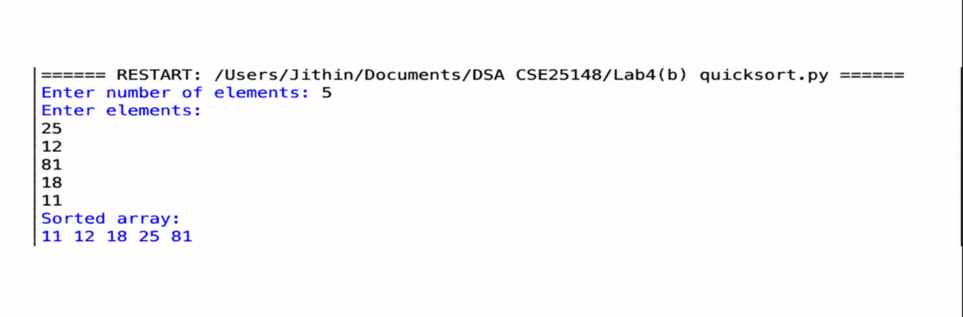
EXPLANATION:

- The quicksort() function is used to arrange the elements of the array in ascending order.
- The condition if low < high checks whether the array portion contains more than one element.
- The variables i and j are used to scan the array from both sides.
- The variable pivot stores the index of the first element selected as the pivot.
- The first while loop moves i forward until an element greater than the pivot is found.
- The second while loop moves j backward until an element smaller than or equal to the pivot is found.
- If i < j, the elements at i and j are swapped.
- The pivot is then swapped with the element at j, placing it in its correct position.
- The function is recursively called for the left and right portions of the pivot.
- The user enters the number of elements and their values, and quicksort() is called to sort the array.
- Finally, the sorted array is displayed.

ERROR TABLE:
S.no. | Errors | Rectification
1. | ValueError occurred when I entered a non-integer value for an array element. | Entered only valid integer values while providing the input.
2. | NameError occurred because I used an incorrect variable name such as pivot, i, or j. | Checked the variable names and corrected their spelling throughout the program.

Week-5

A.AIM: Write a python program to implement single linked list with below operations
- Create Linked list
- Insert beginning
- Insert end
- Insert at index
- Delete by value
- Delete first node
- Delete last node
- Count number of nodes
- Display/Traverse
- Exit
PROGRAM:
class Node:
def __init__(self, data):
self.data = data
self.next = None

class SinglyLinkedList:
def __init__(self):
self.head = None

# 1. Create linked list
def create(self):
n = int(input("Enter number of nodes: "))
for i in range(n):
data = int(input(f"Enter data for node {i + 1}: "))
new_node = Node(data)
if self.head is None:
self.head = new_node
else:
temp = self.head
while temp.next:
temp = temp.next
temp.next = new_node
print("Linked list created successfully.")

# 2. Insert at beginning
def insert_beginning(self):
data = int(input("Enter data: "))
new_node = Node(data)
new_node.next = self.head
self.head = new_node
print("Node inserted at beginning.")

# 3. Insert at end
def insert_end(self):
data = int(input("Enter data: "))
new_node = Node(data)
if self.head is None:
self.head = new_node
else:
temp = self.head
while temp.next:
temp = temp.next
temp.next = new_node
print("Node inserted at end.")

# 4. Insert at specific index
def insert_index(self):
index = int(input("Enter index: "))
data = int(input("Enter data: "))
new_node = Node(data)

if index == 0:
new_node.next = self.head
self.head = new_node
print("Node inserted.")
return

temp = self.head
for i in range(index - 1):
if temp is None:
print("Invalid index.")
return
temp = temp.next

if temp is None:
print("Invalid index.")
return

new_node.next = temp.next
temp.next = new_node
print("Node inserted.")

# 5. Delete by value
def delete_value(self):
value = int(input("Enter value to delete: "))

if self.head is None:
print("List is empty.")
return

if self.head.data == value:
self.head = self.head.next
print("Node deleted.")
return

temp = self.head
while temp.next and temp.next.data != value:
temp = temp.next

if temp.next is None:
print("Value not found.")
else:
temp.next = temp.next.next
print("Node deleted.")

# 6. Delete first node
def delete_first(self):
if self.head is None:
print("List is empty.")
else:
self.head = self.head.next
print("First node deleted.")

# 7. Delete last node
def delete_last(self):
if self.head is None:
print("List is empty.")
return

if self.head.next is None:
self.head = None
print("Last node deleted.")
return

temp = self.head
while temp.next.next:
temp = temp.next
temp.next = None
print("Last node deleted.")

# 8. Count nodes
def count(self):
count = 0
temp = self.head
while temp:
count += 1
temp = temp.next
print("Number of nodes:", count)

# 9. Display / Traverse
def display(self):
if self.head is None:
print("List is empty.")
return

temp = self.head
while temp:
print(temp.data, end=" -> ")
temp = temp.next
print("None")

# Main program
sll = SinglyLinkedList()

while True:
print("\n--- SINGLY LINKED LIST ---")
print("1. Create linked list")
print("2. Insert at beginning")
print("3. Insert at end")
print("4. Insert at specific index")
print("5. Delete by value")
print("6. Delete first node")
print("7. Delete last node")
print("8. Count number of nodes")
print("9. Display / Traverse")
print("10. Exit")

choice = int(input("Enter your choice: "))

if choice == 1:
sll.create()
elif choice == 2:
sll.insert_beginning()
elif choice == 3:
sll.insert_end()
elif choice == 4:
sll.insert_index()
elif choice == 5:
sll.delete_value()
elif choice == 6:
sll.delete_first()
elif choice == 7:
sll.delete_last()
elif choice == 8:
sll.count()
elif choice == 9:
sll.display()
elif choice == 10:
print("Program exited.")
break
else:
print("Invalid choice.")

OUTPUT:
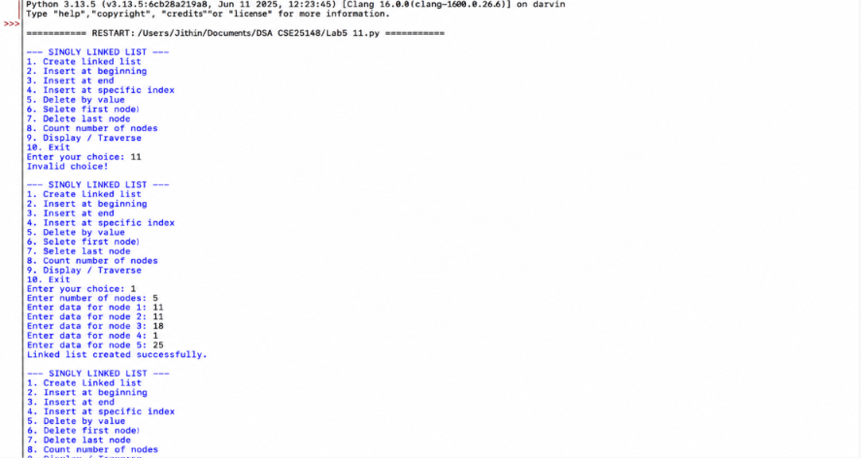

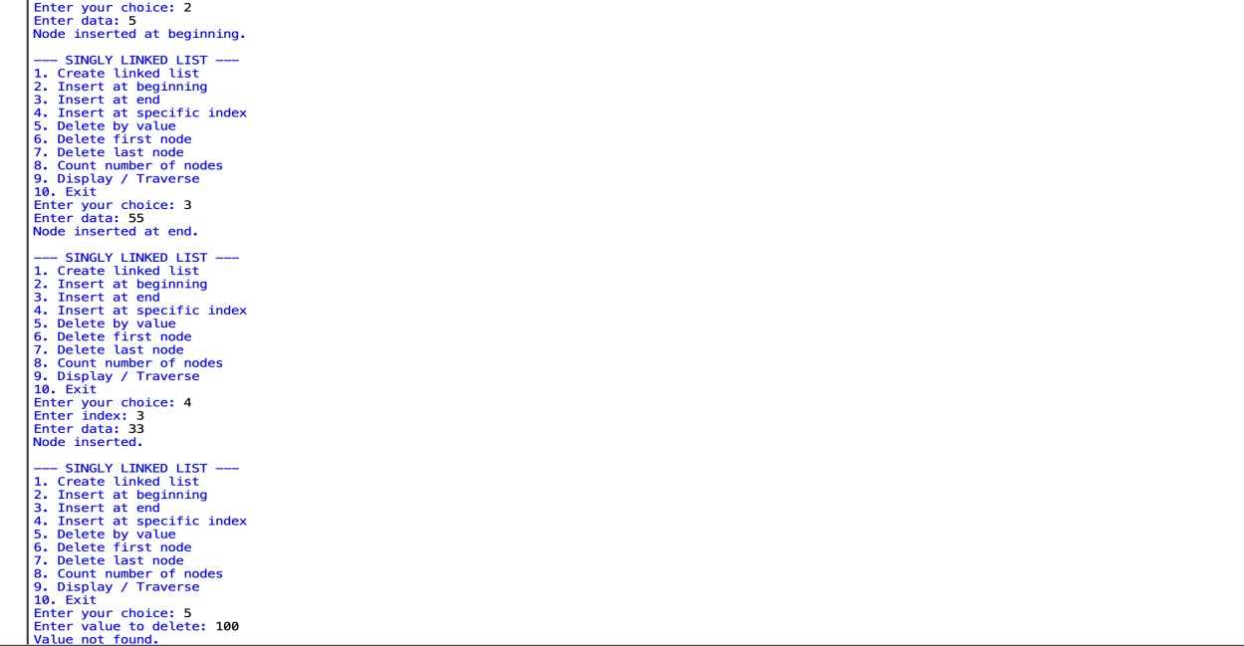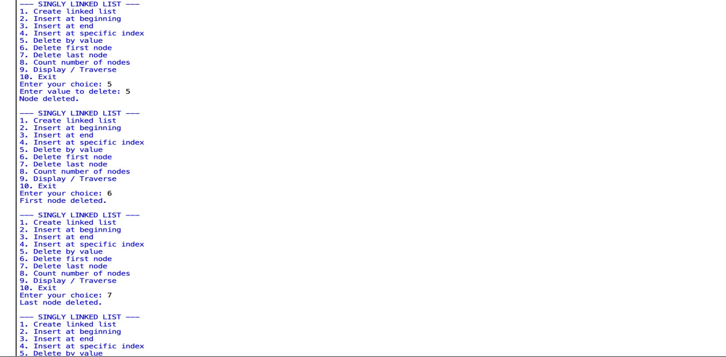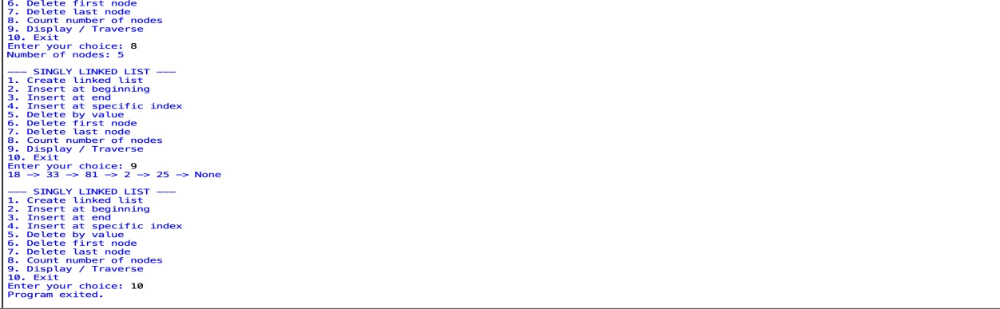

EXPLANATION:
- The Node class is used to create a node containing data and a link to the next node.
- The SinglyLinkedList class maintains the linked list using the head pointer.
- The create() function creates a linked list by adding the given number of nodes.
- The insert_beginning() function adds a new node at the beginning of the list.
- The insert_end() function adds a new node at the end of the list.
- The insert_index() function inserts a node at a specified index.
- The delete_value() function searches for a given value and deletes the corresponding node.
- The delete_first() function removes the first node from the list.
- The delete_last() function removes the last node from the list.
- The count() function counts and displays the total number of nodes.
- The display() function traverses the list and prints all the elements.
- The main program displays a menu and performs the selected linked-list operation.
ERROR TABLE:

S.no. | Errors | Rectification
1. | Node Error occurred because the Node class was not defined properly. | Defined the Node class before using it.
2. | Attribute Error occurred when temp.next was not handled correctly. | Updated temp using temp = temp.next.
3. | Index Error occurred when an invalid index was entered. | Checked whether the index is within the list range.
4. | Value not found occurred when the entered value was not present in the list. | Searched the list and displayed "Value not found."

B.AIM: Write a Python program to implement a Double linked list with the above operations.

PROGRAM:

class Node:
def __init__(self, data):
self.data = data
self.prev = None
self.next = None

class DoublyLinkedList:
def __init__(self):
self.head = None

# 1. Create linked list
def create(self):
n = int(input("Enter number of nodes: "))
for i in range(n):
data = int(input(f"Enter data for node {i + 1}: "))
new_node = Node(data)
if self.head is None:
self.head = new_node
else:
temp = self.head
while temp.next:
temp = temp.next
temp.next = new_node
new_node.prev = temp
print("Doubly linked list created successfully.")

# 2. Insert at beginning
def insert_beginning(self):
data = int(input("Enter data: "))
new_node = Node(data)
if self.head is not None:
new_node.next = self.head
self.head.prev = new_node
self.head = new_node
print("Node inserted at beginning.")

# 3. Insert at end
def insert_end(self):
data = int(input("Enter data: "))
new_node = Node(data)
if self.head is None:
self.head = new_node
else:
temp = self.head
while temp.next:
temp = temp.next
temp.next = new_node
new_node.prev = temp
print("Node inserted at end.")

# 4. Insert at specific index
def insert_index(self):
index = int(input("Enter index: "))
data = int(input("Enter data: "))
new_node = Node(data)

if index == 0:
if self.head:
new_node.next = self.head
self.head.prev = new_node
self.head = new_node
print("Node inserted.")
return

temp = self.head
for i in range(index - 1):
if temp is None:
print("Invalid index.")
return
temp = temp.next

if temp is None:
print("Invalid index.")
return

new_node.next = temp.next
new_node.prev = temp

if temp.next:
temp.next.prev = new_node

temp.next = new_node
print("Node inserted.")

# 5. Delete by value
def delete_value(self):
value = int(input("Enter value to delete: "))
temp = self.head

while temp and temp.data != value:
temp = temp.next

if temp is None:
print("Value not found.")
return

if temp.prev:
temp.prev.next = temp.next
else:
self.head = temp.next

if temp.next:
temp.next.prev = temp.prev

print("Node deleted.")

# 6. Delete first node
def delete_first(self):
if self.head is None:
print("List is empty.")
return

self.head = self.head.next
if self.head:
self.head.prev = None
print("First node deleted.")

# 7. Delete last node
def delete_last(self):
if self.head is None:
print("List is empty.")
return

temp = self.head
while temp.next:
temp = temp.next

if temp.prev:
temp.prev.next = None
else:
self.head = None

print("Last node deleted.")

# 8. Count nodes
def count(self):
count = 0
temp = self.head

while temp:
count += 1
temp = temp.next

print("Number of nodes:", count)

# 9. Display / Traverse
def display(self):
if self.head is None:
print("List is empty.")
return

temp = self.head
while temp:
print(temp.data, end=" <-> ")
temp = temp.next

print("None")

# Main program
dll = DoublyLinkedList()

while True:
print("\n--- DOUBLY LINKED LIST ---")
print("1. Create linked list")
print("2. Insert at beginning")
print("3. Insert at end")
print("4. Insert at specific index")
print("5. Delete by value")
print("6. Delete first node")
print("7. Delete last node")
print("8. Count number of nodes")
print("9. Display / Traverse")
print("10. Exit")

choice = int(input("Enter your choice: "))

if choice == 1:
dll.create()
elif choice == 2:
dll.insert_beginning()
elif choice == 3:
dll.insert_end()
elif choice == 4:
dll.insert_index()
elif choice == 5:
dll.delete_value()
elif choice == 6:
dll.delete_first()
elif choice == 7:
dll.delete_last()
elif choice == 8:
dll.count()
elif choice == 9:
dll.display()
elif choice == 10:
print("Program exited.")
break
else:
print("Invalid choice.")

OUTPUT:
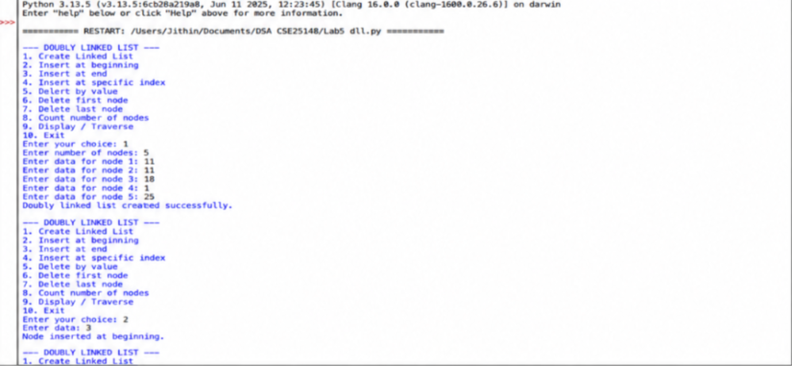

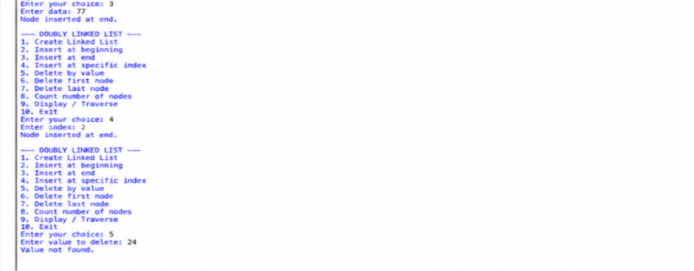
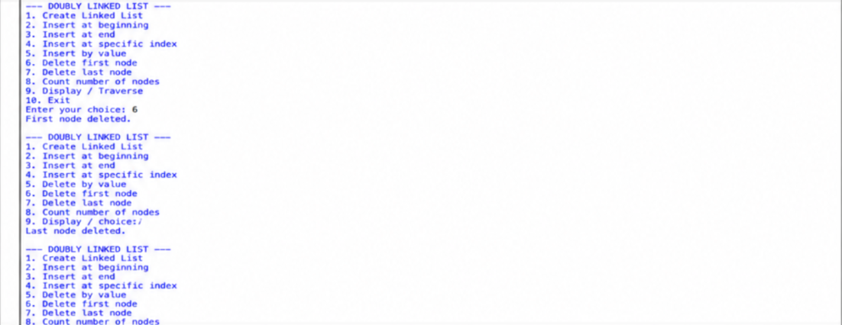
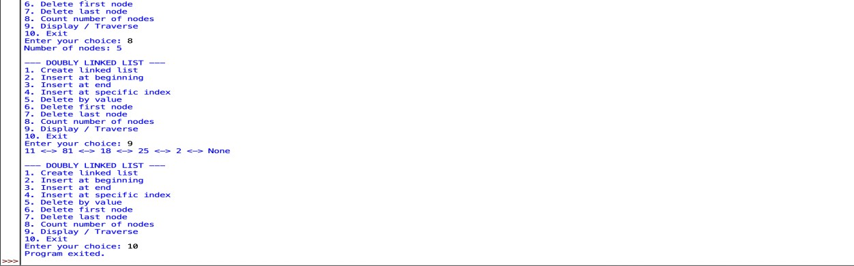

EXPLANATION:
- The Node class creates a node containing data, previous link, and next link.
- The DoublyLinkedList class maintains the list using the head pointer.
- The create() function creates the doubly linked list by adding the given nodes.
- The insert_beginning() function adds a new node at the beginning and updates the previous link.
- The insert_end() function adds a new node at the end of the list.
- The insert_index() function inserts a node at a specified index and updates both links.
- The delete_value() function searches for a given value and removes that node.
- The delete_first() function removes the first node and updates the head.
- The delete_last() function removes the last node from the list.
- The count() function counts and displays the number of nodes.
- The display() function traverses the list and displays the elements using <->.
- The main program provides a menu to select and perform different operations.

ERROR TABLE:
S.no. | Errors | Rectification
1. | IndentationError occurred because the statements were not properly aligned. | Corrected the indentation of all blocks.
2. | NameError occurred because new_node, temp, or other variables were misspelled. | Corrected the variable names and spelling.
3. | AttributeError occurred when prev or next links were not updated correctly. | Updated the prev and next links properly.
4. | IndexError occurred when an invalid index was entered. | Checked whether the index is within the valid range.

C.AIM: Write a Python program to implement a Circular linked list with the above operations.
PROGRAM:
class Node:
def __init__(self, data):
self.data = data
self.next = None

class CircularLinkedList:
def __init__(self):
self.head = None

# 1. Create linked list
def create(self):
n = int(input("Enter number of nodes: "))
for i in range(n):
data = int(input(f"Enter data for node {i + 1}: "))
new_node = Node(data)
if self.head is None:
self.head = new_node
new_node.next = self.head
else:
temp = self.head
while temp.next != self.head:
temp = temp.next
temp.next = new_node
new_node.next = self.head
print("Circular linked list created successfully.")

# 2. Insert at beginning
def insert_beginning(self):
data = int(input("Enter data: "))
new_node = Node(data)

if self.head is None:
self.head = new_node
new_node.next = self.head
else:
temp = self.head
while temp.next != self.head:
temp = temp.next
new_node.next = self.head
temp.next = new_node
self.head = new_node

print("Node inserted at beginning.")

# 3. Insert at end
def insert_end(self):
data = int(input("Enter data: "))
new_node = Node(data)

if self.head is None:
self.head = new_node
new_node.next = self.head
else:
temp = self.head
while temp.next != self.head:
temp = temp.next
temp.next = new_node
new_node.next = self.head

print("Node inserted at end.")

# 4. Insert at specific index
def insert_index(self):
index = int(input("Enter index: "))
data = int(input("Enter data: "))
new_node = Node(data)

if index == 0:
if self.head is None:
self.head = new_node
new_node.next = self.head
else:
temp = self.head
while temp.next != self.head:
temp = temp.next
new_node.next = self.head
temp.next = new_node
self.head = new_node
print("Node inserted.")
return

if self.head is None:
print("Invalid index.")
return

temp = self.head
for i in range(index - 1):
temp = temp.next
if temp == self.head:
print("Invalid index.")
return

new_node.next = temp.next
temp.next = new_node
print("Node inserted.")

# 5. Delete by value
def delete_value(self):
value = int(input("Enter value to delete: "))

if self.head is None:
print("List is empty.")
return

if self.head.data == value:
if self.head.next == self.head:
self.head = None
else:
temp = self.head
while temp.next != self.head:
temp = temp.next
temp.next = self.head.next
self.head = self.head.next
print("Node deleted.")
return

temp = self.head
while temp.next != self.head and temp.next.data != value:
temp = temp.next

if temp.next == self.head:
print("Value not found.")
else:
temp.next = temp.next.next
print("Node deleted.")

# 6. Delete first node
def delete_first(self):
if self.head is None:
print("List is empty.")
return

if self.head.next == self.head:
self.head = None
else:
temp = self.head
while temp.next != self.head:
temp = temp.next
temp.next = self.head.next
self.head = self.head.next

print("First node deleted.")

# 7. Delete last node
def delete_last(self):
if self.head is None:
print("List is empty.")
return

if self.head.next == self.head:
self.head = None
else:
temp = self.head
while temp.next.next != self.head:
temp = temp.next
temp.next = self.head

print("Last node deleted.")

# 8. Count nodes
def count(self):
if self.head is None:
print("Number of nodes: 0")
return

count = 0
temp = self.head
while True:
count += 1
temp = temp.next
if temp == self.head:
break

print("Number of nodes:", count)

# 9. Display / Traverse
def display(self):
if self.head is None:
print("List is empty.")
return

temp = self.head
while True:
print(temp.data, end=" -> ")
temp = temp.next
if temp == self.head:
break

print("HEAD")

# Main program
cll = CircularLinkedList()

while True:
print("\n--- CIRCULAR LINKED LIST ---")
print("1. Create linked list")
print("2. Insert at beginning")
print("3. Insert at end")
print("4. Insert at specific index")
print("5. Delete by value")
print("6. Delete first node")
print("7. Delete last node")
print("8. Count number of nodes")
print("9. Display / Traverse")
print("10. Exit")

choice = int(input("Enter your choice: "))

if choice == 1:
cll.create()
elif choice == 2:
cll.insert_beginning()
elif choice == 3:
cll.insert_end()
elif choice == 4:
cll.insert_index()
elif choice == 5:
cll.delete_value()
elif choice == 6:
cll.delete_first()
elif choice == 7:
cll.delete_last()
elif choice == 8:
cll.count()
elif choice == 9:
cll.display()
elif choice == 10:
print("Program exited.")
break
else:
print("Invalid choice.")

OUTPUT:
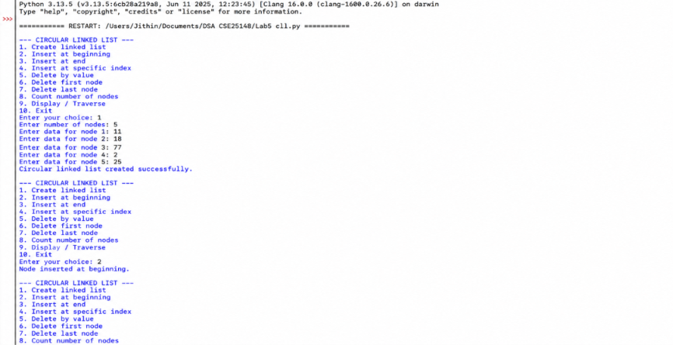
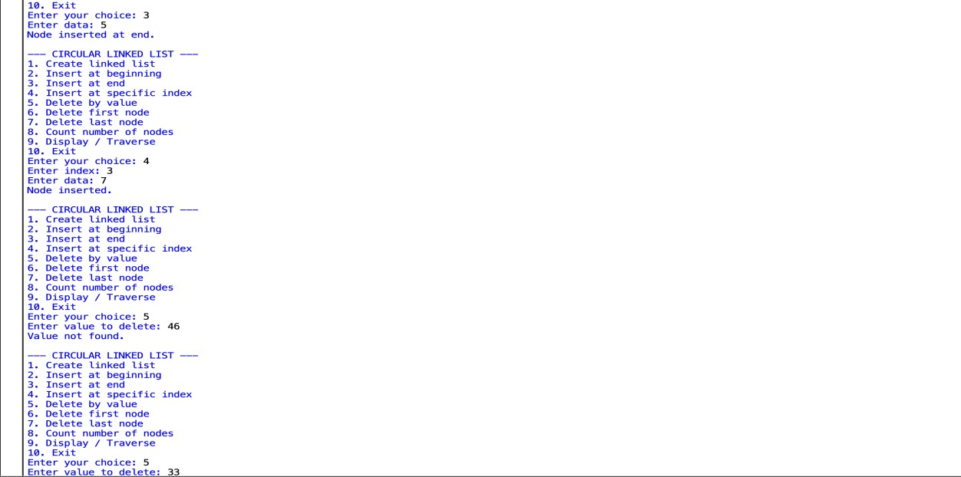
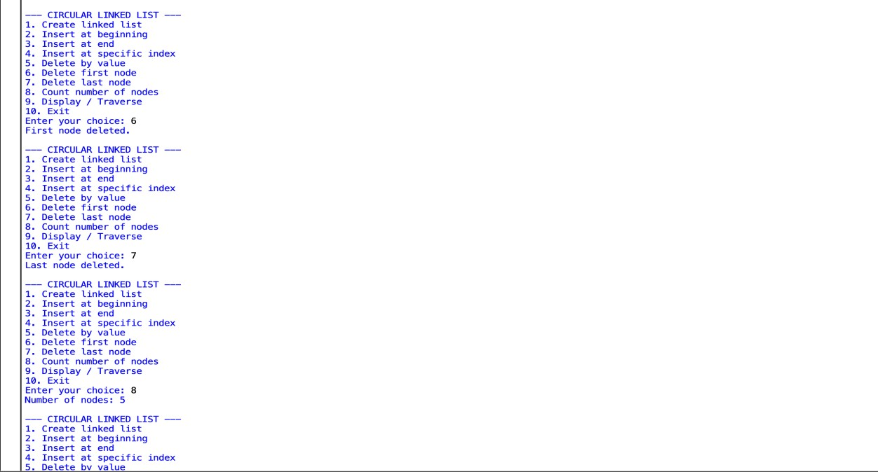
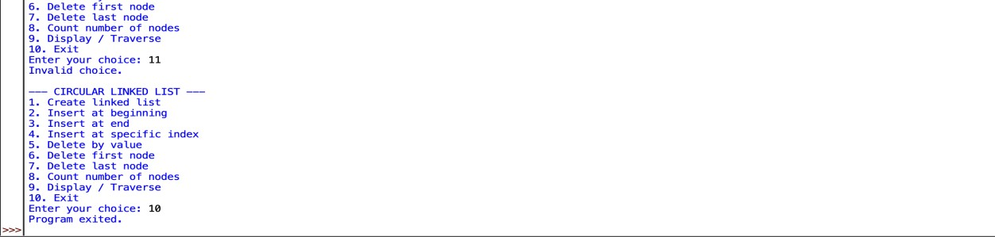
EXPLANATION:
- The Node class creates a node containing data and a link to the next node.
- The CircularLinkedList class maintains the list using the head pointer.
- The create() function creates the circular linked list and connects the last node back to the head.
- The insert_beginning() function adds a new node at the beginning and updates the circular connection.
- The insert_end() function adds a new node at the end and connects it back to the head.
- The insert_index() function inserts a node at a specified index.
- The delete_value() function searches for a value and deletes the corresponding node.
- The delete_first() function removes the first node and updates the head.
- The delete_last() function removes the last node while maintaining the circular connection.
- The count() function counts and displays the total number of nodes.
- The display() function traverses the list and displays the elements until it reaches the head again.
- The main program provides a menu to perform different circular linked-list operations.
ERROR TABLE:

S.no. | Errors | Rectification
1. | IndentationError occurred because the statements were not properly aligned. | Corrected the indentation of all code blocks.
2. | NameError occurred because variables like temp or new_node were misspelled. | Corrected the variable names and spelling.
3. | AttributeError occurred when the next link was not updated properly. | Updated the next links correctly to maintain the circular connection.
4. | IndexError occurred when an invalid index was entered. | Checked whether the index is within the valid range.
5. | Value not found occurred when the entered value was not present in the list. | Searched the list and displayed "Value not found."

Week-6

A.AIM: Write a Python program to implement stack operations such as Push,
Pop, Peek, Display using an array

PROGRAM:
stack = []

# Push operation
def push():
value = int(input("Enter element: "))
stack.append(value)
print("Element pushed.")

# Pop operation
def pop():
if len(stack) == 0:
print("Stack is empty.")
else:
print("Popped element:", stack.pop())

# Peek operation
def peek():
if len(stack) == 0:
print("Stack is empty.")
else:
print("Top element:", stack[-1])

# Display operation
def display():
if len(stack) == 0:
print("Stack is empty.")
else:
print("Stack elements:")
for i in range(len(stack) - 1, -1, -1):
print(stack[i])

# Main program
while True:
print("\n--- STACK USING ARRAY ---")
print("1. Push")
print("2. Pop")
print("3. Peek")
print("4. Display")
print("5. Exit")

choice = int(input("Enter your choice: "))

if choice == 1:
push()
elif choice == 2:
pop()
elif choice == 3:
peek()
elif choice == 4:
display()
elif choice == 5:
print("Program exited.")
break
else:
print("Invalid choice.")

OUTPUT:
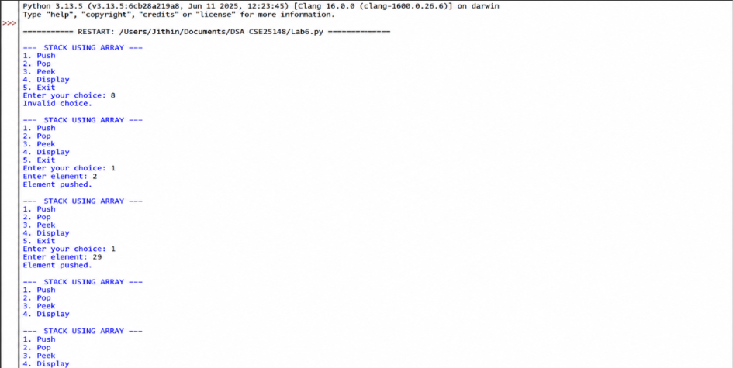

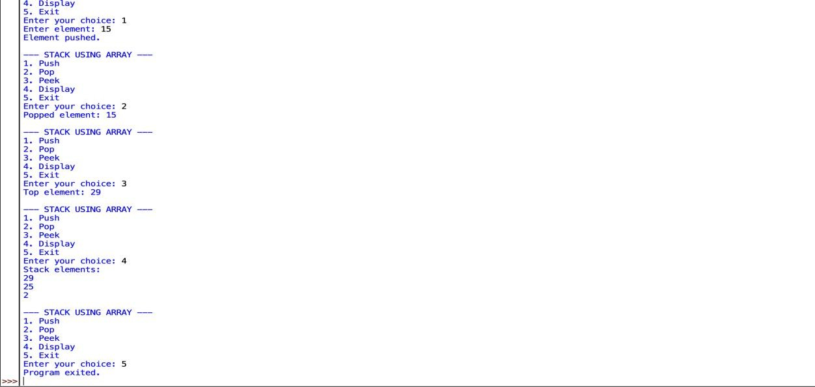

EXPLANATION:
- The stack list is used to store the stack elements.
- The push() function adds an element to the top of the stack.
- The pop() function removes and returns the top element.
- The peek() function displays the top element without removing it.
- The display() function prints all elements from top to bottom.
- len(stack) == 0 checks whether the stack is empty.
- The main program provides a menu to perform different stack operations.
- Stack follows the LIFO (Last In, First Out) principle.

ERROR TABLE:
S.no. | Errors | Rectification
1. | ValueError occurred when a noninteger value was entered. | Entered only valid integer values.
2. | NameError occurred because stack or a function name was misspelled. | Corrected the variable and function names.
3. | Index Error occurred when trying to access the top element of an empty stack. | Checked whether the stack is empty before accessing an element.
4. | Empty stack error occurred when Pop or Peek was performed without any elements. | Checked len(stack) == 0 before performing Pop or Peek.
5. | SyntaxError occurred because of incorrect Python syntax. | Checked and corrected the syntax of the program.

B.AIM: Write a Python program to implement stack operations such as Push,
Pop, Peek, Display using a linked list
PROGRAM:
class Node:
def __init__(self, data):
self.data = data
self.next = None

class Stack:
def __init__(self):
self.top = None

# Push operation
def push(self):
value = int(input("Enter element: "))
new_node = Node(value)
new_node.next = self.top
self.top = new_node
print("Element pushed.")

# Pop operation
def pop(self):
if self.top is None:
print("Stack is empty.")
else:
print("Popped element:", self.top.data)
self.top = self.top.next

# Peek operation
def peek(self):
if self.top is None:
print("Stack is empty.")
else:
print("Top element:", self.top.data)

# Display operation
def display(self):
if self.top is None:
print("Stack is empty.")
else:
temp = self.top
print("Stack elements:")
while temp:
print(temp.data)
temp = temp.next

# Main program
stack = Stack()

while True:
print("\n--- STACK USING LINKED LIST ---")
print("1. Push")
print("2. Pop")
print("3. Peek")
print("4. Display")
print("5. Exit")

choice = int(input("Enter your choice: "))

if choice == 1:
stack.push()
elif choice == 2:
stack.pop()
elif choice == 3:
stack.peek()
elif choice == 4:
stack.display()
elif choice == 5:
print("Program exited.")
break
else:
print("Invalid choice.")

OUTPUT:
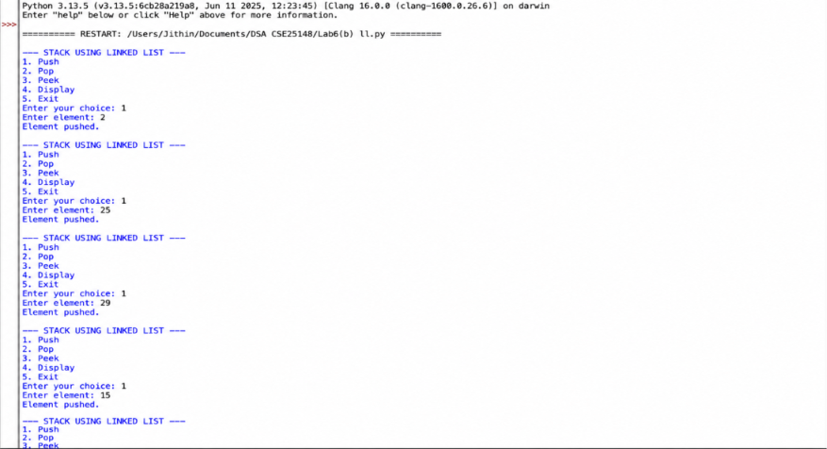

EXPLANATION:
- The Node class creates a node containing data and a link to the next node.
- The Stack class uses top to keep track of the top element.
- The push() function adds a new node at the top of the stack.
- The pop() function removes the top node from the stack.
- The peek() function displays the top element without removing it.
- The display() function traverses the linked list and displays all elements.
- self.top is None checks whether the stack is empty.
- The main program provides a menu for performing stack operations.
- The stack follows the LIFO (Last In, First Out) principle.

ERROR TABLE:
S.no. | Errors | Rectification
1. | NameError occurred because top, temp, or new_node was misspelled. | Corrected the variable names and their spelling.
2. | AttributeError occurred when next was accessed incorrectly. | Correctly used self.top and temp.next.
3. | ValueError occurred when a noninteger value was entered. | Entered only valid integer values.
4. | Empty stack error occurred when Pop or Peek was performed without any elements. | Checked self.top is None before performing the operation.
5. | IndentationError occurred because the statements inside the functions were not properly aligned. | Corrected the indentation of all code blocks.

Week-7

A.AIM: Write a Python program to implement a queue and its operations such as Enqueue, Dequeue, Peek, Display with a menu-driven approach. Implement using array
PROGRAM:
queue = []

# Enqueue operation
def enqueue():
value = int(input("Enter element: "))
queue.append(value)
print("Element inserted.")

# Dequeue operation
def dequeue():
if len(queue) == 0:
print("Queue is empty.")
else:
print("Deleted element:", queue.pop(0))

# Peek operation
def peek():
if len(queue) == 0:
print("Queue is empty.")
else:
print("Front element:", queue[0])

# Display operation
def display():
if len(queue) == 0:
print("Queue is empty.")
else:
print("Queue elements:")
for element in queue:
print(element, end=" ")
print()

# Main program
while True:
print("\n--- QUEUE USING ARRAY ---")
print("1. Enqueue")
print("2. Dequeue")
print("3. Peek")
print("4. Display")
print("5. Exit")
choice = int(input("Enter your choice: "))
if choice == 1:
enqueue()
elif choice == 2:
dequeue()
elif choice == 3:
peek()
elif choice == 4:
display()
elif choice == 5:
print("Program exited.")
break
else:
print("Invalid choice.")

OUTPUT:
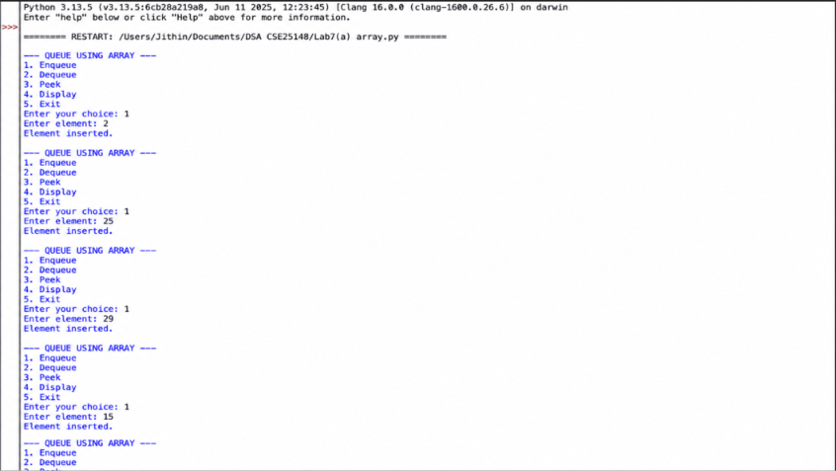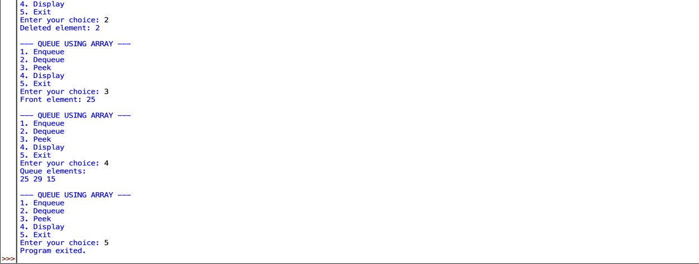

EXPLANATION:
- The queue list is used to store the queue elements.
- The enqueue() function adds an element at the rear of the queue.
- The dequeue() function removes an element from the front of the queue.
- The peek() function displays the front element without removing it.
- The display() function prints all the elements in the queue.
- len(queue) == 0 checks whether the queue is empty.
- The main program provides a menu to select different queue operations.
- Queue follows the FIFO (First In, First Out) principle.

ERROR TABLE:
S.no. | Errors | Rectification
1. | IndentationError occurred because the statements inside the functions were not properly aligned. | Corrected the indentation of all code blocks.
2. | ValueError occurred when a noninteger value was entered. | Entered only valid integer values.
3. | NameError occurred because queue or a function name was misspelled. | NameError occurred because queue or a function name was misspelled.
4. | IndexError occurred when trying to access an element from an empty queue. | Checked whether the queue is empty before accessing elements.

B.AIM: Write a Python program to implement a queue and its operations such as
Enqueue, Dequeue, Peek, Display with a menu-driven approach. Implement using Linked list data.
PROGRAM:
class Node:
def __init__(self, data):
self.data = data
self.next = None

class Queue:
def __init__(self):
self.front = None
self.rear = None

# Enqueue operation
def enqueue(self):
value = int(input("Enter element: "))
new_node = Node(value)
if self.rear is None:
self.front = self.rear = new_node
else:
self.rear.next = new_node
self.rear = new_node
print("Element inserted.")

# Dequeue operation
def dequeue(self):
if self.front is None:
print("Queue is empty.")
else:
print("Deleted element:", self.front.data)
self.front = self.front.next
if self.front is None:
self.rear = None

# Peek operation
def peek(self):
if self.front is None:
print("Queue is empty.")
else:
print("Front element:", self.front.data)

# Display operation
def display(self):
if self.front is None:
print("Queue is empty.")
else:
temp = self.front
print("Queue elements:")
while temp:
print(temp.data, end=" ")
temp = temp.next
print()

# Main program
queue = Queue()
while True:
print("\n--- QUEUE USING LINKED LIST ---")
print("1. Enqueue")
print("2. Dequeue")
print("3. Peek")
print("4. Display")
print("5. Exit")

choice = int(input("Enter your choice: "))

if choice == 1:
queue.enqueue()
elif choice == 2:
queue.dequeue()
elif choice == 3:
queue.peek()
elif choice == 4:
queue.display()
elif choice == 5:
print("Program exited.")
break
else:
print("Invalid choice.")

OUTPUT:
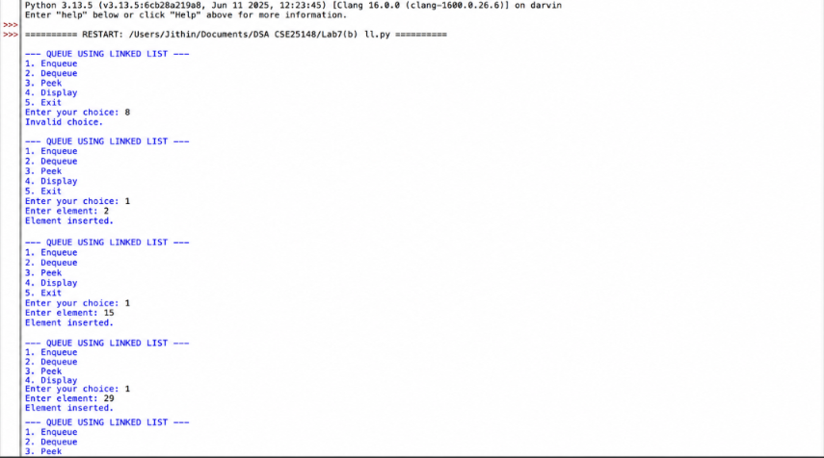
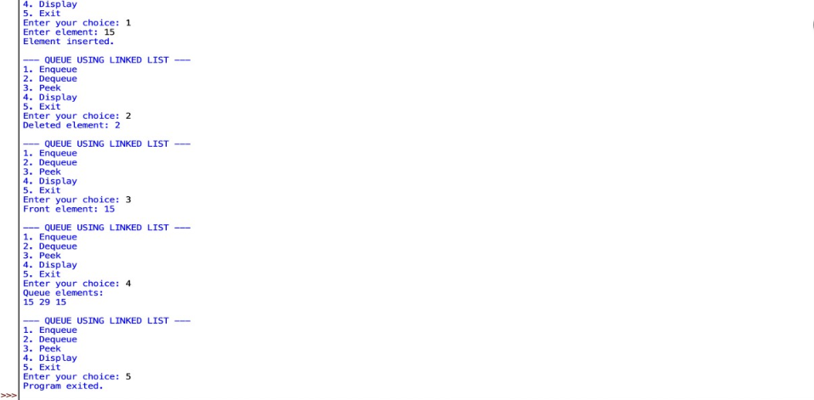
EXPLANATION:
- The Node class creates a node containing data and a link to the next node.
- The Queue class uses front and rear to maintain the queue.
- The enqueue() function adds a new node at the rear.
- The dequeue() function removes a node from the front.
- The peek() function displays the front element without removing it.
- The display() function traverses the linked list and displays all elements.
- The queue follows the FIFO (First In, First Out) principle.
- The main program provides a menu-driven approach for performing the operations.

ERROR TABLE:
S.no. | Errors | Rectification
1. | NameError occurred because front, rear, or new_node was misspelled. | Corrected the variable names and their spelling.
2. | AttributeError occurred when next was accessed incorrectly. | Used self.front, self.rear, and temp.next correctly.
3. | ValueError occurred when a noninteger value was entered. | Entered only valid integer values.
4. | Empty queue error occurred when Dequeue or Peek was performed without elements. | Checked self.front is None before performing the operation.
5. | SyntaxError occurred due to incorrect Python syntax. | Checked and corrected the syntax of the program.

C.AIM:
Write a Python program to implement a queue and its operations such as
Enqueue, Dequeue, Peek, Display with a menu-driven approach. Implement using Circular Queue array structures
PROGRAM:
class CircularQueue:
def __init__(self, size):
self.size = size
self.queue = [None] * size
self.front = -1
self.rear = -1

# Enqueue
def enqueue(self):
value = int(input("Enter element: "))

if (self.rear + 1) % self.size == self.front:
print("Queue is full.")
return

if self.front == -1:
self.front = 0

self.rear = (self.rear + 1) % self.size
self.queue[self.rear] = value
print("Element inserted.")

# Dequeue
def dequeue(self):
if self.front == -1:
print("Queue is empty.")
return

print("Deleted element:", self.queue[self.front])

if self.front == self.rear:
self.front = -1
self.rear = -1
else:
self.front = (self.front + 1) % self.size

# Peek
def peek(self):
if self.front == -1:
print("Queue is empty.")
else:
print("Front element:", self.queue[self.front])

# Display
def display(self):
if self.front == -1:
print("Queue is empty.")
return

print("Queue elements:")
i = self.front

while True:
print(self.queue[i], end=" ")
if i == self.rear:
break
i = (i + 1) % self.size
print()

# Main program
size = int(input("Enter queue size: "))
queue = CircularQueue(size)

while True:
print("\n--- CIRCULAR QUEUE ---")
print("1. Enqueue")
print("2. Dequeue")
print("3. Peek")
print("4. Display")
print("5. Exit")

choice = int(input("Enter your choice: "))

if choice == 1:
queue.enqueue()
elif choice == 2:
queue.dequeue()
elif choice == 3:
queue.peek()
elif choice == 4:
queue.display()
elif choice == 5:
print("Program exited.")
break
else:
print("Invalid choice.")

OUTPUT:
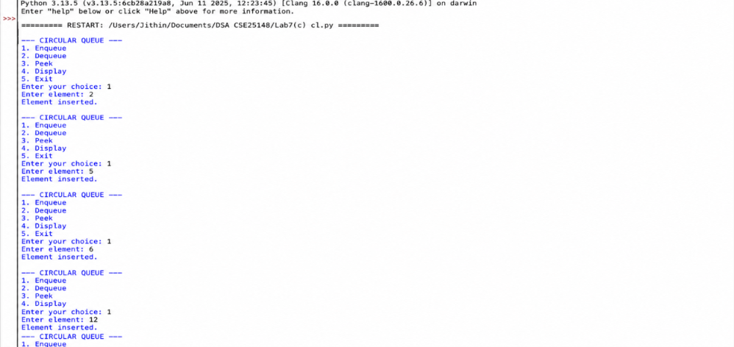

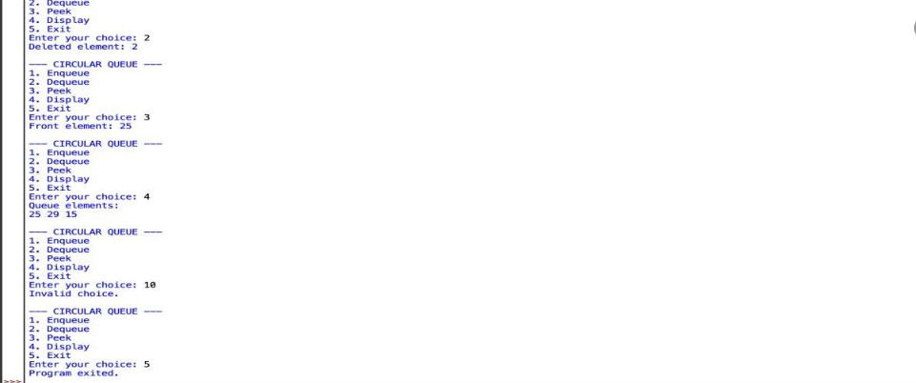
EXPLANATION:
- The CircularQueue class creates a queue using an array.
- front represents the position of the first element, while rear represents the last element.
- enqueue() adds a new element at the rear.
- dequeue() removes an element from the front.
- peek() displays the front element without deleting it.
- display() prints all the elements from front to rear.
- The % size operation makes the rear and front wrap around the array.
- The main program provides a menu-driven interface.
- The queue follows the FIFO (First In, First Out) principle.

ERROR TABLE:

S.no. | Errors | Rectification
1. | IndentationError occurred because the statements were not properly aligned. | Corrected the indentation of all code blocks.
2. | ValueError occurred when a noninteger value was entered. | Entered only valid integer values.
3. | NameError occurred because front, rear, or queue was misspelled. | Corrected the variable names and spelling.
4. | IndexError occurred when an invalid array position was accessed. | Used proper circular indexing with % size.
5. | Queue full error occurred when an element was inserted into a full queue. | Checked the full condition before enqueueing.

D.AIM: Write a Python program to implement a queue and its operations such as
Enqueue, Dequeue, Peek, Display with a menu-driven approach. Implement using Circular Queue Linked list structures.
PROGRAM:
class Node:
def __init__(self, data):
self.data = data
self.next = None

class CircularQueue:
def __init__(self):
self.front = None
self.rear = None

# Enqueue
def enqueue(self):
value = int(input("Enter element: "))
new_node = Node(value)

if self.front is None:
self.front = self.rear = new_node
new_node.next = self.front
else:
new_node.next = self.front
self.rear.next = new_node
self.rear = new_node

print("Element inserted.")

# Dequeue
def dequeue(self):
if self.front is None:
print("Queue is empty.")
return

print("Deleted element:", self.front.data)

if self.front == self.rear:
self.front = None
self.rear = None
else:
self.front = self.front.next
self.rear.next = self.front

# Peek
def peek(self):
if self.front is None:
print("Queue is empty.")
else:
print("Front element:", self.front.data)

# Display
def display(self):
if self.front is None:
print("Queue is empty.")
return

temp = self.front
print("Queue elements:")

while True:
print(temp.data, end=" ")
temp = temp.next
if temp == self.front:
break

print()

# Main program
queue = CircularQueue()

while True:
print("\n--- CIRCULAR QUEUE USING LINKED LIST ---")
print("1. Enqueue")
print("2. Dequeue")
print("3. Peek")
print("4. Display")
print("5. Exit")

choice = int(input("Enter your choice: "))

if choice == 1:
queue.enqueue()
elif choice == 2:
queue.dequeue()
elif choice == 3:
queue.peek()
elif choice == 4:
queue.display()
elif choice == 5:
print("Program exited.")
break
else:
print("Invalid choice.")

OUTPUT:
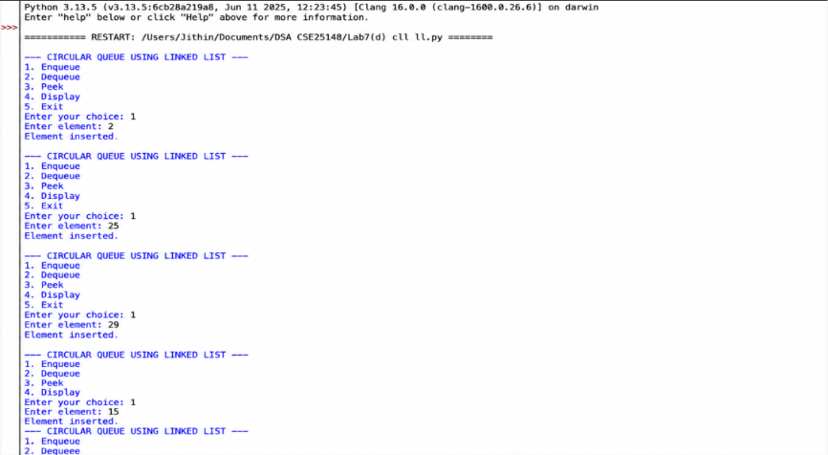
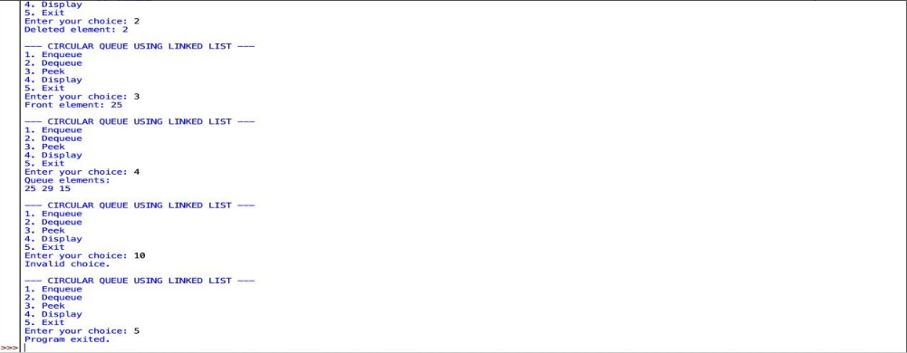

EXPLANATION:
- The Node class creates a node containing data and a next link.
- The CircularQueue class maintains the queue using front and rear.
- The enqueue() function adds a node at the rear and connects it back to the front.
- The dequeue() function removes the front node.
- The peek() function displays the front element without removing it.
- The display() function traverses the circular linked list until it reaches the front again.
- front and rear are set to None when the queue becomes empty.
- The main program provides a menu-driven approach.
- The circular queue follows the FIFO (First In, First Out) principle.

ERROR TABLE:

S.no. | Errors | Rectification
1. | NameError occurred because front, rear, or new_node was misspelled. | Corrected the variable names and spelling.
2. | AttributeError occurred when the next link was not accessed correctly. | Used self.front, self.rear, and temp.next correctly.
3. | ValueError occurred when a noninteger value was entered. | Entered only valid integer values.
4. | Empty queue error occurred when Dequeue or Peek was performed on an empty queue. | Checked self.front is None before performing the operation.
5. | Circular link error occurred when the rear node was not connected back to the front node. | Updated self.rear.next = self.front after insertion and deletion.

Week-8
A.AIM: Write a Python program to implement a binary tree with its operations using an arrays
PROGRAM:
class BinaryTreeArray:
def __init__(self, size):
self.tree = [None] * size
self.size = size

# Insert root
def set_root(self, data):
if self.size > 0:
self.tree[0] = data
else:
print("Tree is empty!")

# Set left child
def set_left(self, parent_index, data):
if parent_index < 0 or parent_index >= self.size:
print("Invalid parent index!")
return

if self.tree[parent_index] is None:
print("Parent node does not exist!")
return

child_index = 2 * parent_index + 1

if child_index < self.size:
self.tree[child_index] = data
else:
print("Index out of range!")

# Set right child
def set_right(self, parent_index, data):
if parent_index < 0 or parent_index >= self.size:
print("Invalid parent index!")
return

if self.tree[parent_index] is None:
print("Parent node does not exist!")
return

child_index = 2 * parent_index + 2

if child_index < self.size:
self.tree[child_index] = data
else:
print("Index out of range!")

# Preorder Traversal
def preorder(self, index=0):
if index >= self.size or self.tree[index] is None:
return

print(self.tree[index], end=" ")
self.preorder(2 * index + 1)
self.preorder(2 * index + 2)

# Inorder Traversal
def inorder(self, index=0):
if index >= self.size or self.tree[index] is None:
return

self.inorder(2 * index + 1)
print(self.tree[index], end=" ")
self.inorder(2 * index + 2)

# Postorder Traversal
def postorder(self, index=0):
if index >= self.size or self.tree[index] is None:
return

self.postorder(2 * index + 1)
self.postorder(2 * index + 2)
print(self.tree[index], end=" ")

# Level-order Traversal
def level_order(self):
for value in self.tree:
if value is not None:
print(value, end=" ")

# Display Array
def display(self):
print("\nArray Representation:")
for i in range(self.size):
print(f"Index {i}: {self.tree[i]}")

# Main Program
tree = BinaryTreeArray(7)
tree.set_root('A')
tree.set_left(0, 'B')
tree.set_right(0, 'C')
tree.set_left(1, 'D')
tree.set_right(1, 'E')
tree.set_right(2, 'F')

tree.display()

print("\nPreorder Traversal:", end=" ")
tree.preorder()

print("\nInorder Traversal:", end=" ")
tree.inorder()

print("\nPostorder Traversal:", end=" ")
tree.postorder()

print("\nLevel-order Traversal:", end=" ")
tree.level_order()
print()

OUTPUT:
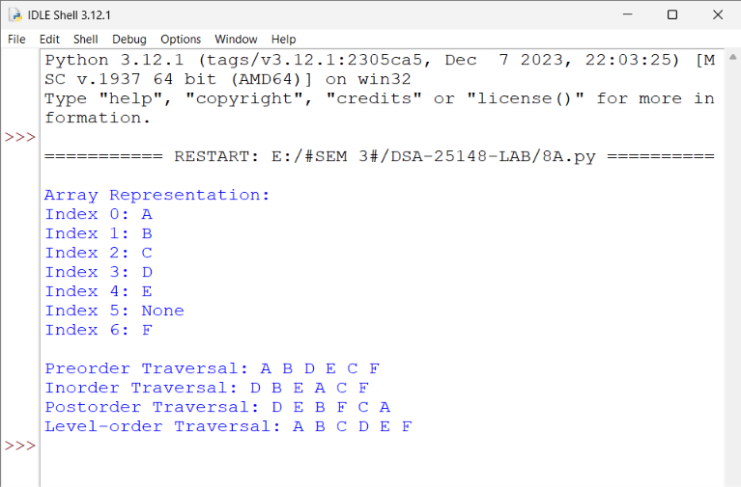

EXPLANATION:
- The BinaryTreeArray class represents a binary tree using an array.
- The __init__() function initializes an array of the given size with None values.
- The set_root() function inserts the root node at index 0.
- The set_left() function inserts the left child of a parent node using the formula 2 * parent_index + 1.
- The set_right() function inserts the right child of a parent node using the formula 2 * parent_index + 2.
- The preorder() function traverses the tree in the order Root → Left → Right.
- The inorder() function traverses the tree in the order Left → Root → Right.
- The postorder() function traverses the tree in the order Left → Right → Root.
- The level_order() function displays the nodes level by level by traversing the array.
- The display() function displays each array index and its corresponding node value.
- The main program creates a binary tree of size 7 and inserts nodes A, B, C, D, E, F.
- The binary tree follows the parent-child relationship, where each node can have at most two children: a left child and a right child.
- The program demonstrates array representation and different tree traversal techniques.

ERROR TABLE:
S.no. | Errors | Rectification
1. | IndexError may occur if an invalid index is accessed in the tree array. | Checked the index range before accessing the array.
2. | Incorrect child index occurred when the left or right child position was calculated incorrectly. | Used 2 * parent_index + 1 for the left child and 2 * parent_index + 2 for the right child.
3. | Parent node error occurred when trying to insert a child for a parent that does not exist. | Checked whether self.tree[parent_index] is None before insertion.
4. | Index out of range error occurred when the child index exceeded the array size. | Checked whether child_index < self.size before inserting the child.
5. | Incorrect traversal output occurred when the preorder, inorder, or postorder sequence was not followed correctly. | Used the correct traversal orders: Root–Left–Right, Left–Root–Right, and Left–Right–Root.

B.AIM: Write a Python program to implement a binary tree with its operations using an Linked list
PROGRAM:
# Binary Tree Using Linked List
class Node:
def __init__(self, data):
self.data = data
self.left = None
self.right = None

class BinaryTree:
def __init__(self):
self.root = None

# Insert root
def set_root(self, data):
if self.root is None:
self.root = Node(data)
else:
print("Root already exists!")

# Set left child
def set_left(self, parent, data):
node = self.search(parent)

if node is None:
print("Parent node not found!")
elif node.left is not None:
print("Left child already exists!")
else:
node.left = Node(data)

# Set right child
def set_right(self, parent, data):
node = self.search(parent)

if node is None:
print("Parent node not found!")
elif node.right is not None:
print("Right child already exists!")
else:
node.right = Node(data)

# Search for a node by its value
def search(self, data):
if self.root is None:
return None

queue = [self.root]

while queue:
node = queue.pop(0)

if node.data == data:
return node

if node.left is not None:
queue.append(node.left)

if node.right is not None:
queue.append(node.right)

return None

# Preorder: Root, Left, Right
def preorder(self, node):
if node is not None:
print(node.data, end=" ")
self.preorder(node.left)
self.preorder(node.right)

# Inorder: Left, Root, Right
def inorder(self, node):
if node is not None:
self.inorder(node.left)
print(node.data, end=" ")
self.inorder(node.right)

# Postorder: Left, Right, Root
def postorder(self, node):
if node is not None:
self.postorder(node.left)
self.postorder(node.right)
print(node.data, end=" ")

# Level-order traversal
def level_order(self):
if self.root is None:
return
queue = [self.root]

while queue:
node = queue.pop(0)
print(node.data, end=" ")

if node.left is not None:
queue.append(node.left)

if node.right is not None:
queue.append(node.right)

# Display tree using preorder
def display(self):
if self.root is None:
print("Tree is empty!")
else:
self.preorder(self.root)
print()

# Main Program
tree = BinaryTree()
tree.set_root('A')
tree.set_left('A', 'B')
tree.set_right('A', 'C')
tree.set_left('B', 'D')
tree.set_right('B', 'E')
tree.set_right('C', 'F')

print("Binary Tree (Preorder): ", end="")
tree.display()

print("Preorder Traversal: ", end="")
tree.preorder(tree.root)

print("\nInorder Traversal: ", end="")
tree.inorder(tree.root)

print("\nPostorder Traversal: ", end="")
tree.postorder(tree.root)

print("\nLevel-order Traversal: ", end="")
tree.level_order()
print()

OUTPUT:
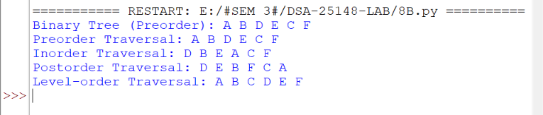

EXPLANATION:
- The Node class creates a node containing data, left, and right links.
- The BinaryTree class manages the binary tree using linked nodes.
- The __init__() function initializes the tree with root = None.
- The set_root() function creates the root node.
- The set_left() function inserts the left child of a parent node.
- The set_right() function inserts the right child of a parent node.
- The search() function searches for a node using a queue.
- The preorder() function traverses in the order Root ---> Left---> Right.
- The inorder() function traverses in the order Left ---> Root ---> Right.
- The postorder() function traverses in the order Left ---> Right ---> Root.
- The level_order() function visits nodes level by level using a queue.
- The display() function displays the tree using preorder traversal.
- The main program creates a binary tree with nodes A, B, C, D, E, F and performs all four traversals.
- The program demonstrates binary tree creation, insertion, searching, and traversal using a linked list.

ERROR TABLE:

S.no. | Errors | Rectification
1. | AttributeError occurred when accessing node links incorrectly. | Used node.left and node.right correctly.
2. | Root already exists error occurred when trying to insert another root. | Checked whether self.root is None before insertion.
3. | Child already exists error occurred when inserting a child into an occupied position. | Checked whether node.left or node.right is None before insertion.
4. | Incorrect traversal output occurred when traversal order was incorrect. | Followed the correct preorder, inorder, postorder, and level-order sequences.

Week-9
AIM: Write a python program to implement a binary search tree with its operations traversals
PROGRAM:
class Node:
def __init__(self, data):
self.data = data
self.left = None
self.right = None

# Insert a node
def insert(root, x):
if root is None:
return Node(x)
if x < root.data:
root.left = insert(root.left, x)
elif x > root.data:
root.right = insert(root.right, x)
else:
print("Duplicate value is not allowed.")
return root

# Inorder Traversal: Left, Root, Right
def inorder(root):
if root is not None:
inorder(root.left)
print(root.data, end=" ")
inorder(root.right)

# Preorder Traversal: Root, Left, Right
def preorder(root):
if root is not None:
print(root.data, end=" ")
preorder(root.left)
preorder(root.right)

# Postorder Traversal: Left, Right, Root
def postorder(root):
if root is not None:
postorder(root.left)
postorder(root.right)
print(root.data, end=" ")

# Find minimum element
def find_min(root):
if root is None:
return None
while root.left is not None:
root = root.left
return root

# Find maximum element
def find_max(root):
if root is None:
return None
while root.right is not None:
root = root.right
return root

# Search for an element
def search(root, x):
if root is None:
return None
if x < root.data:
return search(root.left, x)
elif x > root.data:
return search(root.right, x)
else:
return root

# Count total nodes
def count_nodes(root):
if root is None:
return 0
return 1 + count_nodes(root.left) + count_nodes(root.right)

# Count leaf nodes
def count_leaves(root):
if root is None:
return 0
if root.left is None and root.right is None:
return 1
return count_leaves(root.left) + count_leaves(root.right)

# Count internal nodes
def count_internal(root):
if root is None:
return 0
if root.left is None and root.right is None:
return 0
return 1 + count_internal(root.left) + count_internal(root.right)

# Find height of the tree
def height(root):
if root is None:
return -1
return 1 + max(height(root.left), height(root.right))

# Delete a node
def delete(root, x):
if root is None:
return None
if x < root.data:
root.left = delete(root.left, x)
elif x > root.data:
root.right = delete(root.right, x)
else:
# Case 1: No children
if root.left is None and root.right is None:
return None
# Case 2: Only right child
elif root.left is None:
return root.right
# Case 3: Only left child
elif root.right is None:
return root.left
# Case 4: Two children
successor = find_min(root.right)
root.data = successor.data
root.right = delete(root.right, successor.data)
return root

# Level-order Traversal using a queue
def level_order(root):
if root is None:
return
queue = [root]
front = 0
while front < len(queue):
node = queue[front]
front += 1
print(node.data, end=" ")
if node.left is not None:
queue.append(node.left)
if node.right is not None:
queue.append(node.right)

# Main menu-driven program
root = None
while True:
print("\n\n===== BINARY SEARCH TREE =====")
print("1. Insert")
print("2. Preorder Traversal")
print("3. Inorder Traversal")
print("4. Postorder Traversal")
print("5. Find Minimum")
print("6. Find Maximum")
print("7. Search")
print("8. Delete")
print("9. Count Total Nodes")
print("10. Count Leaf Nodes")
print("11. Count Internal Nodes")
print("12. Find Height")
print("13. Level Order Traversal")
print("14. Exit")

try:
choice = int(input("Enter your choice: "))
except ValueError:
print("Please enter a valid integer choice.")
continue

if choice == 1:
try:
data = int(input("Enter the data to insert: "))
existed = search(root, data) is not None
root = insert(root, data)
if not existed:
print("Element inserted successfully.")
except ValueError:
print("Please enter an integer.")

elif choice == 2:
print("Preorder Traversal:", end=" ")
if root is None:
print("Tree is empty.")
else:
preorder(root)
print()

elif choice == 3:
print("Inorder Traversal:", end=" ")
if root is None:
print("Tree is empty.")
else:
inorder(root)
print()

elif choice == 4:
print("Postorder Traversal:", end=" ")
if root is None:
print("Tree is empty.")
else:
postorder(root)
print()

elif choice == 5:
node = find_min(root)
if node is None:
print("Tree is empty.")
else:
print("Minimum element:", node.data)

elif choice == 6:
node = find_max(root)
if node is None:
print("Tree is empty.")
else:
print("Maximum element:", node.data)

elif choice == 7:
try:
data = int(input("Enter the element to search: "))
if search(root, data) is not None:
print("Element", data, "is found.")
else:
print("Element", data, "is not found.")
except ValueError:
print("Please enter an integer.")

elif choice == 8:
try:
data = int(input("Enter the element to delete: "))
if search(root, data) is None:
print("Element not found.")
else:
root = delete(root, data)
print("Element deleted successfully.")
except ValueError:
print("Please enter an integer.")

elif choice == 9:
print("Number of nodes:", count_nodes(root))

elif choice == 10:
print("Number of leaf nodes:", count_leaves(root))

elif choice == 11:
print("Number of internal nodes:", count_internal(root))

elif choice == 12:
print("Height of BST:", height(root))

elif choice == 13:
print("Level Order Traversal:", end=" ")
if root is None:
print("Tree is empty.")
else:
level_order(root)
print()

elif choice == 14:
print("Program terminated.")
break

else:
print("Invalid choice. Please try again.")

OUTPUT:
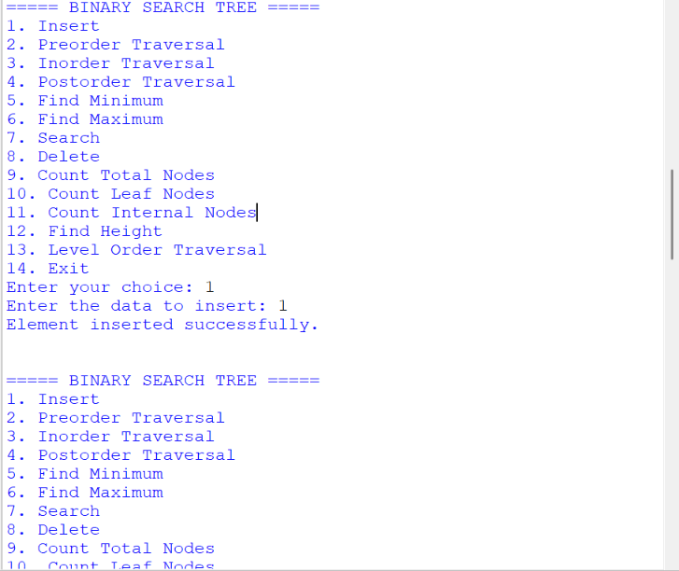

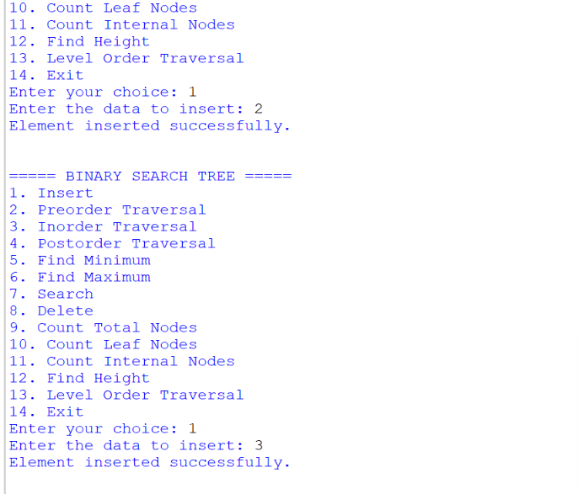
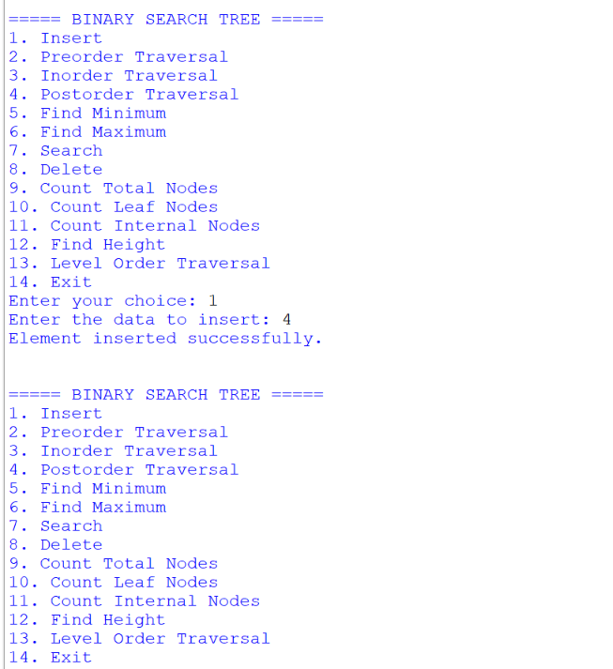
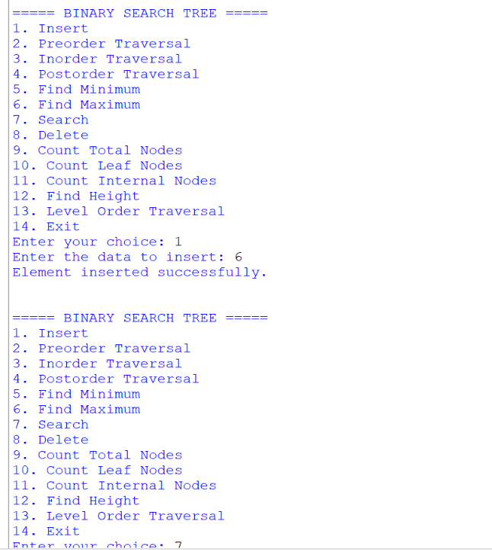
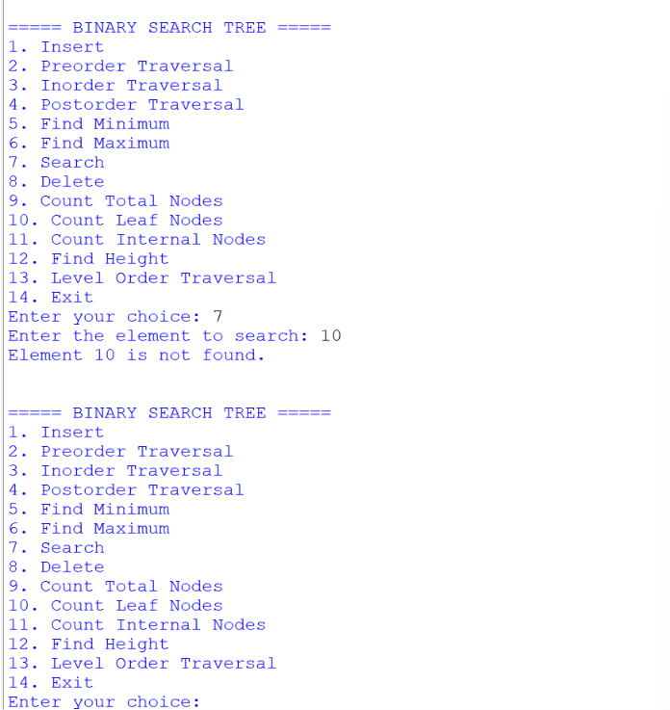

EXPLANATION:
- The Node class creates a node containing data, a left link, and a right link.
- The insert() function inserts values into the BST, placing smaller values on the left and larger values on the right.
- The inorder() function traverses the tree in the order Left → Root → Right.
- The preorder() function traverses the tree in the order Root → Left → Right.
- The postorder() function traverses the tree in the order Left → Right → Root.
- The find_min() function finds the minimum element by moving to the leftmost node.
- The find_max() function finds the maximum element by moving to the rightmost node.The search() function searches for an element using BST comparisons.
- The count_nodes() function counts the total number of nodes. The count_leaves() function counts nodes that have no children.The count_internal() function counts nodes that have at least one child.
- The height() function calculates the height of the tree in edges.
- The delete() function removes a node, handling cases with no children, one child, or two children.The level_order() function visits nodes level by level using a queue.
- The main menu allows the user to select and perform each BST operation, validate inputs, and exit the program.
- The program demonstrates BST insertion, deletion, searching, node counting, height calculation, and four traversal methods.
ERROR TABLE:
S.no. | Errors | Rectification
1. | TypeError / ValueError occurred when invalid input was entered. | Used try-except to validate integer inputs.
2. | Duplicate value error occurred when inserting an existing value. | Checked for duplicate values before insertion.
3. | Search error occurred when the element was not present in the BST. | Checked whether search() returns None before displaying the result.
4. | Empty tree error occurred when finding the minimum or maximum of an empty tree. | Checked whether the root is None before performing the operation.
5. | Deletion error occurred when deleting a node that did not exist. | Searched for the element before calling the delete() function.
6. | Incorrect traversal output occurred when the traversal order was incorrect. | Followed the correct preorder, inorder, postorder, and level-order sequences

Week-10
AIM: Write a python program to implement a AVL tree with all its operations.
PROGRAM:
class Node:
def __init__(self, key):
self.key = key
self.left = None
self.right = None
self.height = 1

class AVLTree:
# Get height of a node
def height(self, node):
if node is None:
return 0
return node.height

# Calculate balance factor
def get_balance(self, node):
if node is None:
return 0
return self.height(node.left) - self.height(node.right)

# Right rotation
def right_rotate(self, y):
x = y.left
T2 = x.right
x.right = y
y.left = T2
y.height = 1 + max(
self.height(y.left), self.height(y.right)
)
x.height = 1 + max(
self.height(x.left), self.height(x.right)
)
return x

# Left rotation
def left_rotate(self, x):
y = x.right
T2 = y.left

y.left = x
x.right = T2

x.height = 1 + max(
self.height(x.left), self.height(x.right)
)
y.height = 1 + max(
self.height(y.left), self.height(y.right)
)
return y

# Insert a key
def insert(self, root, key):
if root is None:
return Node(key)

if key < root.key:
root.left = self.insert(root.left, key)
elif key > root.key:
root.right = self.insert(root.right, key)
else:
return root # Ignore duplicate keys

root.height = 1 + max(
self.height(root.left), self.height(root.right)
)

balance = self.get_balance(root)

# LL Case
if balance > 1 and key < root.left.key:
return self.right_rotate(root)

# RR Case
if balance < -1 and key > root.right.key:
return self.left_rotate(root)

# LR Case
if balance > 1 and key > root.left.key:
root.left = self.left_rotate(root.left)
return self.right_rotate(root)

# RL Case
if balance < -1 and key < root.right.key:
root.right = self.right_rotate(root.right)
return self.left_rotate(root)

return root

# Find node with minimum key
def min_value_node(self, node):
current = node
while current.left is not None:
current = current.left
return current

# Find node with maximum key
def max_value_node(self, node):
current = node
while current.right is not None:
current = current.right
return current

# Delete a key
def delete(self, root, key):
if root is None:
return root

if key < root.key:
root.left = self.delete(root.left, key)
elif key > root.key:
root.right = self.delete(root.right, key)
else:
# Node with zero or one child
if root.left is None:
return root.right
elif root.right is None:
return root.left

# Node with two children:
# Replace with inorder successor
successor = self.min_value_node(root.right)
root.key = successor.key
root.right = self.delete(root.right, successor.key)

# If the tree had only one node then return
if root is None:
return root

# Update height
root.height = 1 + max(
self.height(root.left), self.height(root.right)
)

balance = self.get_balance(root)

# LL Case
if balance > 1 and self.get_balance(root.left) >= 0:
return self.right_rotate(root)

# LR Case
if balance > 1 and self.get_balance(root.left) < 0:
root.left = self.left_rotate(root.left)
return self.right_rotate(root)

# RR Case
if balance < -1 and self.get_balance(root.right) <= 0:
return self.left_rotate(root)

# RL Case
if balance < -1 and self.get_balance(root.right) > 0:
root.right = self.right_rotate(root.right)
return self.left_rotate(root)

return root

# Search for a key
def search(self, root, key):
if root is None or root.key == key:
return root

if key < root.key:
return self.search(root.left, key)

return self.search(root.right, key)

# Inorder traversal: Left, Root, Right
def inorder(self, root):
if root:
self.inorder(root.left)
print(root.key, end=" ")
self.inorder(root.right)

# Preorder traversal: Root, Left, Right
def preorder(self, root):
if root:
print(root.key, end=" ")
self.preorder(root.left)
self.preorder(root.right)

# Postorder traversal: Left, Right, Root
def postorder(self, root):
if root:
self.postorder(root.left)
self.postorder(root.right)
print(root.key, end=" ")

# Level-order traversal
def level_order(self, root):
if root is None:
print("Tree is empty")
return

queue = [root]

while queue:
node = queue.pop(0)
print(node.key, end=" ")

if node.left:
queue.append(node.left)
if node.right:
queue.append(node.right)

# Display tree sideways
def display(self, root, level=0):
if root:
self.display(root.right, level + 1)
print(" " * level + str(root.key))
self.display(root.left, level + 1)

# Main Program
tree = AVLTree()
root = None

while True:
print("\n\n--- AVL TREE OPERATIONS ---")
print("1. Insert")
print("2. Delete")
print("3. Search")
print("4. Inorder Traversal")
print("5. Preorder Traversal")
print("6. Postorder Traversal")
print("7. Level Order Traversal")
print("8. Find Minimum")
print("9. Find Maximum")
print("10. Find Height")
print("11. Display Tree")
print("12. Exit")

choice = input("Enter your choice: ").strip()

if choice == "1":
try:
key = int(input("Enter value to insert: "))
root = tree.insert(root, key)
print("Insertion completed.")
except ValueError:
print("Please enter a valid integer.")

elif choice == "2":
try:
key = int(input("Enter value to delete: "))
if tree.search(root, key):
root = tree.delete(root, key)
print("Deletion completed.")
else:
print("Value not found.")
except ValueError:
print("Please enter a valid integer.")

elif choice == "3":
try:
key = int(input("Enter value to search: "))
if tree.search(root, key):
print("Value found.")
else:
print("Value not found.")
except ValueError:
print("Please enter a valid integer.")

elif choice == "4":
print("Inorder:", end=" ")
tree.inorder(root)
print()

elif choice == "5":
print("Preorder:", end=" ")
tree.preorder(root)
print()

elif choice == "6":
print("Postorder:", end=" ")
tree.postorder(root)
print()

elif choice == "7":
print("Level order:", end=" ")
tree.level_order(root)
print()

elif choice == "8":
if root:
print("Minimum value:", tree.min_value_node(root).key)
else:
print("Tree is empty.")

elif choice == "9":
if root:
print("Maximum value:", tree.max_value_node(root).key)
else:
print("Tree is empty.")

elif choice == "10":
print("Tree height:", tree.height(root))

elif choice == "11":
if root:
print("AVL Tree:")
tree.display(root)
else:
print("Tree is empty.")

elif choice == "12":
print("Exiting program.")
break

else:
print("Invalid choice. Try again.")

OUTPUT:
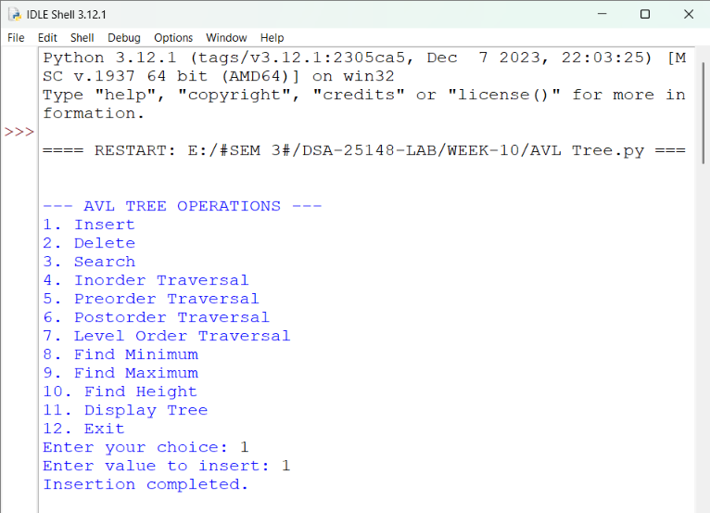
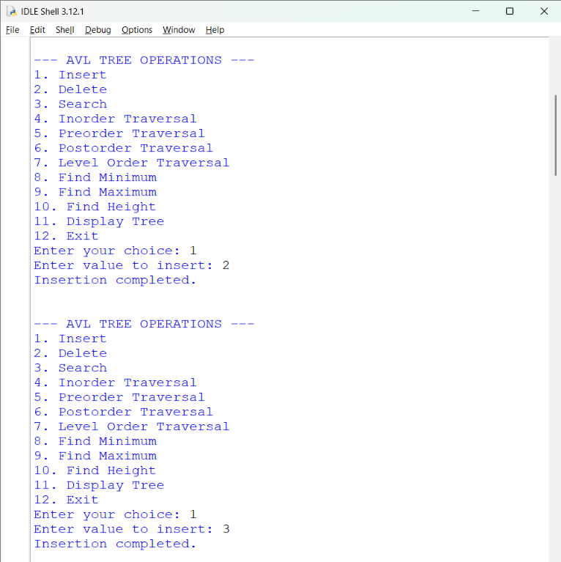
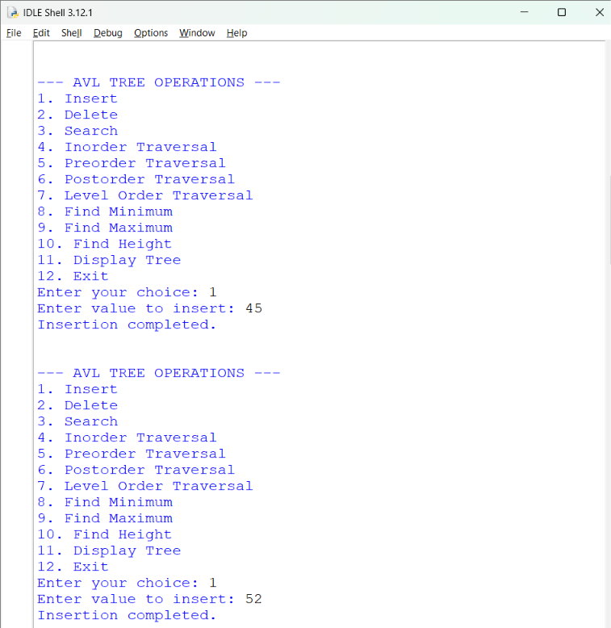
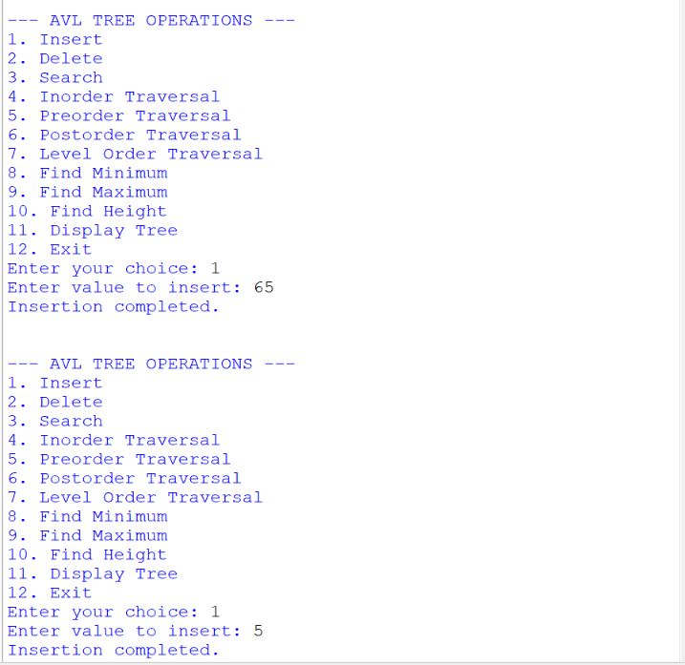
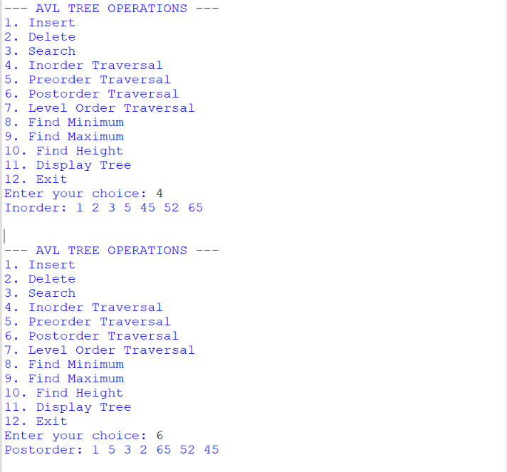

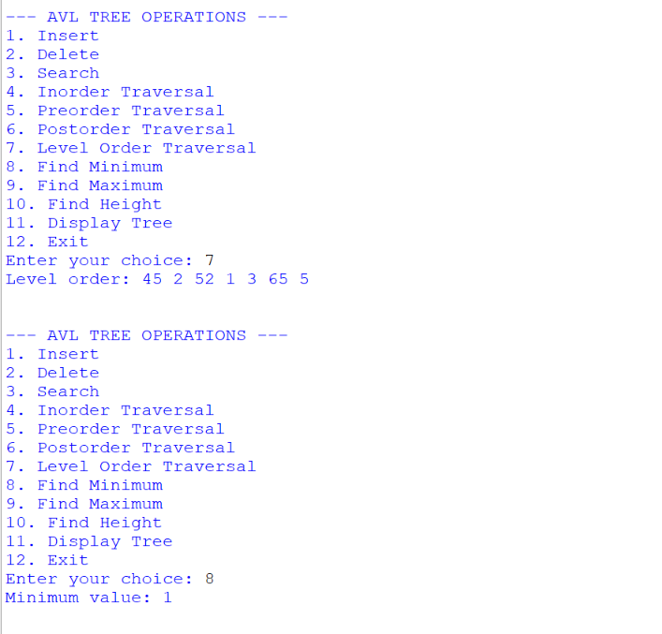
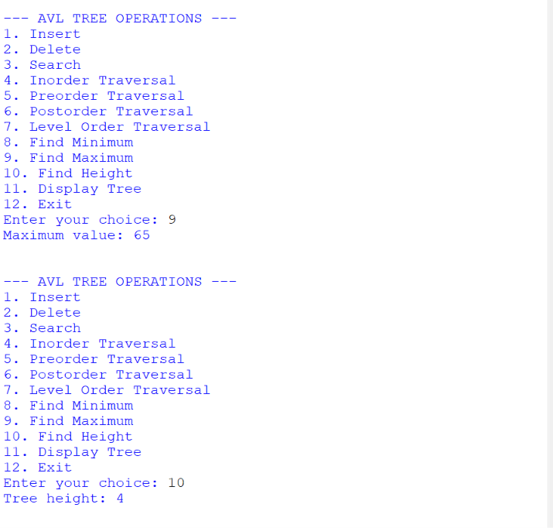
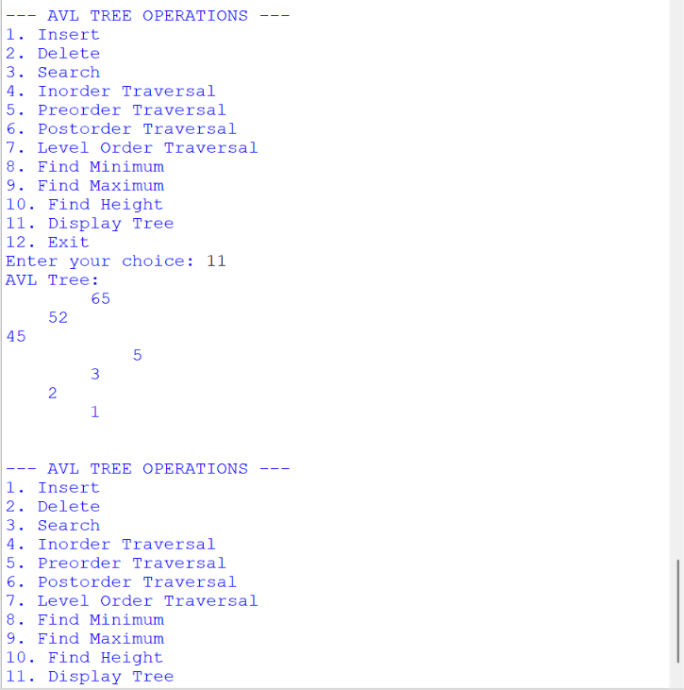
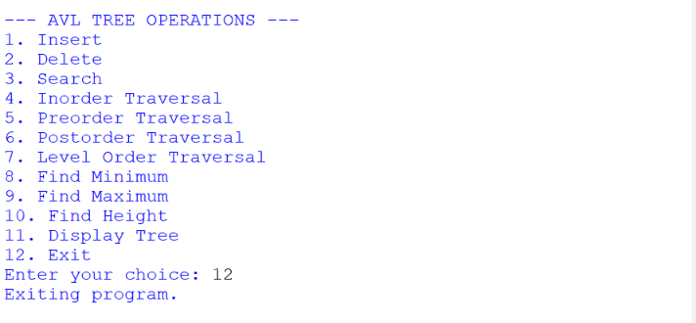

EXPLANATION:
- The Node class creates a node containing a key, left link, right link, and height.
- The height() function returns the height of a node and returns 0 if the node is empty.
- The get_balance() function calculates the balance factor using the heights of the left and right subtrees.
- The right_rotate() and left_rotate() functions perform rotations to balance the AVL tree.
- The insert() function inserts values into the AVL tree, placing smaller values on the left and larger values on the right.
- The LL, RR, LR, and RL cases handle tree imbalance using appropriate rotations.
- The min_value_node() function finds the minimum element by moving to the leftmost node.
- The max_value_node() function finds the maximum element by moving to the rightmost node.
- The delete() function removes a node, handling cases with no children, one child, or two children, and balances the tree.
- The search() function searches for an element using BST comparisons.
- The inorder() function traverses the tree in the order Left → Root → Right.
- The preorder() function traverses the tree in the order Root → Left → Right.
- The postorder() function traverses the tree in the order Left → Right → Root.
- The level_order() function visits nodes level by level using a queue.
- The display() function displays the AVL tree structure sideways.
- The main menu allows the user to select and perform each AVL tree operation, validate inputs, and exit the program.
- The program demonstrates AVL tree insertion, deletion, searching, balancing, minimum and maximum element finding, height calculation, and traversal methods.
ERROR TABLE:
S.no. | Errors | Rectification
1. | ValueError occurred when non-integer input was entered. | Used try-except to validate integer inputs.
2. | Duplicate values were entered during insertion. | Checked for duplicate keys before inserting a new node.
3. | Search failed when the given element was not present in the tree. | Checked whether search() returns None before displaying the result.
4. | Minimum or maximum value could not be found when the tree was empty. | Checked whether the root is None before performing the operation.
5. | Deletion failed when the given element was not present in the tree. | Searched for the element before calling the delete() function.
6. | Tree became unbalanced after insertion or deletion. | Applied appropriate LL, RR, LR and RL rotations.
7. | Traversal operations produced no elements when the tree was empty. | Checked whether the root is None before performing traversal.
8. | Incorrect height was obtained after tree modifications. | Updated node heights after insertion, deletion and rotations.

Week-11

AIM: Write a python program to implement Hashing (Seperate chaining, Linear probing, and Quadratic probing).

PROGRAM:

size = 10

# Separate Chaining

def separate_chaining(keys):

table = [[] for _ in range(size)]

for key in keys:

index = key % size

table[index].append(key)

print("\nSeparate Chaining:")

for i in range(size):

print(i, ":", table[i])

# Linear Probing

def linear_probing(keys):

table = [None] * size

for key in keys:

index = key % size

while table[index] is not None:

index = (index + 1) % size

table[index] = key

print("\nLinear Probing:")

for i in range(size):

print(i, ":", table[i])

# Quadratic Probing

def quadratic_probing(keys):

table = [None] * size

for key in keys:

index = key % size

i = 0

while i < size:

new_index = (index + i * i) % size

if table[new_index] is None:

table[new_index] = key

break

i += 1

print("\nQuadratic Probing:")

for i in range(size):

print(i, ":", table[i])

# Main program

keys = list(map(int, input("Enter the keys (separated by space): ").split()))

separate_chaining(keys)

linear_probing(keys)

quadratic_probing(keys)

OUTPUT:

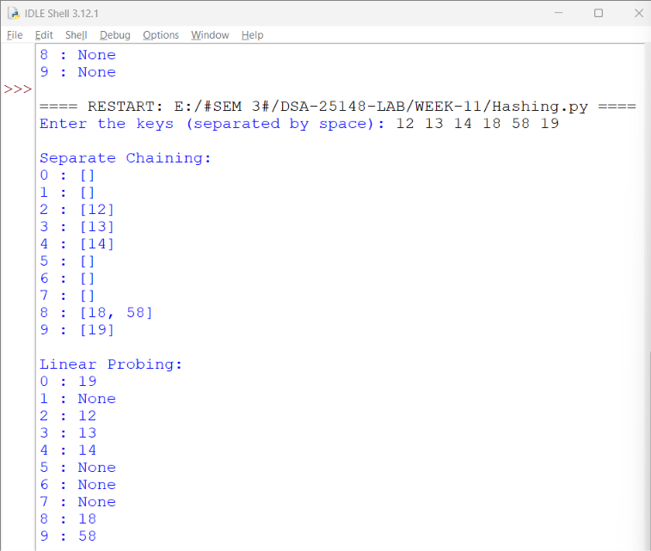

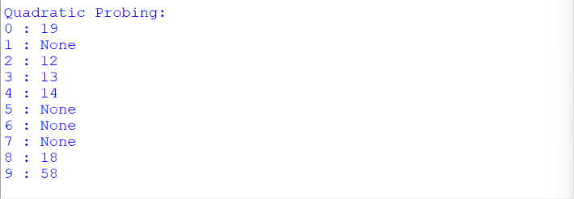

EXPLANATION:
- The size variable defines the size of the hash table as 10.
- The separate_chaining() function creates a hash table with empty lists to store the elements.
- The hash function key % size calculates the index for each key. The append() function inserts keys into the corresponding list. If multiple keys have the same index, they are stored in the same list.
- The linear_probing() function creates an empty hash table using None to represent empty positions.
- The while loop checks whether the calculated index is occupied. If a collision occurs, (index + 1) % size searches for the next available position and inserts the key.
- The quadratic_probing() function resolves collisions by checking alternative positions using square increments.
- The expression (index + i * i) % size calculates the new index. The if condition checks whether the position is empty, and the break statement stops the loop after insertion.
- The i += 1 statement increases the counter to check the next position if a collision occurs.
- The main program accepts multiple integer keys from the user using input (), split (), map (), and list ().
- The three functions are called to perform Separate Chaining, Linear Probing, and Quadratic Probing.
- The program demonstrates hashing, collision detection, and collision resolution using three different techniques.

ERROR TABLE:

S.no. | Errors | Rectification
1. | Collision occurred when multiple keys generated the same index. | Applied separate chaining and probing techniques.
2. | Index error occurred when the table reached its last position. | Used modulo operation to wrap around the table.
3. | Insertion failed when the hash table was full. | Checked for available positions before insertion.
4. | Elements were stored at incorrect  positions during linear probing. | Used (index + 1) % size to find the  next position.
5. | Elements were stored at incorrect positions during linear probing. | Used (index + 1) % size to find the next position.
6. | Incorrect positions were checked during quadratic probing. | Used the formula (index + i * i) % size.

