**LAB CYCLE 1**

**Experiment No: 1**

**Familiarization of DDL Commands**

Data Definition Language (DDL) - These SQL commands are used for creating, modifying,

and dropping the structure of database objects. The commands are CREATE, ALTER,

DROP, RENAME, and TRUNCATE.

A. Consider the database for a college. Write SQL commands to implement the

following:

1. Create a database

2. Select the current database

3. Create the following tables:

a) Student (roll_no integer, name varchar, dob date, address text,

phone_no varchar, blood_grp varchar)

b) Course (Course_id integer, Course_name varchar, course_duration

integer)

4. List all tables in the current database.

5. Display the structure of the Student table.

6. Drop the column blood_grp from Student table.

7. Add a new column Adar_no with domain number to the table Student.

8. Change the datatype of phone_no from varchar to int

9. Drop the tables.

10. Delete the database.

**Queries:**

1) create database 24mca28;

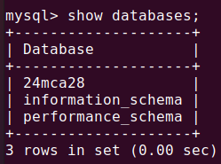

2) use 24mca28;



3) create table Student(roll_no int, name varchar(200), dob date, address text, phone_no varchar(10), blood_grp varchar(3));

create table Course(course_id int, course_name varchar(50), course_duration int);

4) show tables;

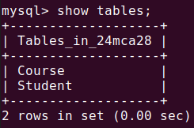

5) desc Student;

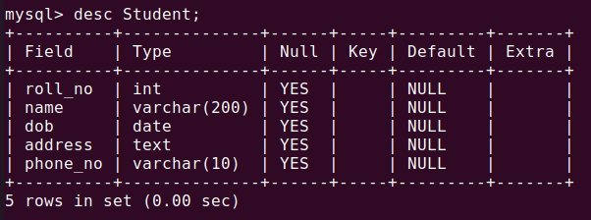

6) alter table Student drop column blood_grp;

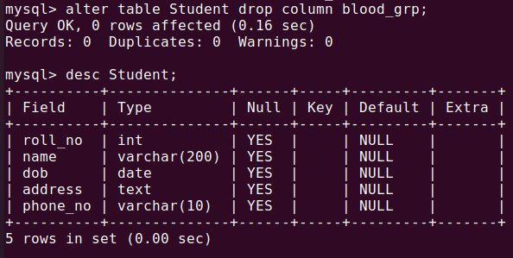

7) alter table Student add adhaar_no int;

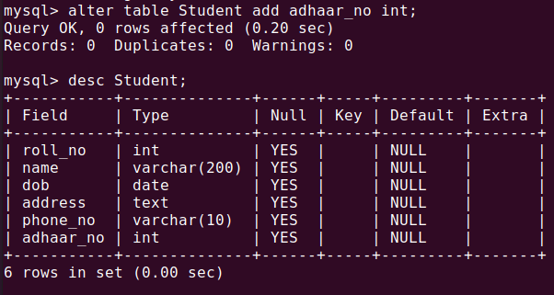

8) alter table Student modify column phone_no int;

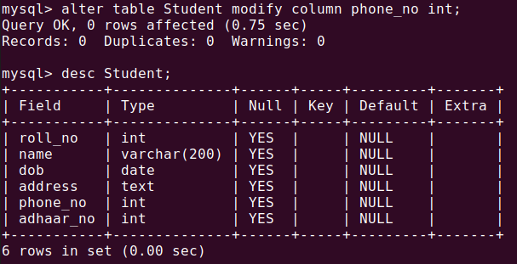

9) drop table Student;

drop table Course;

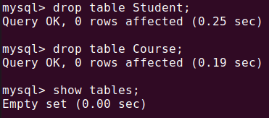

10) drop database 24mca28;

B. Consider the database for an organization. Write SQL commands to implement the

following:

1. Create a database

2. Select the current database

3. Create the following tables:

a) Employee (emp_no varchar, emp_name varchar, dob date, address

text, mobile_no integer, dept_no varchar, salary integer)

b) Department (dept_no varchar, dept_name varchar, location varchar)

4. List all tables in the current database.

5. Display the structure of the Employee table and Department table.

6. Add a new column ‘Designation’ to the table Employee.

7. Drop the column ‘location’ from Department table.

**Queries:**

1) create database 24mca28;



2) use 24mca28;



3) create table Employee(emp_no varchar(10), emp_name varchar(100), dob date, address text, mobile_no int, dept_no varchar(20), salary int);

create table Department(dept_no varchar(20), dept_name varchar(50), location varchar(20));

4) show tables;

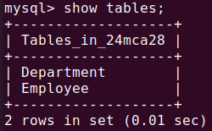

5) desc Employee;

desc Department;

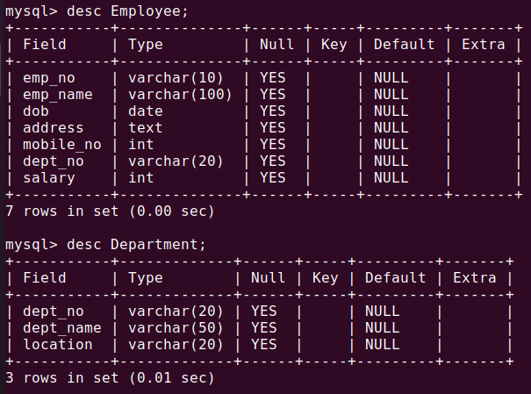

6) alter table Employee add designation varchar(40);

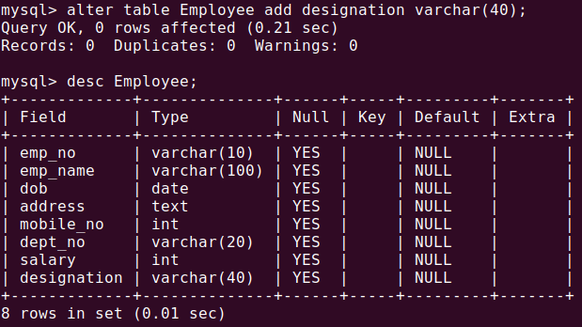

7) alter table Department drop column location;

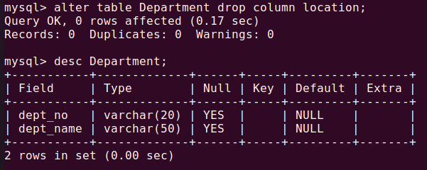

**Experiment No: 2**

**Familiarization of SQL Constraints.**

1. Create new table Persons with attributes PersonID (integer, PRIMARY KEY),

Name (varchar , NOT NULL), Aadhar (Number, NOT NULL, UNIQUE), Age

(integer , CHECK>18).

2. CREATE TABLE Orders with attributes OrderID (PRIMARY KEY),

OrderNumber(NOT NULL) and PersonID( set FOREIGN KEY on attribute

PersonID referencing the column PersonId of Person table)

3. Display the structure of Persons tables.

4. Display the structure of Orders tables.

5. Add emp_no as the primary key of the table Employee.

6. Add dept_no as the primary key of the table Department.

7. Add dept_no in Employee table as the foreign key reference to the table

Department with on delete cascade.

8. Drop the primary key of the table Orders

**Queries:**

1) create table Persons(personid int primary key, name varchar(40) not null, aadhaar int not null unique, age int, check (age>18));

2) create table Orders(orderid int primary key, ordernumber int not null, personid int, foreign key (personid) references Persons(personid));

3)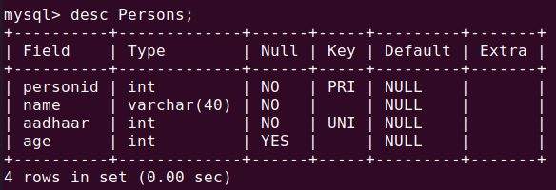 desc Persons;

4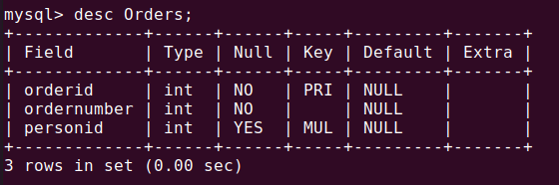) desc Orders;

5) alter table Employee add primary key(emp_no);

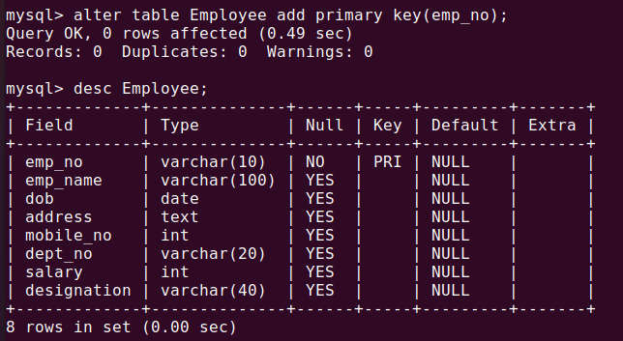

6) alter table Department add primary key(dept_no);

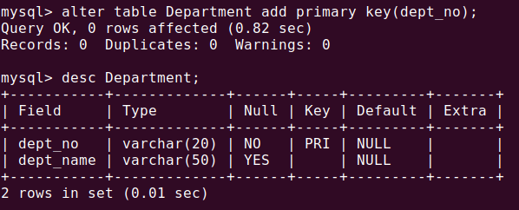

7) alter table Employee add foreign key (dept_no) references Department(dept_no) on delete cascade;

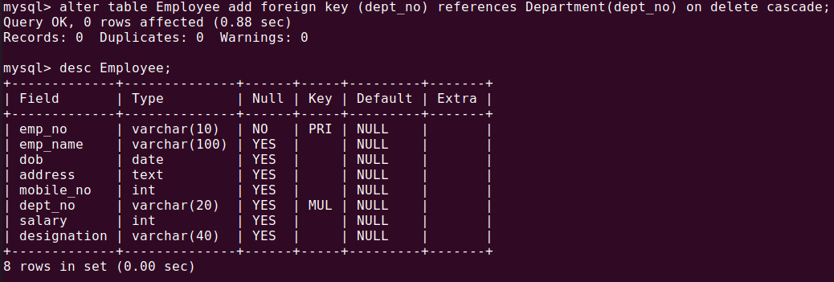

8) alter table Orders drop primary key;

