**LAB CYCLE 2**

**Experiment No: 4**

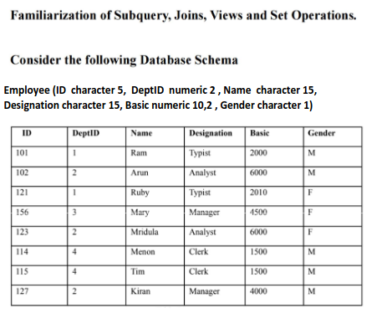

1. Display the different designations existing in the organisation.

2. Display the number of different designations existing in the organisation.

3. Display ID, name, desig,deptID and basic, DA, HRA and net salary of all employees with

suitable headings as DA, HRA and NET_SAL respectively.(DA is 7.5% of basic, and NET_SAL

is Basic + DA+ HRA)

4. Display the maximum salary given for female employees.

5. Add a column manager-id into the above table.

6. Update values of manager id of employees as null for 101, 101 for 102, 121, 156. 102 for

123,114,115.121 for 127.

7. Add a column joining date to the above table and update appropriate values for the

joining date field.

8. Display the details of employees according to their seniority.

9. Create a new table DEPARTMENT with fields DEPTID and DNAME. Make

DEPTID as the primary key and make DEPTID in employee table to refer to the

DEPARTMENT table.

10. Insert values into the DEPARTMENT table. Make sure that all the existing values for

DEPTID in emp is inserted into this table. Sample values are DESIGN, CODING,

TESTING, RESEARCH.

11. Display the employee name and department name.

12. Display the department name of employee Arun.

13. Display the salary given by DESIGN department.

14. Display the details of typist working in DESIGN department.

15. Display the salary of employees working in RESEARCH department.

16. List the female employees working in TESTING department.

17. Display the details of employees not working in CODING or TESTING department.

18. Display the names of department giving maximum salary.

19. Display the names of departments with minimum number of employees.

20. Display the second maximum salary.

21. Display the second minimum salary.

22. Display the names of employees getting salary greater than the average salary of their

department.

23. Display the names of employees working under the manager Ram

**Queries:**

1. select distinct designation from employee;

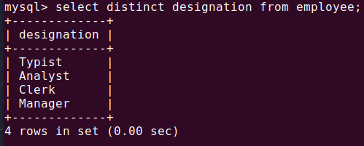

2. select designation, count(*) as count from employee group by designation;

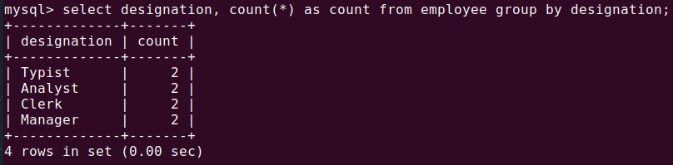

3. select id, name, designation, deptid, basic, basic*0.075 as DA, basic*0.1 as HRA, basic*1.175 as NET_SAL from employee;

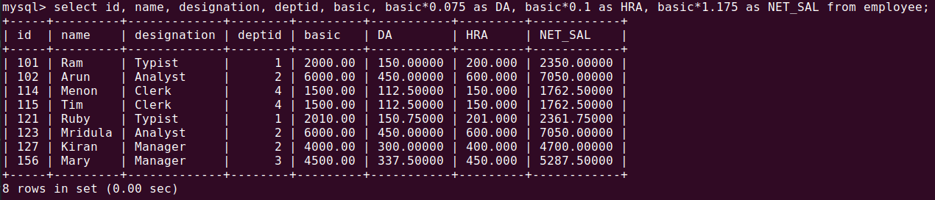

4. select max(basic) as max_salary from employee where gender="F";

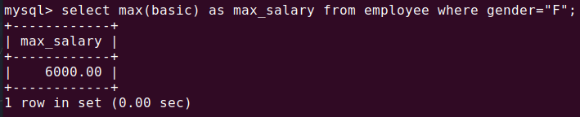

5. alter table employee add column managerid varchar(5);

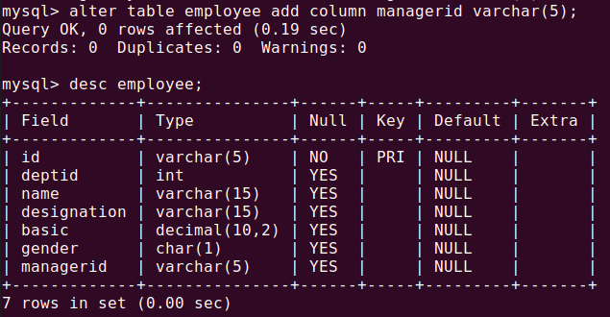

6. update employee set managerid='101' where id in ('102','121','156');

update employee set managerid='102' where id in ('123','114','115');

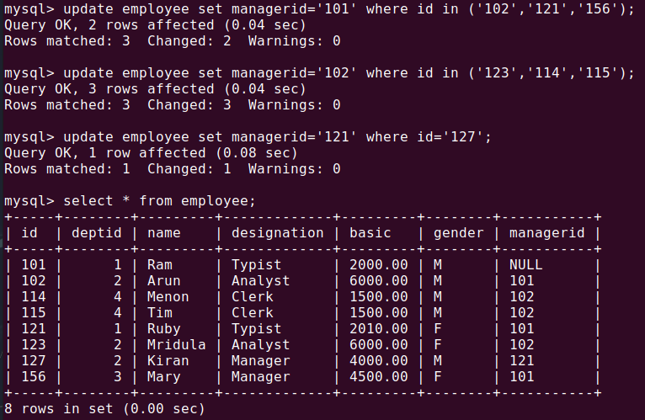update employee set managerid='121' where id='127';

7. alter table employee add column joining_date date;

update employee set joining_date='2020-03-15' where id='101';

update employee set joining_date='2021-06-20' where id='102';

update employee set joining_date='2019-09-10' where id='114';

update employee set joining_date='2022-01-05' where id='115';

update employee set joining_date='2023-07-18' where id='121';

update employee set joining_date='2024-08-19' where id='123';

update employee set joining_date='2022-03-17' where id='127';

update employee set joining_date='2015-07-25' where id='156';

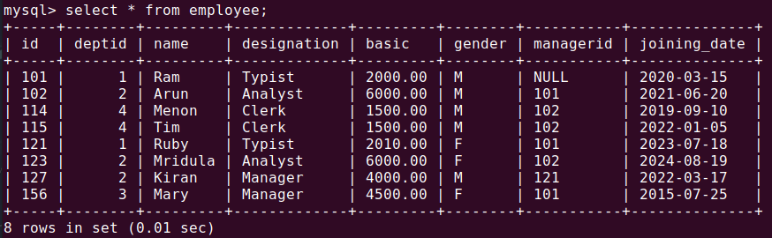

8. select * from employee order by joining_date;

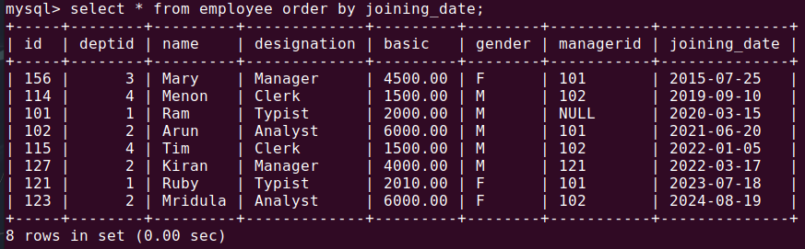

9. create table department (deptid int(2), dname varchar(50), primary key (deptid));

alter table employee add constraint fk_emp_dept foreign key (deptid) references department(deptid);

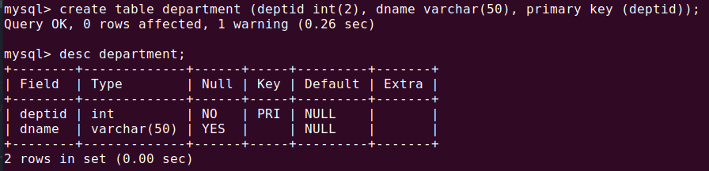

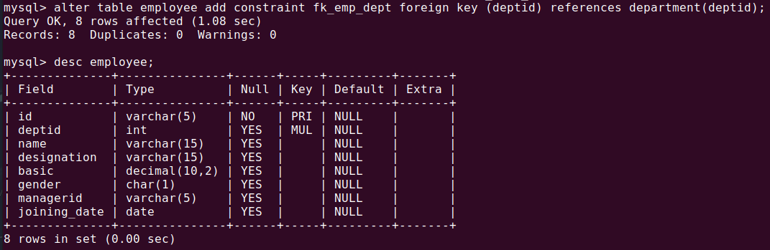

10. insert into department values(1,'design'),(2,'coding'),(3,'testing'),(4,'research');

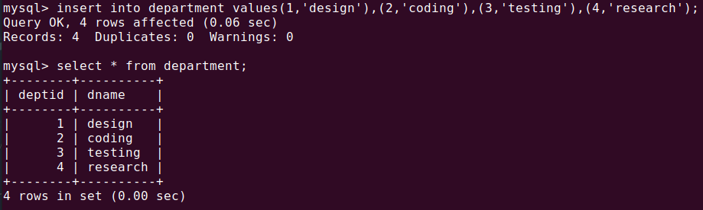

11. select employee.name, department.dname from employee inner join department on employee.deptid = department.deptid;

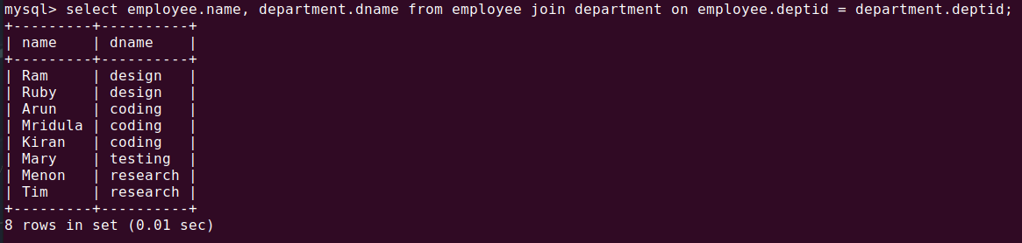

12. select employee.name, department.dname from employee join department on employee.deptid = department.deptid where employee.name="Arun";

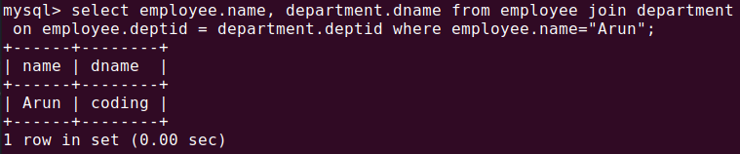

13. select sum(employee.basic) as salary from employee join department on employee.deptid = department.deptid where department.dname="design";

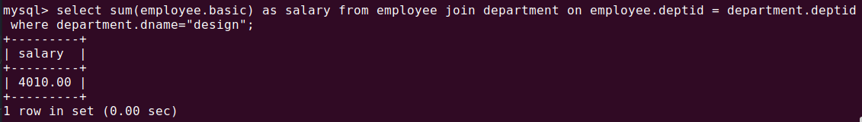

14. select employee.basic from employee join department on employee.deptid = department.deptid where department.dname="design";

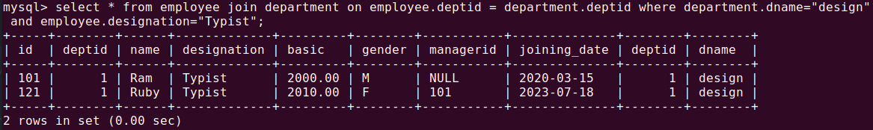

15. select employee.name, employee.basic from employee join department on employee.deptid = department.deptid where department.dname="research";

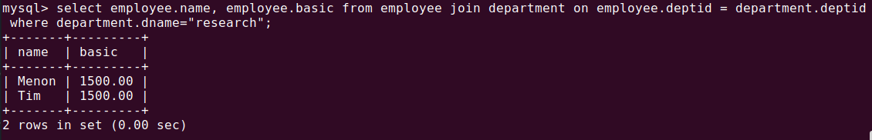

16. select employee.name from employee join department on employee.deptid = department.deptid where department.dname="testing" and gender="F";

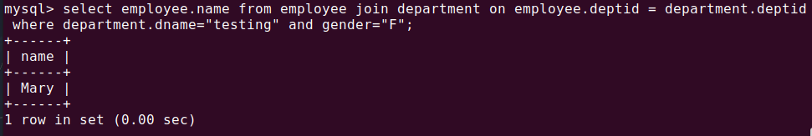

17. select * from employee join department on employee.deptid = department.deptid

where department.dname not in("Coding","Testing");

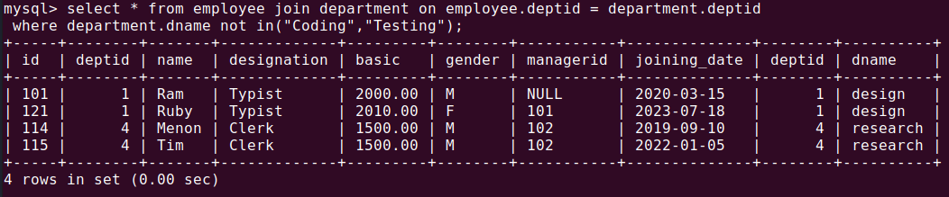

18. select distinct department.dname from department join employee on department.deptid=employee.deptid where employee.basic=(select max(basic) from employee);

