**Labcycle 4**

**Experiment No: 6**

AIM : Familiarisation of TCL Commands

1: Create a Table ‘Order_Details’ with the given data and perform the following operations

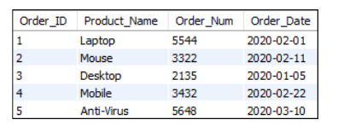

a) Start a new transaction and insert 2 rows into the table Order_Details.

b) Display the details of Order_Details.

c) Rollback the current transaction and check the contents of the table Order_Details.

d) Start a new transaction and delete 2 rows from the table Order_Details.

e) Display the details of Order_Details.

f) Commit the current transaction and check the details of the table Order_Details.

g) Disable autocommit and create a savepoint named ‘Check_Updates’.

h) Update details of the order with Order_Num 5544.

i) Insert 2 more rows into the table.

j) Create a savepoint named ‘Check_delete’

k) Delete order details of a product named ‘Laptop’.

l) Display the current details of the table Order_Details.

m) Rollback to savepoint ‘Check_delete’ and check the details of the table

Order_Details.

n) Rollback to savepoint ‘Check_Updates’ and check the details of the table

Order_Details.

o) Commit the changes and enable autocommit.

a) START TRANSACTION;

INSERT INTO order_details (order_id, product_name, order_num, order_date)

VALUES (6, 'Headphones', 1234, '2020-03-12'),(7, 'Keyboard', 5678, '2020-03-15');



b)

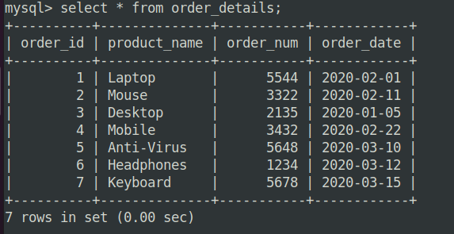

c) ROLLBACK;

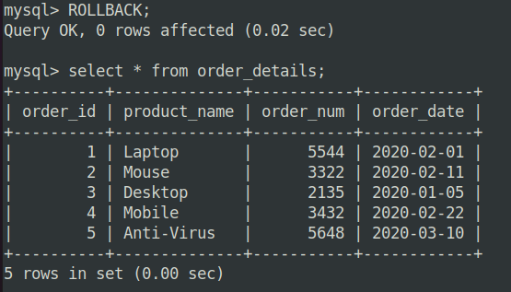

d) START TRANSACTION;

DELETE FROM order_details where order_id in(6,7);

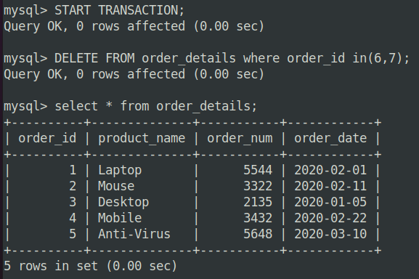

e)

f) COMMIT;

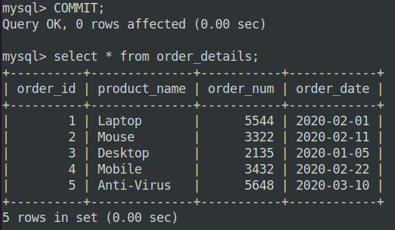

g) SET AUTOCOMMIT = 0;

SAVEPOINT Check_Updates;

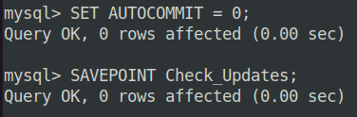

h) UPDATE Order_Details SET product_name = 'Gaming Laptop', order_date = '2020-02-20' WHERE order_num = 5544;

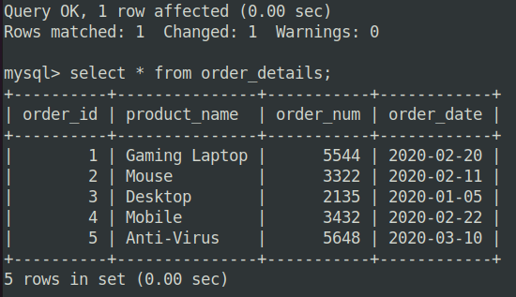

i) INSERT INTO order_details (order_id, product_name, order_num, order_date) VALUES (8, 'Monitor', 9999, '2020-04-01'),(9, 'Mousepad', 8888, '2020-04-02');

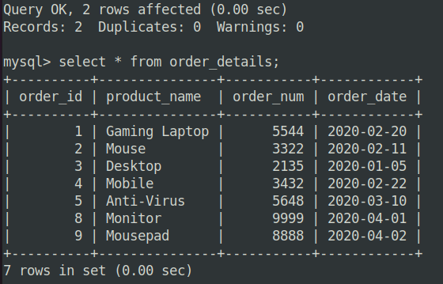

j) SAVEPOINT Check_delete;



k) DELETE FROM order_details WHERE product_name = 'Gaming Laptop';



l)

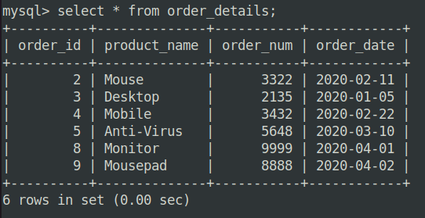

m) ROLLBACK TO SAVEPOINT Check_delete;

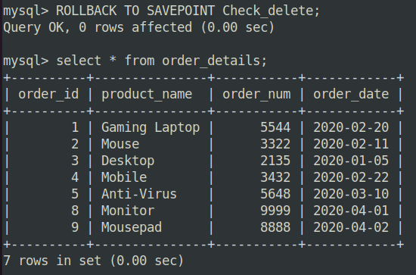

n) ROLLBACK TO SAVEPOINT Check_Updates;



o) COMMIT;

SET AUTOCOMMIT = 1;

