**Shell Scripting Programs (PART 2)**

1. Write a shell program to find the sum of squares of first n numbers (use while).

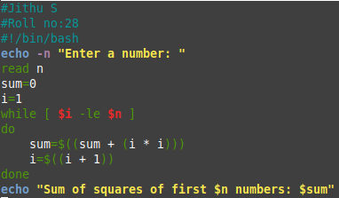



1. Write a menu driven shell program to find the sum, difference, product, quotient of 2 numbers.

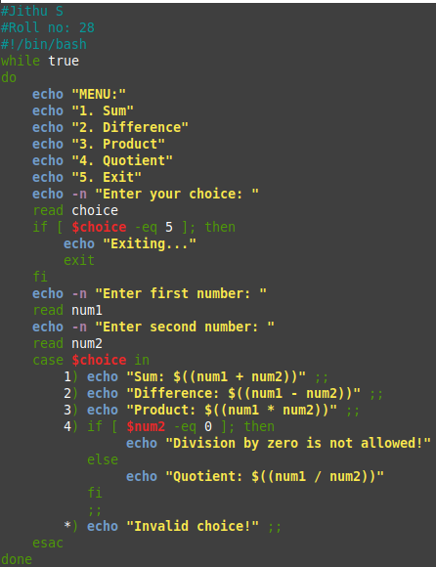

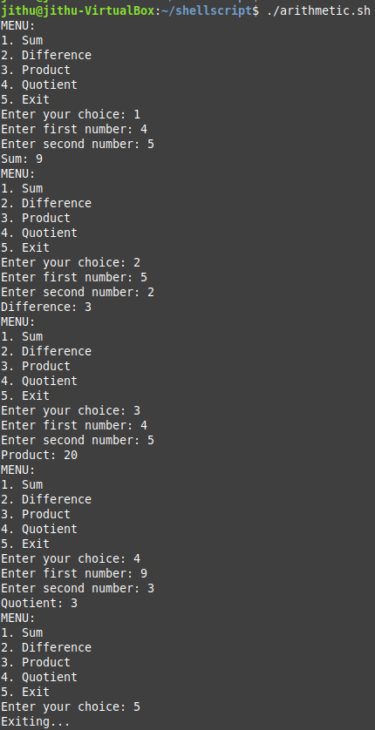

1. Write a menu driven shell program to find the month if a number gives (repeat the menu infinitely).

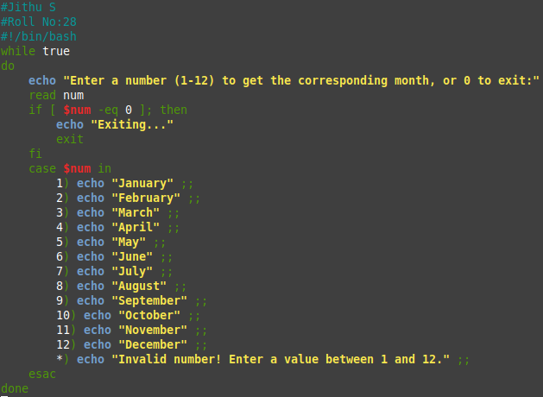

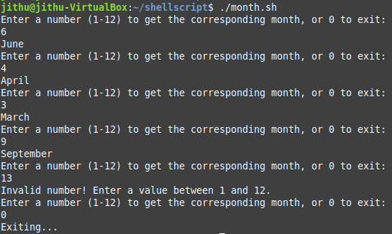

1. Write a shell program to find the factorial of a number (Use function).

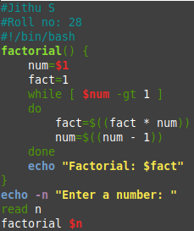



1. Write a shell program to print the Fibonacci numbers upto N.

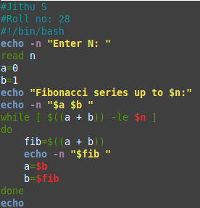

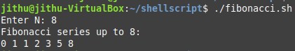

1. Write a shell program to find the sum of squares of first n numbers (Use while).





1. Read a Decimal number. Convert it to Binary and display the result (Use while).

