**Experiment 8**

**Aim**

Write a Java program to store employee details including employee number, name, and salary, and search for an employee by employee number.

**Source Code**

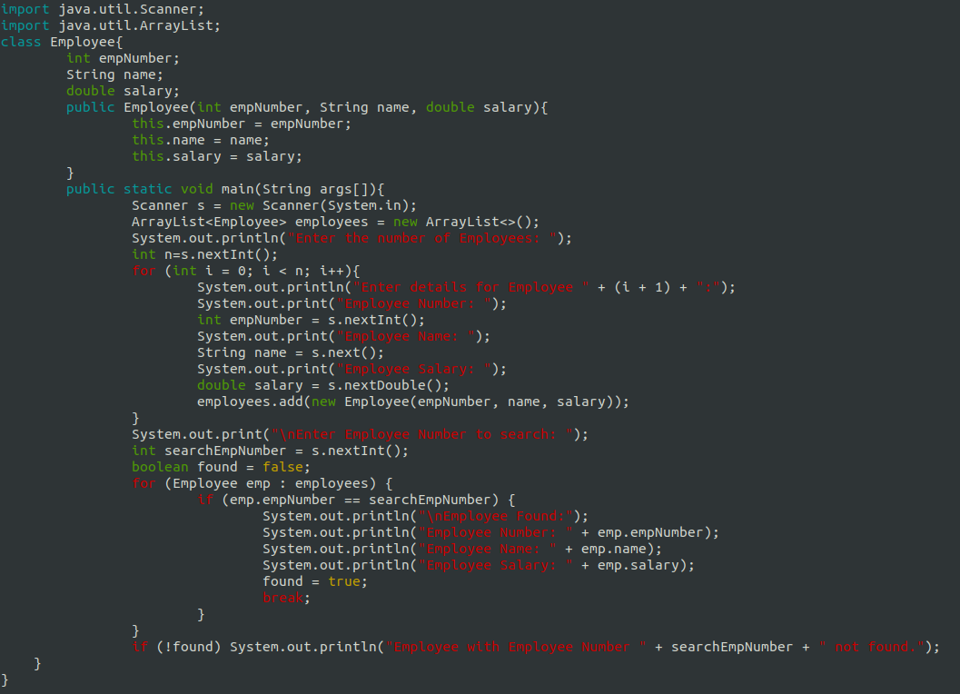

**Output**

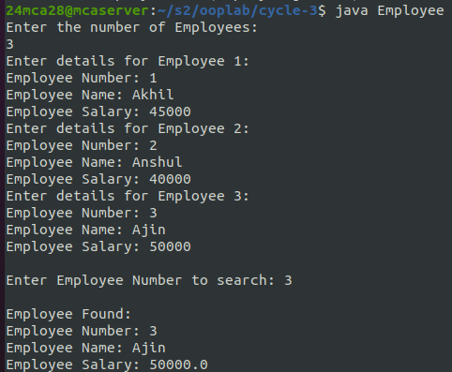

**Experiment 9**

**Aim**

Write a Java program to store ‘n‘ strings in an array. Search for a given string. If found, print its index; otherwise, display ”String not found.”

**Source Code**

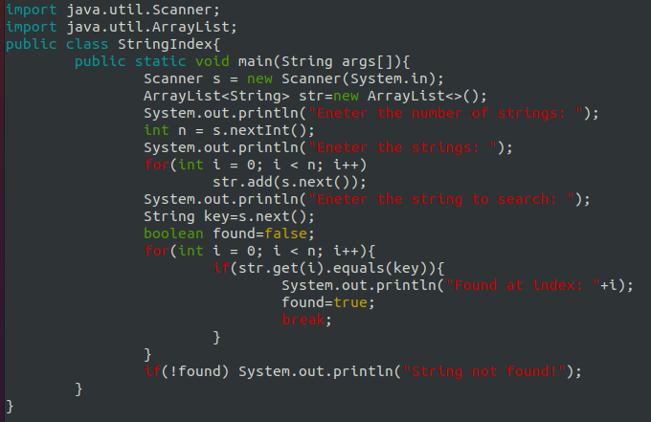

**Output**

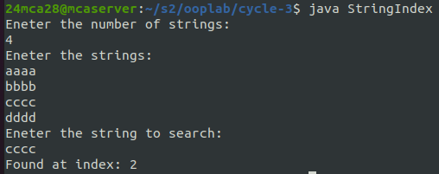

**Experiment 10**

**Aim**

Write a Java program to perform various string manipulations, including finding the length, converting to uppercase and lowercase, extracting characters and substrings, and reversing the string.

**Source Code**

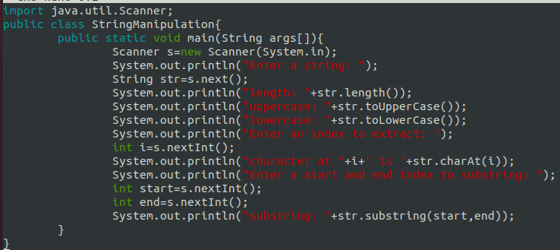

**Output**

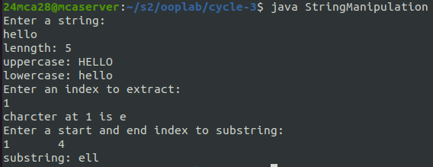

**Experiment 11**

**Aim**

Write a Java program to implement hierarchical inheritance for a book management system. Define

a base class ‘Publisher‘, a derived class ‘Book‘, and two subclasses ‘Literature‘ and ‘Fiction‘. Include methods to read and display book details and demonstrate the functionality using user input.

**Source Code**

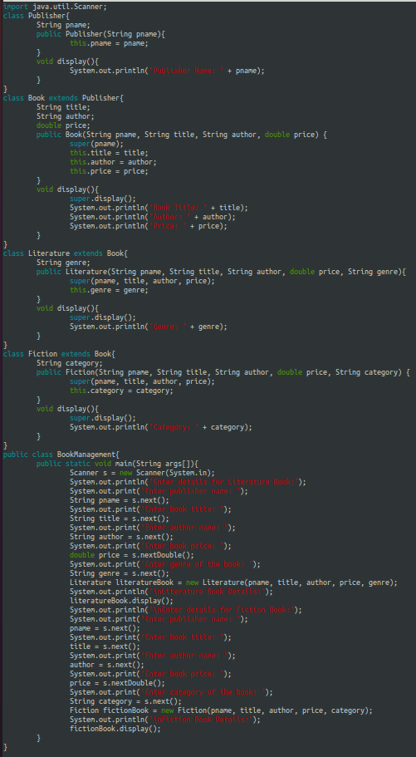

**Output**

