

DEPARTMENT OF CSE

PROJECT ABSTRACT SUBMISSION

COURSE: Adaptive Software Engineering – (24CI3201)
A.Y. 2026 - 2027

TITLE OF THE PROJECT | MedFlow AI – An Agentic Cloud-Native Healthcare Intelligence Platform using Microservices, DevOps and DevSecOps
S. No. | University ID | Name
1 | 2420030586 | JITHYASRI SAMMETA
2 | 2420030474 | DOMA AKSHAYA
3 | 2420030267 | NALLAPU SREEJA
Name of the Guide |  | DR.ARCHANA KALIDINDI

Abstract
Healthcare organizations increasingly rely on digital systems to manage patients, clinicians, appointments, medical records, laboratory services, pharmacy operations, billing, and emergency care, yet many conventional healthcare management applications remain fragmented and process-centric, requiring extensive manual coordination across departments while providing limited intelligent support, resulting in duplicated information, delayed communication, inefficient appointment and queue management, difficulty interpreting medical documents, fragmented patient records, and slower responses to operational and emergency needs. MedFlow AI addresses these challenges through a service-oriented microservices architecture integrated with artificial intelligence and modern software engineering practices, providing role-based workflows for patients, doctors, nurses, receptionists, laboratory staff, pharmacists, billing personnel, emergency staff, and administrators, with core capabilities including authentication, patient profiles and medical histories, appointment management, queue handling, medical records, laboratory reports, prescriptions, pharmacy operations, billing, notifications, and emergency support. An AI service built using Spring AI and the Google Gemini API coordinates six specialized agents—Patient Assistant, Doctor Assistant, Emergency Assistant, Pharmacy Assistant, Billing Assistant, and Hospital Operations Assistant—capable of multi-step reasoning and domain-specific tool use rather than single-shot question answering, supporting medical-report summarization, clinical information organization, appointment and queue guidance, medication and inventory insights, bill explanations, and operational recommendations, while functioning strictly as decision-support tools under human oversight rather than autonomous diagnostic or treatment systems. The system is implemented using Java 21, Spring Boot, Spring Cloud, React.js, and PostgreSQL with a database-per-service architecture, while Spring Security/JWT, API Gateway, Eureka, and OpenFeign provide security, service discovery, API routing, and inter-service communication. Docker, Kubernetes, and AWS support cloud-native deployment, while Jira, GitHub Actions, SonarQube, Trivy, OWASP ZAP, Prometheus, and Grafana enable Agile development, CI/CD, DevSecOps practices, security and code-quality validation, and system monitoring, collectively providing a scalable, secure, reliable, and extensible healthcare platform that demonstrates the integration of agentic AI with modern cloud-native software engineering.

Signature of the Guide HOD

Architecture

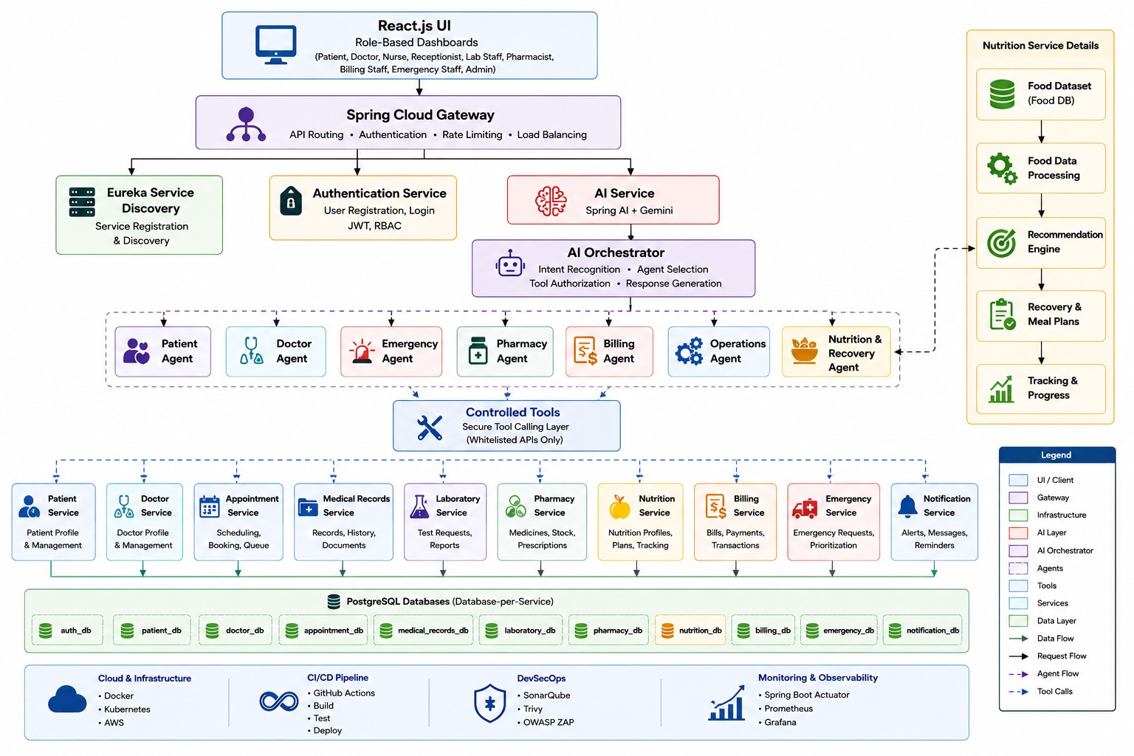

MedFlow AI is a cloud-native, AI-enabled healthcare management platform designed using a microservices/service-oriented architecture. The system provides a React.js-based user interface with role-based dashboards for patients, doctors, nurses, receptionists, laboratory staff, pharmacists, billing staff, emergency staff, and administrators. All client requests are routed through Spring Cloud Gateway, which provides API routing, authentication support, rate limiting, and load balancing, while Eureka Service Discovery enables dynamic registration and discovery of microservices. The Authentication Service manages user registration, login, JWT-based authentication, password security, and role-based access control. The core healthcare functionality is divided into independent microservices including Patient Service for patient profiles and medical information, Doctor Service for doctor profiles and availability, Appointment Service for scheduling, booking and queue management, Medical Records Service for diagnoses, symptoms, treatment plans and medical history, Laboratory Service for test requests and reports, Pharmacy Service for medicines, prescriptions and stock, Nutrition Service for nutrition profiles and personalized plans, Billing Service for bills and transactions, Emergency Service for emergency requests and prioritization, and Notification Service for alerts, messages and reminders. Each microservice follows the database-per-service principle and maintains its own PostgreSQL database, such as auth_db, patient_db, doctor_db, appointment_db, medical_records_db, laboratory_db, pharmacy_db, nutrition_db, billing_db, emergency_db, and notification_db, which improves data isolation, scalability and service independence. The AI layer consists of an AI Service using Spring AI and Gemini, an AI Orchestrator, specialized Patient, Doctor, Emergency, Pharmacy, Billing, Operations, and Nutrition & Recovery Agents, and a Controlled Tools Layer that allows AI agents to access only approved and whitelisted backend APIs. The Nutrition Service additionally contains a dedicated pipeline consisting of a Food Dataset, Food Data Processing, Recommendation Engine, Recovery and Meal Plans, and Tracking and Progress, which can interact with the Nutrition & Recovery Agent. The AI Orchestrator performs intent recognition, selects the appropriate agent, authorizes required tools, and coordinates response generation, while AI is used as a decision-support mechanism rather than making autonomous medical decisions. For deployment, the platform uses Docker for containerization, Kubernetes for container orchestration, and AWS for cloud infrastructure. The GitHub Actions CI/CD pipeline automates building, testing, and deployment, while SonarQube, Trivy, and OWASP ZAP support code-quality and security analysis. Finally, Spring Boot Actuator, Prometheus, and Grafana provide health monitoring, metrics collection, observability, and operational dashboards, making the overall MedFlow AI architecture modular, secure, scalable, maintainable, cloud-ready, and suitable for intelligent healthcare management.

