Name :- Jitiksha Patel
Enrolment Number :-12402080601054
Batch :- 1C8

Subject :- Java
Topic :- Assignment-2

- Find prime numbers using multithreading (Thread,Runnable, Executor Framework)

import java.util.concurrent.*;

class PrimeUtil {
static boolean isPrime(int n) {
if (n < 2) return false;
for (int i = 2; i <= n / 2; i++) {
if (n % i == 0)
return false;
}
return true;
}
}

class PrimeThread extends Thread {
int start, end;

PrimeThread(int s, int e) {
start = s;
end = e;
}

public void run() {
System.out.println("Thread Method:");
for (int i = start; i <= end; i++) {
if (PrimeUtil.isPrime(i))
System.out.print(i + " ");
}
System.out.println("\n");
}
}

class PrimeRunnable implements Runnable {
int start, end;
String label;

PrimeRunnable(int s, int e, String label) {
start = s;
end = e;
this.label = label;
}

public void run() {
System.out.println(label);
for (int i = start; i <= end; i++) {
if (PrimeUtil.isPrime(i))
System.out.print(i + " ");
}
System.out.println("\n");
}
}

public class Program1 {
public static void main(String[] args) throws Exception {

int start = 1, end = 50;

PrimeThread t1 = new PrimeThread(start, end);
t1.start();
t1.join();

Thread t2 = new Thread(new PrimeRunnable(start, end, "Runnable Method:"));
t2.start();
t2.join();

ExecutorService ex = Executors.newFixedThreadPool(1);
ex.execute(new PrimeRunnable(start, end, "Executor Method:"));
ex.shutdown();
}
}

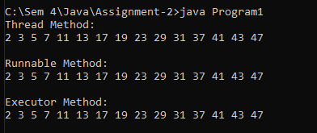

- Producer–Consumer problem using synchronization and inter-thread communication

class Buffer {
int data;
boolean available = false;

synchronized void produce(int value) {
try {
while (available)
wait();

data = value;
System.out.println("Produced: " + data);
available = true;

notify();
} catch (InterruptedException e) {
System.out.println(e);
}
}

synchronized void consume() {
try {
while (!available)
wait();

System.out.println("Consumed: " + data);
available = false;

notify();
} catch (InterruptedException e) {
System.out.println(e);
}
}
}

class Producer extends Thread {
Buffer b;

Producer(Buffer b) {
this.b = b;
}

public void run() {
for (int i = 1; i <= 5; i++) {
b.produce(i);
}
}
}

class Consumer extends Thread {
Buffer b;

Consumer(Buffer b) {
this.b = b;
}

public void run() {
for (int i = 1; i <= 5; i++) {
b.consume();
}
}
}

public class Program2 {
public static void main(String[] args) {
Buffer b = new Buffer();

Producer p = new Producer(b);
Consumer c = new Consumer(b);

p.start();
c.start();
}
}

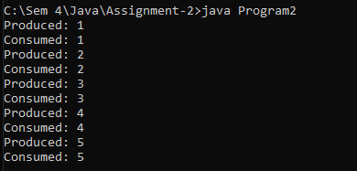

- Implement CRUD operations using Collection API (ArrayList, HashMap, TreeMap)

import java.util.*;

class Program3 {
public static void main(String[] args) {
Scanner sc = new Scanner(System.in);

ArrayList<String> list = new ArrayList<>();
HashMap<Integer, String> map = new HashMap<>();
TreeMap<Integer, String> tmap = new TreeMap<>();

int choice;

do {
System.out.println("\n1.Create 2.Read 3.Update 4.Delete 5.Exit");
System.out.print("Enter choice: ");
choice = sc.nextInt();

switch (choice) {

case 1:
System.out.print("Enter ID: ");
int id = sc.nextInt();
sc.nextLine();
System.out.print("Enter Name: ");
String name = sc.nextLine();

list.add(name);
map.put(id, name);
tmap.put(id, name);

System.out.println("Data Added");
break;

case 2:
System.out.println("ArrayList: " + list);
System.out.println("HashMap: " + map);
System.out.println("TreeMap: " + tmap);
break;

case 3:
System.out.print("Enter ID to update: ");
int uid = sc.nextInt();
sc.nextLine();
System.out.print("Enter new Name: ");
String newName = sc.nextLine();

if (map.containsKey(uid)) {
map.put(uid, newName);
tmap.put(uid, newName);
System.out.println("Updated in Map");
} else {
System.out.println("ID not found");
}

break;

case 4:
System.out.print("Enter ID to delete: ");
int did = sc.nextInt();

map.remove(did);
tmap.remove(did);

System.out.println("Deleted from Map");
break;

case 5:
System.out.println("Exit");
break;

default:
System.out.println("Invalid choice");
}

} while (choice != 5);
}
}

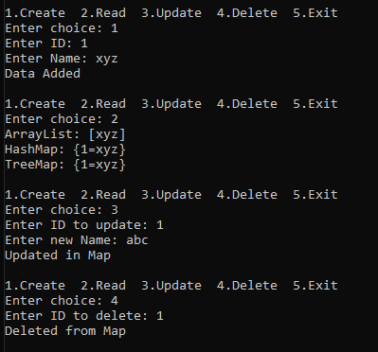

- Sort Book objects using Comparable and Comparator interfaces

import java.util.*;

class Book implements Comparable<Book> {
int id;
String name;
double price;

Book(int id, String name, double price) {
this.id = id;
this.name = name;
this.price = price;
}

public int compareTo(Book b) {
return this.id - b.id;
}

public String toString() {
return id + " " + name + " " + price;
}
}

class NameComparator implements Comparator<Book> {
public int compare(Book b1, Book b2) {
return b1.name.compareTo(b2.name);
}
}

class PriceComparator implements Comparator<Book> {
public int compare(Book b1, Book b2) {
return Double.compare(b1.price, b2.price);
}
}

public class Program4 {
public static void main(String[] args) {

ArrayList<Book> list = new ArrayList<>();

list.add(new Book(3, "Java", 500));
list.add(new Book(1, "Python", 400));
list.add(new Book(2, "C++", 300));

Collections.sort(list);
System.out.println("Sorted by ID:");
for (Book b : list)
System.out.println(b);

Collections.sort(list, new NameComparator());
System.out.println("\nSorted by Name:");
for (Book b : list)
System.out.println(b);

Collections.sort(list, new PriceComparator());
System.out.println("\nSorted by Price:");
for (Book b : list)
System.out.println(b);
}
}

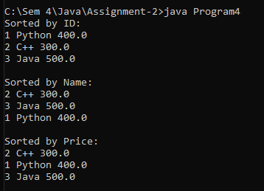

- Count word occurrences from a βile using File Handling APIs

import java.io.*;
import java.util.*;

class Program5 {
public static void main(String[] args) {
HashMap<String, Integer> map = new HashMap<>();

try {
BufferedReader br = new BufferedReader(new FileReader("input.txt"));
String line;

while ((line = br.readLine()) != null) {
String[] words = line.toLowerCase().split("\\W+");

for (String word : words) {
if (word.length() > 0) {
map.put(word, map.getOrDefault(word, 0) + 1);
}
}
}

br.close();

System.out.println("Word Occurrences:");
for (Map.Entry<String, Integer> entry : map.entrySet()) {
System.out.println(entry.getKey() + " : " + entry.getValue());
}

} catch (IOException e) {
System.out.println("Error: " + e.getMessage());
}
}
}

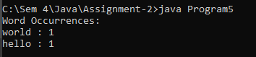

- Display all βiles of a given directory using File class

import java.io.File;
import java.util.Scanner;

class Program6 {
public static void main(String[] args) {
Scanner sc = new Scanner(System.in);

System.out.print("Enter directory path: ");
String path = sc.nextLine();

File dir = new File(path);

if (dir.exists() && dir.isDirectory()) {
String[] files = dir.list();

System.out.println("Files in directory:");
for (String f : files) {
System.out.println(f);
}
} else {
System.out.println("Invalid directory path");
}
}
}

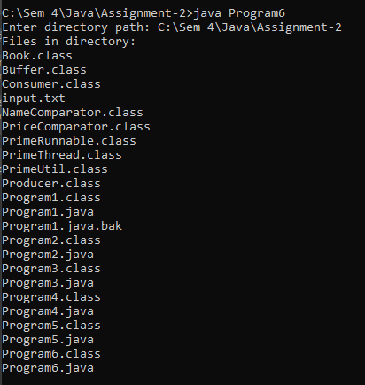

- Implement TCP Echo Client–Server program

EchoServer

import java.io.*;
import java.net.*;
import java.util.Scanner;

class EchoClient {
public static void main(String[] args) {
try {
Socket socket = new Socket("localhost", 5000);

BufferedReader in = new BufferedReader(
new InputStreamReader(socket.getInputStream()));
PrintWriter out = new PrintWriter(socket.getOutputStream(), true);

Scanner sc = new Scanner(System.in);
String msg;

while (true) {
System.out.print("Enter message: ");
msg = sc.nextLine();

out.println(msg);

String response = in.readLine();
System.out.println("Server: " + response);

if (msg.equalsIgnoreCase("exit"))
break;
}

socket.close();

} catch (Exception e) {
System.out.println(e);
}
}
}

EchoClient

import java.io.*;
import java.net.*;
import java.util.Scanner;

class EchoClient {
public static void main(String[] args) {
try {
Socket socket = new Socket("localhost", 5000);

BufferedReader in = new BufferedReader(
new InputStreamReader(socket.getInputStream()));
PrintWriter out = new PrintWriter(socket.getOutputStream(), true);

Scanner sc = new Scanner(System.in);
String msg;

while (true) {
System.out.print("Enter message: ");
msg = sc.nextLine();

out.println(msg);

String response = in.readLine();
System.out.println("Server: " + response);

if (msg.equalsIgnoreCase("exit"))
break;
}

socket.close();

} catch (Exception e) {
System.out.println(e);
}
}
}

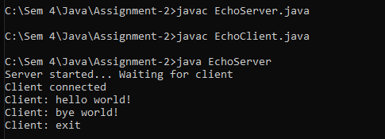

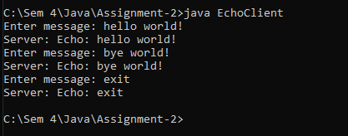

- Develop GUI-based Investment Calculator using Swing

import javax.swing.*;
import java.awt.event.*;

class Program8 extends JFrame implements ActionListener {

JTextField principalField, rateField, timeField, resultField;
JButton calculateBtn;

Program8() {
setTitle("Investment Calculator");
setSize(300, 250);
setLayout(null);

JLabel l1 = new JLabel("Principal:");
l1.setBounds(20, 20, 100, 20);
add(l1);

principalField = new JTextField();
principalField.setBounds(120, 20, 120, 20);
add(principalField);

JLabel l2 = new JLabel("Rate (%):");
l2.setBounds(20, 60, 100, 20);
add(l2);

rateField = new JTextField();
rateField.setBounds(120, 60, 120, 20);
add(rateField);

JLabel l3 = new JLabel("Time (years):");
l3.setBounds(20, 100, 100, 20);
add(l3);

timeField = new JTextField();
timeField.setBounds(120, 100, 120, 20);
add(timeField);

calculateBtn = new JButton("Calculate");
calculateBtn.setBounds(80, 140, 120, 30);
add(calculateBtn);

JLabel l4 = new JLabel("Amount:");
l4.setBounds(20, 180, 100, 20);
add(l4);

resultField = new JTextField();
resultField.setBounds(120, 180, 120, 20);
resultField.setEditable(false);
add(resultField);

calculateBtn.addActionListener(this);

setDefaultCloseOperation(JFrame.EXIT_ON_CLOSE);
setVisible(true);
}

public void actionPerformed(ActionEvent e) {
try {
double p = Double.parseDouble(principalField.getText());
double r = Double.parseDouble(rateField.getText());
double t = Double.parseDouble(timeField.getText());

double amount = p + (p * r * t) / 100;

resultField.setText(String.valueOf(amount));
} catch (Exception ex) {
JOptionPane.showMessageDialog(this, "Invalid Input");
}
}

public static void main(String[] args) {
new Program8();
}
}

