Name :- Jitiksha Patel
Enrolment Number :-12402080601054
Batch :- 1C8

Subject :- Java
Topic :- Assignment-1

- Implement Array and String operations (Reverse, Sort,Search, Average, Maximum) using class and objects

import java.util.Scanner;
class ArrayOperations {
int[] arr;
int n;

ArrayOperations(int size) {
n = size;
arr = new int[n];
}

void input() {
Scanner sc = new Scanner(System.in);
System.out.println("Enter elements:");
for (int i = 0; i < n; i++) {
arr[i] = sc.nextInt();
}
}

void display() {
for (int i = 0; i < n; i++) {
System.out.print(arr[i] + " ");
}
System.out.println();
}

void reverse() {
System.out.println("Reversed Array:");
for (int i = n - 1; i >= 0; i--) {
System.out.print(arr[i] + " ");
}
System.out.println();
}

void sort() {
for (int i = 0; i < n - 1; i++) {
for (int j = i + 1; j < n; j++) {
if (arr[i] > arr[j]) {
int temp = arr[i];
arr[i] = arr[j];
arr[j] = temp;
}
}
}
System.out.println("Sorted Array:");
display();
}

void search(int key) {
for (int i = 0; i < n; i++) {
if (arr[i] == key) {
System.out.println("Element found at position: " + (i + 1));
return;
}
}
System.out.println("Element not found");
}

void average() {
int sum = 0;
for (int i = 0; i < n; i++) {
sum += arr[i];
}
System.out.println("Average = " + (double) sum / n);
}

void maximum() {
int max = arr[0];
for (int i = 1; i < n; i++) {
if (arr[i] > max) {
max = arr[i];
}
}
System.out.println("Maximum = " + max);
}
}

class Program1 {
public static void main(String[] args) {
Scanner sc = new Scanner(System.in);

System.out.print("Enter size of array: ");
int size = sc.nextInt();

ArrayOperations obj = new ArrayOperations(size);

obj.input();

System.out.println("Original Array:");
obj.display();

obj.reverse();
obj.sort();

System.out.print("Enter element to search: ");
int key = sc.nextInt();
obj.search(key);

obj.average();
obj.maximum();
}
}
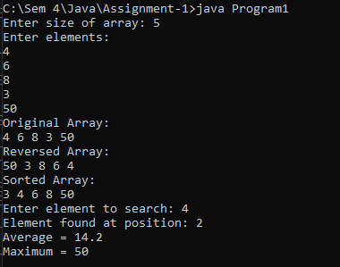

- Develop Matrix class with constructors, transpose and multiplication

import java.util.Scanner;
class Matrix {
int[][] a;
int r, c;

// Constructor
Matrix(int r, int c) {
this.r = r;
this.c = c;
a = new int[r][c];
}

// Input
void input() {
Scanner sc = new Scanner(System.in);
for (int i = 0; i < r; i++)
for (int j = 0; j < c; j++)
a[i][j] = sc.nextInt();
}

// Display
void display() {
for (int i = 0; i < r; i++) {
for (int j = 0; j < c; j++)
System.out.print(a[i][j] + " ");
System.out.println();
}
}

// Transpose
void transpose() {
System.out.println("Transpose:");
for (int i = 0; i < c; i++) {
for (int j = 0; j < r; j++)
System.out.print(a[j][i] + " ");
System.out.println();
}
}

// Multiplication
static void multiply(Matrix m1, Matrix m2) {
if (m1.c != m2.r) {
System.out.println("Multiplication not possible");
return;
}

Matrix res = new Matrix(m1.r, m2.c);

for (int i = 0; i < m1.r; i++)
for (int j = 0; j < m2.c; j++)
for (int k = 0; k < m1.c; k++)
res.a[i][j] += m1.a[i][k] * m2.a[k][j];

System.out.println("Multiplication Result:");
res.display();
}
}

class Program2 {
public static void main(String[] args) {
Scanner sc = new Scanner(System.in);

System.out.print("Enter rows and cols of Matrix 1: ");
int r1 = sc.nextInt();
int c1 = sc.nextInt();

Matrix m1 = new Matrix(r1, c1);
System.out.println("Enter Matrix 1:");
m1.input();

System.out.print("Enter rows and cols of Matrix 2: ");
int r2 = sc.nextInt();
int c2 = sc.nextInt();

Matrix m2 = new Matrix(r2, c2);
System.out.println("Enter Matrix 2:");
m2.input();

System.out.println("Matrix 1:");
m1.display();

m1.transpose();

Matrix.multiply(m1, m2);
}
}
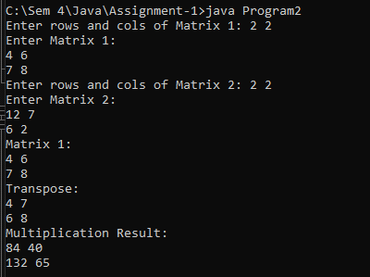

- Write a program demonstrating Wrapper classes and String vs StringBuffer
class Program3 {
public static void main(String[] args) {

// Wrapper Class Demo
int x = 10;

Integer obj = Integer.valueOf(x); // Boxing
int y = obj.intValue(); // Unboxing

System.out.println("Primitive value: " + x);
System.out.println("Wrapper object: " + obj);
System.out.println("Unboxed value: " + y);

// String vs StringBuffer
String s = "Hello";
s.concat(" World"); // does not change original string
System.out.println("\nString after concat: " + s);

StringBuffer sb = new StringBuffer("Hello");
sb.append(" World"); // modifies original object
System.out.println("StringBuffer after append: " + sb);
}
}
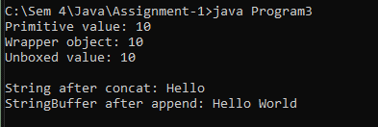

- Implement BankAccount class with deposit, withdraw and balance inquiry
import java.util.Scanner;

class BankAccount {
double balance;

// Constructor
BankAccount(double initialBalance) {
balance = initialBalance;
}

// Deposit
void deposit(double amount) {
balance += amount;
System.out.println("Deposited: " + amount);
}

// Withdraw
void withdraw(double amount) {
if (amount <= balance) {
balance -= amount;
System.out.println("Withdrawn: " + amount);
} else {
System.out.println("Insufficient Balance");
}
}

// Balance Inquiry
void showBalance() {
System.out.println("Current Balance: " + balance);
}
}

class Program4 {
public static void main(String[] args) {
Scanner sc = new Scanner(System.in);

System.out.print("Enter initial balance: ");
double bal = sc.nextDouble();

BankAccount acc = new BankAccount(bal);

int choice;
do {
System.out.println("\n1.Deposit 2.Withdraw 3.Check Balance 4.Exit");
System.out.print("Enter choice: ");
choice = sc.nextInt();

switch (choice) {
case 1:
System.out.print("Enter amount: ");
acc.deposit(sc.nextDouble());
break;

case 2:
System.out.print("Enter amount: ");
acc.withdraw(sc.nextDouble());
break;

case 3:
acc.showBalance();
break;

case 4:
System.out.println("Thank you!");
break;

default:
System.out.println("Invalid choice");
}

} while (choice != 4);
}
}
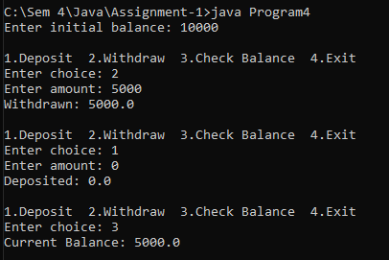

- Develop inheritance-based Cricket–Match system using command line arguments
import java.util.Scanner;

class Cricket {
String team1, team2;

Cricket(String t1, String t2) {
team1 = t1;
team2 = t2;
}

void showTeams() {
System.out.println("Match Between: " + team1 + " vs " + team2);
}
}

class Match extends Cricket {
int score1, score2;

Match(String t1, String t2, int s1, int s2) {
super(t1, t2);
score1 = s1;
score2 = s2;
}

void result() {
if (score1 > score2)
System.out.println(team1 + " wins!");
else if (score2 > score1)
System.out.println(team2 + " wins!");
else
System.out.println("Match Draw!");
}

void display() {
showTeams();
System.out.println(team1 + " Score: " + score1);
System.out.println(team2 + " Score: " + score2);
result();
}
}

class Program5 {
public static void main(String[] args) {
Scanner sc = new Scanner(System.in);

System.out.print("Enter Team 1: ");
String t1 = sc.nextLine();

System.out.print("Enter Team 2: ");
String t2 = sc.nextLine();

System.out.print("Enter Score of " + t1 + ": ");
int s1 = sc.nextInt();

System.out.print("Enter Score of " + t2 + ": ");
int s2 = sc.nextInt();

Match m = new Match(t1, t2, s1, s2);
m.display();
}
}
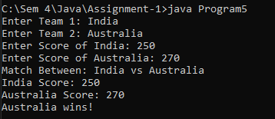

- Implement Cipher system using Abstract class and method overriding
import java.util.Scanner;

abstract class Cipher {
String text;

Cipher(String text) {
this.text = text;
}

abstract String encrypt();
abstract String decrypt();
}

class CaesarCipher extends Cipher {
int shift;

CaesarCipher(String text, int shift) {
super(text);
this.shift = shift;
}

String encrypt() {
String result = "";
for (int i = 0; i < text.length(); i++) {
char ch = text.charAt(i);

if (Character.isLetter(ch)) {
char base = Character.isUpperCase(ch) ? 'A' : 'a';
ch = (char) ((ch - base + shift) % 26 + base);
}
result += ch;
}
return result;
}

String decrypt() {
String result = "";
for (int i = 0; i < text.length(); i++) {
char ch = text.charAt(i);

if (Character.isLetter(ch)) {
char base = Character.isUpperCase(ch) ? 'A' : 'a';
ch = (char) ((ch - base - shift + 26) % 26 + base);
}
result += ch;
}
return result;
}
}

class Program6 {
public static void main(String[] args) {
Scanner sc = new Scanner(System.in);

System.out.print("Enter text: ");
String text = sc.nextLine();

System.out.print("Enter shift value: ");
int shift = sc.nextInt();

CaesarCipher c = new CaesarCipher(text, shift);

String enc = c.encrypt();
System.out.println("Encrypted: " + enc);

CaesarCipher d = new CaesarCipher(enc, shift);
System.out.println("Decrypted: " + d.decrypt());
}
}
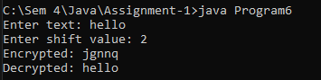

- Demonstrate Inner Classes (member, local, anonymous)
class Outer {

class MemberInner {
void show() {
System.out.println("This is Member Inner Class");
}
}

void display() {

class LocalInner {
void show() {
System.out.println("This is Local Inner Class");
}
}

LocalInner l = new LocalInner();
l.show();
}
}

interface Test {
void show();
}

class Program7 {
public static void main(String[] args) {

Outer obj = new Outer();

Outer.MemberInner m = obj.new MemberInner();
m.show();

obj.display();

Test t = new Test() {
public void show() {
System.out.println("This is Anonymous Inner Class");
}
};
t.show();
}
}
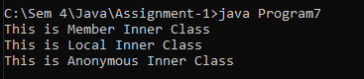

- Create custom exception handling for bank withdrawal scenario
import java.util.Scanner;

class InsufficientBalanceException extends Exception {
InsufficientBalanceException(String msg) {
super(msg);
}
}

class BankAccount {
double balance;

BankAccount(double balance) {
this.balance = balance;
}

void withdraw(double amount) throws InsufficientBalanceException {
if (amount > balance) {
throw new InsufficientBalanceException("Not enough balance!");
} else {
balance -= amount;
System.out.println("Withdrawn: " + amount);
}
}

void showBalance() {
System.out.println("Current Balance: " + balance);
}
}

class Program8 {
public static void main(String[] args) {
Scanner sc = new Scanner(System.in);

System.out.print("Enter initial balance: ");
double bal = sc.nextDouble();

BankAccount acc = new BankAccount(bal);

System.out.print("Enter amount to withdraw: ");
double amt = sc.nextDouble();

try {
acc.withdraw(amt);
} catch (InsufficientBalanceException e) {
System.out.println("Exception: " + e.getMessage());
}
acc.showBalance();
}
}
