# Splunk

Querying for error logs

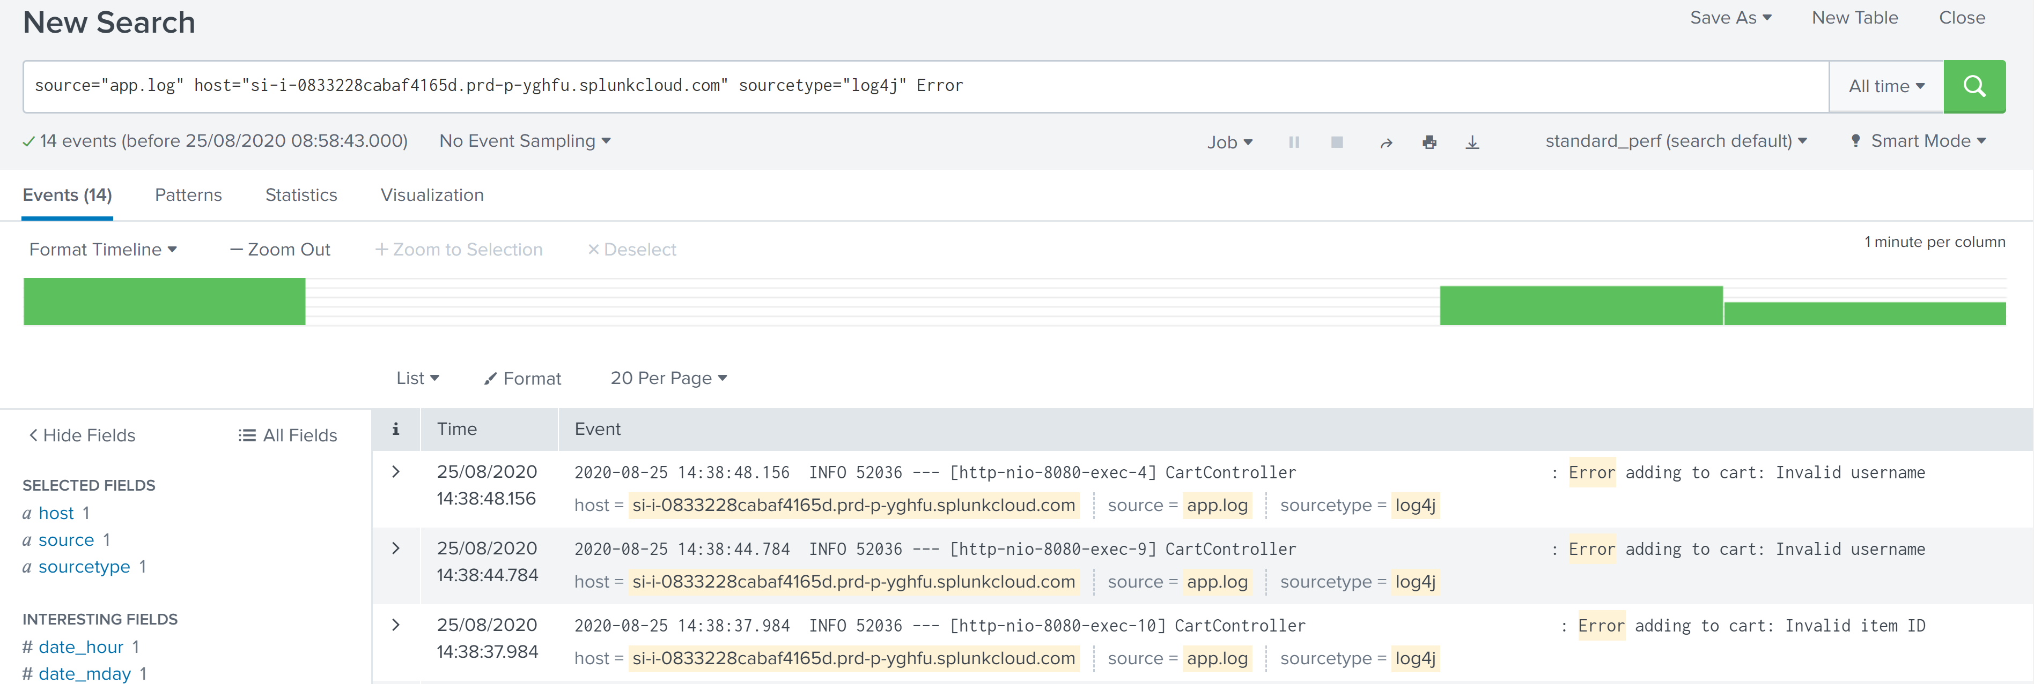

Querying for success logs

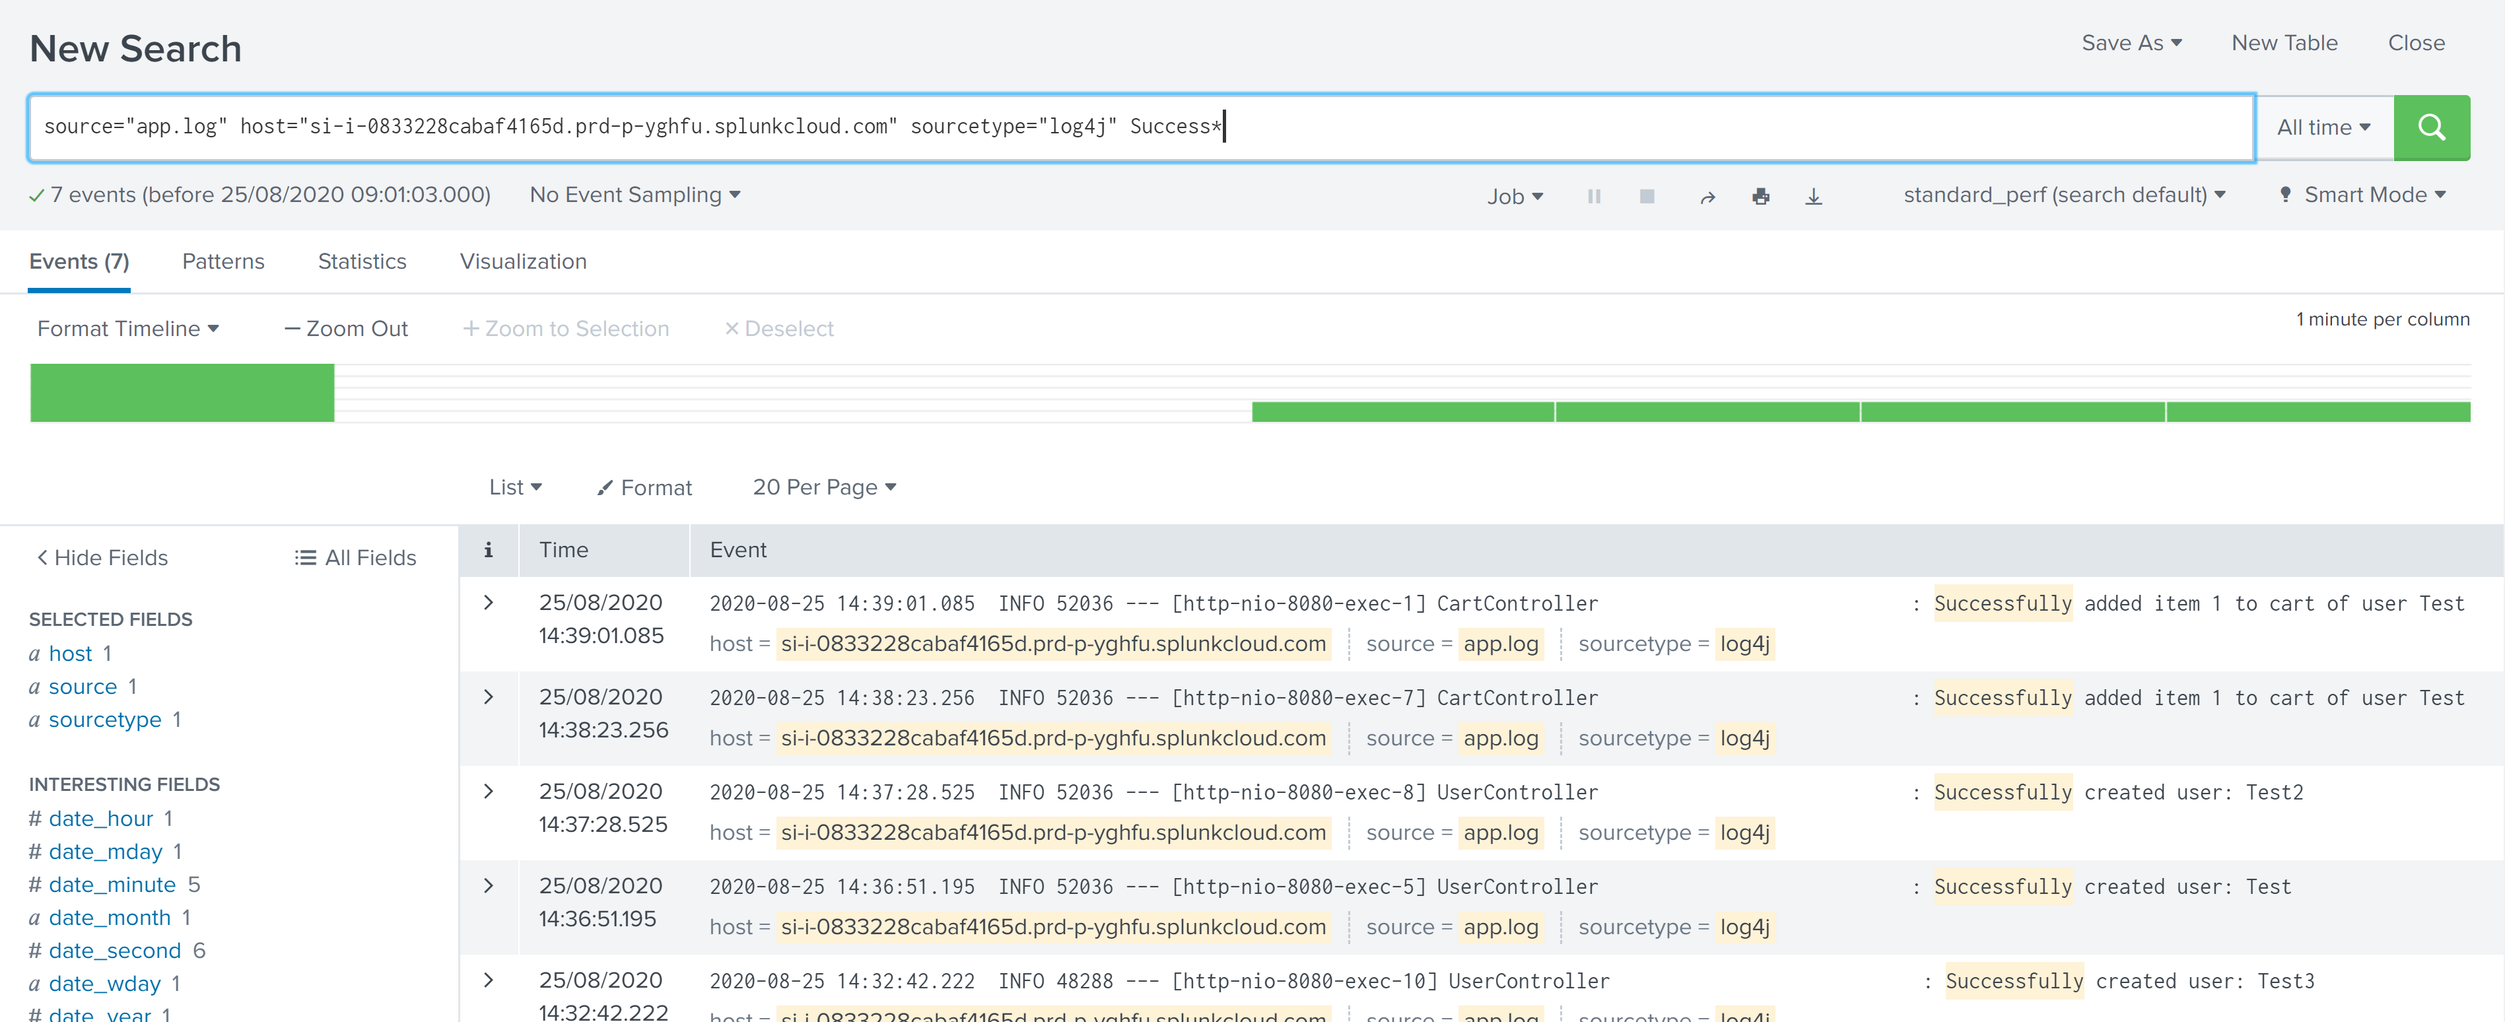

Dashboard for errors in past hour

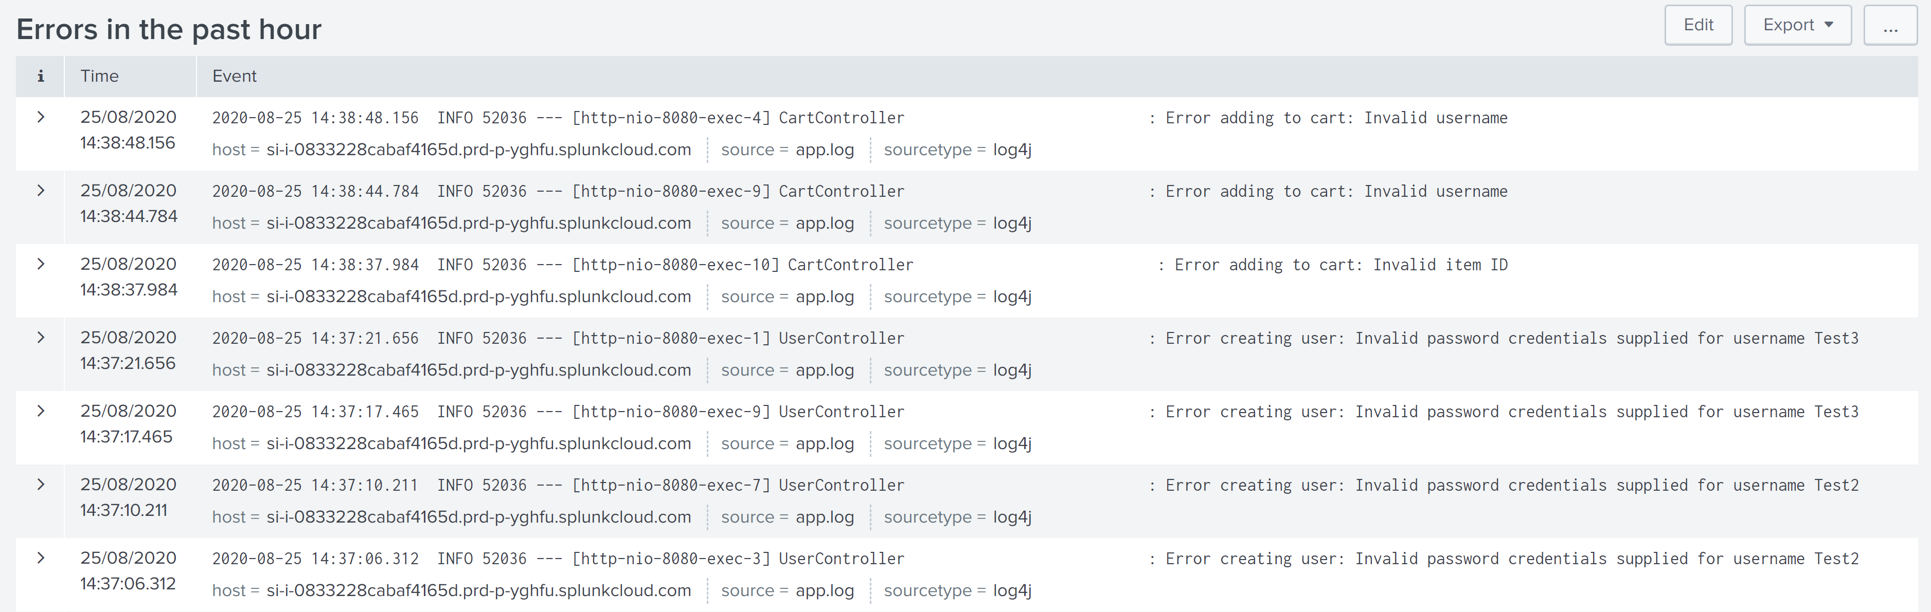

Creating Alert for errors

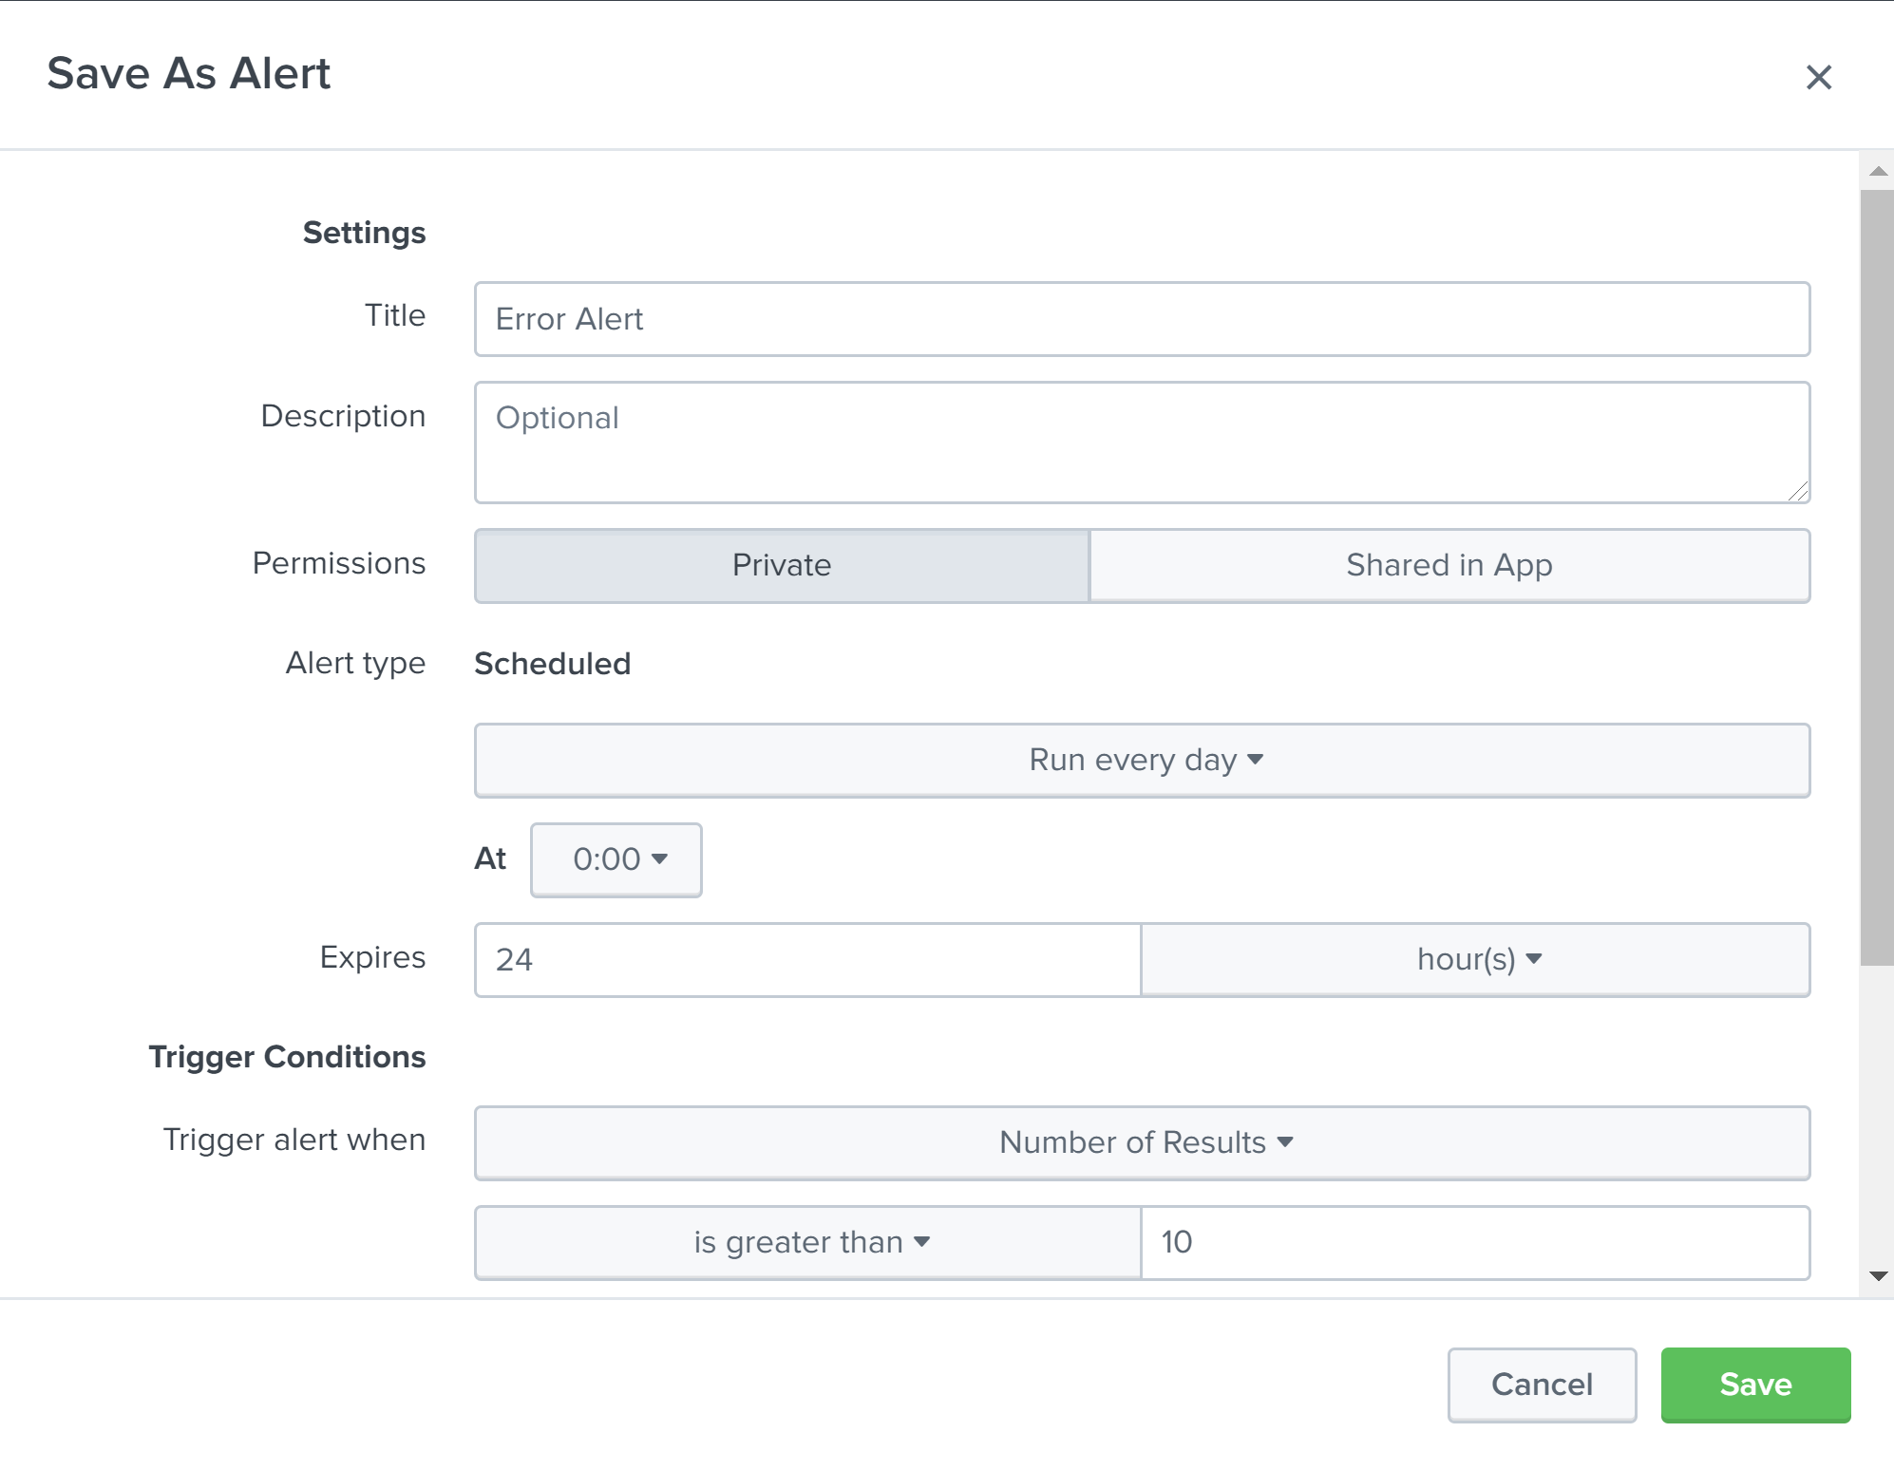

# Jenkins

Successful Build

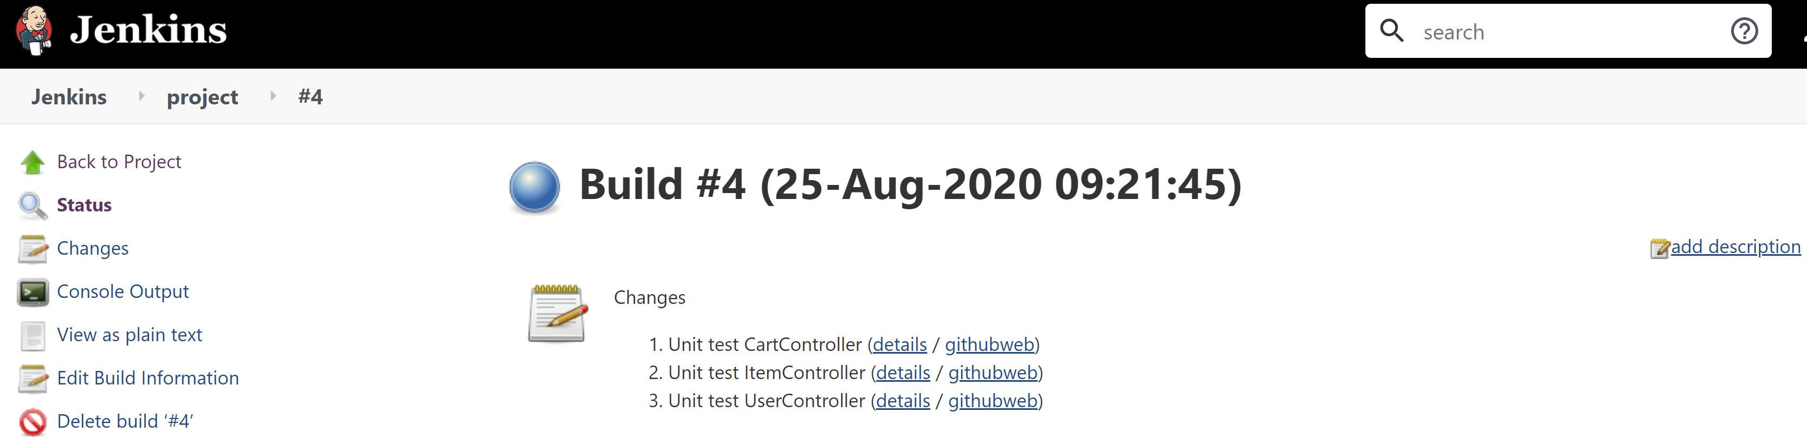

Config

