Wounds heal upwards (granulation), inwards (contraction) and resurface (epithelialisation).

1) Proper identification of wound bed tissues specifies the wound status that will lead to appropriate treatment.

1. Slough:
While some clinical experts have questioned whether slough is in fact tissue or an inflammatory by-product,10 the European Pressure Ulcer Advisory Panel (EPUAP), National Pressure Injury Advisory Panel (NPIAP), and Pan Pacific Pressure Injury Alliance (PPPIA) 2019 Prevention and Treatment of Pressure Ulcers/Injuries Clinical Practice Guideline: The International Guideline did define slough as “soft, moist, devitalized (nonviable) tissue. It may be white, yellow, tan, or green and it may be loose or firmly adherent”). Regardless of whether slough is or is not tissue, clinicians agree that it must be removed in acute and chronic wounds where the goal of care is healing. Sometimes it is referred to as fibrin, but for our purpose we will use both tissues in the same category.
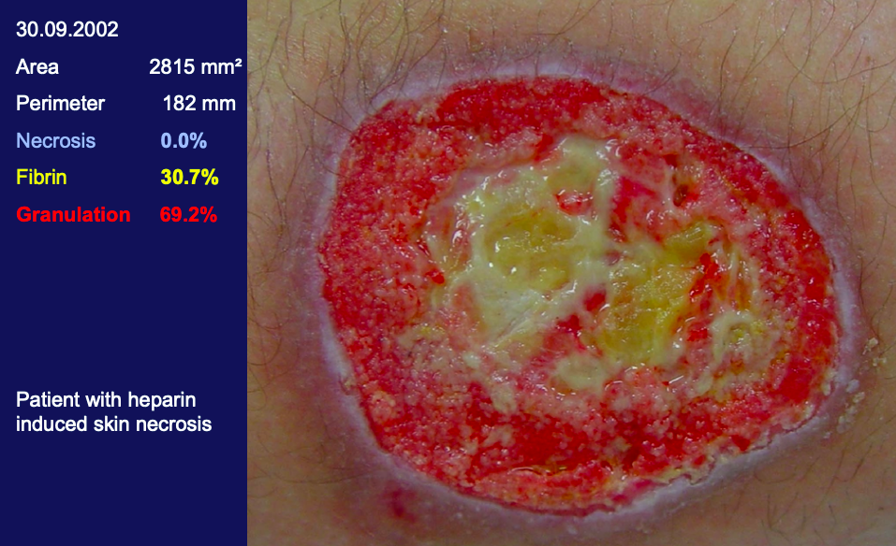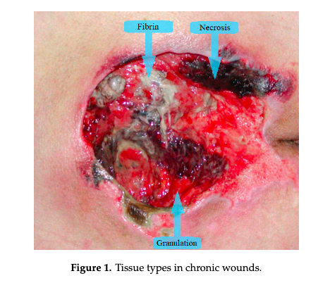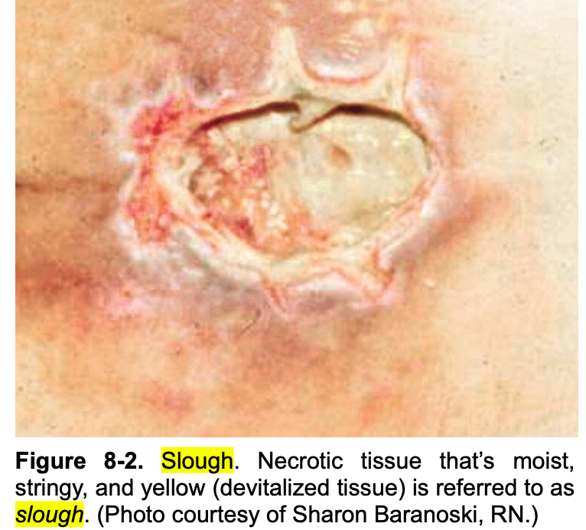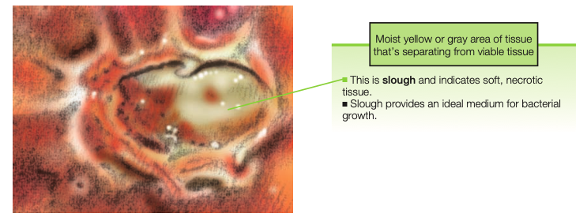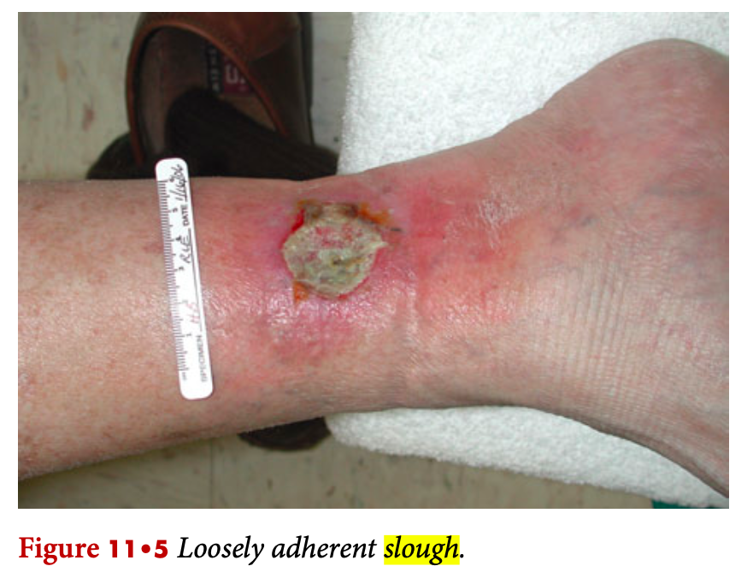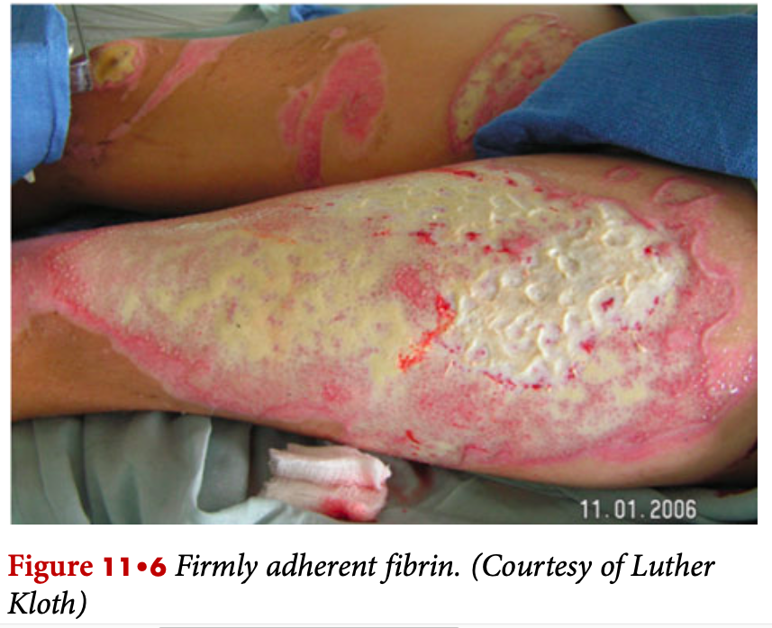

- Granulation healthy red:
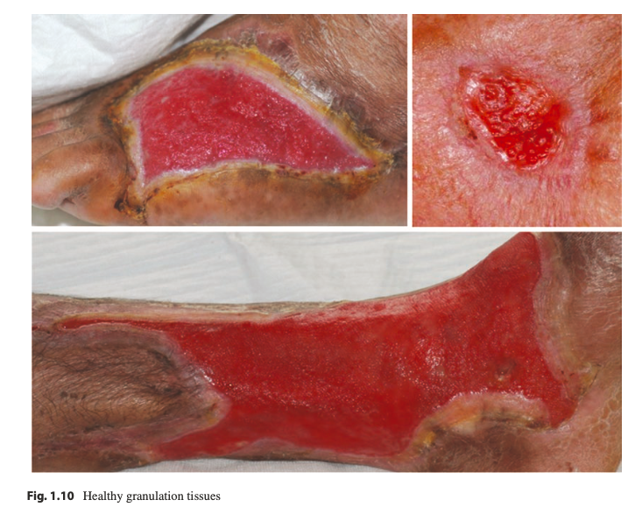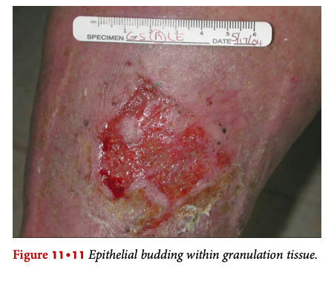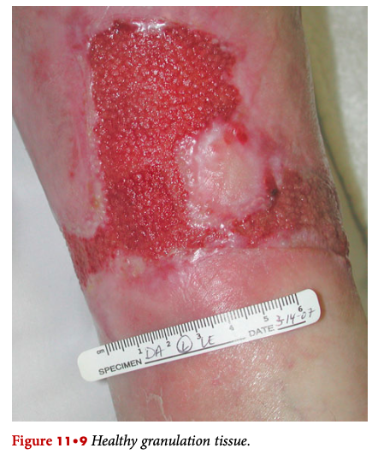
- Granulation unhealthy pale/ dusky-pink: (left healthy/ right unhealthy)
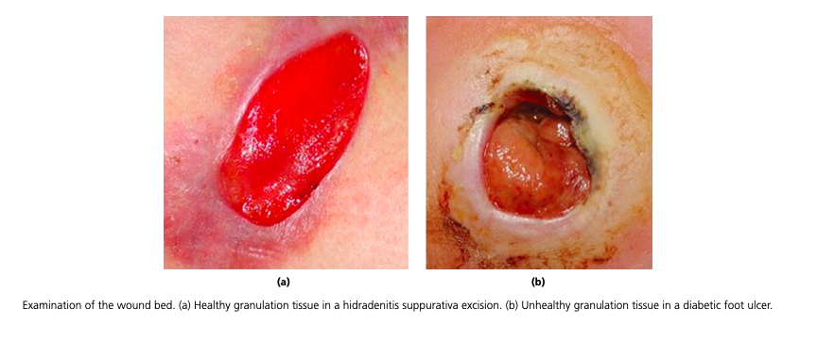
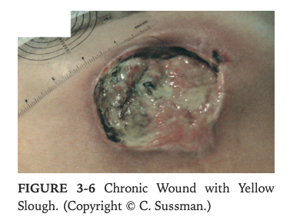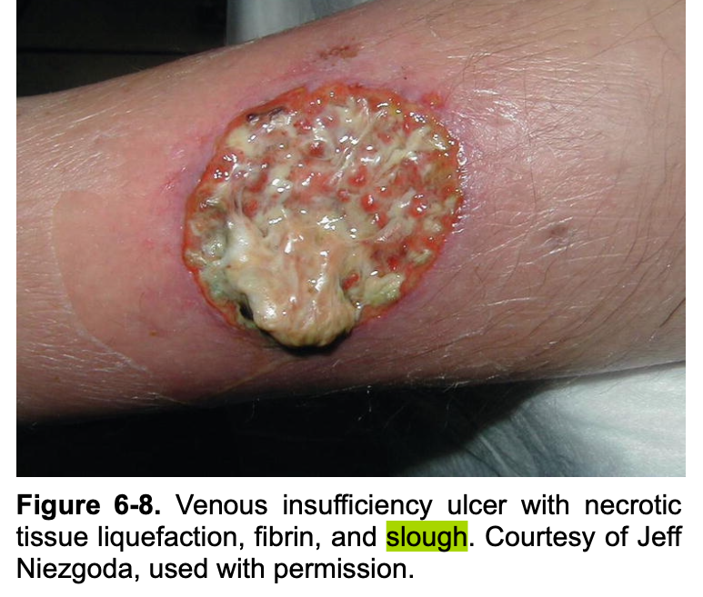
- Necrosis dry: Black eschar
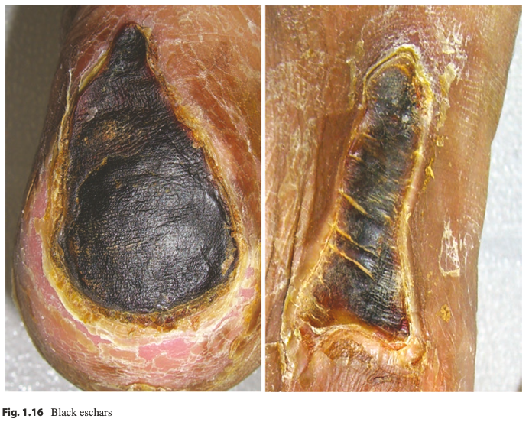

2) Examination of Wound Edges: -> etiology and healing status

