User Interface Design

4.1 Overview of User Interface

The User interface provides nurses with the ability to quickly register patients, list their vitals as well as their symptoms. Features real-time patient tracking, dynamic queue management, and rapid transition from queue to treatment rooms. Theres is only 1 type of actor for the system which is the ER nurse.
Available features for nurses:
- Ensured security with the login feature: Each nurse will have their unique ID and password to not causes confusion between nurses in the ER. If a nurse forgets their password, an administrator has to be contacted to reset it in the database for maximum security.
- Quick registration of patients: Nurses can quicky register newly arrived patients as soon as the enter the ER. Basic information like name or ages shall be used in when registration. Minute details such as medical history can be put in the system as none for seamless entry into the database.
- Patient dashboard with current patient in the ER: Ability to see whole patient list with their current triage level, symptoms, and a view more information button for whole details about patients.
- Current queue information: An interface tailored for the queue of patients in the ER with precautions to not let patients wait long when new patients with a higher triage level arrive. A triage level of 1 shall not be in the queue but instead be put in the in-treatment category immediately. Nurses can send individual patients into the in-treatment category as desired.
- In-treatment list of patients: A separate category of patients separated into being in-treatment. As soon as these patients finish treatment, nurses can send them off with the discharge button to allow more patients into the list.

User Feedback: Through out the interface nurses will be provided with feedback when entering wrong information. Such as in the login form. Nurses who enter a wrong password will be notified that it is wrong. The Patient information registration form will notify nurses as soon as unusual information are present in the wrong fields. Such as having numbers in the name field.

Interface Design Rules

Here are the main principles of the ER triage system interface:
- Fast - The system must be quick and easy to use, especially when many patients arrive at once. Nurses should be able to register patients in under a minute using simple forms with "None" options for missing information.
- Clear - The screen should show which patients need help first using color codes and clear warnings. Everyone should be able to see the current situation in the ER at a glance.
- Safe - The system should prevent mistakes by checking that information makes sense, asking for confirmation before important actions, and automatically saving all work.

4.3 Screen Images

An overview of all the system interface dashboards

4.3.1 Login Interface

Nurses will be prompted to enter their username and password. In case of forgetting either, an administrator has to be contacted in order to reset it simulating real life hospital systems.

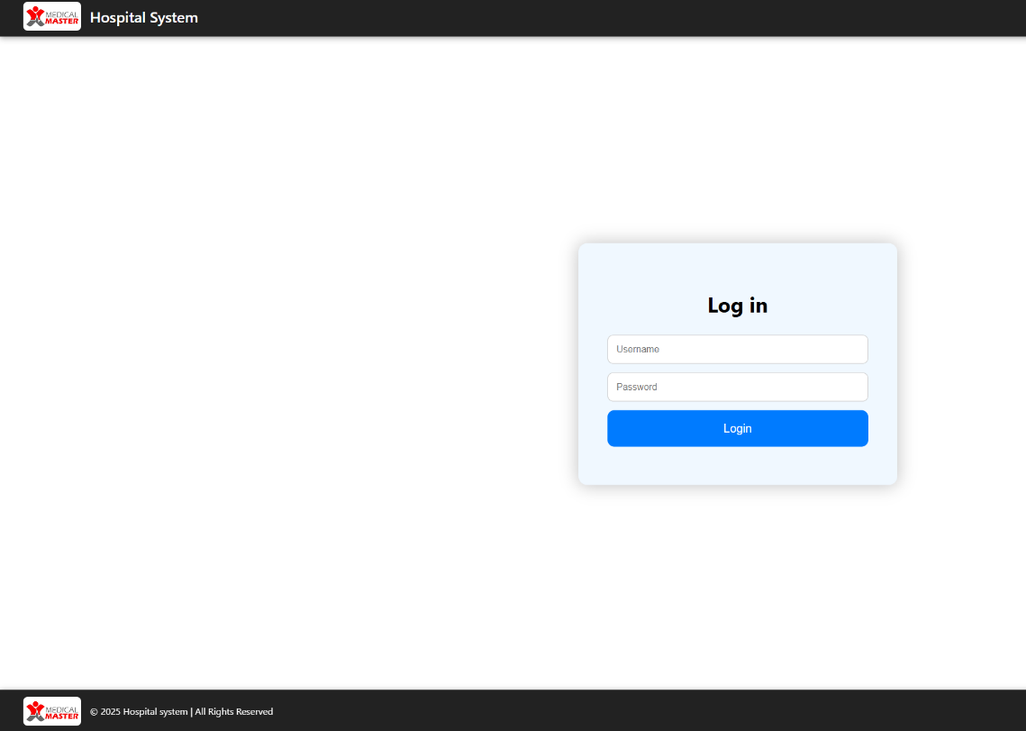

Figure 1: Login Dashboard

4.3.2 Patient registration and view patient dashboard.

A dashboard with 2 buttons for registration and viewing current patients in the ER.

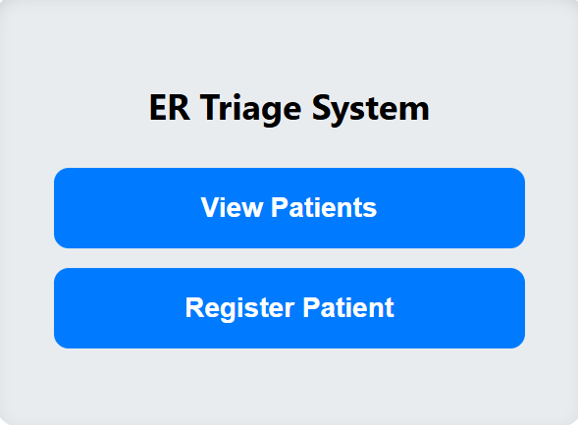

Figure 2: Patient registration and view patient dashboard.

4.3.2.1 Register patient form. Basic information

A form for registration of patients. Unknow information shall be put as none for quick registration.

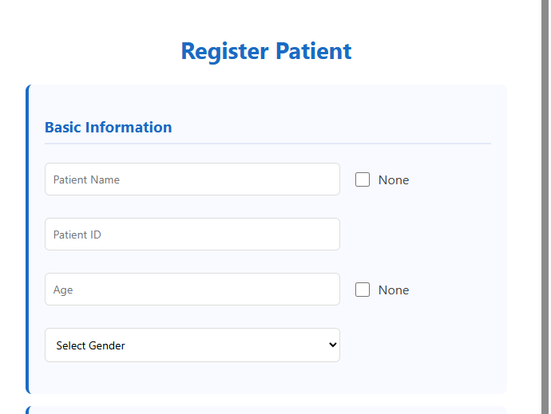

Figure 3: Basic information registration.
4.3.2.2 Register patient form. Medical information

A form for registration of patients. Unknow information shall be put as none for quick registration.

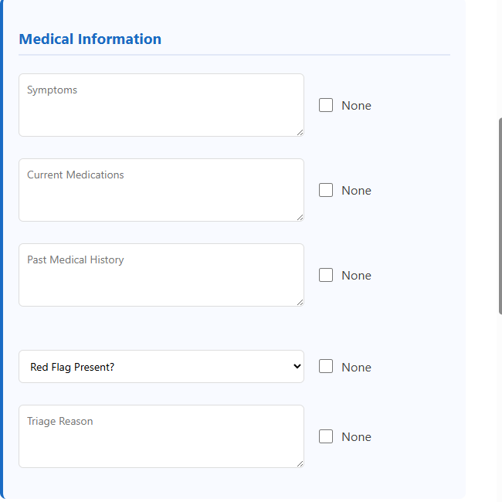

Figure 4: Medical information registration.

4.3.2.3 Register patient form. Vital signs information

A form for registration of patients. Unknow information shall be put as none for quick registration.

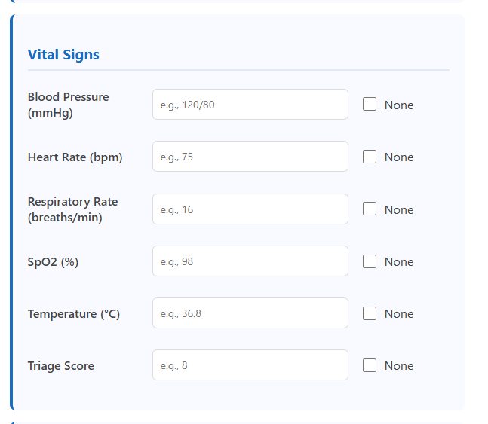

Figure 5: Register patient form. Vital signs information

4.3.2.4 Register patient form. Status information

A form for registration of patients. Unknow information shall be put as none for quick registration.

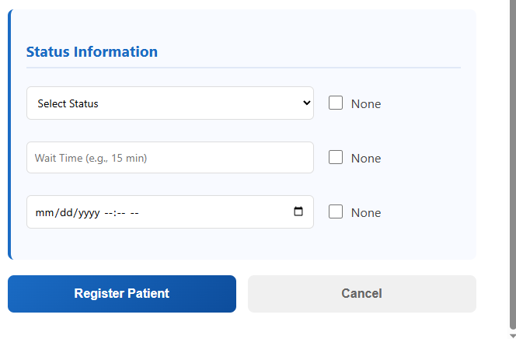

Figure 6: Register patient form. Status information

4.3.3 Patient information dashboard

Dashboard for viewing important patient information. Features a view more button for additional details.

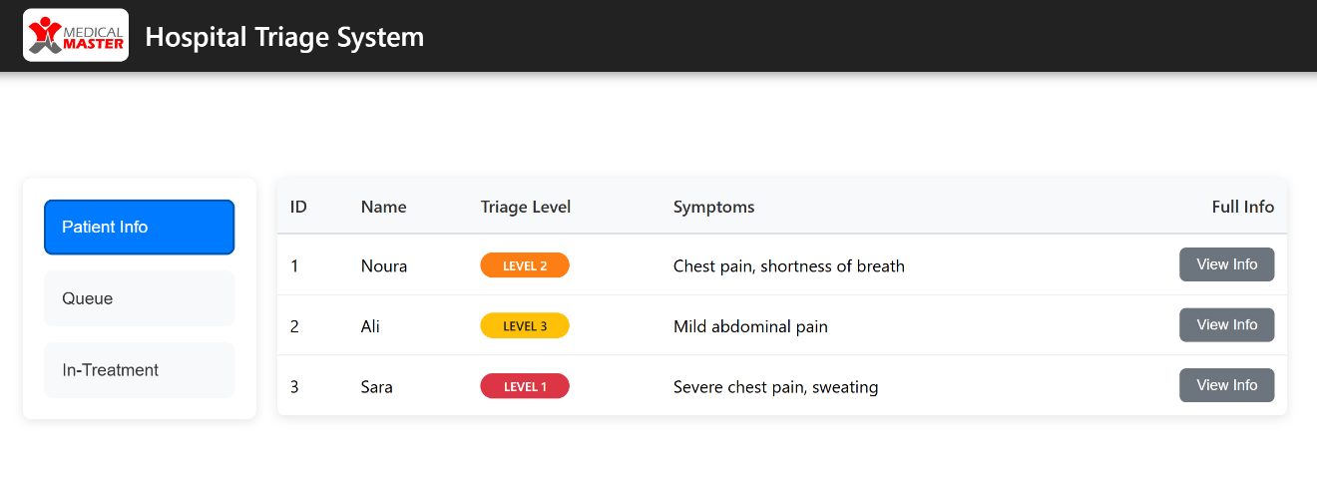

Figure 7: Patient information dashboard
4.3.3.1 Full patient information: vitals

List of patient vitals.

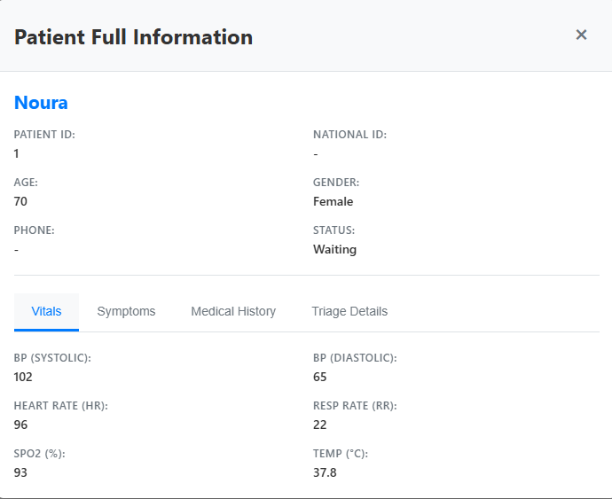

Figure 8: Full patient information: vitals

4.3.3.2 Full patient information: Symptoms

List of patient symptoms.
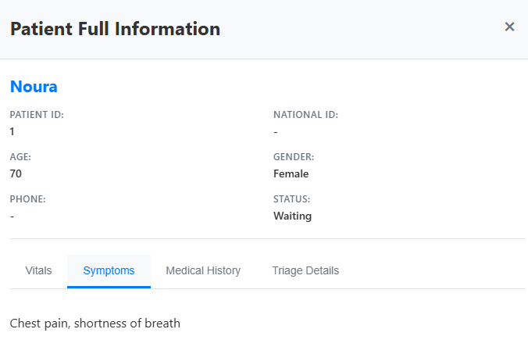

Figure 9: Full patient information: Symptoms

4.3.3.3 Full patient information: Medical history

List of patient medical history.

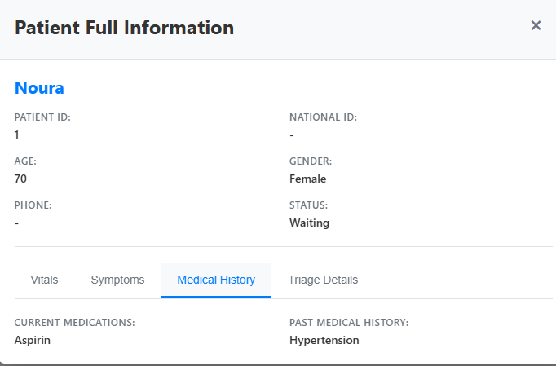

Figure 10: Full patient information: Medical history

4.3.3.4 Full patient information: Triage details

List of patient Triage details.

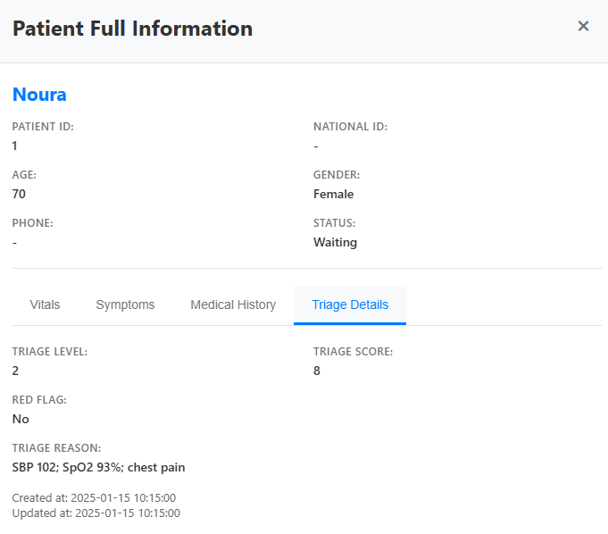

Figure 11: Full patient information: Triage details
4.3.3.5 Patient queue status

Table of current patients in the queue.
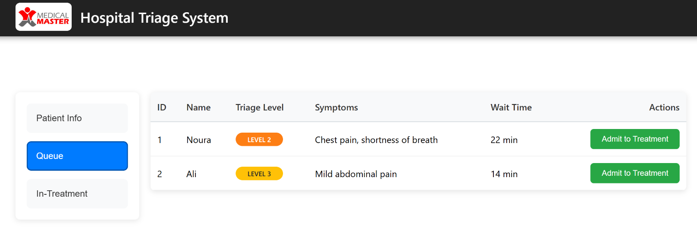

Figure 12: Patient queue status

4.3.3.6 In-treatment patient status

Table of current patients in the queue.

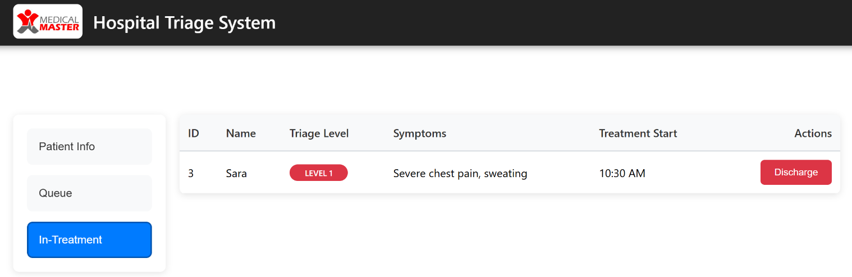

Figure 13: In-treatment patient status

4.3.3.7 Accessibility Panel Interface

A panel for accessibility features.

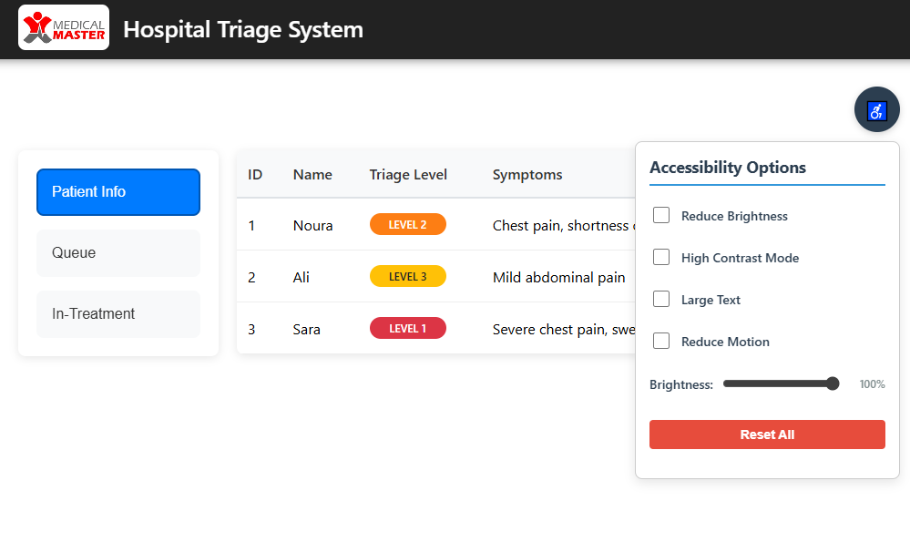

Figure 14: Accessibility Panel Interface

4.4Screen Objects and Actions

A discussion of screen objects and actions associated with those objects.
4.4.1 Common Interfaces

4.4.1.1 Login Interface

Object | Type | Action
Username Field | Text Field | Allows the user to input their username for authentication
Password Field | Text Field | Enables the user to enter their password securely.
Login Button | Button | Authenticates the credentials entered and redirects the user to their respective homepage.
Login Message | Text Display | Shows authentication status and error messages
Table 1: login interface objects

4.4.1.2 Main Dashboard Interface

Object | Type | Action
View Patients Button | Button | Redirects to Patient Dashboard interface
Register Patient Button | Button | Opens the Patient Registration popup form
Patient Registration Form | Modal/Popup | Displays comprehensive patient data entry form
Table 2: Main Dashboard Interface

4.4.2 Patient Registration Interface

4.4.2.1 Patient Registration Interface

Object | Type | Action
Patient Name Field | Text Field | Captures the patient's full name
Patient ID Field | Text Field | Records unique patient identifier
Age Field | Number Field | Inputs patient age with validation (0-200)
Gender Dropdown | Dropdown Menu | Selects patient gender (Male/Female)
None Checkboxes | Checkbox | Marks fields as intentionally left blank

Table 3: Patient Registration Interface

4.4.2.2 Medical Information Section

Object | Type | Action
Symptoms Textarea | Text Area | Records patient symptoms and complaints
Current Medications Textarea | Text Area | Documents currently taken medications
Medical History Textarea | Text Area | Records past medical conditions and history
Red Flag Dropdown | Dropdown Menu | Indicates presence of emergency red flags
Triage Reason Textarea | Text Area | Documents clinical reasoning for triage

Table 4: Medical Information Section

4.4.2.3 Vital Signs Section

Object | Type | Action
Blood Pressure Field | Text Field | Records BP measurement in mmHg format
Heart Rate Field | Number Field | Inputs HR with range validation (30-200 bpm)
Respiratory Rate Field | Number Field | Inputs RR with range validation (6-60 breaths/min)
SpO2 Field | Number Field | Records oxygen saturation (70-100%)
Temperature Field | Number Field | Inputs body temperature (34-42°C)
Triage Score Field | Number Field | Records calculated triage score (0-20)

Table 5: Vital Signs Section

4.4.2.4 Status Information Section

Object | Type | Action
Status Dropdown | Dropdown Menu | Sets patient status (Waiting/In Treatment/Treated)
Wait Time Field | Text Field | Records estimated or actual waiting time
Treatment Start Field | DateTime Field | Captures treatment initiation timestamp
Register Patient Button | Submit Button | Saves all patient data to database
Cancel Button | Button | Closes registration form without saving
Table 6: Status Information Section

4.4.3 Patient Dashboard Interface

4.4.3.1 Navigation Panel

Object | Type | Action
Patient Info Button | Tab Button | Displays comprehensive patient list view
Queue Button | Tab Button | Shows patients in waiting queue (Level 2 & 3)
In-Treatment Button | Tab Button | Displays currently treated patients (Level 1)
Table 7: Navigation Panel

4.4.3.2 Patient Information Table

Object | Type | Action
Patient Table | Data Grid | Displays patient list with key columns
ID Column | Table Column | Shows patient identifier
Name Column | Table Column | Displays patient name
Triage Level Column | Table Column | Shows assigned triage priority level
Symptoms Column | Table Column | Displays primary symptoms
Full Info Buttons | Action Button | Opens detailed patient modal view

Table 8: Patient Information Table

4.4.3.3 Queue Management Table

Object | Type | Action
Queue Table | Data Grid | Shows waiting patients with wait times
Wait Time Column | Table Column | Displays elapsed waiting duration
Action Buttons | Action Buttons | Provides patient management options

Table 10: Queue Management Table

4.4.3.4 In-Treatment Table

Object | Type | Action
In-Treatment Table | Data Grid | Displays currently treated patients
Treatment Start Column | Table Column | Shows treatment initiation time
Action Buttons | Action Buttons | Provides treatment management options

Table 11: In-Treatment Table

4.4.4 Patient Detail Modal Interface

4.4.4.1 Modal Navigation

Object | Type | Action
Close Modal Button | Icon Button | Closes the patient detail modal
Vitals Tab | Tab Button | Displays vital signs information
Symptoms Tab | Tab Button | Shows symptoms and complaints
History Tab | Tab Button | Displays medical history data
Triage Tab | Tab Button | Shows triage assessment details

Table 12: Modal Navigation

4.4.4.2 Basic Information Display

Object | Type | Action
Patient Name Display | Text Display | Shows patient's full name
Patient ID Display | Text Display | Shows unique identifier
Age Display | Text Display | Shows patient age
Gender Display | Text Display | Shows patient gender
Phone Display | Text Display | Shows contact number
Status Display | Text Display | Shows current treatment status

Table 13: Basic Information Display

4.4.4.3 Tab Content Areas

Object | Type | Action
Vitals Grid | Info Grid | Displays all vital sign measurements
Symptoms Text | Text Display | Shows detailed symptoms description
Medical History Grid | Info Grid | Displays medications and past history
Triage Details Grid | Info Grid | Shows triage assessment and reasoning
Timestamp Display | Text Display | Shows record creation and update times
Table 14: Tab Content Areas

4.4.5 Universal Interface Elements

4.4.5.1 Header Component

Object | Type | Action
Hospital Logo | Image | Brand identification and visual anchor
System Title | Text Display | Shows application name and purpose
Table 15: Header Component

4.4.5.2 Footer Component

Object | Type | Action
Footer Logo | Image | Consistent branding across pages
Copyright Text | Text Display | Legal and copyright information
Table 16: Footer Component

4.5 Other Interfaces

4.5.1 Accessibility Panel Interface

Object | Type | Action
Accessibility Toggle Button | Icon Button | Opens/closes the accessibility options panel with ♿ symbol
Accessibility Panel | Modal Panel | Displays all accessibility customization options
Reduce Brightness Checkbox | Checkbox | Instantly reduces screen brightness to 70% for reduced eye strain
High Contrast Mode Checkbox | Checkbox | Toggles high contrast theme with black background and white text
Large Text Mode Checkbox | Checkbox | Increases all text sizes by 20% for better readability
Reduce Motion Checkbox | Checkbox | Disables all animations and transitions for users with vestibular disorders
Brightness Slider | Range Slider | Allows precise brightness adjustment from 50% to 100%
Brightness Value Display | Text Display | Shows current brightness percentage (50%-100%)
Reset All Button | Button | Restores all accessibility settings to default values

