Cloud DataLab:

<https://cloud.google.com/datalab/docs/quickstart>

Enabling API’s:

1. Go to ”API and Services” in google console, click on Enable APIs and services. Search for Cloud Source Repositories API as shown below.

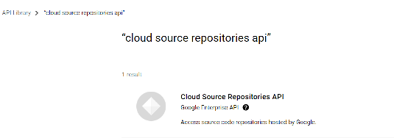

1. Enable the Cloud Source Repositoreis as you will see as shown below.

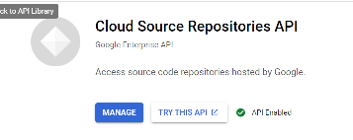

1. Open Cloud shell to access the Datalab.
2. Use command
   1. Datalab create my-datalab
   2. Choose location
   3. It creates network,codes repo, disk, instance and firewall rule.
   4. Datalab connect instance_name
   5. To delete, use datalab delete instance_name
   6. Go to compute engine and select disk , u can see instance running. Delete it.s