**Flask, Authentication, Databases(Login and SignUp)**

Login: <http://127.0.0.1:5000/>

SignUp: <http://127.0.0.1:5000/sign-up>

**Email Address:** chinu@gmail.com

**First Name:** chinu

**Password:** testing

**Conform password:** testing

**Login Page:**

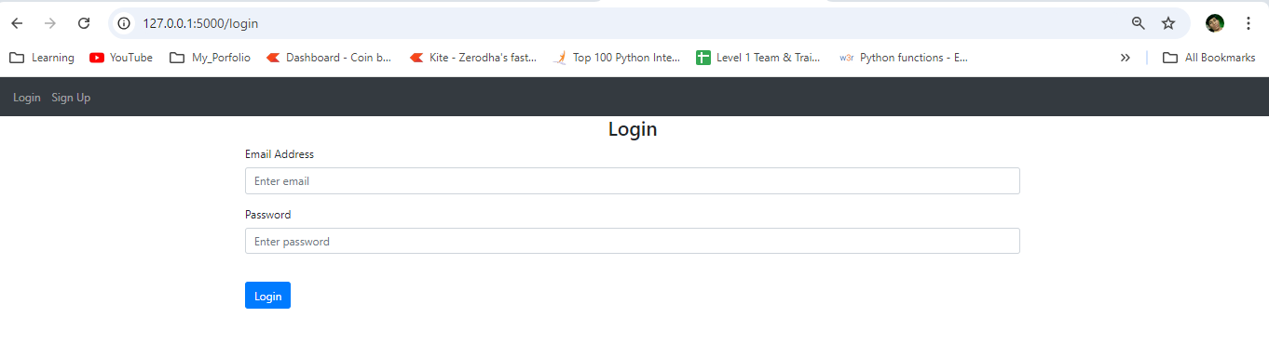

**Sign Up Page:**

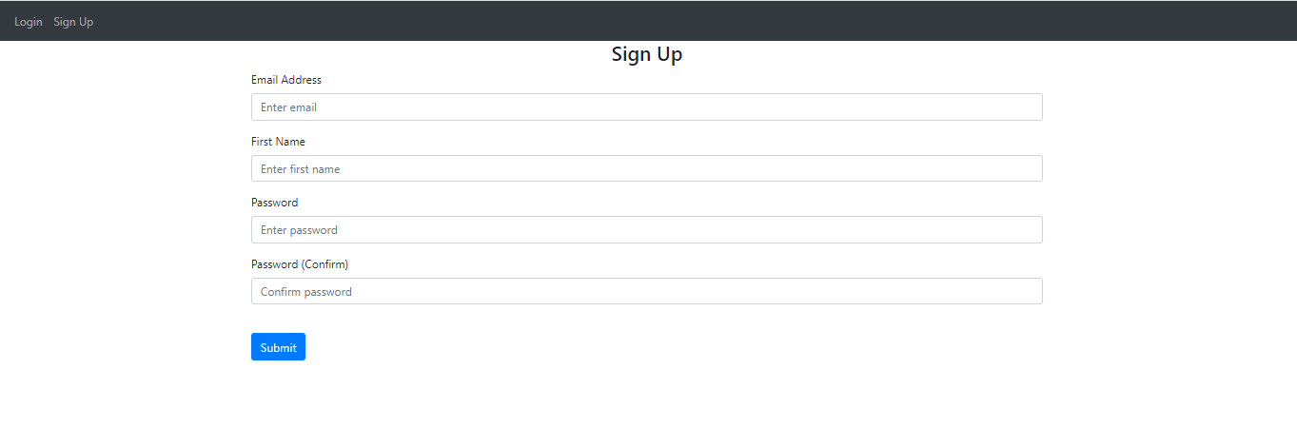

**After sign up page:**

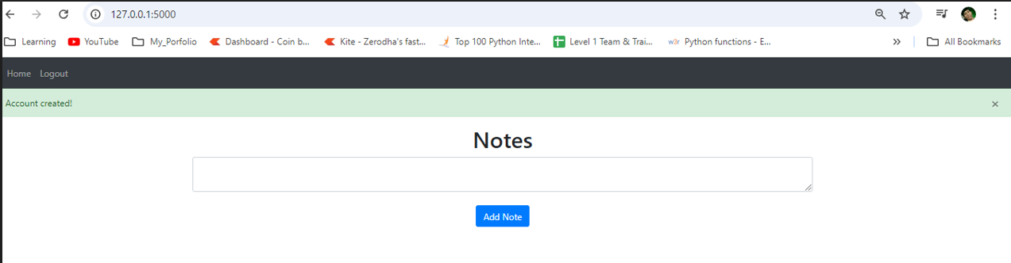

**Add Notes after sign up and login and remove note:**

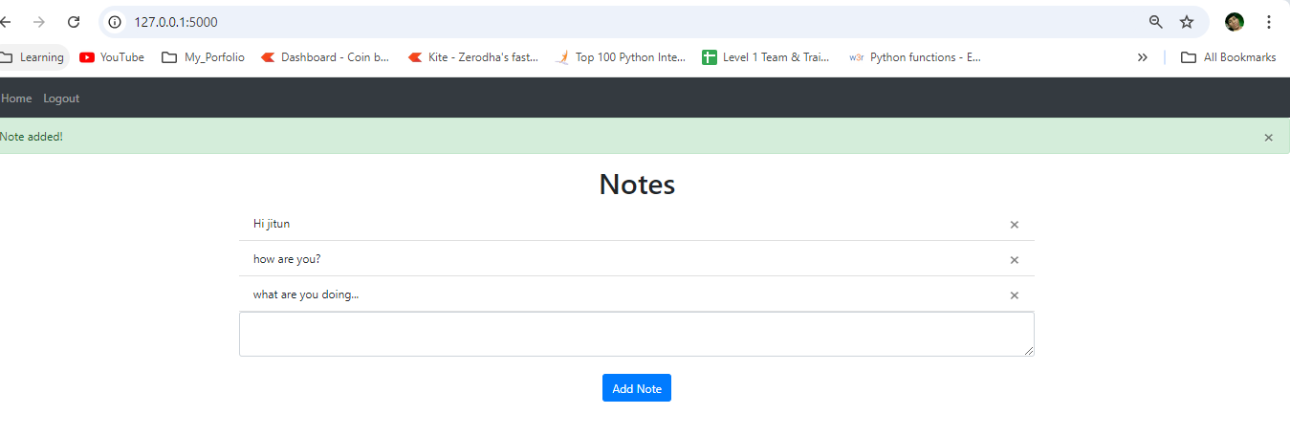

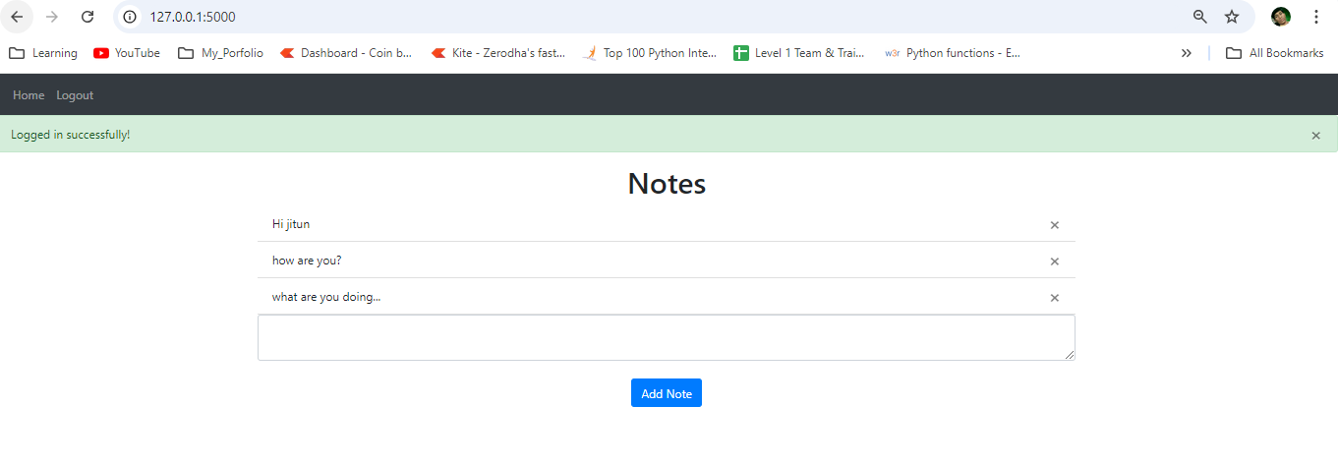

Referred Video: <https://youtu.be/dam0GPOAvVI>