Design Report – Group 48

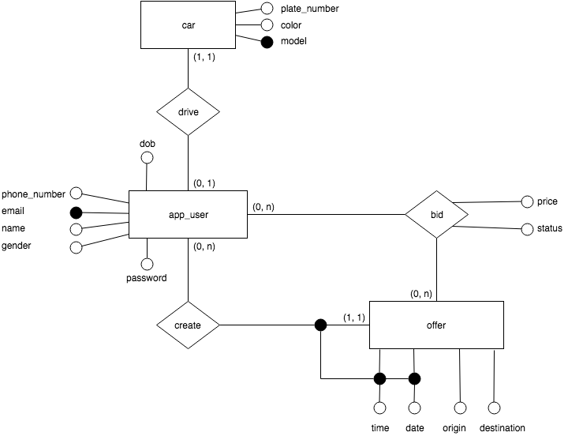

CREATE TABLE car (

plate_number VARCHAR(8) PRIMARY KEY,

model VARCHAR(16) NOT NULL,

color VARCHAR(16) NOT NULL

);

CREATE TABLE app_user (

phone_number CHAR(8) UNIQUE NOT NULL,

email VARCHAR(32) PRIMARY KEY,

name VARCHAR(32) NOT NULL,

gender CHAR(1) NOT NULL CONSTRAINT gender

CHECK(gender = 'M' OR gender = 'F'),

dob DATE NOT NULL,

password VARCHAR(64) NOT NULL

);

CREATE TABLE drive (

driver VARCHAR(32),

car VARCHAR(8),

PRIMARY KEY (driver, car),

FOREIGN KEY (driver) REFERENCES app_user(email),

FOREIGN KEY (car) REFERENCES car(plate_number)

);

CREATE TABLE offer(

date_of_ride DATE,

time_of_ride TIME,

driver VARCHAR(32),

origin VARCHAR(64) NOT NULL,

destination VARCHAR(64) NOT NULL,

PRIMARY KEY (date_of_ride, time_of_ride, driver),

FOREIGN KEY (driver) REFERENCES app_user(email)

);

CREATE TABLE bid (

date_of_ride DATE,

time_of_ride TIME,

driver VARCHAR(32),

passenger VARCHAR(32),

price DECIMAL(19, 4) NOT NULL,

status VARCHAR(16) NOT NULL

CONSTRAINT status

CHECK(status = 'pending' OR status = 'successful'

OR status = 'unsucessful'),

PRIMARY KEY (date_of_ride, time_of_ride, driver, passenger),

FOREIGN KEY (date_of_ride, time_of_ride, driver) REFERENCES offer(date_of_ride, time_of_ride, driver),

FOREIGN KEY (passenger) REFERENCES app_user(email),

CHECK(driver <> passenger)

);