Posting example
1.Post title：
Found my new favorite study spot at Fuzhou University!
Post body：
Dameng Bookstore’s design hits different—curved shelves, built-in lights, and a reflective ceiling that makes every photo look cinematic. My productivity’s through the roof here, and even tiredness fades when I glance out the window.
Post category：
Study Space
Upload images/videos：
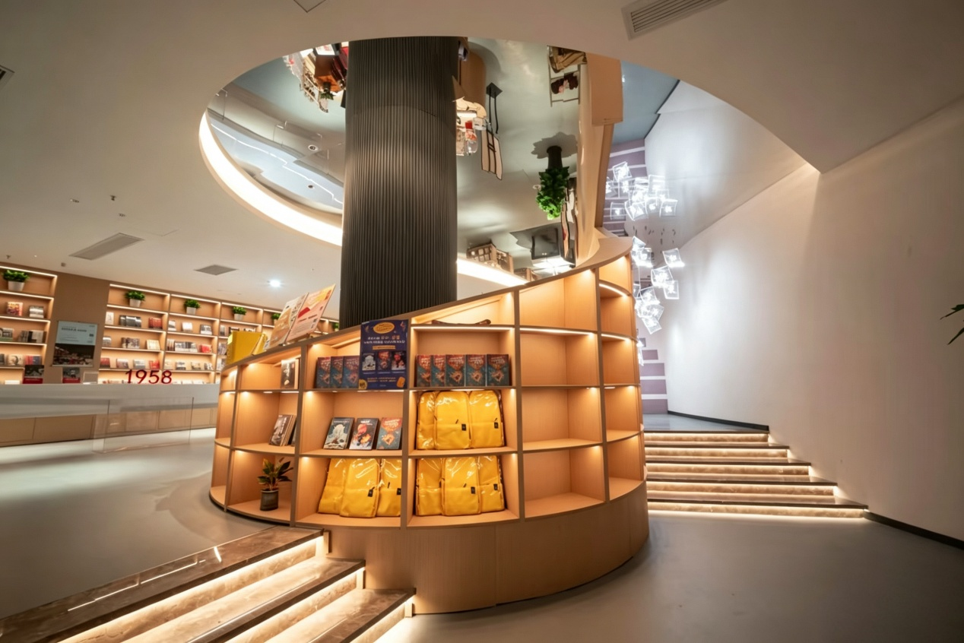

2.Post title：
Checking in at Fuzhou University Library’s study area
Post body：
The familiar wooden tables and neatly arranged bookshelves, with sunlight filtering through the curtains. There’s a quiet, reassuring atmosphere in the air. Pressing the “study start” button here, handing time over to books — this is the most peaceful daily routine.
Post category：
Study Space
Upload images/videos：
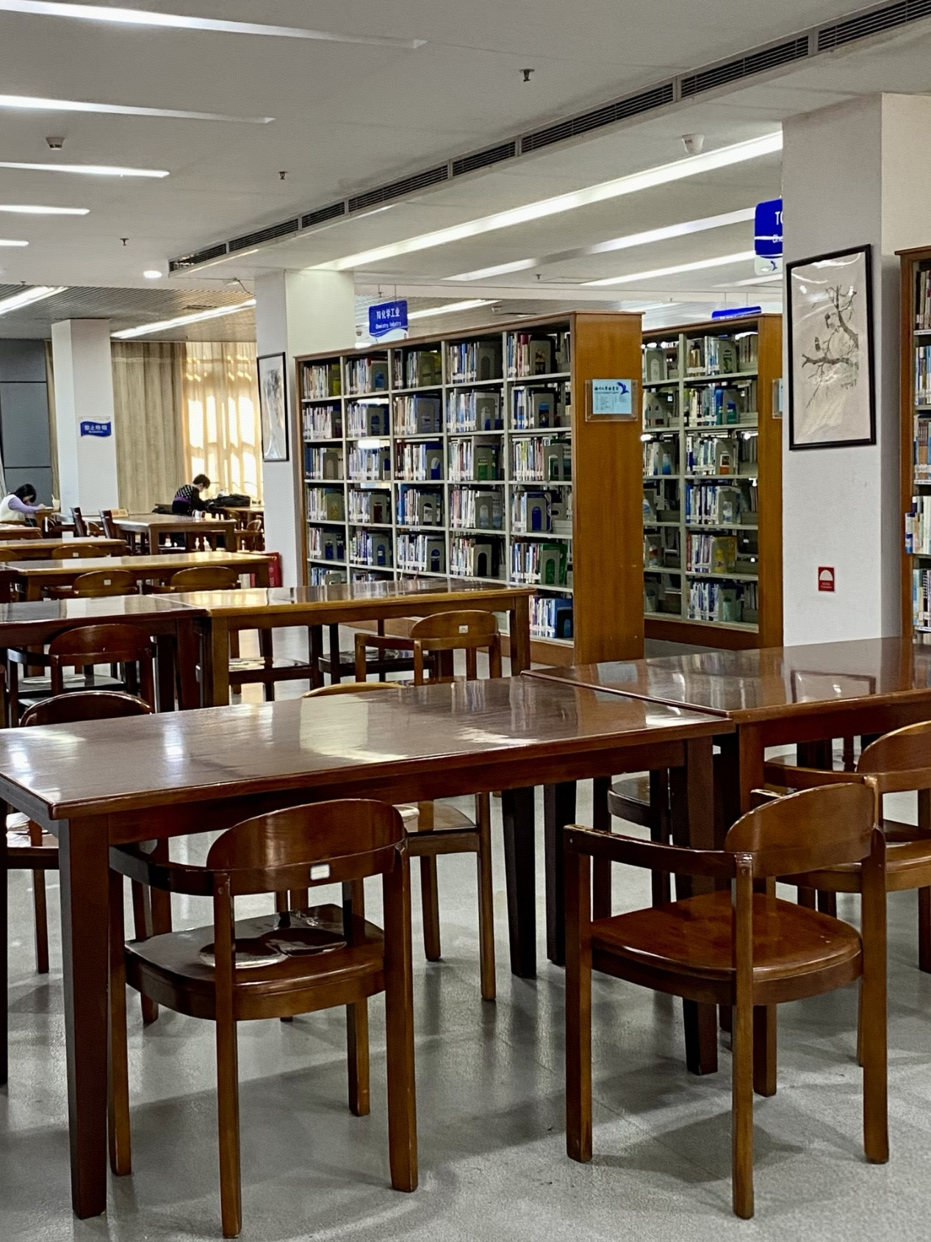

3.Post title：
Fuzhou University! There are sky gardens and private study rooms here!
Post body：
Follow me for a full tour of the brand-new study center in FZU.
Post category：
Study Space
Upload images/videos：
Study_ Center.mp4

4.Post title：
Quiet study spots for reciting texts in Fuzhou University Library!
Post body：
This place is perfect for memorizing knowledge. Many postgraduate entrance exam candidates come here to study, and so do I.
Post category：
Study Space
Upload images/videos：
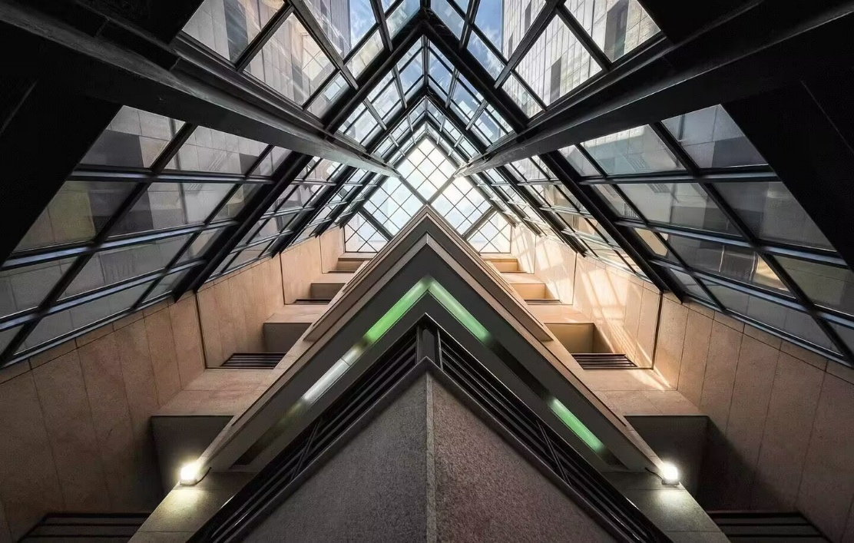
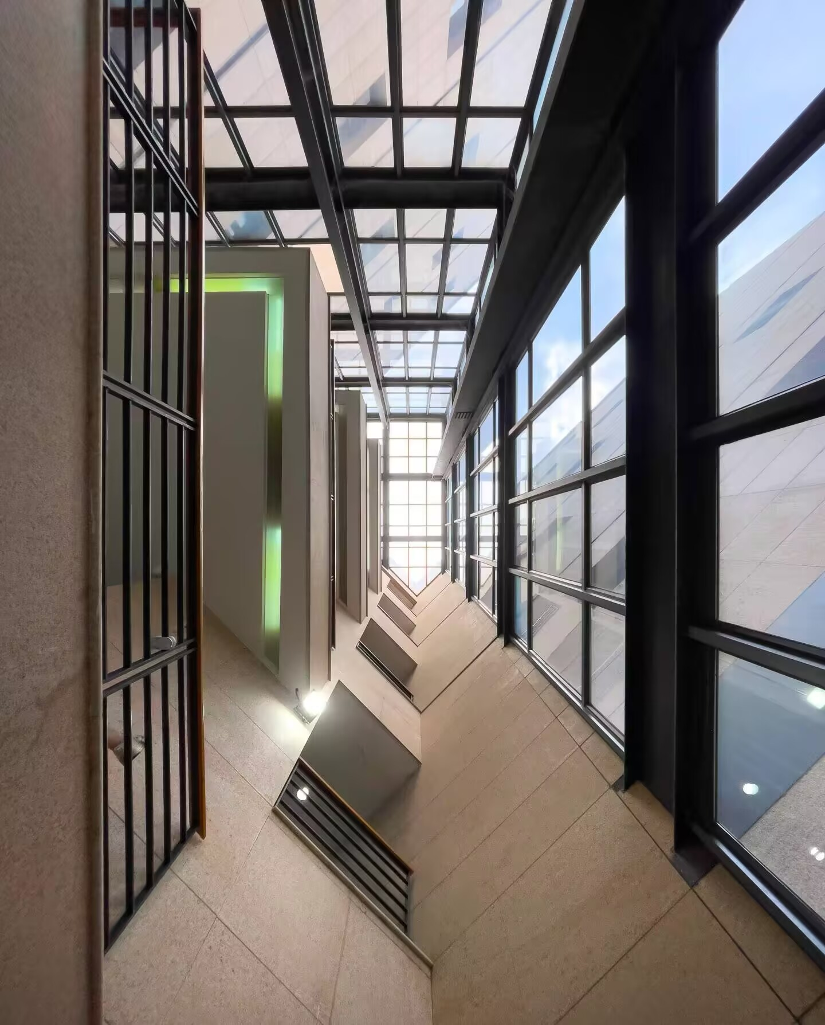
5.Post title：
FZU | Fuyou Pavilion is simply my ideal place!
Post body：
Many people may not know that the interior of Fuyou Pavilion is now open to everyone.
You can buy coffee on the first floor, where plenty of group seats are available for board games. The delicate decorations here are also quite interesting.
You can head upstairs via the staircase next to the coffee counter. The second floor boasts a more open view, equipped with long shared tables as well as single lakeside seats facing all directions. It is incredibly pleasant to enjoy coffee while admiring the lake scenery.
The indoor air conditioning keeps the space comfortably cool all the time, and soft music is played at the front desk, making the whole environment extremely relaxing.
Post category：
Study Space
Upload images/videos：
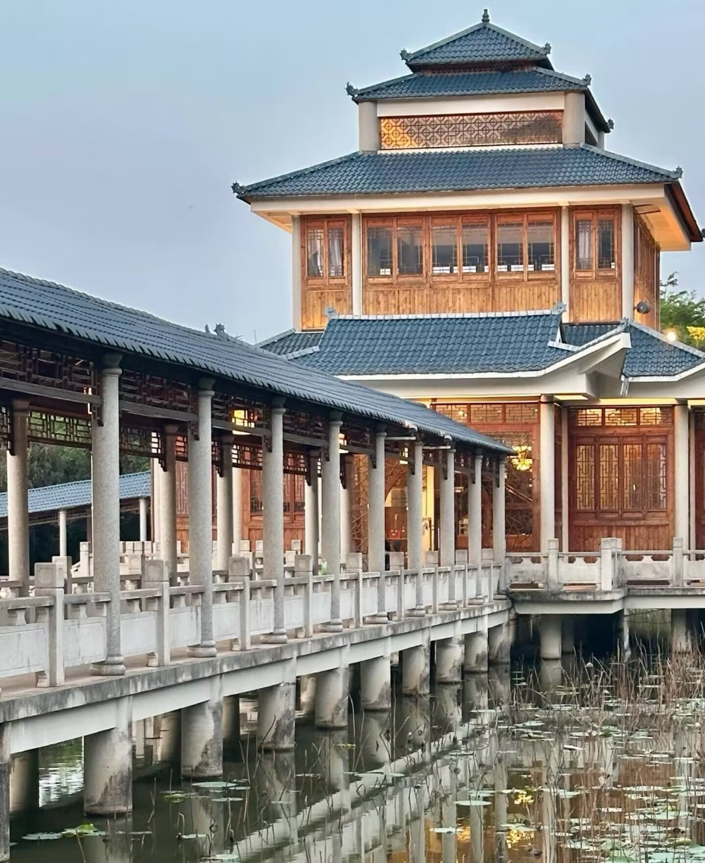
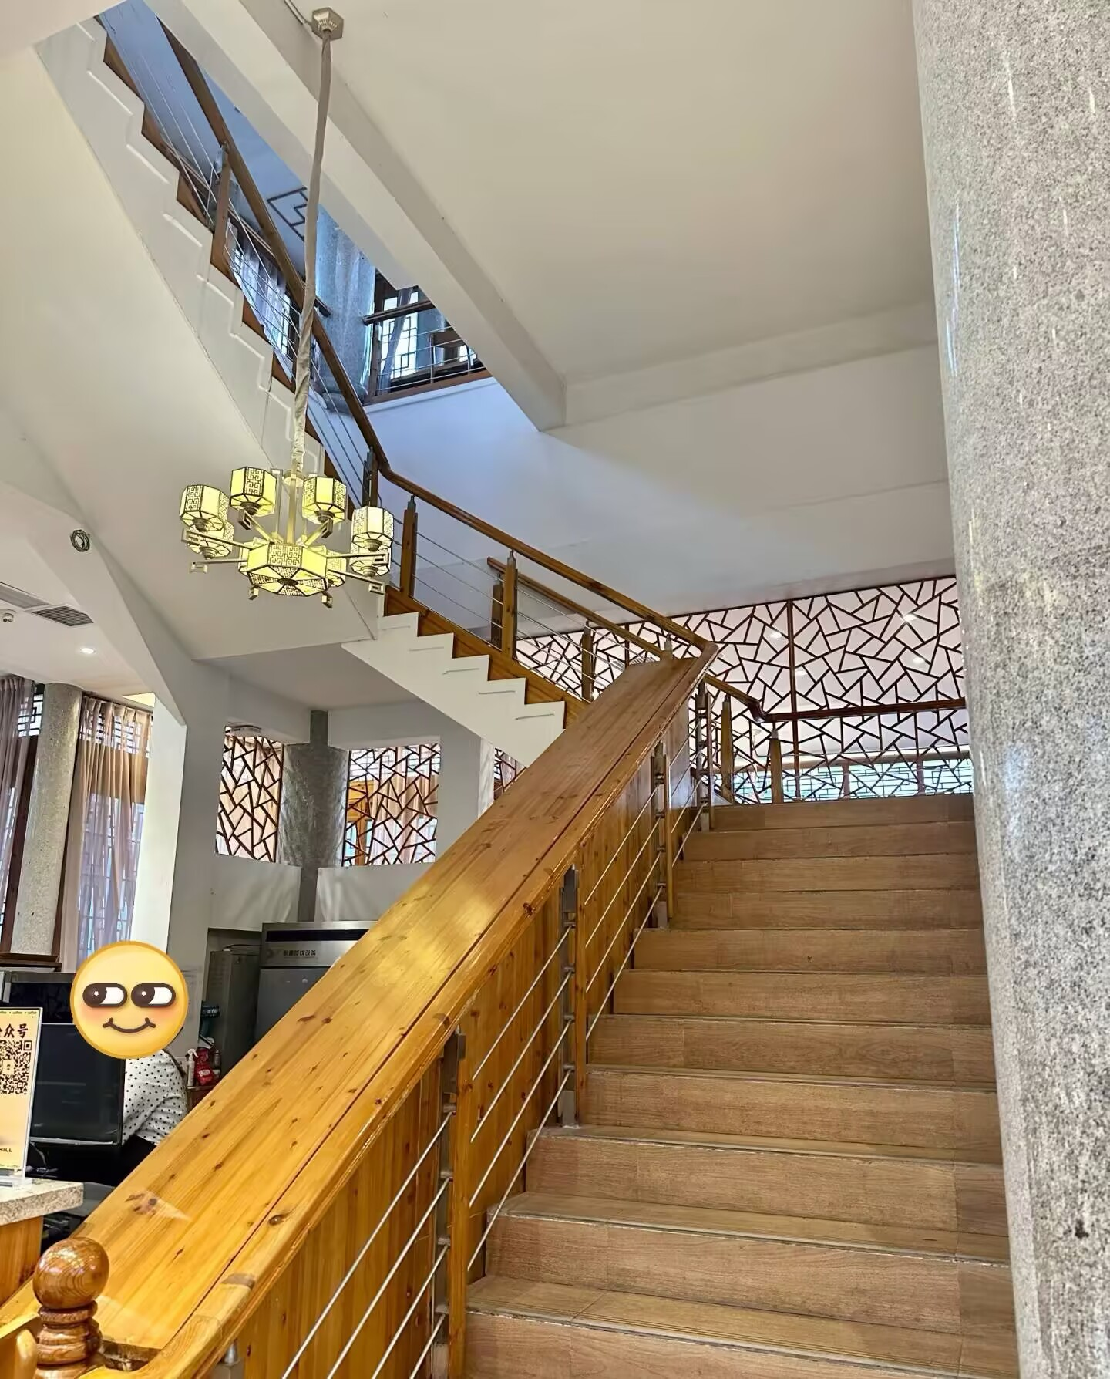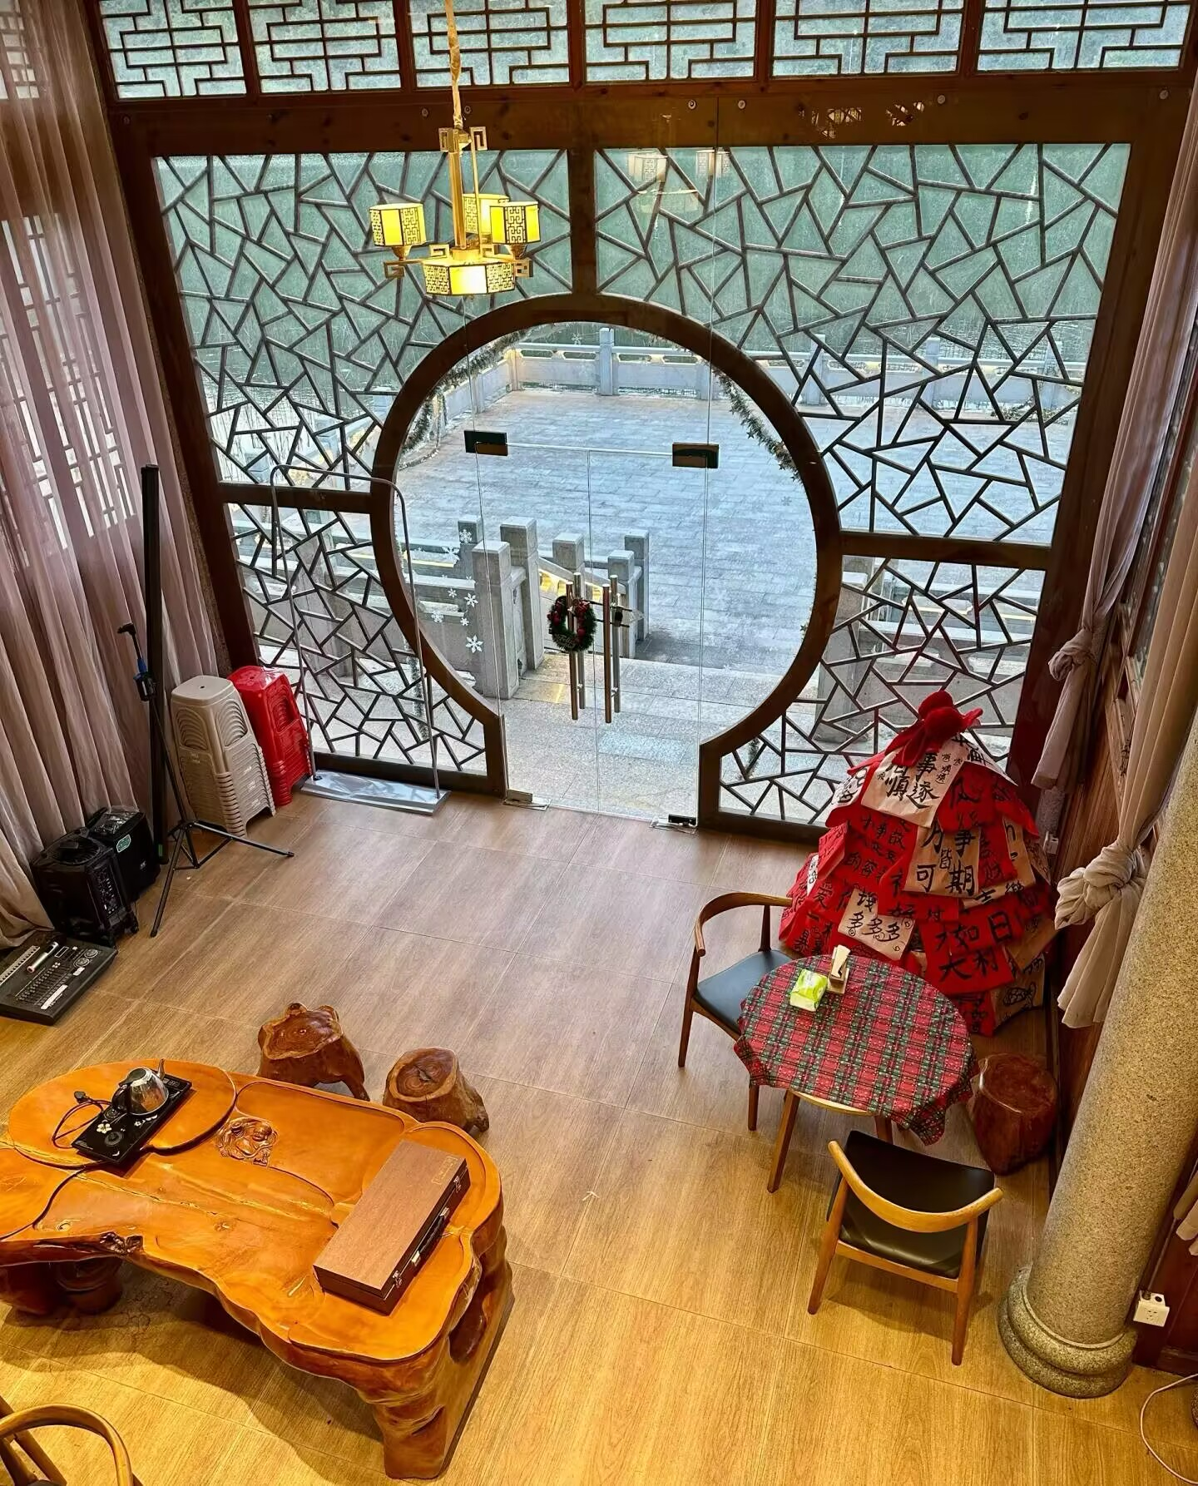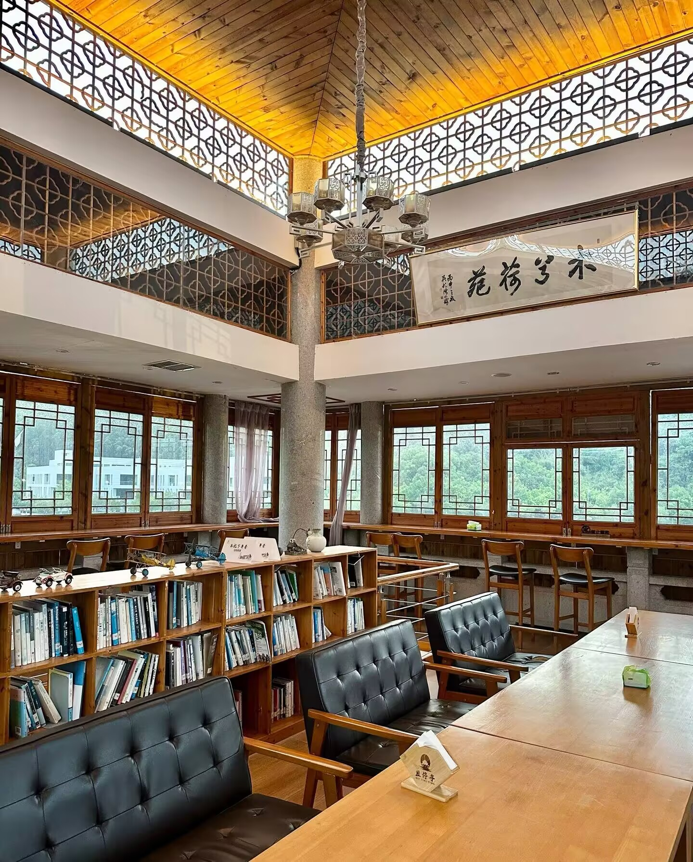

6.Post title：
Checking in at the newly opened Rose Garden Canteen
Post body：
Finally got to visit this legendary new dining hall. The space looks so cozy, instantly boosting my appetite. Ready to explore all the delicious dishes here!
Post category：
Food and Cafe
Upload images/videos：
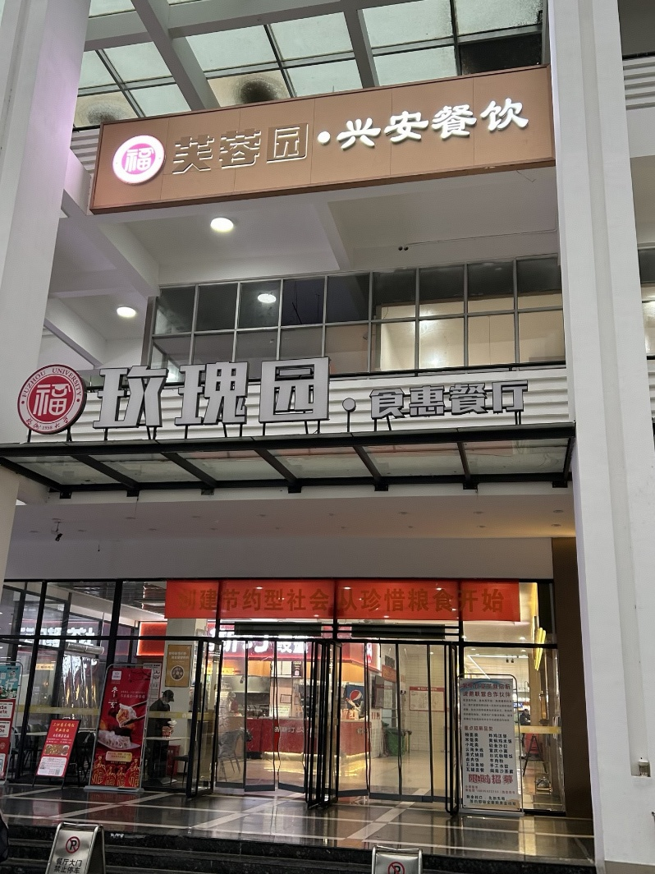

7.Post title：
The wooden barrel rice at FZU canteen is forever the favorite of every foodie
Post body：
The freshly steamed rice with wok aroma, paired with crispy fried toppings and savory sauces. A steaming bowl instantly washes away all tiredness!
Post category：
Food and Cafe
Upload images/videos


8.Post title：
Newly Opened Shop
Post body：
Who has a Hong Kong-style tea restaurant on campus? It’s me!
It didn’t take long to finish renovation and open for business.
The food tastes great, and I’ve dined here twice in three days.
I strongly recommend the flowing curry chicken cutlet rice, which features rich and aromatic curry.
I’m also fond of pineapple buns and black pepper pasta.
There are still crowds queuing up during meal times.
Feel free to come and have a taste if you are interested.
Post category：
Food and Cafe
Upload images/videos
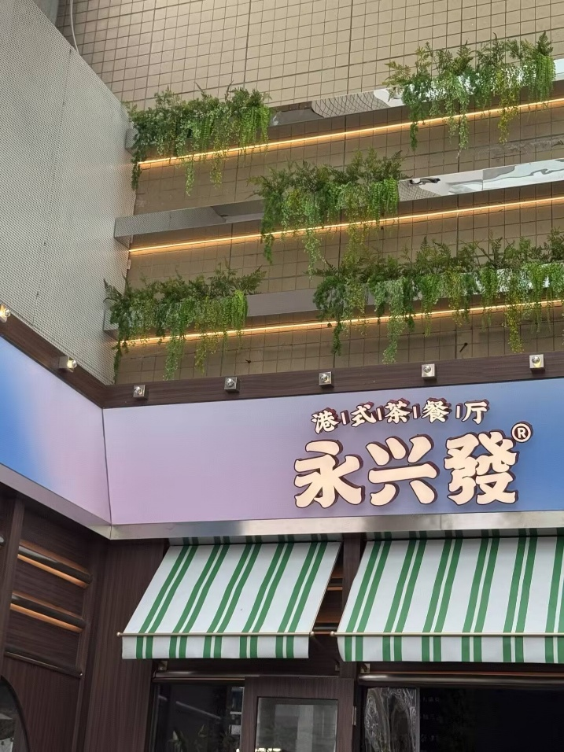
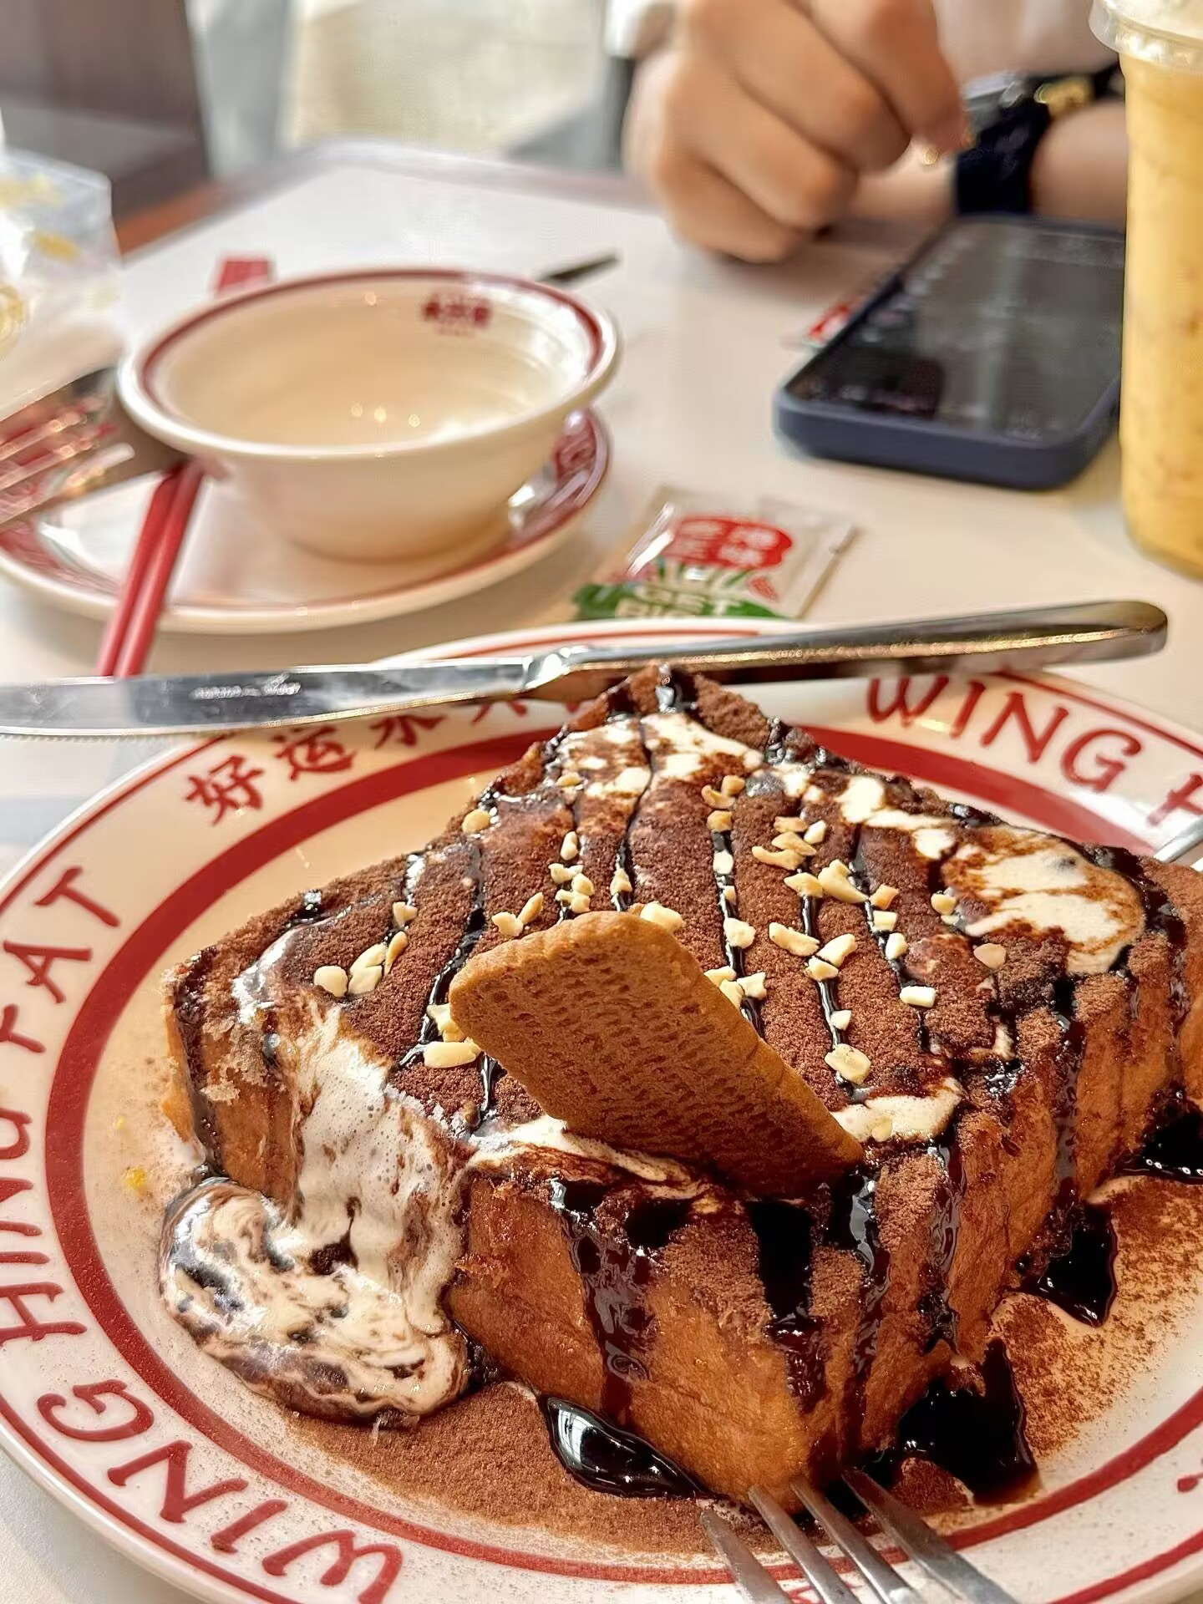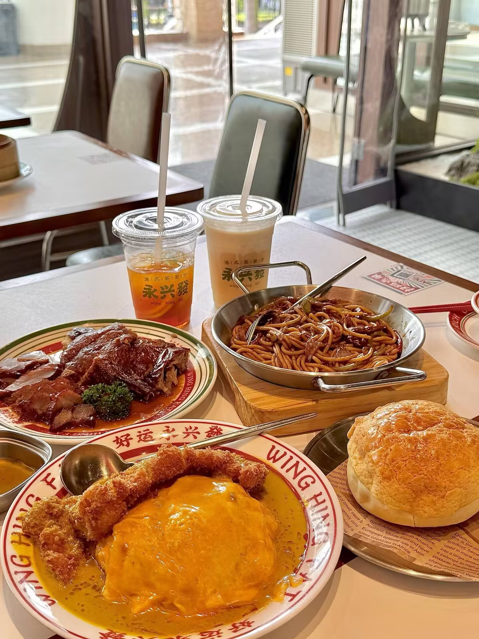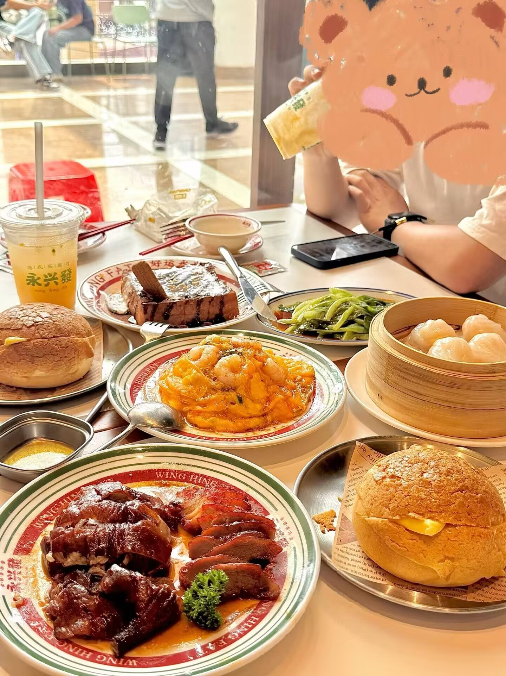
9.Post title：
Fuzhou University | Finals week, you gotta compensate me
Post body：
I always crave drinks the second I start studying.
Mixing coffee, milk tea, fruit tea and booze nonstop.
My top 3 favorite drinks:
1.Heytea Triple Rich Matcha
2.Chaba Green Glutinous Rice Mountain
3.Chen Wendin Lemon Green Tea
Post category：
Food and Cafe
Upload images/videos
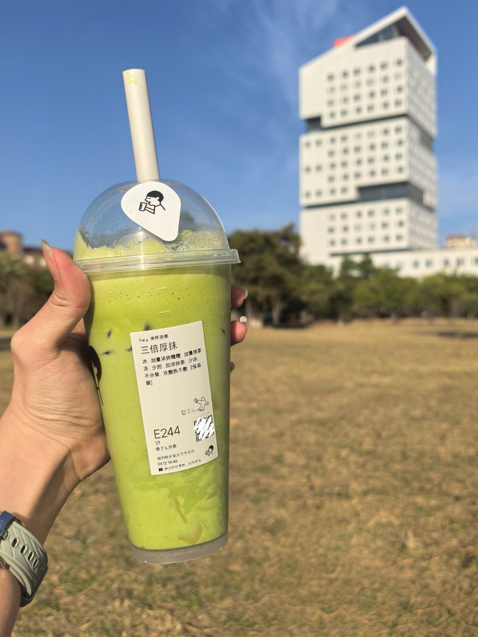
10.Post title：
Food Diary
Post body：
An ordinary day starts with eating.
Post category：
Food and Cafe
Upload images/videos
Food_Diary.mp4

11.Post title：
Christmas at Fuzhou University, hidden in an winter fairy tale
Post body：
Transparent bubbles wrap golden maple leaves, framing the blue sky, white bridge, and teaching building into the same picture. It’s like receiving a romantic letter from campus. The first gentle touch of winter is given by FZU’s trees and sunshine.
Post category：
Digital Memory
Upload images/videos
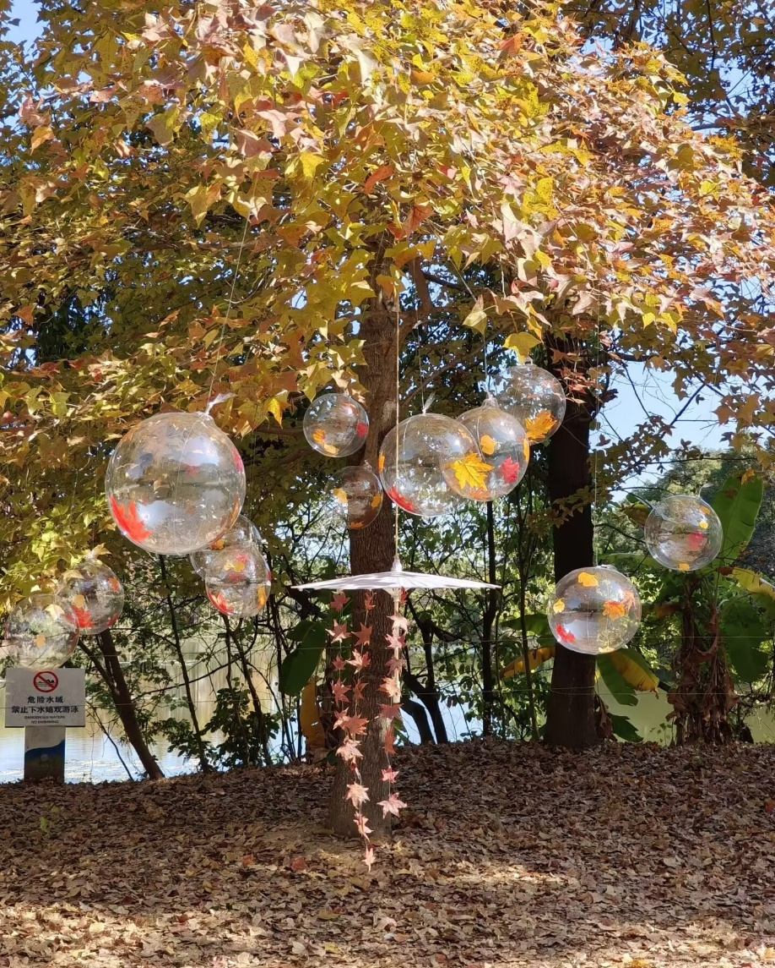
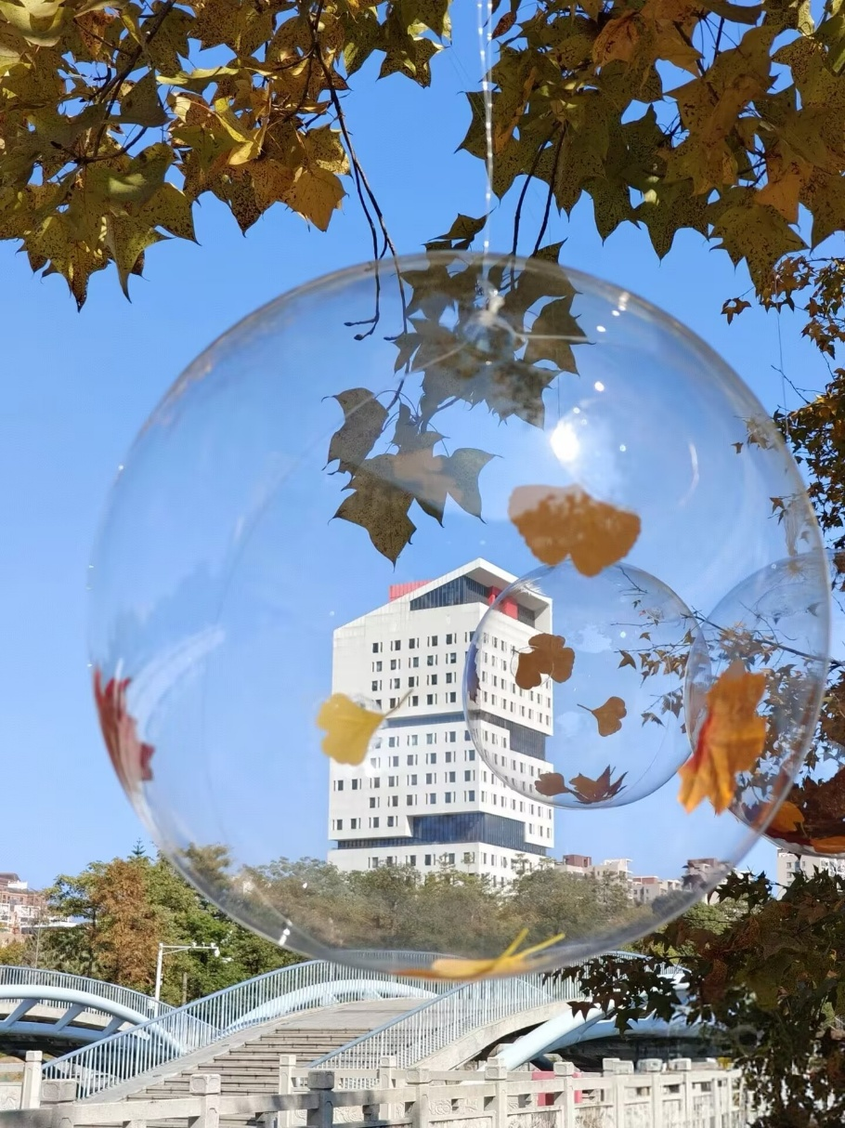
12.Post title：
Youth never ends, we never say goodbye
Post body：
Leaving my graduation gown at FZU, and taking the memories with me. Every shot in the lecture hall, on the bridge, and at the “I ❤️ FZU” sign is a footnote to three years of youth. Graduation isn’t the end — it’s carrying the wind and light from here, and heading for the next chapter.
Post category：
Digital Memory
Upload images/videos
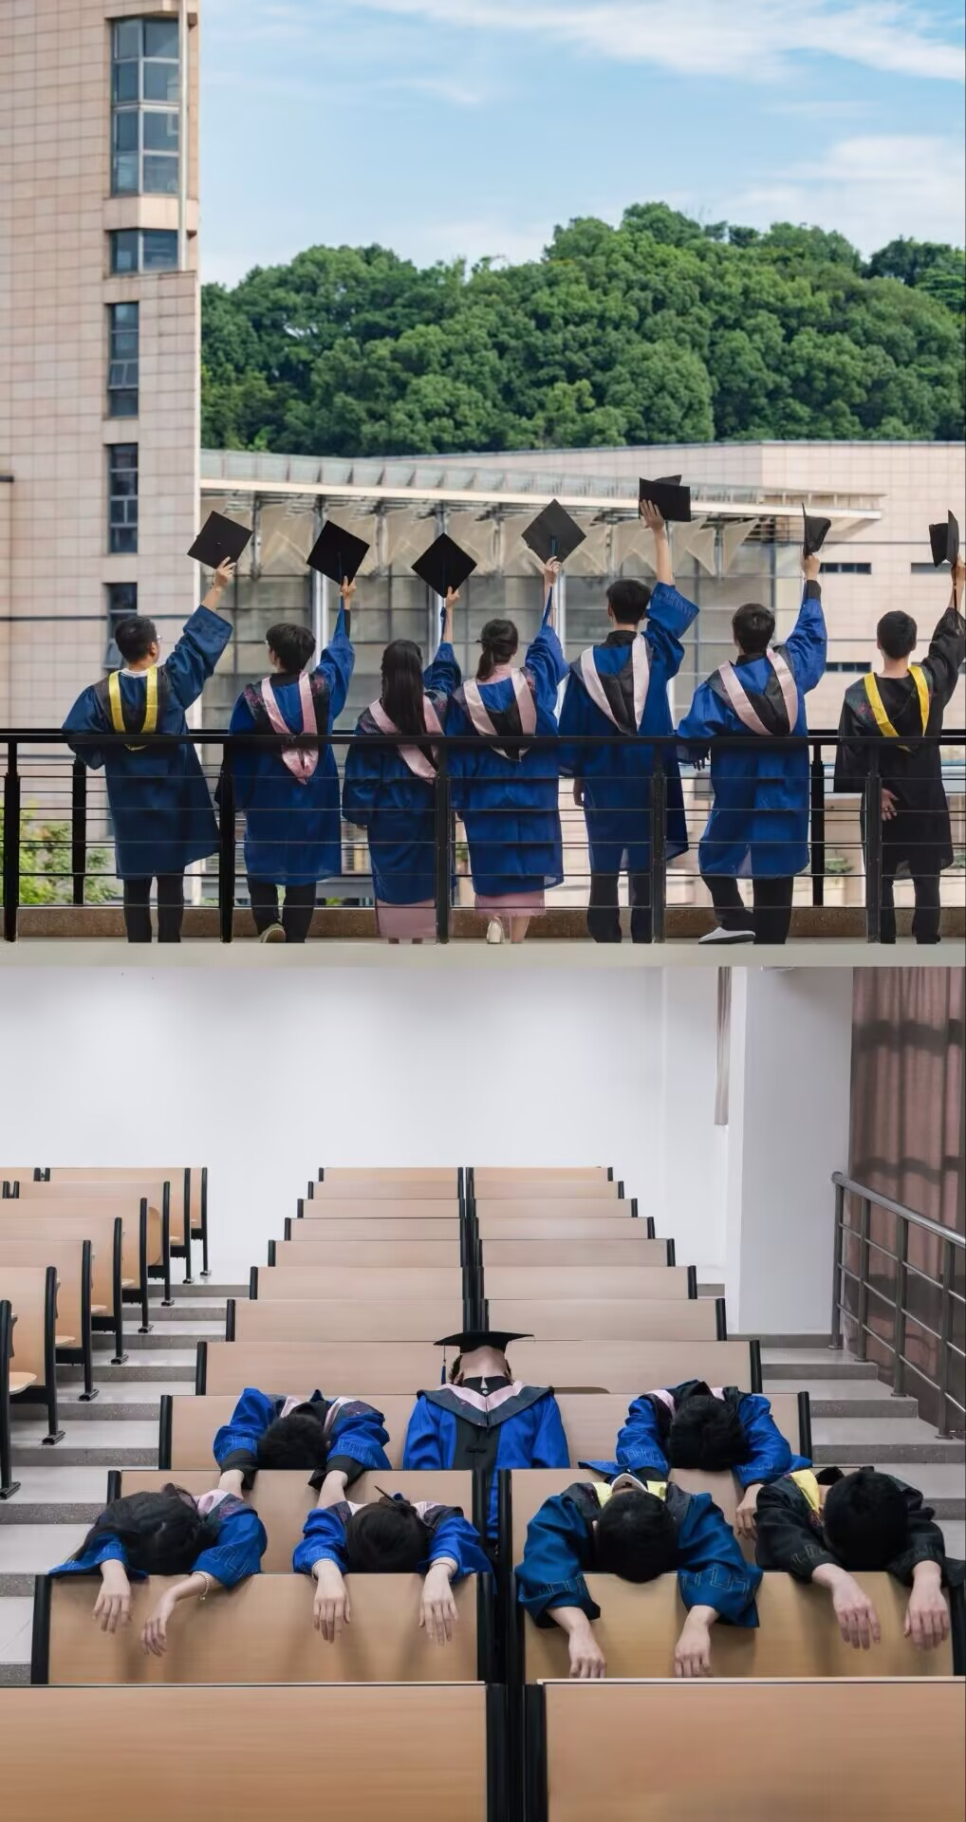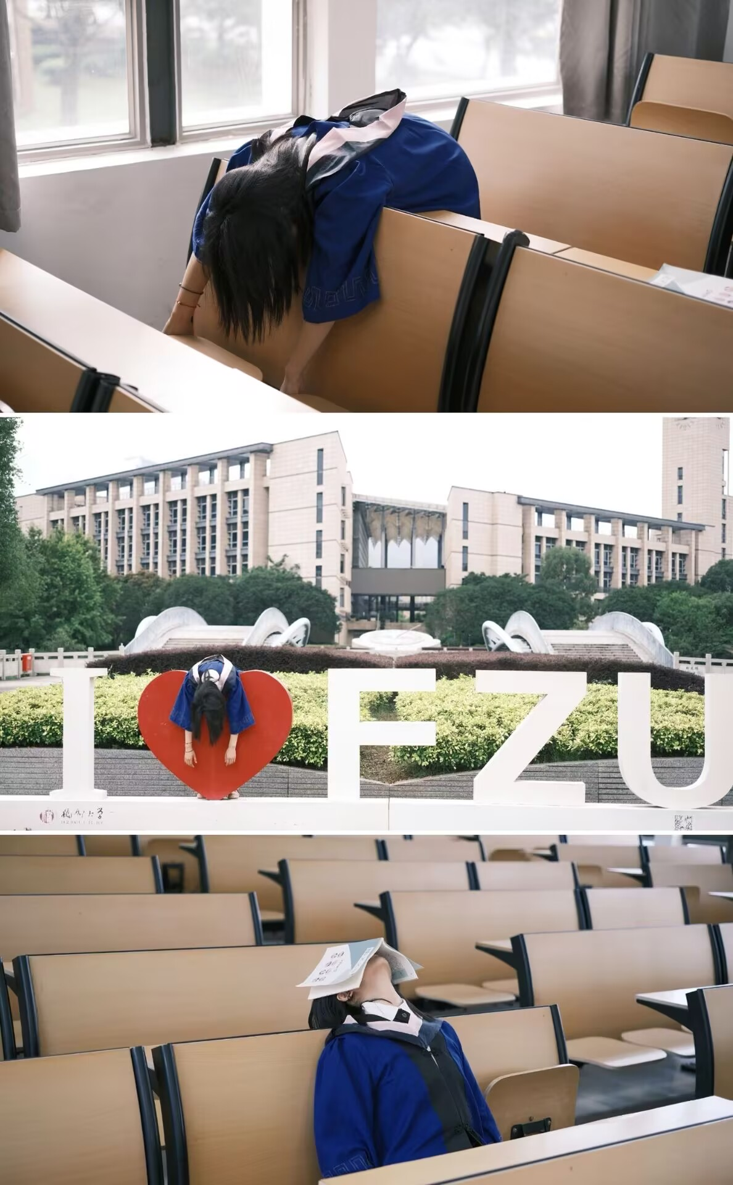

13.Post title：
Youth, in every ride to class
Post body：
We can never hold onto youth and the feeling of it at the same time. Every ordinary morning and afternoon spent rushing to class on these roads is already a memory in the making.
Post category：
Digital Memory
Upload images/videos
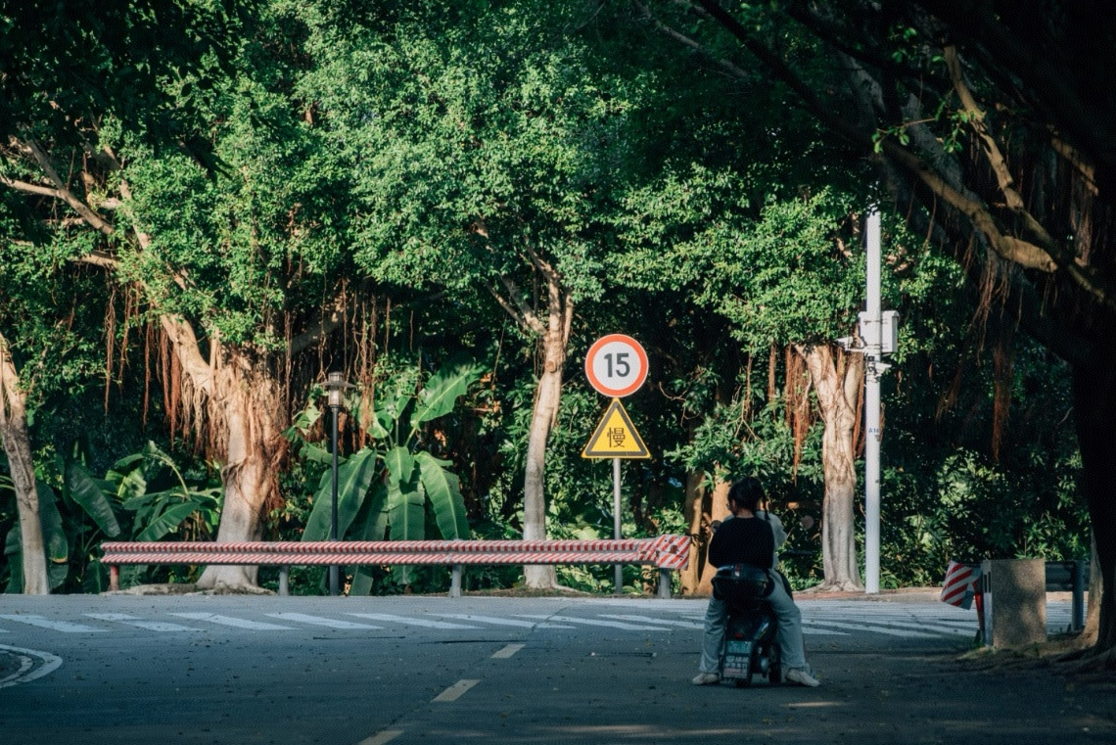
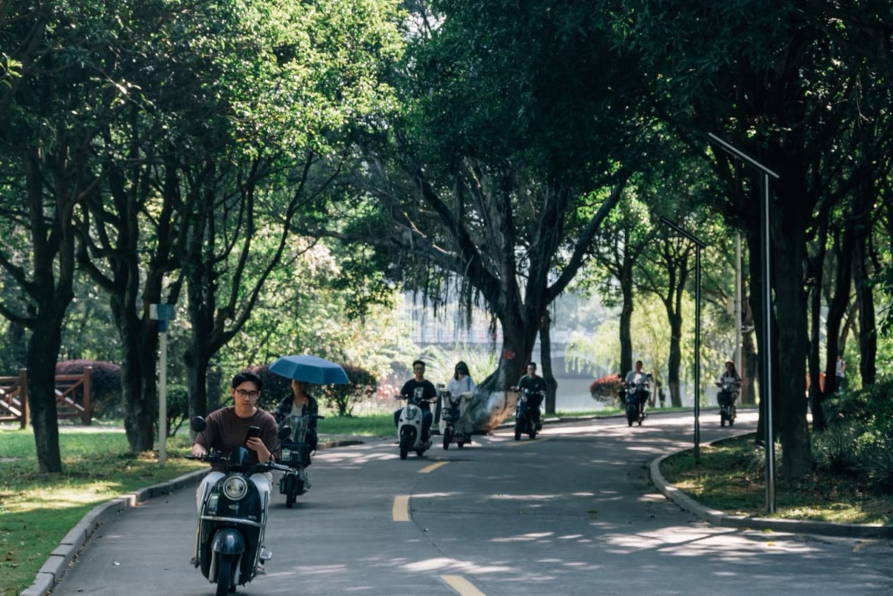
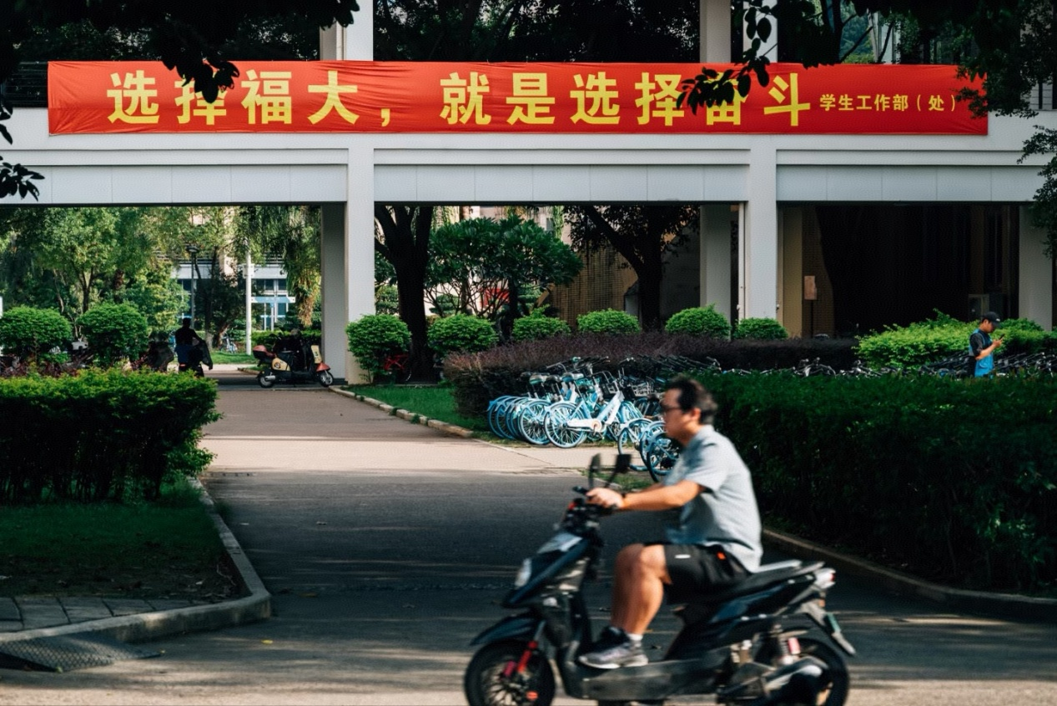
14.Post title：
Kapok flowers bloom all over the campus in October
Post body：
I have been captivated by the bright kapok blossoms along the roads these two weeks. On this sunny weekend, I made up for the regret of not picking up my camera to record the campus scenery in the early morning.
The tents that once blocked the school name at the entrance of Zone Three are finally gone. However, most flowers have withered and fallen along the lakeside path in the living area, and I missed a part of the beauty after all.
I realize that starting from this July, every seasonal scenery on campus will be my last encounter. Therefore, in this busy and hectic graduation year, I will spare no effort to keep all the most beautiful memories of this university.
Post category：
Digital Memory
Upload images/videos
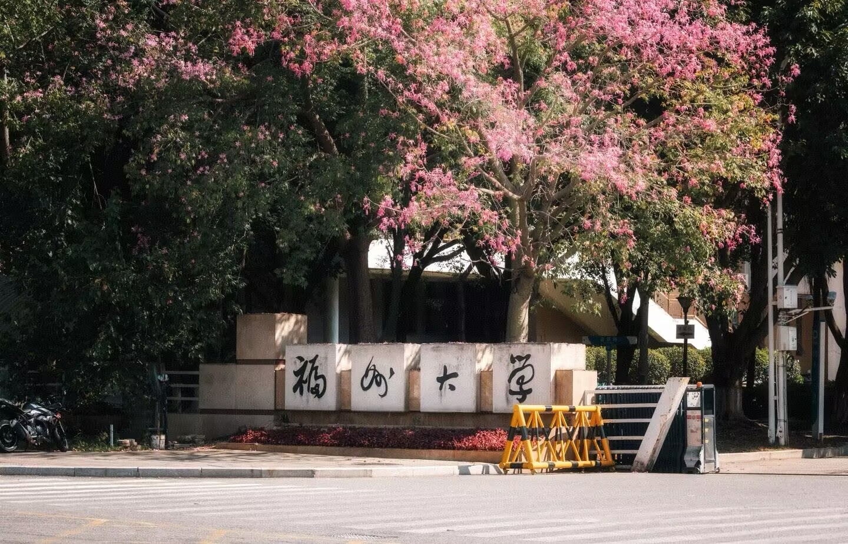

15.Post title：
FZU’s winter exclusive romance is here
Post body：
Fallen leaves, warm sun, friends, and the campus dyed golden by ginkgoes — this is the gentle magic only here has. Turns out you don’t need to travel far to catch the romance of an entire season.
Post category：
Digital Memory
Upload images/videos
