Title: The campus library
Tag: Study Space
Content:
Walking past the library today, the building looked surprisingly sharp against the blue sky. It is the quiet center of our campus. Seeing it on my way to the dining hall was a good reminder that I probably need to spend a few hours in there this weekend to prepare for next week's classes.
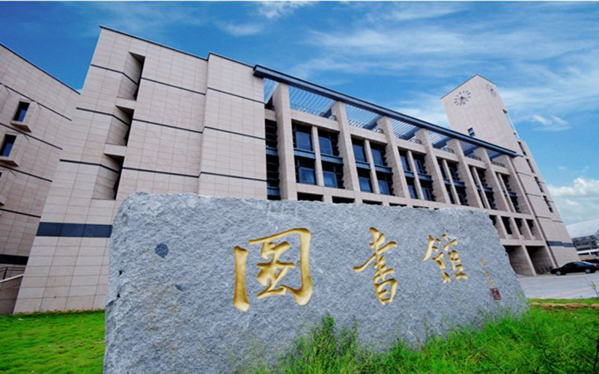

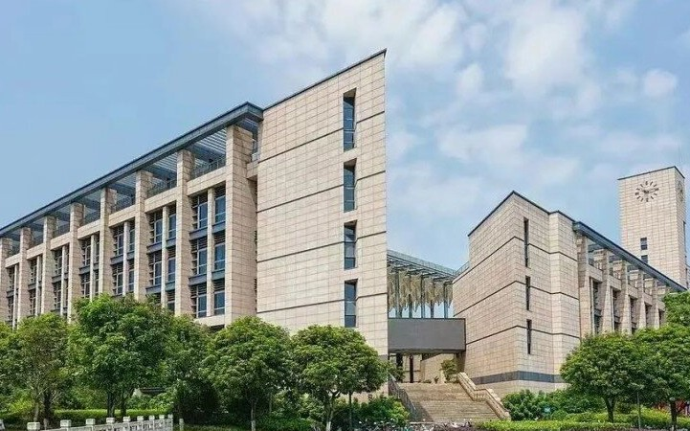

Title: Standing at the main gate
Tag: Campus Landmark
Content:
Standing in front of the main gate today, it finally hit me that I am actually a college student now. The campus looks massive from out here, especially with those mountains in the background. Seeing the university name carved into that giant stone makes the whole thing feel real. I guess this is where the next four years of my life begin. Now I just need to figure out how to carry all my luggage to the dorm.
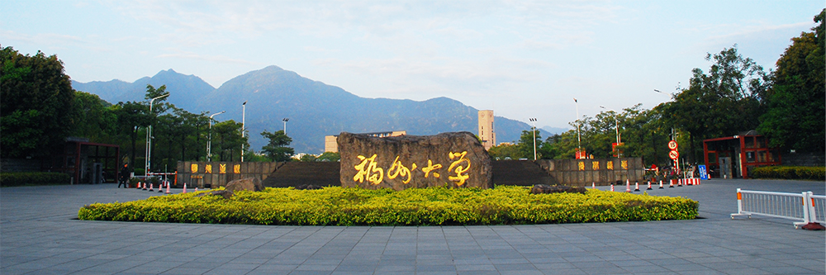

Title: The usual routine
Tag: Student Life
Content:
There is a specific kind of peace in the reading room on a regular day. Everyone is in their own zone, trying to get through their reading lists or finish assignments. Sitting next to these large windows with the trees outside makes it a good place to hide away for a few hours. It is nothing out of the ordinary, just a familiar routine when you have upcoming deadlines.
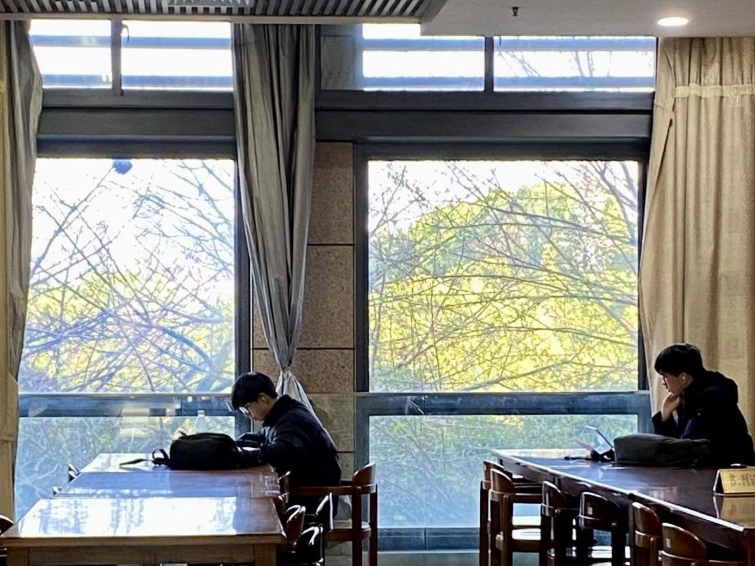
Title: Riding under the trees
Tag: Student Life
Content:
The trees along this main road have grown thick enough to create a long green canopy. Riding a scooter through here is just a regular part of the daily routine, but it is actually quite a pleasant route. It provides a lot of good shade, which makes the ride much better when the weather starts getting warm.
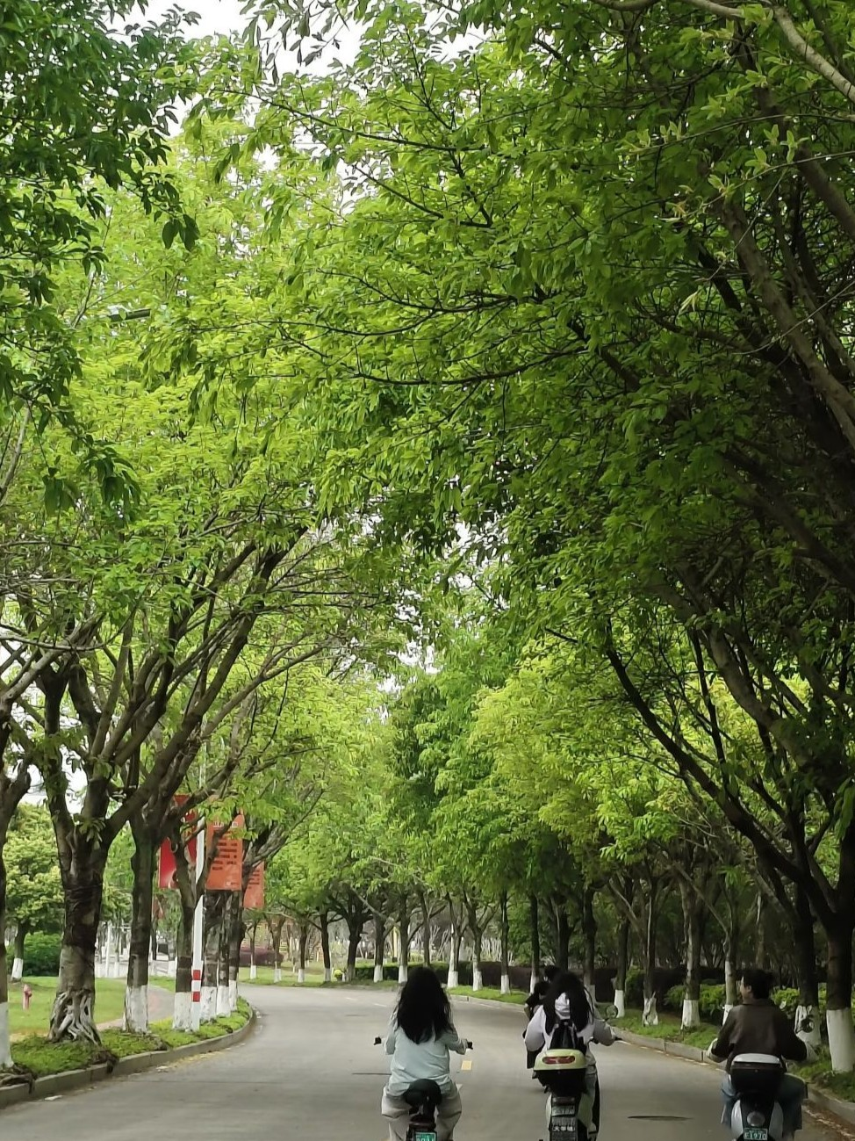

Title: Between sessions
Tag: Food and Cafe
Content:
They set up a pretty nice spread in the hall for the break today. It gets a bit chaotic when everyone pours out of the auditorium at the same time, but people are just happy to get some food and stretch their legs.
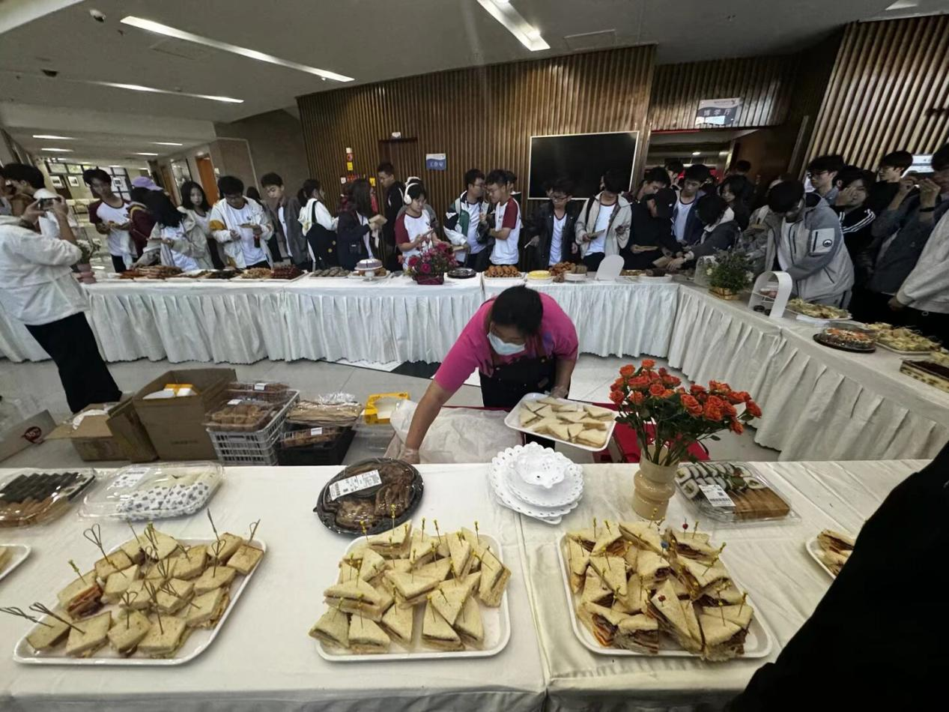

Title: Sports meet week
Tag: Sports and Leisure
Content:
The annual track and field meet is always a big event on campus. The stands are packed with people holding banners and cheering for their own departments. Even if you are not competing in any of the events, it is a good excuse to sit out on the grass with friends and take a break from the usual class schedule. It gets pretty loud near the bleachers with the drums, but overall it is just a relaxed day outside.
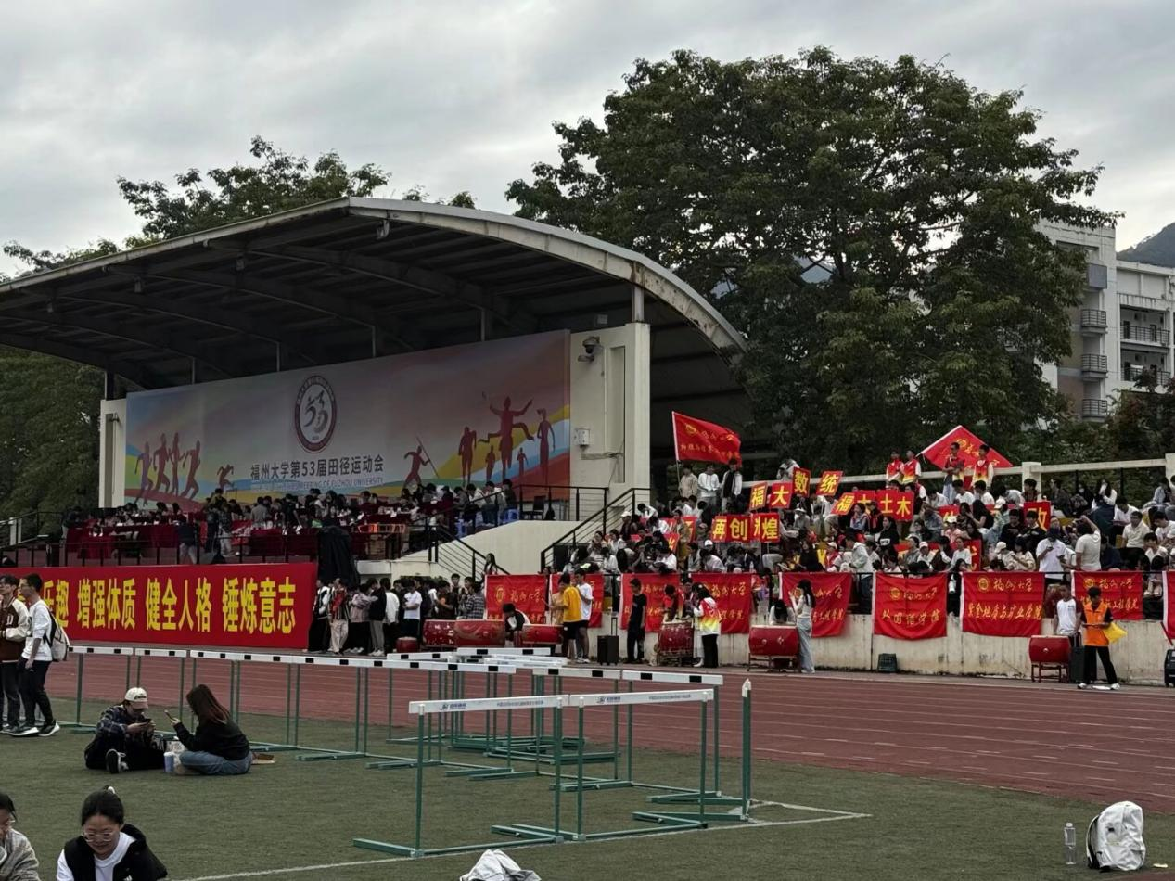

Title: Sunset After Class
Tag: Digital Memory

Content:
Caught this view just after dinner and had to stop for a minute. The sunset behind the mountains made the whole campus area feel unusually calm tonight. Even with the busy streets and lights below, everything somehow felt peaceful. Moments like this make ordinary school days a little more memorable.
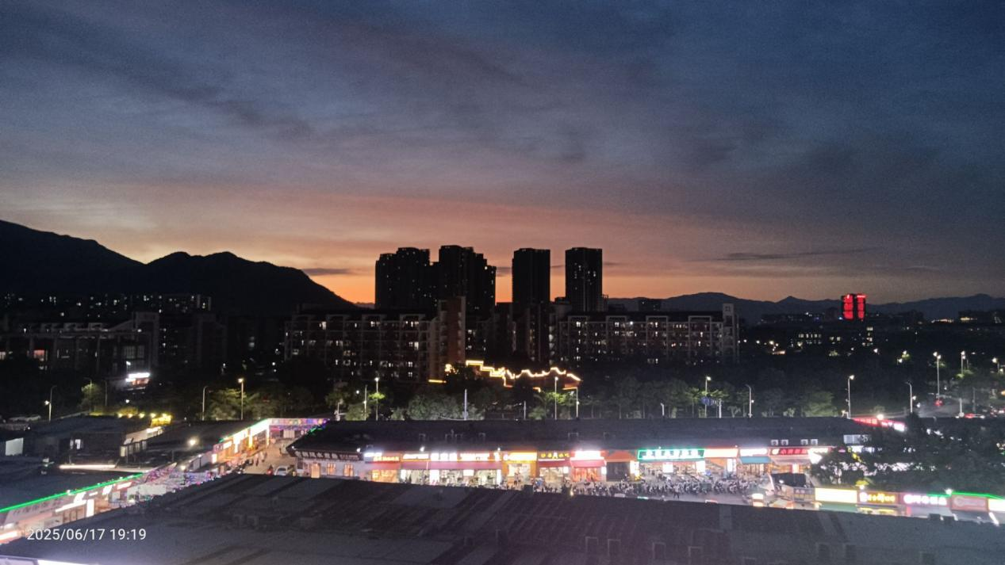

Title: A Night Full of Energy
Tag: Student Life

Content:
Tonight’s campus event was way more exciting than I expected. The music, lights, and performances made the whole place feel alive. Everyone was cheering and taking photos, and the atmosphere was honestly amazing. After weeks of classes and assignments, it felt really good to just sit back and enjoy the night with friends.


Title: Breaking the Ice
Tag: Student Life

Content:
Today’s ice-breaking activity turned out to be much more fun than expected. At first, everyone seemed a little quiet and awkward, but after a few games and conversations, the room became really lively. It was nice meeting new classmates and hearing different stories from everyone. Definitely one of those moments that makes campus life feel more connected.
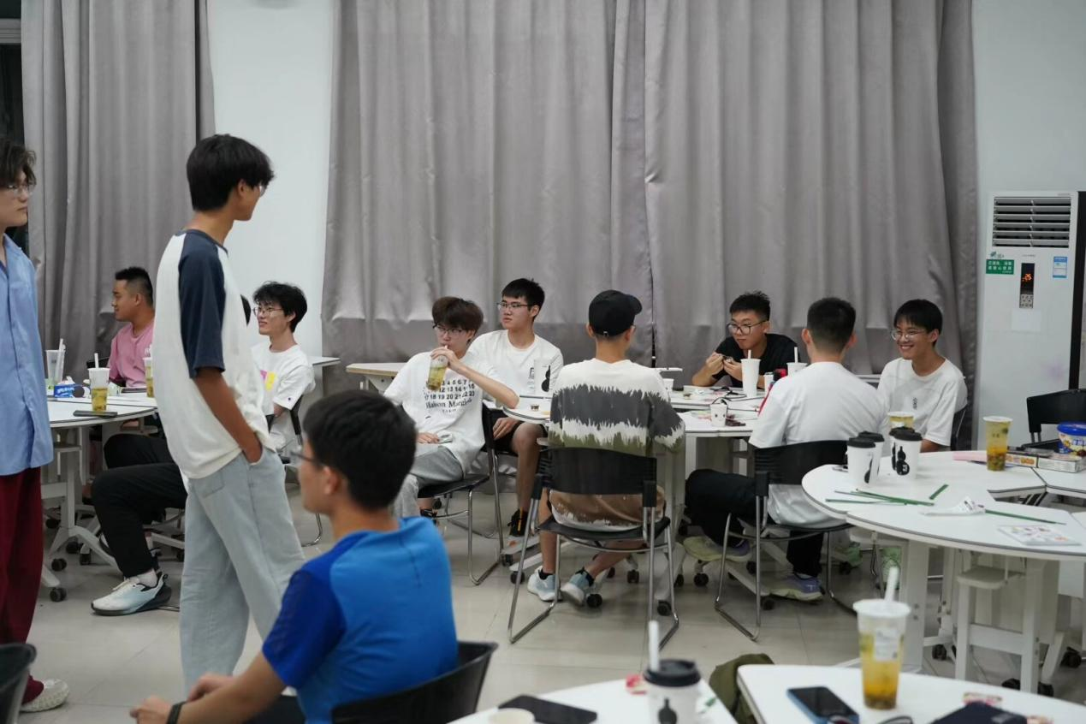

Title: An Interesting Talk on Diplomacy
Tag: Student Life

Content:
Attended a lecture today about basic diplomacy knowledge and China’s foreign relations. The speaker explained a lot of international topics in a very easy-to-understand way, which made the session surprisingly engaging. It was interesting to hear how diplomacy connects with global events and everyday life. Definitely a meaningful experience outside of regular classes.
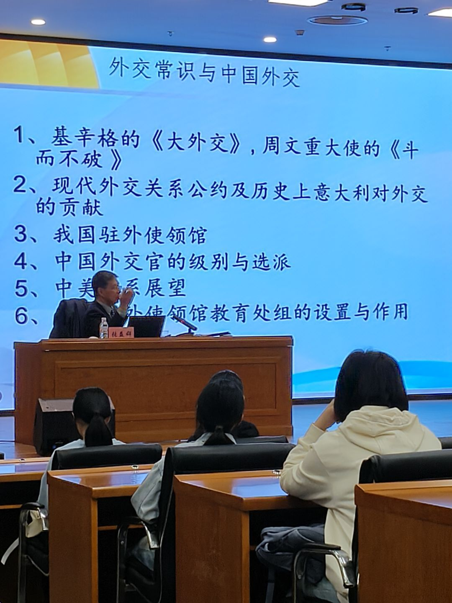
Title: Swans by the Green Water
Tag: Campus Landmark

Content:
Saw these swans near the campus pond today and couldn’t help stopping for a photo. The green water, quiet surroundings, and the contrast between the one black swan and the three white ones made the scene feel really peaceful. It’s nice to have little spots like this on campus where you can slow down for a moment between classes.



Title: Campus Covered in Cherry Blossoms
Tag: Campus Landmark

Content:
The cherry blossoms around campus are finally in full bloom. Walking through the paths today honestly felt like being in a movie scene. Everywhere looked soft and bright, and a lot of students stopped to take photos or just enjoy the view. Spring on campus might be one of the best times of the year.
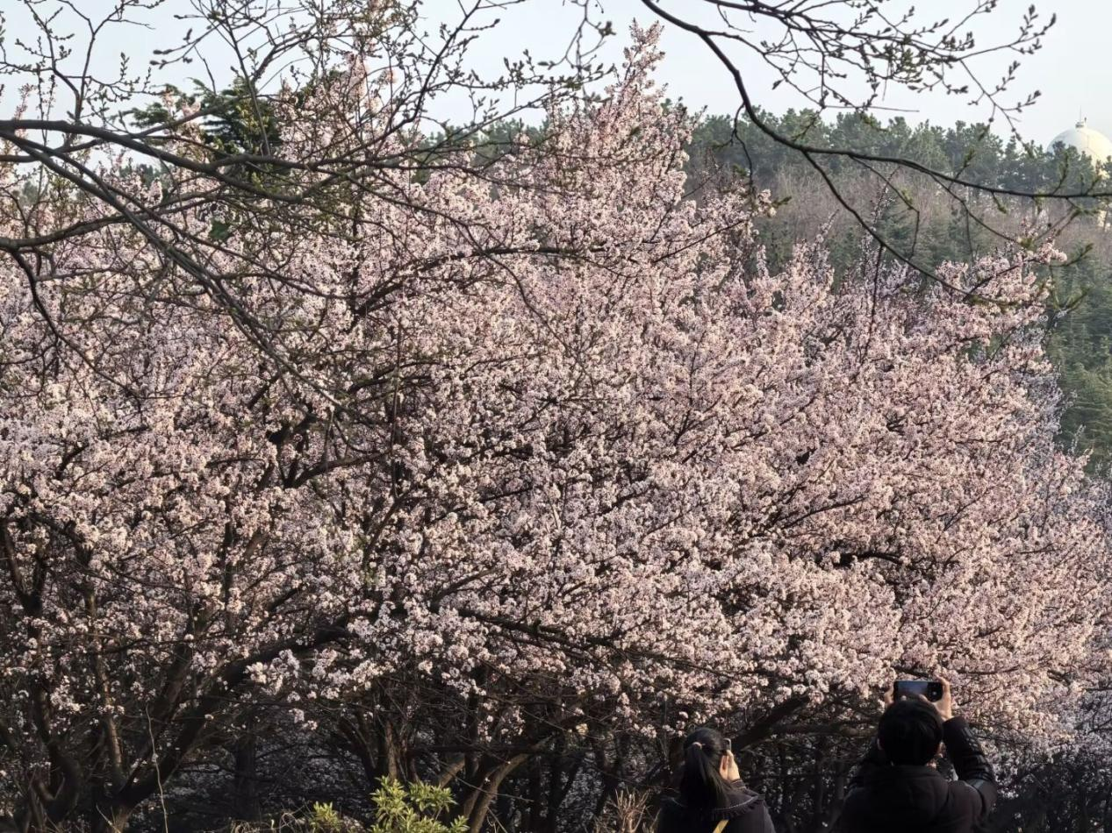

Title: Autumn View on Campus
Tag: Campus Landmark

Content:
The campus looked especially beautiful this afternoon with golden leaves covering the trees and the Jinjiang Building standing quietly in the distance. The cool autumn weather and warm sunlight made the whole scene feel calm and relaxing. Sometimes a simple walk across campus is enough to make a busy day feel much better.
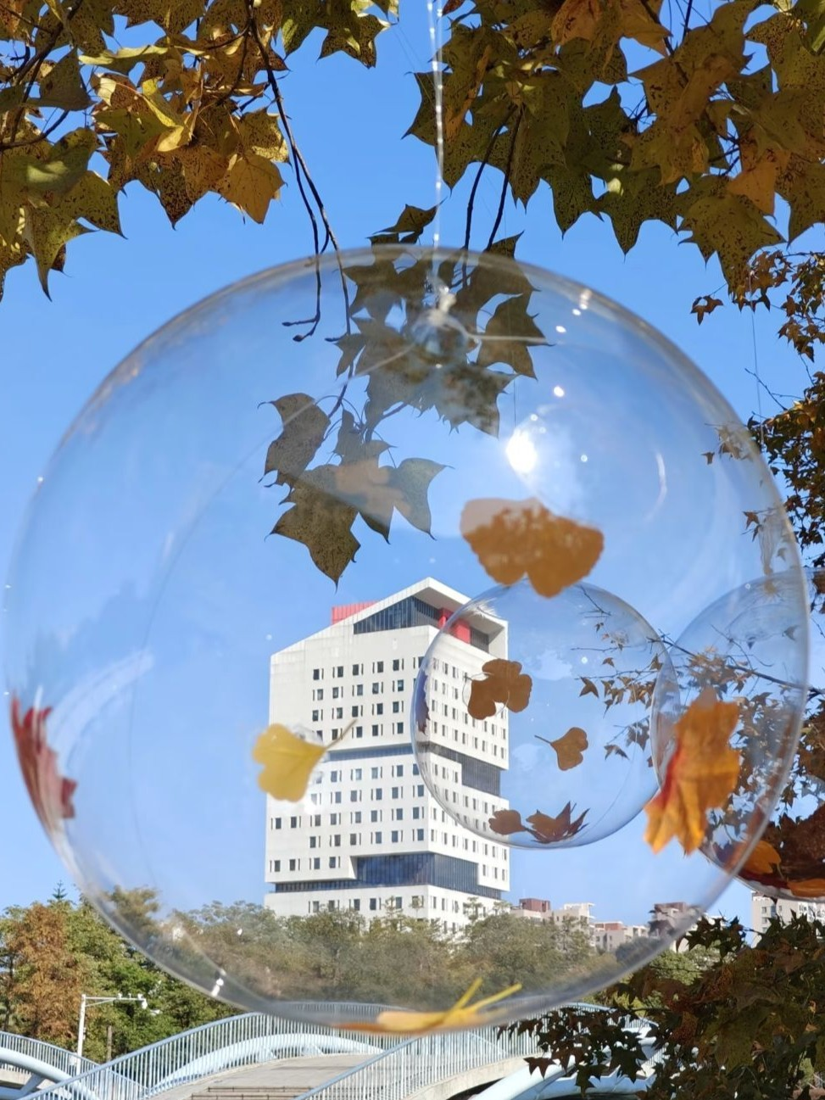
Title: Quiet Afternoon at Fuyou Pavilion
Tag: Campus Landmark

Content:
Stopped by Fuyou Pavilion today and the lotus pond nearby looked incredibly peaceful. The reflection on the water and the gentle breeze made the whole place feel calm and relaxing. It’s one of those hidden campus spots that always helps take your mind off assignments and deadlines for a while.
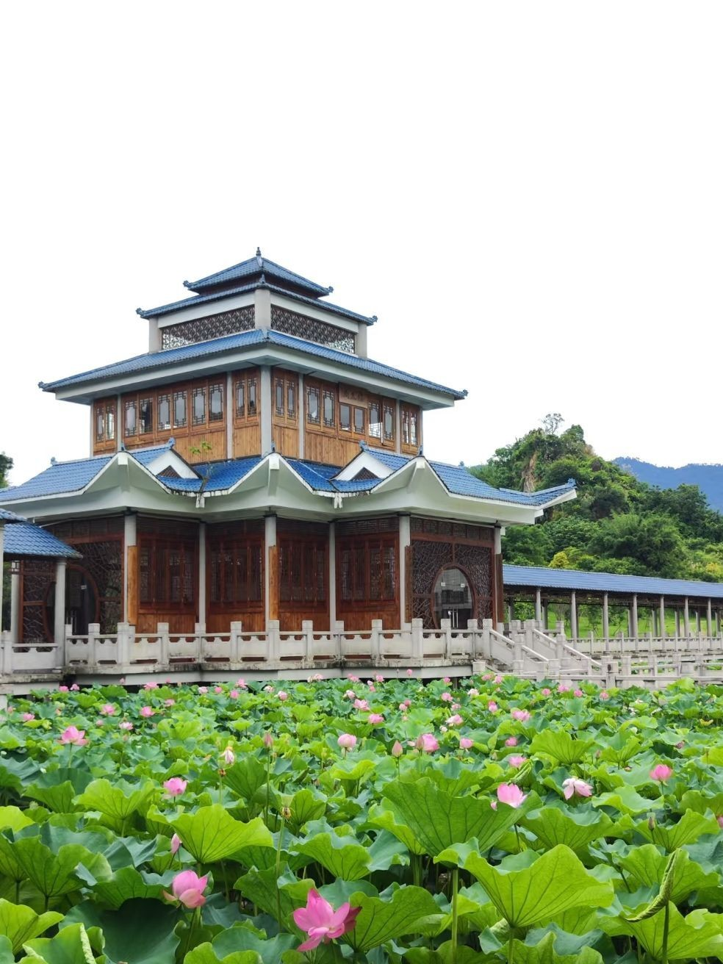
Title: A Relaxing Walk Around Campus
Tag: Sports and Leisure

Content:
Went for a walk around campus this evening and the weather was perfect. The green trees, open lawns, and small park area made everything feel fresh and comfortable. After spending most of the day indoors, it was nice to slow down, get some fresh air, and enjoy a quiet moment outside.
