# NX视频驱动开发说明文档

1、所有视频驱动程序全部继承CE.NX.VD.dll程序集

2、主要功能包括如下，具体参考海康HikvisionDS6101HF及HikvisionDS7604NE1驱动程序

一个视频驱动包括 一个VideoDevice（硬件盒子DVS或NVS等的硬件抽象）和一个VideoCamera（摄像机抽象）

VideoDevice实现的主要功能为下面功能列表，对应到驱动中一个功能可能对应多个方法

## 设备的注册和注销

public override bool RegisterDevice()

public override bool DeviceLogout()

## 实时预览操作

//本地handle启动

public override bool MonitorStart ( Guid cameraid, VideoCamera videoCamera, IntPtr windowHandle )

public override bool MonitorEnd ( Guid cameraid, VideoCamera videoCamera, IntPtr windowHandle )

public override bool MonitorEndAll ( )

//启动码流

public override bool StartGetStream(int channel)

//启动文件流模式

public override bool OpenPlayerOnFileStreamMode(IntPtr windowHandle, byte[] byteHeader)

//关闭文件流模式

public override bool ClosePlayerOnFileStreamMode(IntPtr windowHandle)

//码流播放

public override bool PlayerPlay ( byte[] bytedata, IntPtr handle, Guid cameraid )

//启动码流模式

public override int OpenPlayerOnStreamMode(IntPtr windowHandle,byte[] byteHeader,Guid cameraid)

## 云台操作

public override void MoveLeft ( VideoCamera videoCamera, int step)

public override void MoveUp ( VideoCamera videoCamera, int step)

public override void MoveDown ( VideoCamera videoCamera, int step )

public override void MoveRight ( VideoCamera videoCamera, int step )

public override void MoveLeftUp ( VideoCamera videoCamera, int step )

public override void MoveLeftDown ( VideoCamera videoCamera, int step )

public override void MoveRightUp(VideoCamera videoCamera, int step)

public override void MoveRightDown ( VideoCamera videoCamera, int step )

## 视频参数设置

public override bool SetZoomIn(VideoCamera videoCamera)

public override bool SetZoomOut(VideoCamera videoCamera)

public override bool SetFocusNear(VideoCamera videoCamera)

public override bool SetFocusFar(VideoCamera videoCamera)

public override bool SetIrisOpen(VideoCamera videoCamera)

public override bool SetIrisClose(VideoCamera videoCamera)

//Handle模式下获取和设置某通道视频信息

public override bool GetVideoEffect ( Guid cameraid, VideoCamera videocamera, out double BrightPercent, out double ContrastPercent, out double SaturationPercent, out double HuePercent )

public override bool SetVideoEffect ( Guid cameraid, VideoCamera videocamera, double BrightPercent, double ContrastPercent, double SaturationPercent, double HuePercent )

//码流模式下获取和设置某通道视频信息

public override bool PlayerGetVideoEffect ( Guid cameraid, VideoCamera videocamera, out double BrightPercent, out double ContrastPercent, out double SaturationPercent, out double HuePercent )

public override bool PlayerSetVideoEffect ( Guid cameraid, VideoCamera videocamera, double BrightPercent, double ContrastPercent, double SaturationPercent, double HuePercent )

## 声音控制

public override bool OpenSound(IntPtr windowHandle)

public override bool CloseSound(IntPtr windowHandle)

public override bool AdjustVolume(IntPtr windowHandle, double volumeValue)

## 设备截图到内存中

public override bool CaptureJPEGPicture(VideoCamera videoCamera, string savePath)

## 设备录像操作

//是否支持录像功能

public override bool IsDeviceSupportRecord

//是否支持录像功能

public override bool IsDeviceSupportRecordFunction

//是否支持码流回放

public override bool IsDeviceRecordSupportStreamReplay

//启动录像

public override bool StartRecord(VideoCamera videoCamera)

//停止录像

public override bool StopRecord(VideoCamera videoCamera)

//下载录像文件

public override void DownLoadVideoFileByName ( string filename, string savepath )

//handle回放视频文件

public override bool VideoPlayBack ( IntPtr windowhandle, string filename )

//停止回放handle视频文件

public override void StopVideoPlayBack ( string filename )

//回放码流模式文件

public override bool VideoPlayBackStreamMode ( IntPtr windowhandle, string filename )

//停止回放码流文件模式

public override bool StopVideoPlayBackStreamMode ( string filename )

//暂停

public override bool PauseVideoReplay ( string filename )

//继续

public override bool ContinueVideoReplay ( string filename )

//打开回放声音

public override bool VideoReplayOpenSound ( string filename )

//停止

public override bool VideoReplayCloseSound ( string filename )

//播放总时间

public override void GetVideoTotalTime ( string filename, out int TotalTime )

//播放当前时间

public override void GetVideoCurrentTime ( string filename, out int CurrentTime )

//通过百分比控制播放

public override bool PlayByPosition ( string filename, double playPercent )

//回放中截图

public override bool VideoReplayCaptureImage ( string videofilename, string picfilename )

//快播

public override bool RightQuickPlay ( string filename )

//慢播

public override bool LeftQuickPlay ( string filename )

//正常速度播放

public override bool ReturnNormalPlay ( string filename )

//指定文件名开始录像

public override bool StartRecordData ( IntPtr windowHandle, string fileName )

//结束指定文件名录像

public override bool StopRecordData ( string fileName )

## 本地播放库功能

功能和设备录像相似，不再赘述

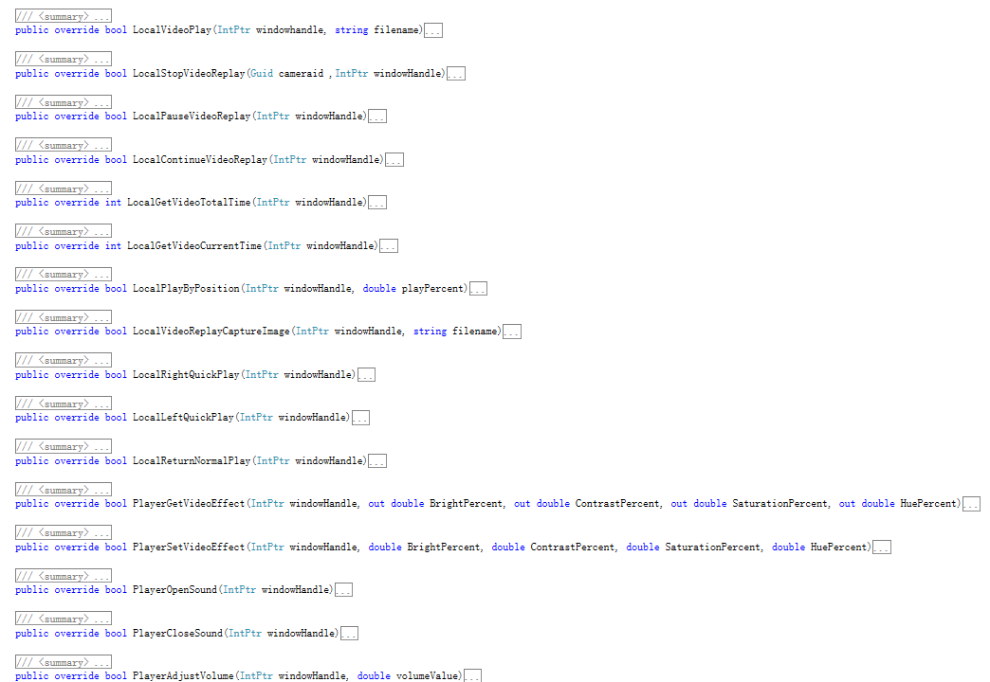

## 本地录像

//是否支持本地录像

public override bool IsDeviceSupportLocalRecordFuction

//保存数据到指定文件

public override bool SaveRealData(IntPtr windowHandle, string fileName)

public override bool StopSaveRealData(IntPtr windowHandle)

## 预置点操作

//添加

public override bool AddPreset(VideoCamera videoCamera, int preset)

//删除

public override bool ClearPreset(VideoCamera videoCamera, int preset)

//调用预置点

public override bool GotoPreset(VideoCamera videoCamera, int preset)

## 巡航路径

//调用巡航路径

public override bool RunCruise(VideoCamera videoCamera, int cruiseRoute)

//停止

public override bool StopCruise(VideoCamera videoCamera, int cruiseRoute)

//添加巡航点

public override bool AddCruisePoint(VideoCamera videoCamera, int cruiseRoute, int cruistPoint, int preset, int stopTime, int curiseSpeed)

//清理巡航点

public override bool ClearCruisePoint(VideoCamera videoCamera, int cruiseRoute, int cruistPoint, int preset)

## 报警信号注册与读取

protected override void RegisterSignalType()

//布防

public override bool StartGetSignal()

//撤防

public override bool StopGetSignal()

//读取信号

public override bool ReadAlarmSignalValue()

## 语音功能（对讲，广播，语音转发）

public override bool StartBroadCast()

public override bool StopBroadCast()

public override bool StartTalkBack()

public override bool StopTalkBack()

public override bool StartGetDeviceVoice()

public override bool SendVoiceToDevice()

## 其他功能

获取通道个数（开发环境下驱动的通道个数的依据）

获取摄像机（获取对应的VideoCamera）

序列化数据和克隆

VideoCamera实现的主要功能

1）水平和垂直速度等级

2）序列化数据