UFC Action Spotting Design Document

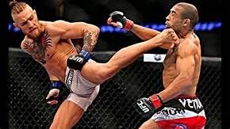

Project:
Action Spotting within UFC videos

Prepared by:
Jiva Kalan

Folder Structure

Data
- SoccerNet V1.1 Commentaries
  - 6 leagues+Champions league
- SoccerNet V1.1 Labels
  - 6 leagues+Champions league
- SoccerNet V1.1 Videos
  - 6 leagues+Champions league
- listgame_Test_100.npy
- listgame_Train_300.npy
- listgame_Valid_100.npy
- SoccerNet V1.1 Commentaries (xlsx)
- SoccerNet V1.1 Labels (xlsx)
- SoccerNet V1.1 Videos (xlsx)
- SoccerNet V1.1 Features
Model
-Src

DATA FOLDER

listgame_test_100.npy: array of the testing set – size (100,0) – names of all the games with scores
listgame_train_300.npy – array of the training set, size (300,0)
listgame_Valid_100.npy - array of ....100

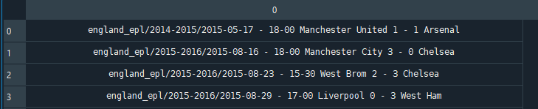

SoccerNet_V1.1_Commentaries: indexes the full commentaries with timestamps for the games which are available in the SoccerNet_V1.1_Commentaries FOLDER within DATA
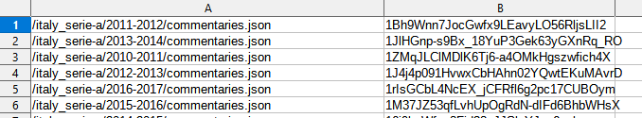

SoccerNet_V1.1_Features
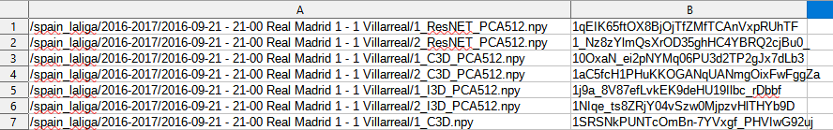
SoccerNet_V1.1_Videos
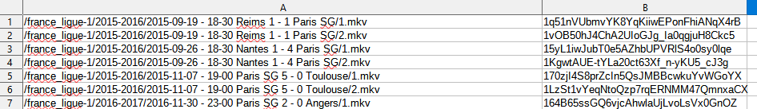
SoccerNet_V1.1_Labels (
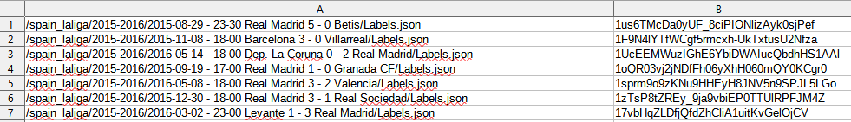

Questions:

