📢 **Python based menu program to manage docker services like (launching container, starting them and removing them etc.)**

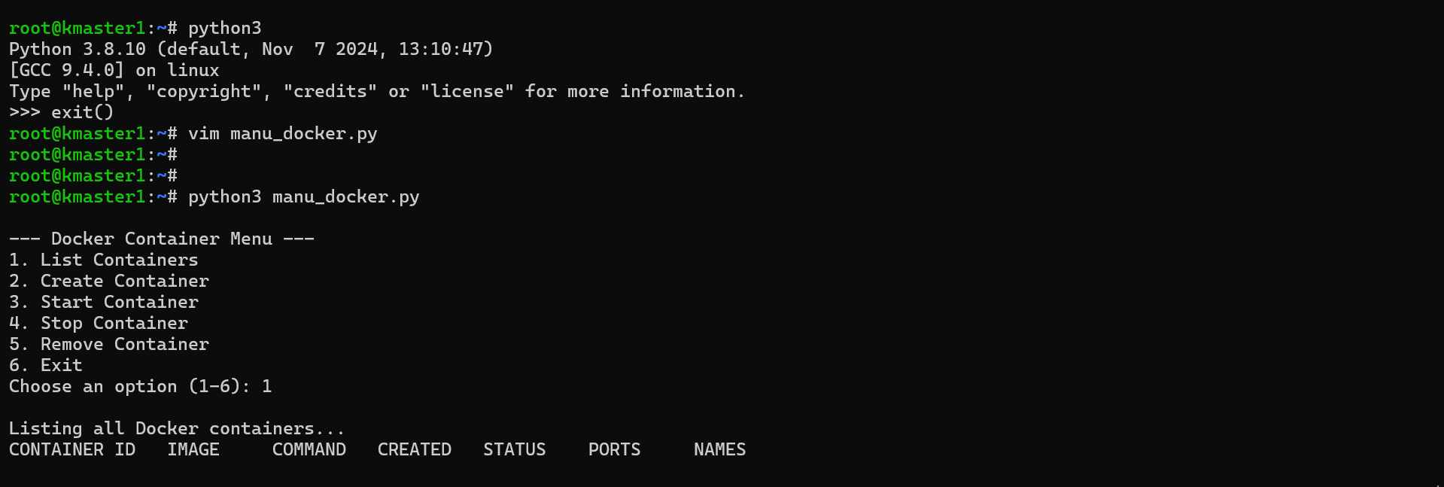

📢 **Python based menu program to manage AWS services like (launching instances, starting them and removing them etc. moreover launching s3 bucket, removing them etc)**  
  
  
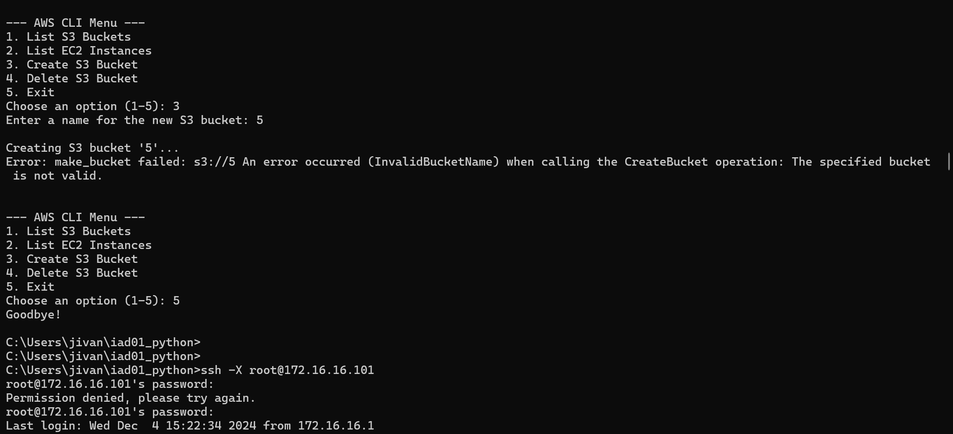

📢 **Python based menu program to monitor Linux server.**



