Digital Printing Business Website Documentation

1. Project Overview
This document provides full documentation for the Digital Printing Business Website. The website was developed to showcase printing services, allow customers to browse products, view pricing, and submit quotation requests online.

2. Objectives
- Present available digital printing services clearly
- Provide pricing transparency
- Allow customers to submit quotation requests
- Strengthen online presence for the family business
- Improve customer accessibility and communication

3. Technologies Used
- HTML
- CSS
- Bootstrap
- JavaScript
- jQuery
- SQL
- .NET Framework / C#

4. Website Structure
The website is composed of the following main sections:
• Home
• Services
• Product Listings
• Get Quotation Form
• About Us

5. Home Page
The Home page introduces the business, highlights its experience, and presents a hero image showing the digital printing machine in operation.
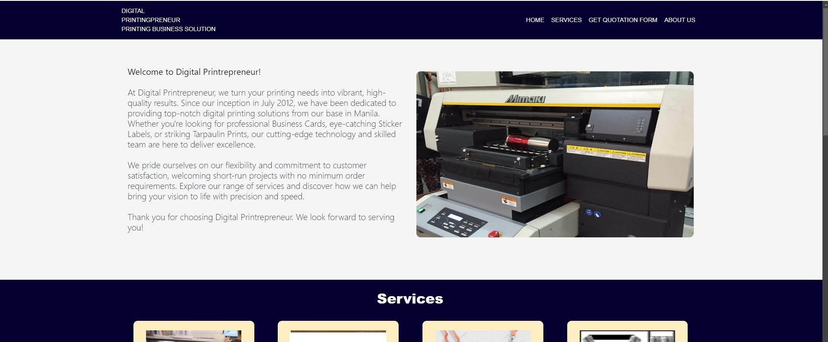

6. Services Section
The Services section displays all available printing services in a card-based layout. Each card includes a product image, service name, and price range.
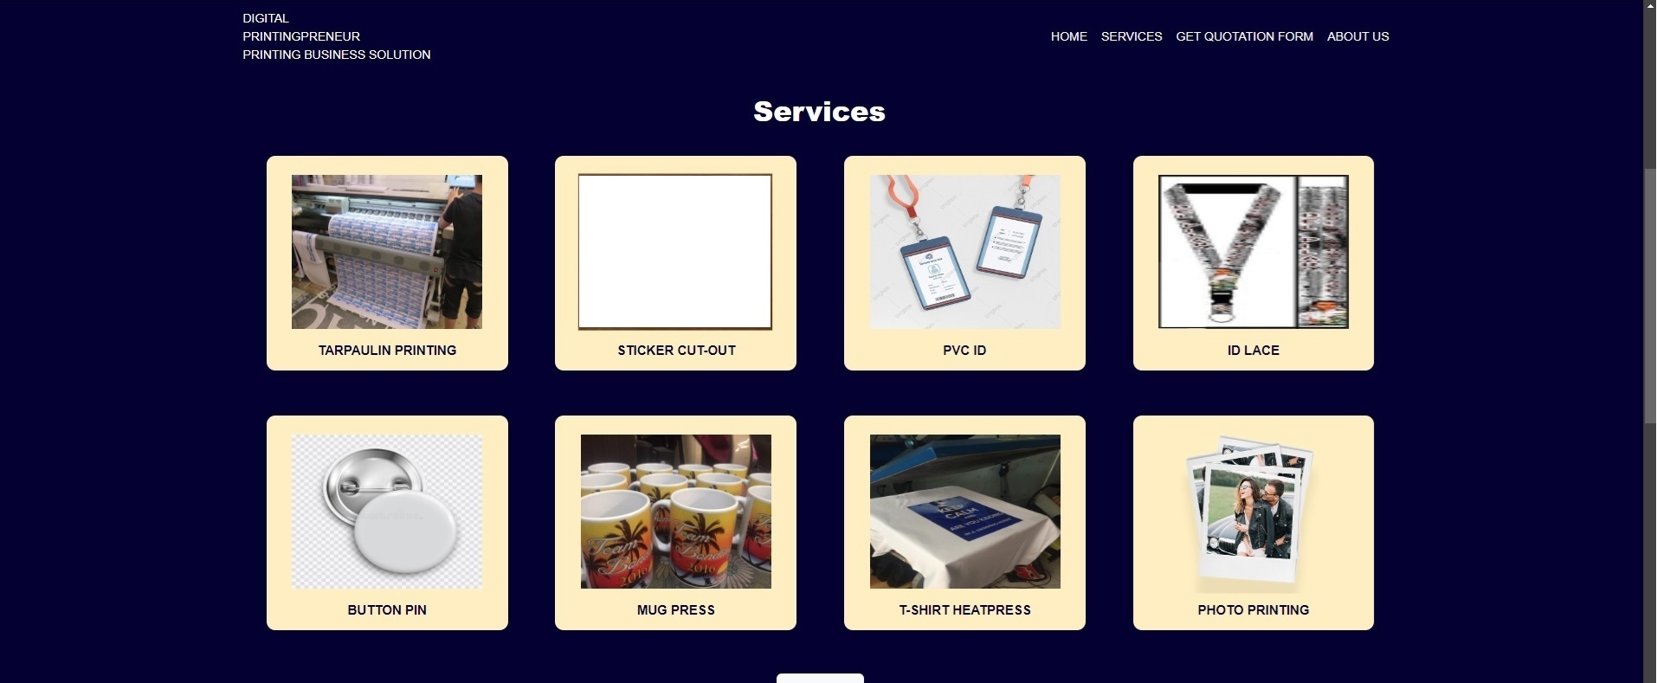
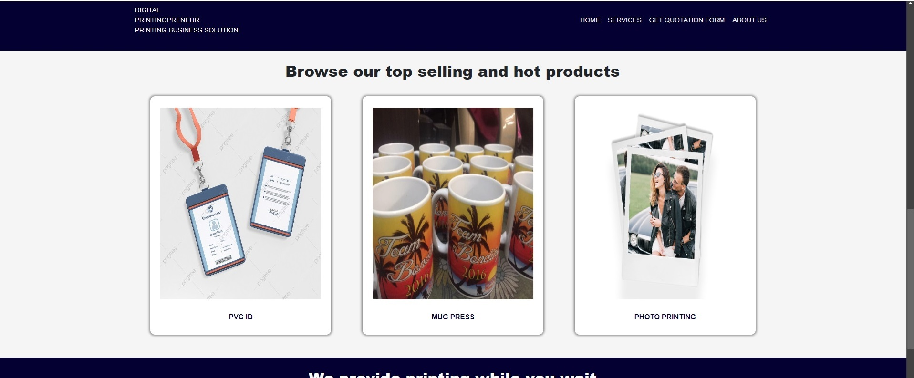
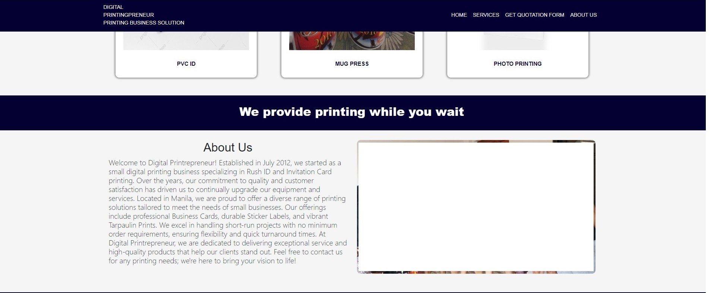
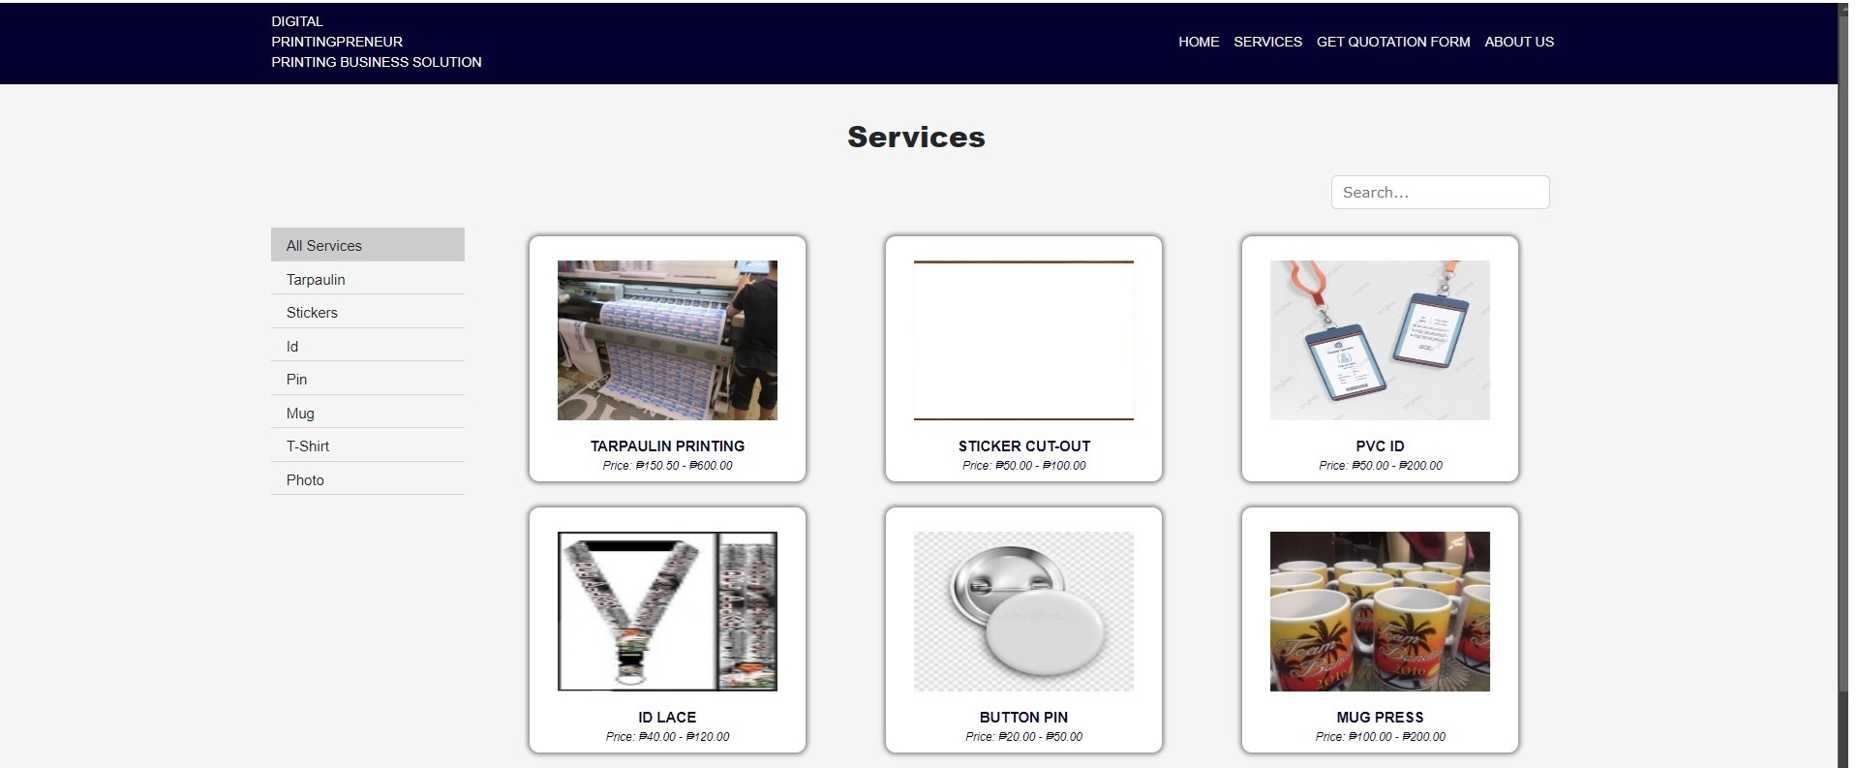

7. Product Categories
Available product categories include:
- Tarpaulin Printing
- Sticker Cut-Out
- PVC ID
- ID Lace
- Button Pin
- Mug Press
- T-Shirt Heatpress
- Photo Printing

8. Search and Filtering
Users can filter services using category navigation and search functionality to quickly locate specific products.

9. Get Quotation Form
The quotation form allows customers to submit inquiries directly from the website. Required fields ensure sufficient information is collected.

Form Fields:
- Name (required)
- Email (required)
- Subject (optional)
- Message (required)
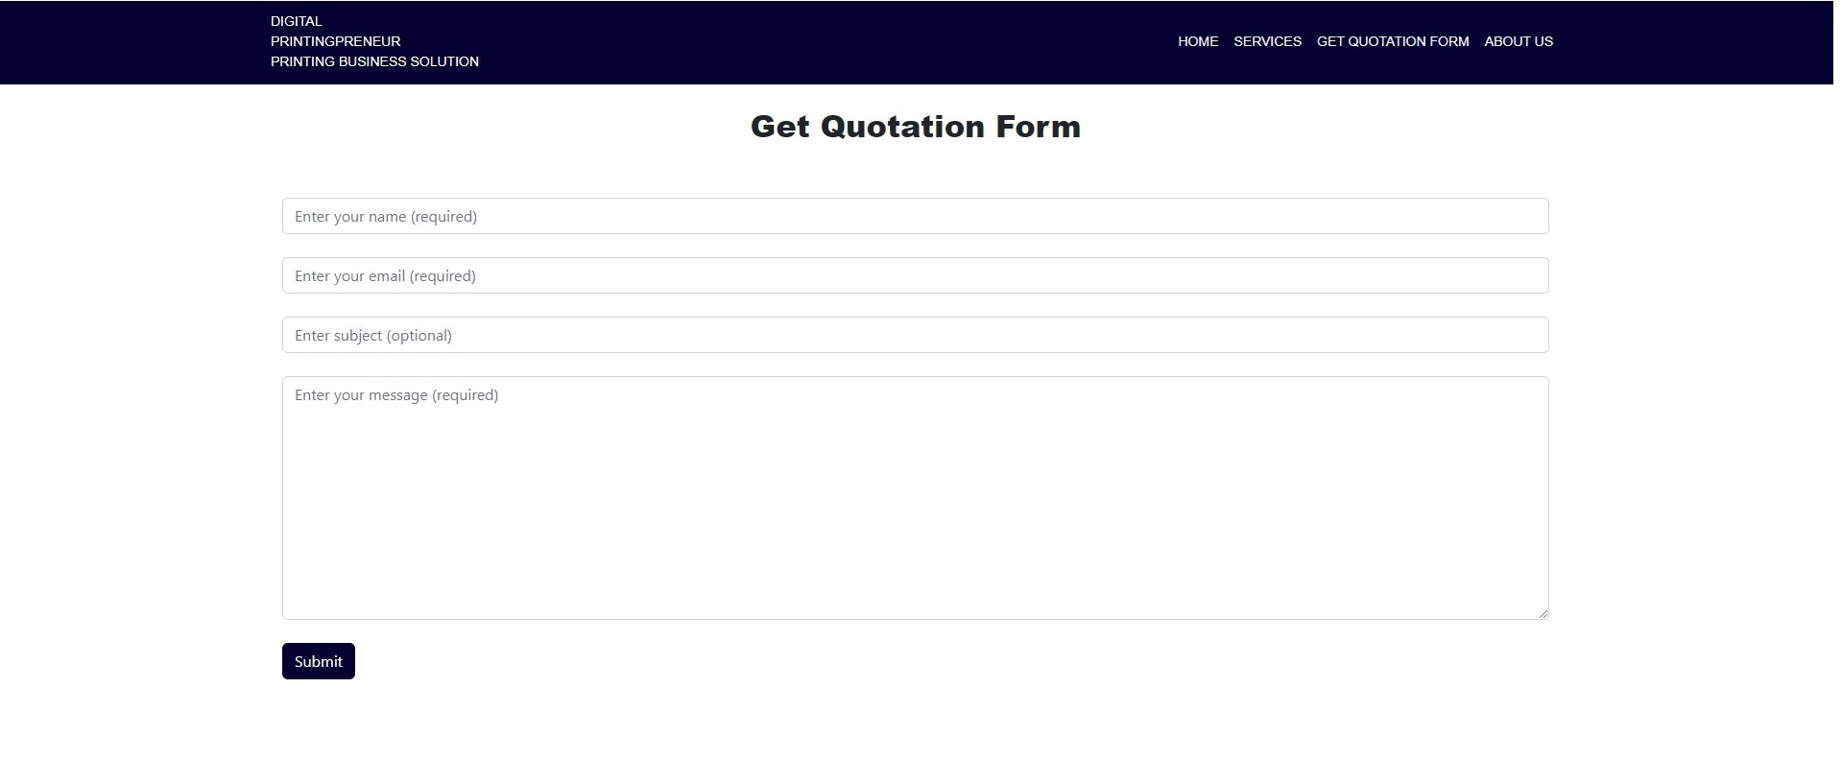

10. About Us
The About Us section provides company background, history, and values. It highlights the business establishment in July 2012 and its commitment to quality and customer satisfaction.

11. Database & Backend
The backend system manages service listings, pricing, and quotation submissions. Quotation requests are stored in a database for follow-up and customer communication. (To be implemented)

12. Future Enhancements
- Online ordering and payment integration
- Admin dashboard for managing services
- Image gallery for completed projects
- SEO optimization
- Mobile application support

14. Conclusion
This website serves as a complete digital solution for the printing business. It enhances customer engagement, simplifies quotation requests, and provides a professional online presence.

