**PRACTICAL NO : 1**

**AIM** : **Introduction to Android, Introduction to Android Studio IDE, Application Fundamentals:**

Creating a project, Android Components, Activities, Services, Content providers, Broadcast Receivers, Interface overview, Creating Android Virtual Device, USB debugging mode, Android Application Overview. Simple “ Hello World” program.

**INPUT :**

**package** com.example.helloworld;  
  
**import** androidx.appcompat.app.AppCompatActivity;  
  
**import** android.os.Bundle;  
**import** android.view.View;  
**import** android.widget.Button;  
**import** android.widget.EditText;  
**import** android.widget.TextView;  
  
**public class** MainActivity **extends** AppCompatActivity {  
 **private** EditText **editText1**;  
 **private** Button **button1**;  
 **private** TextView **textView1**;  
  
 @Override  
 **protected void** onCreate(Bundle savedInstanceState) {  
 **super**.onCreate(savedInstanceState);  
 setContentView(R.layout.***activity_main***);  
 **editText1** = (EditText) findViewById(R.id.***editText1***);  
 **button1** = (Button) findViewById(R.id.***button1***);  
 **textView1** = (TextView) findViewById(R.id.***textView1***);  
  
 **button1**.setOnClickListener(**new** View.OnClickListener() {  
 @Override  
 **public void** onClick(View v) {  
 String s = **editText1**.getText().toString();  
 **textView1**.setText(**"Hello"** + s);  
 }  
 });  
  
 }  
}

**OUTPUT :**

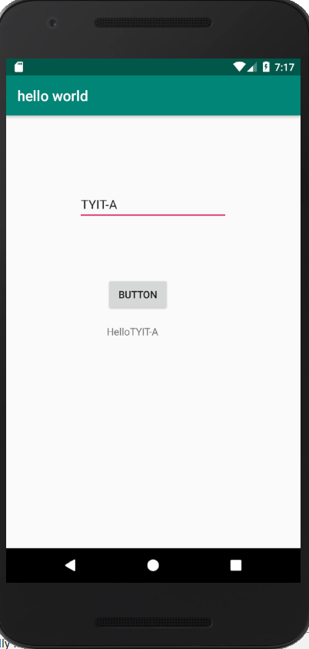

**PRACTICAL NO : 2**

**AIM** **: Design the Calculator.**

**INPUT :**

**package** com.example.calculator;  
  
**import** androidx.appcompat.app.AppCompatActivity;  
  
**import** android.os.Bundle;  
**import** android.view.View;  
**import** android.widget.Button;  
**import** android.widget.EditText;  
**import** android.widget.TextView;  
  
**public class** MainActivity **extends** AppCompatActivity {  
 EditText **t1**,**t2**;  
 Button **b1**,**b2**,**b3**,**b4**;  
 TextView **t3**;  
  
  
 @Override  
 **protected void** onCreate(Bundle savedInstanceState) {  
 **super**.onCreate(savedInstanceState);  
 setContentView(R.layout.***activity_main***);  
 **t1**=(EditText)findViewById(R.id.***t1***);  
 **t2**=(EditText)findViewById(R.id.***t2***);  
 **t3**=(TextView) findViewById(R.id.***t3***);  
 **b1**=(Button)findViewById(R.id.***b1***);  
 **b2**=(Button)findViewById(R.id.***b2***);  
 **b3**=(Button)findViewById(R.id.***b3***);  
 **b4**=(Button)findViewById(R.id.***b4***);  
  
 **b1**.setOnClickListener(**new** View.OnClickListener() {  
 @Override  
 **public void** onClick(View v) {  
 **int** i=Integer.*parseInt*(**t1**.getText().toString());  
 **int** j=Integer.*parseInt*(**t2**.getText().toString());  
 **int** k=i+j;  
 **t3**.setText(**"Addition="**+k);  
  
 }  
 });  
 **b2**.setOnClickListener(**new** View.OnClickListener() {  
 @Override  
 **public void** onClick(View v) {  
 **int** i = Integer.*parseInt*(**t1**.getText().toString());  
 **int** j = Integer.*parseInt*(**t2**.getText().toString());  
 **int** k = i - j;  
 **t3**.setText(**"Subtraction="** + k);  
 }  
 });  
 **b3**.setOnClickListener(**new** View.OnClickListener() {  
 @Override  
 **public void** onClick(View v) {  
 **int** i = Integer.*parseInt*(**t1**.getText().toString());  
 **int** j = Integer.*parseInt*(**t2**.getText().toString());  
 **int** k = i * j;  
 **t3**.setText(**"Multiplication="** + k);  
 }  
 });  
 **b4**.setOnClickListener(**new** View.OnClickListener() {  
 @Override  
 **public void** onClick(View v) {  
 **int** i = Integer.*parseInt*(**t1**.getText().toString());  
 **int** j = Integer.*parseInt*(**t2**.getText().toString());  
 **float** k =(**float**)i/j;  
 **t3**.setText(**"Division="** + k);  
 }  
 });  
  
 }  
}

**OUTPUT :**

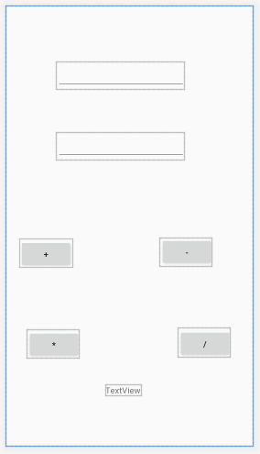

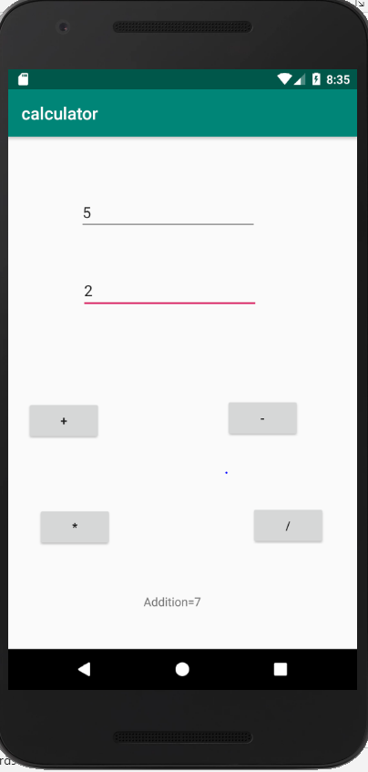 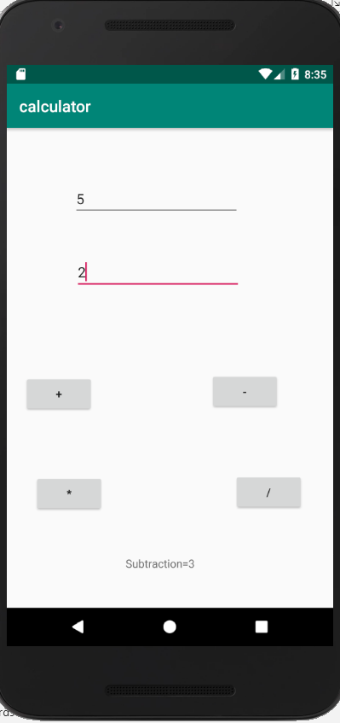

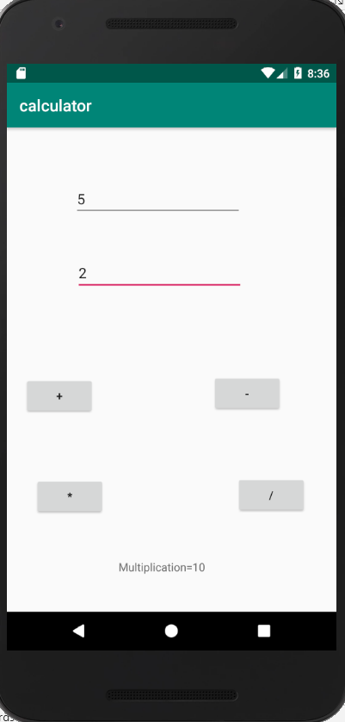 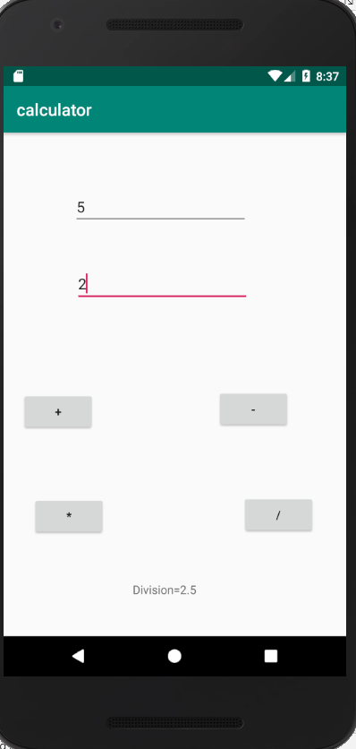

**PRACTICAL NO: 3**

**AIM: Programming Activities and fragments Activity Life Cycle, Activity methods, Multiple Activities, Life Cycle of fragments and multiple fragments.**

**INPUT:**

**package** com.example.prac3;  
  
**import** androidx.appcompat.app.AppCompatActivity;  
  
**import** android.os.Bundle;  
**import** android.util.Log;  
**import** android.widget.TextView;  
  
**public class** MainActivity **extends** AppCompatActivity {  
 TextView **l1**;  
 String **msg**=**"Android"**;  
  
 @Override  
 **protected void** onCreate(Bundle savedInstanceState) {  
 **super**.onCreate(savedInstanceState);  
 setContentView(R.layout.***activity_main***);  
  
 Log.*d*(**msg**, **"The onCreate() event"**);  
 **l1**=findViewById(R.id.***L1***);  
 **l1**.setText(**"The onCreate() event\n"**);  
 }  
 @Override  
 **protected void** onStart()  
 {  
 **super**.onStart();  
 **l1**.append(**"The onStart() event\n"**);  
 Log.*d*(**msg**, **"The onStart() event"**);  
 }  
 @Override  
 **protected void** onResume()  
 {  
 **super**.onResume();  
 **l1**.append(**"The onResume() event\n"**);  
 Log.*d*(**msg**, **"The onResume() event"**);  
 }  
 @Override  
 **protected void** onPause()  
 {  
 **super**.onPause();  
 **l1**.append(**"The onPause() event\n"**);  
 Log.*d*(**msg**, **"The onPause() event"**);  
 }  
 @Override  
 **protected void** onStop()  
 {  
 **super**.onStop();  
 **l1**.append(**"The onStop() event\n"**);  
 Log.*d*(**msg**, **"The onStop() event"**);  
 }  
 @Override  
 **protected void** onRestart()  
 {  
 **super**.onRestart();  
 **l1**.append(**"The onRestart() event\n"**);  
 Log.*d*(**msg**, **"The onRestart() event"**);  
 }  
 @Override  
 **protected void** onDestroy()  
 {  
 **super**.onDestroy();  
 **l1**.append(**"The onDestroy() event\n"**);  
 Log.*d*(**msg**, **"The onDestroy() event"**);  
 }  
}

**OUTPUT:**

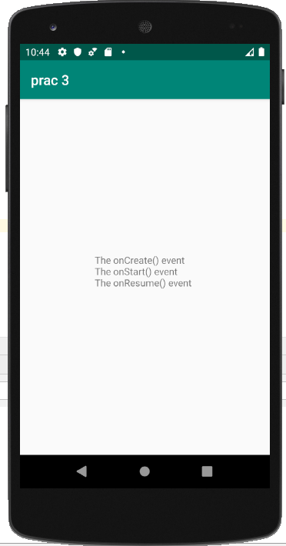 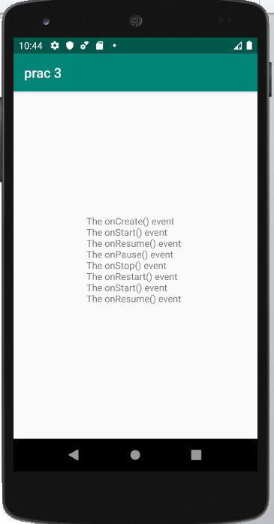

**PRACTICAL NO : 4**

**AIM** : **Programming Resources**

Android Resources: (Color, Theme, String, Drawable, Dimension, Image)

**INPUT:**

**MainActivity.java**

**package** com.example.resources;  
  
**import** androidx.appcompat.app.AppCompatActivity;  
  
**import** android.os.Bundle;  
**import** android.widget.TextView;  
  
**public class** MainActivity **extends** AppCompatActivity {  
 TextView **t4**;  
  
 @Override  
 **protected void** onCreate(Bundle savedInstanceState) {  
 **super**.onCreate(savedInstanceState);  
 setContentView(R.layout.***activity_main***);  
 **t4**=(TextView)findViewById(R.id.***t4***);  
 String s=getResources().getString(R.string.***abc***);  
 **t4**.setText(s);  
  
 **int** c=getResources().getColor(R.color.***pqr***);  
 **t4**.setTextColor(c);  
  
 Float size=getResources().getDimension(R.dimen.***d_size***);  
 **t4**.setTextSize(size);  
 }  
}

**Activity_Main.xml**

*<?***xml version="1.0" encoding="utf-8"***?>*<**androidx.constraintlayout.widget.ConstraintLayout xmlns:android="http://schemas.android.com/apk/res/android"  
 xmlns:app="http://schemas.android.com/apk/res-auto"  
 xmlns:tools="http://schemas.android.com/tools"  
 android:layout_width="match_parent"  
 android:layout_height="match_parent"  
 tools:context=".MainActivity"**>  
  
 <**TextView  
 android:id="@+id/textView1"  
 android:layout_width="@dimen/d_width"  
 android:layout_height="@dimen/d_height"  
 android:layout_marginStart="142dp"  
 android:layout_marginTop="50dp"  
 android:layout_marginEnd="112dp"  
 android:layout_marginBottom="60dp"  
 android:text="@string/abc"  
 android:textColor="@color/pqr"  
 android:textSize="@dimen/d_size"  
 app:layout_constraintBottom_toTopOf="@+id/textView2"  
 app:layout_constraintEnd_toEndOf="parent"  
 app:layout_constraintHorizontal_bias="0.087"  
 app:layout_constraintStart_toStartOf="parent"  
 app:layout_constraintTop_toTopOf="parent"** />  
  
 <**TextView  
 android:id="@+id/textView2"  
 android:layout_width="146dp"  
 android:layout_height="48dp"  
 android:layout_marginStart="147dp"  
 android:layout_marginTop="74dp"  
 android:layout_marginEnd="118dp"  
 android:layout_marginBottom="69dp"  
 android:text="@string/abc"  
 android:textColor="@color/pqr"  
 app:layout_constraintBottom_toTopOf="@+id/textView3"  
 app:layout_constraintEnd_toEndOf="parent"  
 app:layout_constraintStart_toStartOf="parent"  
 app:layout_constraintTop_toBottomOf="@+id/textView1"** />  
  
 <**TextView  
 android:id="@+id/textView3"  
 android:layout_width="139dp"  
 android:layout_height="50dp"  
 android:layout_marginStart="147dp"  
 android:layout_marginTop="32dp"  
 android:layout_marginEnd="125dp"  
 android:layout_marginBottom="50dp"  
 android:text="@string/abc"  
 android:textColor="@color/pqr"  
 app:layout_constraintBottom_toTopOf="@+id/t4"  
 app:layout_constraintEnd_toEndOf="parent"  
 app:layout_constraintStart_toStartOf="parent"  
 app:layout_constraintTop_toBottomOf="@+id/textView2"** />  
  
 <**TextView  
 android:id="@+id/t4"  
 android:layout_width="150dp"  
 android:layout_height="56dp"  
 android:layout_marginStart="135dp"  
 android:layout_marginTop="70dp"  
 android:layout_marginEnd="128dp"  
 android:layout_marginBottom="250dp"  
 android:text="TextView"  
 app:layout_constraintBottom_toBottomOf="parent"  
 app:layout_constraintEnd_toEndOf="parent"  
 app:layout_constraintStart_toStartOf="parent"  
 app:layout_constraintTop_toBottomOf="@+id/textView3"** />  
</**androidx.constraintlayout.widget.ConstraintLayout**>

**Style.xml**

<**resources**>  
  
 *<!-- Base application theme. -->* <**style name="AppTheme" parent="Theme.AppCompat.Light.DarkActionBar"**>  
 *<!-- Customize your theme here. -->* <**item name="colorPrimary"**>@color/colorPrimary</**item**>  
 <**item name="colorPrimaryDark"**>@color/colorPrimaryDark</**item**>  
 <**item name="colorAccent"**>@color/colorAccent</**item**>  
 </**style**>  
  
</**resources**>

**String.xml**

<**resources**>  
 <**string name="app_name"**>RESOURCES</**string**>  
 <**string name="abc"**>TYIT-A</**string**>  
</**resources**>

**Dimens.xml**

*<?***xml version="1.0" encoding="utf-8"***?>*<**resources**>  
 <**dimen name="d_width"**>100dp</**dimen**>  
 <**dimen name="d_height"**>50dp</**dimen**>  
 <**dimen name="d_size"**>20dp</**dimen**>  
</**resources**>

**Colors.xml**

*<?***xml version="1.0" encoding="utf-8"***?>*<**resources**>  
 <**color name="colorPrimary"**>#008577</**color**>  
 <**color name="colorPrimaryDark"**>#00574B</**color**>  
 <**color name="colorAccent"**>#D81B60</**color**>  
 <**color name="pqr"**>#9F19B6</**color**>  
</**resources**>

**OUTPUT:**

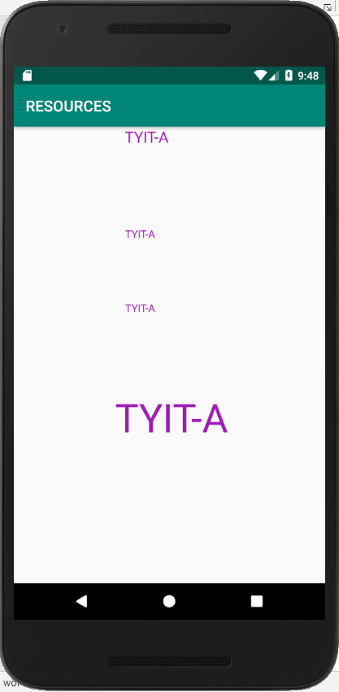

**PRACTICAL NO : 5**

**AIM** : **Programming Related to different layout**

1. Table layout
2. List view
3. Linear
4. Absolute
5. Frame
6. Co-ordinate

**1.Table layout:**

**INPUT:**

**Activity_main.xml**

*<?***xml version="1.0" encoding="utf-8"***?>*<**TableLayout xmlns:android="http://schemas.android.com/apk/res/android"  
 xmlns:app="http://schemas.android.com/apk/res-auto"  
 xmlns:tools="http://schemas.android.com/tools"  
 android:layout_width="match_parent"  
 android:layout_height="match_parent"  
 tools:context=".MainActivity"**>  
<**TableRow android:layout_width="match_parent"  
 android:layout_height="match_parent"**>  
 <**TextView android:text="First Name"  
 android:layout_width="match_parent"  
 android:layout_height="match_parent"  
 android:layout_column="1"**/>  
 <**EditText  
 android:id="@+id/fn"  
 android:layout_width="match_parent"  
 android:layout_height="match_parent"  
 android:layout_column="2"**/>  
  
</**TableRow**>  
 <**TableRow android:layout_width="fill_parent"  
 android:layout_height="match_parent"**>  
 <**TextView android:text="Last Name"  
 android:layout_width="match_parent"  
 android:layout_height="match_parent"  
 android:layout_column="1"**/>  
 <**EditText  
 android:id="@+id/ln"  
 android:layout_width="match_parent"  
 android:layout_height="match_parent"  
 android:layout_column="2"**/>  
 </**TableRow**>  
 <**TableRow** >  
 <**Button  
 android:layout_column="2"  
 android:layout_height="match_parent"  
 android:layout_width="match_parent"  
 android:text="send"  
 android:id="@+id/send"**/>  
 </**TableRow**>  
 <**TableRow**>  
 <**TextView  
 android:layout_column="2"  
 android:layout_height="match_parent"  
 android:layout_width="match_parent"  
 android:id="@+id/output"**/>  
 </**TableRow**>  
  
</**TableLayout**>

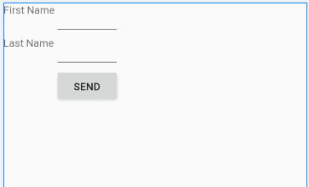

**MainActivity.java**

**package** com.example.prac5;  
  
**import** androidx.appcompat.app.AppCompatActivity;  
  
**import** android.os.Bundle;  
**import** android.view.View;  
**import** android.widget.Button;  
**import** android.widget.EditText;  
**import** android.widget.TextView;  
  
**public class** MainActivity **extends** AppCompatActivity {  
 EditText **t1**,**t2**;  
 Button **b1**;  
 TextView **t3**;  
  
 @Override  
 **protected void** onCreate(Bundle savedInstanceState) {  
 **super**.onCreate(savedInstanceState);  
 setContentView(R.layout.***activity_main***);  
 **t1**=(EditText)findViewById(R.id.***fn***);  
 **t2**=(EditText)findViewById(R.id.***ln***);  
 **b1**=(Button) findViewById(R.id.***send***);  
 **t3**=(TextView) findViewById(R.id.***output***);  
  
 **b1**.setOnClickListener(**new** View.OnClickListener() {  
 @Override  
 **public void** onClick(View v) {  
 String s=**"hii "** + **t1**.getText()+ **" "** +**t2**.getText();  
 **t3**.setText(s);  
 }  
 });  
  
 }  
}

**OUTPUT:**

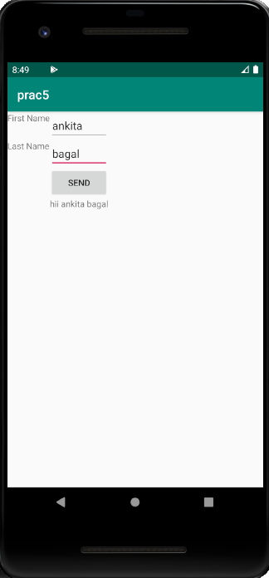

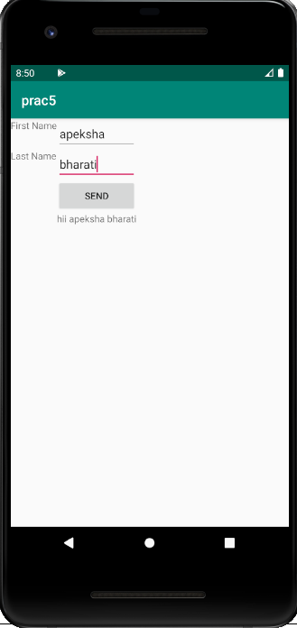

**2.List View:**

**INPUT:**

**Activity_main.xml**

**package** com.example.prac5;  
  
**import** androidx.appcompat.app.AppCompatActivity;  
**import** android.os.Bundle;  
**import** android.widget.ListView;  
**import** android.widget.ArrayAdapter;  
  
**public class** MainActivity **extends** AppCompatActivity {  
 ListView **l1**;  
  
 @Override  
 **protected void** onCreate(Bundle savedInstanceState) {  
 **super**.onCreate(savedInstanceState);  
 setContentView(R.layout.***activity_main***);  
 String[] ab={**"Apeksha"**,**"Ankita"**,**"Rohit"**};  
 ArrayAdapter a=**new** ArrayAdapter(**this**,R.layout.***activity_an***,ab);  
 **l1**=(ListView)findViewById(R.id.***mobile_list***);  
 **l1**.setAdapter(a);  
  
 }  
}

**Activity_an.xml**

*<?***xml version="1.0" encoding="utf-8"***?>*<**Button xmlns:android="http://schemas.android.com/apk/res/android"  
 xmlns:app="http://schemas.android.com/apk/res-auto"  
 xmlns:tools="http://schemas.android.com/tools"  
 android:layout_width="match_parent"  
 android:layout_height="match_parent"  
 android:id="@+id/label"  
 android:background="@color/colorAccent"  
 tools:context=".an"**>  
  
</**Button**>

**Mainactivity.java**

**package** com.example.prac5;  
  
**import** androidx.appcompat.app.AppCompatActivity;  
  
**import** android.os.Bundle;  
**import** android.widget.ListView;  
**import** android.widget.ArrayAdapter;  
  
  
  
**public class** MainActivity **extends** AppCompatActivity {  
 ListView **l1**;  
  
 @Override  
 **protected void** onCreate(Bundle savedInstanceState) {  
 **super**.onCreate(savedInstanceState);  
 setContentView(R.layout.***activity_main***);  
 String[] ab={**"Apeksha"**,**"Ankita"**,**"Rohit"**};  
 ArrayAdapter a=**new** ArrayAdapter(**this**,R.layout.***activity_an***,ab);  
 **l1**=(ListView)findViewById(R.id.***mobile_list***);  
 **l1**.setAdapter(a);  
  
 }  
}

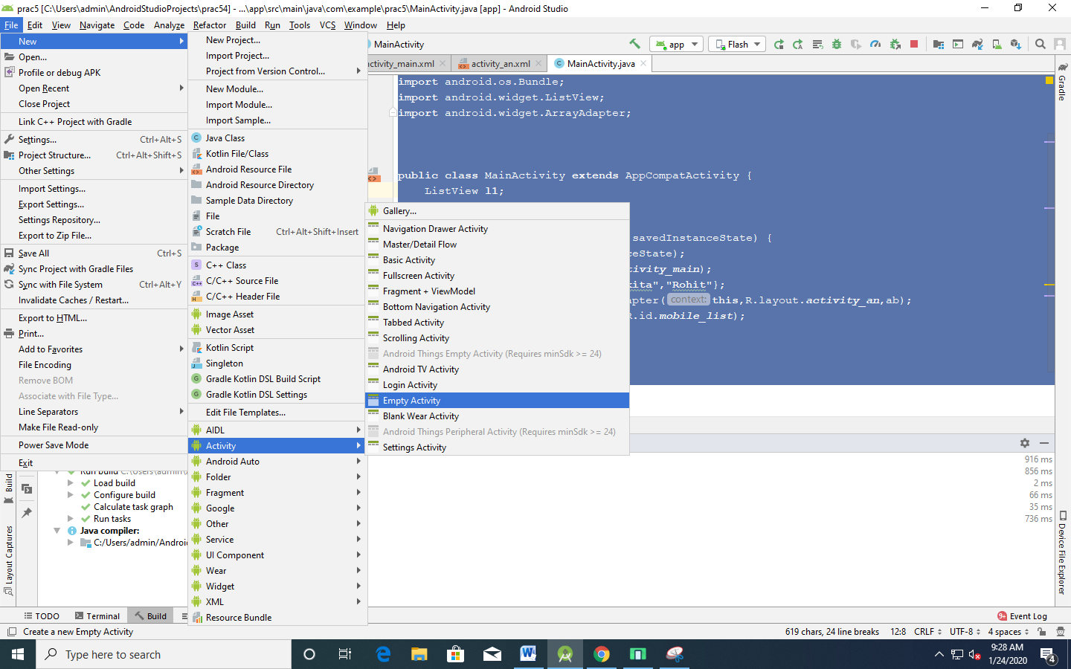

**OUTPUT:**

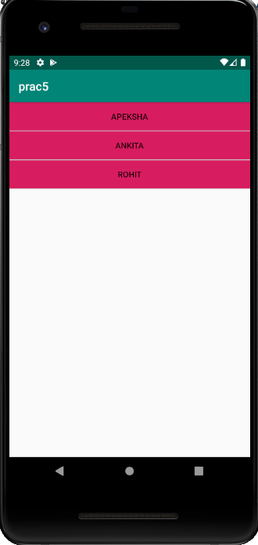

**3.Linear :**

**INPUT:**

*<?***xml version="1.0" encoding="utf-8"***?>*<**LinearLayout xmlns:android="http://schemas.android.com/apk/res/android"  
 xmlns:app="http://schemas.android.com/apk/res-auto"  
 xmlns:tools="http://schemas.android.com/tools"  
 android:layout_width="match_parent"  
 android:layout_height="match_parent"  
 tools:context=".MainActivity"  
 android:orientation="vertical"  
 android:divider="@color/colorAccent"  
 android:gravity="center"**>  
  
 <**Button  
 android:layout_width="wrap_content"  
 android:layout_height="wrap_content"  
 android:text="Enter ur name"  
 app:layout_constraintBottom_toBottomOf="parent"  
 app:layout_constraintLeft_toLeftOf="parent"  
 app:layout_constraintRight_toRightOf="parent"  
 app:layout_constraintTop_toTopOf="parent"** />  
 <**Button  
 android:layout_width="wrap_content"  
 android:layout_height="wrap_content"  
 android:id="@+id/b1"  
 app:layout_constraintBottom_toBottomOf="parent"  
 app:layout_constraintLeft_toLeftOf="parent"  
 app:layout_constraintRight_toRightOf="parent"  
 app:layout_constraintTop_toTopOf="parent"** />  
  
 <**TextView  
 android:layout_width="wrap_content"  
 android:layout_height="wrap_content"  
 android:text="Enter ur rollno"  
  
 app:layout_constraintBottom_toBottomOf="parent"  
 app:layout_constraintLeft_toLeftOf="parent"  
 app:layout_constraintRight_toRightOf="parent"  
 app:layout_constraintTop_toTopOf="parent"** />  
 <**EditText  
 android:layout_width="wrap_content"  
 android:layout_height="wrap_content"  
 android:id="@+id/b2"**

**app:layout_constraintBottom_toBottomOf="parent"  
 app:layout_constraintLeft_toLeftOf="parent"  
 app:layout_constraintRight_toRightOf="parent"  
 app:layout_constraintTop_toTopOf="parent"** />  
</**LinearLayout**>

**OUTPUT:**

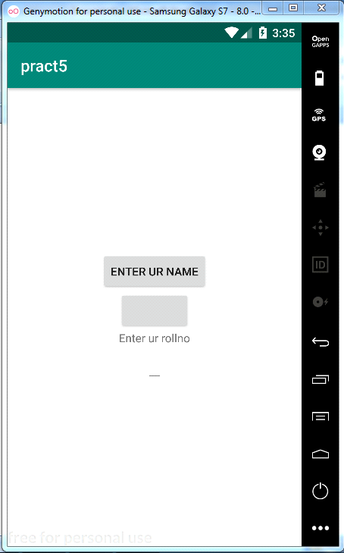

**4.Absolute :**

**INPUT:**

*<?***xml version="1.0" encoding="utf-8"***?>*<**AbsoluteLayout xmlns:android="http://schemas.android.com/apk/res/android"  
 xmlns:app="http://schemas.android.com/apk/res-auto"  
 xmlns:tools="http://schemas.android.com/tools"  
 android:layout_width="match_parent"  
 android:layout_height="match_parent"  
 tools:context=".MainActivity"  
 android:orientation="vertical"  
 android:divider="@color/colorAccent"  
 android:gravity="center"**>  
  
 <**TextView  
 android:layout_width="wrap_content"  
 android:layout_height="wrap_content"  
 android:text="Enter ur name"  
 android:layout_x="200px"  
 android:layout_y="20px"  
 app:layout_constraintBottom_toBottomOf="parent"  
 app:layout_constraintLeft_toLeftOf="parent"  
 app:layout_constraintRight_toRightOf="parent"  
 app:layout_constraintTop_toTopOf="parent"** />

<**EditText  
 android:layout_width="wrap_content"  
 android:layout_height="wrap_content"  
 android:id="@+id/b1"  
 android:layout_x="400px"  
 android:layout_y="40px"  
 app:layout_constraintBottom_toBottomOf="parent"  
 app:layout_constraintLeft_toLeftOf="parent"  
 app:layout_constraintRight_toRightOf="parent"  
 app:layout_constraintTop_toTopOf="parent"** />  
  
 <**TextView  
 android:layout_width="wrap_content"  
 android:layout_height="wrap_content"  
 android:text="Enter ur rollno"  
 android:layout_x="600px"  
 android:layout_y="60px"  
 app:layout_constraintBottom_toBottomOf="parent"  
 app:layout_constraintLeft_toLeftOf="parent"  
 app:layout_constraintRight_toRightOf="parent"  
 app:layout_constraintTop_toTopOf="parent"** />

<**EditText  
 android:layout_width="wrap_content"  
 android:layout_height="wrap_content"  
 android:id="@+id/b2"  
 android:layout_x="800px"  
 android:layout_y="80px"  
  
 app:layout_constraintBottom_toBottomOf="parent"  
 app:layout_constraintLeft_toLeftOf="parent"  
 app:layout_constraintRight_toRightOf="parent"  
 app:layout_constraintTop_toTopOf="parent"** />  
</**AbsoluteLayout**>

**OUTPUT:**

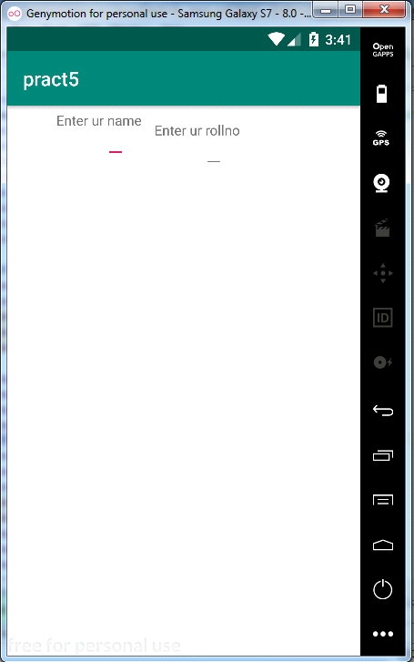

**5.Frame :**

**INPUT:**

*<?***xml version="1.0" encoding="utf-8"***?>*<**FrameLayout xmlns:android="http://schemas.android.com/apk/res/android"  
 xmlns:app="http://schemas.android.com/apk/res-auto"  
 xmlns:tools="http://schemas.android.com/tools"  
 android:layout_width="match_parent"  
 android:layout_height="match_parent"  
 tools:context=".MainActivity"  
 android:orientation="vertical"  
 android:divider="@color/colorAccent"  
 android:gravity="center"**>  
  
 <**TextView  
 android:layout_width="wrap_content"  
 android:layout_height="wrap_content"  
 android:text="Enter ur name"  
 app:layout_constraintBottom_toBottomOf="parent"  
 app:layout_constraintLeft_toLeftOf="parent"  
 app:layout_constraintRight_toRightOf="parent"  
 app:layout_constraintTop_toTopOf="parent"** />  
 <**EditText  
 android:layout_width="wrap_content"  
 android:layout_height="wrap_content"  
 android:id="@+id/b1"  
 app:layout_constraintBottom_toBottomOf="parent"  
 app:layout_constraintLeft_toLeftOf="parent"  
 app:layout_constraintRight_toRightOf="parent"  
 app:layout_constraintTop_toTopOf="parent"** />  
  
 <**TextView  
 android:layout_width="wrap_content"  
 android:layout_height="wrap_content"  
 android:text="Enter ur rollno"  
 app:layout_constraintBottom_toBottomOf="parent"  
 app:layout_constraintLeft_toLeftOf="parent"  
 app:layout_constraintRight_toRightOf="parent"  
 app:layout_constraintTop_toTopOf="parent"** />

<**EditText  
 android:layout_width="wrap_content"  
 android:layout_height="wrap_content"  
 android:id="@+id/b2"  
 app:layout_constraintBottom_toBottomOf="parent"  
 app:layout_constraintLeft_toLeftOf="parent"  
 app:layout_constraintRight_toRightOf="parent"  
 app:layout_constraintTop_toTopOf="parent"** />  
</**FrameLayout**>

**OUTPUT:**

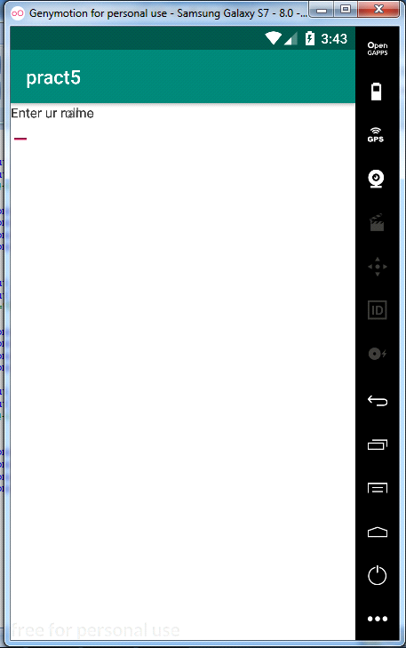

**PRACTICAL NO : 6**

**AIM** : **Programming on intents, events, listeners, adaptor.**

**MainActivity.java:**

**package** com.example.myapplication;  
  
**import** androidx.appcompat.app.AppCompatActivity;  
**import** android.content.Intent;  
**import** android.os.Bundle;  
**import** android.view.View;  
**import** android.widget.Button;  
**import** android.widget.EditText;  
  
**public class** MainActivity **extends** AppCompatActivity {  
EditText **user**,**pass**;  
Button **b1**;  
 @Override  
 **protected void** onCreate(Bundle savedInstanceState) {  
 **super**.onCreate(savedInstanceState);  
 setContentView(R.layout.***activity_main***);  
 **user**=(EditText)findViewById(R.id.***Admin***);  
 **pass**=(EditText)findViewById(R.id.***pass***);  
 **b1**=(Button)findViewById(R.id.***b1***);  
  
 **b1**.setOnClickListener(**new** View.OnClickListener() {  
 @Override  
 **public void** onClick(View v) {  
 String u=**user**.getText().toString();  
 String p=**pass**.getText().toString();  
 **if**(u.equals(**"Admin"**) && p.equals(**"123"**))  
 {  
 Intent i=**new** Intent(getApplicationContext(),ActivityTwo.**class**);  
 startActivity(i);  
 }  
 **else** {  
 Intent i=**new** Intent(getApplicationContext(),MainActivity.**class**);  
 startActivity(i);  
  
 }  
 }  
 });  
 }  
}

**activityMain.xml**

*<?***xml version="1.0" encoding="utf-8"***?>*<**androidx.constraintlayout.widget.ConstraintLayout xmlns:android="http://schemas.android.com/apk/res/android"  
 xmlns:app="http://schemas.android.com/apk/res-auto"  
 xmlns:tools="http://schemas.android.com/tools"  
 android:layout_width="match_parent"  
 android:layout_height="match_parent"  
 tools:context=".MainActivity"**>  
  
 <**EditText  
 android:id="@+id/Admin"  
 android:layout_width="wrap_content"  
 android:layout_height="wrap_content"  
 android:layout_marginStart="100dp"  
 android:layout_marginLeft="100dp"  
 android:layout_marginTop="89dp"  
 android:layout_marginEnd="100dp"  
 android:layout_marginRight="100dp"  
 android:layout_marginBottom="49dp"  
 android:ems="10"  
 android:inputType="textPersonName"  
 app:layout_constraintBottom_toTopOf="@+id/pass"  
 app:layout_constraintEnd_toEndOf="parent"  
 app:layout_constraintStart_toStartOf="parent"  
 app:layout_constraintTop_toTopOf="parent"** />  
  
 <**EditText  
 android:id="@+id/pass"  
 android:layout_width="wrap_content"  
 android:layout_height="wrap_content"  
 android:layout_marginStart="100dp"  
 android:layout_marginLeft="100dp"  
 android:layout_marginTop="49dp"  
 android:layout_marginEnd="100dp"  
 android:layout_marginRight="100dp"  
 android:layout_marginBottom="68dp"  
 android:ems="10"  
 android:inputType="textPersonName"  
 app:layout_constraintBottom_toTopOf="@+id/b1"  
 app:layout_constraintEnd_toEndOf="parent"  
 app:layout_constraintStart_toStartOf="parent"  
 app:layout_constraintTop_toBottomOf="@+id/Admin"** />  
  
 <**Button  
 android:id="@+id/b1"  
 android:layout_width="wrap_content"  
 android:layout_height="wrap_content"  
 android:layout_marginStart="100dp"  
 android:layout_marginLeft="100dp"  
 android:layout_marginTop="43dp"  
 android:layout_marginEnd="100dp"  
 android:layout_marginRight="100dp"  
 android:layout_marginBottom="363dp"  
 android:text="submit"  
 app:layout_constraintBottom_toBottomOf="parent"  
 app:layout_constraintEnd_toEndOf="parent"  
 app:layout_constraintStart_toStartOf="parent"  
 app:layout_constraintTop_toBottomOf="@+id/pass"** />  
</**androidx.constraintlayout.widget.ConstraintLayout**>

**ActivityTwo.java:**

**package** com.example.myapplication;  
  
**import** androidx.appcompat.app.AppCompatActivity;  
  
**import** android.os.Bundle;  
  
**public class** ActivityTwo **extends** AppCompatActivity {  
  
 @Override  
 **protected void** onCreate(Bundle savedInstanceState) {  
 **super**.onCreate(savedInstanceState);  
 setContentView(R.layout.***activity_two***)  
 }  
}

**ActivityTwo.xml:**

*<?***xml version="1.0" encoding="utf-8"***?>*<**androidx.constraintlayout.widget.ConstraintLayout xmlns:android="http://schemas.android.com/apk/res/android"  
 xmlns:app="http://schemas.android.com/apk/res-auto"  
 xmlns:tools="http://schemas.android.com/tools"  
 android:layout_width="match_parent"  
 android:layout_height="match_parent"  
 tools:context=".ActivityTwo"**>  
  
 <**TextView  
 android:id="@+id/textView"  
 android:layout_width="wrap_content"  
 android:layout_height="wrap_content"  
 android:layout_marginStart="100dp"  
 android:layout_marginLeft="100dp"  
 android:layout_marginTop="300dp"  
 android:layout_marginEnd="100dp"  
 android:layout_marginRight="100dp"  
 android:layout_marginBottom="636dp"  
 android:text="Welcome"  
 app:layout_constraintBottom_toBottomOf="parent"  
 app:layout_constraintEnd_toEndOf="parent"  
 app:layout_constraintStart_toStartOf="parent"  
 app:layout_constraintTop_toTopOf="parent"** />  
</**androidx.constraintlayout.widget.ConstraintLayout**>

**OUTPUT:**

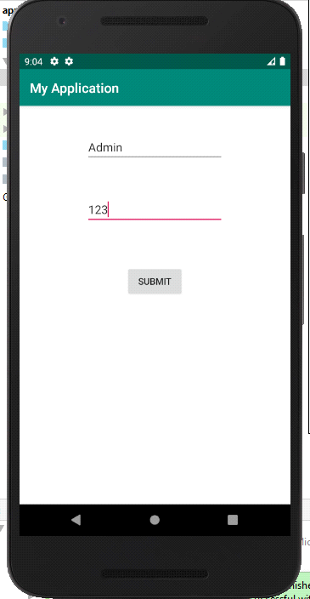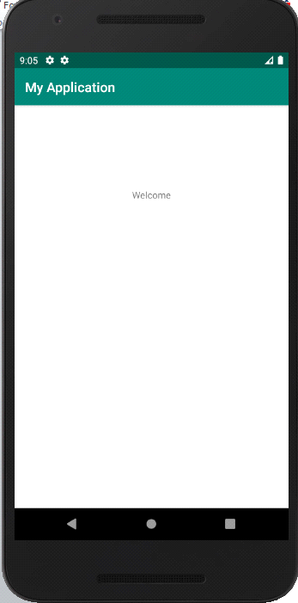

**PRACTICAL NO : 7**

**AIM** : **Programming by android menu and dialog.**

1. Android option menus are primary menus of android.
2. They can be used for setting, search, delete item, etc
3. We are inflating the menu by calling **inflate()** method of **MenuInflater** class.
4. To perform event handling on menu item you need to override **onOptionsItemSelected()** method of Activity class.

**Here we have to create xml file:**

1. In res folder of app create one **folder** using following steps---

Right click on **res** folder select **New** then select and click **Directory**, give name to directory. (eg: **menu**)

1. In menu create one **file** using following steps---

Right click on **menu** select **New** then select and click on **File**, give name to file with extension **.xml** (eg: **menu_options.xml**)

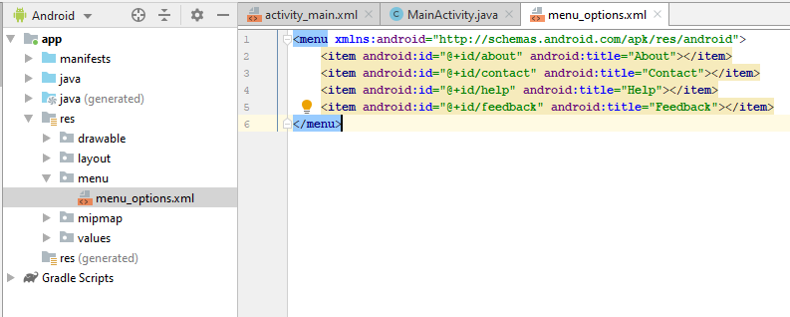

**menu_options.xml:**

<menu xmlns:android="http://schemas.android.com/apk/res/android">  
 <item android:id="@+id/about" android:title="About"></item>  
 <item android:id="@+id/contact" android:title="Contact"></item>  
 <item android:id="@+id/help" android:title="Help"></item>  
 <item android:id="@+id/feedback" android:title="Feedback"></item>  
</menu>

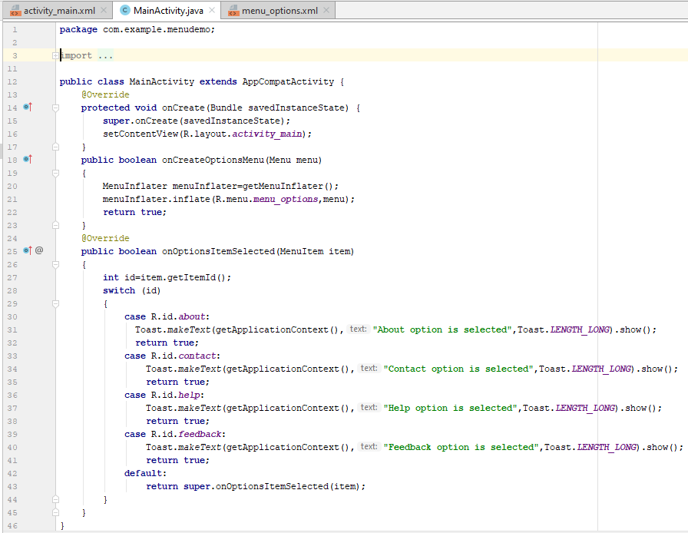

**MainActivity.java:**

**package** com.example.menudemo;  
  
**import** androidx.annotation.NonNull;  
**import** androidx.appcompat.app.AppCompatActivity;  
**import** android.os.Bundle;  
**import android.view.MenuItem;  
import android.view.Menu;  
import android.view.MenuInflater;  
import android.widget.Toast;  
  
public class** MainActivity **extends** AppCompatActivity {  
 @Override  
 **protected void** onCreate(Bundle savedInstanceState) {  
 **super**.onCreate(savedInstanceState);  
 setContentView(R.layout.***activity_main***);  
 }  
 **public boolean onCreateOptionsMenu(Menu menu)  
 {  
 MenuInflater menuInflater=getMenuInflater();  
 menuInflater.inflate(R.menu.*menu_options*,menu);  
 return true;  
 }**  
 @Override  
 **public boolean onOptionsItemSelected(MenuItem item)  
 {  
 int id=item.getItemId();  
 switch (id)  
 {  
 case R.id.*about*:  
 Toast.*makeText*(getApplicationContext(),"About option is selected",Toast.*LENGTH_LONG*).show();  
 return true;  
 case R.id.*contact*:  
 Toast.*makeText*(getApplicationContext(),"Contact option is selected",Toast.*LENGTH_LONG*).show();  
 return true;  
 case R.id.*help*:  
 Toast.*makeText*(getApplicationContext(),"Help option is selected",Toast.*LENGTH_LONG*).show();  
 return true;  
 case R.id.*feedback*:  
 Toast.*makeText*(getApplicationContext(),"Feedback option is selected",Toast.*LENGTH_LONG*).show();  
 return true;  
 default:  
 return super.onOptionsItemSelected(item);  
 }** }  
}

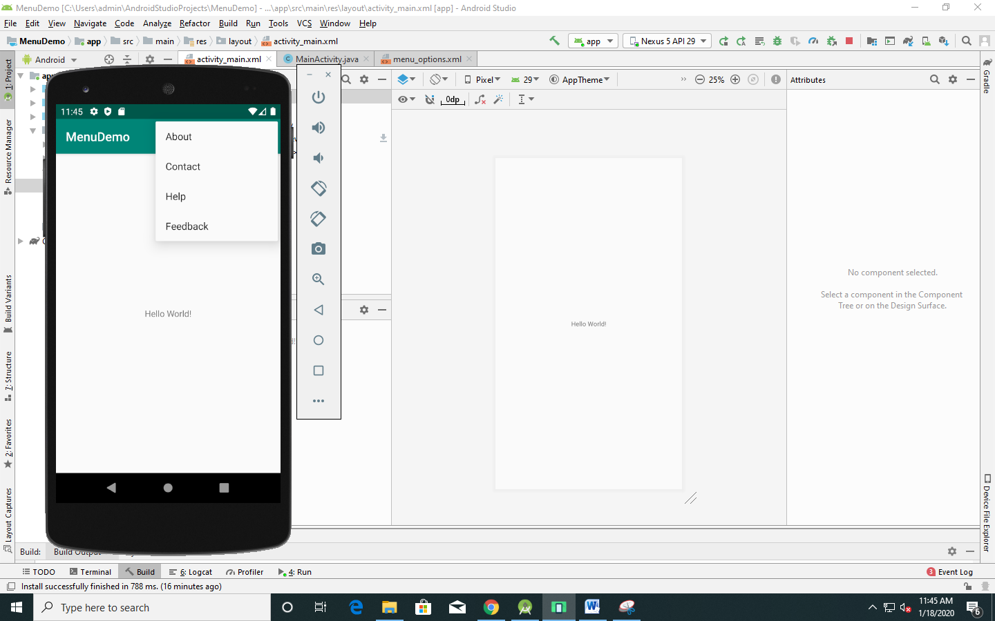

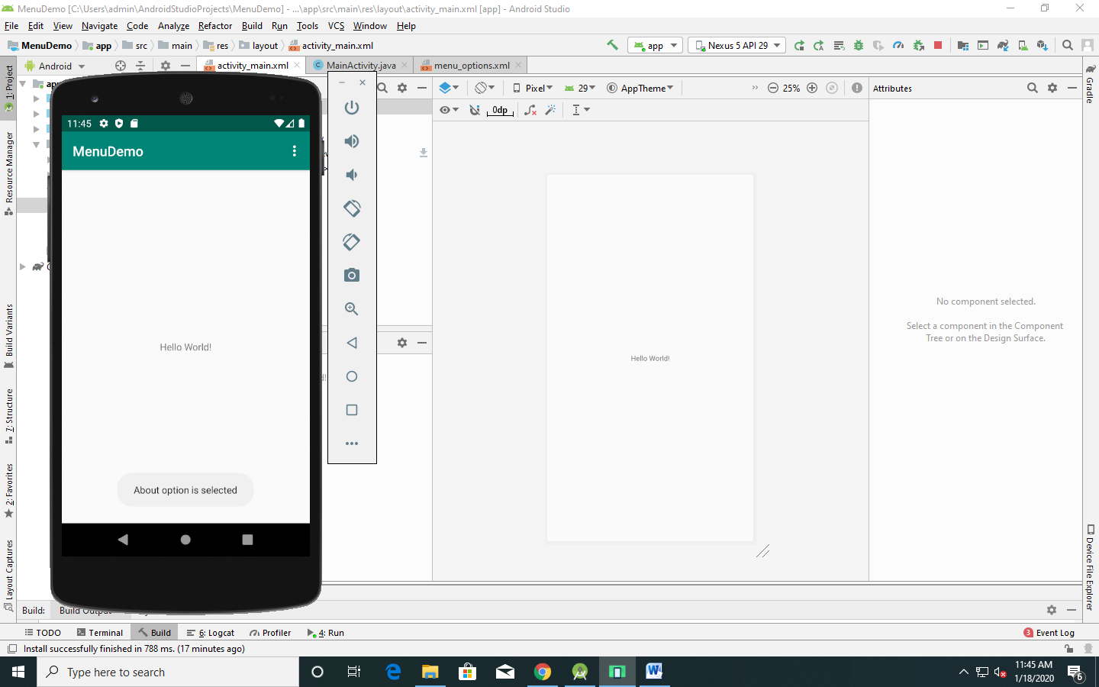

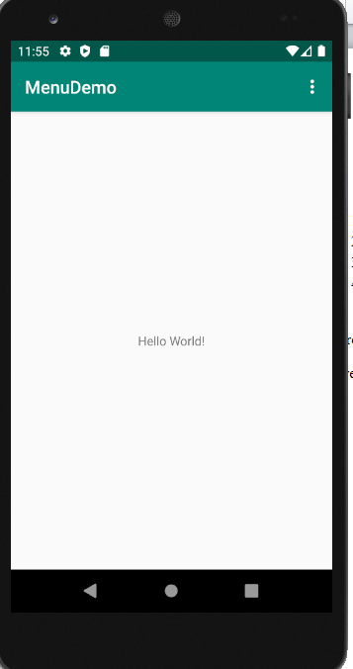

**PRACTICAL NO : 8**

**AIM** : **Database Programming with SQLite.**

**Design:**

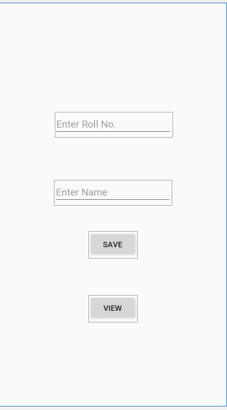

**MainActivity.java:**

**package** com.example.practica8;  
  
**import** androidx.appcompat.app.AppCompatActivity;  
**import** android.content.ContentValues;  
**import** android.database.Cursor;  
**import** android.database.sqlite.SQLiteDatabase;  
**import** android.os.Bundle;  
**import** android.view.View;  
**import** android.widget.ArrayAdapter;  
**import** android.widget.Button;  
**import** android.widget.EditText;  
**import** android.widget.GridView;  
**import** android.widget.Toast;  
  
**public class** MainActivity **extends** AppCompatActivity {  
 EditText **rn**, **name**;  
 Button **save**, **view**;  
 SQLiteDatabase **db**;  
  
  
 @Override  
 **protected void** onCreate(Bundle savedInstanceState) {  
 **super**.onCreate(savedInstanceState);  
 setContentView(R.layout.***activity_main***);  
 **rn** = findViewById(R.id.***rn***);  
 **name** = findViewById(R.id.***name***);  
 **save** = findViewById(R.id.***save***);  
 **view** = findViewById(R.id.***view***);  
  
 **try** {  
 **db** = openOrCreateDatabase(**"college3"**,  
 SQLiteDatabase.***CREATE_IF_NECESSARY***, **null**);  
 } **catch** (Exception e) {  
 }  
 **db**.execSQL(**"CREATE TABLE IF NOT EXISTS student(rn integer, name text)"**);  
  
 **save**.setOnClickListener(**new** View.OnClickListener() {  
 @Override  
 **public void** onClick(View v) {  
 **int** roll = Integer.*parseInt*(**rn**.getText().toString());  
 String name1 = **name**.getText().toString();  
 ContentValues value = **new** ContentValues();  
 value.put(**"rn"**, roll);  
 value.put(**"name"**, name1);  
 **if** (**db**.insert(**"student"**, **null**, value) != -1) {  
 Toast.*makeText*(getApplicationContext(), **"Data Saved"**, Toast.***LENGTH_LONG***).show();  
  
 } **else** {  
 Toast.*makeText*(getApplicationContext(), **"Sorry"**, Toast.***LENGTH_LONG***).show();  
 }  
  
  
 }  
 });  
 **view**.setOnClickListener(**new** View.OnClickListener() {  
 @Override  
 **public void** onClick(View v) {  
 Cursor c=**db**.rawQuery( **"select * from student"**,**null**);  
 c.moveToFirst();  
  
 **while** (!c.isAfterLast())  
 {  
  
 Toast.*makeText*(MainActivity.**this**,**"Roll No."** +c.getString(0) + **"And Name :"** +c.getString(1), Toast.***LENGTH_SHORT***).show();  
 c.moveToNext();  
  
 }  
 c.close();  
  
 }  
 });  
  
  
  
 }  
 **protected void** onStop()  
 {  
 **super**.onStop();  
 **db**.close();  
 }  
}

**OUTPUT:**

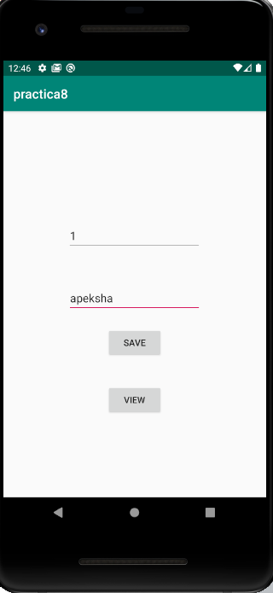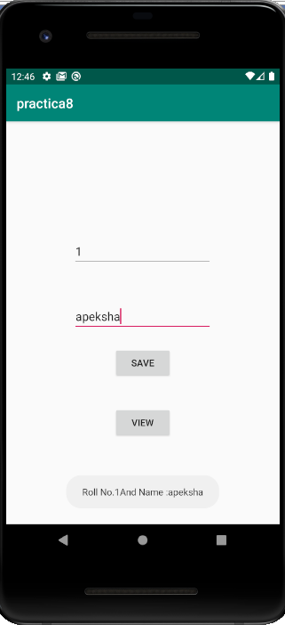

**PRACTICAL NO : 9**

**AIM** : **Programming Telephone API (Sending SMS).**

**Design:**

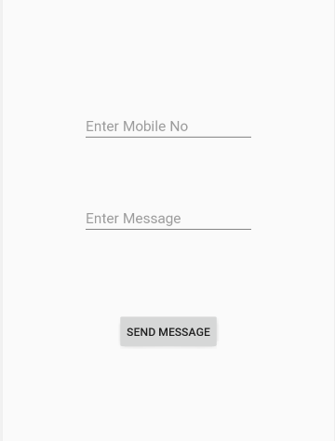

**Activity _main.xml:**

*<?***xml version="1.0" encoding="utf-8"***?>*<**androidx.constraintlayout.widget.ConstraintLayout xmlns:android="http://schemas.android.com/apk/res/android"  
 xmlns:app="http://schemas.android.com/apk/res-auto"  
 xmlns:tools="http://schemas.android.com/tools"  
 android:layout_width="match_parent"  
 android:layout_height="match_parent"  
 tools:context=".MainActivity"**>  
  
 <**EditText  
 android:id="@+id/no"  
 android:layout_width="wrap_content"  
 android:layout_height="wrap_content"  
 android:layout_marginStart="100dp"  
 android:layout_marginTop="200dp"  
 android:layout_marginEnd="100dp"  
 android:layout_marginBottom="67dp"  
 android:ems="10"  
 android:inputType="textPersonName"  
 android:hint="Enter Mobile No"  
 app:layout_constraintBottom_toTopOf="@+id/msg"  
 app:layout_constraintEnd_toEndOf="parent"  
 app:layout_constraintStart_toStartOf="parent"  
 app:layout_constraintTop_toTopOf="parent"** />  
  
 <**EditText  
 android:id="@+id/msg"  
 android:layout_width="wrap_content"  
 android:layout_height="wrap_content"  
 android:layout_marginStart="100dp"  
 android:layout_marginTop="67dp"  
 android:layout_marginEnd="100dp"  
 android:layout_marginBottom="59dp"  
 android:ems="10"  
 android:inputType="textPersonName"  
 android:hint="Enter Message"  
 app:layout_constraintBottom_toTopOf="@+id/send"  
 app:layout_constraintEnd_toEndOf="parent"  
 app:layout_constraintStart_toStartOf="parent"  
 app:layout_constraintTop_toBottomOf="@+id/no"** />  
  
 <**Button  
 android:id="@+id/send"  
 android:layout_width="wrap_content"  
 android:layout_height="wrap_content"  
 android:layout_marginStart="100dp"  
 android:layout_marginTop="100dp"  
 android:layout_marginEnd="100dp"  
 android:layout_marginBottom="359dp"  
 android:text="Send Message"  
 app:layout_constraintBottom_toBottomOf="parent"  
 app:layout_constraintEnd_toEndOf="parent"  
 app:layout_constraintStart_toStartOf="parent"  
 app:layout_constraintTop_toBottomOf="@+id/msg"** />  
</**androidx.constraintlayout.widget.ConstraintLayout**>

**MainActivity.java:**

**package** com.example.send_sms;  
  
**import** android.Manifest;  
**import** android.app.Activity;  
**import** android.app.PendingIntent;  
**import** android.content.Intent;  
**import** android.content.pm.PackageManager;  
**import** android.os.Bundle;  
**import** android.telephony.SmsManager;  
**import** android.view.Menu;  
**import** android.view.MenuInflater;

**import** android.view.View;  
**import** android.widget.Button;  
**import** android.widget.EditText;  
**import** android.widget.Toast;  
**import** androidx.core.app.ActivityCompat;  
**import** androidx.core.content.ContextCompat;  
  
**public class** MainActivity **extends** Activity {  
EditText **no**,**msg**;  
Button **send**;  
 @Override  
 **protected void** onCreate(Bundle savedInstanceState) {  
 **super**.onCreate(savedInstanceState);  
 setContentView(R.layout.***activity_main***);  
 **no**=findViewById(R.id.***no***);  
 **msg**=findViewById(R.id.***msg***);  
 **send**=findViewById(R.id.***send***);  
 *//custom call permission dialog in android* **if** (ContextCompat.*checkSelfPermission*(**this**,  
 Manifest.permission.***SEND_SMS***)  
 != PackageManager.***PERMISSION_GRANTED***) {  
 ActivityCompat.*requestPermissions*(**this**,  
 **new** String[]{Manifest.permission.***SEND_SMS***},  
 0);  
 } **else** {  
 Toast.*makeText*(getApplicationContext(),**"SMS Permission already granted."**,Toast.***LENGTH_LONG***).show();  
 }  
 **send**.setOnClickListener(**new** View.OnClickListener() {  
 @Override  
 **public void** onClick(View v) {  
 String no1=**no**.getText().toString();  
 String msg1=**msg**.getText().toString();SmsManager sms=SmsManager.*getDefault*();  
 sms.sendTextMessage(no1,**null**,  
 msg1,**null**,  
 **null**);  
 Toast.*makeText*(getApplicationContext(),  
 **"Message Sent"**,  
 Toast.***LENGTH_LONG***).show();  
 Intent intent=**new** Intent(getApplicationContext(),  
 MainActivity.**class**);  
 startActivity(intent);

}  
 });

}  
}

**AndroidManifest.xml:**

*<?***xml version="1.0" encoding="utf-8"***?>*<**manifest xmlns:android="http://schemas.android.com/apk/res/android"  
 package="com.example.send_sms"**>  
<**uses-permission android:name="android.permission.SEND_SMS"**></**uses-permission**>  
 <**uses-permission android:name="android.permission.RECEIVE_SMS"**></**uses-permission**>  
 <**application  
 android:allowBackup="true"  
 android:icon="@mipmap/ic_launcher"  
 android:label="@string/app_name"  
 android:roundIcon="@mipmap/ic_launcher_round"  
 android:supportsRtl="true"  
 android:theme="@style/AppTheme"**>  
 <**activity android:name=".MainActivity"**>  
 <**intent-filter**>  
 <**action android:name="android.intent.action.MAIN"** />  
 <**category android:name="android.intent.category.LAUNCHER"** />  
 </**intent-filter**>  
 </**activity**>  
 </**application**>  
</**manifest**>

**OUTPUT:**

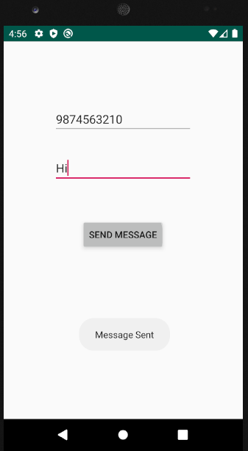

**PRACTICAL NO : 10**

**AIM** : **Multimedia in Android.**

**Activity_main.xml:**

*<?***xml version="1.0" encoding="utf-8"***?>*<**androidx.constraintlayout.widget.ConstraintLayout xmlns:android="http://schemas.android.com/apk/res/android"  
 xmlns:app="http://schemas.android.com/apk/res-auto"  
 xmlns:tools="http://schemas.android.com/tools"  
 android:layout_width="match_parent"  
 android:layout_height="match_parent"  
 tools:context=".MainActivity"**>  
  
 <**Button  
 android:id="@+id/button"  
 android:layout_width="wrap_content"  
 android:layout_height="wrap_content"  
 android:layout_marginStart="100dp"  
 android:layout_marginTop="44dp"  
 android:layout_marginEnd="100dp"  
 android:layout_marginBottom="400dp"  
 android:text="Play"  
 app:layout_constraintBottom_toBottomOf="parent"  
 app:layout_constraintEnd_toEndOf="parent"  
 app:layout_constraintHorizontal_bias="1.0"  
 app:layout_constraintStart_toStartOf="parent"** />  
  
 <**Button  
 android:id="@+id/pause"  
 android:layout_width="wrap_content"  
 android:layout_height="wrap_content"  
 android:layout_marginStart="100dp"  
 android:layout_marginTop="20dp"  
 android:layout_marginEnd="100dp"  
 android:layout_marginBottom="228dp"  
 android:text="Pause"  
 app:layout_constraintBottom_toBottomOf="parent"  
 app:layout_constraintEnd_toEndOf="parent"  
 app:layout_constraintHorizontal_bias="1.0"  
 app:layout_constraintStart_toStartOf="parent"  
 app:layout_constraintTop_toBottomOf="@+id/button"  
 app:layout_constraintVertical_bias="1.0"** />  
  
 <**Button  
 android:id="@+id/stop"  
 android:layout_width="wrap_content"  
 android:layout_height="wrap_content"  
 android:layout_marginStart="100dp"  
 android:layout_marginTop="400dp"  
 android:layout_marginEnd="100dp"  
 android:layout_marginBottom="144dp"  
 android:text="Stop"  
 app:layout_constraintBottom_toBottomOf="parent"  
 app:layout_constraintEnd_toEndOf="parent"  
 app:layout_constraintHorizontal_bias="1.0"  
 app:layout_constraintStart_toEndOf="@+id/pause"  
 app:layout_constraintTop_toTopOf="parent"  
 app:layout_constraintVertical_bias="0.0"** />  
</**androidx.constraintlayout.widget.ConstraintLayout**>

**MainActivity.java:**

**package** com.example.audio_play;  
  
**import** androidx.appcompat.app.AppCompatActivity;  
**import** android.media.MediaPlayer;  
**import** android.net.Uri;  
**import** android.os.Bundle;  
**import** android.os.Environment;  
**import** android.view.View;  
**import** android.widget.Button;  
**import** android.widget.MediaController;  
**import** android.widget.Toast;  
**import** android.widget.VideoView;  
  
**public class** MainActivity **extends** AppCompatActivity {  
Button **play**,**pause**,**stop**;  
MediaPlayer **mediaPlayer**;  
 @Override  
 **protected void** onCreate(Bundle savedInstanceState) {  
 **super**.onCreate(savedInstanceState);  
 setContentView(R.layout.***activity_main***);  
 **play**=findViewById(R.id.***button***);  
 **pause**=findViewById(R.id.***pause***);  
 **stop**=findViewById(R.id.***stop***);  
 **try** {  
 **mediaPlayer** = MediaPlayer.*create*(**this**, R.raw.***baghi***);  
 }**catch**(Exception e){  
 Toast.*makeText*(getApplicationContext(),**""**+e,Toast.***LENGTH_LONG***).show();  
 }  
 **play**.setOnClickListener(**new** View.OnClickListener() {  
 @Override  
 **public void** onClick(View v) {  
 **mediaPlayer**.start();  
 Toast.*makeText*(getApplicationContext(),**"Audio Playing..."**,Toast.***LENGTH_LONG***).show();  
 }  
 });  
 **pause**.setOnClickListener(**new** View.OnClickListener() {  
 @Override  
 **public void** onClick(View v) {  
 **mediaPlayer**.pause();  
 Toast.*makeText*(getApplicationContext(),**"Audio Pause."**,Toast.***LENGTH_LONG***).show();  
 }  
 });  
 **stop**.setOnClickListener(**new** View.OnClickListener() {  
 @Override  
 **public void** onClick(View v) {  
 **mediaPlayer**.stop();  
 Toast.*makeText*(getApplicationContext(),**"Audio Stop!"**,Toast.***LENGTH_LONG***).show();  
 }  
 });  
 }  
}

**OUTPUT:**

