In dynamics 365 CRM we have PowerApp (Model driven and Canvas App), Power automate flows, Plugins and Javascripts. In Vystar we do not Plugins currently and very minimal javascripts.

Today I will show Member 360 Canvas App and Power Automate flow

Member 360:

It is 360 degree view of a member record and our canvas app in embedded inside the model driven app (Vystar Service)

Now I will open any member record and show M360 App

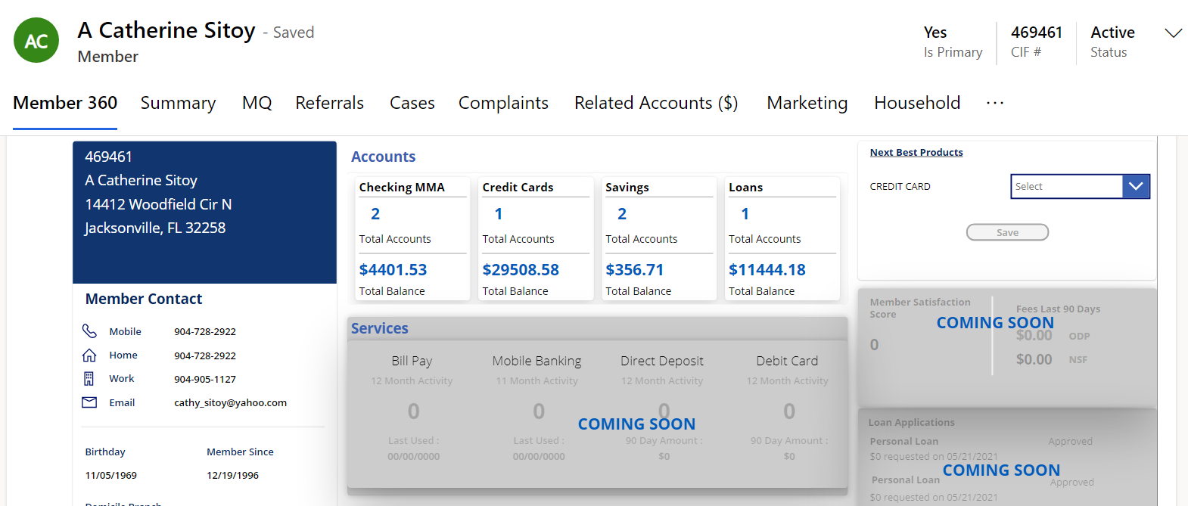

Information like:- Name, address ,phone, email etc is present in CRM

Data for the accounts section and Next Best Product section is fetched Via Stor proc

Now ask mobile number from anyone and I will show OTP demo

This is functional side of the Canvas app. Now I will show M360 Appin edit mode

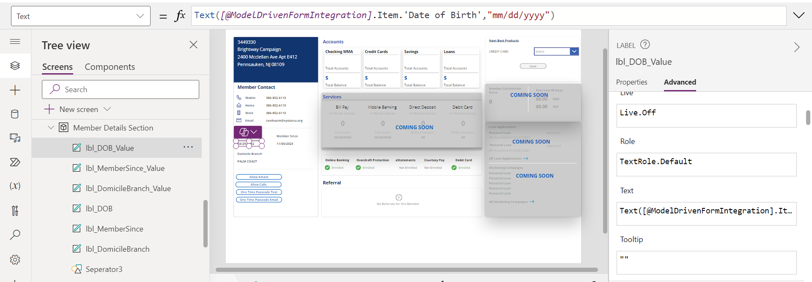

Canvas App edit screen looks like this.

Left section is Tree view of the canvas app. Here we will have Screens, Coponents, flows, variables etc

Middle section is App

Right section is to customize and and change properties of the canvas app🡪 We can write formulas, select color etc here

NOW I will show OTP FLOW IN EDIT MODE

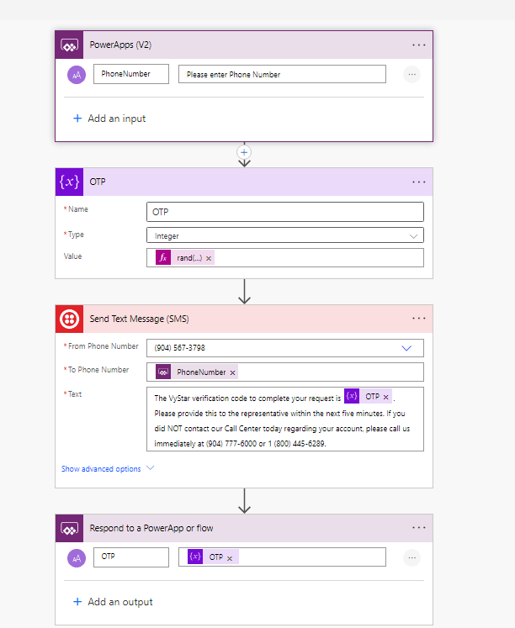

1. Triggerpoint: In our case it is M360 Power App
2. Otp Variable: Generating 4 digit random number with the formula **rand(1000,9999)**
3. This is Twilio connector and we have passed Twilio Api details to send OTP
4. Finally we are responding to PowerApp with the OTP that was generated in point 2