TECHNICAL NOTES FOR 1956

SCOPE AND METHOD

This survey of research and development was conducted in the summer and fall of 1957 by the U.S. Department of Labor, Bureau of Labor Statistics, under contract with the National Science Foundation. It was part of a broad program of studies of scientific and engineering research and development undertaken by the Foundation pursuant to its responsibilities for making comprehensive studies of the Nation’s research resources and developing and recommending policies to strengthen scientific research.

This appendix contains a brief nontechnical discussion of the coverage and conduct of the survey as a background for interpreting the statistical findings presented in the text and in the appendix tables.

Coverage of the Survey

There were three parts to the present survey. Part I covered manufacturing and nonmanufacturing industries; Part II covered commercial laboratories and engineering and architectural service firms; and Part III dealt with trade associations.

The survey of manufacturing and nonmanufacturing industries was based on the same sample as the previous survey of 1953–54, brought up to date by the addition of a sample of company births and with certain other augmentations and exclusions. For the 1953–54 survey the sample of companies was drawn primarily from the master list of those liable for old age and survivors insurance taxes, compiled by the Bureau of Old Age and Survivors Insurance as of March 1951. This was the latest complete compilation available when both the 1953–54 and the current surveys were begun. The BOASI list was supplemented by separate lists of interstate railroads and Federal Reserve Banks, which are not subject to OASI taxes. These combined lists included nearly 2,800,000 organizations and represented the most comprehensive available roster of companies in the United States. To bring the sample more nearly up to date for the 1956 survey, a sample of companies that had come into existence since the earlier survey was selected from OASI records and added to the existing sample.

Certain industries were eliminated from the listings before either the original sample or the sample of newly established firms was selected. This was done for two principal reasons—either because a separate survey of the given industry was being conducted or sponsored by the National Science Foundation, or because the amount of research and development performed by a given industry was believed to be negligible. The industries omitted from the 1953–54 survey were those classified according to the 1947 Standard Industrial Classification Manual in the following major groups: 01—Farms; 73—Miscellaneous business services; 80—Medical and other health services; 82—Educational services; 84—Museums, art galleries, and botanical and zoological gardens; 86—Nonprofit membership organizations; 88—Private hospitals; 89—Miscellaneous services; 90—Government; and 99—Nonclassifiable establishments.

All industries included in the 1953–54 survey were included in the current survey, and the following industries not previously covered were added: 73—Miscellaneous business services, and 891—Engineering and architectural services.

Companies below a specified minimum size, which was separately determined for each major industry group both for the companies in existence in 1951 and for the newer firms, were excluded from the listing in both surveys. However, the minimum size-of-firm cutoffs of the two surveys differ. For the 1953–54 survey, in most branches of manufacturing, mining, transportation and other public utilities, agricultural services, and forestry and fisheries, only companies with less than eight employees were excluded. In radio broadcasting, every company, no matter how small, was included in the universe. In many other nonmanufacturing industries, the cutoff was set at 50 employees; the major exceptions were construction and railroads for which the cutoff was 100 employees.

An analysis of the information obtained in the 1953–54 survey from companies in the smallest size groups suggested that in several industries a considerable number of firms with less than eight employees did some R&D work or employed scientists and engineers, although the aggregate cost of their R&D activities or the numbers of scientists and engineers employed was very small relative to industry totals. Hence, for those industries which met an established criterion with respect to the employment of scientists and engineers in the smallest size class, the cutoff for the current survey was lowered, to four employees in some industries and included every company in others. A supplementary sample was drawn to cover these additional small firms. Because of the difficulty of sampling the great number of construction companies in the United States, and the financial and other limitations on the survey, it seemed desirable to continue to exclude all construction firms of less than 100 employees although a sizable number of engineers are undoubtedly employed in such organizations. Industry and size of firm coverage of the two surveys are outlined below:

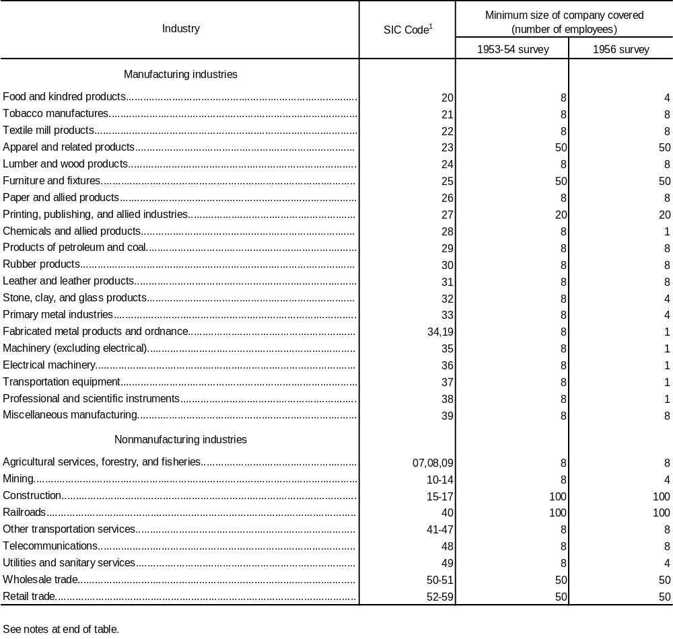
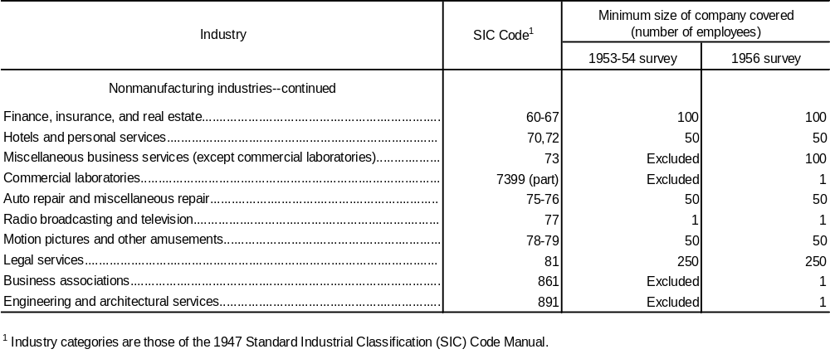

The list of companies to be sampled was stratified by industry and by size, and a random sample was selected from the industry-size strata. The sampling ratio was varied in relation to size of company and other factors so as to obtain maximum reliability at minimum cost. All of the approximately 3,000 companies with 1,000 or more employees in the list were included in the sample. In other industry-size cells, sampling ratios ranging from 1 in 2 to 1 in 100 were used; in some of the cells for the sample of newer firms, a sampling ratio as low as 1 in 200 was used because of the large number of such firms. In general, higher sampling ratios were applied to larger companies and to more research-intensive industries.

The sample originally selected for the 1953–54 survey was reduced by using the data obtained in that survey to subsample cases which reported zero to the major items for 1953 or 1954; approximately 2,700 companies were deleted from the original sample by the subsample procedure. The final size of the sample used in the 1956 survey was 11,192 companies.

The sample for the engineering and architectural service firms came from BOASI listings for SIC Industry 891—Engineering and architectural services. The sample for the commercial laboratories was selected from a current list prepared for the National Science Foundation by the Maxwell Research Center of Syracuse University. The overlap between this list and BOASI listings of companies in manufacturing and other industries resulted in duplication of the estimates for commercial laboratories and estimates for manufacturing and other industries. The summary data on pages 3–5 of this report have been adjusted to remove this duplication. On the other hand, data for commercial laboratories presented in Part II have not been so adjusted, in order to preserve a meaningful analysis of this industry.

The sample of commercial laboratories consisted of laboratories with 100 or more employees, as well as all others identified as having conducted research and development, plus a 1 in 10 sample of the remaining organizations in the list not falling into either of the two previous categories. The final mailing list for commercial laboratories consisted of 805 cases.

The part of the current survey dealing with trade associations covered national trade associations listed in Directory of National Trade Associations. From this Directory all associations were selected for which the Department of Commerce had prior knowledge of R&D work; all of these were included in the sample. The remaining associations were sampled with a ratio of 1 in 10. The final size of the trade association sample was 466.

Conduct of the Survey

The questionnaires used in the previous survey were developed in consultation with the National Science Foundation and with the advice and cooperation of many industry representatives—especially the Research Committee of the National Association of Manufacturers and the Industrial Research Institute. The questionnaires for the current survey were revised versions of those used in 1953–54.

The new questionnaires included three substantive additions to the 1953–54 questionnaires. The respondents were asked to give data on the cost of applied research and also of development; the total of applied research and development cost distributed according to selected classes of products; and current capital expenditures for research and development. Several items of marginal interest in the 1953–54 questionnaire were dropped.

Two new questionnaires were developed for the current survey. One was designed for organizations whose primary business is providing scientific and technical services under contract to others, and was used for commercial laboratories and engineering and architectural services. The second new questionnaire was designed for trade associations.

Since the survey of manufacturing and nonmanufacturing industries covered a wide range of different industries and companies of greatly varying size, the same questionnaire would not have been appropriate for all firms. Accordingly three different questionnaires were used in this part of the survey, as was also true in 1953–54. The longest and most detailed version (BLS Form 2437aa) was sent to companies which reported on the long form in the 1953–54 survey that they had R&D cost or expenditures, and also to a few selected companies which reported more than $25,000 of R&D cost for 1953 on the less detailed questionnaires. BLS Form 2437aa was also sent to the small firms added to the current sample in research-intensive industries and also, within selected cells, to newly established firms added to the sample.

The second questionnaire (Form 2437bb) was sent to firms which reported on the long questionnaire that they had no R&D cost or expenditures in 1953, and also to companies previously sent the less detailed forms which reported some R&D cost or expenditures for 1953 (except for the few companies in this category referred to in the previous paragraph). The third and most simple questionnaire (2437cc) was mailed to respondents with no R&D cost or expenditures in 1953–54 and to nonrespondents to the previous survey, in the expectation that the brief questionnaire might elicit responses from them.

To aid in the maintenance of comparability of data with that reported in the previous survey, all reporters in the 1953–54 survey were sent, with the current questionnaire, a schedule showing the key items previously reported to BLS by the company. These respondents were requested to use this information as a reference in completing the current questionnaire, and were requested to furnish revisions in the 1953–54 data if they felt an error had been made either in reporting or in their interpretation of relevant definitions.

Mailing and Response

Initial contact with most of the companies in the sample was made by mail during July and August 1957. Personal visits were made to about 100 of the largest companies, however, to discuss the new survey with these complex industrial organizations which, in general, have special reporting problems.

At least two followups of nonrespondents were made by mail beginning in October 1957 and continuing to March 1958, except for the trade association and new firm segments of the survey for which only one mail followup was made. Field visits and telephone calls were made to the major nonrespondents. When the tabulations were finally closed in April 1958, usable information had been received for 8,686 companies, or approximately 80 percent of all those in the sample. This rate of return, although high, is lower than that for the previous survey.

Nature of Estimates

The statistical findings derived from the sample data and presented in this report are of two types, denoted as primary and secondary estimates. Items classified as primary estimates were: Total R&D cost, total expenditures for research and development done outside the reporting company, total scientists and engineers, and R&D scientists and engineers.

The process of obtaining the primary estimates involved, for an estimating cell, first, adjustment of the sample data for 1956 or 1957 for each industry-size cell for nonresponse, and second, inflation of these data by the reciprocal of the applicable sampling ratio. The difference between the inflation estimate for 1956 (or January 1957 for personnel items) and a corresponding inflation estimate for 1953 (or January 1954) was obtained. This difference was added to the cell estimate for the 1953–54 survey to obtain the current estimate for the primary item; this estimate is referred to as a “difference estimate.” The cell estimates were then summed to provide totals for all industries and sizes of company (with size of company being the same as that for the 1953–54 survey at this stage of the estimating process).

Items of estimate classified as secondary were, in general, components of primary items and included, for example, cost of basic research, a component of R&D cost, and employment in engineering and the various scientific fields. The method of obtaining secondary estimates may be illustrated by that used in deriving an estimate of the number of research chemists. Ratios of research chemists to all research scientists and engineers were computed for each estimating cell, based on information for only those companies supplying data on both items, and then each ratio was multiplied by the final estimate of the related primary item (in this case, the number of research scientists and engineers) for the given cell.

The statistics which include companies with employment of less than 1,000 are subject in all instances to sampling errors. Additionally, as in all surveys, all data from this survey are subject to reporting, editing, and tabulating errors. Such errors have been eliminated, to the maximum extent possible, through checking procedures and through correspondence with a number of companies whose reports appeared to involve inconsistencies of misinterpretations of the questionnaire. It is believed also that returning to the company a schedule showing the key items previously reported aided in maintaining comparability of the reporting for the two surveys.

Definitions

Definitions of research and development and of other important items were included in the 1956 questionnaires. These definitions, with the exception noted below, were the same as those used in the previous survey, and were developed in consultation with industry representatives and others having an expert knowledge of industrial research, and tested through visits to a number of companies. The aim was to arrive at definitions which would describe accurately the information desired and also conform as far as possible with customary accounting practices and thus make it feasible for companies to supply the requested data. However, wide differences exist among industries, and among companies in the same industry, in corporate structure, in accounting practices, and in the nature and organization of R&D activities, and these differences make some variations in interpretation and application of the definitions inevitable. This was the major reason for the statement on the questionnaires that “Reasonable estimates will be satisfactory.”

The definition of basic research used in the previous survey was found to be particularly subject to varying interpretations, and hence was revised for the current survey—the only definition that was revised. The revised definition of basic research appeared, on examination of the returns, to have been subject to significantly less misinterpretation than before, but indications were that some companies still classified as basic research activities not within the intended meaning of the definition. Insofar as possible, letters were written to companies that reported an unusually large proportion of their R&D cost as basic research, and a number of corrections were made on the basis of replies received. Additional adjustments were made in the data for a number of other companies that had apparently misinterpreted the definition.

Another important definition was that of the reporting unit for which it was desired to obtain information. This definition was necessarily based upon that used by the BOASI in the listing of companies from which the sample was drawn. In accordance with the BOASI definition, separate information was requested in the 1953–54 survey for each corporation or other legally separate company in continental United States. It was recognized, however, that some families of companies might find it difficult or impossible to supply the requested figures for each separately incorporated subsidiary, and it was therefore stated on the questionnaire that the data might be submitted instead on a consolidated basis for the entire corporate family. This alternative procedure was followed in the 1953–54 survey by about 200 parent companies with many subsidiaries. These parent companies were requested to report for the 1956 survey on the same consolidated basis in order to maintain comparability with the previous survey. The definition of a company also has an important bearing on the figures for different industries and for different sizes of companies, as indicated in the following section.

Industry Classification

Since the sample of companies in this survey was drawn from the list developed by the Bureau of Old- Age and Survivors Insurance, and stratified by industry according to the BOASI industrial classification system, the classification of companies by industry in the survey is based on that system. In accordance with it, the industry categories used are those of the 1947 Standard Industrial Classification Manual. The industry of each establishment was determined on the basis of principal activity or product; a company with more than one establishment was given the industry code of the establishment (or establishments) having the greatest number of employees. For the segment of the sample of business births for which BOASI had not as yet assigned an industry code, BLS coded the company on the basis of principal activity or product as collected on a special short schedule requesting this information.

It should be noted that the reporting unit in the survey was a company, rather than an establishment. In consequence, all statistics for each company had to be classified in the single industry which represented the company’s principal field of employment.

The industry code assigned to a company by BOASI was changed for both of these surveys in a relatively small number of cases of the two following types: (1) Where consolidated returns were received for an entire corporate family, all the companies in that family were shown in the industry with which the parent company was primarily associated; (2) the classification of a few large companies was changed for the 1953–54 survey, because the industry codes given to them by BOASI, based on criteria involving both employment and value of shipments, seemed inappropriate to a survey of research and development. There were no other changes made in the industry classification of individual companies for the 1956 survey.

Comparability With 1953–54 Survey

As noted above, the coverage of the current survey was extended beyond that of the 1953–54 survey. The addition of commercial laboratories, engineering and architectural service firms, and trade associations involved no special problems of comparability of estimates of R&D costs and personnel in manufacturing and other industries, since commercial laboratories and other organizations were entirely outside the scope of the earlier survey and could be presented as separate parts of this report. However, the extension of the size-of-firm coverage in a number of industries surveyed previously (see accompanying table) and the addition of SIC 73 (miscellaneous business services) made it necessary to treat the estimates of trend differently from the estimates of aggregates.

The trend figures shown in this report were based on estimates from both surveys for the industry and size coverage of the 1953–54 survey. Consequently, the application of percent change figures in this report to the current survey aggregate figures shown will not lead to the estimates published in the 1953–54 survey report; the difference between the published figures for 1953–54 and the 1953–54 estimates, which may be derived from the data in this report, is due to the increased coverage of the current survey.

Revised estimates for the earlier survey have been made for this report for 1953 and 1954 R&D cost only. The revisions made in these figures are of two types. First, those made because several companies revised their reported R&D cost for the earlier period when they reported in the current survey. Second, estimates for 1953 and 1954 for the industry and size coverage extensions of the current survey, made by applying the trend derived for comparable industry and size coverage to the estimates for the industry and size coverage extensions, have been added.

Comparability With Survey by the Bureau of the Census

Since completion of this survey, a similar survey of R&D cost for 1957 has been made by the Bureau of the Census, also under the sponsorship of the National Science Foundation, in which 1956 R&D cost data were obtained to provide a link with the 1953 to 1956 series developed from the BLS surveys. Estimates based upon these two independent collections of data on 1956 R&D cost show a rather close correspondence between overall totals. However, the two sets of estimates do differ by industry and by size class, the discrepancies ranging from almost negligible to very marked.

There were a number of reasons for these discrepancies. The Census industry classifications differed in some cases from the classifications used by BLS. Second, the BLS reporting unit, except for consolidated returns, was a single legal entity, while the Census reporting unit was a company or group of companies under the same ownership or control; these different definitions of reporting unit caused differences in industry and size classification in a small number of cases—some of them quite important. Third, there was some variation in responses received from the same reporting unit. Finally, there were differences in the sampling schemes and estimating methods used.

National Science Foundation, Science and Engineering in American Industry: Final Report on a 1953-54 Survey. Washington 25, D.C.: Supt. of Documents, U.S. Government Printing Office, 1956.
This list was compiled for the Foundation by the Maxwell Research Center of Syracuse University in the course of conducting a project which resulted in Directory of Independent Commercial Laboratories Performing Research and Development, 1957. Washington 25, D.C.: Supt. of Documents, U.S. Government Printing Office, 1958.
U.S. Department of Commerce, Directory of National Trade Associations. Washington 25, D.C.: Supt. of Documents, U.S. Government Printing Office, 1956.

