TECHNICAL NOTES FOR 1958

Introduction

The statistics gathered in this survey on research and development are directly comparable with the 1957 data that, in effect, were resurveyed for 1958. Because of the concept and accounting problems in this field, the procedure of placing previously reported figures before a respondent when he files for the year was extended to all items on the 1959 form. This procedure yields accurate data on year-to-year changes, although questions may still remain regarding the level for any 1 year, as illustrated by the conceptual problems discussed below.

Additional insight was obtained during the course of this survey regarding steps that may improve reporting by type of research and development. The problem of measuring research and development in small firms also received special attention.

Method of Survey

The sample for the 1958 survey of industrial research and development represented all manufacturing industries, and those nonmanufacturing industries believed to conduct or finance research and development.

The sample for manufacturing industries was that used in 1957 with one exception: All multiplant companies with more than 1,000 employees were checked against the lists of such companies included in the 1958 census. Any companies found not to be represented in the sample through this check with the Census universe were added with certainty. This check substantially guaranteed the results against any significant distortion as a result of company growth since 1956.

In manufacturing, the sampling unit used was the company defined as all establishments under common ownership or control. All companies with 1,000 employees or more were included in the sample with certainty. Smaller companies were samples with rates ranging from 1,000 downward depending upon their industry and size. The 300 largest companies from a Department of Defense list of R&D contractors were included in the panel with certainty regardless of their industry classification or employment size.

The nonmanufacturing sample was drawn from the records of the Bureau of Old-Age and Survivors Insurance as of 1956. Special mention should be made regarding the sampling of “commercial laboratories.” The nonmanufacturing sample, which accounted for 2 percent of the industrial research and development dollar performance, included cases from the SIC industry that covered commercial laboratories (i.e., companies whose primary business was performing laboratory work for others). This industry, of course, includes those companies whose primary business is performing research and development for the Federal Government. A number of companies, small and large, have come into existence in recent years to handle various types of Government research contracts. There is some evidence that the classification of some of these companies, on the basis of information available, have presented a particularly difficult job to the Bureau of Old-Age and Survivors Insurance and to the Census Bureau. Certainly, the figures obtained in this survey do not permit any separate industry estimate for commercial laboratories. The 1958 Census of Business included a specific code for these laboratories. When these establishment codes are reflected later in the Bureau of Old-Age and Survivors Insurance universe, it may be possible to come closer to a separate estimate of research and development performed by companies whose principal business is performing research and development for others.

In total, 6,338 manufacturing and nonmanufacturing companies were included in the sample. A total of 1,918 certainty companies (all those with 1,000 or more employees and others in selected industry-size strata) accounted for 94 percent of the total estimate of R&D performance funds. The balance was sampled at varying rates; tables B-1 and B-2 show the probabilities of selection applied for each industry-size stratum.

As in 1957, the survey was a mail canvass. Three basic forms were used. Form RD-1 was used for companies with 100 employees or more. Forms RD-4 and RD-5, or the equivalent Forms RD-2 and RD-3, were used by selecting for RD-4 all odd numbered cases and for RD-5 all even numbered cases in the mailing list of companies with less than 100 employees and all new companies. These two types of small forms were designed to check on a reporting problem encountered with small firms in earlier surveys as discussed below.

Forms for the companies reporting on forms RD-1 were mailed in August 1959, the balance in September and October. Nonrespondents were followed up by mail. Since total R&D performance funds and total Federal funds expended by industry for research and development are now included in the Census Bureau’s company statistics program, the few large companies that did not reply were mailed the Census mandatory Form MC-K3. The figures so obtained were totaled and are included in this report. About $80 million of R&D funds were reported in this way. A total of $48 million or less than 1 percent of the total R&D funds were estimated as representing work performed by smaller companies that did not report in the survey.

For further details on the method by which the sample was selected and how these surveys are processed, see the discussion for the 1957 methodology in the report for that year. The 1959 sampling errors for selected items and the amount of imputation made by the Bureau of the Census in the major items are shown in the tables B-3 and B-4.

Comparability with earlier surveys

(1) The Shuttle Form. The 1958 survey form, in addition to figures for 1958, included space for comparable figures for 1957 funds for total research and development, basic research, applied research, development, company funds, Federal funds, and total R&D scientists and engineers. The 1957 data were entered by the Census Bureau before the 1958 forms were mailed. This system of having previous data available on the same form that the company will use to report current data is the essence of a “shuttle” reporting system. It has a special application in areas such as R&D reporting where concepts and accounts are apt to be unevenly interpreted.

(2) Changes in What Companies Include as Research and Development and the Effect of a Shuttle Form. In the 1957 survey, more than 50 percent of the 300 largest companies were found to have changed the 1956 control figures from those reported on a separate earlier survey. In the 1958 survey, this type of change was greatly reduced both in terms of number and amount. Most of the reporters chose to leave the earlier year estimates unchanged, but 17 percent of the largest companies did show some revisions in the 1957 figures. The total change, without regard to size, amounted to 8 percent of the total R&D funds for the 1957 survey, and only 3 percent for the 1958 survey. Algebraically, these revisions amounted to 4 percent and 1 percent, respectively.

It is possible that a number of manufacturing concerns did not consider the 1957 figures when preparing the 1958 estimates and that the effort to obtain comparable data for the 2 years fell somewhat short. But from correspondence accompanying the schedules and field visits during the survey, the Census Bureau is confident that noncomparability due to changes in the method of reporting from one year’s figures to the next has been largely eliminated by the use of a shuttle form.

There are important differences among companies to be reckoned with in what activities individual companies classify as research and development. In many respects, the sum of the amounts reported by the different companies for an item can be considered as a general measure of magnitude. On the other hand, the year-to-year changes in such amounts represent much more accurate figures.

(3) Other Changes That Affect Statistical Totals. The totals for any 1 year are also influenced by redefinition of scope, changes in company compositions through new plants, mergers, etc., and changes in size class. These are the influences that actually accounted for the greatest changes in the 1957 figures between (a) those tabulated in the 1957 survey and (b) those tabulated in the 1958 survey.

Several privately operated Government-owned facilities that were not included in the 1957 survey were added to the scope of the 1958 survey. By far the most important of these are the ones designated by the National Science Foundation as “Federal contract research centers,” because the principal activity of the operation is research and development for the Federal Government, which is generally carried out in facilities owned by the Government. These facilities added about $470 million to the total R&D performance reported by industry for 1957 and about $25 million to the total basic research for the same year. In this survey, they are included with the parent or operating company so far as industry, size, and other classifications are concerned.

A second set of changes occurred when a few industrial units treated as separate companies in 1957 were combined to reflect the revised company composition reported to the Census Bureau during the 1958 Census. Finally, a word about size and industry classifications. The same size codes and industry codes were used in tabulating 1957 and 1958 data for respondents in the 1958 survey. These codes were the latest available. The size code was based on employment reported on the 1958 questionnaire and the industry code for each manufacturing company was determined by the Census annual survey of manufactures. Industry code changes may be expected in a subsequent survey when the 1958 Census industry codes for manufacturing companies become available. Although the change in size class of a company since the 1957 survey will not affect overall or industry totals, they do affect totals by size. Research and development is concentrated to an unusual extent among a relatively few companies in each size class. If one or more of these companies with relatively large R&D programs change size during the year, then, the finer the size break, the more likely a large change in the figures for that industry-size class.

Some measure of the differences in total performance by industry and size, as reported in the 1957 survey and as reported for 1957 in the 1958 survey, and the principal reasons for these differences are shown below:

Industry and size of company based on number of employees | Estimates of R&D performance funds in 1957 reported in— |  | Principal reasons for difference
Industry and size of company based on number of employees | 1957 survey | 1958 survey | Principal reasons for difference
Industry and size of company based on number of employees | (Millions of dollars) |  | Principal reasons for difference
Chemicals and allied products: Companies with 5,000 or more employees | $324 | $490 | Inclusion of Federal contract research centers in 1958 survey. Growth of smaller companies into this size class. Revisions of the 1957 figures reported in 1958.
Electrical equipment and communication: Companies with 5,000 or more employees. | 1,139 | 1,544 | Classification by the Census Bureau of Communication industry (SIC 48) with the electrical machinery, equipment, and supplies industry (SIC 36) in the 1958 survey. Inclusion of Federal contract research centers in 1958 survey. Growth of companies into the cell.
Electrical equipment and communication: Companies with 1,000 to 4,999 employees. | 132 | 112 | Growth of companies out of the cell.

In general, the differences do not permit direct comparison with the detailed data published from the 1957 survey. But the revised 1957 data for principal measures are directly comparable with the 1958 data. Also, the details are not directly comparable with 1956 and 1953 data.

Selected reporting characteristics and problems

The work of improving statistical data on industrial research and development has led to a number of special inquiries during the course of these annual surveys. The following paragraphs deal with four principal areas of study during the past year:

(1) Data on Sources of R&D Funds. The R&D operations covered by the survey include (1) the work initiated by the company, and (2) the R&D work performed for others as a service. This second type is substantially all work for the Federal Government; in dollar terms, this work now exceeds the company-initiated research and development.

(a) Company-initiated research and development. The source of data on research and development initiated by a company depend upon the organization of the company. If all research and development in a company is a responsibility of a designated official, then the accounts of a company will very likely reflect the cost of the work as reported in this survey. In some companies, the R&D work is combined with other activities requiring an estimate of the separate R&D figures, or portions of the R&D program will be combined with other activities throughout the company and estimates must be obtained for these portions of the work.

Research and development is concentrated more than other economic activities among the larger companies where it is likely that research and development will be recognized as a separate activity on which records will be maintained. Among the smaller companies performing research and development, it is more likely that the person assigned the responsibility will have other functions not separated in the accounts. Thus, considerably more estimating will be required in preparing R&D reports for small companies.

(b) Federal R&D contracts. The expenditures for research and development performed for the Federal Government involve prime contracts or subcontracts which by law must be accounted for separately on a performer’s books. Once the contract is identified by a manufacturer as an R&D contract, then it is possible for him to take from his records a figure on the total expenditures for these contracts. The Federal appropriation number can be used in identifying many of these projects but if the research and development is performed with procurement funds, then it becomes necessary for someone familiar with the work to identify the particular contracts to be included. To meet the instructions, it is also necessary for a company to exclude from the total expenditures the amount subcontracted to R&D units of other companies. Finally, the instructions ask manufacturers to include only the R&D portion of contracts. It would appear that many of the more important contractors of Federal R&D work do make this distinction.

(2) Research and Development, By Type: Basic, Applied, and Development. Reporting by type of research and development, i.e., basic research, applied research, and development, affects company-funded and federally financed work in much the same way. During the course of these annual R&D surveys, the Census Bureau has obtained from respondents information on the source of the figures for these different categories. Only companies with more than 100 employees and those reporting more than $50,000 in research and development are asked for this detail. By mail and through visits to companies that accounted for about $3.5 billion in R&D funds in 1958, the information received on methods used to classify R&D expenditures by type fell into four major categories: (1) approximately 50 percent of the $3.5 billion was classified by type as a result of a special classification of individual research projects; (2) another 20 percent was derived from accounts considered to be substantially equal to the basic research, applied research, and development categories; (3) 20 percent was attributed to companies that estimated the breakdown; and (4) the remaining 10 percent was reported in total only.

The line traced by the instructions between the various categories is difficult to locate. The principal point that the Census Bureau and the National Science Foundation plan to examine further is the possibility of defining large sections of the development category specifically and separately for various industry groups. It has been suggested that in the aircraft and missile area, R&D contracts calling for deliverable hardware could be reported separately and with considerable accuracy classified as development. This would presumably represent a large part of the total of these industry groups for this industrial area. Study contracts, on the other hand, would be more difficult to classify but would also represent a much smaller part of the total. Pilot plants, semiworks and all activity beyond the bench scale stage represent an area in some other industries that can apparently be separated and would account for a large part of the development category. The detailed instructions now used cover most of these points, but it does seem from experience to date that the instructions and possibly the form may be better adapted to meet the reporting problems of separate industries. Furthermore, if a clearer description of what is to be reported can be prepared with the help of industry representatives, such a model will in time have its effect on the internal accounting systems of individual companies.

During the past year, experience with a related survey underscored the difficulty of applying the definition of basic research. In an effort to learn more about publication practices of industry in the research field, the National Science Foundation requested that the Census Bureau mail schedules to the President’s Office of the 200 companies reporting $50,000 or more in basic research in 1957. As a result, may industry officials who prepared these reports were different persons from those who prepared the R&D cost survey. Although the definitions of basic research included in both surveys were identical, 16 of the 200 companies included in the survey returned their schedules with the notation that they did not perform basic research as defined in the survey. It is true that these 16 companies accounted for only 2 percent of the total basic research performed by the 200 companies, but the differences in interpretation of the concept are nevertheless underscored by this experience. All the companies involved were asked to give the reasons for the apparent inconsistency or change in reporting. Most of them said that their research was considered to have a “specific commercial objective” and consequently would not be classified as basic research according to the survey definition. Some of the companies pointed out that the classification was a matter of opinion that could change, depending upon what office prepared the company report.

(3) Separate R&D Establishments. In the 1957 survey, the Census Bureau found that the largest amount of imputation due to item-nonresponse of companies was required in the questions regarding the wages paid to research scientists and engineers and to supporting personnel. When similar detailed questions, including the cost of materials and capital expenditures for research and development, were proposed for the 1958 survey, the Census Bureau and the National Science Foundation decided to address these questions only to those parts of the company represented by separate R&D establishments, where such records would normally be maintained. The responses to this series of questions indicated that only 15 percent of funds for industrial R&D performance in 1958 were accounted for by these separate research and development establishments (table A-29). Among seven major industry groups for which such data were available, the percentages of total research and development performed in separate R&D establishments ranged from 5 percent in the aircraft and parts industry to 56 percent in the petroleum refining and extraction industry. From survey experience, it is recognized that the wording of the questions could exclude a number of separately operated R&D units. But it would appear that a sizable portion of R&D funds, particularly in such industries as aircraft and parts, are performed by units in which research and development is only one and not the main activity assigned to the units.

Two-thirds of the companies reporting separate R&D establishments showed 90 percent or more of the company research and development performed in the separate establishment. The classification of the 293 companies by percent of total funds for R&D performance accounted for by the separate R&D establishment was as follows: 200 companies, 90 percent or more; 30 companies, 60 to 89 percent; 35 companies, 30 to 59 percent; and 29 companies, less than 30 percent.

One assumption regarding these separate R&D establishments was that the companies reporting such an organization would account for a greater share of basic research than the average company. Actually there was virtually no difference in basic research expenditures of companies reporting separate R&D establishments and those not reporting such establishments. Funds for basic research performance amounted to 3 percent of total R&D funds in companies with separate R&D establishments, compared with 4 percent for all other companies.

The relatively small share of total research and development accounted for by separate R&D establishments may be attributed at least in part to the manner in which this new question was asked. Some 8 years ago, a study by the Harvard Graduate School of Business Administration, covering 191 large companies, found 85 percent of the total research and development was accounted for “by separate research organizations.” These 191 companies accounted for 30 percent of funds for industrial R&D performance estimated for that year. It would appear that the proportionate share of R&D funds accounted for by separate R&D organizations in the 1952 survey and the separate R&D establishments in the current survey would be more comparable. Additional work to determine the reason for the difference between the 1952 results and those obtained in this survey is continuing.

(4) Attempt to Measure R&D Activities of Small Companies; The 1958 Supplemental Sample. Experience with a special 1958 sample of small firms has added more information about the problem of identifying research and development in small firms. The mailing list for the 1958 survey was expanded in the small industry size area by the addition of some 4,000 small manufacturing firms in an attempt to obtain estimates for small industry size categories with sampling errors approximating 10 percent. The additional cases were in the company-size classes, 0 to 7 employees and 8 to 99 employees.

Technically, the new cases were handled as a separate sample of manufacturing companies. This approach permitted separate estimates for the original sample and for the new supplemental sample for the selected small industry-size cells. The desired reliable figures for these small industry-size classes were not obtained. Rather, the experience demonstrated again that other factors than sampling were operating in the field, i.e., that there are considerable concept or response errors still to be isolated. Figures from the 2 samples, on (1) estimated number of companies with 8 to 99 employees performing research and development, and (2) the estimated amounts and sampling errors of their R&D funds by industry, are shown below:
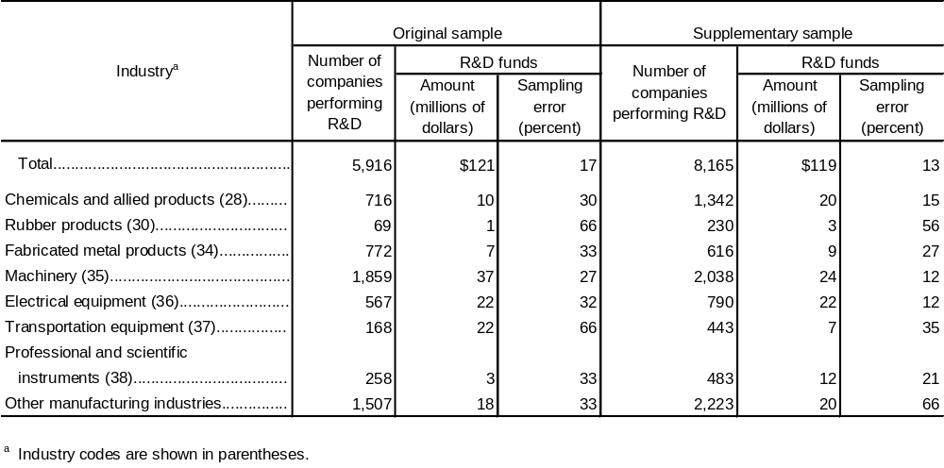

Although the differences in the size class 8 to 99 employees were severe, the differences in the less highly sampled 0 to 7 employees-size class were even greater. Only 6 out of 282 cases originally included in the 1957 sample in this size group said they were performing research and development in 1958. On the other hand, 38 out of 385 cases in the supplementary sample said they were performing research and development. On an inflated basis, this gave a total for all manufacturing of 1,038 cases performing research and development in the 1957 sample, compared with 4,328 cases in the 1958 supplementary sample.

Present experience in the reporting of small companies suggests that little success can be expected from attempts to show separate R&D statistics for small-size classes on a year-to-year basis. Surveys have provided data on the level of R&D performance of small companies, but it has not been possible to measure year-to-year changes within this group. Variations in estimates of the number of manufacturing companies in the small-size classes performing research and development, derived in the 1957 and 1958 Census surveys and the 1953 survey by the Bureau of Labor Statistics are as follows:

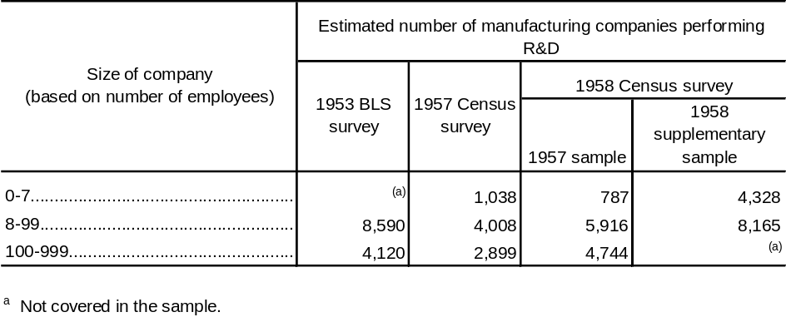
Probably more important than the standard error of these estimates are the apparent biases associated with figures for the small-size classes. Notwithstanding wide variations among estimates, the 4 sets of estimates confirm the fact that manufacturing companies with less then 100 employees performing research and development comprise a relatively small fraction of total manufacturing companies in this size class. The estimated proportion of manufacturing companies with less than 100 employees performing research and development in the 4 separate samples ranged between 2 and 5 percent. Experience bears out the conclusion reached in the preceding 1957 survey when it was noted that the Census sample yielded estimates including only one-half of the total number of companies conducting research and development found in the 1956 BLS survey in the size group of less than 100 employees. A possible cause for some of the differences observed in 1957 was the way the questions were asked of small firms in the two different surveys. To check this possibility, the 1958 survey made use of two small forms that approximated the format of the earlier BLS and Census short forms. The mailing list was divided evenly in the 1958 survey with RD-4 sent to the odd-numbered companies and the RD-5 sent to the even-numbered companies for all those new to the sample for 1958. However, preliminary tests of the results of reporting on the two forms do not show any statistically significant difference attributable to the particular type of form employed.

Prepared by the U.S. Bureau of the Census, the collecting and compiling agent in this survey for the National Science Foundation.
This indicates that a sampling ratio of 1:1 (or 1.000) was employed in the selection of companies in this particular size class.
The 1958 Census of Business showed total receipts or sales of $534 million by establishments classified as commercial laboratories including testing laboratories. The portion of these receipts accounted for by companies with this industry code will be available at a later date. For establishment data relating to commercial laboratories, see U.S. Bureau f the Census, U.S. Census of Business: 1958, Selected Services, BC58-SA1, United States Summary (Washington 25, D.C.: Superintendent of Documents, U.S. Government Printing Office, 1960), p.6.
NSF 60-49. op. cit., p. 95
The principal reasons for noncomparability of the 1957 survey with earlier R&D surveys are summarized in NSF 60-49, op. cit., p.97.
In comparison, the statistics on R&D activities, maintained by Government agencies, notably the Department of Defense, classify entire contracts in a single category.
Dearborn, DeWitt C., Rose W. Kneznek, and Robert N. Anthony, Spending for Industrial Research, 1951–52, p. 7. (Boston, Mass.: Harvard University, Graduate School of Business Administration, Division of Research, 1953.)

