TECHNICAL NOTES FOR 1988

General Notes

The Bureau of the Census (Census), Department of Commerce, has conducted the annual survey of Industrial Research and Development for the National Science Foundation (NSF) since 1957. This report provides data on research and development (R&D) funding for the years 1978–88 and on R&D personnel for the period from January 1979 to January 1989.

All companies—foreign and domestic as well as those privately held—that perform R&D in the United States are included or represented in survey data.

The industry R&D survey does not cover trade associations. Although their primary mission is to serve industry, these associations are established as nonprofit organizations, and it is estimated that their R&D expenditures are less than 1 percent of the industry R&D total.

It is an enterprise- rather than an establishment-based survey. Therefore all R&D data for each enterprise are reported in the major Standard Industrial Classification (SIC) code of the firm. Data are aggregated in this manner for all tables in this report.

Data are based on probability samples selected about every five years. In intervening years, a subset of the last sample, called a “panel,” is used. The latest probability sample was selected and first used for survey year 1987.

Census staff conduct the survey under Title 13 of the U.S. Code, which prohibits publication or release of data that may reveal information about individual companies. Therefore, on some tables of this report, the symbol “(D)” is used as a footnote reference to indicate that data are being withheld to avoid possible disclosure of information about operations of individual companies.

TECHNICAL NOTES

INTRODUCTION

The Survey of Research and Development in Industry provides national estimates of the total expenditures on R&D performed within the United States by industrial firms, whether U.S.- or foreign-owned. It is a sample survey in which it is intended that all R&D-performing companies, including privately-held firms, are included or represented. All companies that are identified in the sample year as annually spending more than $1 million on R&D in the United States receive a survey form every year. Information from individual companies in the sample is used to develop national estimates on an industry-by-industry basis.

NSF has been sponsoring a survey of industrial R&D since 1953. The 1988 Survey of Research and Development in Industry is the 32nd in the annual series sponsored by NSF and conducted since 1957 by Census. NSF’s Division of Science Resources Studies monitors the survey. NSF also sponsored two industrial R&D surveys covering the 1953–56 period that were conducted by the Bureau of Labor Statistics (BLS), Department of Labor. Data obtained in the earlier BLS surveys are not directly comparable with Census figures for 1957–88 because of methodological and other differences in the surveys.

Respondents receive detailed definitions to help them determine which expenses to include or exclude from the R&D data they provide. Nevertheless, the statistics presented in this report are subject to response and concept errors caused by different respondent interpretations of the definitions of R&D activities and by variations in company accounting procedures. Consequently, the data are better indicators of changes in, rather than absolute levels of, R&D spending and personnel. Data quality has improved substantially since the first industry R&D survey was undertaken mainly because respondents have adopted more accurate and sophisticated accounting procedures over the years.

The survey’s primary focus is on U.S. industry as a performer of, rather than as a source of funds for, R&D. Thus, data on Federal support of R&D activities performed by industry are collected and appear in several tables, but data on industrial funding of R&D undertaken at universities and colleges and other nonprofit organizations are not included in the major tables.

The survey data provide (1) national estimates of total R&D performed by industry in the United States; (2) the portion of the effort that is financed by U.S. Government funds; and (3) the amount financed by the companies themselves or by other non-Federal sources such as state and local governments or other industrial firms (see chart 1). Also included are data on both the number of employees and the number of R&D-performing scientists and engineers at the firm, as well as on the domestic net sales for the company, and on the total funds for R&D financed by the domestic firm but performed outside the United States.
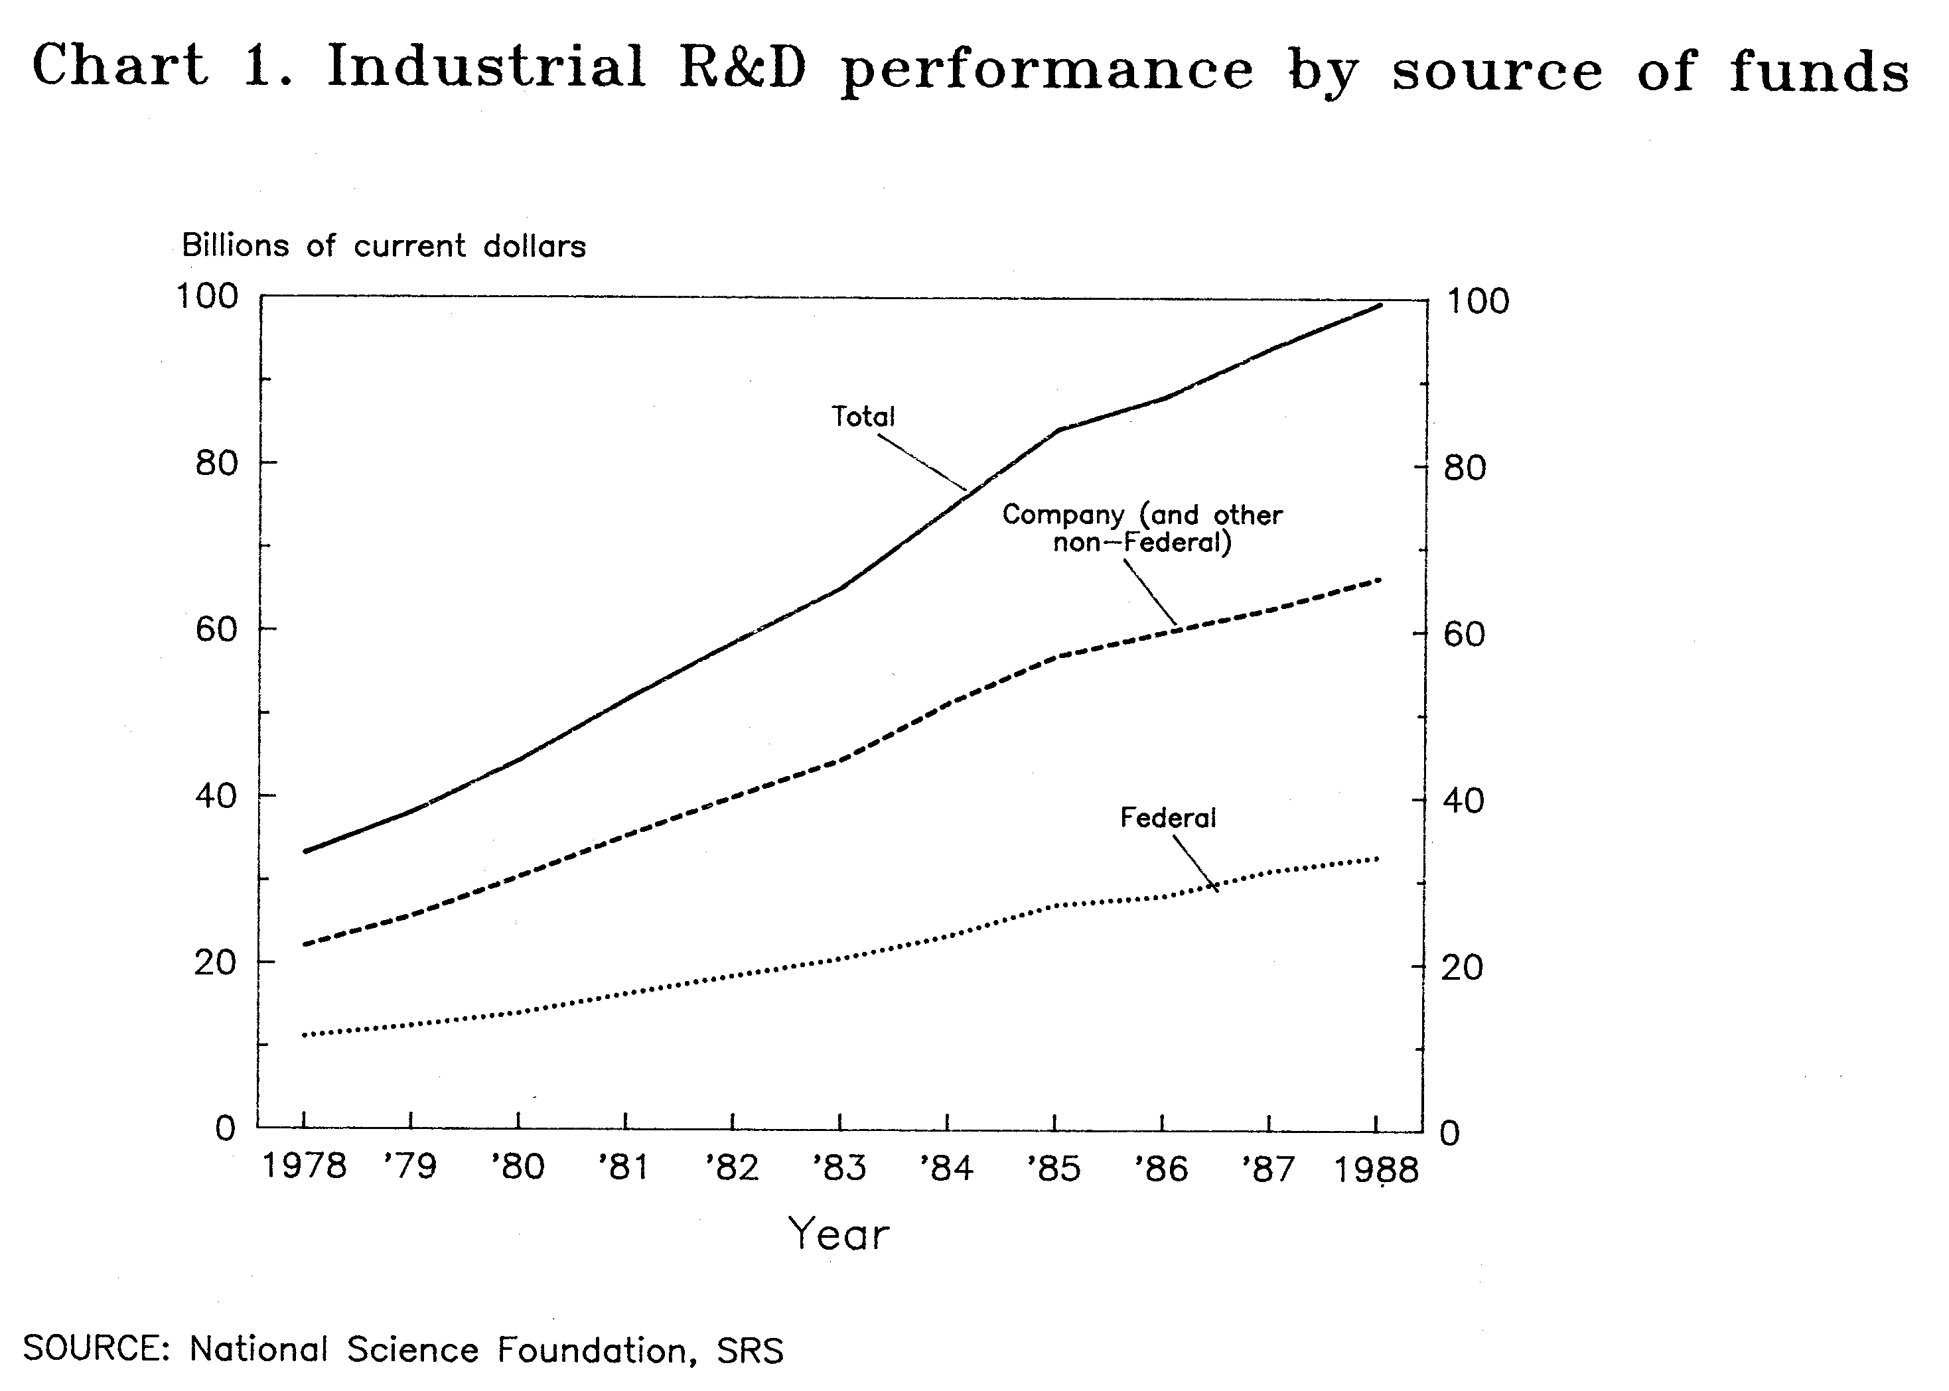
The scope of the survey has been expanded and refined over the years, in response to an increasing policy need for more detailed information on the Nation’s R&D effort. For example, questions on energy R&D were added in the early seventies following the first oil-shortage crisis. On the other hand, the frequency of collection of certain data items has been reduced in an attempt to alleviate some of the respondent burden that has been placed on industry from all sources in recent years. The detailed questionnaire is now mailed only in odd-numbered years; abbreviated survey forms containing only the most crucial data elements are sent to respondents in the intervening, even-numbered years. Both long and short survey forms are called RD-1.

The shortened survey form was used for the first time to collect industrial R&D data for 1978. This report provides data collected from the short form that covers 1988 data.

Questions appearing only biennially on the long form request detail on such areas as the following: R&D by product field, company expenditures for R&D projects that were contracted to outside organizations rather than performed in-house, Federal R&D support to the firm by contracting agency, R&D expenditures by geographic area, and some detailed data on energy and pollution-abatement R&D activities.

METHODOLOGY OF SURVEY

Overview

Data in this survey are based on a sample of industrial firms, selected approximately every five years (e.g., 1976, 1981, 1987). In intervening years only a subset of the sample, or “panel,” receives annual survey forms (for a complete discussion see, The Annual Panel) and Census makes estimates for the changes in R&D for the firms not canvassed annually. The sampling unit for this survey is the enterprise, or company, defined as a business organization consisting of one or more establishments under common ownership or control. The 1988 data in this publication are based on responses from a panel derived from the sample selected and first used for survey year 1987. (The previous sample was selected for the 1981 survey and the panel was used in subsequent annual surveys until 1987.)

The sampling frame from which the sample was drawn includes companies in all manufacturing industries and on the basis of earlier samples, a select number of nonmanufacturing industries known to conduct R&D.

The Standard Statistical Establishment List (SSEL), a Census compilation that contains information on 3.5 million to 4.0 million establishments, was the universe frame used to select the 1987 sampling frame. Where necessary for multiestablishment companies, Census summed establishment-level data to the company level, and then assigned a single Standard Industrial Classification (SIC) code to that firm—the SIC code of the establishment(s) having the highest dollar-value of payroll.

The weight given to an individual company is in general the inverse of the probability that the company would have been selected for inclusion in the sample. Certainty companies (for a detailed discussion, see Frame Creation) have a weight of 1.00. The company weight is retained in both the sampling year and in the years between samples. To minimize respondent burden, only the “panel” subset of the sample is canvassed between sample years. Most small firms are not re-contacted, but in each succeeding year Census estimates the data for each non-canvassed firm, based on the changes in the initial value of the R&D reported by the firm, and the average growth rate for the firm’s industry.

Frame Creation

In selecting a sample frame from which to draw a sample of R&D-performing industries, NSF staff make certain assumptions about industries to be able to maximize sampling efficiency given a finite budget for sample selection. That is, they apply a priori knowledge of industrial R&D activity to eliminate some industries from the possibility of selection by the initial SSEL sort and to designate other companies for sampling with 100 percent certainty. In addition, NSF staff made several innovations for the sample drawn in 1987 to improve its quality.

As in previous sample years, all companies that had been on the previous panel once again received a survey form. In addition, Census staff reviewed lists of R&D contractors published by the Department of Defense (DoD) and the National Aeronautics and Space Administration (NASA) to ensure that all their large industrial R&D-performing contractors were included in the sample with certainty.

From the outset in the latest sample selection, the major goal was to eliminate from the sampling frame, to the greatest extent possible, companies unlikely to have R&D programs. This was done to minimize the number of companies chosen for the sample which had no R&D activity. To accomplish this objective, two steps were taken:

1. NSF staff narrowed the list of nonmanufacturing industries considered “in-scope,” by eliminating those likely to engage in little or no R&D activity. Thus, companies in the eliminated nonmanufacturing industries had no chance of being selected. This gave companies in the manufacturing industries and the remaining nonmanufacturing industries a greater probability of selection than they had in past sample selections.
2. Companies below a certain employment size level—even in some “in-scope” industries—were eliminated from the universe frame. An assumption was made that companies with only a small number of employees in some industries are unlikely to engage in R&D activity. NSF staff provided an employment cutoff for each industry group. Generally the cutoff in the selected industries was 250 employees, but hospitals were given an employment cutoff of 1,000 employees. Those companies with smaller employment levels were eliminated from the frame.

Further, all companies with more than 500 employees in the “in-scope” industries, except for hospitals that had a cutoff of 1,000 were sampled with certainty.

In another effort to improve coverage of R&D-performing companies, NSF staff in 1987 provided to Census the names of firms, identified through media reports or other sources as R&D performers, that were to be included in the sample with certainty. Most of these companies would have received questionnaires anyway because they met other established criteria; the few that did not were added to the sample by Census.

All certainty companies—those on lists provided by NSF staff, on lists of DoD and NASA contractors, companies with more than 500 employees, and previous panel members—are self-representing, i.e., they have sampling weights of unity (1.00).

Based on (1) SIC code, (2) total employment cutoffs, (3) inclusion on an NSF, DoD, or NASA list, or (4) previous panel membership, approximately 154,000 companies were identified as “in scope” of the survey and therefore were included in the sampling frame. The new efforts to improve targeted coverage resulted in a sharp reduction in the size of the total in-scope universe: it dropped from about 450,000 companies in the 1981 sampling frame to approximately 154,000 companies in the latest operation.

It is likely that a small number of companies actually engaged in R&D activity was omitted from the sampling frame as a result of these first-time sample selection operations. It was agreed, however, that the benefit from the new operations—greater sampling efficiency resulting in improved national estimates of industrial R&D expenditures and employment—far outweighed the cost of the loss of a few companies that may have been eliminated from the inscope sampling frame.

Probability Proportionate to Size

As with most types of economic surveys, the sample selection process for the industrial R&D survey used probabilities proportionate to size. That is, “large” companies have a proportionately higher probability of selection than do “small” companies, where large or small is measured relative to the statistic being estimated.

For the R&D survey, it would have been ideal if size could be determined by the amount of a company’s R&D expenditures. Unfortunately, except for the companies that were in the current panel, it was impossible for Census to know the R&D expenditure values for firms in the universe frame. One logical solution was to estimate each company’s R&D expenditures and base the probability of selection on the estimated values. The same strategy had been employed in the 1981 sampling operation.

Clearly, this strategy has weaknesses. Even with the reduced number of in-scope industries in the sampling frame, many companies chosen for the frame may not have engaged in any R&D activity. Nevertheless, the procedure used to estimate the size of companies, described in the following paragraph, was forced to treat all companies as if they did in fact, perform R&D.

Census estimated the size of each company’s R&D expenditures by using a relationship linking the size of its employment to its the amount of R&D expenditures. [Since company employment was known for the universe, it was possible to use this relationship to estimate R&D expenditures values for all companies in the frame. Census derived this relationship for each SIC classification category, using data collected in the then most recent (1985) R&D survey]. Rather than treating all companies equally, the larger the number of employees in a company, the higher the probability of selection for inclusion in the sample. It was deemed reasonable to assume that large companies were more likely to have R&D programs than small companies.

One further adjustment was introduced that had not been made in previous sample selections. This was based on the assumption that multiestablishment companies of a given size and in a given industry would on average be expected to perform more R&D than single-establishment companies of the same size and in the same industry. Once again, 1985 panel data were used to develop this adjustment factor. Finally, it should be noted that the actual reported R&D activity, not an imputed value, was used for companies which were in the previous panel, and the data were not adjusted.

Sample Allocation and Relative Standard Error Constraints

The sampling program utilized for this operation allowed parameters to be assigned permitting the sample to be allocated across various levels or strata that correspond to industry groupings. This procedure permitted a desired sample size or a desired sampling error to be achieved for each strata. Estimated errors of total R&D estimates for these strata were not to exceed certain levels. Since the amount of funds provided by NSF determined the size of the sample to be drawn, the only constraint in achieving these results was that the total sample size across all the strata could not exceed 12,000–13,000 companies. NSF staff provided relative rankings for each industry group—high, medium, or low—to determine the precision of the estimate. An actual translation to what high, medium, or low meant specifically could not be determined until Census staff arbitrarily investigated several sampling error levels, computed the sample size that these levels implied, and applied the constraint of the total sample size of 13,000. The result of this investigation led to the following criteria for the target sampling error of estimate of funds for R&D performance:

a. High precision: sampling error not to exceed 2 percent
b. Medium precision: sampling error not to exceed 5 percent
c. Low precision: sampling error not to exceed 10 percent

Based on the desired precision, these criteria suggested a total sample size of approximately 13,500. This number was not excessively beyond the stated limit of 13,000, so this was the sample size parameter chosen for the selection process.

One limitation should be noted. Sampling errors were controlled by using a universe total that in large part was improvised; that is, and as previously noted, Census assigned an R&D value to every company in the frame record, even though many companies in the sampling frame may not actually have had R&D expenditures. The value assigned was imputed for the great majority of companies in the frame, and, as a consequence, the estimated universe and the distribution of individual company values did not necessarily reflect reality. Estimates of sampling variability were nevertheless based on this distribution. The presumption was—and this had been confirmed in the previous sample selection—that actual variation in the sample design would be less than that estimated because so many of the sampled companies have true R&D values of zero, not the widely varying values that were imputed using total employment as a predictor of R&D. Thus, the 2 percent, 5 percent, and 10 percent error levels described earlier are conservative. [See table A-1 for a complete list of the actual standard errors in the 1988 survey.]

The particular sample selected is one of a large number of the same type and size that, by chance, might have been selected. Estimates from each of the different samples would differ somewhat from each other and from the results of a complete canvass conducted under essentially the same conditions as the survey.

In addition to sampling error, the estimates are subject to nonsampling error that would also occur if a complete canvass were to be conducted under the same conditions.

Sample selection

The sample selection program was run with a specified sample size (expected) of 13,500 and with other parameters set to ensure compliance with the relative standard error constraints. An actual sample of 13,917 was selected. The actual sample size differs from the specified for two reasons:

First, the program used independent sampling. Each company had an independent chance of selection based on its assigned probability; the selection, or nonselection, of a company was completely independent of the selection of any other company.

In independent sampling, sample size is itself a random variable. Theoretically, a sample of size 0 or a sample the size of the entire universe is possible, but the probabilities of these extremes are so small that these are nearly impossible situations. The actual sample size is usually quite close to the specified size. If there is too much deviation, the program is simply executed again.

Second, a minimum probability rule was imposed. As noted earlier, the sampling program assigns probabilities proportionate to size (where size in this case is the imputed R&D value assigned each company). Selected companies that have R&D programs vastly larger than their assigned values can have adverse effects on the estimates once the data are collected. To lessen these effects, the maximum weight a company can assume was arbitrarily controlled by specifying that the probability of selection cannot be less than a certain value. If the probability based on its size is less than this minimum value, then it is set equal to this value. The consequence of raising these original probabilities to the minimum probability is to raise the expected sample size. It is likely that most of the difference between the specified sample size and the actual sample size is due to this rule.

The Annual Panel

The panel is a group of companies that receive a survey questionnaire, form RD-1, annually. The following is a description of how the present panel was formed from the new sample in 1987:

The basic tool for the survey is form RD-1, which is used to collect detailed R&D information. Companies that were in the old panel and had received a 1986 RD-1 form (1,095 companies) once again received an RD-1 form for 1987. The remaining certainty companies (6,903) and noncertainty companies (5,919) in the new sample received an RD-lA survey form for 1987. Form RD-1A is an abbreviated version of RD-1 and is generally mailed to companies only in the year in which a new sample is drawn. The purpose is to canvass smaller R&D performers, while imposing a minimum of reporting burden on them.

Of the 13,917 companies that received a form in 1987, 3,648 respondents reported that their companies were R&D performers, or were identified as R&D performers based on information from other sources. The 3,648 companies were ranked by total R&D funds (both companies’ own and Federal) within each SIC code. All companies with over $1 million in total R&D expenditures were placed on the RD-1 panel. In addition, in some industries Census added to the panel companies with less than $1 million in R&D expenditures, in an attempt to ensure 95 percent coverage of the R&D total for each industry.

The result of this process was an increase of panel size from 1,095 companies based on the previous sample to 1,742 companies based on the sample drawn in 1987. All companies selected for the panel will receive the RD-1 questionnaire annually until the next sample is drawn. The other companies will not receive another questionnaire; their R&D data will be estimated in subsequent years by Census staff, using their 1987 reports as a base.

Timing of the 1988 Survey

The survey questionnaires were mailed in January 1989, and nonrespondents received followup letters and telephone calls. Even when forms are received, however, there are often problems with item nonresponse. Many firms choose to send back the survey forms with one or more items blank, for varying reasons—for instance, the internal accounting procedures of the firm may not allow it to quantify R&D by, say, pollution-abatement expenditures.

In addition, some firms as a matter of policy refuse to answer any voluntary questionnaires. Four data items on the RD-1 questionnaire (total R&D expenditures, Federal R&D funds, net sales, and employment), however, are in fact included in Census’ mandatory statistical program. Therefore the few companies that had not returned form RD-1 for 1988 were mailed MA-121 forms, which are questionnaires used to collect only the items for which replies are mandatory. The response rate for these mandatory items was obviously better than for the other questions on the survey.

When respondents do not provide the requested information, Census estimates the missing data for each firm by using the current average change for that firm’s industry applied to a base of data provided by the company in earlier years. This procedure is also used to estimate the R&D of non-panel firms—i.e., firms that are in the sample and receive an RD-lA form in the sample year, but which because of size are not surveyed again until the next sample.

Table A-2 contains imputation rates for the principal survey items. For a detailed discussion of the problems stemming from item nonresponse, see the companion Technical Report, Estimating Basic and Applied Research and Development in Industry: A Preliminary Review of Survey Procedures.

COMPARABILITY OF DATA OVER A PERIOD OF SEVERAL YEARS

Several procedures are undertaken to revise data and maintain the reliability of the time series data of industial R&D:

Two-Year Comparability

Before the survey forms are mailed each year, Census imprints on each questionnaire the data reported by the respondent the previous year (or two years earlier for items asked only in odd-numbered years.) Respondents are asked to adjust data for the previous year(s) if necessary to make them comparable to data provided for the current year. Such adjustments are necessitated by any of several developments, e.g., changes in company structure such as mergers, acquisitions, or divestitures; changes in reporting concepts; and even correction of any errors that may have been made previously. Thus, there is comparability in the reporting of survey data over any 2-year period. To maintain consistency of published data, Census adjusts the employment-size classification of any company affected by such changes so that the company is tabulated in the same employment-size category for two consecutive years.

These adjustments can be examined by comparing data for the same year reported in two succeeding periods, e.g., 1987 data appearing in the 1987 edition of Research and Development in Industry may differ from 1987 data in this volume. Totals for broad classifications are likely to be very close in the two editions; differences are more noticeable in the finer detail. These differences underscore the point that the measures are approximate and indicative rather than precise.

Historical Data Revisions

The published industry R&D survey data are revised periodically, usually because of changes in the SIC code classifications of companies. In addition, two other major data revisions were made in the data for the 1981-87 periods. All of the revisions are explained as follows:

Companies may shift from one SIC code into another because of any of the following: (1) The growth and/or decline of product lines, (2) the merger of two or more companies, (3) the acquisition of one company by another, (4) divestiture, or (5) the formation of conglomerates. When Census staff are aware of the year in which changes #2, #3, #4, or #5 occurred [respondents are asked on the questionnaire about changes in ownership], they reclassify that firm’s data into the new industry for the year the change actually occurred. If a change was not discovered until the new sample was selected or if it could not be determined when a shift actually occurred (i.e., #1), other methodologies were used to adjust, or “backrest,” the data to reflect the move of a company out of one industry and into another. Since 1967, three revisions were made in the data, covering the periods 1967–76, 1976–81, and 1981–87.

1. The 1967–76 Period

The SIC codes assigned to companies in the panel for the years 1967 through 1975 were based on data reported in the 1967 economic census. The 1974 SSEL file was used to assign SIC codes to companies in the next panel chosen for the 1976 survey. These codes were used to revise 1975 data received in the 1976 survey. The SIC codes of companies in the 1967 and 1976 panels were examined to determine which companies had changed classifications. Since it was not known in which year changes actually occurred, data of companies that had changed SIC codes were revised for the years 1968 through 1974 to smooth the changes over the period 1967–76. To illustrate, if a company was originally in SIC A in 1967 but was discovered to be in SIC B in 1974, its data for 1967–74 were allocated between the two industries as follows: 1967—all of the company’s data were retained in industry A; 1968—14.3 percent of the company’s data was allocated to industry B, and the remainder retained in industry A: 1969—28.6 percent was allocated to industry B, and the remainder retained in industry A; and so on until 1974, when all of the company’s data were allocated to industry B.

2. The 1976–81 Period

“Backcasting” revisions in the industry R&D data for 1976–80 were also made to reflect the classification changes revealed in the new sample drawn in 1981; however, a different methodology was used for the revisions.

When the new panel was selected in 1981, companies were assigned SIC codes from the 1981 SSEL and the 1981 Enterprise Files. Prior-period (1980) data were collected in the 1981 survey. These data were presumed to be more accurate than those collected in the 1980 survey because they not only reflected updated SIC code classifications, but also were obtained from a larger panel providing better coverage of U.S. industry. Data obtained for 1976–80 using the panel selected in 1976 were revised subject to the following constraints:

- Data for 1976, revised from the 1977 survey would remain unchanged since this was the first year the 1976 panel was used, and since that panel was an accurate reflection of company SIC codes in 1976.

- Data for 1980 collected in the 1981 survey would be used instead of the 1980 data collected in the 1980 survey.

An algorithm was used to link data from 1976 with those collected in 1981, preserving, to the greatest extent possible, year-to-year trends in data for each industry by revising data for the years 1977, 1978, and 1979.

The following data elements were adjusted using the methodologies just described: Funds spent on R&D (total, Federal, and companies’ own); number of FTE R&D scientists and engineers; total and company R&D funds as a percent of net sales; and cost per R&D scientist or engineer. No adjustments were made in other data elements.

3. The 1981–86 Period

Similar “backcasting” revisions in the industry R&D data were made in 1987 for the industry data previously reported for the years 1981–86. Several other adjustments were made in 1987 in addition to the original methodology described for the revisions made in 1981.

When the 1987 sample was selected, companies were assigned SIC codes from the 1987 SSEL File. Companies in the sample were asked to submit their prior-year (1986) data along with the information collected for the 1987 survey. These “new” 1986 data were used in lieu of the data originally collected in the 1986 survey because they reflected updated SIC code classifications of companies, and also were collected from a much larger sample that had been was designed to provide better coverage of U.S. industry, particularly the nonmanufacturing portion. Data obtained for 1981–86 using the panel selected in 1981 were revised in 1987 subject to the following constraints:

a. Data for 1981, revised from the 1982 survey, would remain unchanged since this was the first year the 1981 panel was used, and since that panel was an accurate reflection of company SIC codes in that year.
b. Data for 1986 collected in the 1987 survey would be used instead of the 1986 data collected in the 1986 survey.

There was an increase of $9,265 million between the 1986 data based on the old panel, and the 1986 data reported by the new panel identified in 1987. Most of that aggregate revision was caused by the addition of new R&D performing firms identified through the improved sampling procedures in 1987. An algorithm was used to link data from 1981 with those collected in 1987, preserving to the greatest extent possible, year-to-year trends that had previously been reported in data for each industry by revising data for the years 1982, 1983, 1984, and 1985. Interested persons should contact Census to obtain further information about the construction and content of the algorithm.

4. Data Reevaluations for 1987

Aside from the “backcasting” adjustments made to previously published data based on new information discovered in the sample in 1987, there was also an additional adjustment made to 1987 data in 1988, based on revised information that was received with the 1988 forms: Many of the small firms identified in the enlarged sample in 1987 were receiving this kind of form for the first time, and a number of these firms were not accustomed to receiving questionnaires that asked for answers rounded to the nearest thousand. Consequently, several firms were selected for the 1987 panel based on the size of their reported R&D program. These same firms realized their initial rounding error when they received the 1988 form with the imprinted prior-year data. The respondents made revisions to their 1987 data when they submitted the 1988 forms; these revisions resulted in an aggregate downward revision of the 1987 data of $1,717 million. These revisions are reflected in the current publication.

Based on all the adjustments listed above, chart 2 depicts trends in company R&D expenditures for individual industries.

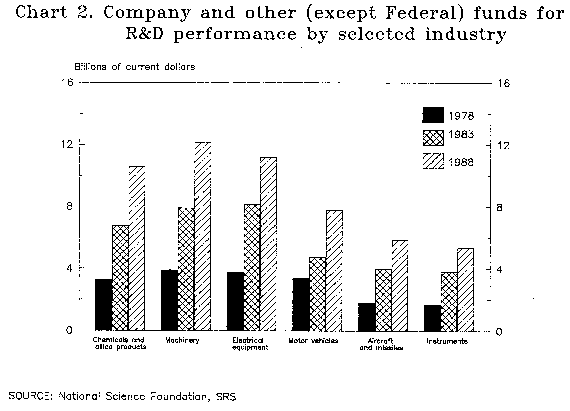

5. Federal Data for 1986

There will be one additional revision to 1986 data that does not appear in this volume. Shortly before this document was published, NSF staff discovered that 1986 data on Federal R&D support for industry had been miscalculated. Data for a merger between two companies had not been correctly processed, resulting in an overcount of $356 million. The 1986 industry R&D total (company, Federal, and other funds) should be $87,823 million instead of $88,179 million, and Federal total should be $27,891million instead of $28,247 million. Revised 1986 data will be printed in the 1989 edition of this report. Published individual industry data will not change, because data for the affected industry were withheld to avoid possible disclosure of information about operations of individual companies (i.e., these data cells are marked with the symbol “D”).

In addition to Research and Development in Industry: 1988, the following NSF publications also contain the $356 million overcount:

a. National Patterns of R&D Resources: 1990 (NSF 90-316) Revised data will be printed in the next edition of this report.

b. Science and Technology Data Book: 1990 (NSF 90-304) Revised data will be printed in the next edition of this report.

A third publication, a Technical Note that is a companion to this present volume, Estimating Basic and Applied Research and Development in Industry: A Preliminary Review of Survey Procedures, contains the corrected data.

SURVEY DEFINITIONS

Research and development—Basic and applied research in the sciences and engineering and the design and development of prototypes and processes. This definition excludes quality control, routine product testing, market research, sales promotion, sales service, other nontechnological activities or routine technical services, and research in the social sciences or psychology.

Basic research—Original investigations for the advancement of scientific knowledge not having specific immediate commercial objectives, although such investigations may be in fields of present or potential interest to the reporting company.

Applied research—Investigations for the discovery of new scientific knowledge having specific commercial objectives with respect to products or processes. This definition differs from that of basic research chiefly in terms of the objectives of the reporting company.

Development—Technical activities of a nonroutine nature concerned with translating research findings or other scientific knowledge into products or processes. Not included are routine technical services to customers or other activities excluded from the foregoing definition of R&D. See next subsection, Explanation of Tabular Data, for a discussion of the format in which these data are being published.

Full-time-equivalent (FTE)—The number of scientists and engineers in the company who are assigned full time to R&D projects together with the fraction of total work time spent on R&D projects by non-full-time R&D scientists and engineers.

Funds for R&D—Operating expenses incurred by a company in the conduct of R&D in its own laboratories or other company-owned or -operated facilities. These expenses include wages and salaries, materials and supplies consumed, property and other taxes, maintenance and repairs, depreciation, and an appropriate share of overhead, but exclude capital expenditures. Except where indicated in table B-1, all funds for R&D performance are expressed in current, rather than constant, dollars.

Company (and other) funds for R&D—Cost of R&D actually performed within the company, and funded by the company itself or by other non-Federal sources via contract. These data therefore do not include the cost of R&D supported by companies but contracted to outside organizations, such as research institutions, universities and colleges, nonprofit organizations, or (to avoid double-counting) other companies. Since it is a survey of R&D performers, industrial firms that undertake R&D supported by outside organizations do report the funds received in payment for the R&D work they perform. These monies are classified under the industries of the performing companies.

Federal funds for R&D—Represents receipts for R&D performed by the company on Federal R&D contracts or subcontracts and R&D portions of procurement contracts and subcontracts.

Federally funded research and development centers (FFRDCs)—R&D-performing organizations administered by industrial, educational, or other institutions on a nonprofit basis, exclusively or substantially financed by the Federal Government. FFRDCs are supported by the Federal Government either to meet a particular R&D objective or, in some instances, to provide major facilities at universities for research and associated training purposes. R&D expenditures of the FFRDCs that are industry-administered are included with the Federal R&D data of the industry classification of each of the administering firms.

R&D scientists and engineers—The January number of those engaged full time in R&D and the full-time equivalent of those working part time in R&D. Scientists and engineers are defined as persons engaged in scientific or engineering work at a level that requires knowledge of physical, life, engineering, or mathematical science equivalent at least to that acquired through completion of a 4-year college program with a major in one of those fields.

Employment—Total number of persons domestically employed by R&D-performing companies in all activities during the pay period that includes the 12th of March. These data are not completely comparable with the data on R&D scientists and engineers described in the foregoing paragraph because the earlier data are collected for January of each year.

Net sales and receipts—Recorded dollar values for goods sold or services rendered by R&D-performing companies to customers (outside the company), including the Federal Government, less such items as returns, allowances, freight, charges, and excise taxes. Domestic intracompany transfers and sales by foreign subsidiaries are excluded, but transfers to foreign subsidiaries and export sales to foreign companies are included.

Geographic area covered—Includes only those operations located in the 50 States and the District of Columbia.

EXPLANATION OF TABULAR DATA

Classification of reporting units—The basic reporting unit is the company or corporate family that includes all establishments under common ownership or control. All R&D expenditures and all scientists and engineers of each company are classified into a single SIC code and size-category.

Industry classification—Census staff assigned an enterprise-level SIC code to each company. A single SIC code was assigned to multiestablishment companies, based on the code which represented the most dominant aggregated activity for that firm (in terms of total payroll).⁶ Data for the following industry groupings [with SIC code(s) shown in parentheses] are published in this report:

Food and tobacco (20,21)
Textiles and apparel (22,23)
Lumber, wood products, and furniture (24,25)
Paper and allied products (26)

Chemicals and allied products (28)
Industrial chemicals (281-82,286)
Drugs and medicines (283)
Other chemicals (284-85,287-89)

Petroleum refining and extraction (13,29)
Rubber products (30)
Stone, clay, and glass products (32)

Primary metals (33)
Ferrous metals and products (331-32,3398-99)
Nonferrous metals and products (333-36)

Fabricated metal products (34)
Machinery (35)
Office, computing, and accounting machines (357)
Other machinery, except electrical (351-56,358-59)

Electrical equipment (36)
Radio and TV receiving equipment (365)
Communication equipment (366)
Electronic components (367)
Other electrical equipment (361-64,369)

Transportation equipment (37)
Motor vehicles and motor vehicles equipment (371)
Other transportation equipment (373-75,379)
Aircraft and missiles (372,376)

Professional and scientific instruments (38)
Scientific and mechanical measuring instruments (381-82)
Optical, surgical, photographic, and other instruments (383-87)

Other manufacturing industries⁸—printing and publishing (27), leather products (31), and miscellaneous manufacturing industries (39)

Nonmanufacturing industries—mining (10-11,14); construction (15-17); transportation, communications, electric, gas, and sanitary services (40-42,44-49); wholesale and retail trade (50-51,53-54,56); finance, insurance, and real estate (60,62-63); personal and business services (72-73); motion pictures (78); health services (806-07); and engineering, accounting, research, management, and related services (87)

Company size-class—Companies are categorized by their total number of domestic employees. The following are the six company size-classes used in this report: fewer than 500 employees; 500 to 999 employees; 1,000 to 4,999 employees; 5,000 to 9,999 employees; 10,000 to 24,999 employees; and 25,000 or more employees.

Cost per R&D scientist or engineer—The number of FTE R&D scientists and engineers used to estimate the cost per R&D scientist or engineer for 1978–88 is the arithmetic mean of the numbers of FTE R&D scientists and engineers reported for January in two consecutive years. This number is then divided into the total R&D expenditures of the earlier year, and the ratio is attributed to the earlier year. For example, the mean of the numbers of FTE R&D scientists and engineers in January 1988 and January 1989 is divided into total 1988 R&D expenditures for a total cost per R&D scientist or engineer in 1988.

Method of computation—Because of rounding, detailed statistics in tables may not add to totals or subtotals. Also, percentages were calculated on the basis of thousands of dollars and may differ from those based on rounded figures shown.

Nonavailability of statistics—Census staff conduct the survey under Title 13 of the U.S. code which prohibits publication or release of data that may reveal information about individual companies. Therefore, some of the Detailed Statistical Tables, section B, contain one or both of the following footnotes:

- “(D),” which is used to indicate data are being withheld to avoid possible disclosure of information about operations of individual companies. This occurs when a small number of companies, usually one or two, accounts for a large percentage of the R&D funds or of scientists and engineers in a particular data cell. The tables most often affected by this rule are those that contain data on Federal support to companies for R&D performance.

- “(S),” which is used to indicate that the imputation rate—the percentage of the statistic not reported by respondents and consequently estimated by Census staff—exceeds 50 percent for that item. Users should consult table A-2 for imputation rates for specific items.

Although publication of data may be withheld from certain cells, they are always included in totals. In some instances, data withheld because of high imputation rates (footnote reference “(S)”) can be derived by subtraction from higher-level totals. In such cases, the user should be aware that the derived numbers are statistically unreliable. In no instance can data be derived that would disclose operations of individual companies (footnote “(D)”).

Procedure for publication of detail on basic research, applied research, and development (character of work) expenditures—Over the years there have been concerns about the response rate for questions on basic research, applied research, and development data, and about the ability of Census to produce estimates of national totals for these data items having low response rates. There is a two-fold difficulty in collecting these character-ofwork details: (1) To minimize reporting burden, the non panel firms in the sample, which are small in terms of R&D expenditures, do not receive a questionnaire asking for the breakdown of their R&D expenditures into character of work categories. (2) There is a relatively low response rate for these data items from the companies which are asked to provide a breakdown of their R&D into basic research, applied research, and development expenditures. Consequently, Census distributed only approximately 70 percent of total estimated industrial R&D into these character of work categories. Census did not distribute the remaining 30 percent of industrial R&D; as a result, character-of-work tables have not been published in the Research and Development in Industry for the past three years.

For the first time, however, data on industrial basic research, applied research, and development expenditures are being published in a separate technical report, Estimating Basic and Applied Research and Development in Industry; A Preliminary Review of Survey Procedures. The report contains several versions of tables showing data for 1986, 1987, and 1988. The tables illustrate how estimated figures for basic research, applied research, and development can vary depending on assumptions made about the Census’ “not-distributed” category of R&D expenditures. Explanations of the assumptions underlying different estimates are provided, along with an overview of the Survey of Research and Development in Industry and an explanation of some general problems of missing information.

National Science Foundation, Science and Engineering in American Industry. Final Report on a 1953-54 Survey (NSF 56-16) and Science and Engineering in American Industry, 1956 (NSF 59-50) (Washington, D.C.: Supt. of Documents, U.S. Government Printing Office, 1956 and 1960).
Data on industry funding of R&D performed at universities and colleges are collected in the annual Survey of Scientific and Engineering Expenditures at Universities and Colleges. More information about this survey is available from the Universities and Colleges Studies Group of NSF’s Division of Science Resources Studies.
The bulk of this section was prepared in the Industry Division of the Bureau of the Census, the collecting and compiling agent for the National Science Foundation.
Executive Office of the President, Office of Management and Budget, Standard Industrial Classification Manual, 1972 (Washington, D.C.: Supt. of Documents, U.S. Government Printing Office).
Company-sponsored R&D performed outside the United States by foreign subsidiaries of U.S. domestic companies is reported in table B-10 but excluded from all other tables.
An exception was made for most of the companies classified in SIC code 13 (oil and gas extraction) and SIC code 50 (wholesale trade, durable goods). Because the R&D activity of these companies is in manufacturing product areas rather than service areas, their R&D expenditures were included with the SIC classifications of the manufacturing codes which encompassed the highest dollar-value of their payroll. The R&D of all such firms in SIC 13 were included with the firms in SIC 29 (petroleum). There were several manufacturing SIC codes that received the R&D expenditures of these types of firms in SIC 50.
When the sample was drawn in 1987, the 1972 SIC code numbers were in effect. For the convenience of researchers who may want to cross-reference these data with current data from other sources, the stubs of the tables contain the new SIC codes. Thus, in table B-1, research and development laboratories are listed under the 2-digit SIC code 87, although they carried an SIC code of 73 when they were originally selected.
Until 1984, tobacco products (SIC 21) was included with “other manufacturing industries.”
Companies primarily engaged in the manufacture of ordnance and accessories, including complete guided missiles, are grouped with companies primarily engaged in the manufacture of aircraft and parts because of the close similarity of their R&D activities.

