**Mail Sender API**

**(This document consists only the overview of the methods provided by the service. As far as the code is concerned, there are appropriate comments provided everywhere for easy understanding)**

This Mail Sender API is basically a service written using Flask which consists of the following APIs :

* **sendMail()** 
  + Endpoint to be called - /sendMailOTP
  + Input – JSON with the following fields:
    - otp – the generated otp (The OTP is generated on the client side and then sent here to the service)
    - email – email of the student
  + This method basically sends a mail to the respective student with the generated otp so that it can be verified on the client side
  + The mail id **from** which the mail has to be sent is specified in this line (Comments added in the code as well for reference)
  + 
  + Be sure to use Christ Mail so that the limit of the number of mails is not restricted!!
  + Now for the mail id that is given here, in order to support the smtp features from the python program follow the following steps after logging in to your Gmail account in the browser
  + 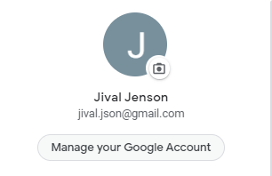
  + Go to Manage your google account
  + 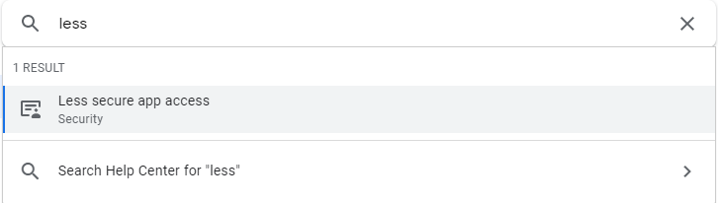
  + Search for Less secure app access and select it
  + 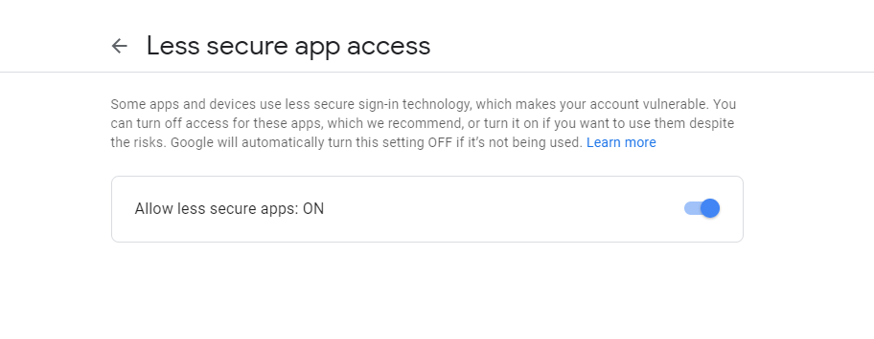
  + Make sure this feature is turned on
  + Without this the mails won’t be sent
* **sendConfirmMail()**
  + Endpoint to be called - /sendMailConfirmation
  + Input Required [Json with following fields]
    - email – email of the student
    - first – first preference chosen [Subject Code]
    - second – second preference chosen [Subject Code]
    - third – third preference chosen [Subject Code]
  + This method sends the confirmation to the students with their preferences
  + The mail id and credentials is to be mentioned similar to the above method
  + There is a dictionary defined to lookup the subject names from the code that is received from the client side
  + Change the dictionary according to the subjects of that particular year

**Deploying Instructions**

The platform used to deploy the service was Heroku and it can be done for free

Any tutorial on the web can be referred to deploy the app on Heroku

Few important points to take care of are the Procfile and the requirements.txt

Since the github repo has the right ones there shouldn’t be any problems however you could again go through the official docs in case you are stuck with any errors during deployment