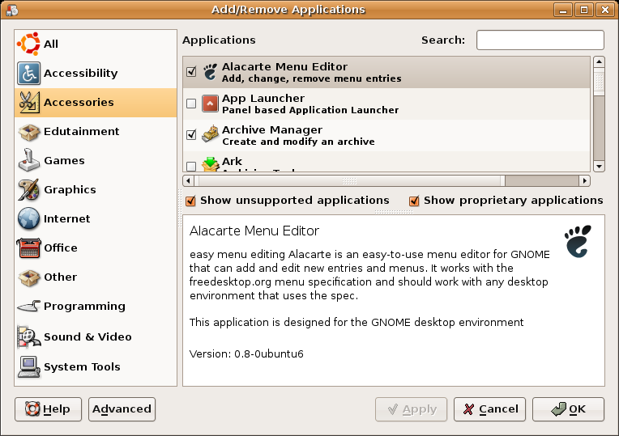
Welcome to Ubuntu

Ubuntu is a Linux-based operating system consisting of Free and Open Source software for laptops, desktops, and servers. Ubuntu is community developed, commercially supported, and offers free security updates for at least 18 months after release, with regular releases every six months.
Ubuntu has a clear focus on the user and usability – it should Just Work. The OS ships with the latest Gnome release as well as a selection of server and desktop software that makes for a comfortable desktop experience off a single installation CD.

Absolutely Free of Charge
Ubuntu is Free Software, and available to you free of charge. It's also Free in the sense of giving you rights of Software Freedom. The freedom to run, copy, distribute, study, share, change and improve the software for any purpose, without paying licensing fees. The Ubuntu team also believes that Free software should be free of software licensing charges.

Fast, Easy Install
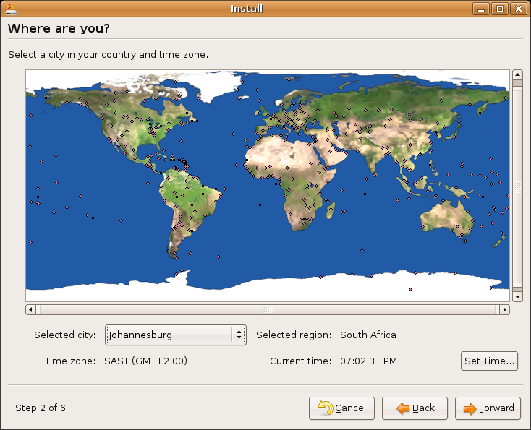
The Ubuntu installer asks a minimal number of questions, and the defaults will work for most people. We have kept the distribution installation CD set down to one single CD, everything else is available on-line if you need it. On a typical computer, installation takes less than 25 minutes, and can now be done directly from the Live CD session with the Ubiquity utility.
In addition, Ubuntu supports upgrades via the network, so you never need to reinstall the operating system - just upgrade from each released version to the next when you want to.

Immediately Useful
When you finish your Ubuntu installation your system is immediately usable. That one CD gives you a good desktop environment out of the box, with many applications for business, home and personal computer users installed by default. You have a full set of business productivity applications, internet applications, drawing and graphics applications, and games. In addition, there are thousands of other applications just a few clicks away.

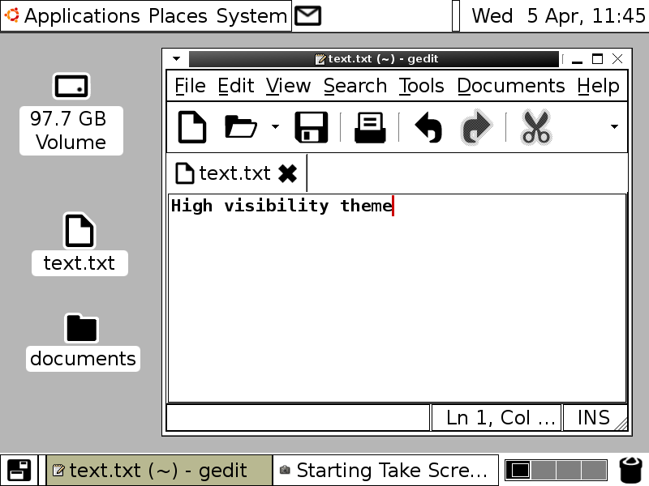
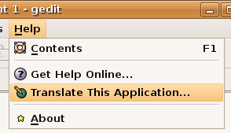
Language Support and Accessibility
Ubuntu is an ancient African word, meaning "humanity to others". Ubuntu also means "I am what I am because of who we all are". The Ubuntu Linux distribution brings the spirit of Ubuntu to the software world.
Desmond Tutu described ubuntu in the following way:
"A person with ubuntu is open and available to others, affirming of others, does not feel threatened that others are able and good, for he or she has a proper self-assurance that comes from knowing that he or she belongs in a greater whole."
We chose the name Ubuntu for this distribution because we think it captures perfectly the spirit of sharing and cooperation that is at the heart of the open source movement. In the Free Software world, we collaborate freely on a volunteer basis to build software for everyone's benefit. We improve on the work of others, which we have been given freely, and then share our improvements on the same basis.
Ubuntu aims to include the very best localisation and accessibility infrastructure that the Free Software community has to offer, to make Ubuntu usable by as many people as possible. To help us translate an application into your own language, simply click on Translate This Application in the Help menu and you will be directed to the on-line Rosetta translation tool, in which all translations for Ubuntu are coordinated.
Ubuntu includes special assistive technology features to make the OS accessible to as many as possible, including high visibility themes, a screen magnifier, a screen reader and an on-screen keyboard. As of Ubuntu 6.06 LTS, the Live CD now makes it possible to start these features from first boot. From the Live session it is in turn possible to install Ubuntu to the local hard drive using the new Espresso feature, enabling an independent install procedure for new groups of users.

Regular and Predictable Releases
The Ubuntu team releases a fresh version every six months which includes the latest kernel, X, Gnome and other key applications, and is supported with security updates for 18 months. You can download the CD and burn it yourself or have us ship you a CD. Selected releases have an extended support period of 3 years (5 years for server use).

Participate in the Community
Every Ubuntu user can participate in the Ubuntu Community. There are many levels of participation, from simply giving advice to fellow Ubuntu users to becoming a maintainer of core packages. We welcome new drive and ideas and any contributions to improve Ubuntu and spread Free Software. To read more about the Ubuntu Community and how you can participate visit www.ubuntu.com and click on 'Community'.

